EXPERIMENT NO- 1

**AIM:** To study various Social Media platforms, Social Media analytics tools, Social Media Analytics techniques and engagement metrics, Applications of Social media analytics for business.

# THEORY:

1. **Social media platforms: -**

Social media are interactive media technologies that facilitate the creation and sharing of information, ideas, interests, and other forms of expression through virtual communities and networks. While challenges to the definition of social media arise due to the variety of stand-alone and built-in social media services currently available, there are some common features:

* + Social media are interactive Web 2.0 Internet-based applications.
  + User-generated content—such as text posts or comments, digital photos or videos, and data generated through all online interactions—is the lifeblood of social media.
  + Users create service-specific profiles for the website or app that are designed and maintained by the social media organization.
  + Social media helps the development of online social networks by connecting a user's profile with those of other individuals or groups.

The term social regarding media suggests that platforms are user-centric and enable communal activity. As such, social media can be viewed as online facilitators or enhancers of human networks—webs of individuals who enhance social connectivity.The term social media refers to a computer-based technology that facilitates the sharing of ideas, thoughts, and information through virtual networks and communities. Social media is internet-based and gives users quick electronic communication of content, such as personal information, documents, videos, and photos. Users engage with social media via a computer, tablet, or smartphone via web-based software or applications. While social media is ubiquitous in America and Europe, Asian countries like Indonesia lead the list of social media usage. More than 4.5 billion people use social media, as of October 2021.

# Different types of social media

1. **Traditional social networking sites** - Most of us are familiar with social networking sites like Facebook, Twitter, LinkedIn, and TikTok. These platforms help us connect with friends, family, and brands. They encourage knowledge-sharing and are all about personal, human-to-human interaction.
2. **Social review sites** - Review sites like Yelp and TripAdvisor display reviews from community members for all sorts of locations and experiences. This eliminates a lot of the guesswork that goes into booking a restaurant or hotel.
3. **Image and video sharing sites** - Visual content like images, infographics, and illustrations capture our hearts, eyes and imaginations. Social media platforms like Instagram, Imgur, and Snapchat are designed to amplify the power of image sharing. (Or these days, video sharing.)
4. **Video hosting sites -** YouTube revolutionized the way we watch, create, and think about video. It transformed the medium into something accessible. Recent improvements in tech and connectivity helped video go the rest of the way.
5. **Community blogs -** Sometimes an image or post isn’t complex enough for the message you’ve got to share, but not everyone on the internet wants to run a blog from a self-hosted website. That’s a lot of work. Shared blogging platforms like Medium and Tumblr give people a space to express their thoughts and help connect them with readers.

# Benefits of social media:

* + Faster, Easier Communication
  + Social Makes Your Brand More Relatable
  + Social is Great for Promoting Content
  + Reputation Management
  + Generate Leads Directly & Indirectly

# Social Media analytics tools: -

Social media analytics is the ability to gather and find meaning in data gathered from social channels to support business decisions and measure the performance of actions based on those decisions through social media.

Social media analytics is broader than metrics such as likes, follows, retweets, previews, clicks, and impressions gathered from individual channels. It also differs from reporting offered by services that support marketing campaigns such as LinkedIn or Google Analytics.

Social media analytics uses specifically designed software platforms that work similarly to web search tools. Data about keywords or topics is retrieved through search queries or web ‘crawlers’ that span channels. Fragments of text are returned, loaded into a database, categorized and analyzed to derive meaningful insights.

Social media analytics includes the concept of social listening. Listening is monitoring social channels for problems and opportunities. Social media analytics tools typically incorporate listening into more comprehensive reporting that involves listening and performance analysis.

# What Does Social Media Analytics Tools Mean?

Social media analytics tools are pieces of web application analysis software that are used to monitor, assess and consequently improve social media performance. They are simply a subset of web analytics tools that are designed to gather and make sense of web performance data produced by social media sites and platforms, and consists of the usual graphical dashboard and data visualization techniques that give the user a clear understanding on the performance of their social media presence.

Social media analytics tools are essential in running a successful social media campaign. It allows social media experts to track and determine the performance of various portions of the social marketing campaign such as sales, customer service and sentiment analysis.

In terms of sales, these tools show how well a social media marketing campaign is going by showing all positive turnovers or purchases that come directly from social media sources such as Facebook and Twitter. These sites are useful for disseminating purchase or signup links and correlate directly to traffic which can be picked up by a specific social media analytics tool. For brand recognition and sentiment analysis, some tools are able to mine the data from social networking sites in order to find or discover the sentiment of people towards a brand or business through methods such as natural language processing and pattern recognition.

Examples of social media analytics tools or platforms:

# Google Analytics

Google Analytics is a web analytics service that provides statistics and basic analytical tools for search engine optimization (SEO) and marketing purposes. The service is part of the Google Marketing Platform and is available for free to anyone with a Google account. Google Analytics is used to track website performance and collect visitor insights. It can help organizations determine top sources of user traffic, gauge the success of their marketing activities and campaigns, track goal completions (such as purchases, adding products to carts), discover patterns and trends in user engagement and obtain other visitor information such as demographics.

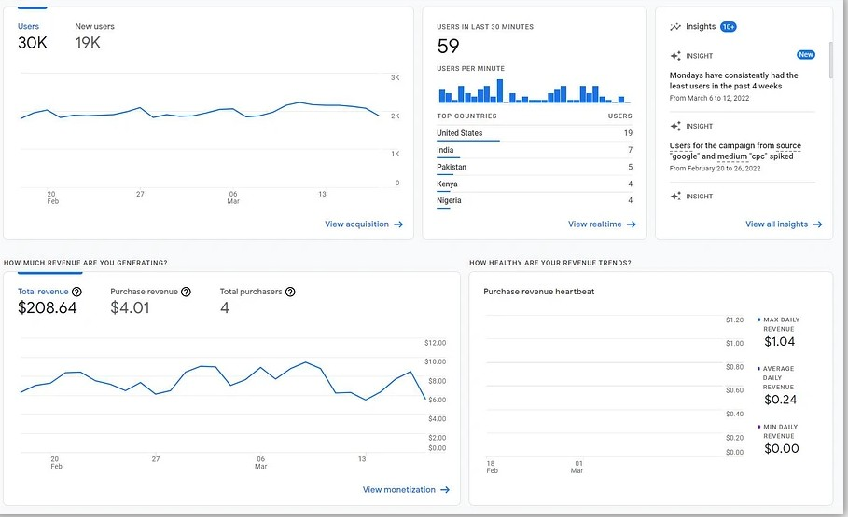

# Fig. Google Analytics Dashboard

* **Twitter Analytics**

Twitter Analytics is a free web analytics tool offered by Twitter that allows you to measure, track, and optimize your Twitter performance to grow your profile’s impact and business through the social media platform. Everyone involved with Twitter can access Twitter Analytics to see key metrics about their followers, tweets, conversions, and much more. You can use Twitter Analytics dashboards to get an overview of your Twitter marketing efforts or to discover the metrics that drive your engagement on the platform.

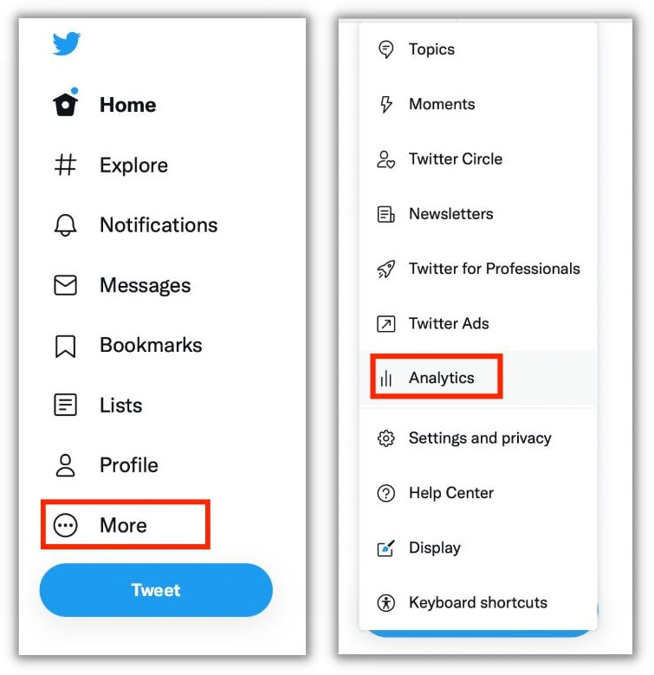

# Fig Twitter analytics menu

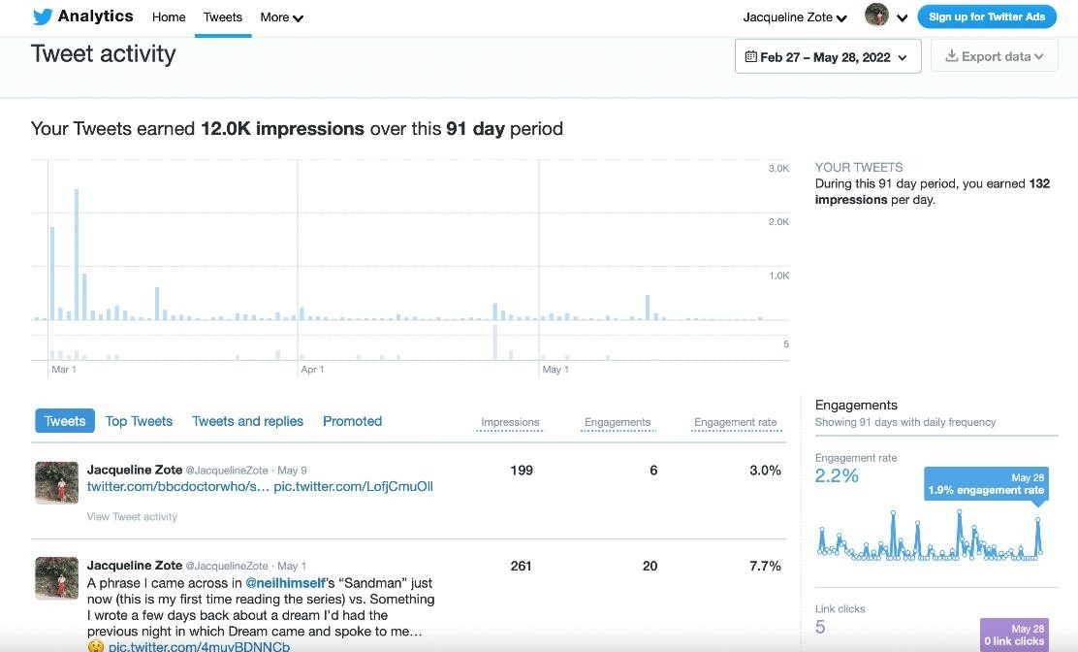

**Fig. Tweet activity**

# Facebook Insight

Facebook Insights visualizes incoming data from your business page so you can learn how users are behaving on your page, what content they're engaging with, and how your page matches up to competitors. Facebook Audience Insights, on the other hand, is used for ad campaigns and helps marketers understand Facebook audiences in general (which can also include those who follow your page)

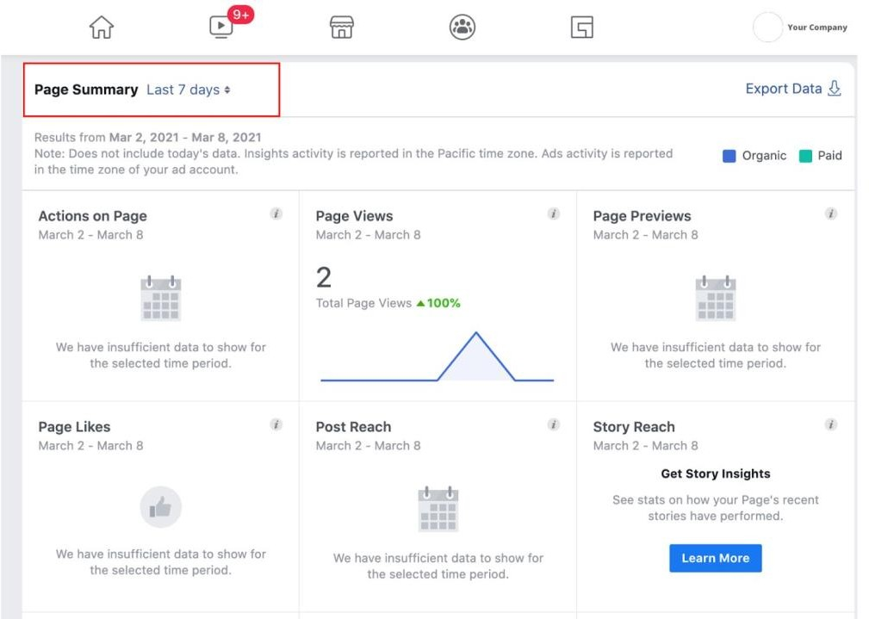

# Fig. Facebook Insights dashboard

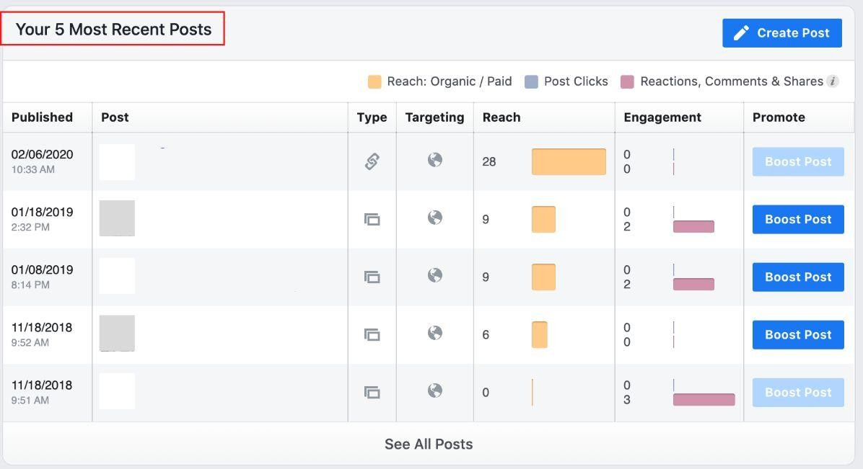

**Fig. Recent Posts Dashboard Activity**

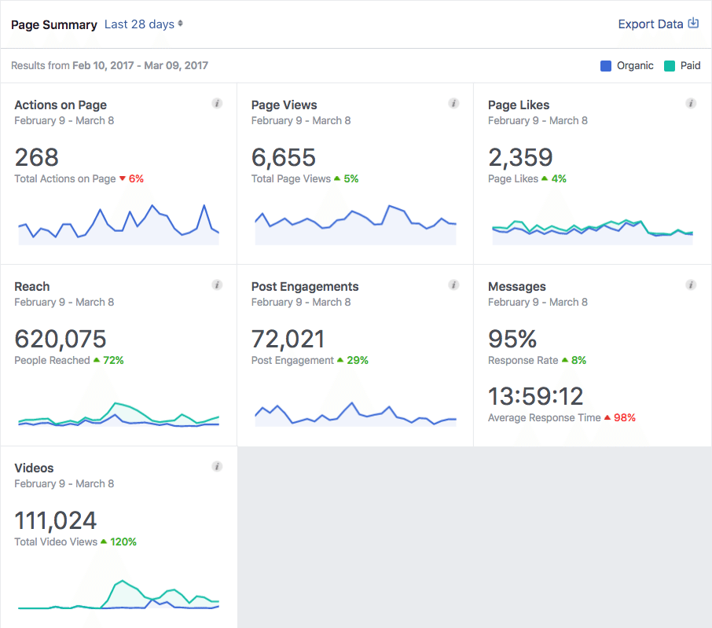

# Fig. Visualization of Page summary

* **Hootsuite**

Overview of Insights, powered by Brandwatch is a social listening solution. Search Insights to find out how people are talking about any topic, and get insights for your own content strategy or marketing campaigns. Insights uses the Brandwatch Data Library, a shared collection of public data acquired by Brandwatch, to match mentions to search queries. Brandwatch gathers the data using custom web crawlers, search APIs, data streams from third-party data providers, and direct relationships with specific sites. Insights returns mentions from a wide variety of platforms, including the sites listed in the following sections.

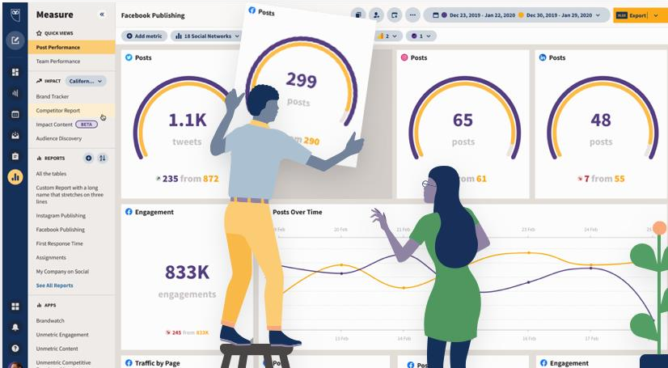

# Fig (a)

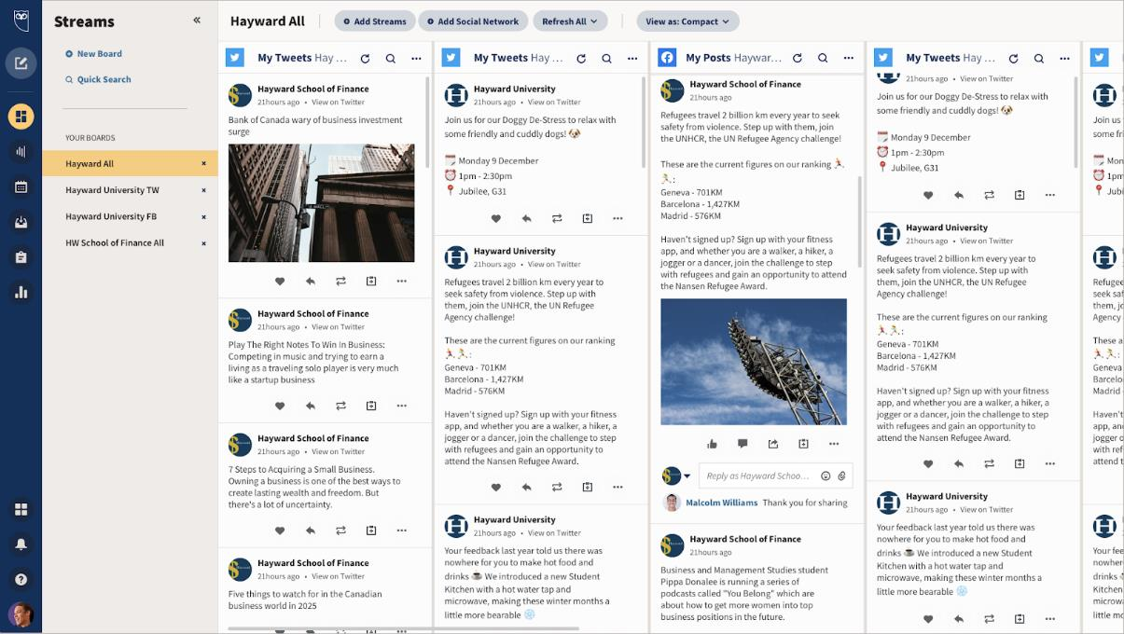

**Fig (a) & (b). Hootsuite Dashboard**

# Social Media Analytics techniques and engagement metrics: -

In Social Analytics reports we display data as it comes from the various social channel's APIs.

As there are many different types of data, understanding these can be difficult and it may appear to vary from tool to tool or even from the native channels. Rest assured that our data is accurate, and there is usually an explanation for any apparent data discrepancies.

If you'd like to learn the definitions for the metrics within Owned Social Analytics, check out our dedicated article here.

In Social Analytics there are three different types of data:

* + **Page level** data accounts for actions taken on the page during a time frame.
  + **Post level** data is lifetime values specific to actions taken on those posts.
  + **Member data** are the demographics and audience location data points and widgets.

In Social Analytics, most metrics, such as the overview cards at the top and graphs showing data over time, are based on Page level data. For example, Total Impressions is the total number of impressions on any post on the page during the time frame.

Post level data is seen in the Gallery and List view of the Top Performing Posts widget. This is showing the lifetime value of engagements, impressions, etc. on the posts published during the selected time frame.

# What are social media metrics?

Social media metrics are the data points that show you how well your social media strategy is performing.

Helping you understand everything from how many people see your content all the way through to how much money you earn from social media, metrics are the building blocks for ongoing improvement and growth.

The most important social media metrics

1. [Reach](https://blog.hootsuite.com/social-media-metrics/" \l "1_Reach)
2. [Impressions](https://blog.hootsuite.com/social-media-metrics/" \l "2_Impressions)
3. [Audience](https://blog.hootsuite.com/social-media-metrics/" \l "3_Audience_growth_rate) growth rate
4. [Engagement](https://blog.hootsuite.com/social-media-metrics/" \l "4_Engagement_Rate) Rate
5. [Amplification](https://blog.hootsuite.com/social-media-metrics/" \l "5_Amplification_rate) rate
6. [Virality](https://blog.hootsuite.com/social-media-metrics/" \l "6_Virality_rate) rate
7. [Video](https://blog.hootsuite.com/social-media-metrics/" \l "7_Video_views) views
8. [Video](https://blog.hootsuite.com/social-media-metrics/" \l "8_Video_completion_rate) completion rate
9. [Customer](https://blog.hootsuite.com/social-media-metrics/" \l "9_Customer_satisfaction_CSAT_score) satisfaction (CSAT) score
10. [Net](https://blog.hootsuite.com/social-media-metrics/" \l "10_Net_promoter_score_NPS) promoter score (NPS)
11. [Click-through](https://blog.hootsuite.com/social-media-metrics/" \l "11_Click-through_rate_CTR) rate (CTR)
12. [Conversion](https://blog.hootsuite.com/social-media-metrics/" \l "12_Conversion_rate) rate
13. [Cost-per-click](https://blog.hootsuite.com/social-media-metrics/" \l "13_Cost-per-click_CPC) (CPC)
14. [Cost](https://blog.hootsuite.com/social-media-metrics/" \l "14_Cost_per_thousand_impressions_CPM) per thousand impressions (CPM)
15. [Social](https://blog.hootsuite.com/social-media-metrics/" \l "15_Social_share_of_voice_SSoV) share of voice (SSoV)
16. [Social](https://blog.hootsuite.com/social-media-metrics/" \l "16_Social_sentiment) sentiment

# Applications of Social media analytics for business.: - Google Analytics:

Google Analytics is a web analytics service offered by Google that tracks and reports website traffic, currently as a platform inside the Google Marketing Platform brand. Google launched the service in November 2005 after acquiring Urchin.

As of 2019, Google Analytics is the most widely used web analytics service on the web. Google Analytics provides an SDK that allows gathering usage data from iOS and Android app, known as Google Analytics for Mobile Apps. Google Analytics can be blocked by browsers, browser extensions, firewalls, and other means.

Google Analytics is used to track website activity such as session duration, pages per session and the bounce rate of individuals using the site, along with the information on the source of the traffic. It can be integrated with Google Ads, with which users can create and review online campaigns by tracking landing page quality and conversions (goals). Goals might include sales, lead generation, viewing a specific page, or downloading a particular file. Google Analytics' approach is to show high-level, dashboard-type data for the casual user, and more in-depth data further into the report set. Google Analytics analysis can identify poorly performing pages with techniques such as funnel visualization, where visitors came from (referrers), how long they stayed on the website and their geographical position. It also provides more advanced features, including custom visitor segmentation. Google Analytics e-commerce reporting can track sales activity and performance. The e-commerce reports show a site's transactions, revenue, and many other commerce-related metrics.

# How Google Analytics works

Google Analytics is a platform that collects data from your websites and apps to create reports that provide insights into your business.

# Measuring a website

To measure a website, you first have to create a Google Analytics account. Then you need to add a small piece of JavaScript measurement code to each page on your site. Every time a user visits a webpage, the tracking code will collect pseudonymous information about how that user interacted with the page.

For the Google Store, the measurement code could show how many users visited a page that sells drinkware versus a page that sells houseware. Or it could tell us how many users bought an item like an Android doll by tracking whether they made it to the purchase-confirmation page.

The measurement code will also collect information from the browser like the language setting, the type of browser (such as Chrome or Safari), and the device and operating system on which the browser is running. It can even collect the “traffic source,” which is what brought users to the site in the first place. This might be a search engine, an advertisement they clicked on, or an email marketing campaign.

# Processing and reporting

When the measurement code collects data, it packages that information up and sends it to Google Analytics to be processed into reports. When Analytics processes data, it aggregates and organizes the data based on criteria like whether a user’s device is mobile or desktop, or which browser they are using.

But there are also configuration settings that allow you to customize how that data is processed. For example, you might want to apply a filter to make sure your data does not include any internal company traffic or developer traffic.

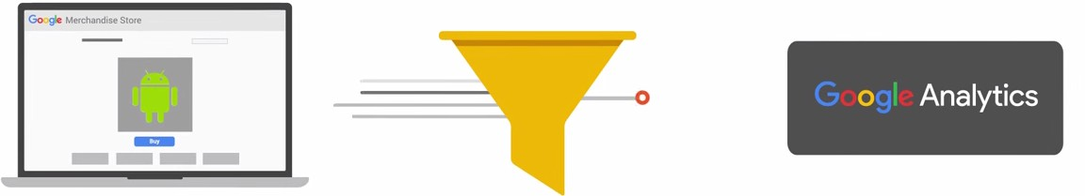

Once Analytics processes the data, it’s stored in a database where it can’t be changed.

So remember, when you set up your configuration, don’t exclude any data you think you might want to analyze later. Once the data has been processed and stored in the database, it will appear in Google Analytics as reports.

# CONCLUSION: -

In this experiment we learnt about various Social Media platforms, Social Media analytics tools, Social Media Analytics techniques and engagement metrics, Applications of Social media analytics for business.