EXPERIMENT NO- 4

**AIM:** To study Exploratory Data Analysis and visualization of Social Media Data for business.

**RESOURCES REQUIRED:** Windows/MAC/Linux O.S, Compatible version of Python.

**THEORY:**

**What is Exploratory Data Analysis?**

We can define exploratory data analysis as the essential data investigation process before the formal analysis to spot patterns and anomalies, discover trends, and test hypotheses with summary statistics and visualizations. It gives an idea about the data we will be digging deep into while analyzing. It aids in formulating how we can handle data during analysis, like choosing models, handling outliers, deciding model accuracy parameters, etc. Visualization helps to infer insights easily from massive datasets.

# Types of Exploratory Data Analysis

1. **Univariate Plots**

Univariate plots show the frequency or the distribution shape of a variable.

# Histograms

Histograms are two-dimensional plots in which the x-axis divide into a range of numerical bins or time intervals. The y-axis shows the frequency values, which are counts of occurrences of values for each bin. Bar graphs have gaps between the bars to indicate that they compare distinct groups, but there are no gaps in histograms. Hence, They tell us if the distribution is left/positively skew (most of the data falls to the right side), right/negatively skewed (most of the data falls to the left side), bi-modal (graphs having two distinct peaks), normal (perfectly symmetrical without skew), or uniform (almost all the bins have similar frequency).

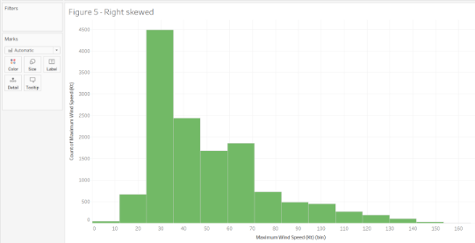

# Probability Distribution Plots

Probability distributions are mathematical functions that describe all the possible values that a random variable can assume within a given range. They help model random phenomena, allowing us in order to estimate the probability of a particular event. This type of distribution is helpful to know the likely outcomes and the spread of potential values.

For a single random variable, probability distributions can be divided into two types:

1. Discrete Probability Distributions for Discrete Variables
2. Binomial Distribution

# Run Sequence Plots

A run chart, also known as a run-sequence plot, displays observed data in a time sequence. So, Often, the data displayed represents some aspect of a business process’s output or performance. It is, therefore, a form of a line chart. They are often analyzed in order to locate anomalies in data that suggest shifts in a process over time. Changes in location and scale and outliers can easily be detected.

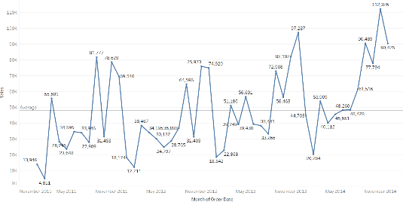

# Bivariate Plots

Bivariate plots display the relationship between two variables in exploratory data analysis.

# Bar Graphs

Bar charts can be used to compare nominal or ordinal data. They are helpful for recognizing trends.

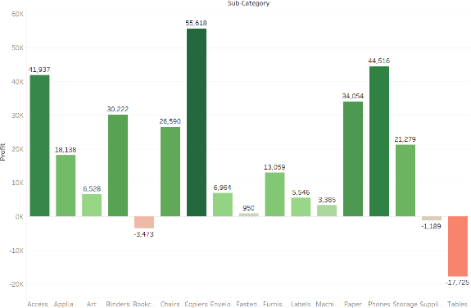

# Scatter Plots

Scatter plots are commonly used in statistical analysis in order to visualize numerical relationships. So, They are use in order to determine whether two measures are correlate by plotting them on the x and y-axis. They are suitable for recognizing trends.

For instance, you can see a scatter plot of two measures in the figure – the house’s area against price and the trend line. The data points are concentrated in the lower price and lower area range. A few outliers are indicating larger area houses available for lower prices.

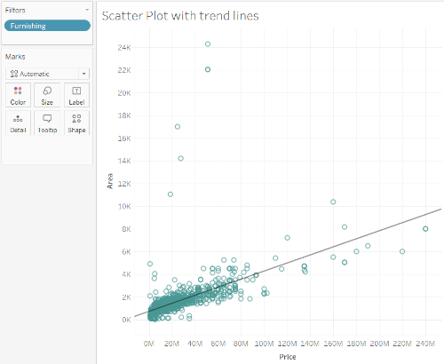

# Box Plots

These charts show the distribution of values along an axis. Rectangular boxes are used in order to bucket the data, giving us an idea of how the data points are spread out. These boxes are also called quartiles which represent a quarter of a data set. Boxes can be drawn vertically or horizontally.

Box plots are suitable for identifying outliers. The below figure shows the structure of a box plot.

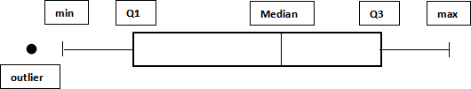

# Heat Maps

For instance, correlation heat maps show the interrelationship between variables—areas as shaded as per the data’s values. So, Color differences can easily spot similar and different values and make sense of the data variation. They are usually helpful when you have a large amount of data. They are used during A/B testing to see which parts of a web page are accessed by users on a website.

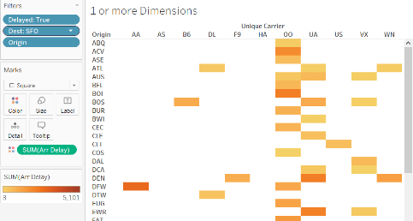

**CONCLUSION:** Hence, we have successfully studied Exploratory Data Analysis and visualization of Social Media Data for business.