EXPERIMENT NO- 7

**AIM:** To Develop a dashboard and reporting tool based on real time social media data.

**RESOURCES REQUIRED:** Windows/MAC/Linux O.S, similar web account.

**THEORY:**

**What is a social media dashboard?**

A social media dashboard monitors your social media performance metrics like engagement, subscriber or follower count, and audience insights. Social media dashboards bring together metrics from platforms like Facebook, Twitter, and YouTube to display your social media marketing performance in a single view. When you track your metrics on a social media dashboard, you have quick access to insights that will help you make smart, data-driven marketing decisions.

# Why should I use a social media dashboard?

A social media monitoring dashboard displays all your metrics in a single view. Use your social media metrics to shape your marketing strategy, engage with your audience, increase your conversion rates, and generate revenue. Social media dashboards allow you to gain insight with a single glance and share your performance with your team so you can stay on top of your social media strategies.

# What should be on a social media dashboard?

The top social media metrics for data-driven marketers include:

* Followers
* Content Engagement
* Reach
* Impressions
* Likes, Comments, and Shares
* Post Clicks
* Average Video Watch Time
* Retweets and mentions

A social media dashboard is a platform that allows you to view all of your social media activity in one place. This includes scheduling and creating posts, tracking analytics, and interacting with your followers. The best social media dashboards will also allow you to do things like track trending content, manage ad campaigns, and analyze results across platforms. Not only does this make social media marketing more efficient, but it also allows you to get a better understanding of your overall social media performance — something that is nearly impossible to do while toggling back-and-forth between native social media business profile solutions. Want to see how a social media dashboard works in action? The video below shows an overview of the Hootsuite dashboard.

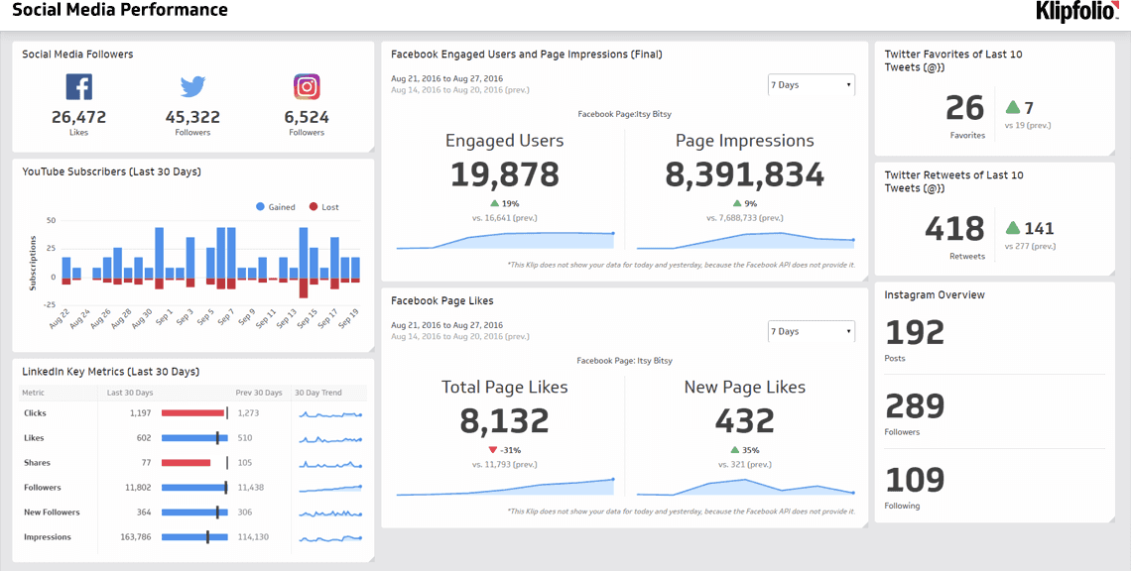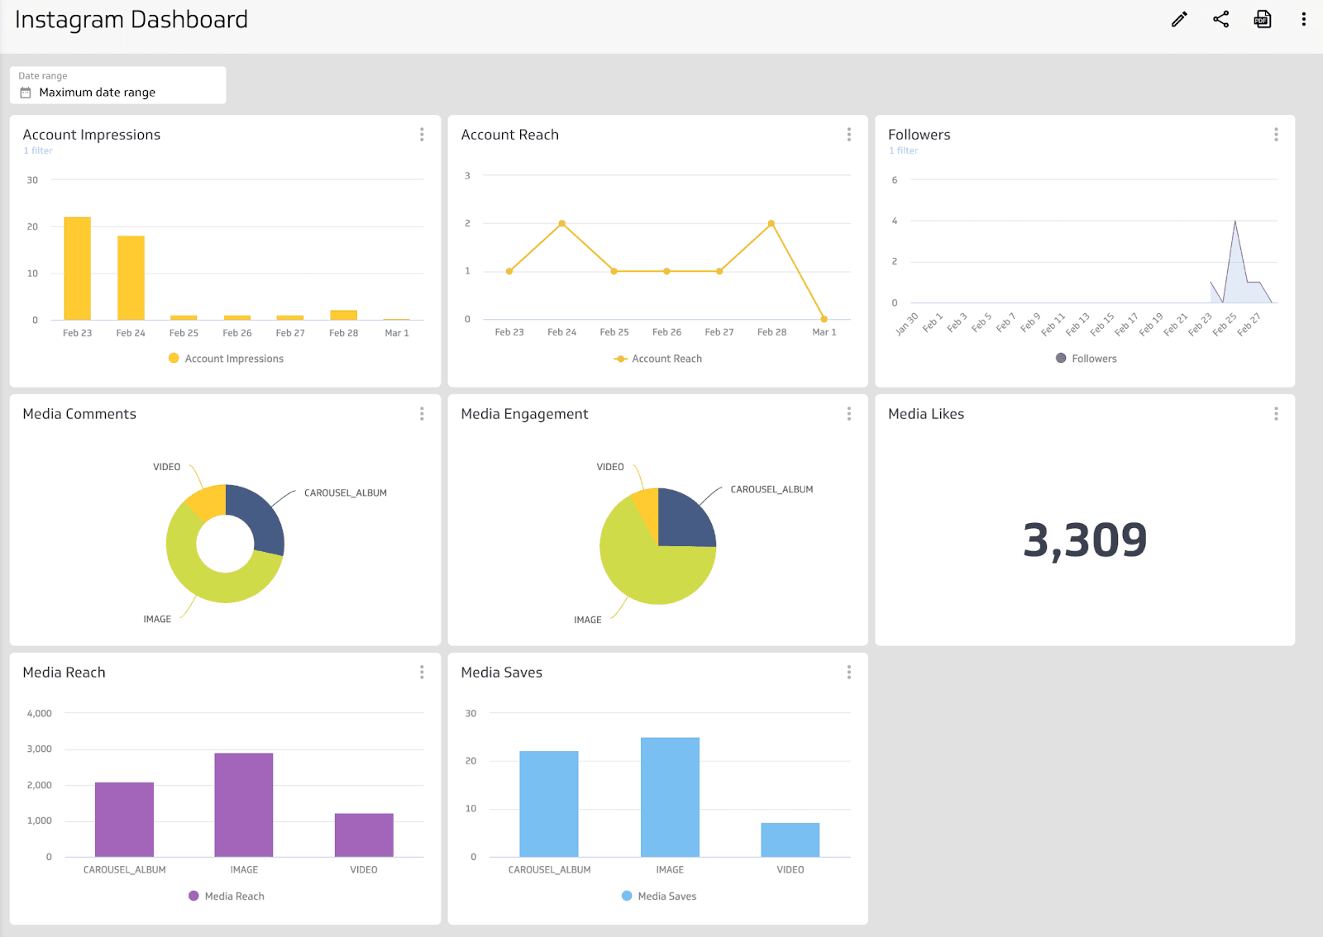

**IMPLEMENTATION:**

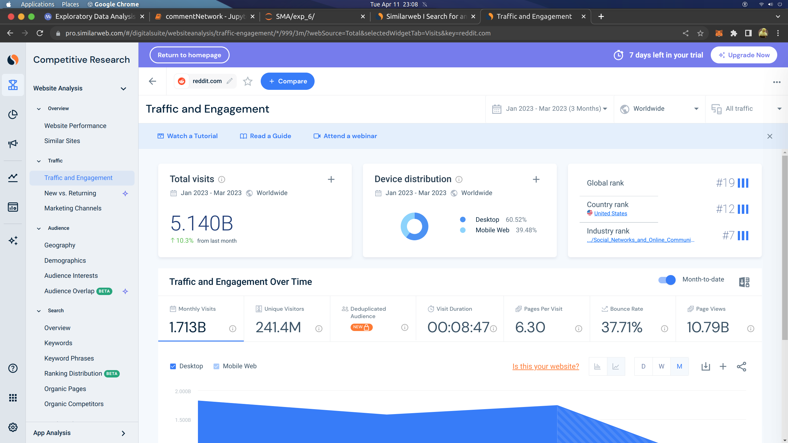Fig a. Traffic and engagement of users on reddit

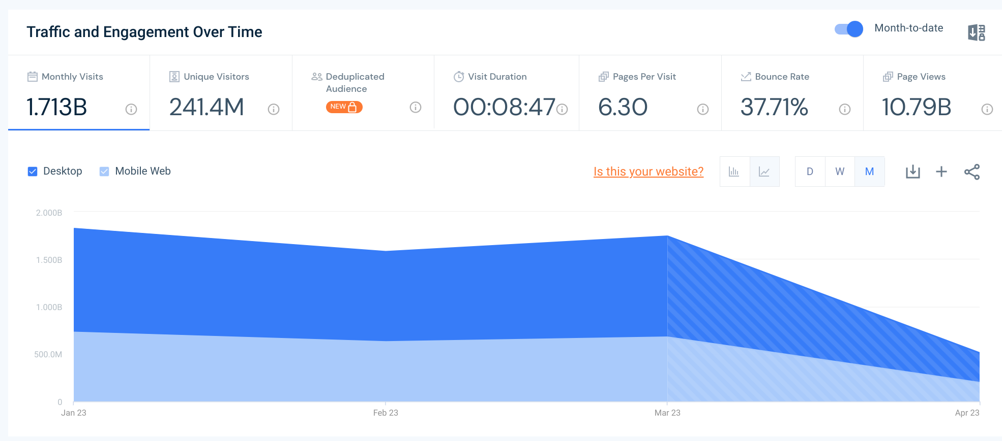

Fig b. Monthly traffic of users on reddit graph

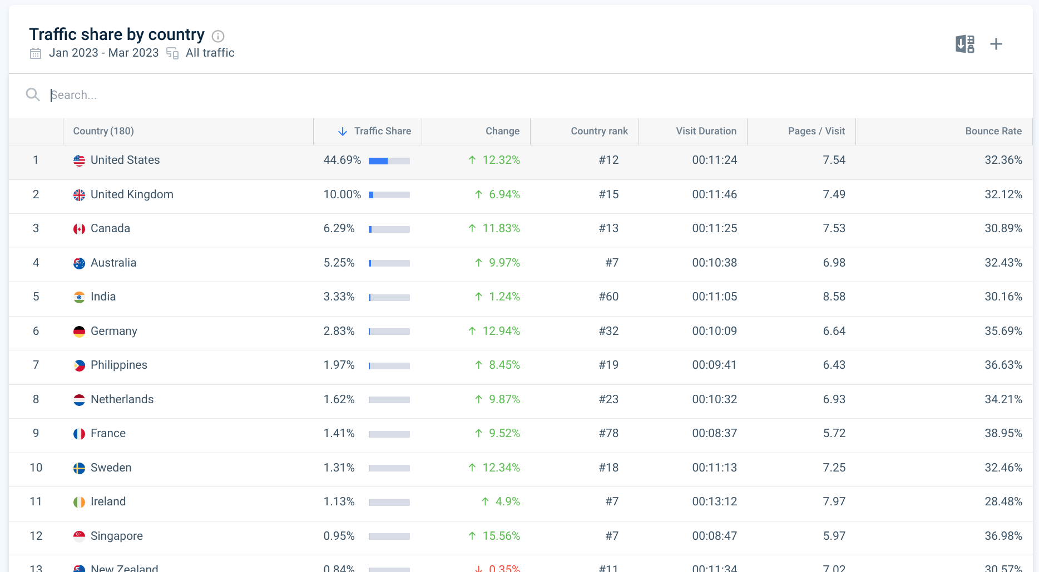

Fig c. Traffic group by country

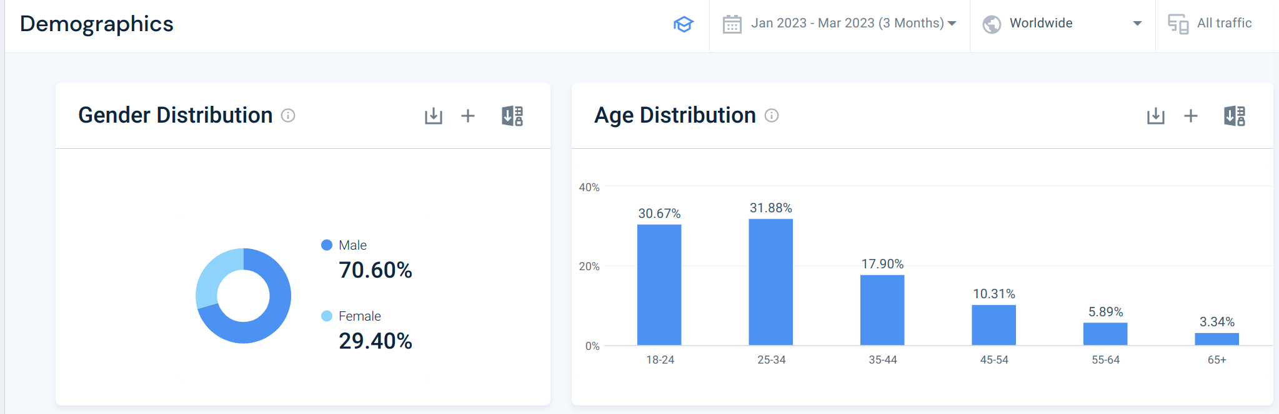Fig d. Customer Demographics

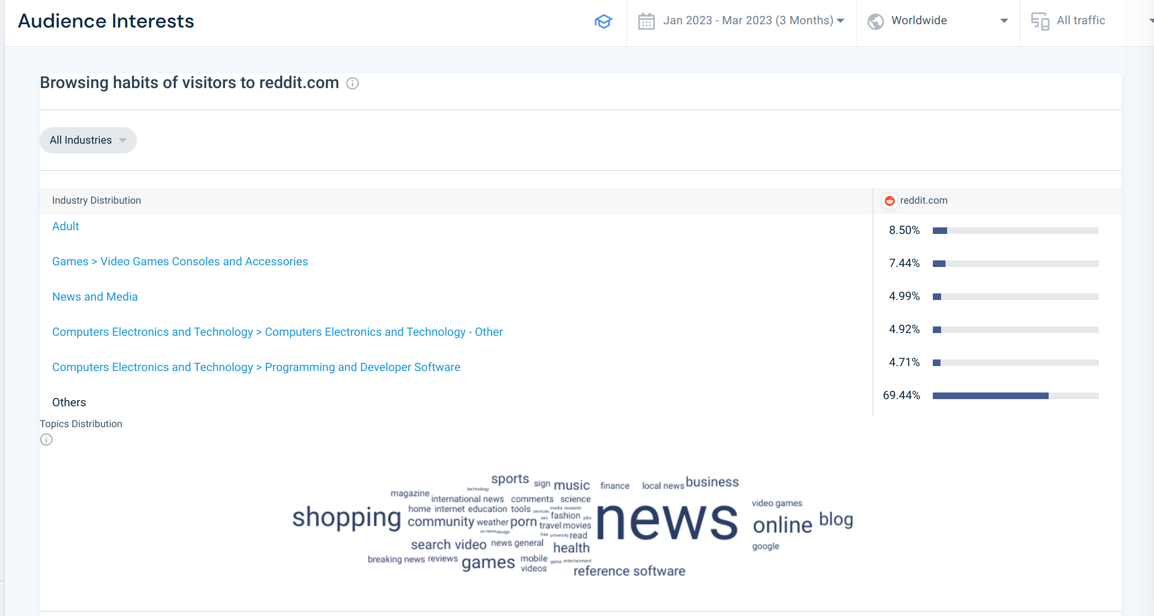Fig e. Interest of users engaging on reddit

**CONCLUSION:** Hence, we have successfully studied to Develop a dashboard and reporting tool based on real time social media data.