EXPERIMENT NO- 9

## **AIM:** To analyse competitor activities using social media data.

**RESOURCES REQUIRED:** Windows/MAC/Linux O.S, similar web account.

# THEORY:

A competitive analysis is an analysis of your competition to find out what their strengths and weaknesses are, and how those strengths and weaknesses compare to your own. It is a process of benchmarking your own results against the heavy-hitters in your industry, so you can identify opportunities for growth as well as strategies that aren’t performing as well as they should.

A competitor analysis, also referred to as a competitive analysis, is the process of identifying competitors in your industry and researching their different marketing strategies. You can use this information as a point of comparison to identify your company’s strengths and weaknesses relative to each competitor.

You can do a competitor analysis at a high level, or you can dive into one specific aspect of your competitors’ businesses. This article will focus on how to conduct a general competitive analysis, but you’ll want to tailor this process to match the needs and goals of your business.

### A social media competitive analysis, specifically, will help you:

* Identify who your competitors are on social media
* Know which social platforms they are on
* Know how they are using those platforms
* Understand how well their social strategy is working
* Benchmark your social results against the competition
* Identify social threats to your business
* Find gaps in your own social media marketing strategy

### How to do a competitor analysis

Figuring out what to focus on when conducting a competitive analysis can be tricky. Below are 6 steps to help you get started. Before you begin your competitor analysis, consider what you want to get out of it. Add any other areas of research that align with these goals.

### Identify your competitors

To create a list of potential competitors, consider where your customers would turn if they didn’t buy from your company. An easy way to start is to search your product name or category on Google or another search engine and explore the results. You can also survey or interview existing customers to ask them what alternatives they considered before deciding on your product or service. When you finalize your list, aim to include a diverse set of companies to get an accurate assessment of what the market is like. You should consider businesses that fall into each of the 3 categories of competitors.

### Create a competitor matrix

Before you dive into your competitor analysis, take a moment to get organized. A competitor matrix, also known as a competitor grid, is a table or spreadsheet you can use to compile your research. This will make it easier to compare your findings across competitors and spot larger trends. Start by devoting one row or column to each competitor that you’ve identified. On the other axis, list data points or categories of information you’d like to find out about each competitor. Don’t worry if you’re not sure what you should be looking for at this point. You can also always add more categories as you progress through your research.

### Gather background information

Once you have a list of competitors to research, start learning about their businesses. Look for the most basic information first, and then build your way up from there. Start by looking at company websites, social media pages, and any news articles that have been published about them. Here’s some basic information that you may want to look for.

### Profile your competition’s target customers

A company is nothing without its customers. Getting an idea of who your competitors sell to will tell you a lot about their businesses. To pinpoint the target customer for any business:

* + Read their mission statement.
  + Look at what kind of messaging they use.
  + Track who they interact with on social media.
  + See if they feature any existing customers in their content**.**

Use this information to construct a profile of who your competitors are trying to reach with their products or services. These customer profiles will probably resemble your own target customers—these are your competitors, after all—so make note of even small differences.

### Focus on the 4 P’s

Now that you’ve identified the target customer for each competitor, it’s time to look into how they go about reaching that segment of the market. This will require a deep dive into their marketing strategies. The marketing mix, also known as the 4 P’s—product, price, promotion, and place—covers the must-have elements when bringing a product to market. As part of your research, ask yourself the following questions for each competitor you’ve selected.

### Product

* + What are they selling?
  + What features are included in their product or service?
  + What is most appealing to customers about the product or service? What are some weak points of the product or service? (Pro tip: Check out customer reviews.)

### Price

* + What kind of pricing model do they use? Is it a one-time purchase or a subscription?
  + How much do they charge for their product or service? Do they offer sales or discounts?
  + How does their pricing reflect the quality, or perceived quality, of their product or service?

### Promotion

* + How do they get the word out about their product or service? What advertising channels (social media, email marketing, print advertisements, etc.) do they use?
  + What elements of their product or service do they emphasize? What’s their unique selling proposition?
  + What’s their company story? How do they talk about their brand?

### Place

* + Where do they sell their product? Do they sell online or in brick-and-mortar locations?
  + Do they sell to customers directly, or do they partner with retailers or third-party marketplaces? These questions are meant to be a starting point. Feel free to expand on them and tailor your questions to your industry and the goals of your research.

You’ll likely find a lot of information. Try to condense your findings into short bullet points that you can easily reference later. Be sure to include quantitative data where appropriate if you’re able to find it.

### Analyze strengths and weaknesses—yours and your competitors’

Using the information you’ve collected, consider the strengths and weaknesses of each of your selected competitors. Ask yourself why consumers choose a particular company’s product or service over the other available options. Record your conclusions in your spreadsheet. Last, consider your own company’s strengths and weaknesses. How does your business compare to the competitors you’ve researched? Knowing what sets your business apart from the competition—and where it falls short of expectations—can help you better serve your target customers.

# IMPLEMENTATION:

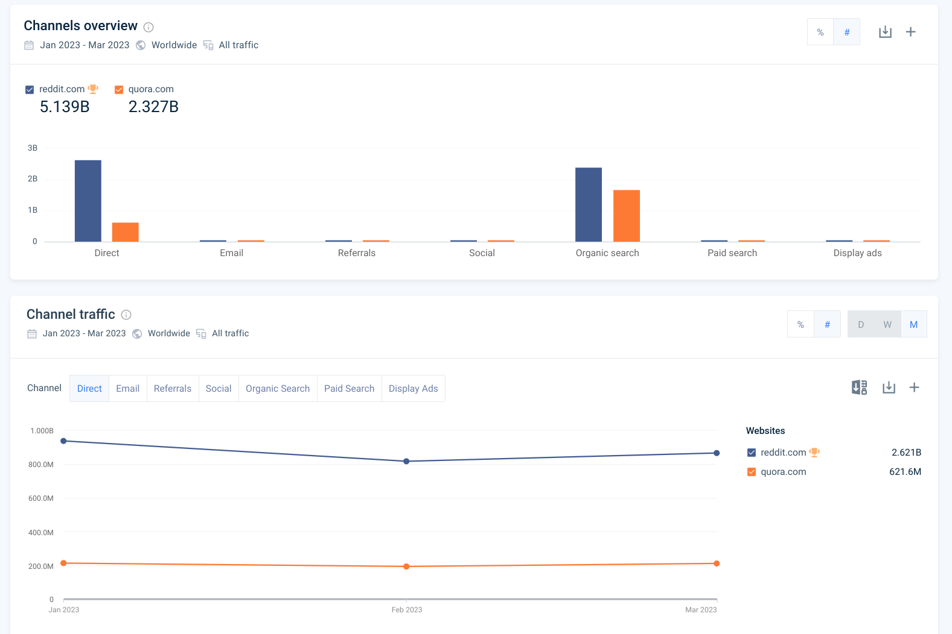**Fig a. Users traffic**

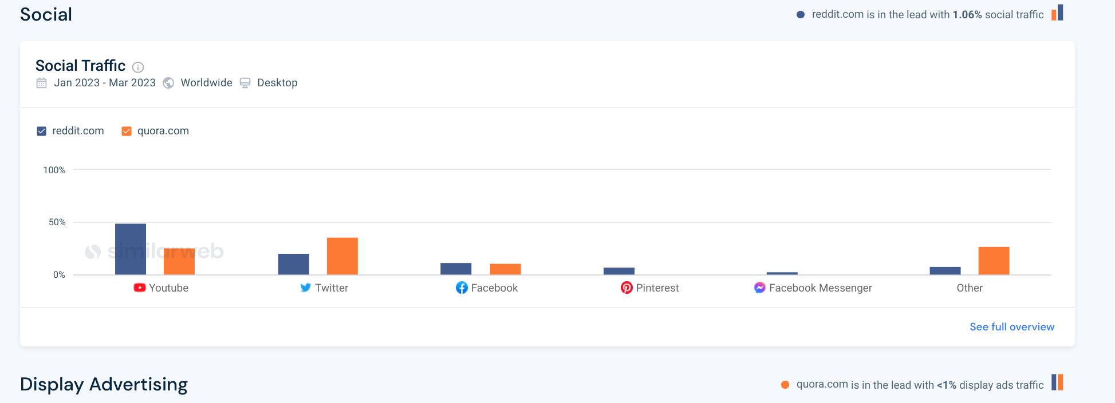**Fig b. Traffic coming from different websites**

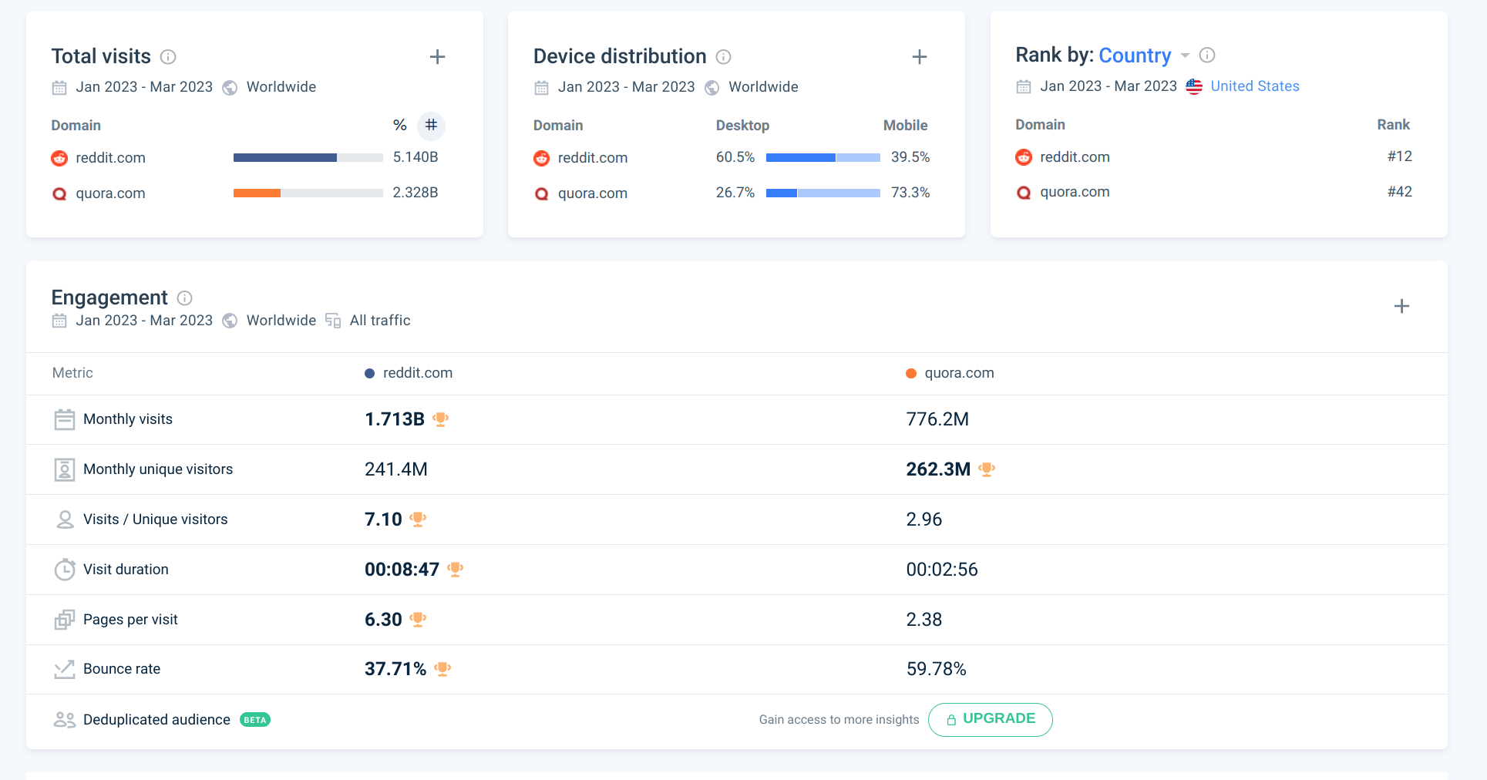**Fig c. Top level description**

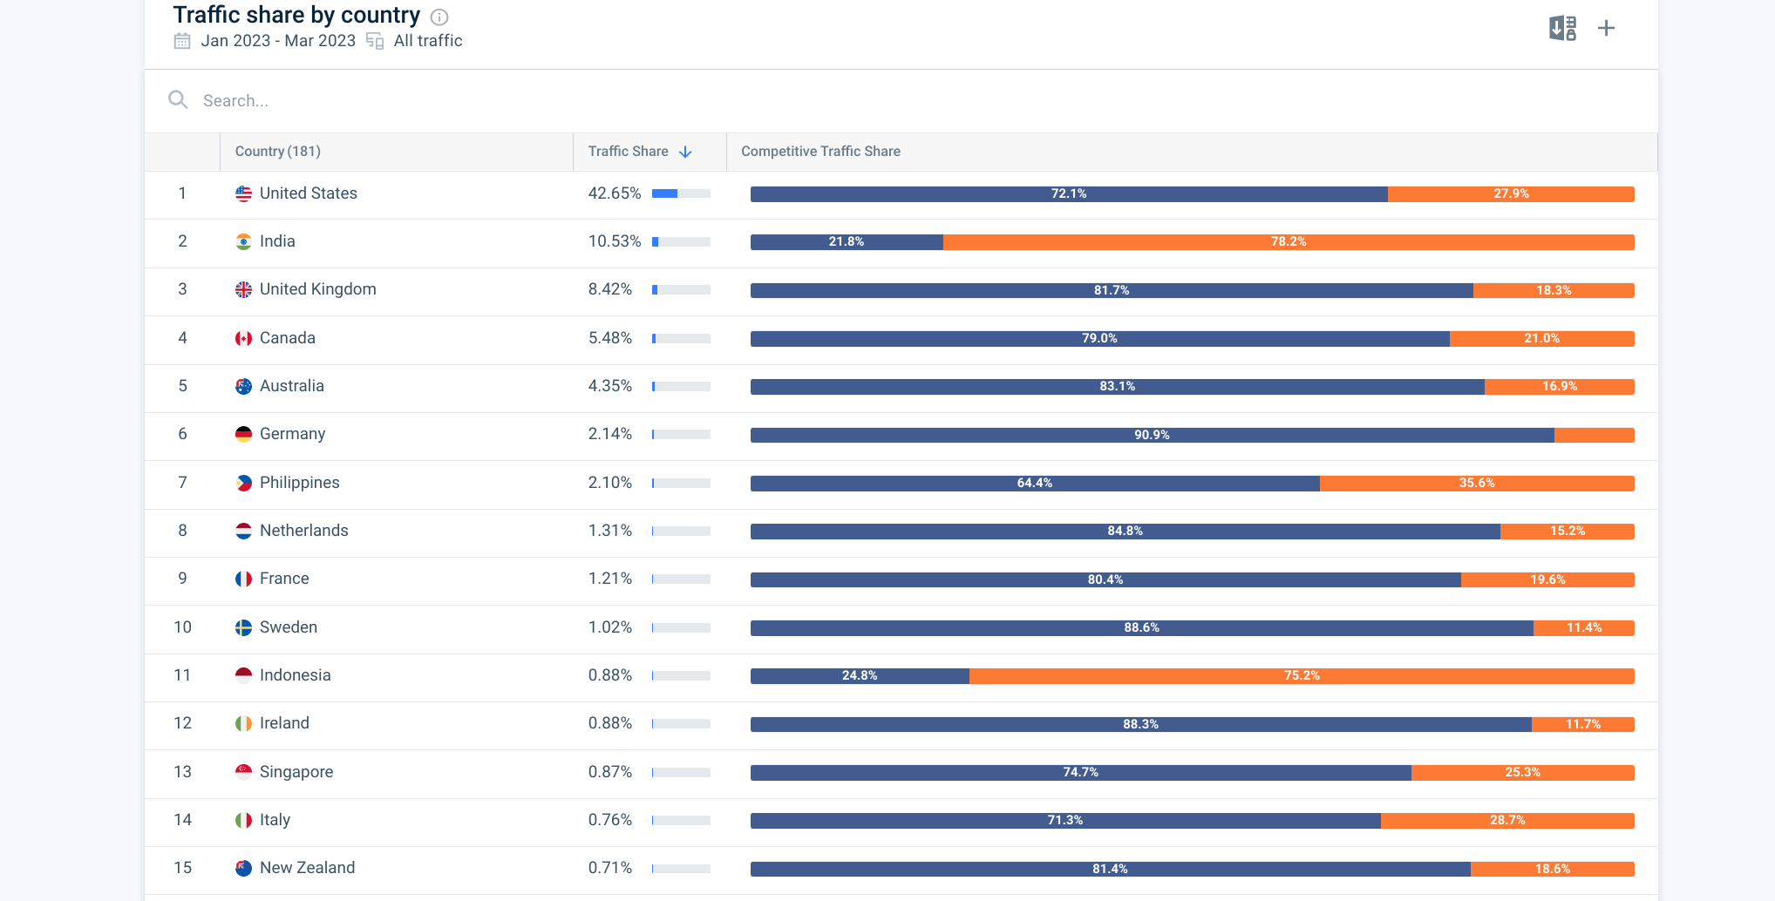**Fig d. Traffic group by country**

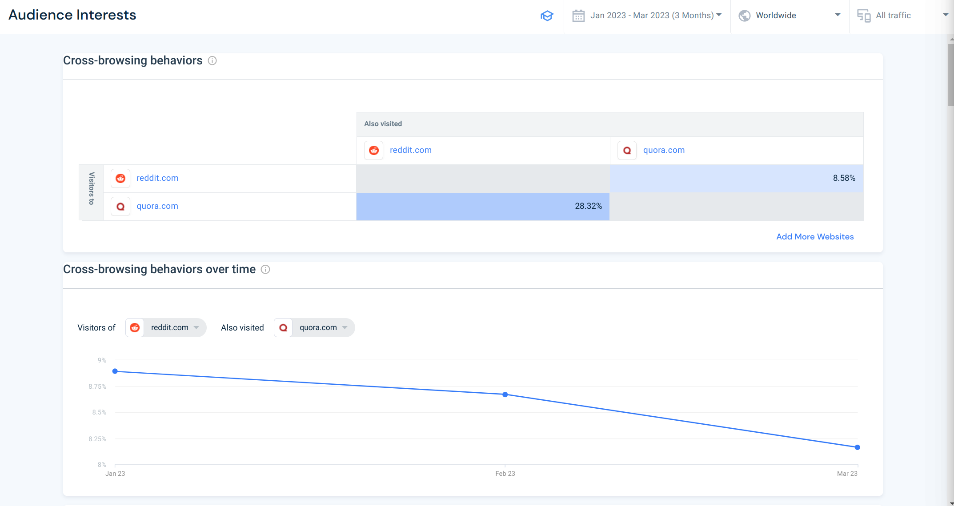**Fig e. Users cross browsing both websites**

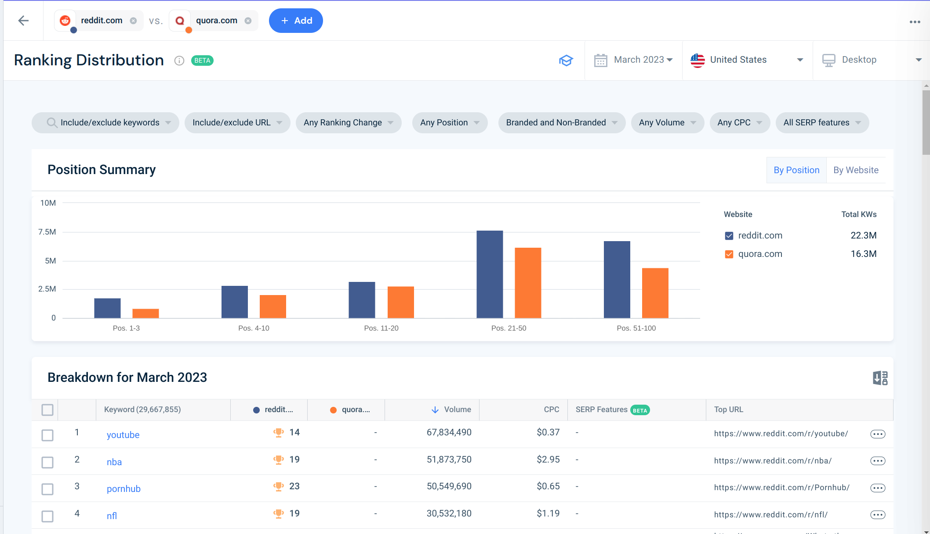**Fig f. Frequency of mentioned on internet**

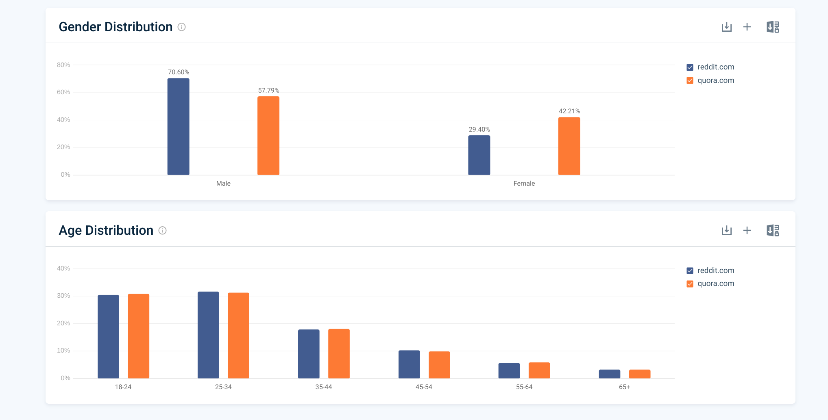**Fig g. Users demographic**

## **CONCLUSION:** Hence, we have successfully analysed competitor activities using social media data.