Thesis title

Subtitle if any

Author’s name



Department of Computer   
and Systems Sciences

Degree project XX HE credits

Computer and Systems Sciences

Degree project at the bachelor/master level

Autumn/Spring term 20XX

Supervisor: Name

Swedish title: XXX – not mandatory

Abstract

The abstract and the keywords should not exceed the limit of this page

*Keywords:* Keywords should be written in order of relevance

Synopsis

Background

Some text here

Problem

Some text here

Research Question

Some text here

Method

Some text here

Result

Some text here

Discussion

Some text here

Acknowledgement

Table of Contents

1 First Chapter 1

1.1 A New Section 1

1.1.1 A Subsection 1

2 Second Chapter 2

3 Third Chapter 3

4 Fourth Chapter 4

5 Fifth Chapter 5

References 6

Appendix A – An Appendix 7

Appendix B – Another Appendix 8

Appendix C – Reflection Document 1 9

Appendix D – Reflection Document 2 10

List of Figures

Figure 1 This is not a pipe 1

Figure 2 Research Strategies and Research Methods 3

List of Tables

Table 1 Philosophical Titles 1 4

Table 2 Philosophical Titles 2 4

List of Abbreviations

# First Chapter

This chapter offers an introduction to the thesis and typically introduces the problem, the research question and delimitations.

It can be nice to include figures already in this first chapter. A picture of a pipe (but not a pipe) is given in Figure 1.

## A New Section

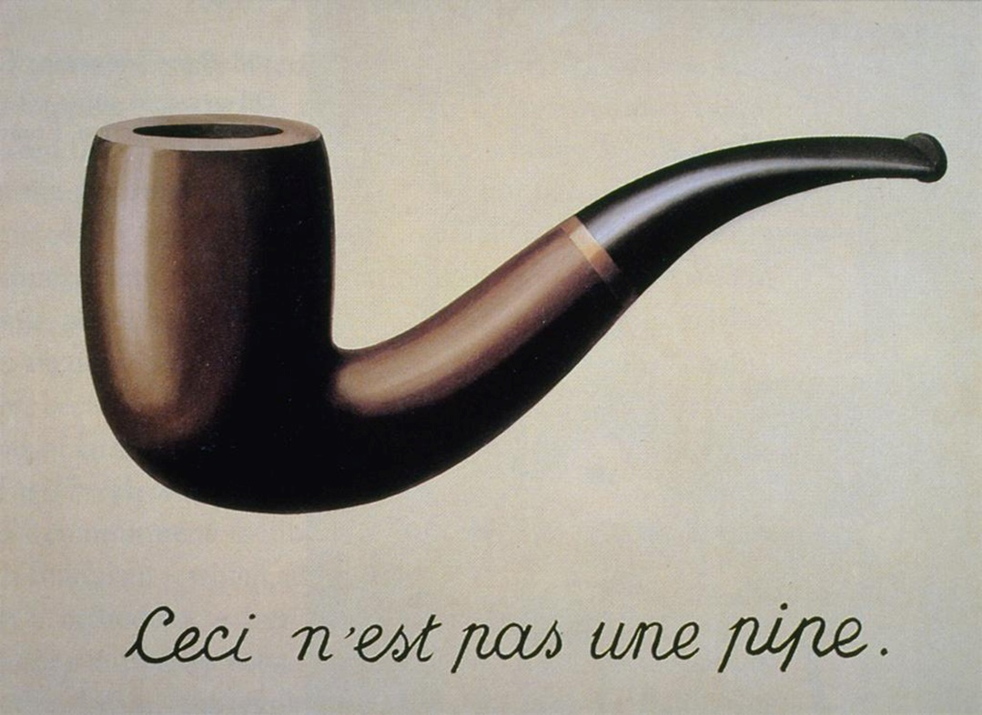

Figure 1 This is not a Pipe

(Managing figure and table captions in Word can be tricky, but an easy to follow guide can help: <https://libroediting.com/2012/12/27/table-of-figures-and-table-of-tables/>.)

### A Subsection

# Second Chapter

The second chapter in a thesis can provide an extended background and introduce related research.

# Third Chapter

The third chapter can be about methodology and discuss research strategies, data collection methods and data analysis methods. A simple overview of the relationships between these is given in Figure 2.

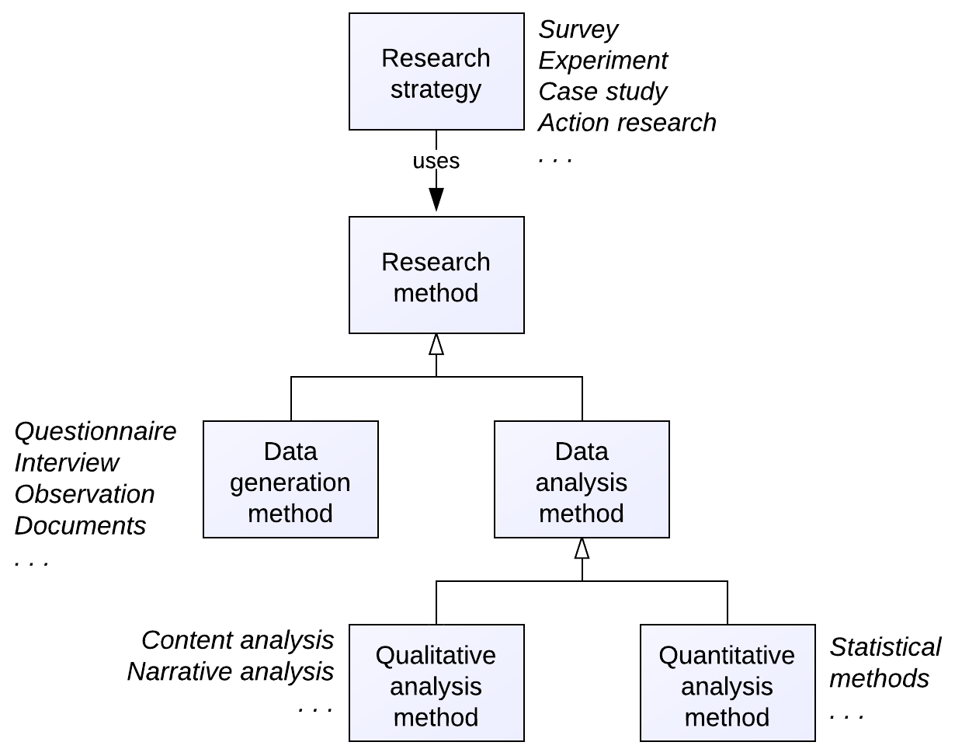

Figure 2 Research Strategies and Research Methods

# Fourth Chapter

This chapter can present the results of the study. Tables are often helpful for presenting results. For example, have a look at Table 1.

|  |  |  |
| --- | --- | --- |
| Author | Title | Publication Year |
| Gottlob Frege | Begriffsschrift | 1879 |
| Bertrand Russell | Principia Mathematica | 1910 |
| Ludwig Wittgenstein | Philosophical Investigations | 1953 |

Table 1 Philosophical Titles 1

The same data are shown in Table 2 but with different formatting.

|  |  |  |
| --- | --- | --- |
| Author | Title | Publication Year |
| Gottlob Frege | Begriffsschrift | 1879 |
| Bertrand Russell | Principia Mathematica | 1910 |
| Ludwig Wittgenstein | Philosophical Investigations | 1953 |

Table 2 Philosophical Titles 2

# Fifth Chapter

This chapter could discuss your work. Comparing your results to those of previous work is one important part of the discussion. See how this can be done in Simon (1996) and Hevner et al. (2004).

(Literature references can be handled in different ways in Word. In order to obtain correctly formatted citations, you can search in Google Scholar and grab a citation by clicking on the “Cite” link below a search result. You can also use reference managers, such as Mendeley, Paperpile or Zotero.)

References

Hevner, Alan et al. "Design science in information systems research." *MIS quarterly* 28.1 (2004): 75-105.  
  
Simon, Herbert A. *The sciences of the artificial*. MIT press, 1996.

Appendix A – An Appendix

Appendix B – Another Appendix

Appendix C – Reflection Document 1

Appendix D – Reflection Document 2