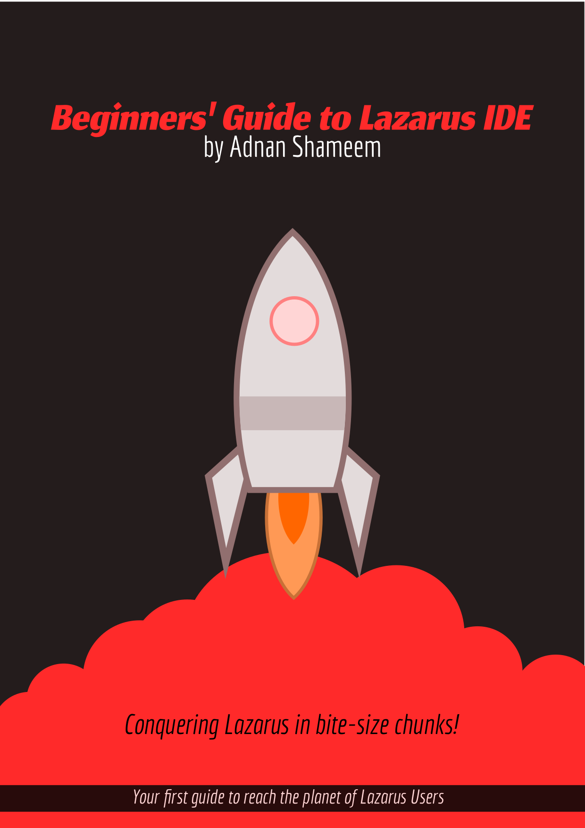

Beginners’ Guide to Lazarus IDE
Conquering Lazarus in bite-size chunks!
An E-book on Lazarus IDE to help newbies start quickly
by Adnan Shameem
from LazPlanet

First Edition: 15 December 2017
First Revision: 20 August 2018 [Work ongoing. May change.]

This book is licensed under Creative Commons Attribution 4.0 International (can be accessed from: https://creativecommons.org/licenses/by/4.0/). You can modify, share and use it in commercial projects as long as you give attribution to the original author. Such use and remix is encouraged. Would love to see this work being used in the Free Culture.

Source files for this E-book can be found at:
https://github.com/adnan360/lazarus-beginners-guide
Fork and remix. Have fun!

Contents
1: What is Lazarus 1
2: How to Install 2
3: How to Create Your First Program 3
4: How to Position Stuff on a Form 5
5: How to Customize your Tools 7
6: How to use Events 9
7: How to Save your Project 11
8: How to Extend Code with Custom Functions and Variables 13
9: Sharing Your Project 18
10: Compiling and Sharing Your Executable 20
Congratulations! 21

1: What is Lazarus
Lazarus is a Cross Platform IDE which lets you easily create the programs you want. It has an easy-to-use interface and works out of the box so that you can start right away!
IDE means Integrated Development Environment – which means it is an interface to create software fast. So fast that it is called a Rapid Application Development or RAD IDE.
Cross Platform means you can run the IDE across platforms, in any Operating System you use, Windows, Linux, Mac, BSD, Raspberry Pi – you name it! Your programs will run there too!
Let’s not spend more words on this. Let’s jump right in…!



2: How to Install
Installing Lazarus is easy and is similar to installing any other software. Just make sure your platform is supported and off you go!
Any system you use – Windows, Linux, Mac or a Raspberry Pi – chances are, you would be able to install Lazarus. Let’s take a minute and install away…!

On Windows
Just download the exe file, then double click it and follow the on screen instructions.
Download the file from here: http://www.lazarus-ide.org/index.php?page=downloads

On Ubuntu
Open a terminal (Ctrl+Alt+T), then run these commands:
sudo aptitude install lazarus
sudo aptitude install fpc fpc-source lcl

On Arch Linux
Normally this should do it:
sudo pacman -S lazarus lazarus-gtk2 gdb
If you are using KDE or lxqt, go ahead and run this instead:
sudo pacman -S lazarus lazarus-qt gdb

On Fedora / RedHat / Cent OS etc.
You can go ahead and run:
sudo yum install lazarus gtk2-devel

On a Raspberry Pi (Raspbian)
See here for details: http://wiki.freepascal.org/Lazarus_on_Raspberry_Pi

On a Mac
See this video: https://www.youtube.com/watch?v=QE_IAjkXElg or look in the wiki.

On other Operating Systems
Follow the instructions described here for your OS: http://wiki.freepascal.org/Installing_Lazarus#Installing_Lazarus

3: How to Create Your First Program
Creating with Lazarus is very easy. With just some quick clicks and a bit of typing you can achieve what others take hours and even days.
Start Lazarus – just like any other program.
If this is your first time, you should see a dialog titled Welcome to Lazarus IDE 1.6.4. Click Start IDE.
It should start the Lazarus IDE. Now move and resize the windows a little bit and it would look something like this:
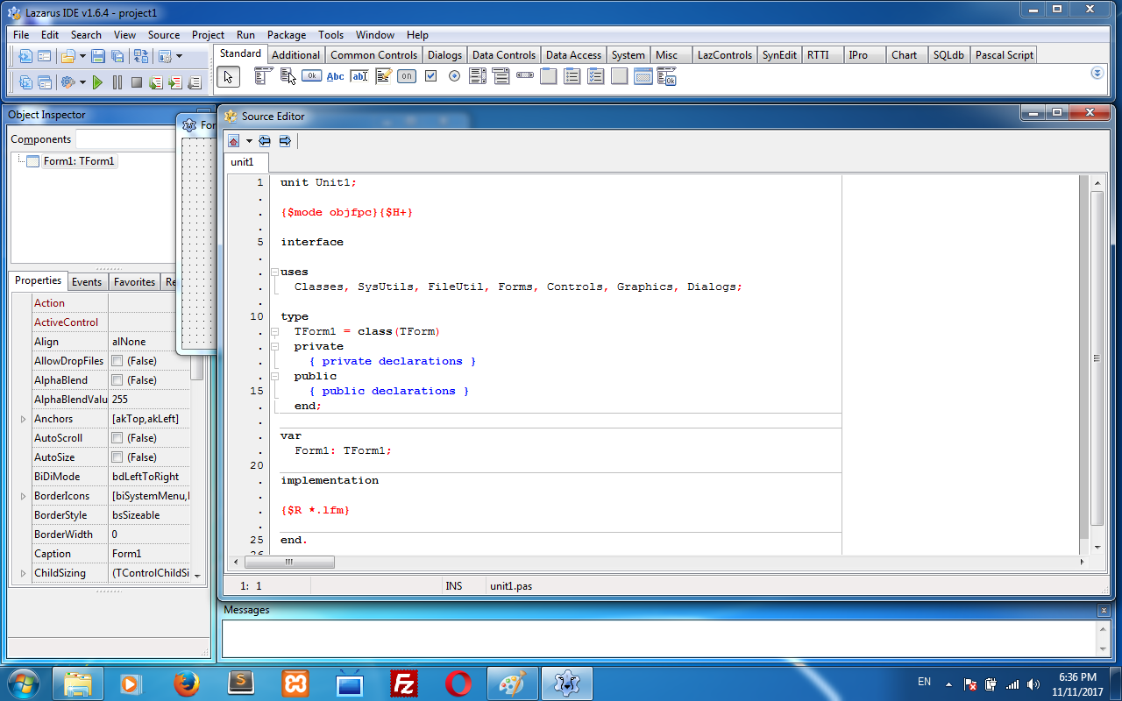
Too many windows! But don’t worry. It gets real easy once you get the hang of it.
At the top there are some “tools” that you would drop into your form. (“Tools” are formally called “components”. But let’s forget that for now!)
At the left you can customize those tools, change appearance etc.
On the right you can write code to do something with your program.
Let’s get into designing. Press F12. You should see your form on your screen. It is not currently running. You just design your program here.
Now focus at the top of your screen. You will see endless list of tools.
By default, you should be on the Standard tab. Now forget all the other tools, just select the icon that has a little Ok written on it.
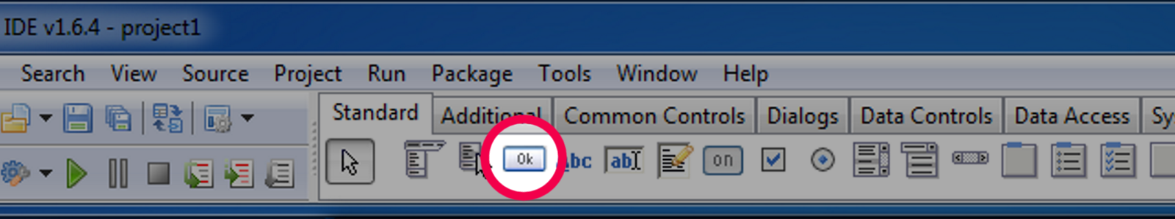
With it selected, click and drag your mouse cursor to draw an imaginary rectangle on your form where you want your button to appear on the form. You will see a button appear on that area.
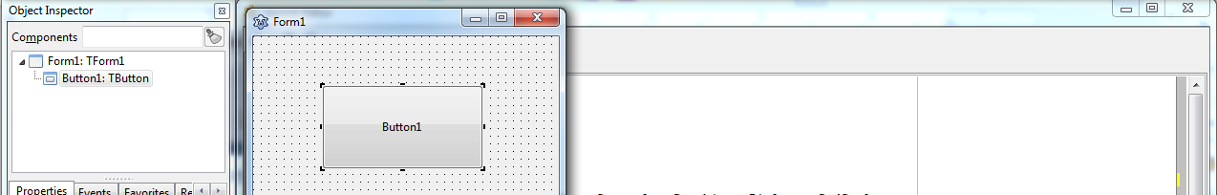
Now double click on that button. It will create some code automatically and place a cursor on the editor. Now, copy-paste the following code where your cursor is placed:
Close;
Now Run your program pressing F9 or clicking on Run – Run menu. Your program will now run, like it would for a user. Now you should see the exact form you designed earlier onto your screen:
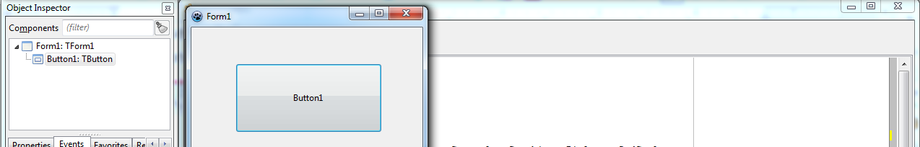
Now you can click on the button and your program will close.
So, now you have created your first app in Lazarus. Sweet!

4: How to Position Stuff on a Form
Positioning stuff on the form lets your users use your software with ease. We can’t just stack buttons on top of one another and call it software! So let’s move some tools and make it look great...
Press F12 until you bring up the form on screen.
You can use any tools from the top. We would get into it, but first, did you know, you can drag the corner of the form to resize?! Go ahead, try it.
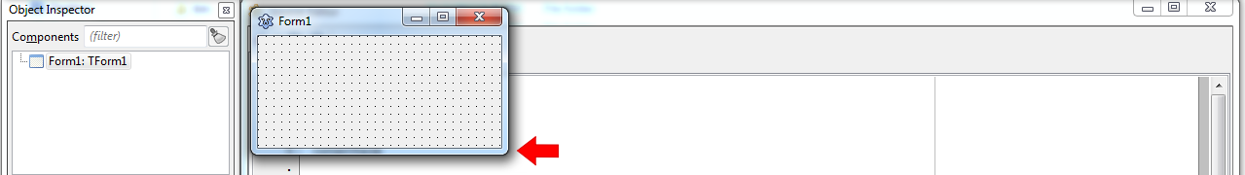
You can click on any tools from the top. Whenever you click on it, it gets selected. Let’s click on TButton, the one with the Ok button.
And then when you draw a rectangle on the form, you will see the tool to be placed on the form. We’ve done that before. Easy-peasy!
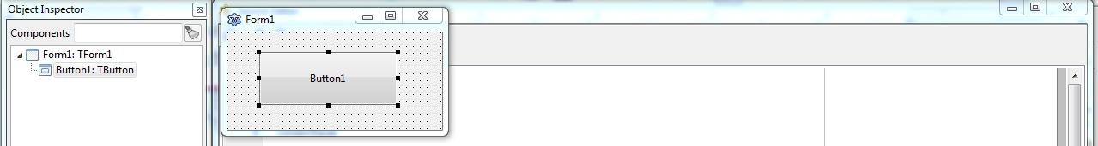
After that you would see a bunch of black boxes around the tool you placed:
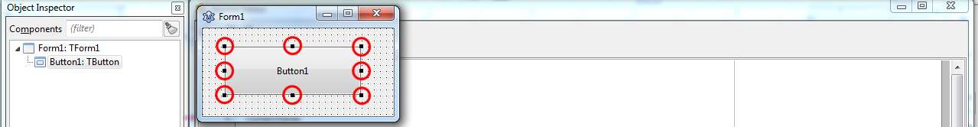
Drag these black boxes – to resize
Drag the tool itself – to move
Select TButton again from the top toolbar and drag another rectangle on your form. Now another button will be placed and it will be selected. You can do the previous things to it as well – resize, move, play around! Neat!
Go ahead, play all you want. You’ve earned it! Place some buttons here and there, move them, resize them, do anything with them!
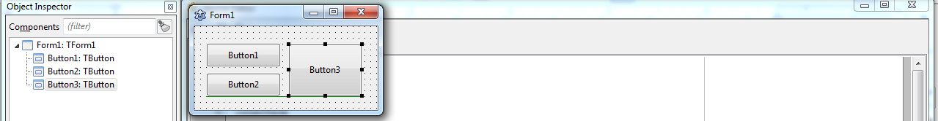
To select a tool on your form – click on it. With it selected, you will see the black boxes around it and you can move and resize them anyway you want.
You can also select multiple items by holding down shift and clicking on them.
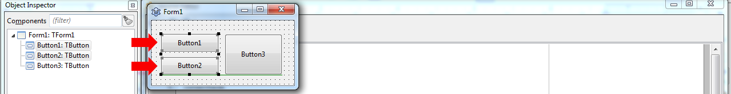
There are some other tools that can hold other tools inside them. For example, TGroupBox, TPanel, TScrollBox etc. (Don’t worry, they’re just names. You don’t have to memorize them. ☺ )
You can draw a TGroupBox on the form.
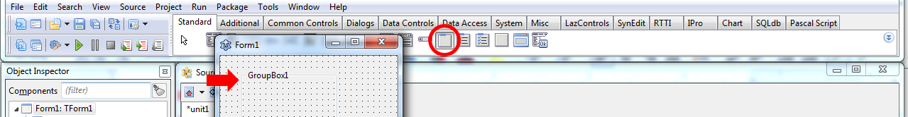
We can now put tools inside it. To put some tools inside it, when drawing the tool, just start drawing from inside the GroupBox and it will let you keep it inside the GroupBox.
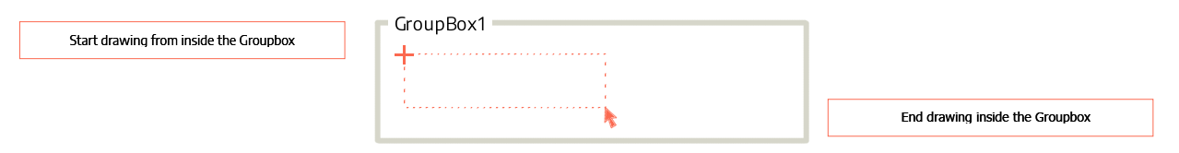
When you will do this successfully, the Object Inspector will also show the tool inside the Groupbox.
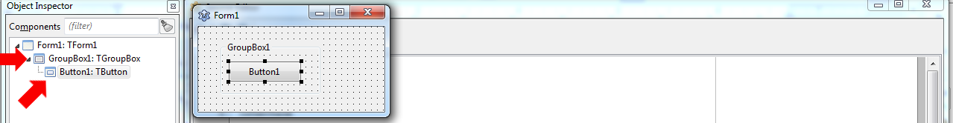
Now, when you move the GroupBox, it will move the tools inside it as well.

5: How to Customize your Tools
There are some default settings on your tools. But you may not always like how it looks or works by default. That’s why you need to change some properties once in a while...
On the left you will see a panel with a title Object Inspector. This has the Properties area. It shows the various aspects you can change for the selected tool.
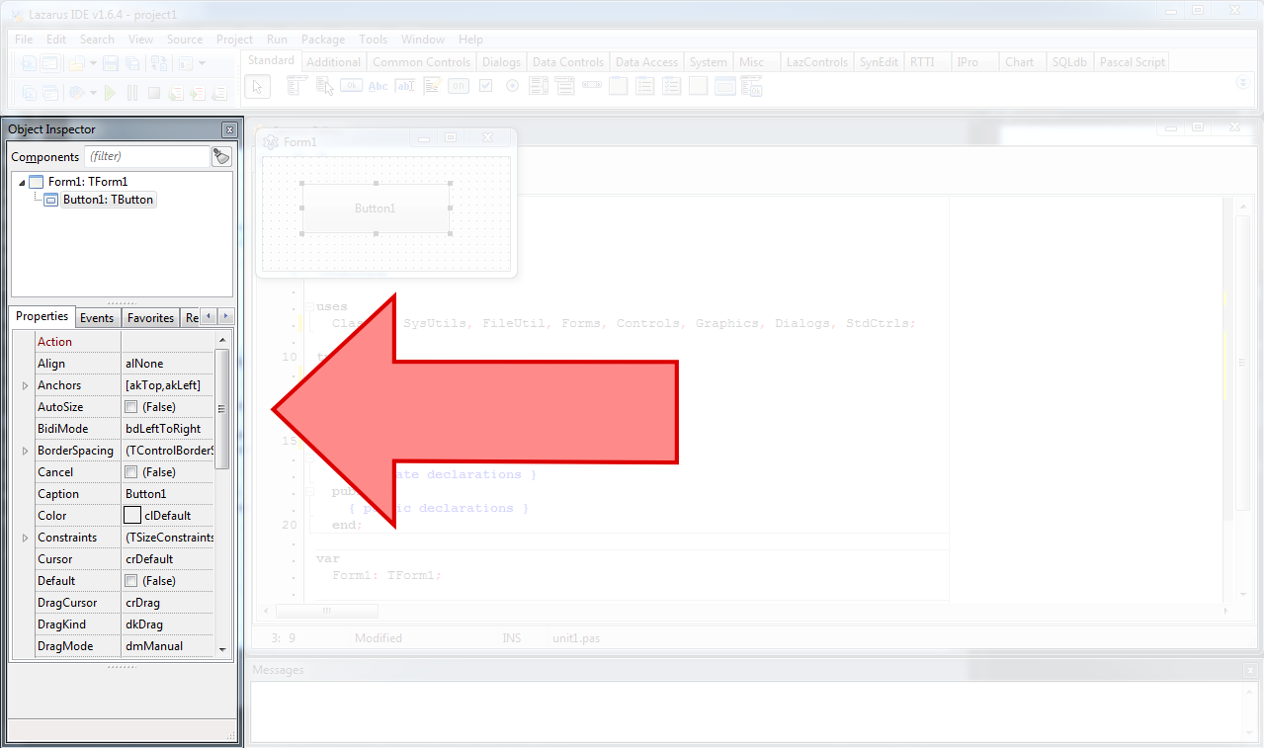
You can change the Font name, Font size, Caption, Name, Visibility etc. from this pane.
Let’s practice… Go on and create a new project: Project → New Project → Application → OK. Place a TButton on the form. Now with the button selected, move over to the Properties area on the left, then click the box to the right of the Caption property. Then write anything for the label of the button and press enter.
This is like sticking labels on jars. It will tell you what your button is for. It will change the label of the button to your new text:

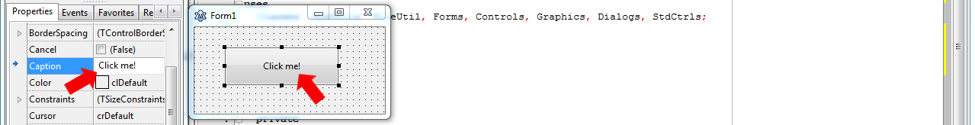
You can change the button’s text size and font. Look into these properties:
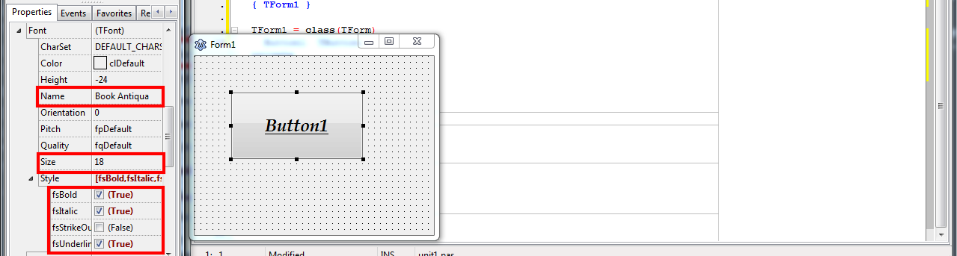
You can get these if you expand the items under Font and Style Property. I have changed some properties for test. You can see the results on the right.
There are many other properties as well. Go ahead, change them and run your little experiments on them! Try to figure out what they do.

Changing Properties with Code
We can also change these from our code if we want. And this is also a great fun to play with. Create a new project and place a button. Double click on Button1 and enter:
Button1.Visible := false;
Place another button. This would possibly be named Button2. Double click it and enter:
Button1.Visible := true;
Now Run (F9) and then click on Button1. This would hide Button1. Click on Button2 and it will show again. Just something fun to try on.
If you don’t like calling your buttons Button1, Button2 etc. on your code, you can change their Name property to something like btnShow, btnHide etc.

6: How to use Events
An Event runs whenever the user does something. If the user clicks on something an event runs. If he types something an event runs. Whatever he does on your program is an event.
In gist:
- When user clicks, double clicks, moves mouse, types something etc. – it’s an event.
- We can do something when user does these things – with code.
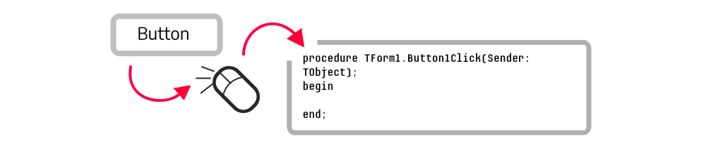
Whenever you double click a button on the form, Lazarus automatically creates an OnClick event and let’s you write code. OnClick is an event.
We have many other events. When you select a tool on the form, then (1) go to Object Inspector – Events tab, you will see a list of events. (2) Click on an event, (3) then click on […] button beside it. After you click it, it will create some code automatically! You can write your code where Lazarus placed the cursor, and it will be run when that event occurs. Easy!

Enough talk! Now let’s see events in action!
Go on and create a new project: Project → New Project → Application → OK. Now Draw a TButton on the form (select TButton from the top and draw a rectangle on the form).
Now we will change this button’s Caption when user does various things to it. We would show a Caption when user clicks on it. So double click on it to create a code for OnClick event. And enter:
Button1.Caption:='Clicked!';
Now, click on the Events tab on the left. Click on OnKeyPress, click the […] button beside it. Now we would write some code to show when some key is pressed. Enter:
Button1.Caption:='Key Pressed!';
Now, again, on the Events tab click on OnMouseWheel, click the […] button beside it. Enter:
Button1.Caption:='Mouse wheel scrolled!';
Now Run the program by Run – Run menu or F9 key.
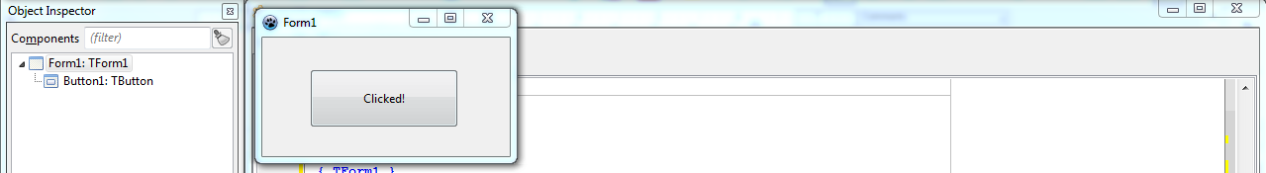
Now click on the button, it will say “Clicked!” Now press some letter keys in the keyboard, it will say “Key Pressed!” Now move your mouse cursor over the button and scroll the mouse wheel (the wheel between your left click and right click buttons), it will show “Mouse Wheel Scrolled!”
Now there you go, a fun project to show how the events work. Have fun!

7: How to Save your Project
There is an art in saving a Lazarus Project! You would need to create a folder, give some appropriate names to your files – it is much more than just saving a file. But at the end it is worth it!
You know what they say - write early, save early! To save a project, you would need to use the File – Save All menu.
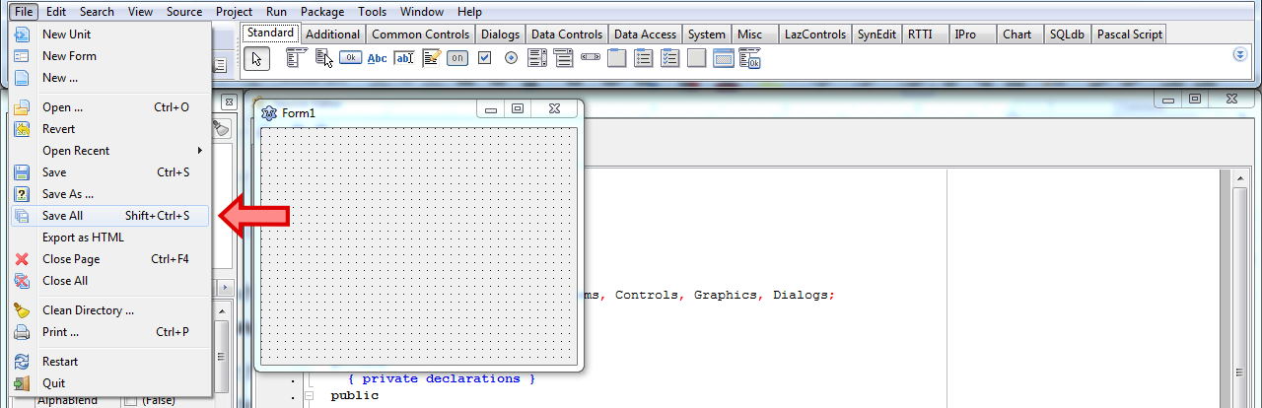
Your project has multiple files for keeping project data, code, and form data. So, be sure to create a folder to accommodate them all.
1. First, when you hit Save All, you would be asked for the name of your project file.
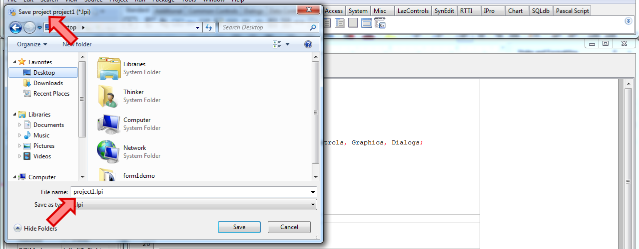
2. Don’t save yet. Create a folder for it first. (This may vary according to your system, but you know how to create folders, right?! Easy thing to do.)
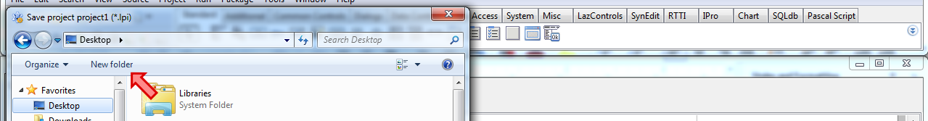
3. Then give an appropriate file name, like project_1, hello_world, message_demo etc. Remember, Lazarus does not like spaces in these names, and lowercase letters is the norm.
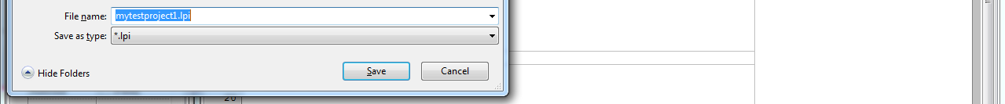
4. Second, your unit or form files. When saving form data, you can keep the filename as is, or change as you wish.
It can be something like frm1, frmmain, frmmessage etc. But remember, don’t name this exactly with your form’s name. E.g. naming this form1 will cause a compile error.
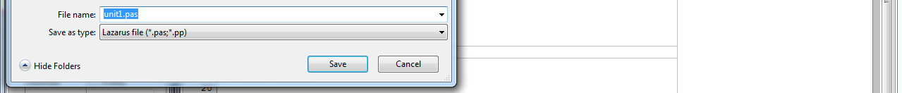
And done!
Now all the project files should be available on the directory. You can double click on the .lpi or .lpr file to open the project.

For curious ones...
If you like mysteries, this is one. Why does Lazarus need to keep all these files for a simple project? Because, there are many things going on on a project. There are many kinds of data to keep. There are codes that we write, tools that we place, properties that we change etc. You can read details here.
Basic anatomy is like this:
- .pas – contains the code you write for your forms
- .lfm – contains the properties of the tools we place on the form
- .res – saves the images you choose on properties into this file
- .lps – contains data about the last opened files
- .lpr – this file actually runs your project (kickstarts everything)
- .lpi – contains information about project properties
- .ico – the icon you select for your project or form

8: How to Extend Code with Custom Functions and Variables
We have looked into customizing tools. We can also enjoy convenience by extending code as well. We look into some coding goodies that help ease our writing.
The codes you’ve written so far, is on a magical language called Free Pascal. It has an amazing feature to divide codes into smaller and more manageable pieces – called functions and procedures. Functions and procedures are nearly the same – so some call them just “functions”.
- A Function is a collection of code that we group together.
- We give it a name, and later we call it by that name.
- Calling it runs the codes on that function.
- Writing Functions or Procedures is completely optional. We can use it whenever we like, for our convenience.
- We can use a function again and again without rewriting the same code. We can just run the function every time, to run that group of code.
We have some coding involved in this. But don’t worry. Just copy-paste and have fun!

Procedure
Start Lazarus and create a new Project (Project – New Project – Application – OK).
Press F12 until you see your Source Editor. Now find something like TForm1 = class(TForm) and some lines below, a line with the text public.
Under public, there is a line saying {public declarations}. This is because we declare all the functions and procedures here. (Declare means we just register the name of the functions here. We will elaborate the function later on, on a different place, you’ll see.)
Now copy-and-paste the text below after the public line:
procedure test1(somevar:string);
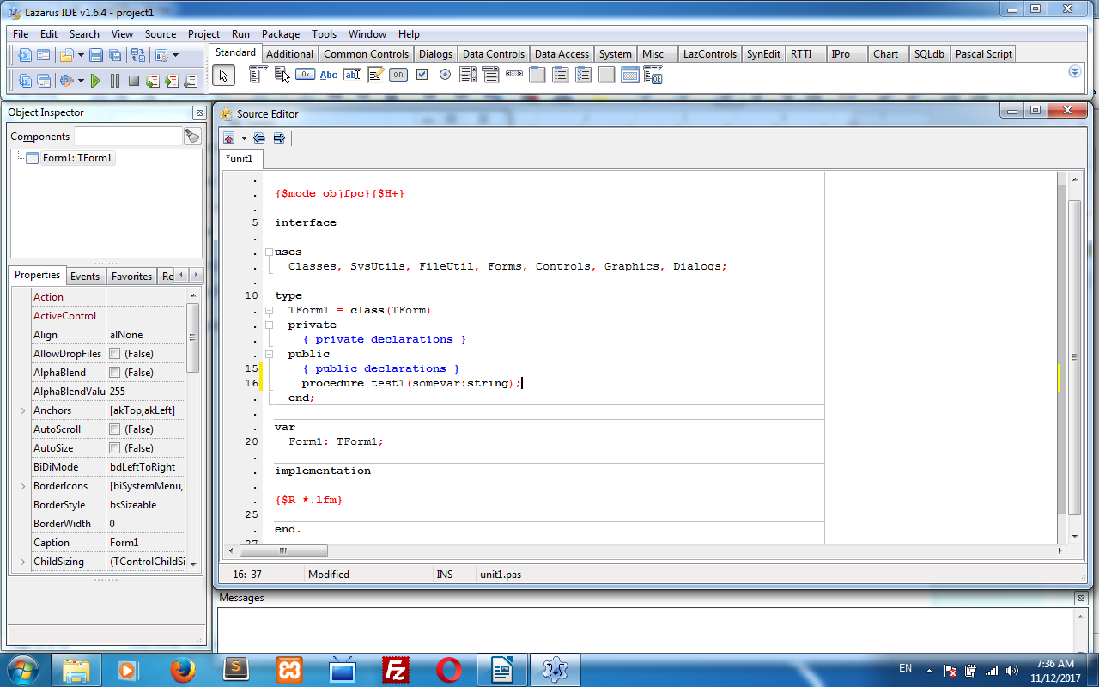
After you have pasted it, with your cursor still on the line, press Ctrl+Shift+C. Lazarus will then automatically create a place for this procedure so that you can write some code on it.
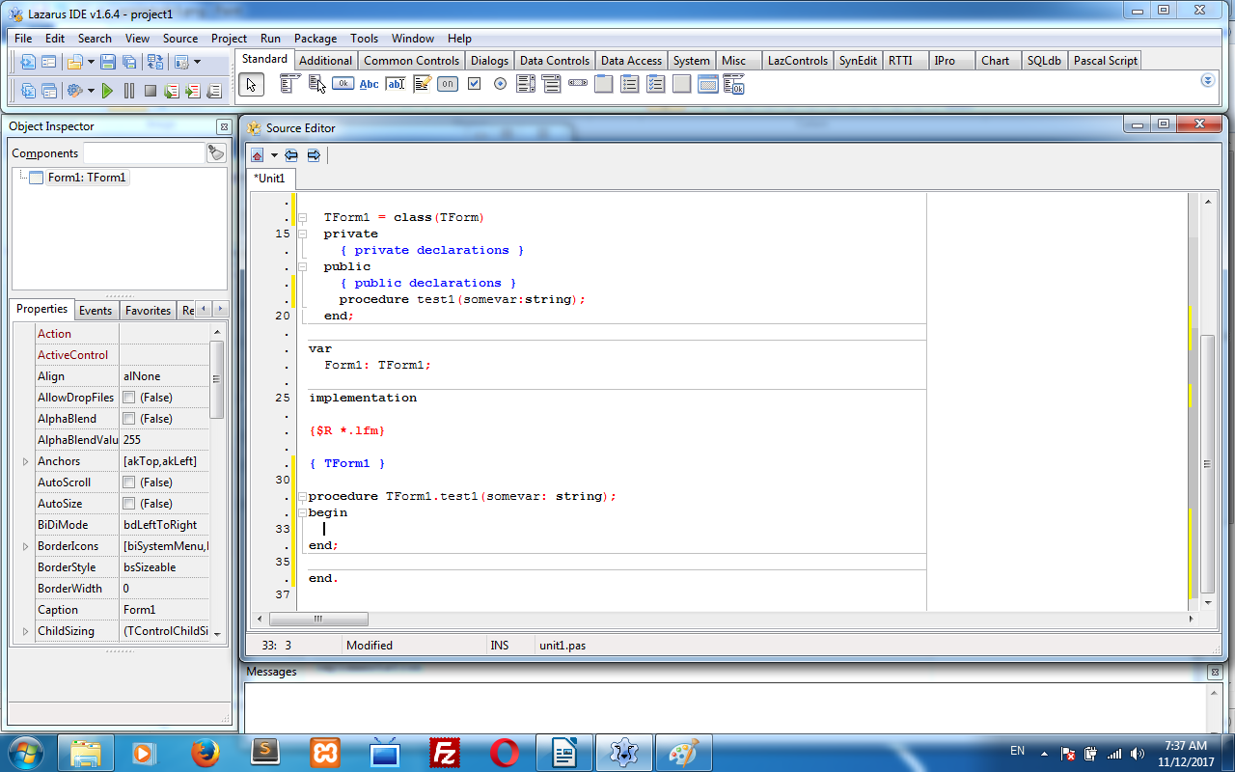
You can write anything on it, such as:
ShowMessage(somevar);
This will use the somevar variable that it passed to our procedure. But let’s forget this for the moment.
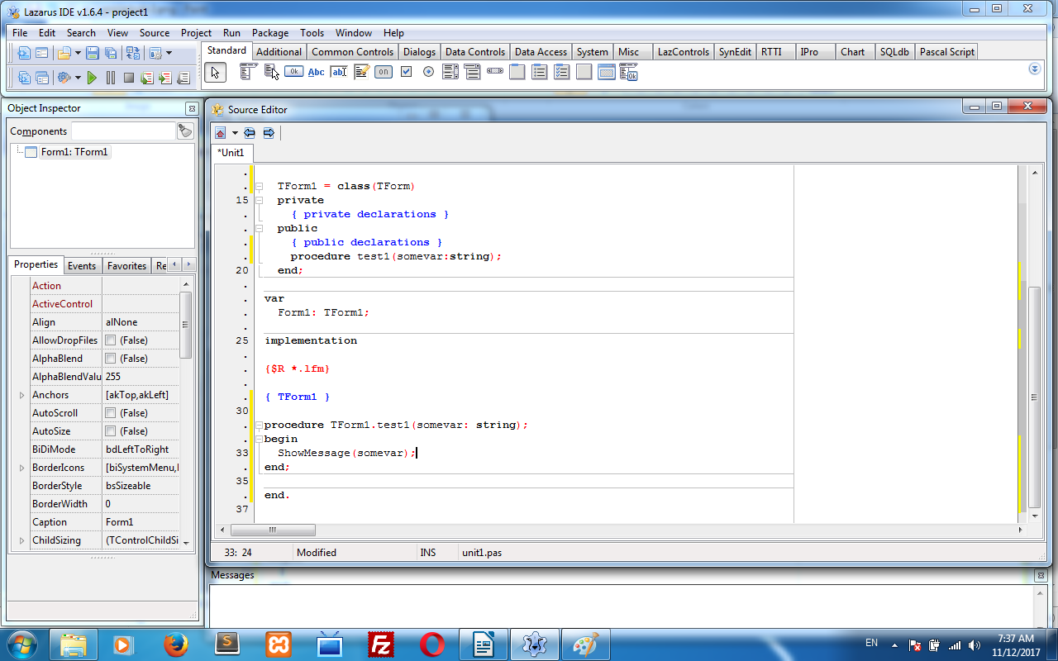
Now, press F12 to show the form. Now draw a button on the form. Then double click on the button. A procedure will be created.
Write something like this on the procedure:
test1('testing testing...');
Then Run the project (F9 or Run - Run menu). Now click the button. It will show testing testing… in a messagebox. Cool!
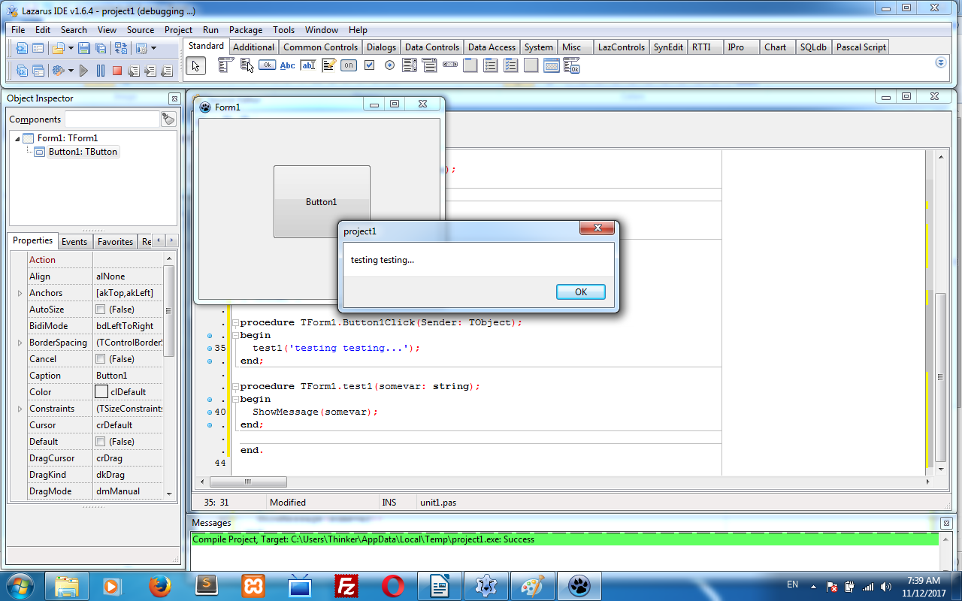
What’s happening is:
- when we click the button we are running our test1 procedure with “testing...” text.
- Our test1 procedure is then running the ShowMessage procedure.
- ShowMessage procedure is getting the message from our somevar variable, which takes the “testing...” message we written earlier while running our function.
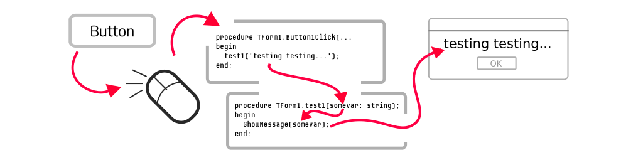
We could’ve avoided the use of a procedure since the code is small. We’re just using it to learn procedures. Trust me, it will get easier over time.

Functions
Functions are very similar to procedures. As an extra, it can give us something back after it’s finished.
Let’s say, we want to write a function to add 2 numbers. It would take 2 numbers, sum them up, and then give us the total to us. It is not possible in procedures, but very possible with functions. Programmers use it all the time to make the computer do stuff and get stuff in return!
Go to Project – New Project – Application – OK. Then press F12 to see your code editor. Now find TForm1 = class(TForm) and then public under the line.
Now copy-and-paste the text below after this line:
function add(num1:integer; num2:integer):integer;
Now with your cursor still on the line, press Ctrl+Shift+C. You should get the function code to be automatically generated. Now write:
Result := num1 + num2;
Now press F12 to go to form view. Place a button, then double click it. Then write the following code:
Caption := inttostr( add(10,5) );
Now click Run – Run or press F9 to run. Then click on the button. Tada! It will add 10 and 5 and show 15 as a result in the Titlebar of our form.

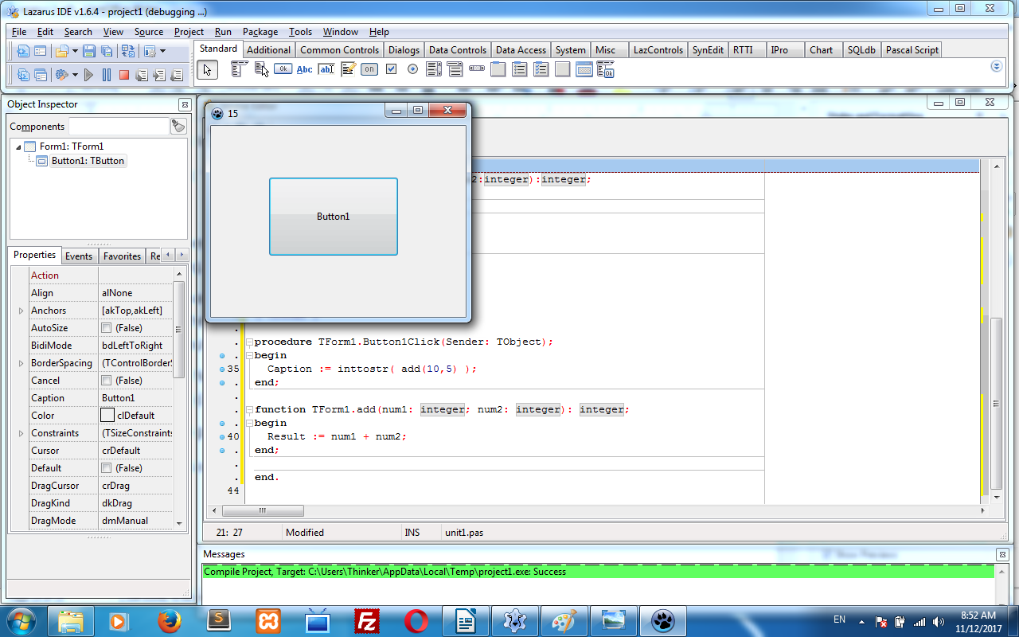
For curious ones...
You would notice that we’ve used inttostr() in our code. It is also a function, something like this:
function IntToStr(Value: Longint): string;
It takes a number (which is also called Integer or LongInt) and converts it into a string (text). Integers are numbers, and Strings are text – this is enough to know right now.
As humans, we see numbers and text as the same, but computers see numbers in one way and text in a different way. That’s why the separate naming!
So, the problem was that our Form Caption was a String and in our function code, we had an interger. So we needed to convert it to string to show it on the Caption.
You will also notice that we have seen Procedures before. Remember when we created events? Whenever we pressed the […] button beside an event, it creates a procedure for us. The procedure had many extra data passed to us. For example, if a key is pressed, we have a variable to determine which key was pressed:
procedure TForm1.Button1KeyPress(Sender: TObject; var Key: char);
begin
…
The Key here is a variable that has the key that has been pressed. Speaking of variables…

Variables
Well, Variables are nothing, they are just names so that you can store some stuff in them!
You can store numbers, letters, sentences in them. You can also change them, work with them, add them, multiply them etc. Fun stuff!
For example, in math:
Let x = 10
So, x + 20 = 30
Similarly, when coding:
procedure examplemath();
var
x: integer;
begin
x := 10;
ShowMessage( inttostr( x + 20 ) );
end;
It is the same as we use variables in math. In both cases, we are storing the number 10 in the variable x.
- When we need to store numbers (1, 2, 3…) – call it integer
- ...to store text – call it string
- ...to store numbers with decimal places (1.1, 1.2, 1.3…) – call it real or single or double
- …to store only yes and no or true and false – call it boolean
I know it’s a mouthful. But you will get used to it in no time once you start working on your projects! I know I did.

Constants
Let me mention just one little thing. There is also a kind of variable, the value of which cannot be changed. Once you set it, it’s set. It’s called a constant. You can write it under the const clause, something like this:
const
pi = 3.1415;

Some Other Tiny, but Important Things...
We take decisions in our life all the time. Our code can do that too, based on logic.
For example, “if it is raining outside, take the umbrella, otherwise not.” This is perfect logic!
If we code this, it can become something like:
var
raining: boolean; // true = raining, false = not raining
begin
raining := SomeFunctionToSeeIfRaining(); // this function will do its thing and tell us if it is raining, true or false

if raining then
ShowMessage('Take the umbrella');
else
ShowMessage('No need to take the umbrella, for now');
end;
So, our code is getting information and taking a decision based on that information.
Another thing is looping. It means doing the same thing again and again. Loops are very common to automate something. For example, an automated robot hand in a car factory does the same thing again and again. It is looping the same actions all day.
We can make the computer say Hello! five times, just for fun, with something like this:
var
index: integer;
begin
for index := 1 to 5 do
ShowMessage('Hello!');
We make a variable named index, and the for command gives this variable a value of 1, then runs the code, value of 2, then runs the code, value of 3, then runs the code and so on. You can also write ShowMessage( 'Hello '+inttostr(index) ); and see what happens!

9: Sharing Your Project
Sharing is caring. In order to share your code to the public or someone in private, you can tidy up things for the other person. Such as, cleaning up unnecessary files and including hints in the code etc.
When you Save your project, some files get created. These are just to make the project work.
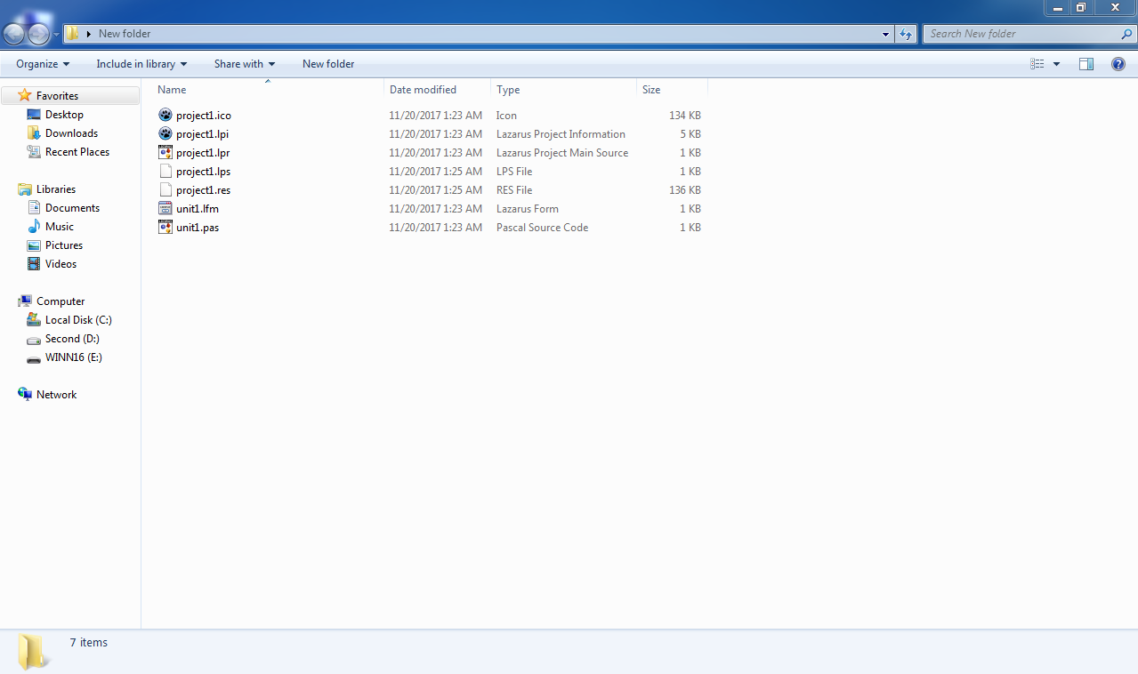
But there are some files that are not needed.
- Delete backup and lib folders from the project folder as a basic cleanup.
- Sometimes you can have a .dbg file on the project directory. You can delete that as well.
If you want, you can include the exe with the project files. But some people like to keep the source code separate from the non-source files, like exe files. So it depends.
Note: Windows executables have .exe extension. Mac OS X has .dmg. Linux does not have any extension (it needs to have some special permission to run the executable). If it is not executing for some reason, you can run chmod +x /path/to/executable on Terminal.
Also, you can include a Readme.txt file to let people know what your code does.
Before creating exes, you can comment your codes. They say, the most mysterious code is what you, yourself wrote 5 years ago and did not comment it! Without comments it is difficult to understand what some code does. This is especially true if you are creating a large project that does big things.
Comments are like little notes in the code. The compiler does not bother with them, so you can write anything you want – it will not run. Something like:
// Some notes
or you can use multi-line comments:
{ Some long
notes }

For curious ones…
After you have done the cleanup and commenting, you can share your code on the internet. You can share your code on Github.com, BitBucket.com, gitlab.com, notabug.org etc. You can upload the code or you can also use tools like git.
These sites have separate sections in the repository to keep the exe files, named “Downloads” or “Releases”.
To host your code on one of these, you can create a code repository, then clone the repository, put your code in, add the files, then commit. It would look something like this:
git clone somegiturl.git
cd some-repo-directory
# add some files, then...
git add .
git commit -m "initial commit"
git push origin master
When you make some change, you can:
cd some-repo-directory
git add .
git commit -m "some change"
git push origin master
Seems like too much, but once you get used to it, it will be so smooth that someone seeing you do all this would get jealous. I know I get some people jealous!
Plus, git lets you see what you changed through your codes for its lifetime. So no matter what you do to your code, it will keep a record of your changes, line by line.
Git is used by professionals to maintain software projects. Git is incredibly powerful and very useful to manage and share your code with the world. And more importantly, it lets multiple people to work on the same code – isn’t that amazing?!
Although it’s hard for some people, there are tools like “Github for Windows” that makes the process easier.
But again, you can just use plain simple email to share your code.
Sharing is fun, once you get the hang of it. But it is completely optional if you want to keep the source to yourself.

10: Compiling and Sharing Your Executable
You can share your source code or your executables or both. But before you do, go ahead and have a read at this.
We compile all the time. Whenever we Run our program it is actually being compiled. It takes our code, creates a .exe file and then executes it. But it has debug data by default, so the exe is huge in size.
To be able to ditch debug data from exe, you can follow these crazy steps...
Go to Project – Project Options – Compiler Options.
Check Build Modes.
Then click […].
Then Create Debug and Release modes.
Press OK, then OK again.
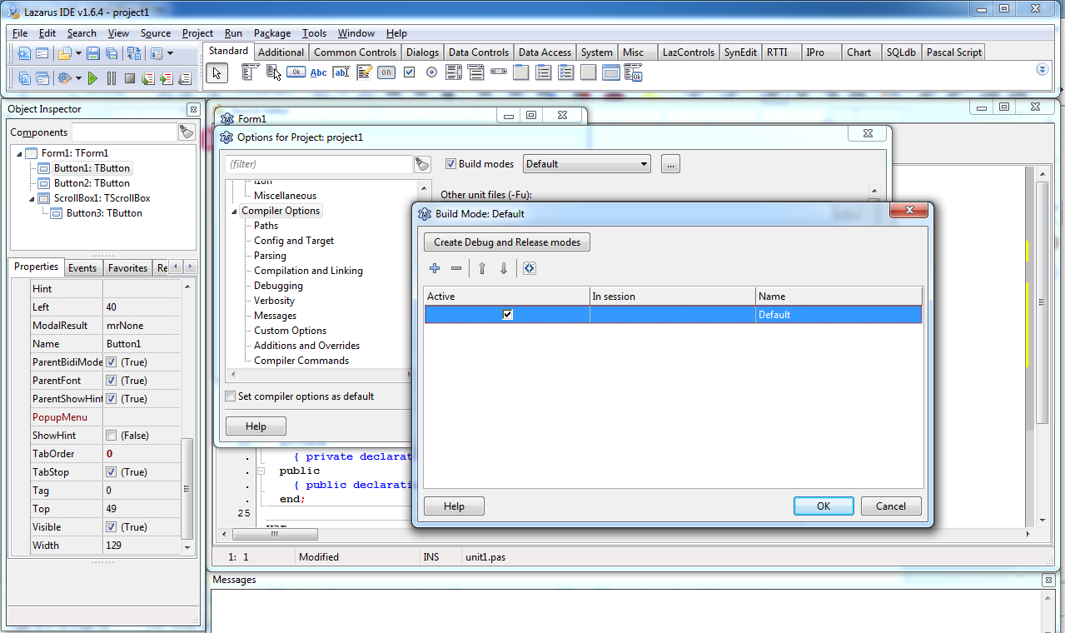
Now click the arrow beside the Cog icon on toolbar and select Release.
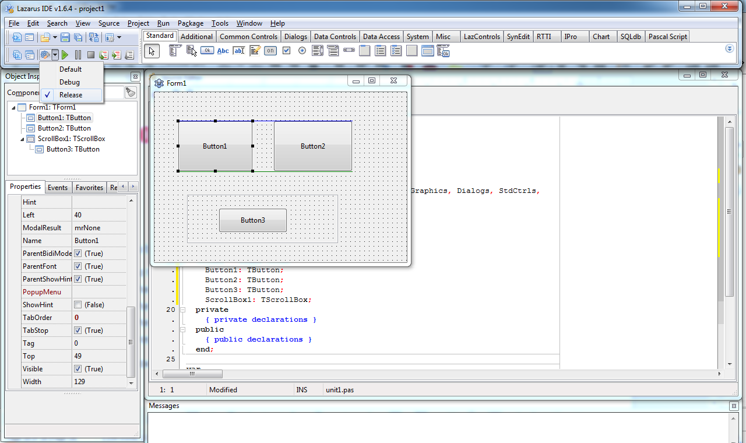
Now when you Run - Run the project or select Run - Build, it will create an exe file and get rid of all the debug data from the file.
You should get the exe file from your project folder. You can get it and share it with everyone on the internet.
Tip: To change the icon of the exe file, you can use: Project – Project Options – Icon – Load Icon. You can use png, gif, ico etc. files for icon. You can find many icons on the internet which are aptly licensed. http://aiconica.net is a good place to start.

Congratulations!
If you have followed along, then you have successfully landed on the Planet of Lazarus Users! You are now part of the community!
But is this the end? No. This is just the beginning! This is some stuff to let you know how to do basic things in Lazarus. You’ve got many other things to build and code!
To continue this wonderful journey, you can check these pages:
- This video more or less summarizes what we have learned in this book: https://www.youtube.com/watch?v=3APFv8Rj2iU
- Other videos to get you started easily. Good for beginners: http://wiki.freepascal.org/Lazarus_videos
- Incredibly detailed Lazarus basics page: http://wiki.lazarus.freepascal.org/Lazarus_Tutorial
- Build cool things. Has little sample codes and projects to tingle your curiosity: http://lazplanet.blogspot.com
- Easy FreePascal Tutorial. Short and Informative: http://wiki.freepascal.org/Object_Pascal_Tutorial
- E-Book for learning Free Pascal. In depth, but good for reference. Teaches through code examples: http://code-sd.com/startprog/StartProgUsingPascal.pdf

