Lab Task– 2
Reinforcement Learning Laboratory
Experiment 2: Interactive Exploration of Tic-Tac-Toe using Reinforcement Learning

Name - Mohammad Adnan Ali
Registration Number - BL.SC.P2CSE25010

Task 1: RL Components

RL Component | Observation
Agent | RL player (AI agent) playing Tic-Tac-Toe
Environment | Tic-Tac-Toe game board
State Representation | Current 3×3 board configuration (X, O, Empty)
Action Space | Place a mark in any empty cell
Reward Function | +1 for win, 0 for draw, -1 for loss
Learning Approach Used | Reinforcement Learning through self-play (Q-Learning/Temporal Difference learning)

Question and Answers

1. Who is the learning agent in this environment?
Answer: The RL Tic-Tac-Toe player (AI).

2. What is considered as the environment?
Answer: The Tic-Tac-Toe game board.

3. How is the game state represented?
Answer: The current arrangement of X, O, and empty cells on the 3×3 board.

4. What are the possible actions available to the agent?
Answer: Placing its mark in any empty cell.

5. When does the agent receive a positive reward?
Answer: When it wins the game.

6. Which Reinforcement Learning approach is used for learning?
Answer: Self-play using Reinforcement Learning (Q-learning/Temporal Difference Learning).

7. Is the agent trained using labelled data? Justify.
Answer: No.
Justification: It learns through rewards and penalties by interacting with the environment instead of labelled examples.

8. Explain how RL differs from Supervised Learning using this example.
Answer: Reinforcement Learning: Learns by playing games and receiving rewards.
Supervised Learning: Learns from labelled examples showing the correct move.

Task 2: Training Observation

Training Episodes | Win % | Loss % | Draw % | Behaviour Observed
100 | 48.6% | 42.2% | 9.2% | Opening move still inconsistent; agent occasionally blocks/takes wins but plays close to randomly overall.
500 | 59.1% | 32.3% | 8.6% | Begins consistently choosing corner openings; reliably blocks opponent threats and takes available wins.
1,000 | 56.8% | 31.6% | 11.5% | Continues blocking and winning reliably; draw rate starts rising as mistakes become less common.
5,000 | 80.6% | 2.6% | 16.8% | Losses become rare; agent almost always blocks/wins when possible; plays near-optimally.
10,000 | 83.6% | 0.3% | 16.0% | Losses nearly eliminated; win rate plateaus; behaviour converges to consistent, strong play.

Question and Answers

9. How does the quality of play change as training episodes increase?
Answer: The agent improves from random play to strategic and near-optimal play.

10. At approximately how many training episodes does the agent begin making intelligent decisions?
Answer: Around 1,000 episodes.

11. At what stage does the learning appear to converge?
Answer: Around 5,000–10,000 episodes.

12. Why does the win percentage improve with additional training?
Answer: Because the agent learns which actions produce higher rewards and avoids poor moves.

13. Why do most games end in a draw after sufficient training?
Answer: Both players learn nearly optimal strategies and avoid mistakes.

14. What happens if the number of training episodes is too small?
Answer: The agent plays randomly and loses more frequently because it has not learned good strategies.

Conclusion
The RL agent improves its performance through repeated self-play. Initially, it makes random moves and loses many games. As the number of training episodes increases, it learns to block opponents, prefer center and corner positions, and make strategic decisions. After sufficient training, the agent rarely loses and often forces a draw. This demonstrates how Reinforcement Learning enables an agent to learn optimal behavior through rewards rather than labelled data.

100 Training Episodes 500 Training Episodes
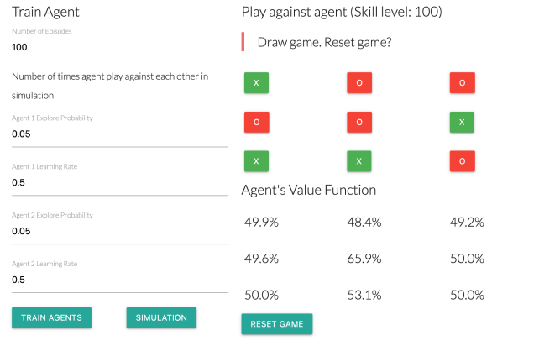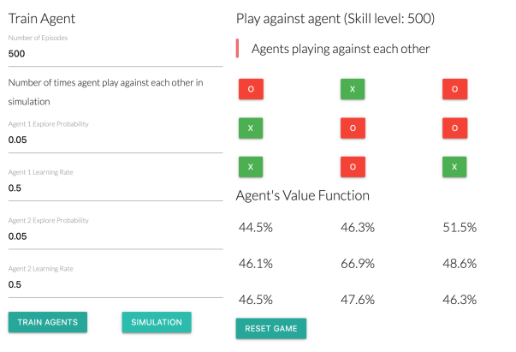

1000 Training Episodes 5000 Training Episodes
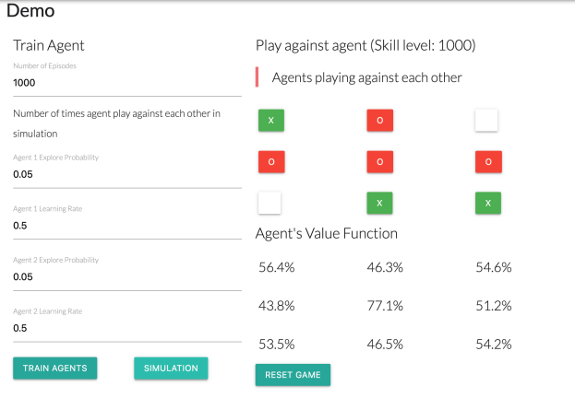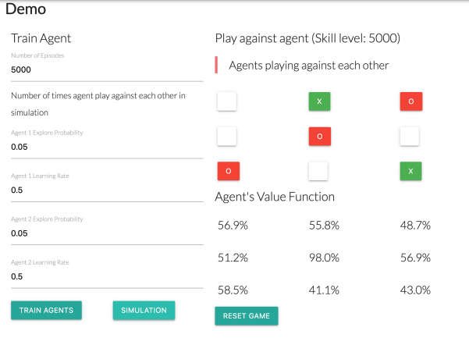

10000 Training Episodes
