Lab Assignment 4: MATLAB Reinforcement Learning Onramp
Reinforcement Learning Laboratory
Student Name: Mohammad Adnan Ali
Roll Number: BL.SC.P2CSE25010
Program: MTech (CSE)
Date of Submission: 09/Sep/2026

TITLE
MATLAB Reinforcement Learning Onramp: Agent Training and Learning Curve Analysis

OBJECTIVE
The objective of this assignment is to introduce students to the MATLAB Reinforcement Learning environment through the Reinforcement Learning Onramp course. Students will complete the guided training modules, train an RL agent, observe the agent's learning behaviour, and analyze the resulting learning curves.

TASK 1: COMPLETE MATLAB REINFORCEMENT LEARNING ONRAMP
All learning modules of the MATLAB Reinforcement Learning Onramp course have been successfully completed. The course covers the following key modules:
Module | Description | Status
Overview of Reinforcement Learning | Introduction to RL concepts; simulating with a pretrained agent | 100%
Define the Environment | Components of an RL model; defining environment interface; providing rewards; including actions in the reward; connecting Simulink environment to MATLAB agent | 100%
Define Agents | Critics and Q-values; representing critics with neural networks; actors and critics; summary of agents | 100%
Train Agents | Training; changing training options; improving training | 100%
Conclusion | Review of RL workflow; additional resources | 100%
All interactive exercises, programming exercises, and assessments/quizzes have been completed successfully.

IMAGE1: COURSE COMPLETION REPORT


IMAGE 2: COURSE COMPLETION CERTIFICATE


TASK 2: TRAIN AN RL AGENT IN MATLAB
IMAGE 3: TRAINING PROGRESS WINDOW (LEARNING CURVE)
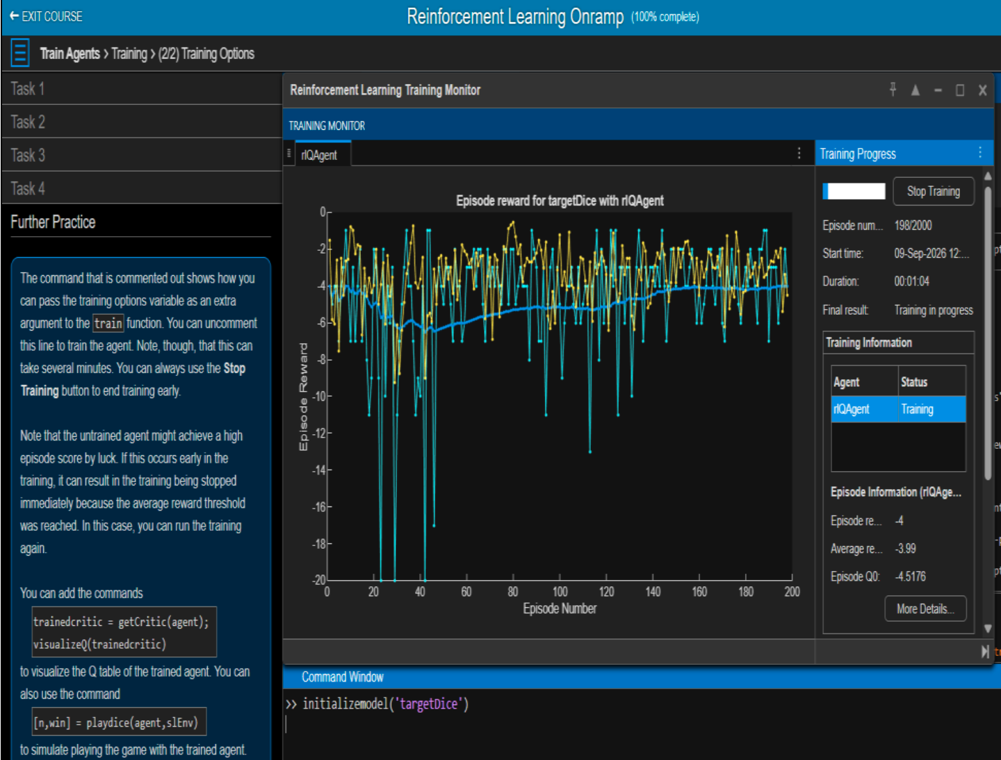

ENVIRONMENT AND AGENT DESCRIPTION
The RL environment used in the Onramp exercise is a Simulink-based Dice Game environment (targetDice model). The agent interacts with this environment to learn the optimal die‑choosing strategy.
Component | Description
Environment | slEnv – a SimulinkEnvWithAgent object containing the Simulink model targetDice and the agent block targetDice/RL die chooser
Observations | Discrete set representing the target value (the number the agent needs to achieve or match)
Actions | Discrete set representing the choice of die (which die to roll)
Reward | The agent receives a negative reward (cost) for each step. The goal is to minimize the total cost (i.e., make the reward less negative). The training stops when the average reward reaches -3 or higher.
Agent Type | rlQAgent – a Q-learning agent with a neural network critic (Q-value approximator)

TRAINING CONFIGURATION
The following training options were used (as defined in the diceopts structure):
Parameter | Value
MaxEpisodes | 2000
MaxStepsPerEpisode | 20
ScoreAveragingWindowLength | 100
StopTrainingCriteria | "AverageReward"
StopTrainingValue | -3
Plots | "training-progress"

OBSERVATION TABLE
Parameter | Observation
RL Environment | Simulink model targetDice (Dice Game environment)
Agent Used | rlQAgent (Q-learning agent with neural network critic)
Number of Training Episodes | 886 episodes
Initial Performance | Enter the Episode Reward from Episode 1 of your training graph
Final Performance | -4
Training Time | 1 min 04 sec
Training Stopped/Converged At | Episode 886; training stopped when Average Reward reached -3

QUESTIONS
Q20. What type of RL environment is used in the Onramp exercise?
Answer: The environment is a Simulink-based Dice Game environment (targetDice). It is a discrete environment where the agent observes a target value and must choose a die to roll. The environment is wrapped as a SimulinkEnvWithAgent object (slEnv) that connects the Simulink model to the MATLAB RL agent.

Q21. What type of agent is trained?
Answer: The agent is an rlQAgent, which is a Q-learning agent that uses a neural network critic as a Q-value approximator. The critic estimates Q-values for the available actions, and the agent uses these values to select suitable actions.

Q22. What is the purpose of training the agent?
Answer: The purpose of training the agent is to learn an optimal policy that maps the observed target value (observation) to the best die choice (action) in order to minimize the cumulative cost (i.e., achieve the least negative reward). Since the reward is negative, the agent learns to make decisions that reduce the total penalty over the course of a game (episode). The ultimate goal is to achieve an average reward of -3 or higher, which indicates the agent has learned a near‑optimal strategy.

Q23. What performance measure is used during training?
Answer: The primary performance measures used are:
- Episode Reward – the total reward accumulated in a single training episode (shown as the blue line).
- Average Reward – the moving average of episode rewards over the last 100 episodes (shown as the black line).
The training stops automatically when the Average Reward reaches the threshold value of -3, as specified by the StopTrainingCriteria and StopTrainingValue settings.

Q24. How does the agent's performance change as training progresses?
Answer: At the beginning of training, the agent performs poorly and the episode rewards are generally low and fluctuate because the agent is still exploring different actions. As training progresses, the agent learns which die choices are more suitable for each target value, so the rewards generally improve and become less negative. The average reward shows an overall upward trend, although some fluctuations remain due to exploration. Near the end of training, the average reward approaches the stopping threshold of -3, indicating that the agent has learned a good policy.

TASK 3: ANALYZE THE LEARNING CURVE

LEARNING CURVE STAGE ANALYSIS
Training Stage | Episode Range | Reward/Performance | Observation
Initial | Episodes 1–200 | Approximately -20 to -12 | The agent takes mostly exploratory actions, resulting in highly negative and fluctuating rewards.
Early Training | Episodes 200–500 | Approximately -12 to -7 | The agent begins learning better die-selection actions. The average reward gradually improves, although fluctuations are still present.
Middle Training | Episodes 500–700 | Approximately -7 to -4 | The agent increasingly uses learned knowledge. Rewards improve and the average reward moves closer to the target of -3.
Late Training | Episodes 700–886 | Approximately -4 to -3 | Performance approaches the target. The average reward becomes close to -3, with smaller fluctuations.
Final / Convergence | Episode 886 | Average Reward = -2.99 | Training stops because the average reward reached the stopping threshold of -3. The agent has learned a near-optimal policy.

ANALYSIS QUESTIONS
Q25. What does the learning curve represent?
Answer: The learning curve represents the agent's performance over the course of training. In this exercise, it plots the Episode Reward (y‑axis) against the Episode Number (x‑axis). The blue line shows the reward for each individual episode, while the black line shows the smoothed moving average over the last 100 episodes. The curve reveals how the agent improves over time, how quickly it learns, and when it reaches a stable, converged policy.

Q26. Why is the reward generally low during the initial training episodes?
Answer: The reward is low (highly negative) during the initial episodes because the agent has not yet learned an effective policy. The Q-network (critic) is initialized with random weights, causing the agent to take essentially random actions. Since the dice game rewards are negative (costs), random choices lead to large penalties. Additionally, the agent must spend time exploring different actions to gather experience, which inevitably results in poor performance initially.

Q27. What indicates that the agent is learning?
Answer: The following indicators from the learning curve confirm that the agent is learning:
- The average reward (black line) shows a consistent upward trend (becoming less negative).
- The individual episode rewards (blue line) gradually shift from highly negative values toward the target (-3).
- The variance/fluctuations decrease over time as the agent becomes more consistent.
- The agent eventually reaches the stopping criterion (average reward ≥ -3), indicating that it has learned a sufficiently good policy.

Q28. Does the reward increase consistently throughout training? Explain.
Answer: No, the reward does not increase perfectly consistently. While the overall trend is upward, the learning curve shows fluctuations and occasional dips. This is normal in reinforcement learning due to:
- Exploration – the agent sometimes tries suboptimal actions to discover potentially better strategies, which can temporarily reduce rewards.
- Stochasticity – the dice game has inherent randomness (dice rolls), causing variability even with the same policy.
- Neural network updates – gradient‑based updates can occasionally cause the Q‑estimates to worsen before improving again.
The moving average line provides a better indication of the true learning trend, smoothing out these short‑term fluctuations.

Q29. How can you identify convergence from the learning curve?
Answer: Convergence can be identified when the moving average reward becomes approximately flat and remains within a narrow range of values. In this exercise, training stops when the average reward reaches the specified stopping value of -3. Other signs of convergence include:
• No further significant upward trend in the moving average.
• Episode rewards remain relatively stable around the converged value.
• Additional training episodes are unlikely to provide significant improvement.

Q30. What could cause fluctuations in the learning curve?
Answer: FFluctuations in the learning curve can be caused by:
- Exploration vs. Exploitation – The agent may occasionally explore different actions, which can result in worse rewards temporarily.
- Stochasticity in the Environment – The dice game involves random dice rolls, so the same action can produce different outcomes across episodes.
- Neural Network Updates – Changes to the Q-value estimates during training can cause temporary variations in performance.
Therefore, some fluctuations are normal even when the overall average reward is improving.

Q31. What happens if the agent is trained for a larger number of episodes?
Answer: If the agent is trained for a larger number of episodes beyond convergence, the learning curve would generally show a plateau, with the average reward remaining around the converged value. Once the agent has learned a good policy, additional episodes are unlikely to provide significant improvement. Training also requires additional computation and time.
In this exercise, training is configured to stop when the average reward reaches -3 or when the maximum number of 2000 episodes is reached.

Q32. Why is it important to analyze the learning curve rather than considering only the final reward?
Answer: Analyzing the learning curve is important because it shows how the agent's performance changes throughout training, not just its final reward.
• Shows learning progress – It shows whether the agent's reward is improving over time.
• Identifies convergence – It helps determine whether the average reward has stabilized.
• Shows learning speed – It indicates how quickly the agent improves during training.
• Detects instability – Large fluctuations or a lack of improvement can indicate unstable training.
• Helps evaluate training effectiveness – The curve shows whether additional training is producing meaningful improvement.

