Github flow

Creating a branch – branches are like a timeline of how our project has changed over time.
Master branch is the branch created by default. This is the main branch which usually goes to prdouction. Best to create a new branch that extends from the master.

A branch is essentially a pointer to a specific point in time in the master (production) branch that a new timeline/branch was created. To make changes to your copy (the new branch) we make commits.

Pull request – Incorporating our local changes to the master branch is a pull request. It will show a comparison of the changes I’ve made to code on my with the original version that’s on Github. Then discuss and review commits. Do it early to get feedback on the changes early, and work towards agreed upon changes faster then to make all changes and then introduce it all, only for collaborators to not like it and ask to make a bunch of changes. If approved, we then deploy our branch to the master branch.

Deploy – This deploy system is set up to deploy our Feature branch into production, into the testing environment. When everything goes well, we then merge this branche to master.

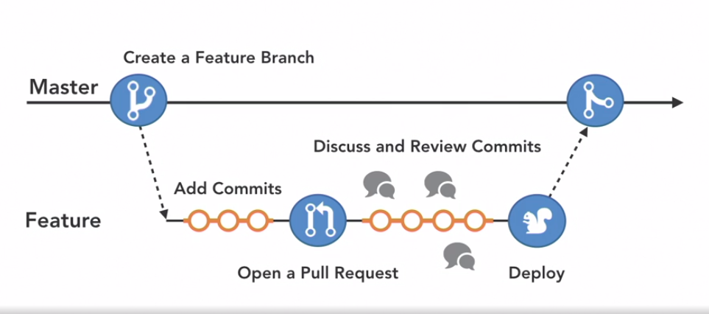
Fig: Entire timeline (branching concept)

