1)IMU with 6 DOF (ability to move in three dimensions). device contains gyroscope and accelerometer used to measure

inertia position rotation...

2)acceleration vs inertial force acting on the accelerometer (work in opposite direction)

3)guroscope used to measure angle orientation on three different levels(pitch roll yaw)

mems technology used in mpu6050. when an axis is rotated a voltage is produced.Voltage is sampled

with 16 bits ADC inside the MPU6050

4)temperature sensor is implemented on the MPU6050 and DMP(digital motion process)

used to corrolate data from accelerometer and gyroscope

pin configuration

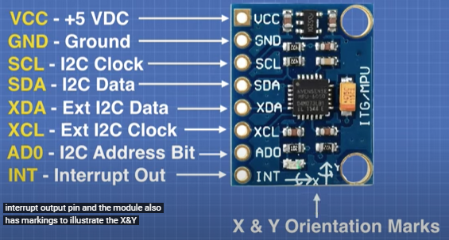

Info: <https://www.dofbot.com/post/angle-measure-using-mpu-6050-3-axis-accelerometer-and-gyroscope-sensor>