

# **Issues and Fixes**

# **for BiBimCart**

**Issue # 1:**

Why this showing white strips on sides in my screen, it is not visible in your screen, it means this is not responsive to my screen

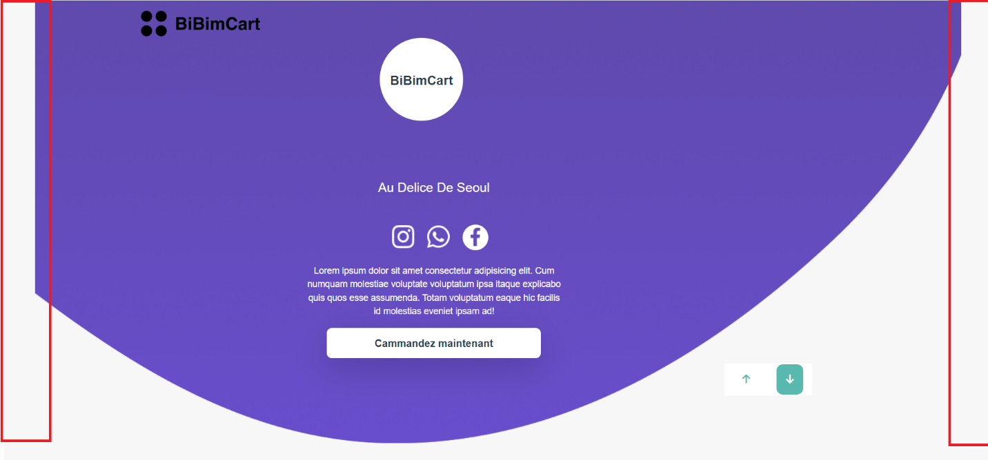

**Issue # 2:**

Buttons are not same as in figma and other pages

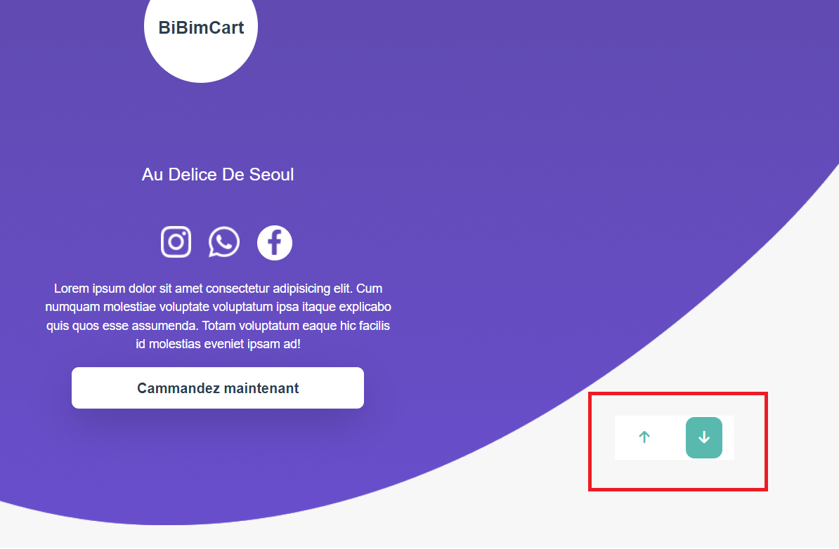

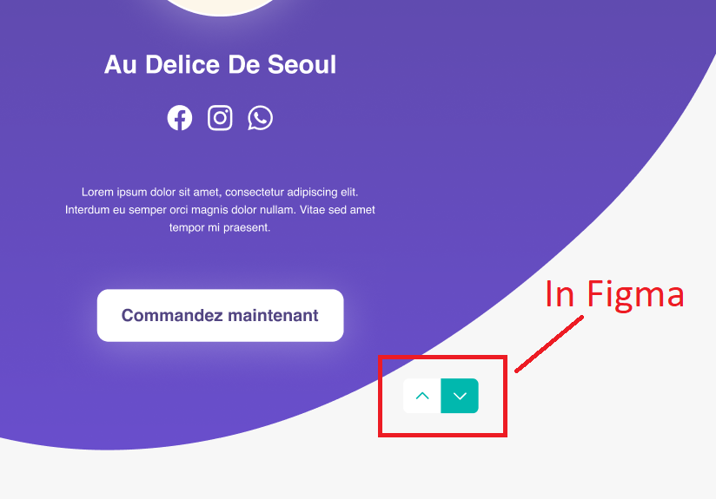

**Issue # 3:**

In Figma the position of buttons is same in all pages, while in your work it is not the same

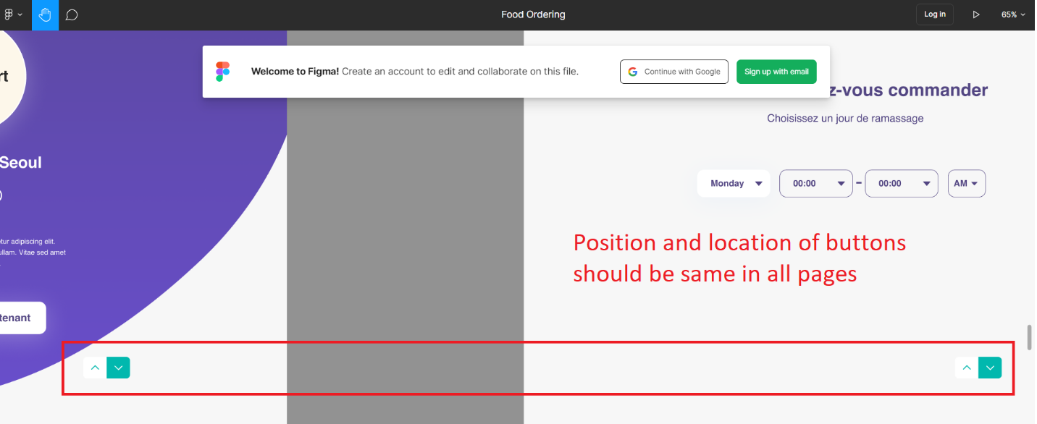

**Issue # 4:**

Dropdown is not same as figma

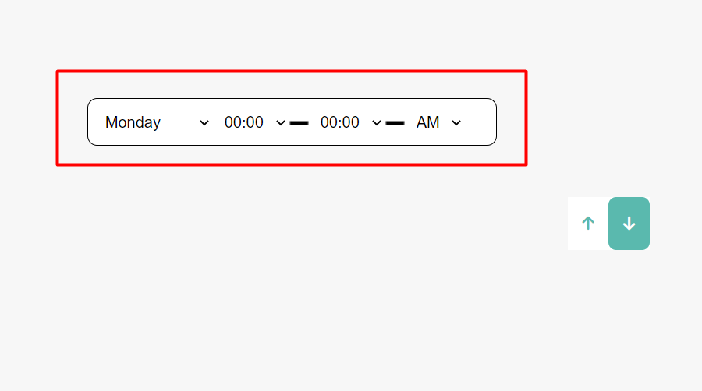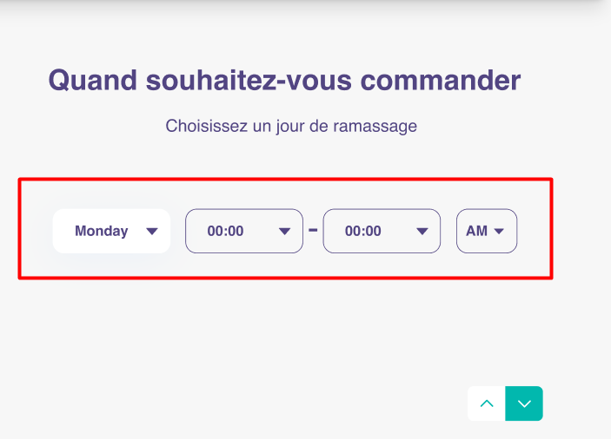

**Issue # 5:**

Products are not being shown the same way as in figma, there are half in card and half outside in figma, but in your page all are in cards. And border radius is also different.

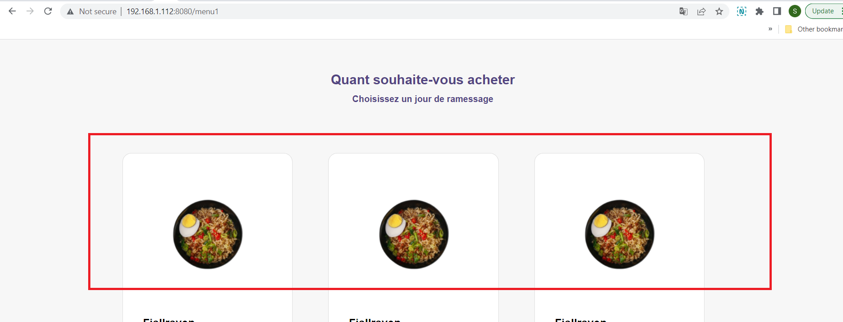

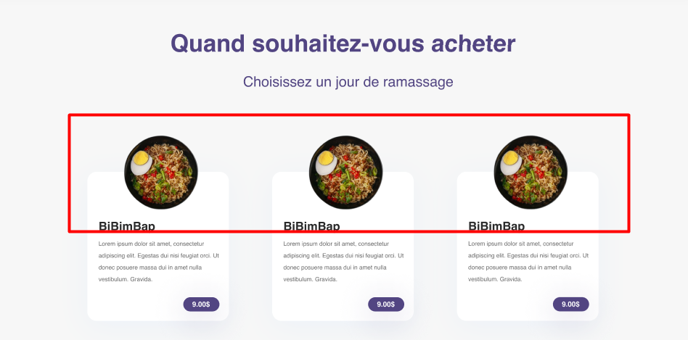

**Issue # 6:**

Here there is difference b/w your modal and figma design

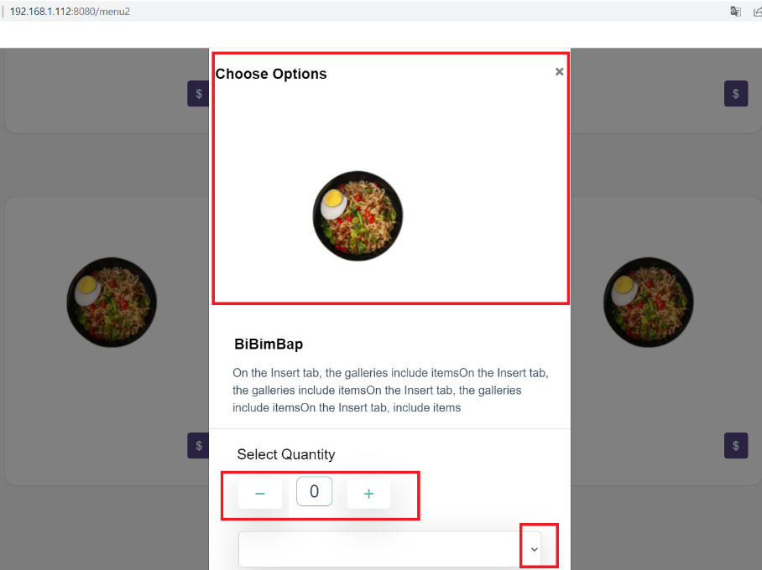

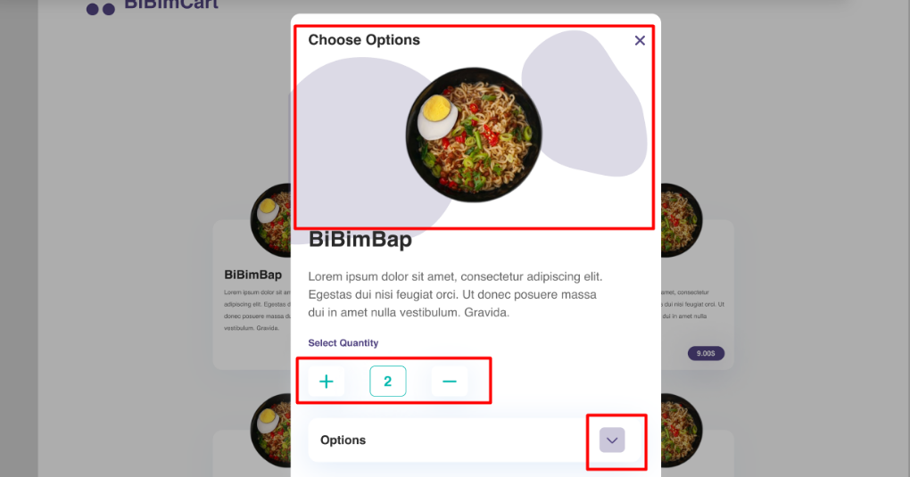

**Issue # 7:**

Your page should be same as figma, size of modal is not same either.

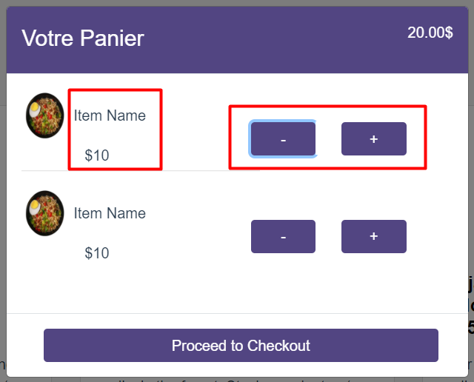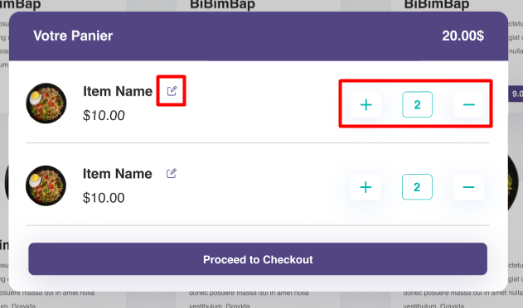

**Issue # 8:**

Why these up, down button are shown like this with modal, it should be on behind page not in modal.

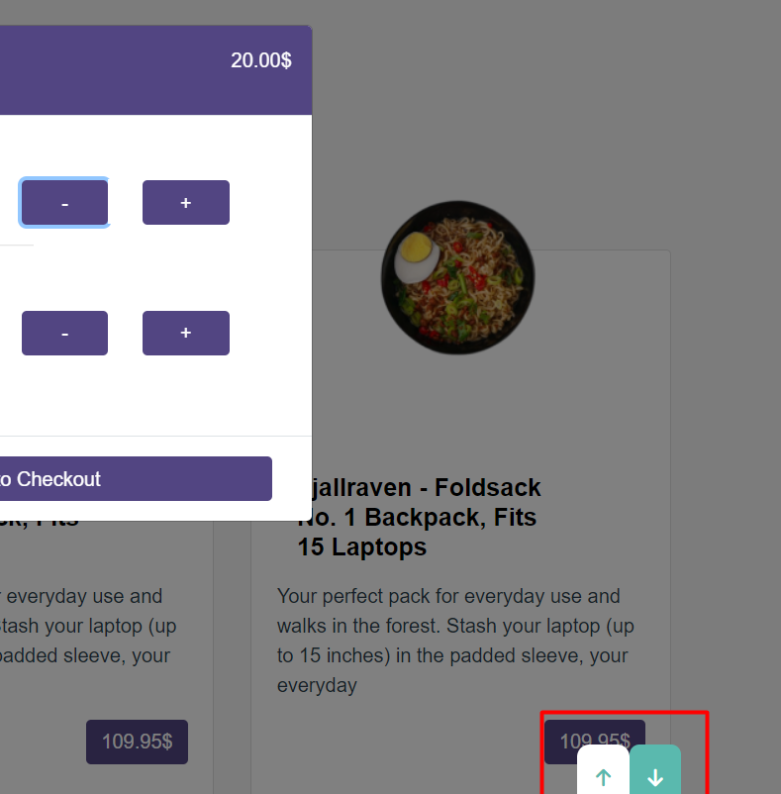

**Issue # 9:**

Does this look same as figma design to you ?, fix these in address, email pages too

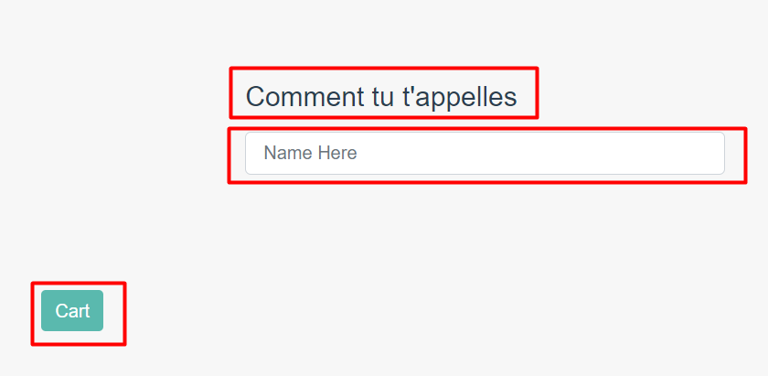

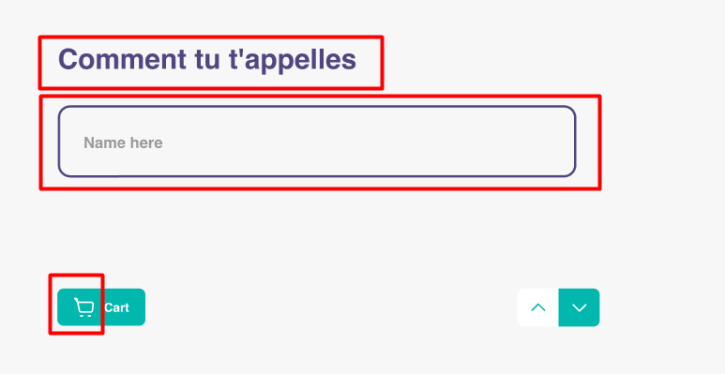

**Issue # 10:**

Can you see the difference in your page & figma page

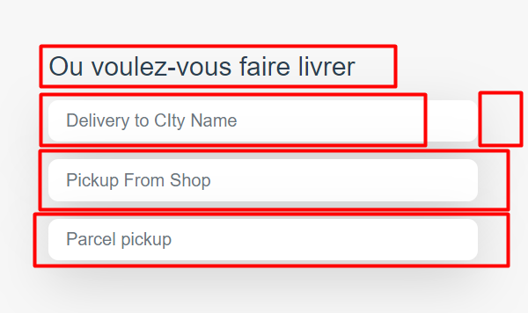

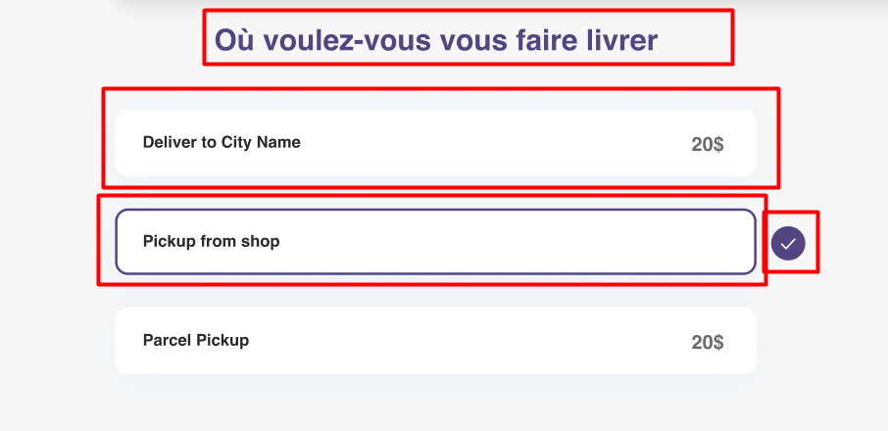

**Issue # 11:**

Please make it same as figma

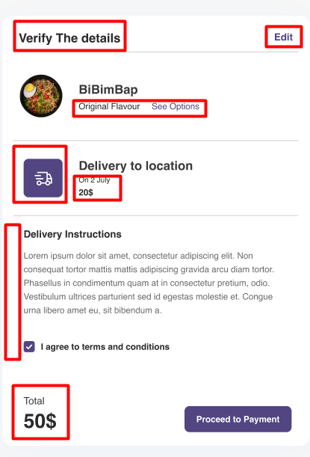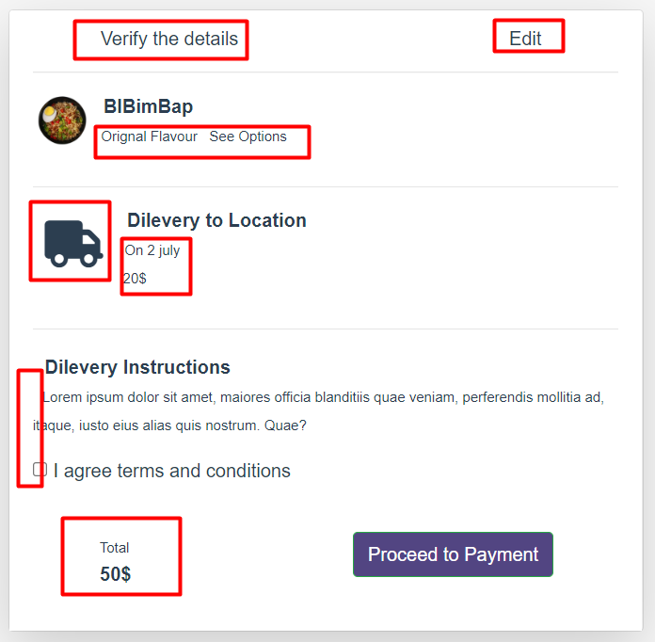

**Issue # 12:**

