Assignment # 2 – Group #5

**2024F FIN 4104 1 [Online 5] Investments II**

**Online Assignment 2**

**Assignment #2 – Group #5**

**SYED ADNAN C0908413**

**HARSHDEEP SINGH C0904869**

**JANKI THAKKAR C0904860**

**MEHAK SAINI C0913094**

**YASH AGGARWAL C0904878**

* **Scotia Canadian Dividend Fund - Series A Canadian Dividend & Income Equity (DIVIDEND)**

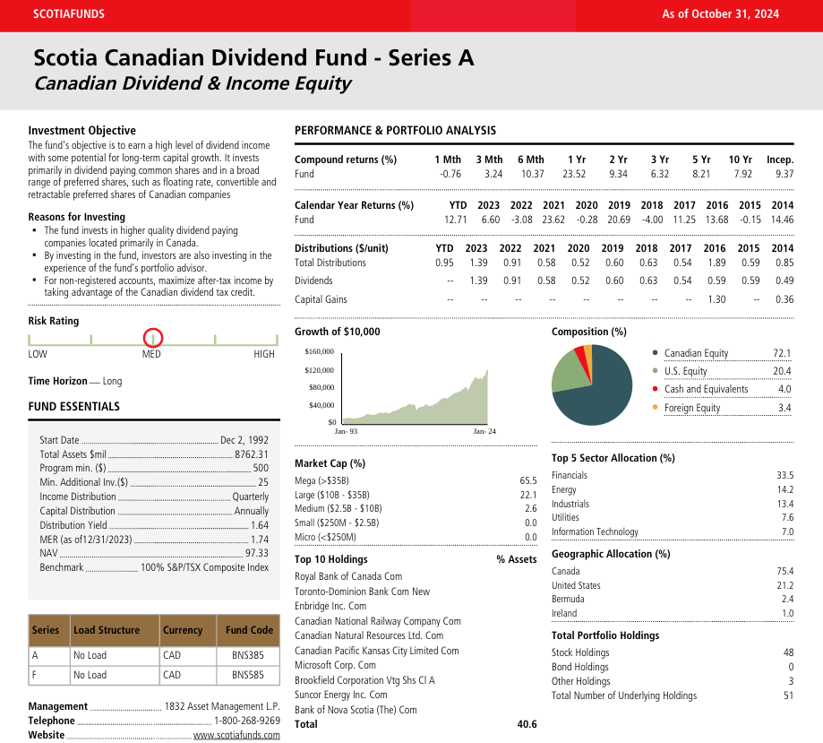

The Fund invests in a diversified portfolio of dividend-paying common and preferred shares of Canadian issuers, including floating rate, convertible and retractable preferred shares, with the objective of providing a high dividend income and the potential for long-term capital growth.

Reasons to Invest: The fund invests in high-quality dividend-paying companies, primarily domiciled in Canada. Investors benefit from the portfolio advisor's experience. Maximize after-tax income in non-registered accounts by taking advantage of the Canadian dividend tax credit.

* **Scotia Canadian Growth Fund - Series A Canadian Focused Equity (GROWTH)**

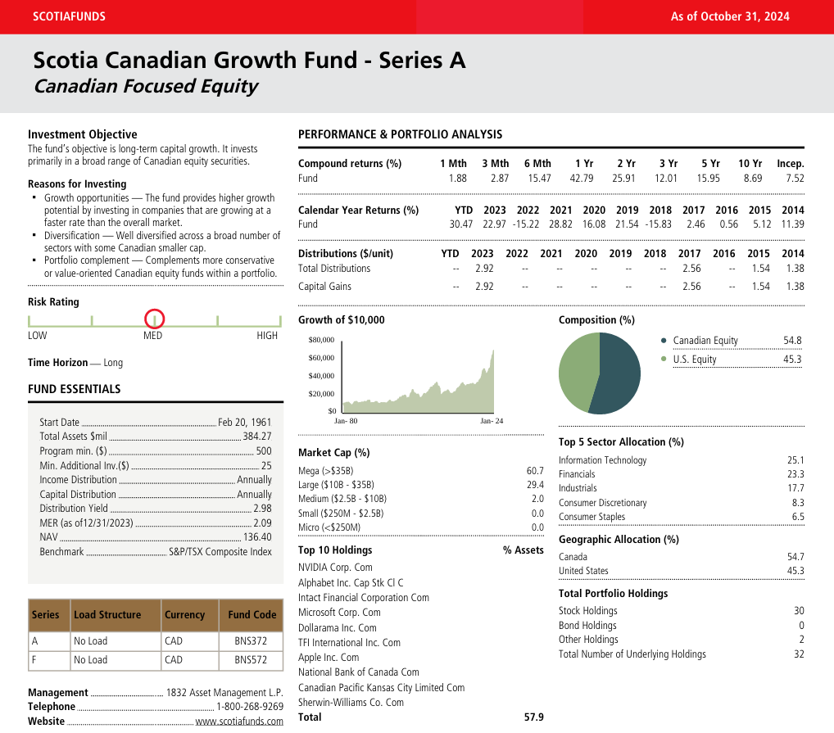

Investment Objective

The fund seeks long-term capital growth. The investment strategy focuses on Canadian equity securities.

Reasons For Investing

The fund invests in companies that outperform the market in terms of growth.

Diversification: Well-diversified across multiple sectors, including some Canadian smaller cap companies.

Portfolio complements include conservative or value-oriented Canadian equity funds in a portfolio.

* **Scotia International Equity Index Fund - Series A International Equity (GEOGRAPHIC)**

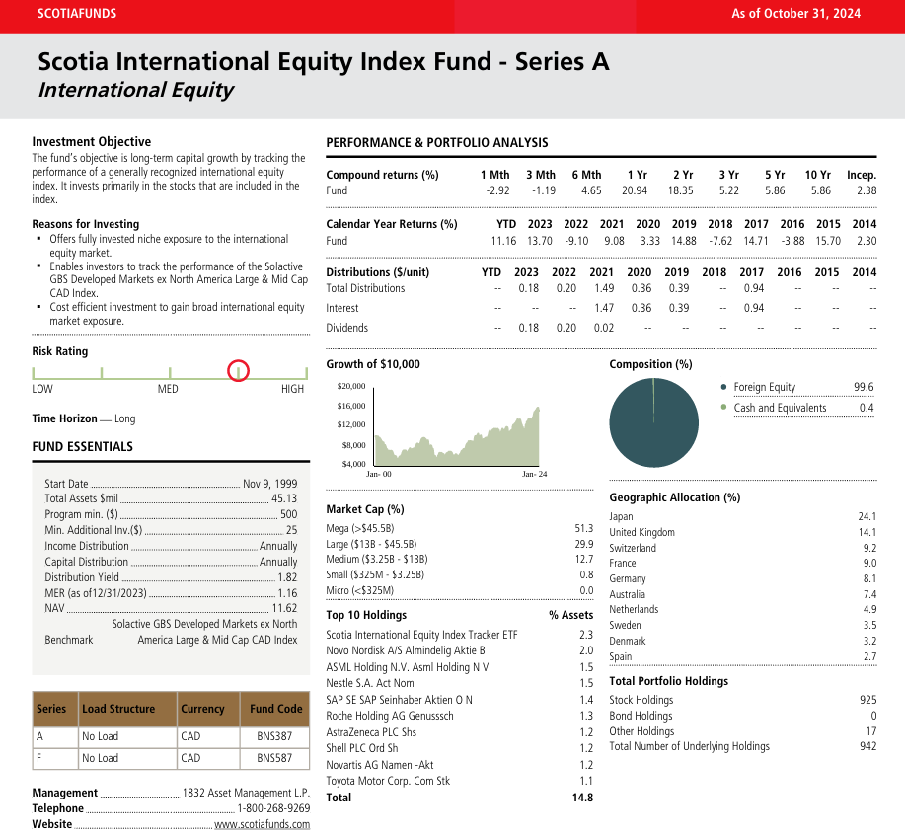

**Investment Objective**   
The Fund aims to achieve long-term capital growth by replicating the returns of a widely recognized international equity index. It primarily invests in index-based stocks.

**Reasons For Investing**   
Provides fully invested niche exposure to the international equity market.   
Investors can track the performance of the Solactive GBS Developed Markets Ex North America Large & Mid Cap CAD Index.   
Investing in international equity markets can be cost-effective and provide broad market exposure.

* **Scotia Money Market Fund - Series A Canadian Money Market (LOW BETA)** 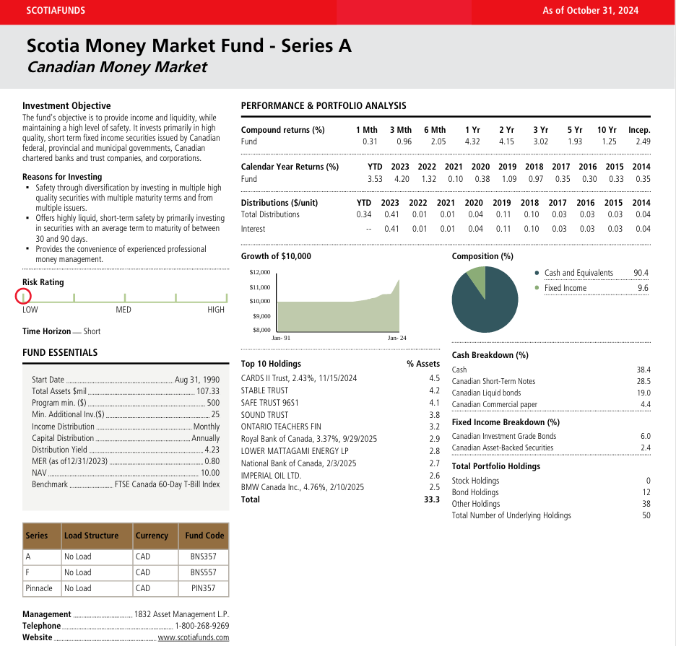

**Investment Objective**

The fund seeks a high level of current income consistent with liquidity and preservation of capital. The fund primarily invests in high-quality, short-term fixed-income securities issued by Canadian governments, banks, trust companies, and corporations.

Investing for safety and diversification means holding several high-quality securities with various maturity terms and issuers.

Offers highly liquid, short-term safety by primarily investing in securities with an average term to maturity of between 30 and 90 days.

Provides the convenience of experienced professional money management.

* **1832 Management L.P. Scotia Canadian Small Cap Fund - Series A High beta fund**A screenshot of a financial report

  Description automatically generated

**Significant elements of the fund's investment approach:**

1. **Emphasis on Small and Medium Businesses:**targets businesses that have lower market capitalisations since they usually have more room to expand than bigger, more established companies.
2. **Attention to the Canadian Market:**Most of the assets are in Canadian investments, which is consistent with a plan for local growth.
3. **International Exposure:**To provide diversity and provide access to wider markets, foreign securities may account for up to 30% of the fund's assets.
4. **Sectionalization:**Considerable investments in dynamic and growth-oriented industries like finance (28.7%), Industries (21.2%), Information Technology (19.6%).

* **1832 Asset Management L.P. Scotia U.S. Dividend Fund - Series A objectives:**

**Mega cap fund**

1. **Income Generation:** The fund invests mainly in equity securities of American companies that pay dividends or are anticipated to do so in hopes to generate a consistent income stream. This is consistent with the objective to provide investors with profits.
2. **Capital Appreciation:** The fund seeks to attain long-term growth in capital by investing in businesses that exhibit the ability to provide income in addition to capital appreciation, even as it concentrates on dividend-paying equities.
3. **Diversification:** The fund invests in different types of industries as well as large U.S. large companies for the purpose of reducing risk in the overall portfolio, though a small portion is taken up by foreign companies.

* **Large cap fund**

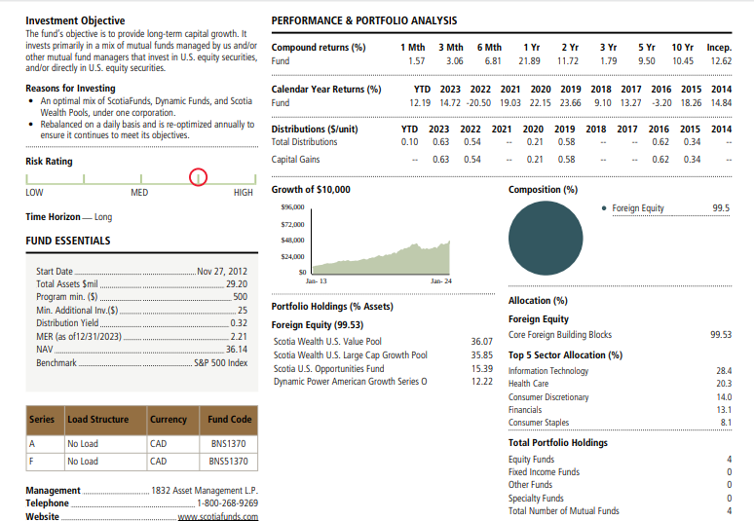

**Scotia U.S. Equity Blend Class - Series A**

**Objectives:** Long-term growth: The additional capital is created by the fund while focusing on US Stocks along with equity-related securities.

Diversified Exposure: It invests in a diversified portfolio of large-cap US Companies, hence provides exposure to Growth as well as Value equities.

Diversified Investment Strategy: The fund invests in other mutual funds in its portfolio to achieve its investment objectives, which include large-cap growth and value companies.

.

* **Mid cap fund**

**1832 Asset Management L.P. Scotia Wealth Canadian Mid Cap Pool - Series**

**Objectives:**

1. **Growth Focus:** It primarily invests in Canadian companies with medium market capitalizations for capital growth. While these companies are believed to have significant growth potential, they are riskier and more volatile than large-cap shares.
2. **Diversity:** By allocating up to 30% overall its assets to foreign securities, the mutual fund provides a certain amount of diversity. These lessens the danger of investments that can be overly dependent on one market or economic circumstance.
3. **Focus on the Mid-Cap Sector:** By focused on mid-cap organisations, the fund aims to take advantage of the special possibilities presented by well-established but still-expanding organisations, which frequently provide faster growth rates than large-cap firms.

* **Small cap fund**

**1832 Asset Management L.P. Scotia Canadian Small Cap Fund - Series A**

**Objectives:**

1. **Emphasis on Smaller Canadian Firms:** The fund mainly focusses in equity securities of Canadian small- and mid-cap businesses, which are seen to have more space to expansion than established, bigger firms.
2. **Capital Appreciation:** Despite the inherent risk of volatility found in smaller equities, the main goal is to produce a lasting appreciation in capital for investors by making investments in enterprises with strong growth potential.
3. **Sector Diversification:** To lower the possible risk of section-specific downturns, the fund makes sure that different fields, including industrials, power and real estate, are diversified.
4. **Foreign Securities Inclusion:** Foreign assets may account for up to 30% of the fund's assets, allowing Canadian investors more growth opportunities and global diversity.

* **Cyclicals**

**1832 Asset Management L.P. Scotia Canadian Equity Fund - Series A**

**Objectives:**

1. **Long-Term Growth:** Focusses on generating financial gains via investments in sizable Canadian companies.
2. **sector diversification:** By spreading investments over several sectors, sector diversification lowers the risk of slumps in any one among these industries.
3. **Dividend Income:** Seek ways of earning income by giving out dividends from prominent companies.
4. **Professional Management:** For outstanding portfolio management, 1832 Asset Management is in responsibility.
5. **Risk-Adjusted Returns:** A somewhat risky profile that strikes a balance between volatility reduction and expansion.

* **Defensives**

**1832 Asset Management L.P. Scotia Canadian Income Fund - Series A**

**Objectives:**

1. Income Generation: To generate regular interest income through investment in bonds and dividend-paying equity.

2. Capital Preservation: Emphasize the preservation of resources by adopting a low-risk allocation of premium bonds issued by companies and governments.

3. Low Growth: Achieve consistent earnings with modest long-term growth.

4. Diversification: Invest in a mix of corporate and provincial and government bonds to bring down risk, in addition to dividend stocks.

**Bonds:**

* **Scotia Canadian Income Fund - Series A (Long Duration)**

Investment Objective

Generate long-term capital appreciably with regular income on a steady basis.

The fund combines global stocks and bonds to offer a growth and stability balance over a period.

Reasons to Invest

Sustained Growth: Aims to grow your investment over years by balancing stocks (higher growth potential) with bonds (stability).

Global Opportunities: Diversifies across global markets, giving you access to strong performers worldwide, reducing reliance on any one country.

This fund would be ideal for long-term goals such as retirement or legacy building.

* **Scotia Global Bond Fund - Series A (Medium Duration)**

**Investment Objectives**

**Generate regular and stable income principally along with the receipt of interest income and some capital appreciation. Invest primarily in bonds issued by governments and companies globally, including higher-quality, medium-term issues. Reasons to Invest Income Generation: A good avenue for returns through regular income from interest in a secured manner. Medium-Term Goals: The fund suits investors seeking stability and returns over a medium time frame, thus avoiding higher risks associated with long-term bonds.**

**This is an excellent fund for those seeking to balance income and risk without having to tie up one's money for too long.**

* **Scotia Money Market Fund - Series A (Short Duration)**

**Investment Objectives (Short-Duration Focus in Simple Terms)**

Keep your money safe while earning steady income.

Invests in high-quality, short-term bonds and other secure financial instruments.

**Reasons to Invest (Short-Duration Focus in Simple Terms)**

Safety First: Focuses on reliable investments like government and bank securities to protect your money.

* **Scotia U.S. Equity Fund - Series A (QUALITY)**

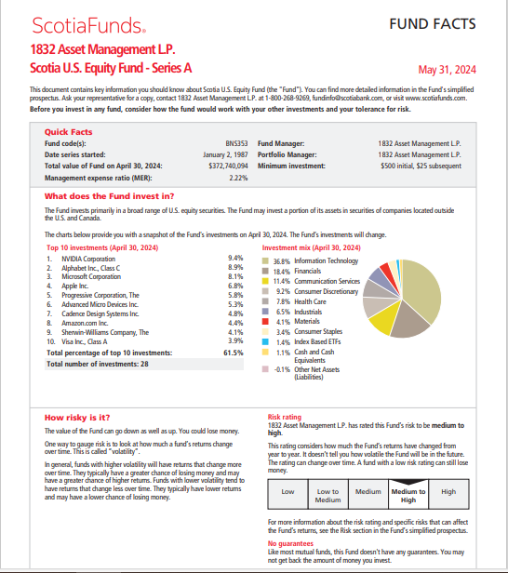

The Scotia US Equity Fund invests primarily in equity securities of US companies for long-term capital growth. The fund is invested in high-quality businesses across diverse sectors offering strong potential for growth in the world's largest economy.

Reasons to Invest: The fund is invested in leading US companies that drive innovation and determine global trends. The Fund is actively managed by some experience portfolio advisors who undertake deeper market research with a view to optimize the performance of the Fund. It will also help investors diversify their portfolios from a geographical perspective and lessen the risks that come with overexposure to just one single market. It follows the best-suited pattern for building wealth over the long term.

* **Scotia Diversified Monthly Income Fund - Series A (DEFENSIVE)**

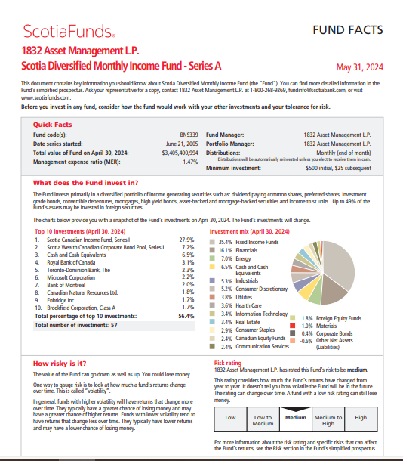

The Fund aims at offering regular income with the preservation of capital and the potential for modest long-term growth. It will primarily invest in the Utilities, Consumer Staples, and Health Care sectors, looking for companies possessing strong balance sheets, steady earnings, and regular dividend distributions. The goal is to lessen volatility and provide downside protection when markets go down.

Reasons to Invest: The fund produces a steady income with little likelihood of capital erosion, thus this investment is suitable for the conservative investor or for the investor needing to reduce overall portfolio risk. The defensive positioning in this fund is targeted towards realizing better downside protection from market volatility and yet has the scope of providing long-term, moderate capital appreciation as well

* **Scotia Global Growth Fund - Series A (HIGH BETA)**

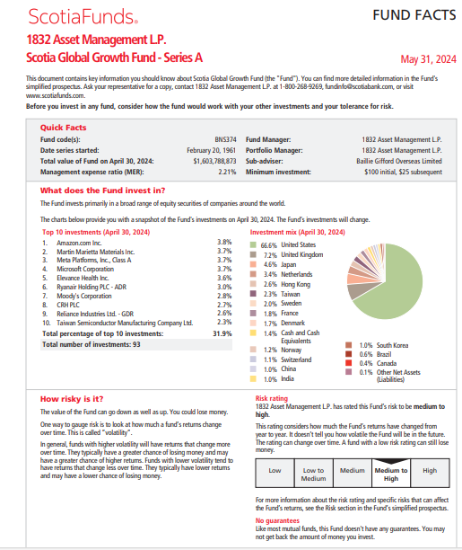

The Fund has adopted the investment objective of seeking long-term capital growth. In pursuit of its investment goal, the primary strategy the Fund will select a globally diversified portfolio of equity securities that are positioned to deliver, using fundamental analysis, above-average long-term growth.

Reasons to Invest: Exposure to a diversified portfolio of global equities that could be expected to benefit from growth opportunities around the world. Focus on above-average growth potential companies; implies higher risk and return, characteristics typical of high beta investments.

* **Scotia Canadian Dividend Fund - Series A (LARGE CAPITALIZATION)**

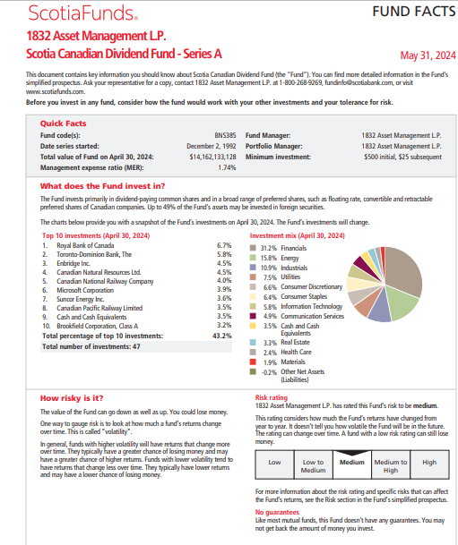

The Fund's investment objective is to provide a high dividend income with the potential for long-term capital growth. It primarily invests in dividend-paying common shares and a diverse array of preferred shares, including but not limited to floating rate, convertible, and retractable preferred shares of Canadian companies.

Reasons to invest: Consequently, the equity style for this fund is "Large Cap Blend," since the fund focuses on large capitalizations. Investors benefit from the portfolio advisor's skill in identifying well-established companies with strong dividend histories.

Reference:

ScotiaFunds. (n.d.). *All funds*. Scotiabank. Retrieved November 27, 2024, from <https://www.scotiafunds.com/en/home/all-funds.page.1.html>