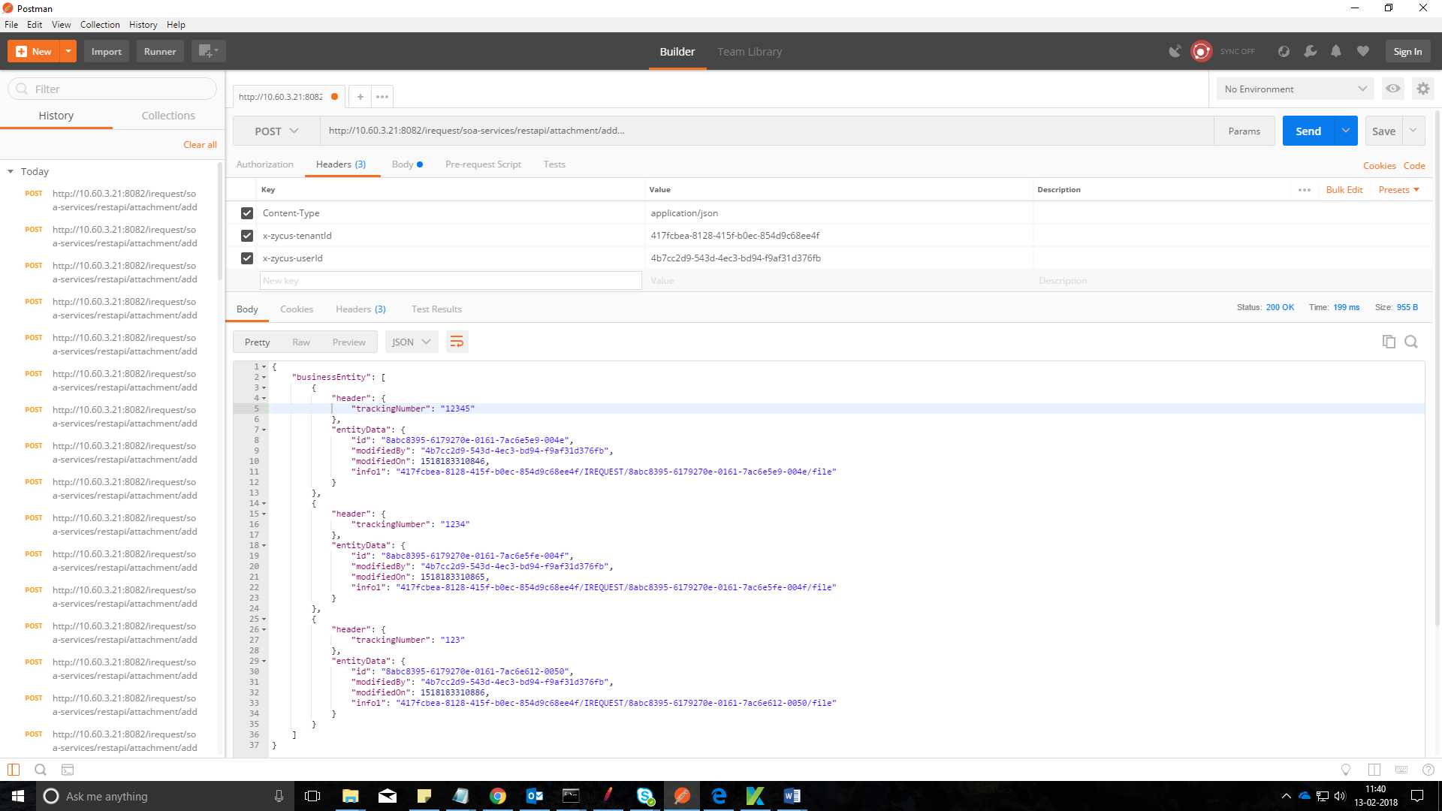

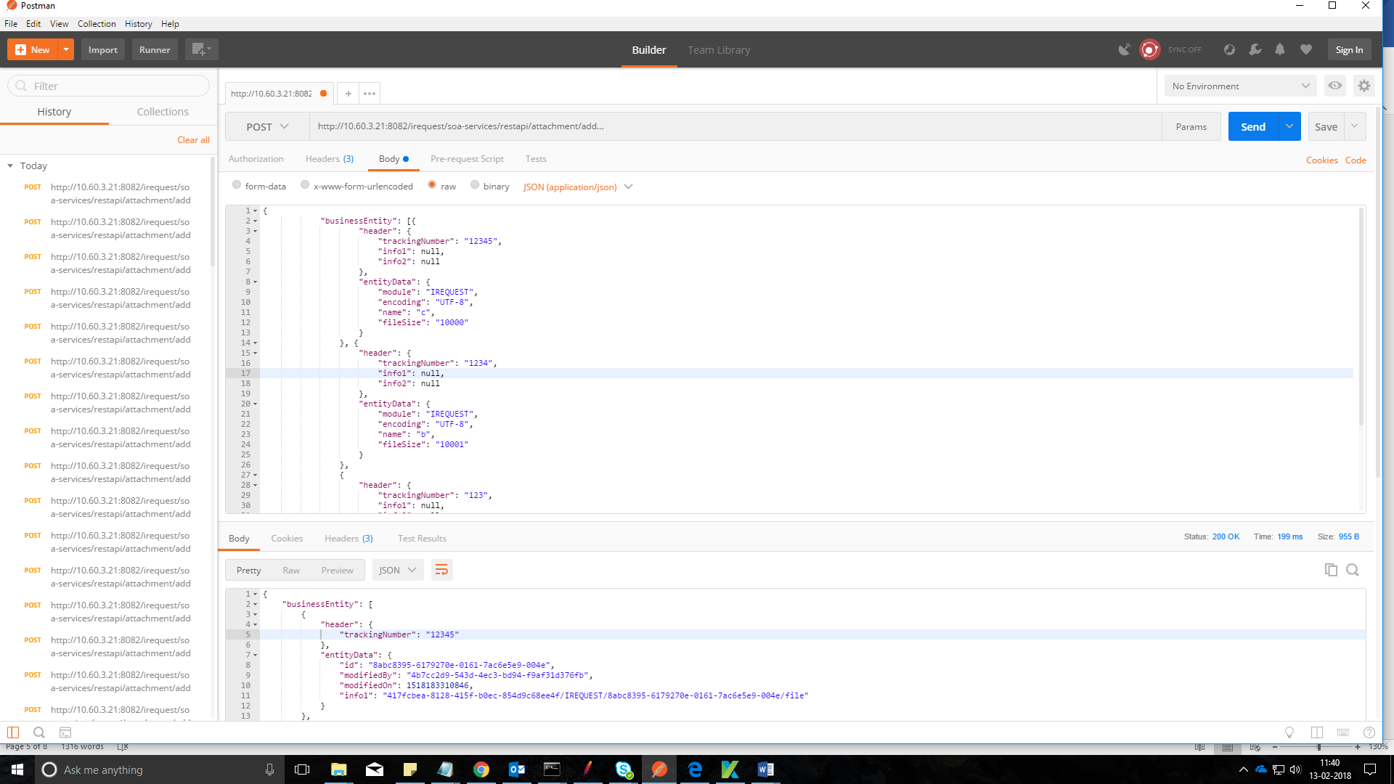

For adding any files

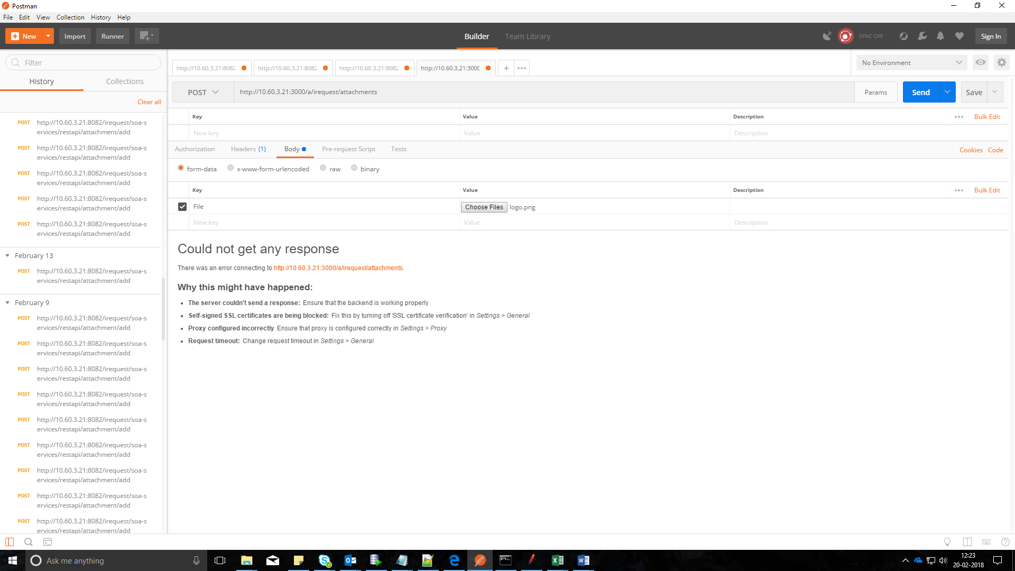

For BFF API we have to add cookies, by opening the application click F12, go to debugger cookies

Copy “SAAS_COMMON_BASE_TOKEN_ID=2c22ed98-f384-4172-ac0c-15d605f8964f “ and paste it in postman cookie

