**Screenshots of AWS Cloud Components Creation**

The cloud architecture is built using the AWS Management Console. The screenshots below show the AWS components created using the AWS Management Console.

**EC2 Instances:**

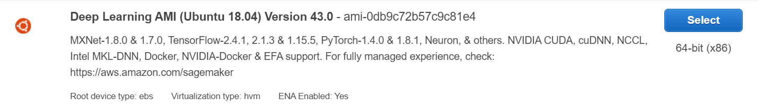

**Figure:** AMI used for the EC2 instance

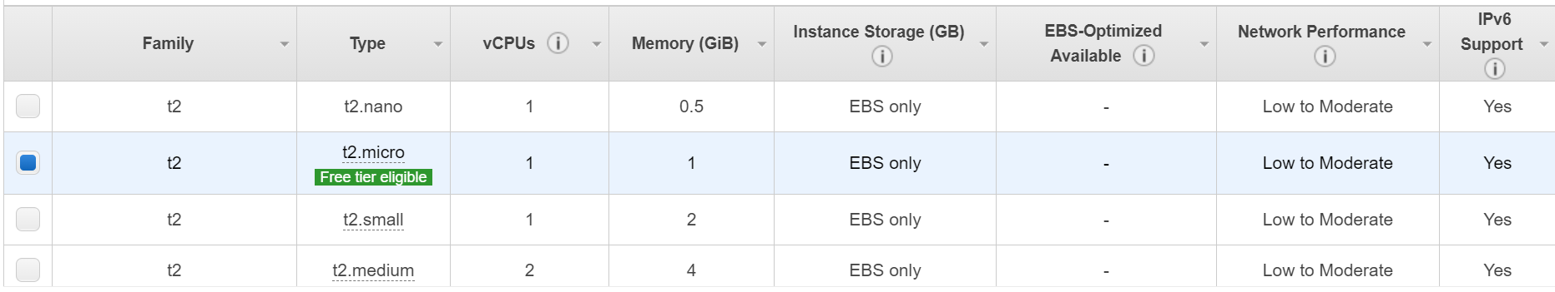

**Figure:** EC2 instance type

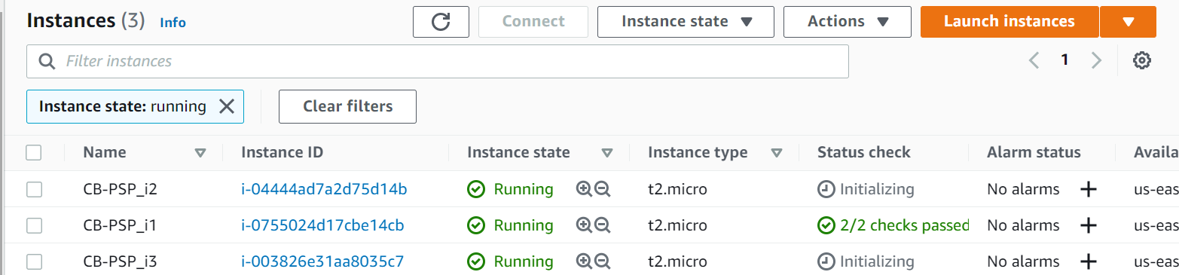

**Figure:** Multiple EC2 instances running

**EBS Volume:**

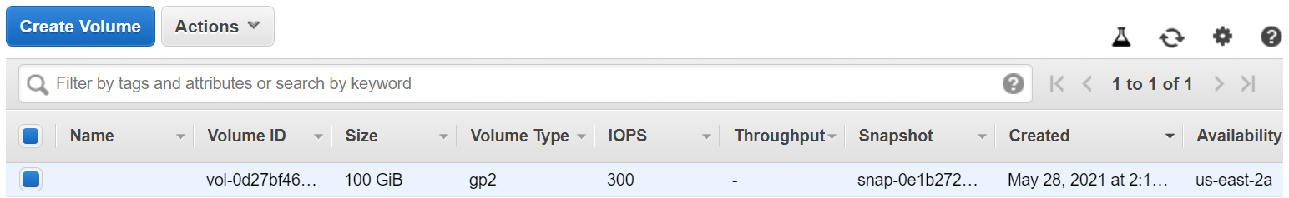

**Figure:** EBS volume for one of the EC2 instance

**Load Balancer with Auto Scaling:**

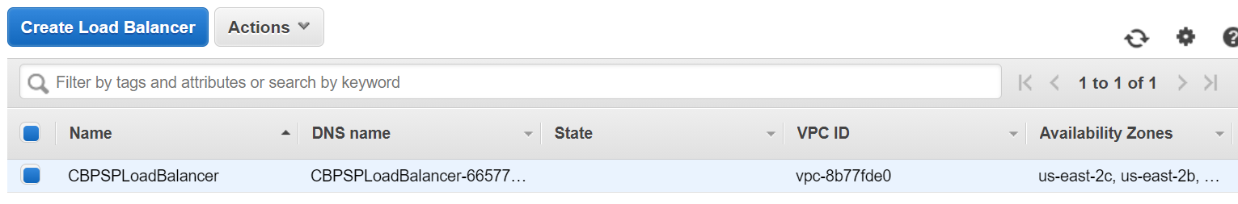

**Figure:** Load Balancer Creation

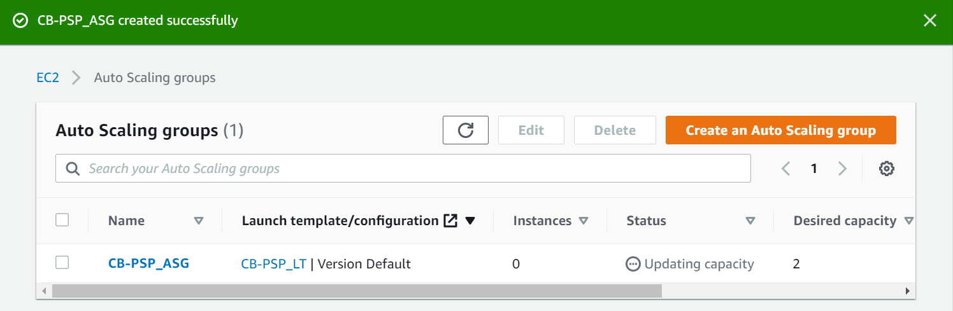

**Figure:** Auto Scaling Group created using a Launch Template (instead of Launch Configuration)

**S3 Bucket:**

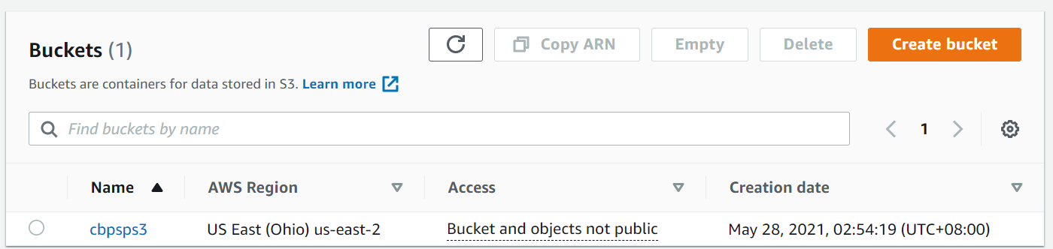

**Figure:** S3 bucket creation