**1. Locally Setup CB-PSP**

The following steps can be followed in order to setup and run CB-PSP locally.

*Supporting Libraries used: flask, pickle, NumPy, TensorFlow, Keras, datetime, pandas, matplotlib, mpld3, requests, json, glob, sklearn, iso3166,*

1. If, Anaconda not installed, then download and install it from: https://www.anaconda.com/products/individual
2. Open Anaconda Prompt.
3. Cd into CB-PSP folder (inside the supporting documentation folder).
4. Install the supporting libraries mentioned above with “pip install *library*”.
5. On Anaconda Prompt type: “app.py”
6. This will run the model on: <http://localhost:5000/>
7. Open any web browser and copy and paste the address: <http://localhost:5000/> on the address bar.
8. The home webpage will pop up.
9. Done.

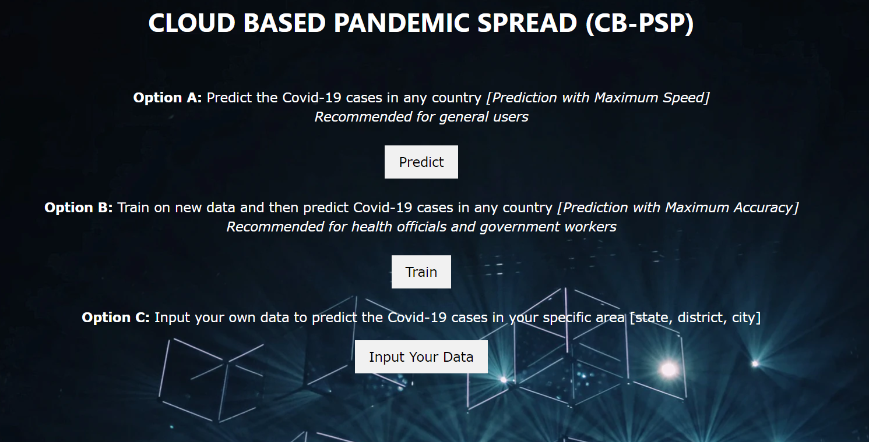

**Figure:** Home Webpage

**2. Website Navigation**

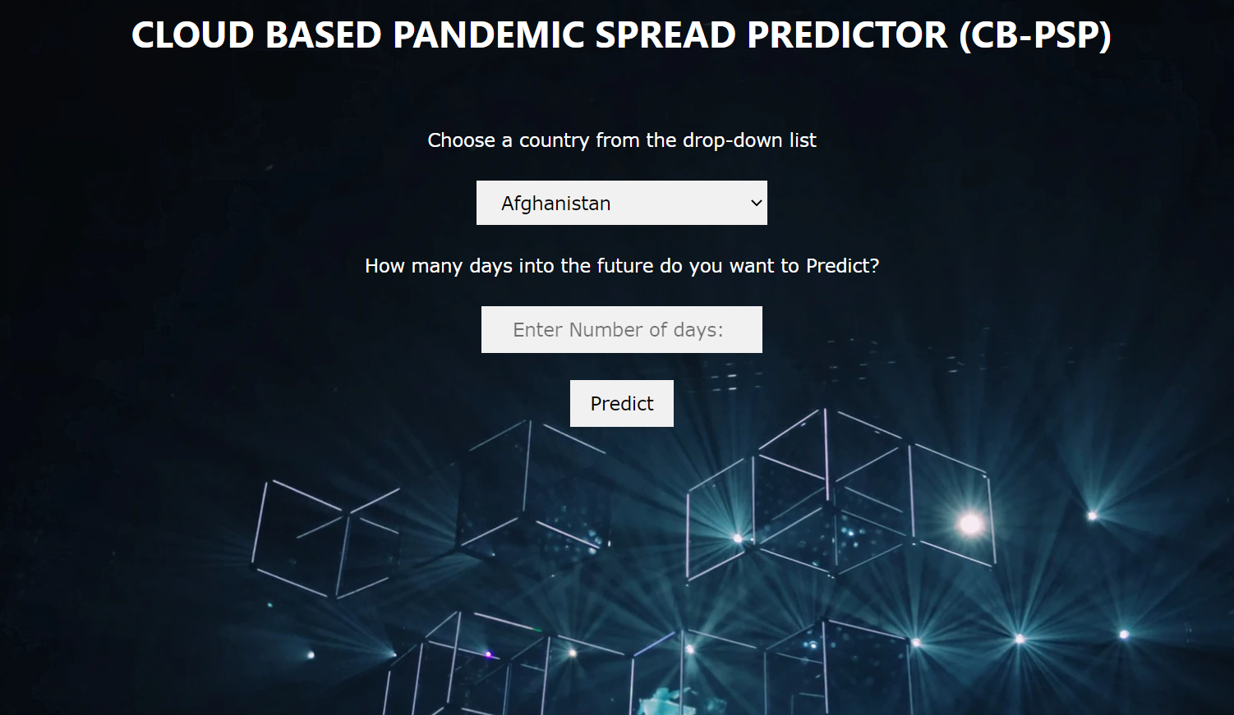

**Figure:** After pressing “Predict” on the homepage

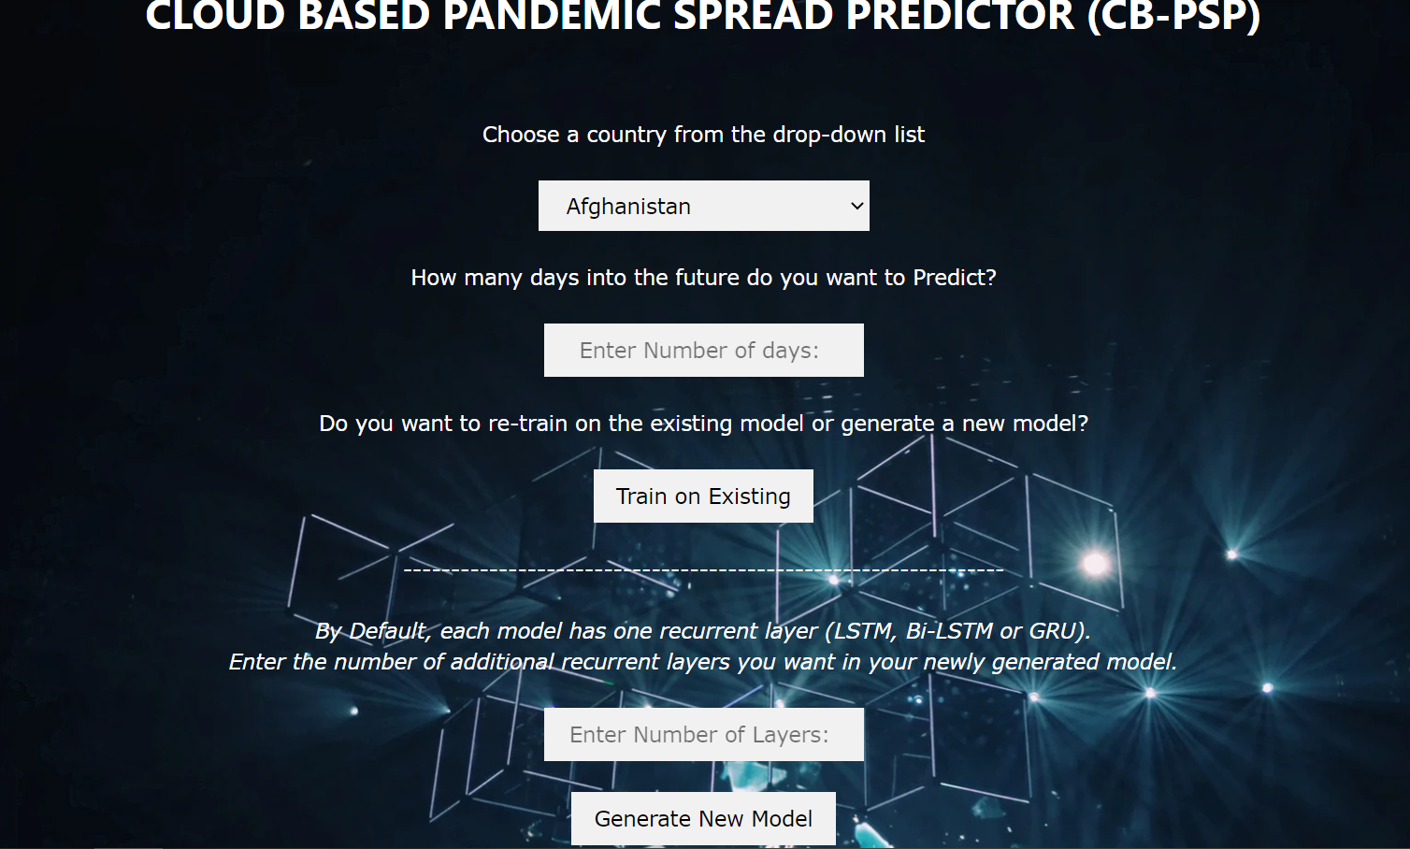

**Figure:** After pressing “Train” on the homepage

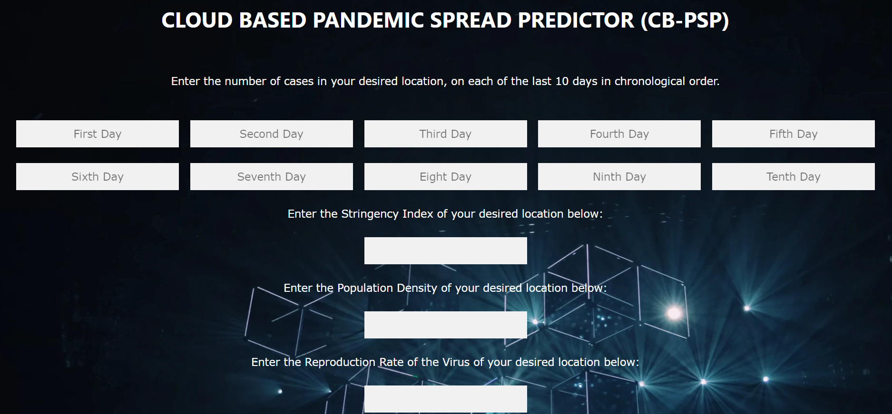



**Figure:** After pressing “Input your Data” on the home page

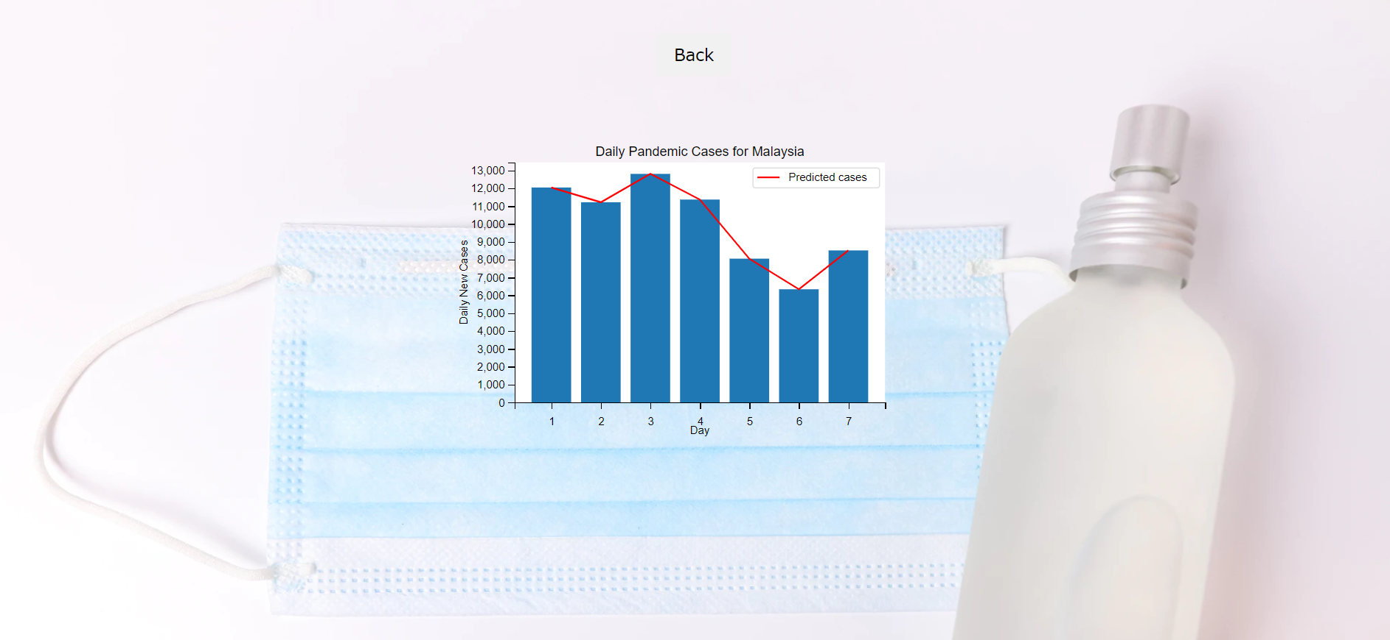

**Figure:** The results/ graph display page