Chapter # 1: Introduciton

Student : Ramman

Title: ERP System For Institutes

Contents

Chapter 1: Introduction 3

Enterprise Resource Planning System (Background) 3

OPEN ERP (Python) 3

Knowledge Management in ERP System 4

Educational ERP system in the Market 4

Identification Analysis of Failure Attribute of ERP System 4

Implementation of Higher Studies ERP System 4

Success Factors for Higher Education ERP 4

Aims & Objective of Research Project 4

Project TimeLine 5

Metrics Based Analysis of Educational ERP Solution 6

Technology 6

# Chapter 1: Introduction

Enterprise resource planning system control various educational resources , it encourages students to login to ERP portal to executes theri educationl resources. (Sun, G., Huang, Z. and Yue, L., 2022) this project going to develop the ERP system proposed on python Flask web application which complete with MYSQL server database for recording the student information. Flask is micro web framework of python which is better than DJANGO, it contains render templates to execute HTML and CSS files using the main root directory of python application.

This project using the advanced programming technique including user friendly management of resources such as login page, sing up page and home page. This project only focused on MSc computer science student which comprised of semester system. It facilitate the overall MSc degree program content composed of assignment, lecture notes, lecture slides, video lecture, lecture schedules and faculty meeting time which is designed according to the time period. However the educational resource management approach based on model selection which process the backend query on database server engine.

Hence teaching and learning material is major requirement to fulfill the research gap in the previous ERP system releases. Since the entire learning process design to facilitate the student requirements according to the given ERP condition. New student first signup to complete their registration process after it get the login id and password to proceeds the home page of ERP, in view of home page which get the latest assignments, Video lectures, slides and other material resources. This project design with Pycharm community 2022 edition including python latest library and MYSQL server. In the previous ERP releases student do not have open platform to execute the educational resources.

## Enterprise Resource Planning System (Background)

(Kendle, A.S., Nagare, et.al. 202) enterprise resource planning system encourage the institutes to manage their finance and fee related issues, online admission system process and student semester management system proceeds with web based portal which manage and organize various system in order to manage the educational resources. The proposed system is called educational management comprised of MSc student program. Python flask organizing render templates html & css files which focused on student data management system such as assignment, task, project, lecture notes etc. digital platform developed with MYSQL database system providing forum to student hiring process. (Sisyukov, A.N., Bondarev, V.K. and Yulmetova, O.S., 2020,) ERP data analysis including data visualization which process the high computing to integrate the educational resource in less time. Comparison of previous ERP system composed of Oracle, Java and C# ASP application which does not perform well due to high complexity of programming and database binding. ERP analytics performed using the SAP/HANA platform which carries data analytics to handle the complexities in different term.

## OPEN ERP (Python)

In previously open ERP project designed which provides solution open source management solution. Various business application has been managed by this project which contains necessary features and action in order to optimize and organize the different enterprise process.

1. Financial & Accounting
2. E-commerce
3. Sales and purchase management
4. HRM & Marketing

The research gap has been identified because educational OPEN ERP does not includes in this projection.

## Knowledge Management in ERP System

(Kumar, A. and Gupta, P.C., 2012) since ERP system manage & organized various educational resources system which adapted the advance technology hence implementation of ERP system to support colleges and Universities of UK which needs customized support to achieve the objective of educational resources. In previous releases of ERP software which does not perform better according to the educational needs and requirement. The implementation of real ERP resource planning system which includes various complex functionality that process the finance management with educational resource management. Various online educational resource management system available but the lack of business requirement which exist the major gap to manage the educational resources. Hence enterprise knowledge management system which organize the way of meeting to conduct online session to meet the student forums.

## Educational ERP system in the Market

(Kulkarni, A., Hegde, N., et.al., 2015.) ERP solution provides the solution to solve various complexity in one vision platform which designed according to the vision of faculty and student management purposes. Educational environments improves the overall condition of teaching and learning but student required online learning which composed of lecture slides, notes, video lecture. This research dealing the market competitive ERP solution which comprised of various educational management system hence the corresponding features would be part of dealing the student resource management. OPEN source online ERP solution does not provides the customized feature to manage educational requirement, so this forum is fail to deliver the complete vision.

## Identification Analysis of Failure Attribute of ERP System

(Kumar, A. and Gupta, P.C., 2012.) Rapid development of ERP system which needs higher studies guideline to design the solution which focused on higher studies student. The higher educational resources composed of undergraduate and graduate program, higher educational identified the required attributes which required by the higher studies student. This research studies the case studies of higher education system which dealing on different failure of ERP solution, ERP system easily crashed due to negligence in the programing.

## Implementation of Higher Studies ERP System

(Qian, L., Schmidt, E.K. and Scott, R.L., 2015) the framework of ERP solution in vision of higher student management hence higher educational institutes which adapt the business management solution. Enterprise resource planning system recommends the key factor of Purdue University which implements on SAP, hence the SAP solution which failure and crashed in lack of educational requirements and poor interface system. The ERP solution design to meet the internal departmental requirements such as administration department should meet the finance department via ERP system. The implementations of ERP solution designed with solution oriented to achieve the business goals.

## Success Factors for Higher Education ERP

(Bologa, R., Bologa, A.R. and Sabau, G., 2009,) success factors of higher education system implementation of correct ERP system which meets the educational requirement. Since the critical success factor of educational ERP system designed with customize solution which identify the project outcomes. Since the project management of ERP solution planning according to the business and student requirement. Previous releases of ERP solution which was crash and fail due to poor planning of interface and poor planning of resource management system.

## Aims & Objective of Research Project

Aims of this research project to develop ERP solution composed of Flask web framework and objective achieved on the following parameter:

* By developing python flask web framework composed of render html template which designed on MYSQL database platform to record the student profile.
* Deploying the Bootstrap web application framework to design student signup and sing in page which essential elements of every ERP to manage the user session.
* Conduct critical literature review composed of latest ERP solution.
* Develop Flask Solution to achieve the MSc student studies content in order to achieve the project timeline.
* Develop lecture and studies material based student profile which designed on single user login platform which meet all the business and educational requirements.

## Project TimeLine

Gantt chart design to develop the python flask web application framework which meet the higher studies requirement as follows:

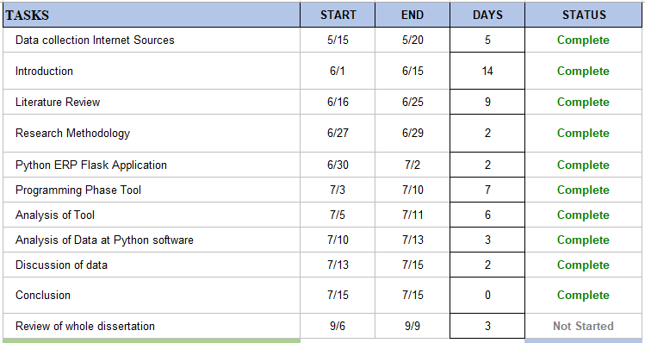

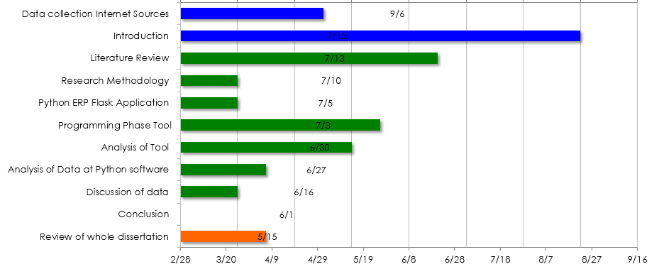

The project timeline make attention with supervision of project supervisor which deal all the necessary actions taken to complete the project on the given time period.

## Metrics Based Analysis of Educational ERP Solution

The metric based ERP solution analysis has been made by using the fuzzy logic AI system which developed to meet the entire finance and administration requirement. Since fuzzy logic system is branch of mathematics computing which build the real world model in way of meet the critical requirement. Since the implementation of testing ERP solution by meeting the view of ERP solution which mean to evaluate and identify the student and business requirement. The performance and metric evaluation which identify the failure and success factor of recent ERP solution. The current projection designing are composed of Python Flaks ERP solution which meet all the necessary requirement. The studies and lecture material which are major elements of every ERP solution success hence the combination of assignment and assignment task solution which fulfill the research gap by deploying this comprehensive and easiest application using the python flask framework.

## Technology

Python programing is major programming tool which are one of the best reasoning to choose because its light weight and easy to develop including MYSQL database application. The design and implementation of ERP solution which mean to deploy the MSc student studies program, only focused to design the studies and teaching related queries. The student query related to assignments which are revised regularly on the basis of student requirement because requirement has been change on daily basis. Class schedules and assignment uploading schedules are mandatory part of this project success. The success goal of this project are laid down on the following parameter of technology as follows:

1. Python Pycharm Community
2. Python Flask tool
3. MYSQL database engine
4. Bootstrap templates (HTML &CSS)