Security standards. Legislation associated with data protection and computer misuse.

Name: Dharmendar

Abstract—security standard tools enable the organization to protect the data and personal asset from vulnerable attack by following the method of ISO based standard since the OSI layers follows the IEEE and ANSI modeling to each layer protect with ISO 27001 standard rules and law. Hence the cybersecurity mechanism design to facilitate the organization asset from unknown attack. Since the information security management planned risk policies and law policies to regulate the user login and user data. Organization planned the pattern to follows the security standard to avoid them hacking attack.
Keywords—security standard, legislation, computer misuse, protection (key words)

Introduction
[1] Computer fraud adapted by various authority to capture data and information form the system. computer fraud could be avoided if the organization implemented some security principles to deploy in the network. Implementation control over the computer network would achieve the security parameter. [2] software requirement engineering policies implemented in the compliance of Italian data protection legislation by using the security development parameter. Formal analysis method copes the requirement analysis in which various complex infrastructure has been updated and implemented hence the ISO 17799 security management requirement defined according to the ISO and IEEE protocol parameter standard. [3] computer misuse at workplace, since various data safety professional works to achieve the standard goal of information management because they believe that the indorsing good end user behavior and restricted unsuitable end user conduct which is actual energetic information management role. [4] organizational employee abuse on computer control to manage the data & information on the way to achieve the sustain period of information management including security protocols. Hence network security protocols work to secure the computer misuse the protocols consist of IPSec VPN, SSL and TLS, application transparent including transport layer security Kerberos, OSPF authentication, SNMP. [5] data protection in the United States of America since US follows the sectoral approach of data security, the privacy protection of personal data would be part of federal legislation which ensures the privacy and protection act according to the ISO security standards. The administrative rules and regulations planned to achieve the primarily protection of data with specific sector which includes the data protection directives that works on administrative rules to sustain the computer misuse.[6] there are two primary security standards which used in organization to protect the computer abuse ISO 27001 and ISO 27002 which established on the requirements of the creating information security management rules hence ISMS is important audit compliance to achieve the mitigation over the network. Security standards used to protection the data and information on the entire computer management. Three basic security required by the system confidentiality, integrity and availability, since security adviser fail to assist that how security measures works to sustain the data and information in the entire system. cybersecurity standards should meet the organization standards to protect the cyber threats and help to improve the cyber security posture the cybersecurity posture applied in all over the world organization to protect organization data and protect system.

ISO 27001 Standard

International standard for information security
International standard for information security to protect the computer organization data and information from misuse attack, hence various security measurements protocols used to protect the data from the outside attack. Hence ISO 27001 is standard to advise organization to support in establish, implement, monitor, review, maintain to improve information standard according to the rules and regulations which was developed.

ISMS information securiyt management systme
Its holistic approach to securing the confidentiality integrity and availability of organization asset, ISO 27001 which based on policies procedure and another control system which based on group of advisors to process the information technology within the law and regulations.

Literature Review
[7] the important element in security management to follows the rules and law which defined by the ISO and IEEE communication network protocol, which ensures the network security parameter more secured and more achievable. Security policy implemented by regulate the protocols parameter which ensures the security measurement more reliable and manageable. [8] IT governance guide based on ISO27001 standard which based on security guides and parameter to ensures the computer data security including protocol policies and management. System administrator able to build the security policies according to ISO 27001 toolkit parameter which includes all pre written policies and parameter procedure and templates that guide the organization management which how they prevent computer abuse form unauthorized access.

Security Risk Management
Risk management is part to design the cornerstone of ISO/IEC ISMS policy, hence all information and security management policies regulate risk assessment to control which security measures are involved in this to implement and maintain the system. the standard defines the requirement of risk management process [9] risk management compliance some way of understanding the process of ISO 9000 and ISO 14000 in today all business benchmarks follows these standards to measure the risk parameter hence in manufacturing and service sector should deploy the parameter of ISO. Quality control measurement

Benefits of implemented ISMS using ISO 27001 Policy
- [10] the high amount of information managed according to the low security management system in which various manufacturing industry implements security standards. This research proposes the implementation of information security management system to manage risk policy and to manage the compute and data.

Security Risk Management in Internet of things
- [11] IOT devices and system are top edge connected system which deeply in risk of capturing real time data of smart system, since security become critical concern in the management of IOT system, hence huge amounts of IOT devices control the office management and home management security system enables the user to connected over the neighbors networks of IOT network. Hence individual nodes connected to build the cognitive node which connected on top to select number of nodes, the cognitive network present the formation of independent which informed in holistic manner

Data Protection tools
- [12] methods and tools in management of GDPR compliance policy by design by viable in order to obtain the effective involved of technological tools get closer to their mindset, since the software system and engineering methods used as tool to monitor the privacy engineering, essential task of computer network to secure and manage the information communication network, to ensure reliability since communication management tools hence network tools based on physical, technical and administrative to manage the detective preventive and corrective way of computer network. Hence antivirus tool is not good working because itself is a virus developed by Microsoft.
Identify applicable funding agency here. If none, delete this text box.

Computer Secuerity Check list
Ensure that computer and email password is protected and operating system is updated, download software from reputable link, ensure widow defender security setting actively works and terminal unusual services such as consumer resources ensure firewall is updated and works according to the need, ensure system backup regularly clear user private data from web browser.

Methods: Computer Security Protection

Computer security
Keep the works station computer updated according to the requirement of ISO 27001 and IEEE rules. Hence update window application software on priority basis. Create restore point to restore the original settings of the operating system. enable window firewall and security defender settings from control panel.

Update window operating system
Update and upgrade all window security features on every end of month. Scanning missing files and update them according to need.

Update server computer
Update server computer on daily and planned backup on daily basis. Backup the system essential utilities program which required by daily routine.

User Account
Use standard user account, and secure window operating system from other network, secure firewall secure window WIFI connection. Keep user account control.

Secure web browswer
Secure web browser when online use unencrypting tool for hardware system.

Network Firewall
- Common network firewall works very well to secure computer hardware and software from unknown network.
- Since firewall is network security system that monitor and control incoming and outgoing traffic based on predetermined security rules
- CISCO ASA Series, Juniper, SONIC Wall, PF Sense and Fortinet, hence windows 10 operating system comes with pre-installed antivirus and firewall system.
- Window Firewall Settings configured according to the system settings and works on security parameter to achieve the

Intrusion Detection System
Intrusion detection system is a device or software application that monitor a network or system from malicious activity or policy violations. Hence intrusion detection system used to ensure the firewall and router security settings. Since intrusion detection is important like firewall system because its work to stop the outside network communication which interrupts them. Network administrator ensures the network security management by installing them the security rules, IDS block the hacking attack which are coming from outsides. Its helps in tracking logs, tracking user activities and tracking WIFI network activities which based on the network security parameters and rules.
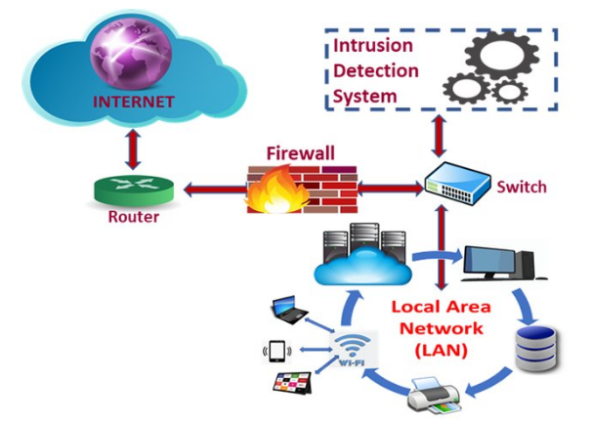
Figure: intrusion detection system and Local area network

Intrusion detecion software

Solarwind securiyt event manager tools works efficiently to scan and secure the computer network form outside access. This tool high capable to manage the entire network to organize the security in highly intelligent threat detection. The data is consistently optimized in the sytem and process in the intrusion detection system to organize the log and ID since the risk assessment report to stakholder to optimize the data which are secured in the operating system environment since the data is created to identify the system parameter once its bieng captured by the system.

KISMET Tool
Intrusion detection KISMET tools used to secure the operating system and data and entire computer network of the organization. The focused on wireless protocols like Bluetooth, WIFI, since the unauthorized access can be created accidently to point out the employees’ signature easily. Kismet tool extended the plugin support. Hence the functionality to detect user login and logs information and capture IP address by sniffing the network routes.

Result & Analysis
The intrusion detection system used to secure the computer network and operating system from outside access. The network intrusion detection software used to protect the system from unauthorized access in the organization. SNORT is free tool to implement in the network. SNORT tools are one of the best intrusion detection software which used to scan and prevent the network. It performed port scanning, it has real time signature-based network which notify the system administrator are attacks like port scanner, DDOS attack CGI attack and back door attacks and OS fingerprints.

SNORT Configuration command prompt
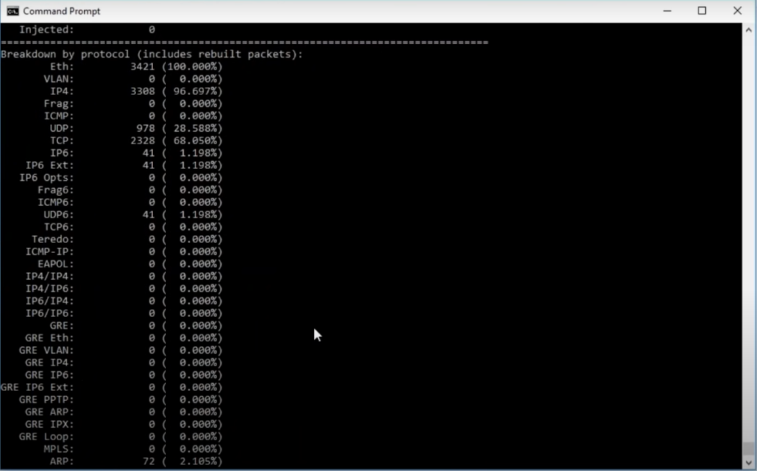

Logs and Information capturing at Command Prompt using SNORT
Since SNORT is intrusion detection software free to use at windows operating platform to secure windows server computers and windows operating system. hence all vulnerability has been captured by the SNORT shell in the window shell prompt and capture the real time live events on the event on the go beyond scene. It analyze the computer network Logs, IP, MAC address and real time software analysis by capturing the scene.
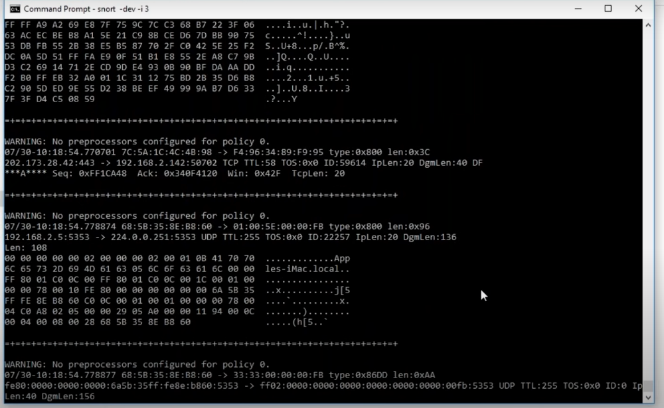

Securing Network VPN
Hence the network VPN needs to secure in the system by obtaining all the private network information under confidentiality and integrate in secure environment and hide the locations from the unknown user.
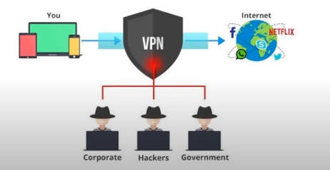

WINDOW WINPCAP
Its works together with SNORT software which plugins to executes the SNORT shell in the windows operating system to capture the network vulnerability attack within the server system.



Network Control Security Features tools
- Confidentiality
- Data integrity
- Availability
- Control
- Audit
- Hardware protection
- Software protection

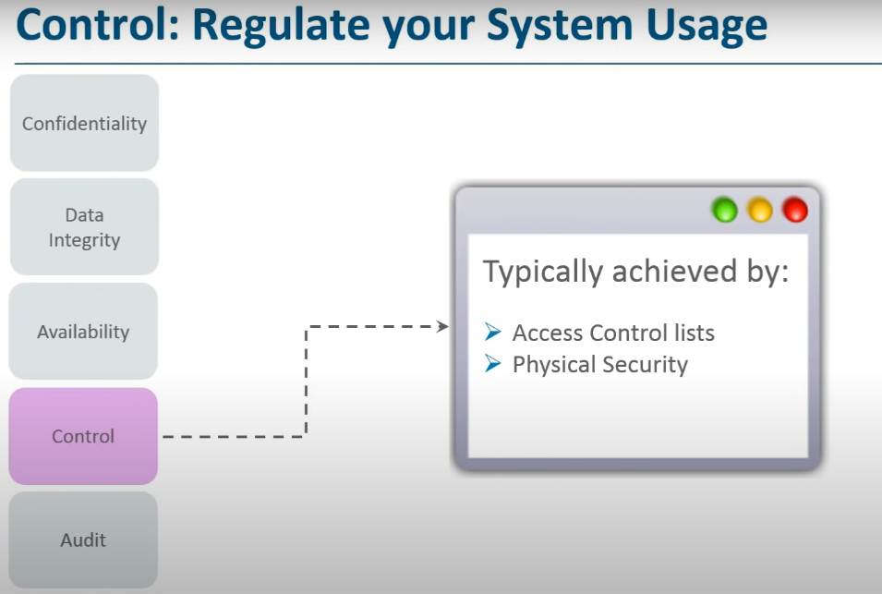
- Security tool
Software | Network Security Software intrusion detection
Software | Free to use | Unlimited | Forever
1 | KISMET | Yes | Yes
2 | SNORT | Yes | Yes
3 | SOLARWIND Secuity | Yes | Yes

Conclusion
Network and system security tool essentially used to protect the system from misuse and vulnerable attack, organization follows the ISO 27001 standard to secure the network hence security tools one of the best choices to protect the organization data and system.

References
Dhillon, G., (1999). Managing and controlling computer misuse. Information Management & Computer Security.
- Massacci, F., Prest, M. and Zannone, N., (2005). Using a security requirements engineering methodology in practice: the compliance with the Italian data protection legislation. Computer Standards & Interfaces, 27(5), pp.445-455.I.
- Herath, H.M.P.S. and Wijayanayake, W.M.J.I., (2009). Computer misuse in the workplace. Journal of Business Continuity & Emergency Planning, 3(3), pp.259-270.
- Willison, R. and Warkentin, M., (2013). Beyond deterrence: An expanded view of employee computer abuse. MIS quarterly, pp.1-20.
- Boyne, S.M., (2018). Data protection in the united states. The American Journal of Comparative Law, 66(suppl_1), pp.299-343.
- Siponen, M., (2006). Information security standards focus on the existence of process, not its content. Communications of the ACM, 49(8), pp.97-100.
- Höne, K. and Eloff, J.H.P., (2002). Information security policy—what do international information security standards say?. Computers & security, 21(5), pp.402-409.
- Calder, A., (2008). IT governance: A manager's guide to data security and ISO 27001/ISO 27002.
- Brenner, J., (2007). ISO 27001 risk management and compliance. Risk management, 54(1), pp.24-29.
- Velasco, J., Ullauri, R., Pilicita, L., Jácome, B., Saa, P. and Moscoso-Zea, O., (2018), November. Benefits of implementing an ISMS according to the ISO 27001 standard in the ecuadorian manufacturing industry. In 2018 International Conference on Information Systems and Computer Science (INCISCOS) (pp. 294-300). IEEE.
- Chen, J. and Zhu, Q., (2019). Interdependent strategic security risk management with bounded rationality in the internet of things. IEEE Transactions on Information Forensics and Security, 14(11), pp.2958-2971.
- Martin, Y.S. and Kung, A., (2018), April. Methods and tools for GDPR compliance through privacy and data protection engineering. In 2018 IEEE European symposium on security and privacy workshops (EuroS&PW) (pp. 108-111). IEEE.

