**QR CODE GENERATOR USING PYTHON**

TABLE OF CONTENTS

1. Introduction

2. Requirements

3. Procedure

4. Code Implementation

5. Expected output

1. INTRODUCTION:

* A QR code (short for Quick Response code) is a two-dimensional barcode that can be scanned using a smartphone or a QR code reader to quickly and easily access information.
* QR codes consist of black and white squares arranged in a square grid on a white background. The squares are arranged in a specific pattern that allows them to be read by a QR code scanner.
* In Python, you can generate QR codes using third-party libraries like ‘**qrcode’**, which allow you to create QR codes programmatically and customize them with different colours, sizes, and styles.

1. REQUIREMENTS:

* CMD prompt
* Visual Studio code
* Modules like
* qrcode

1. PROCEDURE:

* Install the module (qrcode) in CMD prompt.
* Create a new python file in visual studio code.
* Write the code in a file and run after the code written.
* Observe the output.

4.CODE IMPLEMENTATION:



5.EXPECTED OUTPUT:

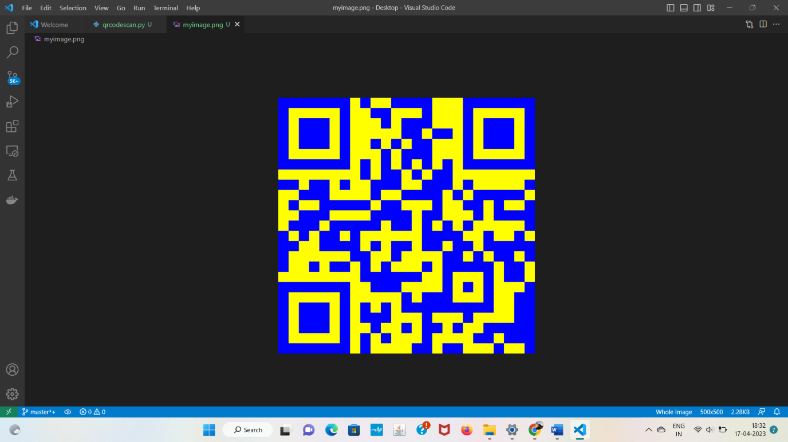

* If we give input as details, then the QR code will generate with that details.