Superior University Lahore
Department of Computer Science
PROJECT REPORT
Bluetooth Controlled Robot with Obstacle Detection
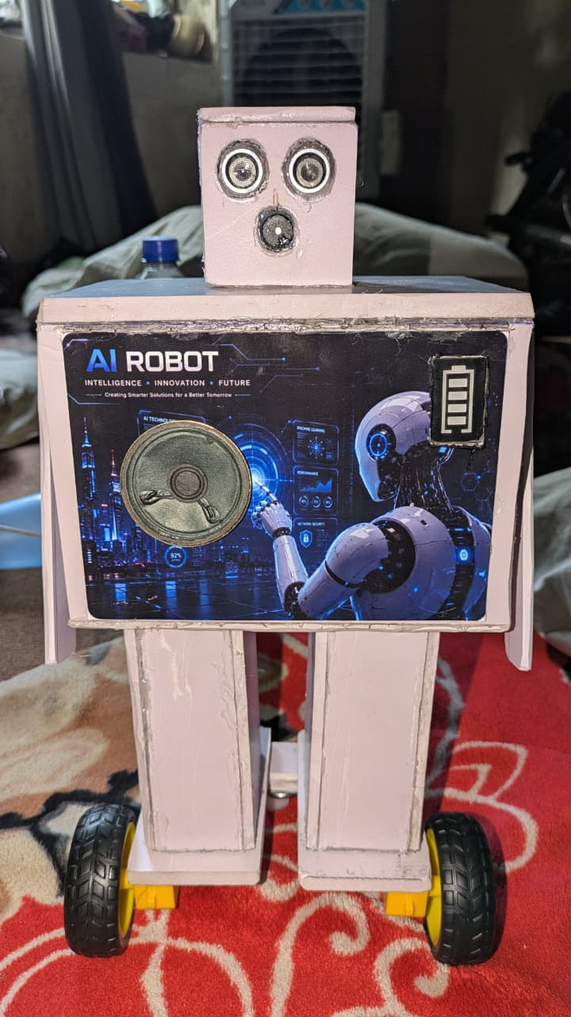
Field | Detail
Student name | Muhammad Adnan Rasheed
Roll number | SU92-BSCSM-F25-324
Department | Computer Science
Course | Digital Logic Design (DLD)
Instructor | Muqaddas
Submission date | 08/25/2026

Abstract
This project presents a robot car that is driven from a mobile phone over Bluetooth and stops by itself when an obstacle comes in front of it. An Arduino board receives movement commands from an HC-05 Bluetooth module and drives two DC motors through a motor shield. An ultrasonic sensor measures the distance ahead continuously; when an object is closer than 20 cm, the motors are released and a buzzer sounds. The result is a low-cost robot that combines wireless control with a basic safety feature.

1. Introduction and Objectives
Remote-controlled robots are widely used for tasks that are unsafe or inconvenient for people. A remote operator can drive such a robot into an obstacle, so collision protection is a useful addition. This project builds a small robot that is controlled wirelessly and protects itself from collisions.
The objectives are:
- Control the robot wirelessly from a mobile phone using Bluetooth.
- Support forward, backward, left, right, stop and short-turn movements.
- Measure the distance ahead with an ultrasonic sensor.
- Stop the robot automatically and sound a buzzer when the distance falls below 20 cm.

2. Components Used
Component | Connection | Role
Arduino board (Uno) | Main board | Runs the program and coordinates all parts
Adafruit motor shield | Stacked on the Arduino | Drives the two DC motors (left on M2, right on M4)
HC-05 Bluetooth module | RX on pin 2, TX on pin 3 | Receives commands from the phone
Ultrasonic sensor | Trig on A0, Echo on A1 | Measures the distance to the obstacle ahead
Buzzer | Pin A2 | Warns when an obstacle is too close
2 DC motors with wheels | Motor shield | Move and turn the robot
Mobile phone with Bluetooth app | Wireless link | Sends the control commands

3. System Design
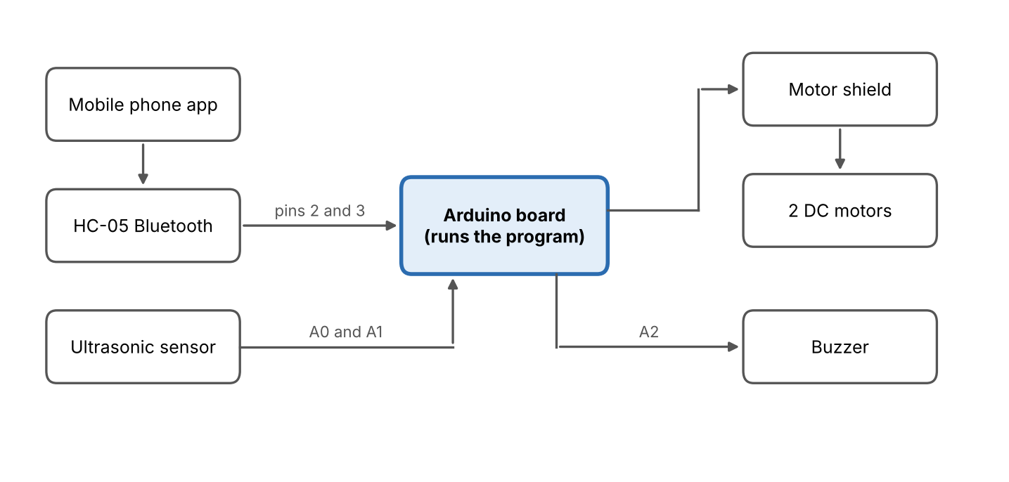
Figure 1: Block diagram of the robot
Commands reach the Arduino through the HC-05 and distance readings arrive from the sensor on A0 and A1. The Arduino answers by driving the motors through the motor shield and switching the buzzer on pin A2.

4. Working Principle and Software
The program is written in the Arduino IDE using the AFMotor and SoftwareSerial libraries. setup() runs once at power-on: it starts serial communication at 9600 baud, configures the sensor and buzzer pins, sets both motors to speed 180 (out of 255) and keeps the robot stopped. loop() then repeats continuously and does two jobs in every cycle.
Bluetooth control. The Arduino reads one byte from the HC-05 and runs the matching movement. The phone app must send these numbers.
Command | Action | How the motors move
1 | Forward | Both motors forward
2 | Backward | Both motors backward
3 | Left | Left motor forward, right motor backward
4 | Right | Left motor backward, right motor forward
5 | Stop | Both motors released
6 | Short right turn | Turns right for 800 ms, then stops
7 | Short left turn | Turns left for 800 ms, then stops

Obstacle detection. The sensor sends a 10 microsecond trigger pulse and the program measures how long the echo takes to return. The distance is calculated from the speed of sound:
distance (cm) = duration (µs) × 0.034 / 2
The division by 2 is needed because the sound travels to the obstacle and back. If no echo arrives within 30 ms, the function returns 0 and the reading is ignored. When the distance is above 0 and below 20 cm, the program releases both motors and turns the buzzer on; otherwise the buzzer stays off. This check runs in every cycle, so the robot stays stopped while the obstacle is in front of it, even if a forward command is received.

5. Results, Limitations and Future Work
Results. The robot was built and tested. It responds to commands sent from the mobile phone over Bluetooth, moves in all the programmed directions, and stops when an object comes in front of it. The Serial Monitor shows each received command and the measured distance in centimetres, which made testing and debugging easy.
Limitations.
- The sensor faces forward only, so the robot is not protected while reversing or turning.
- The motor speed is fixed at 180 and cannot be changed from the phone.
- The short-turn commands use delay(800), which pauses the program, including obstacle checking, during the turn.
- Control depends on the phone app sending the exact numbers 1 to 7.
Future work.
- Add a rear sensor, or a servo-mounted sensor that scans left and right.
- Add speed control from the phone app.
- Add automatic obstacle avoidance so the robot can steer around objects.
- Add a camera or additional sensors for monitoring tasks.

6. Conclusion
The project achieved its aim of building a Bluetooth-controlled robot with automatic obstacle stopping. It shows how a microcontroller can combine wireless input with sensor feedback to make a machine safer to operate. The design uses common, low-cost parts and can be extended with more sensors and smarter navigation.

