[Figma wireflow prototype](https://www.figma.com/proto/7dNd9TiHMF8vBW5tvDDDfp/Mobile-Wireframe-UI-Kit-(Community)?node-id=427-5823&scaling=scale-down&page-id=427%3A5822&starting-point-node-id=427%3A5823)

1st usability test:

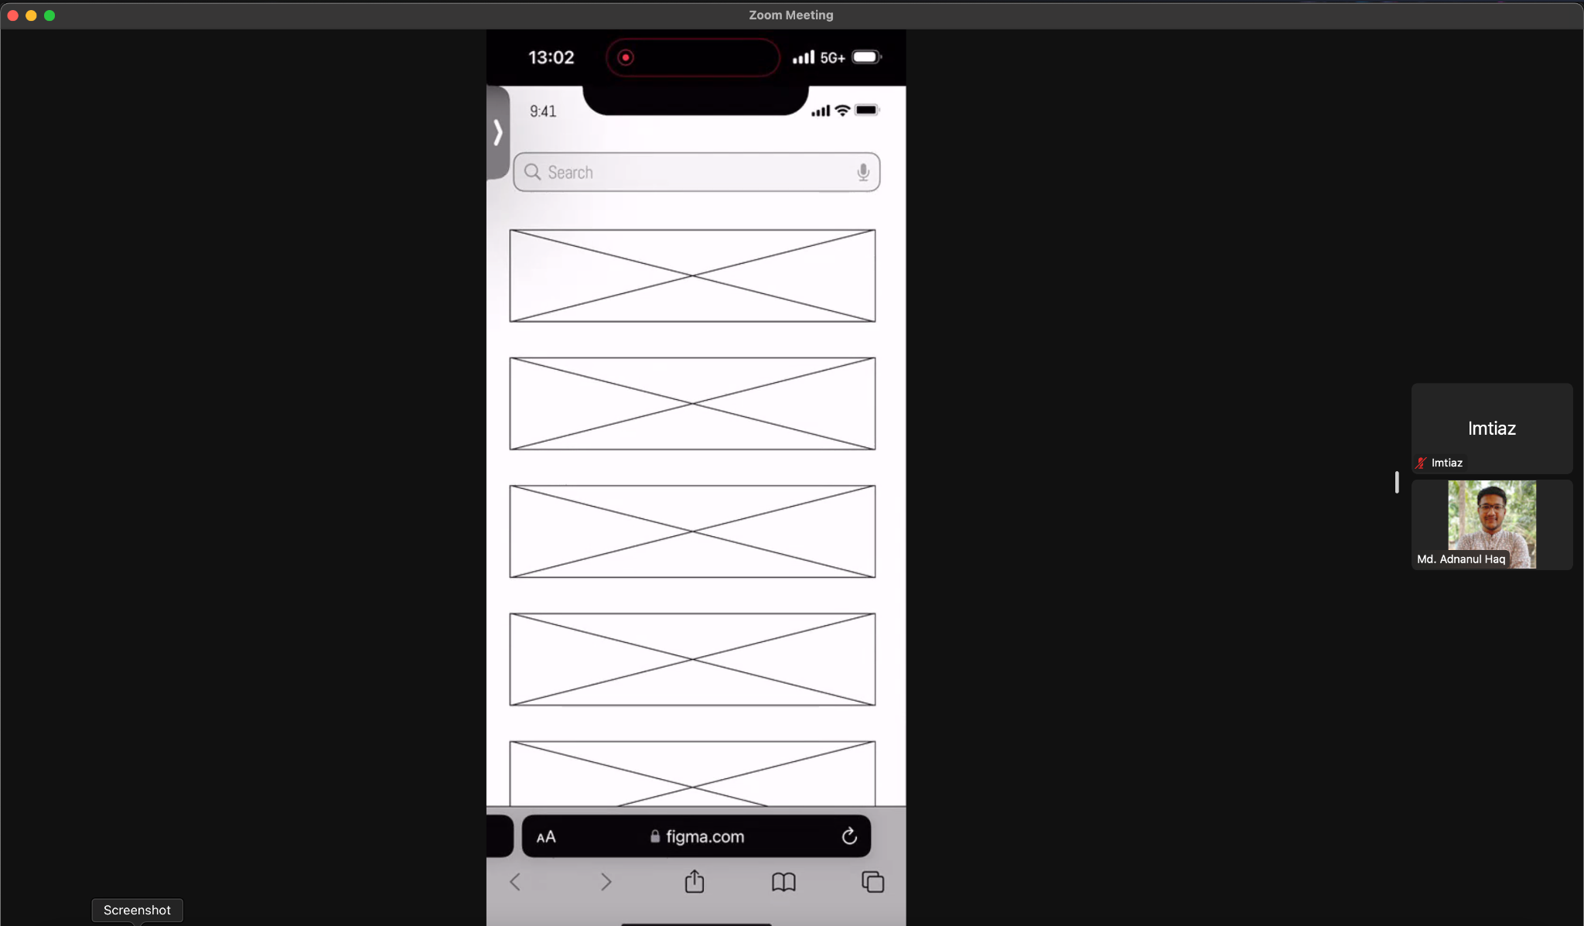

In the first usability test I asked the user to add a new reminder, he did that smoothly but I forgot to put the keyboard that time so he was confused. I have fixed that after the test. Overall he completed the task easily.

2nd usability test:

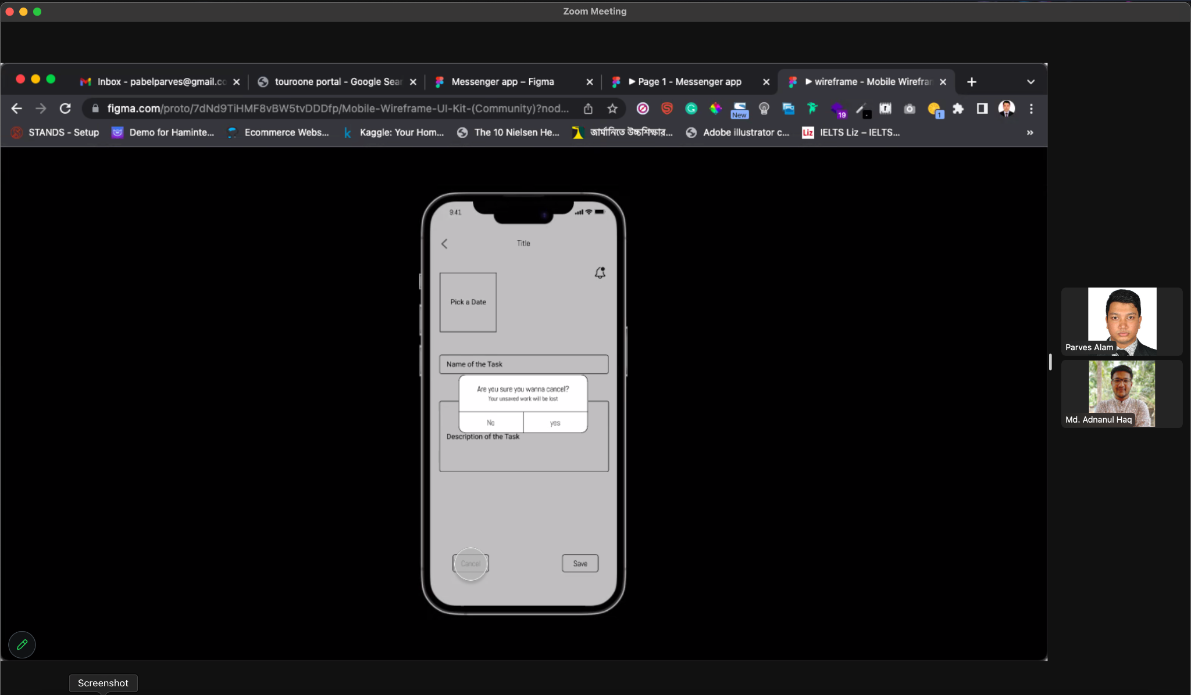

In the second usability test I asked the user to go to the new add reminder page and cancel that. It went well but that time I found that the back arrow does not work so I have fixed that after that.

3rd usability test:

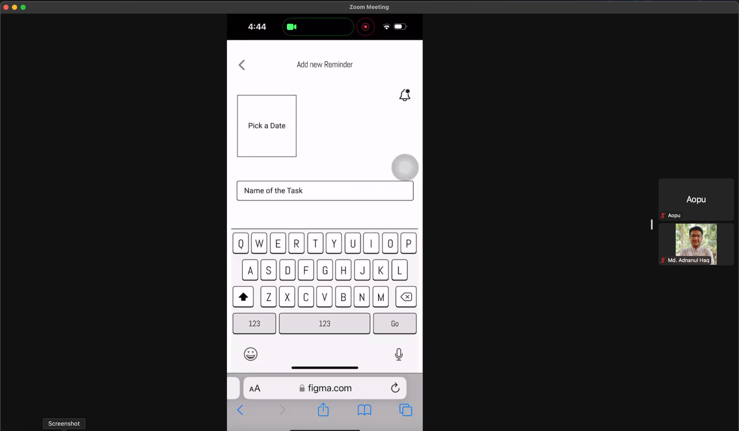

In the third usability test I asked the user to add a new reminder and he did it very easily and he did not get confused at any point. It was a successful test.