TRAINING MANAGEMENT SYSTEM
Entity Relationship Diagram (ERD)
Mermaid Source & Rendered Diagrams

Document Type | Software Design Supporting Artifact
Version | 1.0
Technology Context | Node.js / Express.js / Bootstrap / MySQL
Purpose | Maintainable ERD source and visual reference

1. Document Purpose
This document provides the Training Management System logical Entity Relationship Diagrams together with the Mermaid source used to define each diagram. The source is retained as a version-controllable design artifact, while the rendered image provides a review-friendly visual representation.

2. Diagram Conventions
Primary keys are marked PK and foreign keys are marked FK. Mermaid crow's-foot cardinality is used: '||' means exactly one, 'o|' means zero or one, and 'o{' means zero or many. The diagrams are separated by domain to keep the model readable while preserving the approved logical relationships.

3. Logical ERD — Overview

Mermaid Script
erDiagram
USER_ROLE_ACCESS ||--o| PARTICIPANT : "has profile"
USER_ROLE_ACCESS ||--o{ TRAINING_PROGRAM : "assigned as trainer"
PROGRAM_CATEGORY ||--o{ TRAINING_PROGRAM : "classifies"
PARTICIPANT ||--o{ REGISTRATION : "registers"
TRAINING_PROGRAM ||--o{ REGISTRATION : "receives registrations"
REGISTRATION ||--o| ATTENDANCE : "has attendance"
REGISTRATION ||--o| CERTIFICATE : "may produce certificate"
REGISTRATION ||--o{ NOTIFICATION_OUTBOX : "creates notification"
USER_ROLE_ACCESS ||--o{ AUDIT_RECORD : "performs"
USER_ROLE_ACCESS ||--o{ REPORT_REPORTING_DATA : "generates"

Generated Diagram
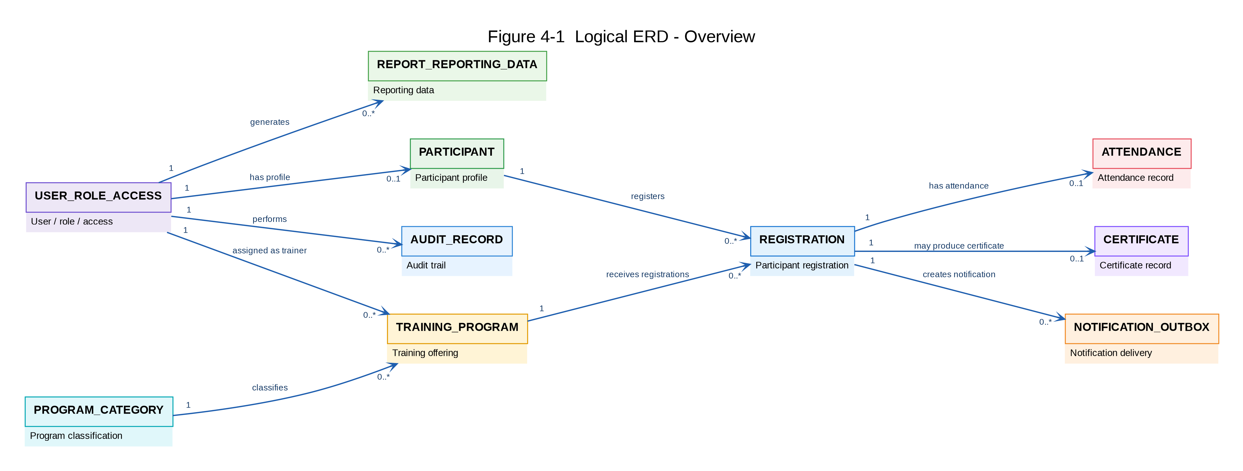
Figure 4-1 — Logical ERD — Overview

4. Account & Program Management ERD

Mermaid Script
erDiagram
USER_ROLE_ACCESS ||--o| PARTICIPANT : "has profile"
USER_ROLE_ACCESS ||--o{ TRAINING_PROGRAM : "assigned as trainer"
PROGRAM_CATEGORY ||--o{ TRAINING_PROGRAM : "classifies"
USER_ROLE_ACCESS {
bigint user_id PK
string account_identifier
string username
string name
string email
bigint role_id
string role_name
string account_status
datetime last_login_at
datetime created_at
datetime updated_at
}
PARTICIPANT {
bigint participant_id PK
bigint user_id FK
string nric_passport_no
string name
string mobile_no
datetime created_at
datetime updated_at
}
PROGRAM_CATEGORY {
bigint category_id PK
string name
string description
string status
datetime created_at
datetime updated_at
}
TRAINING_PROGRAM {
bigint program_id PK
string code
string name
bigint category_id FK
bigint trainer_user_id FK
date training_date
time start_time
time end_time
string venue
string delivery_mode
int capacity
datetime registration_open_at
datetime registration_close_at
string status
string certificate_type
datetime created_at
datetime updated_at
}

Generated Diagram
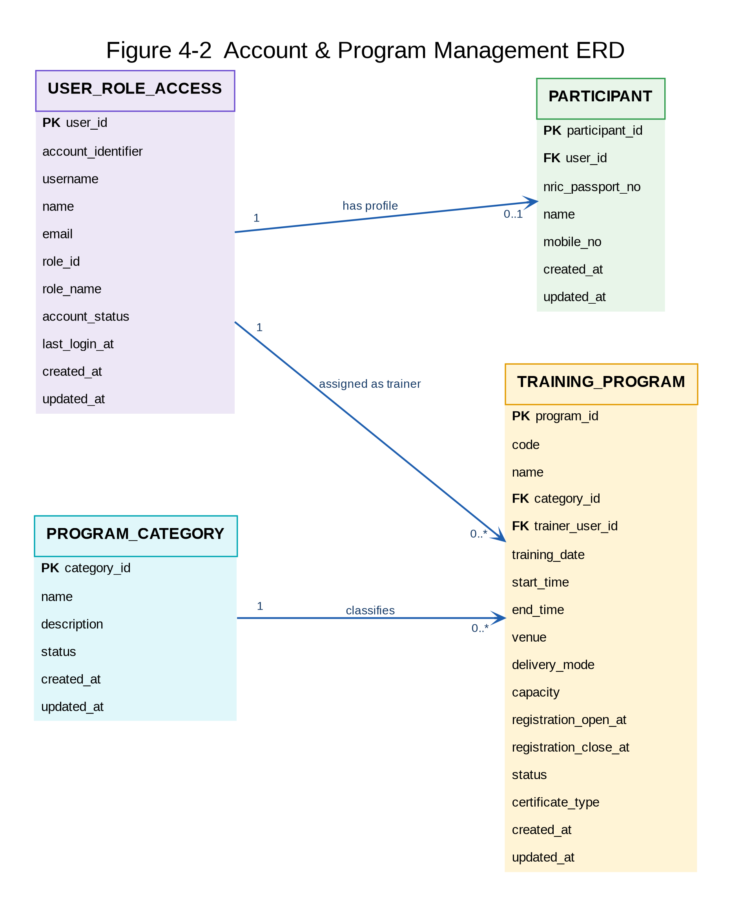
Figure 4-2 — Account & Program Management ERD

5. Registration Lifecycle ERD

Mermaid Script
erDiagram
PARTICIPANT ||--o{ REGISTRATION : "registers"
TRAINING_PROGRAM ||--o{ REGISTRATION : "receives registrations"
REGISTRATION ||--o| ATTENDANCE : "has attendance"
PARTICIPANT ||--o{ ATTENDANCE : "attendance belongs to"
TRAINING_PROGRAM ||--o{ ATTENDANCE : "attendance for"
REGISTRATION ||--o| CERTIFICATE : "may produce"
PARTICIPANT ||--o{ CERTIFICATE : "receives"
TRAINING_PROGRAM ||--o{ CERTIFICATE : "certificate for"
PARTICIPANT {
bigint participant_id PK
bigint user_id FK
string nric_passport_no
string name
string mobile_no
}
TRAINING_PROGRAM {
bigint program_id PK
string code
string name
bigint category_id FK
bigint trainer_user_id FK
date training_date
time start_time
time end_time
int capacity
datetime registration_open_at
datetime registration_close_at
string status
}
REGISTRATION {
bigint registration_id PK
string reference_no
bigint participant_id FK
bigint program_id FK
datetime registered_at
string status
datetime cancelled_at
string cancellation_reason
datetime created_at
datetime updated_at
}
ATTENDANCE {
bigint attendance_id PK
bigint registration_id FK
bigint participant_id FK
bigint program_id FK
date attendance_date
string status
decimal percentage
bigint recorded_by FK
datetime created_at
datetime updated_at
}
CERTIFICATE {
bigint certificate_id PK
string certificate_number
bigint participant_id FK
bigint registration_id FK
bigint program_id FK
string certificate_type
string eligibility_status
decimal attendance_percentage
date completion_date
date issue_date
string certificate_status
bigint issued_by FK
datetime created_at
datetime updated_at
}

Generated Diagram
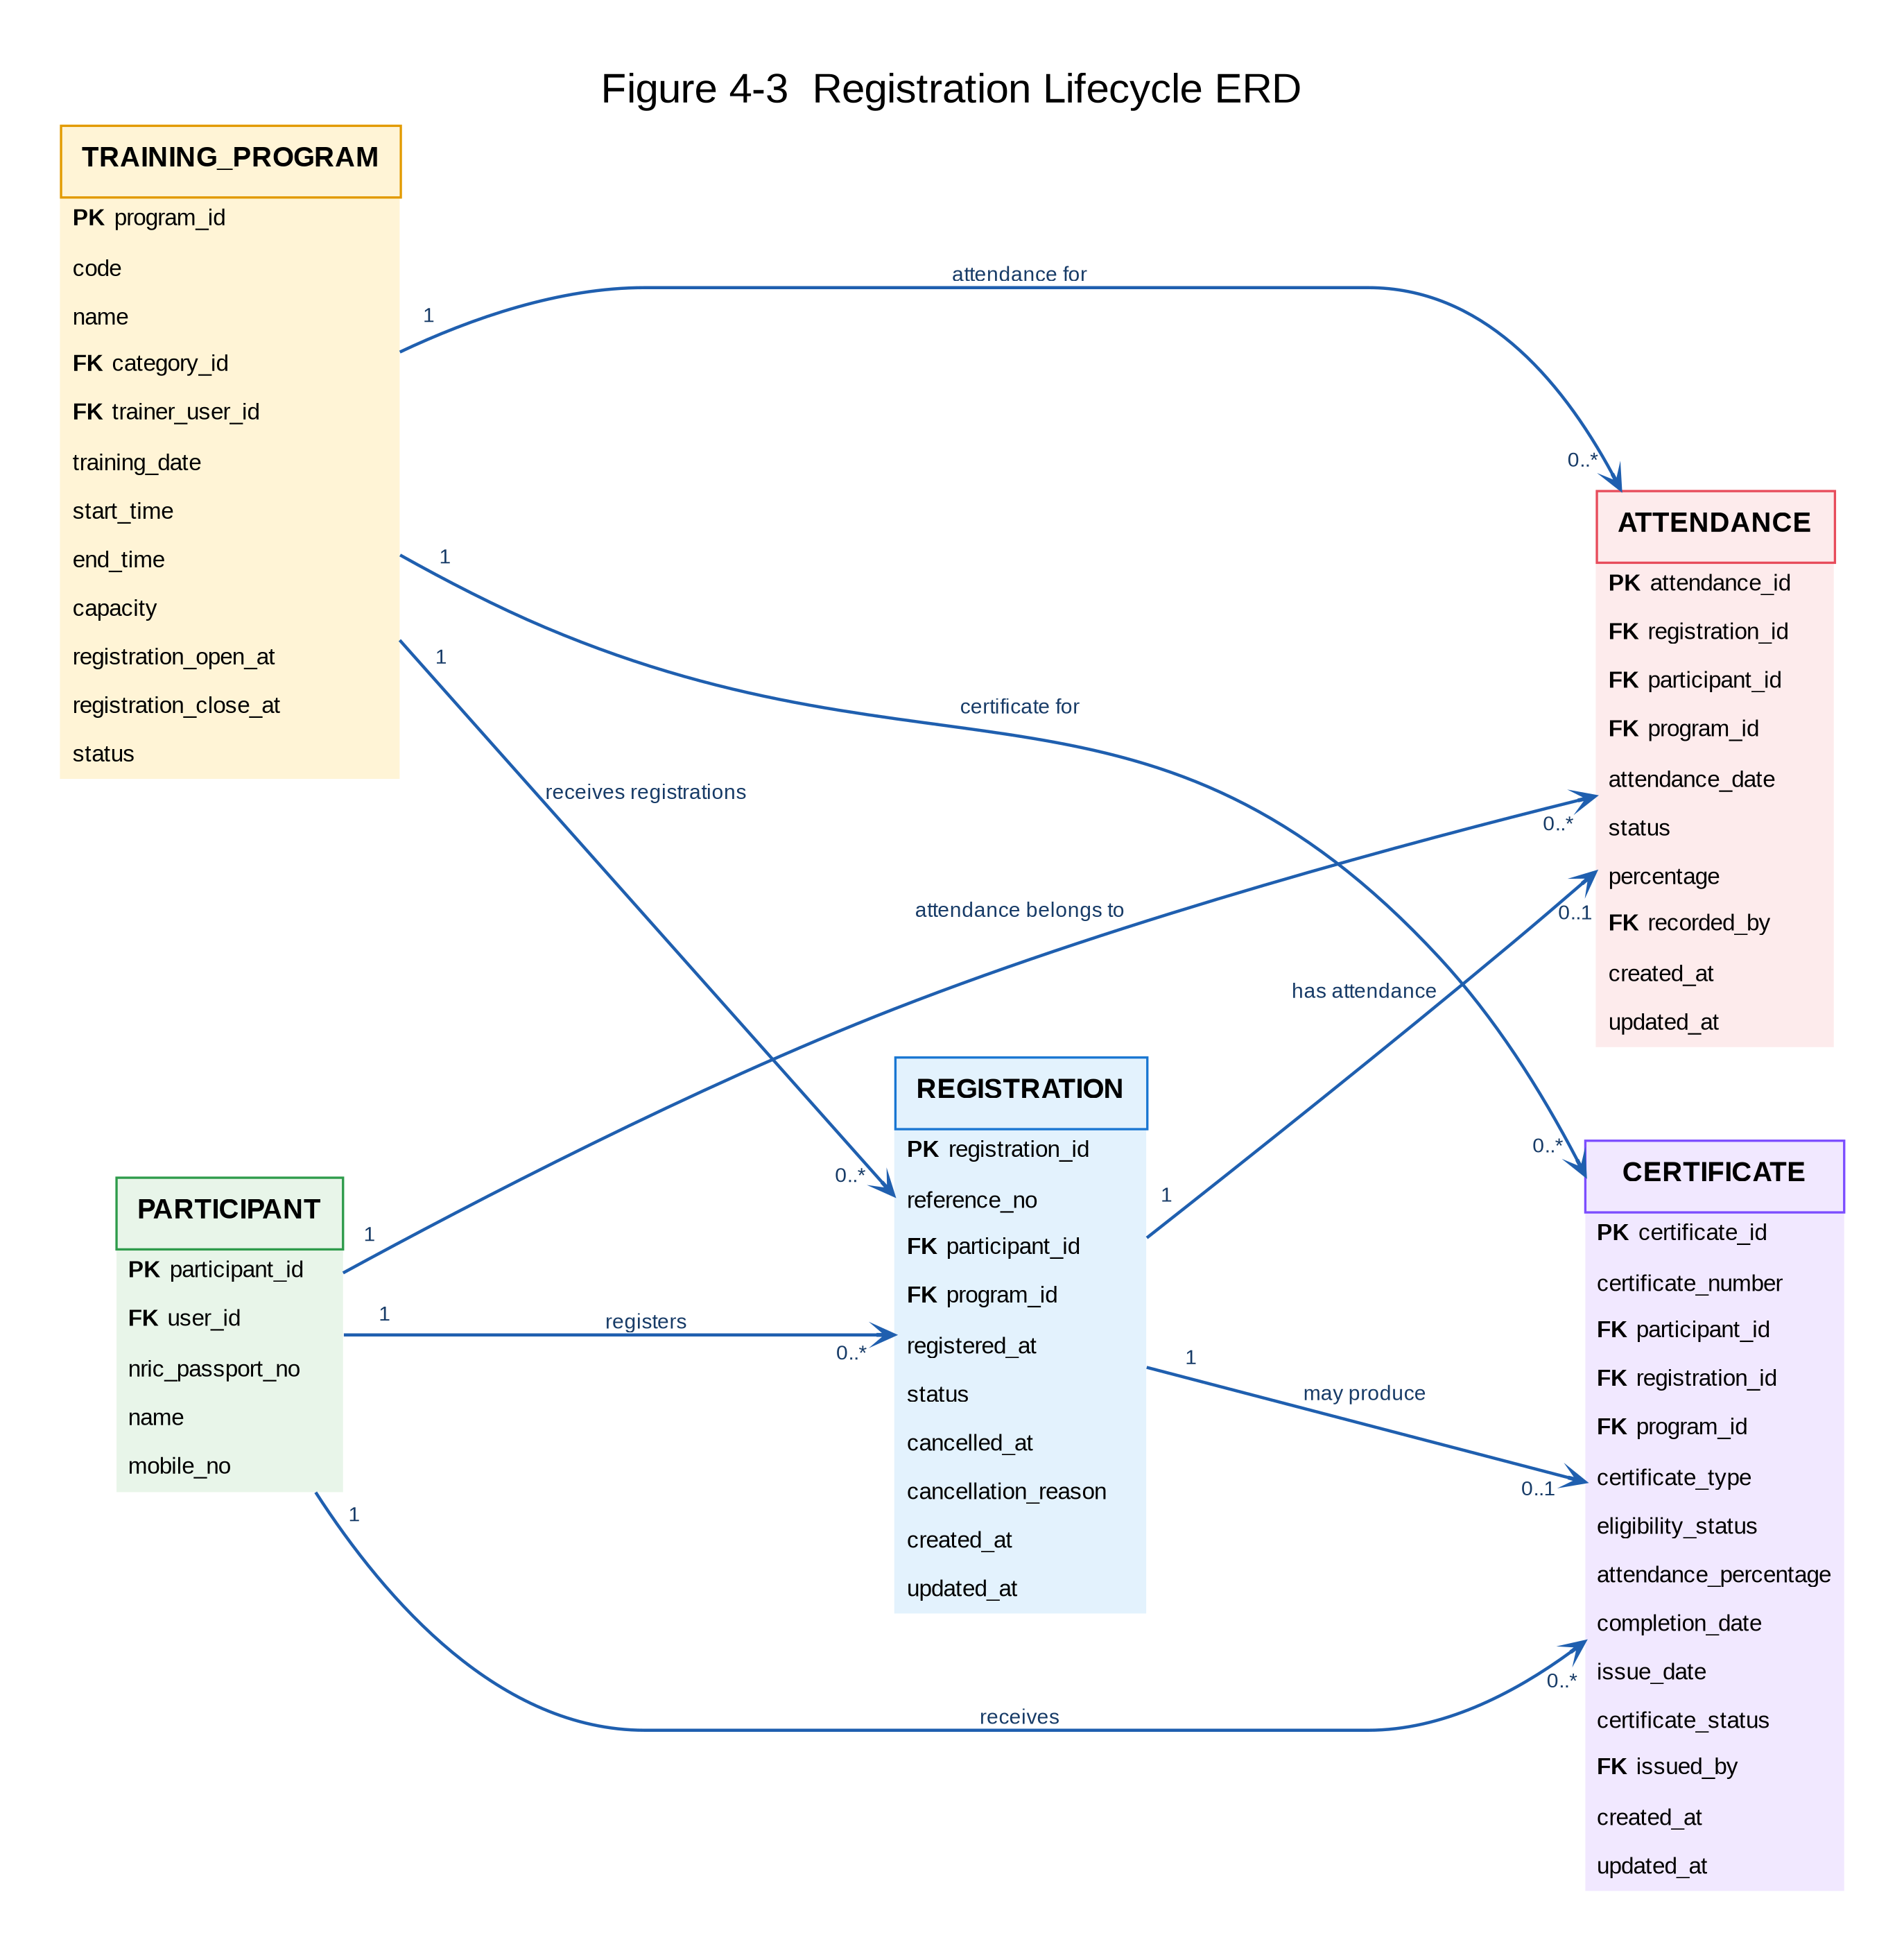
Figure 4-3 — Registration Lifecycle ERD

6. Supporting & Governance ERD

Mermaid Script
erDiagram
REGISTRATION ||--o{ NOTIFICATION_OUTBOX : "creates"
USER_ROLE_ACCESS ||--o{ AUDIT_RECORD : "performs"
USER_ROLE_ACCESS ||--o{ REPORT_REPORTING_DATA : "generates"
USER_ROLE_ACCESS {
bigint user_id PK
string account_identifier
string username
string name
string email
bigint role_id
string role_name
string account_status
}
REGISTRATION {
bigint registration_id PK
string reference_no
bigint participant_id FK
bigint program_id FK
datetime registered_at
string status
}
NOTIFICATION_OUTBOX {
bigint outbox_id PK
string event_type
string aggregate_type
bigint aggregate_id
string recipient
string subject
string status
int attempt_count
datetime next_attempt
string last_error
datetime created_at
datetime updated_at
}
AUDIT_RECORD {
bigint audit_id PK
datetime event_timestamp
bigint actor_user_id FK
string actor_role
string action
string entity_type
bigint entity_id
string result
string change_summary
string correlation_id
}
REPORT_REPORTING_DATA {
bigint report_id PK
string report_name
string report_type
string reporting_period
datetime generated_at
bigint generated_by FK
string status
string output_reference
string data_access_classification
}

Generated Diagram
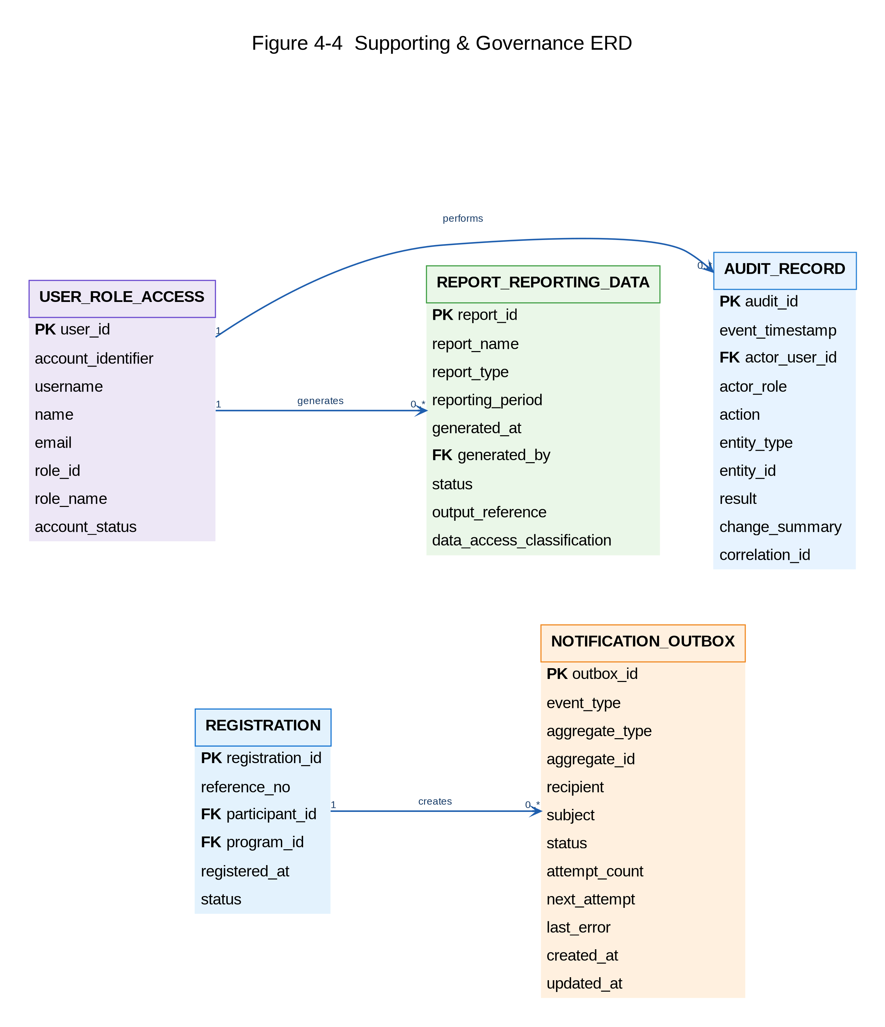
Figure 4-4 — Supporting & Governance ERD

7. Implementation Notes
The Mermaid definitions should be maintained alongside the application source code so that data-model changes can be reviewed through normal version control. When a database change is approved, update the Mermaid source, regenerate the corresponding diagram, and update the Software Design Document in the same change set.
The ERD is a logical design artifact. Physical MySQL implementation details such as exact column lengths, indexes, constraints, engine settings, migration scripts and environment-specific configuration should remain aligned with the approved database design and implementation specifications.

