Software Design Document
Training Management System
Design Baseline v1.15 — Code Generation Baseline

Document Item | Value
Source of Truth | Training Management System Requirements Analysis v2.5
Document Type | System Design Baseline — Code Generation Ready for Approved Scope
Design Status | System Design Baseline — Code Generation Ready for Approved Scope
Technology Constraints | Node.js, Express.js, Bootstrap, MySQL
Purpose | Software Design → Code Generation → Test Scripts → UAT
Current Readiness | READY FOR CODE GENERATION — CONFIRMED CURRENT-RELEASE SCOPE; compliance/privacy approval is a production release gate and does not block code generation

Design principle: The approved Requirements Analysis is the source of truth. Where the requirements do not define a design decision, the item is explicitly recorded as a Design Gap.

1. Design Governance and Baseline Control

1.1 Document Control
Version 1.16 incorporates the final code-generation readiness corrections identified during the v1.14 review: corrected document-control wording; retained the 95% / 2-second performance target as a recommended technical target pending final technical confirmation; made MySQL AUTO_INCREMENT explicit in every applicable physical BIGINT primary-key definition; clarified CSV export as an implementation convenience within the three confirmed reports; and separated technical code-generation readiness from formal organizational approval. Privacy/compliance approval remains a production release gate and does not block code generation.
Document Item | Value
Document Title | Training Management System — Software Design Document
Design Version | 1.16
Source Requirements | Training_Management_System_Requirements_Analysis_v2.5
Status | System Design Baseline — Code Generation Ready for Approved Scope
Design Owner | Solution Architecture / Technical Lead
Intended Consumers | Development, QA, UAT, Delivery and Operations

1.2 Version History
Version | Stage / Date | Description of Change | Status
0.1 | Initial Design Draft | Initial software design derived from Requirements Analysis v2.4; architecture, data, operations, workflows, UI and NFR design introduced. | Draft
1.0 | System Design Baseline Candidate | Consolidated architecture, ERD, DFD, sequence diagrams, wireframes, validation design and requirements traceability. Outstanding governance/design gaps retained explicitly. | Superseded
1.1 | Code Generation Baseline | Closed the readiness questions through controlled design decisions; finalized security, permissions, data model, API contracts, workflows, NFR targets, configuration, testing and implementation baseline. | Superseded
1.2 | Consistency / Governance Remediation | Resolved schema/API/RBAC/audit/retention/CSRF consistency issues and formalized the code-generation baseline while retaining explicit governance dispositions. | Superseded
1.3 | Physical / API / Traceability Remediation | Resolved registration re-registration uniqueness; consolidated the physical users schema; completed FK/delete/check constraints; aligned RBAC and report authorization; defined audit transaction behavior; corrected retention to the Requirements baseline; completed API/CSRF/time contracts; aligned ERD/architecture/DFD; and corrected traceability/readiness wording without changing approved business scope. | Superseded
1.4 | Final Code-Generation Readiness Remediation | Corrected document-control and decision-table inconsistencies; removed duplicate report schema; finalized Training Administrator registration-management scope using the existing cancellation operation; aligned API, permissions, validation, workflow and UI contracts; and clarified that compliance/release gates do not block code generation. | Superseded
1.5 | Code-Generation Baseline Correction | Removed unsupported Training Administrator cancellation authority; completed DR-006/DR-007/DR-008/DR-009 physical mappings; corrected NFR traceability; aligned report-period rules, certificate issuance rules, OP-016, API, RBAC, validation, workflow and UI contracts. Compliance/privacy remains a production release gate and does not block code generation. | Superseded
1.6 | API / Code-Generation Finalization | Finalized field-level API request/response contracts; removed duplicate registration endpoints and stale FR-022 traceability; aligned report period requirements; completed certificate issuance integrity; clarified Trainer authorization, audit system actor and mutable fields; consolidated certificate-output baseline; and confirmed compliance/privacy remains a production release gate that does not block code generation. | Superseded
1.7 | API / Capacity / Integrity Finalization | Resolved the remaining FR-021 traceability and capacity API inconsistency; made program capacity an explicit mutable field of the program update contract; aligned the permission matrix; clarified server-derived participant identity; made attendance percentage deterministic for the single-occurrence program model; strengthened certificate participant/program referential integrity; corrected certificate_type nullability; cleaned the design-gap summary; and reconfirmed that compliance/privacy approval remains a production release gate and does not block code generation. | Superseded
1.8 | Registration / Certificate / API Contract Finalization | Formally dispositioned re-registration after cancellation; introduced a deterministic unique opaque certificate reference generation mechanism while retaining the business-facing number format as deferred; recorded the single-occurrence attendance percentage rule as a controlled design decision; corrected participant registration API request/response contracts and removed participant identity fields from the GET registration query contract; and reconfirmed that privacy/compliance approval remains a production-release gate and does not block code generation. | Superseded
1.9 | Participant Identity / Registration API / Audit Finalization | Resolved the remaining participant registration POST contract issue; unified authenticated identity for Participant, Trainer, Training Administrator and System Administrator through the users/session model; aligned participant audit identity and report Created By derivation; corrected certificate/design-decision traceability; corrected stale version references; and reconfirmed that privacy/compliance approval remains a production-release gate and does not block code generation. | Superseded
1.10 | Participant Account / Role / Audit Finalization | Finalized participant account identifier and username generation/defaults; normalized canonical role codes across schema and APIs; defined the reserved non-interactive technical audit actor within the four-role model; made the users-to-participants relationship explicitly one-to-one for participant accounts; finalized Student Account Creation Report Created By derivation; corrected certificate-output wording so the technical opaque certificate reference remains in code-generation scope while business-facing numbering/document format remains deferred; and reconfirmed that privacy/compliance approval remains a production-release gate and does not block code generation. | Superseded
1.11 | Code Generation Baseline Finalization | Finalized document-control version consistency; clarified that participant account_identifier and username use defined server-side ULID generation rules rather than deterministic values; explicitly defined the technical audit actor password-hash treatment and authentication exclusion; separated report Created By presentation from audit actor identity; standardized canonical role-code terminology across the design; and reconfirmed that privacy/compliance approval remains a production-release gate and does not block code generation. | Superseded
1.12 | API Contract / Code Generation Finalization | Corrected the participant account-creation and administrator user-creation API table column alignment so Auth / Purpose, Request Contract and Response / HTTP Contract are explicitly separated; retained the finalized participant identity, role-code, audit-actor and report derivation controls; and reconfirmed that privacy/compliance approval remains a production-release gate and does not block code generation. | Superseded
1.13 | Authentication API Contract Finalization | Finalized the authentication and System Administrator bootstrap API request/response contracts by explicitly separating Auth / Purpose, Request Contract and Response / HTTP Contract columns for all authentication endpoints; retained the finalized participant account, canonical role-code, technical audit-actor and report derivation controls; and reconfirmed that privacy/compliance approval remains a production-release gate and does not block code generation. | Superseded
1.14 | Final Code-Generation Readiness Remediation | Closed the remaining RBAC/API/physical-schema consistency gaps: restricted /api/v1/admin/users to System Administrator account creation only; defined MySQL AUTO_INCREMENT generation for all BIGINT primary keys; defined server-side non-participant account_identifier generation; clarified registration confirmation as pre-submission UI; standardized authentication response role naming; removed the unnecessary trainerUserId from the public program-detail response; strengthened FR-016 cancellation traceability; and reconfirmed that privacy/compliance approval remains a production-release gate and does not block code generation. | Superseded
1.15 | Final Code-Generation Baseline Corrections | Corrected stale document-control version wording; retained NFR-007 as a recommended 95% / 2-second technical target pending final technical confirmation; made AUTO_INCREMENT explicit on all applicable BIGINT primary keys; clarified CSV as an implementation convenience within the confirmed reports; separated technical code-generation readiness from formal organizational approval; and reconfirmed that compliance/privacy approval remains a production-release gate only and does not block code generation. | Superseded
1.16 | Username Identity / UI Contract Alignment | Aligned the approved identity contract with Requirements v2.5: Participant login remains Email Address + Password with server-generated/internal participant username; System Administrator, Training Administrator and Trainer account creation requires an administrator-supplied unique Username. Updated UI-007/UI-009 design rules and related authentication/account semantics without changing unrelated approved scope. Updated document-control source baseline to Requirements v2.5. | Current System Design Baseline

1.3 Design Control Principles
- Use only approved requirements as the business basis for design.
- Do not introduce unsupported functionality, actors, business rules or data.
- Every major design element shall be traceable to an approved requirement.
- Approved NFRs shall be translated into appropriate technical controls without redefining them.
- Insufficient information shall be recorded as a Design Gap.
- All architecture, data, API, workflow and UI artifacts shall remain consistent with this written design.
- Changes affecting scope, business rules, security, data, interfaces or NFRs shall be assessed through controlled change management.

2. Design Overview

2.1 System / Feature
Training Management System

2.2 Purpose
The purpose of this Software Design Document is to translate Requirements Analysis v2.4 into a technical design suitable for Software Design → Code Generation → Test Scripts → UAT.

2.3 Scope

2.3.1 In Scope
- Participant account creation and authentication.
- System Administrator bootstrap account creation and authentication.
- Training Administrator and Trainer account creation by System Administrator.
- Training Administrator and Trainer authentication.
- Program and category management.
- Program browsing and program details.
- Participant registration and registration validation.
- Capacity management, duplicate registration and schedule-overlap prevention.
- Registration cancellation.
- Registration confirmation email.
- Attendance recording.
- Certificate eligibility and issuance recording.
- Required operational reports.
- Role-based administrative access.
- Audit history.
- Participant and registration data retention.

2.3.2 Out of Scope
- Payment processing and payment gateway integration.
- Bank transfer processing.
- HR / participant-management-system integration.
- Native mobile applications.
- Training content delivery.
- Video conferencing.
- Accounting or payroll functionality.

2.4 Design Principles
- Requirements-first.
- No unsupported business rules.
- Role-based access control.
- Server-side validation.
- Transactional data integrity.
- Separation of concerns.
- Maintainability.
- Auditability.
- Responsive web design.
- End-to-end requirement traceability.

3. Architecture

3.1 Architectural Overview
The design uses a layered modular web-application architecture. The presentation layer uses server-rendered HTML, Bootstrap and browser JavaScript/fetch. Express.js 5 provides the HTTP/API boundary. Application services contain business rules and validation. Repository/data-access components use MySQL 8.4 LTS. Authentication uses server-side sessions with secure cookies. Registration confirmation requests are written to a transactional notification outbox and delivered asynchronously by a worker to the Email Service. Audit records are persisted as part of the same database transaction as mandatory business changes. The application is stateless between requests except for authenticated session state held in the database-backed session store, allowing more than one application process to support the availability target.

3.2 Architectural Diagram
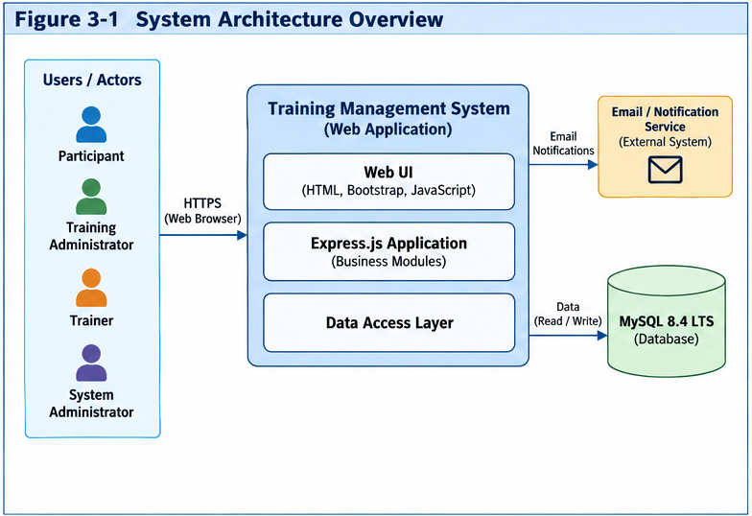
Figure 3-1 — System Architecture Overview

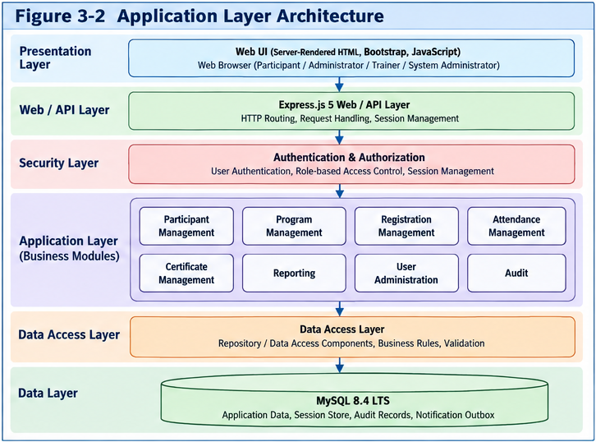
Figure 3-2 — Application Layer Architecture

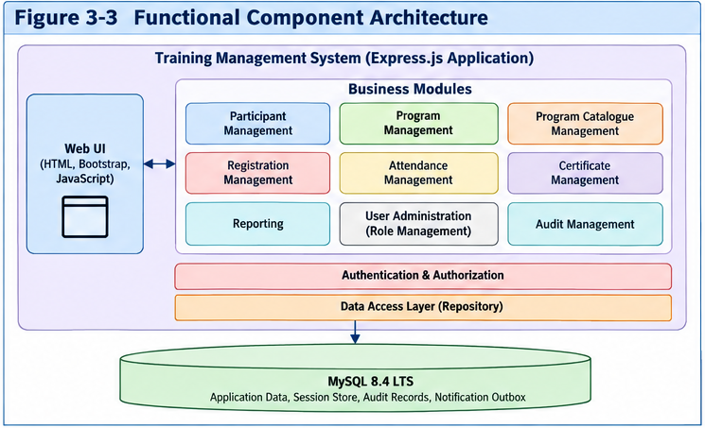
Figure 3-3 — Functional Component Architecture

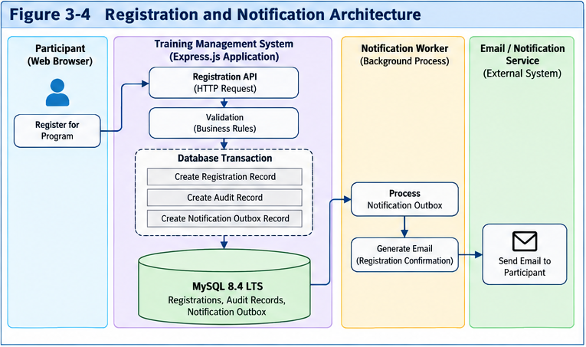
Figure 3-4 — Registration and Notification Architecture

3.3 Components / Modules
ID | Component | Responsibility | Dependencies
CMP-001 | Web UI | Render participant, administrator and trainer views | Express API, Bootstrap
CMP-002 | Authentication | Account creation, password hashing, login, session creation, logout, timeout and account-status enforcement | User/Access data
CMP-003 | Authorization | Enforce role permissions and participant resource ownership on every protected operation | Authentication, User/Access
CMP-004 | Participant Management | Maintain participant account and participant information | Authentication, MySQL
CMP-005 | Program Management | Create/update programs, categories and capacity | Authorization, MySQL
CMP-006 | Program Catalogue | Display available programs, categories and details | Program Management
CMP-007 | Registration | Create, view and cancel participant registrations with transaction-safe capacity enforcement | Participant, Program, MySQL
CMP-008 | Registration Validation | Mandatory data, duplicate, overlap, registration-window, availability and capacity validation | Registration, Program
CMP-009 | Attendance | Record attendance against registration/program | Trainer authorization, Registration
CMP-010 | Certificate | Evaluate eligibility and record certificate issuance | Attendance, Registration
CMP-011 | Reporting | Generate three confirmed reports | Participant, Program, Registration, Attendance, Certificate
CMP-012 | Notification | Send registration confirmation email; email failure is recorded and does not roll back a committed registration | Email Service
CMP-013 | Audit | Record security and business audit events; audit records are append-only | Applicable modules
CMP-014 | User Administration | Create Training Administrator and Trainer accounts | System Administrator authorization
CMP-015 | Data Access | Transactional persistence and retrieval | MySQL
CMP-016 | Notification Outbox / Worker | Persist committed notification requests and asynchronously deliver registration confirmation email with retry and failure tracking; email failure never rolls back committed registration. | MySQL, Email Service

4. Data Design

4.1 Entities
ID | Entity | Purpose | Key Attributes | Requirements
ENT-001 | Participant | Represents a participant using the system | Participant ID, User ID, NRIC/Passport No, Name, Email (derived from User), Mobile No, Account Status (derived from User), Last Login Date/Time (derived from User), Created/Updated timestamps | DR-001
ENT-002 | Training Program | Represents an offered training program | Program ID, Code, Name, Description, Objectives, Target Audience, Prerequisites, Category ID, Trainer User ID, Training Date, Start/End Time, Venue, Delivery Mode, Capacity, Derived Available Seats, Registration Open/Close DateTime, Status, Cancellation Policy Reference, Certificate Eligibility Criteria, Certificate Type, timestamps | DR-002
ENT-003 | Program Category | Classifies training programs | Category ID, Name, Description, Status, timestamps | DR-003
ENT-004 | Registration | Represents participant registration | Registration ID, Reference No, Participant ID, Program ID, Registration DateTime, Status, Cancellation DateTime, Cancellation Reason, timestamps | DR-004
ENT-005 | Attendance | Records attendance | Attendance ID, Registration ID, Participant ID, Program ID, Attendance Date, Status, Percentage, Check-In, Check-Out, Verification Method, Evidence/Reference, Remarks, Recorded By, timestamps | DR-005
ENT-006 | Certificate | Records certificate eligibility and issuance | Certificate ID, Number, Participant ID, Registration ID, Program ID, Certificate Type, Title, Eligibility Status, Eligibility Criteria/Result, Attendance/Completion %, Completion Date, Issue Date, Certificate Status, Document/Reference, Verification Reference, Issuing Authority/Signatory, Revocation Date/Reason, timestamps | DR-006
ENT-007 | User Role / Access | Represents authenticated accounts, roles and access for Participant, Training Administrator, Trainer and System Administrator; each PARTICIPANT account has exactly one linked participant profile and non-PARTICIPANT accounts have no participant profile | User ID, User/Account Identifier, Linked Participant Identifier (derived through participants.user_id), Username, Name, Email, Role ID, Role Name, Permissions/Access Scope, Permitted Responsibilities, Account Status, Role Assignment Date/Time, Role Expiry Date/Time, Activation/Deactivation Date/Time, Last Login Date/Time, Authentication Method/Reference, Created/Updated timestamps | DR-007
ENT-008 | Audit Record | Records significant administrative and registration actions | Audit ID, Timestamp, Actor User ID, Actor Role, Action, Entity Type/ID, Result, Change Summary, Previous Value/Reference, New Value/Reference, Access Scope/Classification, IP Address, User Agent, Correlation ID | DR-008
ENT-009 | Report / Reporting Data | Supports required operational reports | Report execution metadata: Report ID/Name, Report Type, Reporting Period, Generation Date/Time, Parameters/Filters, Generated By, Status, Output/Reference, Data Access Classification | DR-009
ENT-010 | Notification Outbox | Persists notification delivery requests created in the same transaction as committed business events | Outbox ID, Event Type, Aggregate Type/ID, Recipient, Subject, Payload, Status, Attempt Count, Next Attempt, Last Error, Created/Updated timestamps | Design support for email integration / NFR-005

4.2 Relationships
Entity | Relationship | Entity | Cardinality
Program Category | classifies | Training Program | 1 : many
User Role / Access | assigns trainer to | Training Program | 1 : many
Training Program | has | Registration | 1 : many
Registration | has attendance for | Attendance | 1 : 0..1
Participant | has | Attendance | 1 : many
Training Program | has | Attendance | 1 : many
Registration | may result in | Certificate | 1 : 0..1
Participant | may receive | Certificate | 1 : many
Training Program | may have | Certificate | 1 : many
Registration | creates | Notification Outbox | 1 : many
User Role / Access | generates | Report Execution | 1 : many
Report Execution | reads | Reporting Data | logical/read

4.3 Entity Relationship Diagrams (ERD)
For readability, the approved logical data model is presented as one overview diagram followed by three domain-focused ERDs. Entities may appear in more than one detailed diagram where required to preserve relationship context; together, the diagrams represent the same approved logical model and do not introduce additional entities or relationships.
Figure 4-1 — Logical ERD — Overview
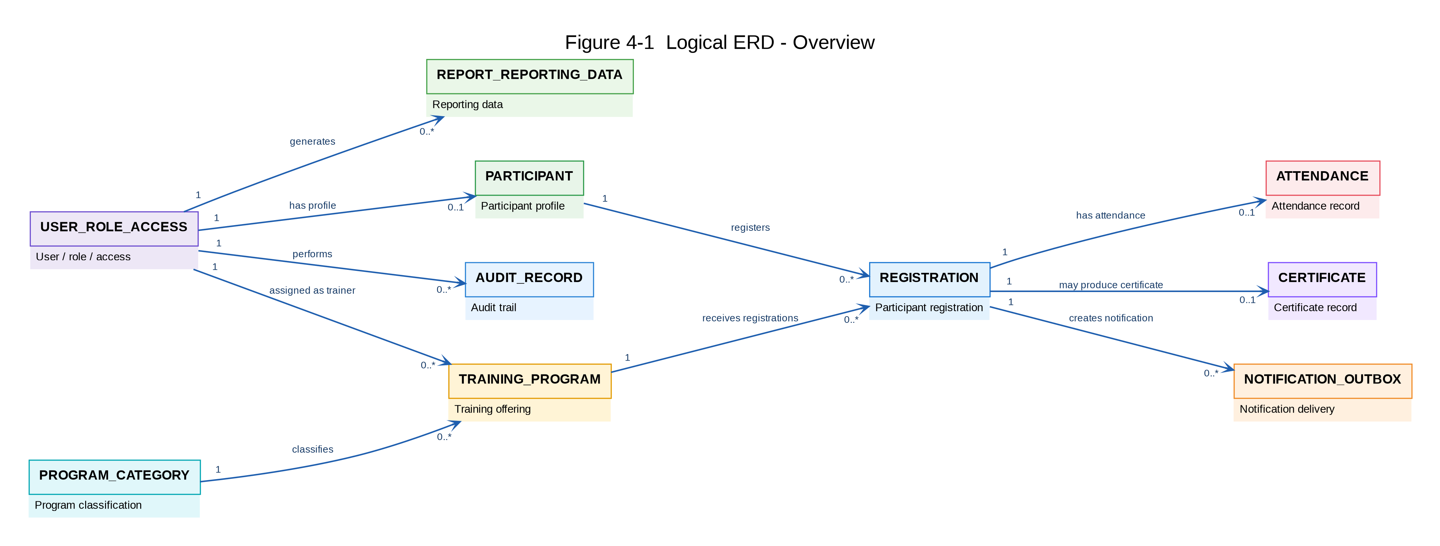
All approved entities and their principal relationships are shown at a high level to provide the complete system data-model context.

Figure 4-2 — Account & Program Management ERD
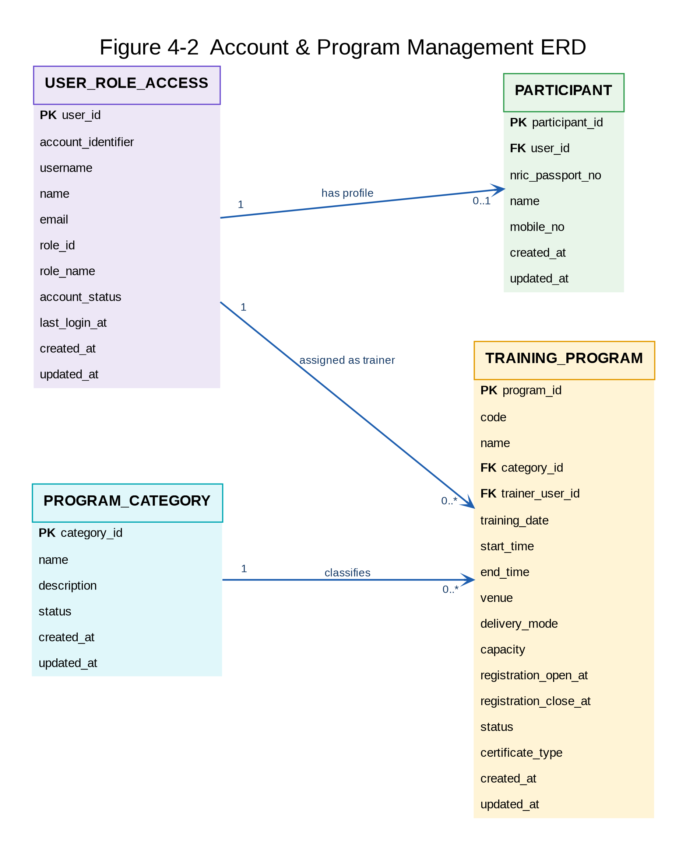
Shows account identity, participant profile, trainer assignment, program categorization and the core training-program structure.

Figure 4-3 — Registration Lifecycle ERD
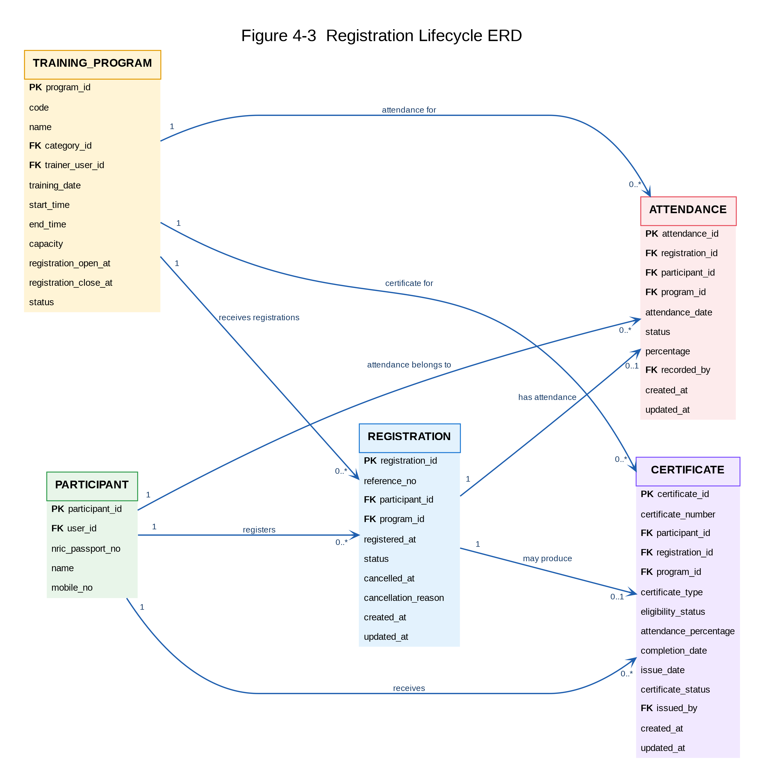
Shows the core participant registration lifecycle and its attendance and certificate records in the context of a training program.

Figure 4-4 — Supporting & Governance ERD
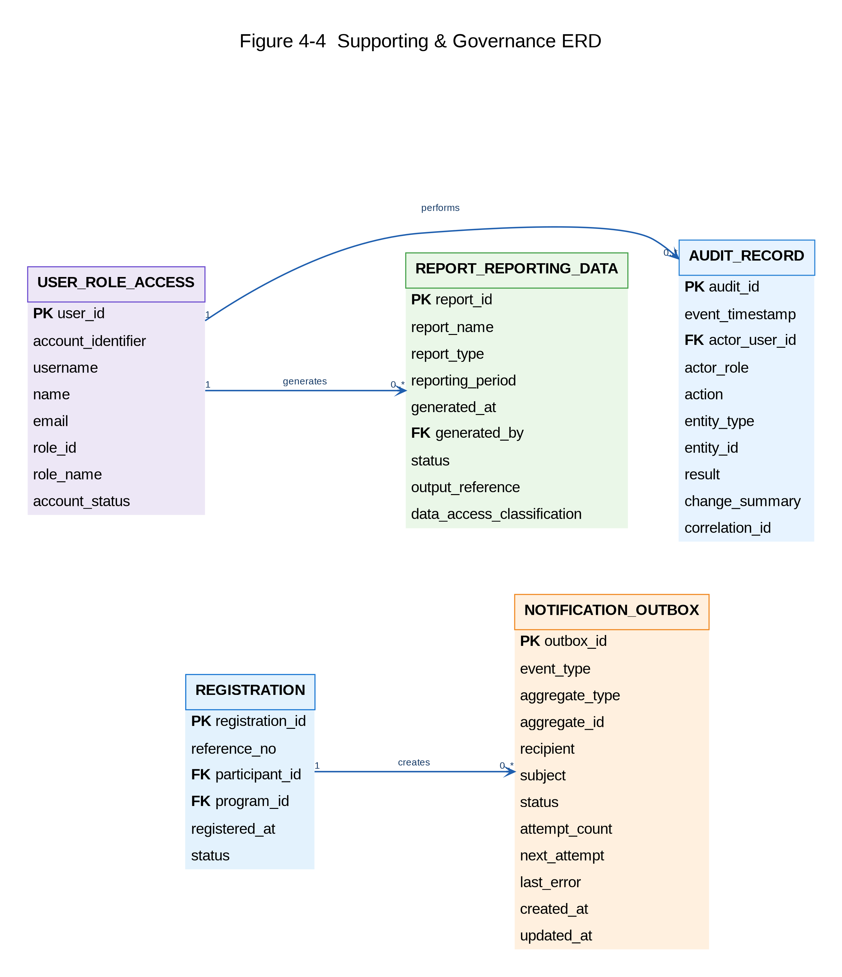
Shows the supporting notification, audit and reporting relationships separated from the core training lifecycle for clarity.

4.4 Data Integrity Design
Table | Physical design | Indexes / constraints
participants | participant_id BIGINT AUTO_INCREMENT PK; user_id BIGINT NOT NULL UNIQUE FK→users.user_id; nric_passport_no VARCHAR(50) NOT NULL UNIQUE; name VARCHAR(200) NOT NULL; mobile_no VARCHAR(30) NOT NULL; created_at DATETIME NOT NULL; updated_at DATETIME NOT NULL | Indexes on user_id, nric_passport_no; participant email, account status and last-login values are derived from the linked users record; participant account credentials are stored only in users.password_hash; FK delete rule RESTRICT | Indexes on user_id and nric_passport_no; participants.user_id is a required UNIQUE FK to users.user_id and establishes a one-to-one participant-account relationship; participant email, account status, failed-login state and last-login timestamp are derived from users; participant credentials are not stored in this table; non-PARTICIPANT users must not have a participant profile; no mobile uniqueness is assumed because it is not a confirmed business rule; FK delete rule RESTRICT
program_categories | category_id BIGINT AUTO_INCREMENT PK; name VARCHAR(150) NOT NULL UNIQUE; description VARCHAR(500) NULL; status VARCHAR(20) NOT NULL; created_at DATETIME NOT NULL; updated_at DATETIME NOT NULL | Index status; category deletion is prohibited when referenced by a program; status values limited to ACTIVE/INACTIVE
users | user_id BIGINT AUTO_INCREMENT PK; account_identifier VARCHAR(100) NOT NULL UNIQUE; username VARCHAR(100) NOT NULL UNIQUE; name VARCHAR(200) NOT NULL; email VARCHAR(254) NOT NULL UNIQUE; password_hash VARCHAR(255) NOT NULL; role_id VARCHAR(50) NOT NULL; role_name VARCHAR(100) NOT NULL; permissions JSON NOT NULL; access_scope JSON NOT NULL; permitted_responsibilities JSON NOT NULL; account_status VARCHAR(20) NOT NULL; failed_login_count INT NOT NULL DEFAULT 0; lockout_until DATETIME NULL; role_assigned_at DATETIME NOT NULL; role_expires_at DATETIME NULL; activated_at DATETIME NULL; deactivated_at DATETIME NULL; last_login_at DATETIME NULL; authentication_method VARCHAR(100) NULL; created_at DATETIME NOT NULL; updated_at DATETIME NOT NULL | Indexes account_identifier/username/email/role_id/account_status; canonical role codes are PARTICIPANT, TRAINER, TRAINING_ADMINISTRATOR and SYSTEM_ADMINISTRATOR; role_id and role_name persist only these canonical codes and display labels are UI-only; role display labels are UI-only; only System Administrator may create Training Administrator or Trainer accounts; Participant account creation creates the users row and linked participants row atomically: validate uniqueness, generate user_id/account_identifier/username, resolve the PARTICIPANT role defaults, create users, create the participants row referencing users.user_id, create the account-creation audit event, then commit; on failure the complete account/profile/audit transaction is rolled back. For participant accounts, account_identifier and username use the defined server-side ULID generation rules; account status values are ACTIVE/INACTIVE/LOCKED/DISABLED; one primary role per account; participant linkage is represented by participants.user_id; referenced user records are not hard-deleted; non-PARTICIPANT account_identifier values use the server-side A-<ULID> rule and are unique opaque immutable identifiers
training_programs | program_id BIGINT AUTO_INCREMENT PK; code VARCHAR(50) NOT NULL UNIQUE; name VARCHAR(200) NOT NULL; description TEXT NOT NULL; objectives TEXT NOT NULL; target_audience VARCHAR(500) NOT NULL; prerequisites VARCHAR(1000) NULL; category_id BIGINT NOT NULL FK→program_categories.category_id; trainer_user_id BIGINT NOT NULL FK→users.user_id; training_date DATE NOT NULL; start_time TIME NOT NULL; end_time TIME NOT NULL; venue VARCHAR(300) NULL; delivery_mode VARCHAR(50) NOT NULL; capacity INT NOT NULL; registration_open_at DATETIME NOT NULL; registration_close_at DATETIME NOT NULL; status VARCHAR(30) NOT NULL; cancellation_policy_reference VARCHAR(255) NULL; certificate_eligibility_criteria VARCHAR(100) NOT NULL; certificate_type VARCHAR(100) NULL; created_at DATETIME NOT NULL; updated_at DATETIME NOT NULL | Indexes category/status/date; CHECK capacity > 0, end_time > start_time and registration_open_at < registration_close_at; application validation requires trainer_user_id to reference an ACTIVE Trainer; available_seats is derived as capacity minus active REGISTERED registrations and is not independently stored; FK delete rule RESTRICT
registrations | registration_id BIGINT AUTO_INCREMENT PK; reference_no VARCHAR(50) NOT NULL UNIQUE; participant_id BIGINT NOT NULL FK→participants.participant_id; program_id BIGINT NOT NULL FK→training_programs.program_id; registered_at DATETIME NOT NULL; status VARCHAR(20) NOT NULL; cancelled_at DATETIME NULL; cancellation_reason VARCHAR(500) NULL; registration_remarks VARCHAR(500) NULL; created_at DATETIME NOT NULL; updated_at DATETIME NOT NULL; active_registration_key VARCHAR(100) GENERATED ALWAYS AS (CASE WHEN status = 'REGISTERED' THEN CONCAT(participant_id, ':', program_id) ELSE NULL END) STORED | UNIQUE active_registration_key enforces one active registration per participant/program while allowing re-registration after cancellation; indexes participant_id/status and program_id/status; status values limited to REGISTERED/CANCELLED; FK delete rules RESTRICT; cancelled rows are retained
attendance | attendance_id BIGINT AUTO_INCREMENT PK; registration_id BIGINT NOT NULL FK→registrations.registration_id; participant_id BIGINT NOT NULL; program_id BIGINT NOT NULL; attendance_date DATE NOT NULL; status VARCHAR(20) NOT NULL; percentage DECIMAL(5,2) NOT NULL; check_in_at DATETIME NULL; check_out_at DATETIME NULL; verification_method VARCHAR(50) NULL; evidence_reference VARCHAR(255) NULL; remarks VARCHAR(500) NULL; recorded_by BIGINT NOT NULL FK→users.user_id; created_at DATETIME NOT NULL; updated_at DATETIME NOT NULL | UNIQUE registration_id enforces one attendance record per registration; participant_id/program_id must match the referenced registration and are immutable after creation; CHECK percentage between 0 and 100; for the single-occurrence program model, PRESENT derives to 100.00 and ABSENT derives to 0.00; percentage is server-derived and not trusted from client input; status limited to PRESENT/ABSENT; application authorization requires recorded_by to be an ACTIVE Trainer authorized for the selected program; FK delete rules RESTRICT
certificates | certificate_id BIGINT AUTO_INCREMENT PK; certificate_number VARCHAR(60) UNIQUE NULL; participant_id BIGINT NOT NULL FK→participants.participant_id; registration_id BIGINT NOT NULL FK→registrations.registration_id; program_id BIGINT NOT NULL FK→training_programs.program_id; certificate_type VARCHAR(100) NOT NULL; certificate_title VARCHAR(255) NOT NULL; eligibility_status VARCHAR(30) NOT NULL; eligibility_result VARCHAR(255) NOT NULL; attendance_percentage DECIMAL(5,2) NOT NULL; completion_date DATE NOT NULL; issue_date DATE NULL; certificate_status VARCHAR(30) NOT NULL; document_reference VARCHAR(500) NULL; verification_reference VARCHAR(255) NULL; issuing_authority VARCHAR(255) NULL; revocation_date DATE NULL; revocation_reason VARCHAR(500) NULL; issued_by BIGINT NULL FK→users.user_id; created_at DATETIME NOT NULL; updated_at DATETIME NOT NULL | UNIQUE registration_id enforces one certificate record per registration; participant_id/program_id must match the referenced registration and are immutable after creation; participant_id/program_id also reference participants/training_programs respectively; CHECK attendance_percentage between 0 and 100; when certificate_status = ISSUED, certificate_number, issue_date and issued_by are mandatory; business-facing certificate numbering format, document/PDF and signatory content remain deferred; current implementation generates a unique opaque UUID/ULID-compatible certificate reference at issuance and stores it in certificate_number; FK delete rules RESTRICT
audit_records | audit_id BIGINT AUTO_INCREMENT PK; event_timestamp DATETIME NOT NULL; actor_user_id BIGINT NOT NULL FK→users.user_id; actor_role VARCHAR(30) NOT NULL; action VARCHAR(100) NOT NULL; entity_type VARCHAR(100) NOT NULL; entity_id VARCHAR(100) NOT NULL; result VARCHAR(20) NOT NULL; change_summary TEXT NOT NULL; previous_value JSON NULL; new_value JSON NULL; access_scope VARCHAR(100) NOT NULL; data_classification VARCHAR(50) NOT NULL; ip_address VARCHAR(45) NULL; user_agent VARCHAR(500) NULL; correlation_id VARCHAR(100) NULL | Indexes timestamp, actor_user_id, entity_type/entity_id, correlation_id; Participant actions are audited through the same users identity as other authenticated principals; application APIs never update/delete audit rows; system-originated events use a reserved non-interactive technical System Audit Actor provisioned by the initial migration; FK delete rule RESTRICT | Indexes timestamp, actor_user_id, entity_type/entity_id and correlation_id; all authenticated principal actions, including Participant actions, reference users.user_id; application APIs never update/delete audit rows; system-originated events use the reserved technical audit actor defined in DEC-015 (users.role_id=SYSTEM_ADMINISTRATOR, account_status=DISABLED, authentication_method=SYSTEM, non-interactive); the actor has a generated unusable password_hash value, is never issued a usable credential and is rejected by interactive authentication because it is DISABLED/SYSTEM; FK delete rule RESTRICT
sessions | session_id VARCHAR(128) PK; user_id BIGINT NOT NULL FK→users.user_id; session_data TEXT NOT NULL; expires_at DATETIME NOT NULL | Indexes user_id and expires_at; every authenticated principal, including Participant, has a users record; expired sessions are purged; FK delete rule CASCADE because sessions have no independent business value | Indexes user_id and expires_at; every authenticated principal, including Participant, has a users record; expired sessions are purged; FK delete rule CASCADE because sessions have no independent business value
notification_outbox | outbox_id BIGINT AUTO_INCREMENT PK; event_type VARCHAR(100) NOT NULL; aggregate_type VARCHAR(100) NOT NULL; aggregate_id BIGINT NOT NULL; recipient VARCHAR(254) NOT NULL; subject VARCHAR(255) NOT NULL; payload JSON NOT NULL; status VARCHAR(20) NOT NULL; attempt_count INT NOT NULL DEFAULT 0; next_attempt_at DATETIME NULL; last_error VARCHAR(1000) NULL; created_at DATETIME NOT NULL; updated_at DATETIME NOT NULL | Indexes status/next_attempt_at and aggregate; status values limited to PENDING/PROCESSING/SENT/FAILED; unique business-event key where required for idempotency; created in the same transaction as the registration
report_executions | report_execution_id BIGINT AUTO_INCREMENT PK; report_name VARCHAR(100) NOT NULL; report_type VARCHAR(50) NOT NULL; period_from DATETIME NOT NULL; period_to DATETIME NOT NULL; parameters JSON NULL; generated_at DATETIME NOT NULL; generated_by BIGINT NOT NULL FK→users.user_id; status VARCHAR(20) NOT NULL; output_reference VARCHAR(500) NULL; data_access_classification VARCHAR(50) NOT NULL | Indexes generated_at, report_type, generated_by; CHECK period_from <= period_to; report generation and download are auditable; FK delete rule RESTRICT
Validate participant
↓
Validate program availability / registration window
↓
Lock program capacity state / validate active registration uniqueness
↓
Validate schedule overlap
↓
Create Registration = Registered
↓
Create mandatory Audit Record
↓
Create Notification Outbox record
↓
Commit transaction
↓
Outbox Worker delivers confirmation email asynchronously All BIGINT primary-key identifiers are generated by MySQL using AUTO_INCREMENT; application code does not calculate or reuse BIGINT primary-key values. Opaque business/account references such as account_identifier, username and certificate_number follow their separately defined generation rules.

5. Data Flow

5.1 Data Flow Overview
Actor
↓
Web UI
↓
Express API
↓
Authentication / Authorization
↓
Business Module
↓
Validation
↓
MySQL
↓
Business Result
↓
Web UI

5.2 Data Flow Diagrams (DFD)
The DFD is presented as four focused logical views followed by a consolidated overview. Each focused view includes the maintainable Mermaid.js definition and its rendered diagram so the design remains readable in Microsoft Word while preserving a version-controllable source representation.

5.2.1 View A - Identity, Authentication and User Administration

Mermaid.js Source
flowchart LR
Participant[Participant]
SystemAdmin[System Administrator]
P1((P1 Account Management))
P2((P2 Authentication & Access Control))
P9((P9 User Administration))
D1[(D1 Users)]
D2[(D2 Participants)]
D3[(D3 Roles & Access)]
D9[(D9 Audit Records)]
Participant -->|Account information| P1
P1 -->|Create participant account| D1
P1 -->|Create participant profile| D2
P1 -->|Account creation outcome| Participant
Participant -->|Login credentials| P2
P2 -->|Validate user| D1
P2 -->|Read role and access| D3
P2 -->|Authentication outcome / session| Participant
P2 -->|Authentication audit event| D9
SystemAdmin -->|Administrative user maintenance| P9
P9 -->|Create / maintain staff user| D1
P9 -->|Assign role and access| D3
P9 -->|User administration outcome| SystemAdmin
P9 -->|User administration audit event| D9

Generated Diagram
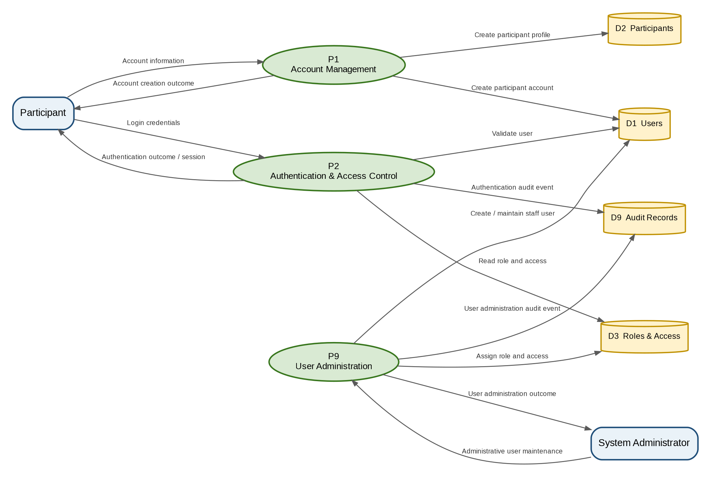
Figure 5-1 - DFD View A - Identity, Authentication and User Administration

5.2.2 View B - Program Management and Participant Browsing

Mermaid.js Source
flowchart LR
Participant[Participant]
TrainingAdmin[Training Administrator]
P3((P3 Program Management))
P4((P4 Program Browsing))
D4[(D4 Program Categories)]
D5[(D5 Training Programs)]
D9[(D9 Audit Records)]
TrainingAdmin -->|Program and category maintenance| P3
P3 -->|Maintain categories| D4
P3 -->|Maintain programs| D5
P3 -->|Program administration outcome| TrainingAdmin
P3 -->|Program administration audit event| D9
Participant -->|Browse / view program request| P4
D4 -->|Category information| P4
D5 -->|Program details and availability| P4
P4 -->|Program listing / details| Participant

Generated Diagram
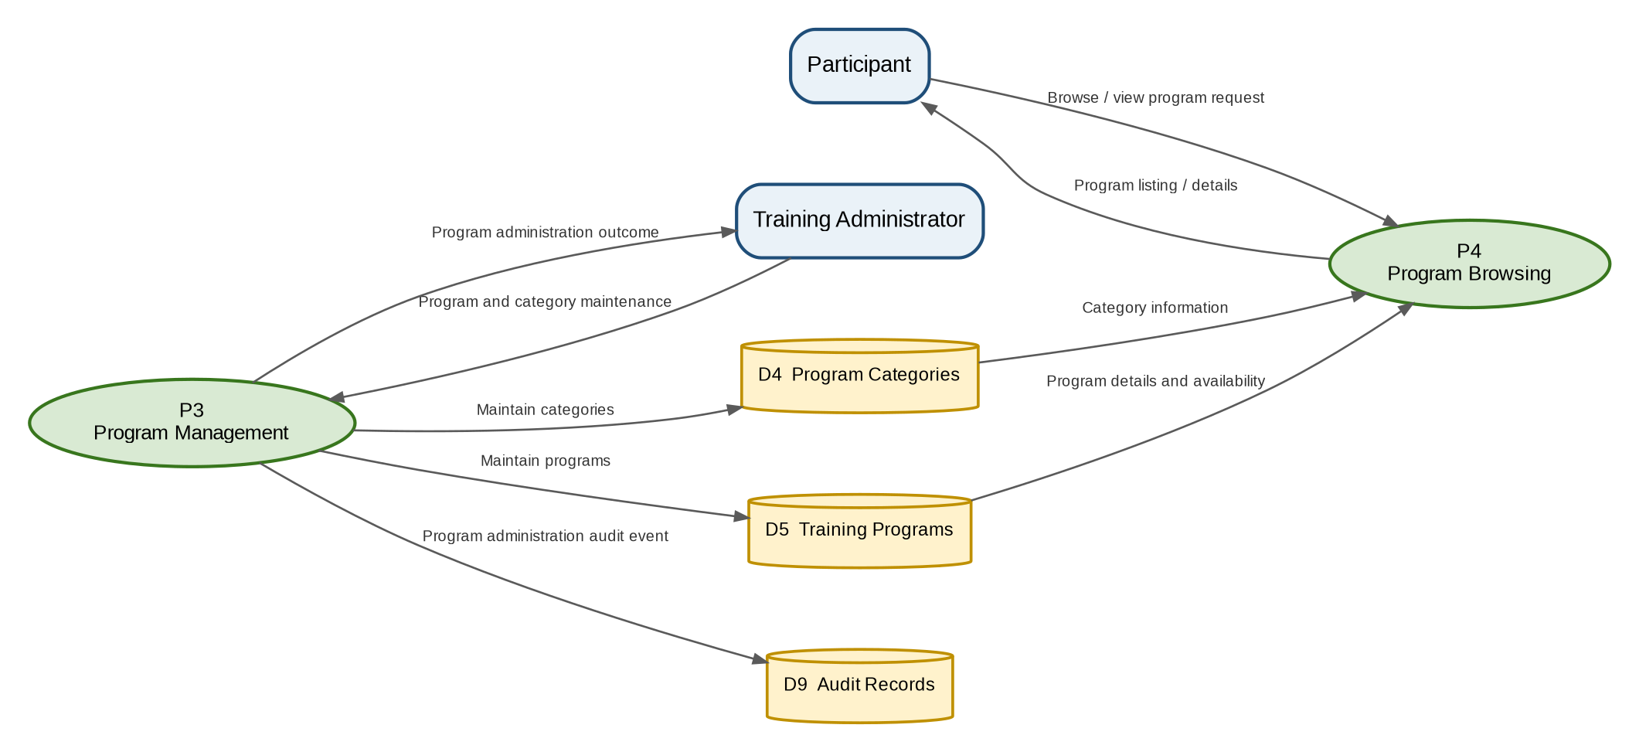
Figure 5-2 - DFD View B - Program Management and Participant Browsing

5.2.3 View C - Registration, Cancellation and Notification

Mermaid.js Source
flowchart LR
Participant[Participant]
TrainingAdmin[Training Administrator]
EmailService[Email / Notification Service]
P5((P5 Registration Management))
P10((P10 Notification Processing))
D2[(D2 Participants)]
D5[(D5 Training Programs)]
D6[(D6 Registrations)]
D9[(D9 Audit Records)]
D10[(D10 Notification Outbox)]
Participant -->|Registration / cancellation request| P5
D2 -->|Participant information| P5
D5 -->|Program rules, schedule and capacity| P5
D6 -->|Existing registration information| P5
P5 -->|Create / cancel registration| D6
P5 -->|Registration result| Participant
TrainingAdmin -->|View registration request| P5
P5 -->|Registration information| TrainingAdmin
P5 -->|Registration audit event| D9
P5 -->|Confirmation notification request| D10
D10 -->|Pending notification| P10
P10 -->|Registration confirmation email| EmailService
EmailService -->|Delivery result| P10
P10 -->|Update delivery status| D10
P10 -->|Notification audit event| D9

Generated Diagram
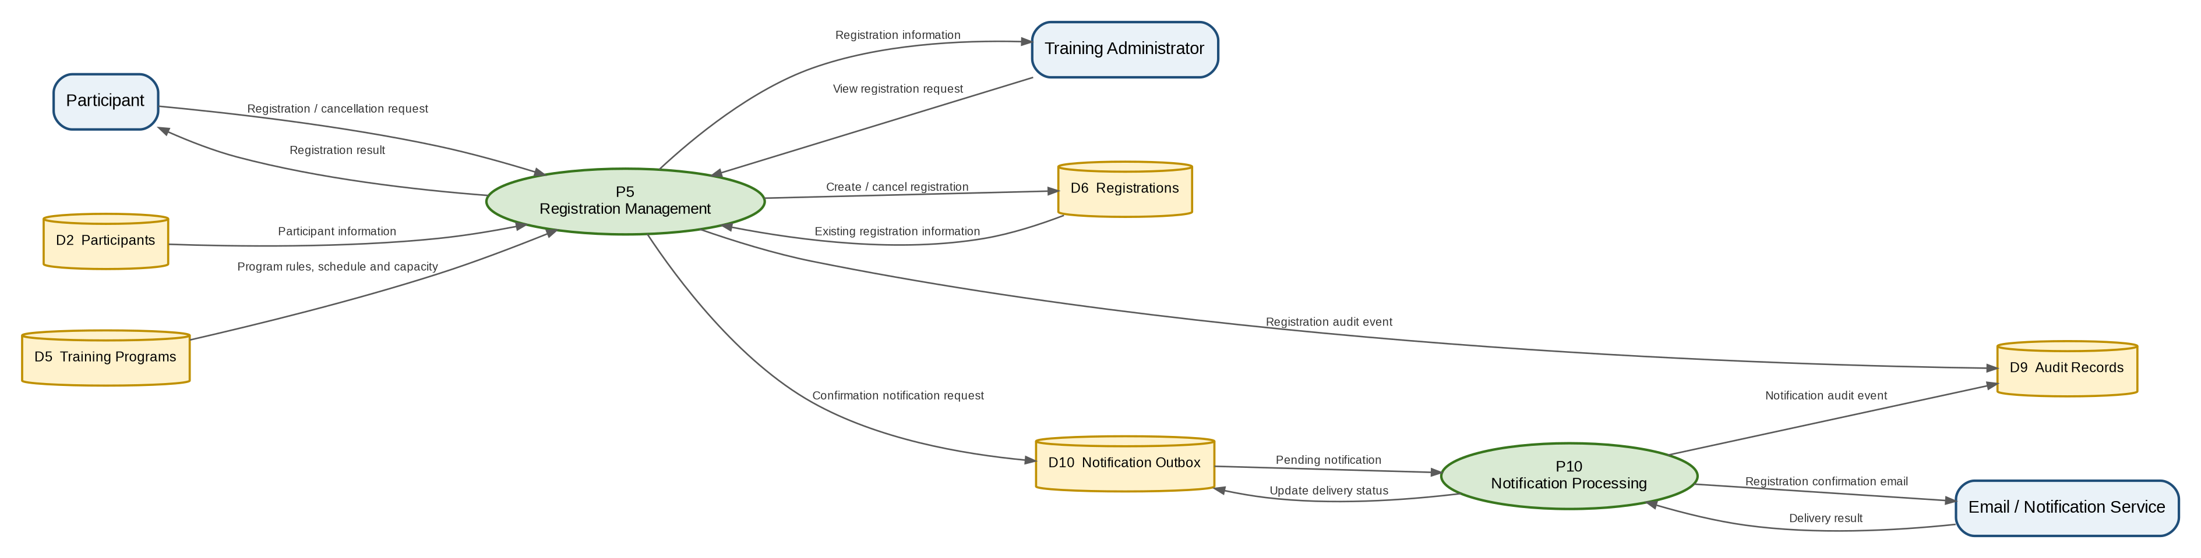
Figure 5-3 - DFD View C - Registration, Cancellation and Notification

5.2.4 View D - Attendance, Certificate and Reporting

Mermaid.js Source
flowchart LR
Trainer[Trainer]
TrainingAdmin[Training Administrator]
P6((P6 Attendance Management))
P7((P7 Certificate Management))
P8((P8 Reporting))
D1[(D1 Users)]
D2[(D2 Participants)]
D5[(D5 Training Programs)]
D6[(D6 Registrations)]
D7[(D7 Attendance)]
D8[(D8 Certificates)]
D9[(D9 Audit Records)]
Trainer -->|Attendance entry| P6
D6 -->|Registered participant list| P6
P6 -->|Save attendance| D7
P6 -->|Attendance result| Trainer
P6 -->|Attendance audit event| D9
TrainingAdmin -->|Certificate eligibility / issuance request| P7
D6 -->|Registration information| P7
D7 -->|Attendance information| P7
P7 -->|Save certificate record| D8
P7 -->|Certificate result| TrainingAdmin
P7 -->|Certificate audit event| D9
TrainingAdmin -->|Report request| P8
D1 -->|Account information| P8
D2 -->|Participant information| P8
D5 -->|Program information| P8
D6 -->|Registration information| P8
D7 -->|Attendance information| P8
D8 -->|Certificate information| P8
P8 -->|Confirmed reports| TrainingAdmin
P8 -->|Report audit event| D9

Generated Diagram
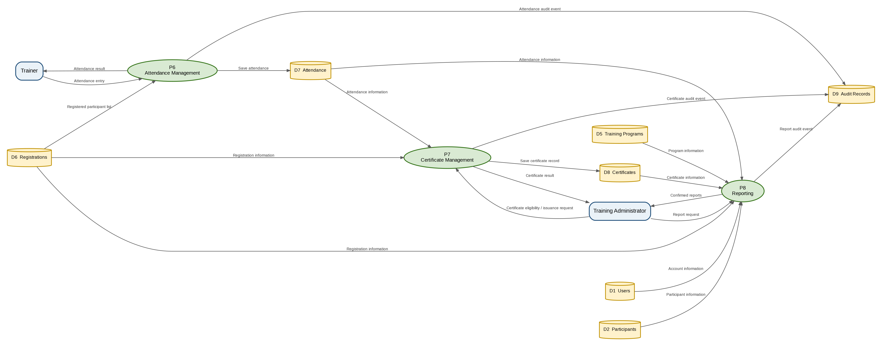
Figure 5-4 - DFD View D - Attendance, Certificate and Reporting

5.3 Complete DFD Overview
The complete overview consolidates the four logical views into one end-to-end data flow diagram. The split views above should be used for detailed review; this overview provides overall system context.

Mermaid.js Source
flowchart LR
%% External Entities
Participant[Participant]
TrainingAdmin[Training Administrator]
Trainer[Trainer]
SystemAdmin[System Administrator]
EmailService[Email / Notification Service]
%% Processes
P1((P1 Account Management))
P2((P2 Authentication & Access Control))
P3((P3 Program Management))
P4((P4 Program Browsing))
P5((P5 Registration Management))
P6((P6 Attendance Management))
P7((P7 Certificate Management))
P8((P8 Reporting))
P9((P9 User Administration))
P10((P10 Notification Processing))
%% Data Stores
D1[(D1 Users)]
D2[(D2 Participants)]
D3[(D3 Roles & Access)]
D4[(D4 Program Categories)]
D5[(D5 Training Programs)]
D6[(D6 Registrations)]
D7[(D7 Attendance)]
D8[(D8 Certificates)]
D9[(D9 Audit Records)]
D10[(D10 Notification Outbox)]
%% Participant account and authentication
Participant -->|Account information| P1
P1 -->|Create participant account| D1
P1 -->|Create participant profile| D2
P1 -->|Account creation outcome| Participant
Participant -->|Login credentials| P2
P2 -->|Validate user| D1
P2 -->|Read role and access| D3
P2 -->|Authentication outcome / session| Participant
P2 -->|Authentication audit event| D9
%% Program administration and browsing
TrainingAdmin -->|Program and category maintenance| P3
P3 -->|Maintain categories| D4
P3 -->|Maintain programs| D5
P3 -->|Program administration outcome| TrainingAdmin
P3 -->|Program administration audit event| D9
Participant -->|Browse / view program request| P4
D4 -->|Category information| P4
D5 -->|Program details and availability| P4
P4 -->|Program listing / details| Participant
%% Registration and notification
Participant -->|Registration / cancellation request| P5
D2 -->|Participant information| P5
D5 -->|Program rules, schedule and capacity| P5
D6 -->|Existing registration information| P5
P5 -->|Create / cancel registration| D6
P5 -->|Registration result| Participant
P5 -->|Registration audit event| D9
P5 -->|Confirmation notification request| D10
D10 -->|Pending notification| P10
P10 -->|Registration confirmation email| EmailService
EmailService -->|Delivery result| P10
P10 -->|Update delivery status| D10
P10 -->|Notification audit event| D9
%% Registration administration
TrainingAdmin -->|View registration request| P5
D6 -->|Registration information| P5
P5 -->|Registration information| TrainingAdmin
%% Attendance
Trainer -->|Attendance entry| P6
D6 -->|Registered participant list| P6
P6 -->|Save attendance| D7
P6 -->|Attendance result| Trainer
P6 -->|Attendance audit event| D9
%% Certificate
TrainingAdmin -->|Certificate eligibility / issuance request| P7
D6 -->|Registration information| P7
D7 -->|Attendance information| P7
P7 -->|Save certificate record| D8
P7 -->|Certificate result| TrainingAdmin
P7 -->|Certificate audit event| D9
%% Reporting
TrainingAdmin -->|Report request| P8
D1 -->|Account information| P8
D2 -->|Participant information| P8
D5 -->|Program information| P8
D6 -->|Registration information| P8
D7 -->|Attendance information| P8
D8 -->|Certificate information| P8
P8 -->|Student account / registration / certificate reports| TrainingAdmin
P8 -->|Report audit event| D9
%% Administrative user management
SystemAdmin -->|Administrative user maintenance| P9
P9 -->|Create / maintain staff user| D1
P9 -->|Assign role and access| D3
P9 -->|User administration outcome| SystemAdmin
P9 -->|User administration audit event| D9

Generated Diagram
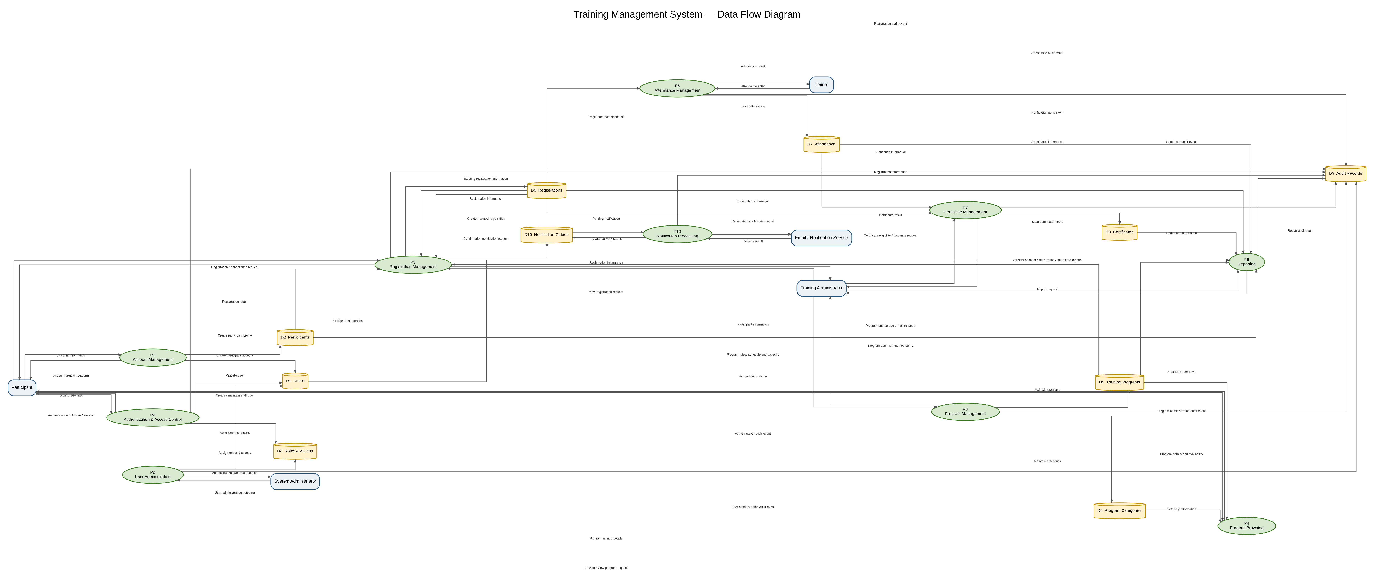
Figure 5-5 - Complete Training Management System Data Flow Diagram

Design Notes
- The split views do not change the logical design; they partition the same DFD by functional concern for document readability.
- Participant registration is validated against participant, program and existing registration information before a registration is created or cancelled.
- Registration confirmation uses the Notification Outbox and Notification Processing flow so email delivery is decoupled from the committed registration transaction.
- Audit events are captured for authentication and key business or administrative operations.
- Reporting reads authoritative account, participant, program, registration, attendance and certificate data.

5.4 Registration Implementation Flow
Participant
↓
Registration UI
↓
Registration API
↓
Authentication / Authorization
↓
Registration Validation
├── Participant / Program checks
├── Active-registration uniqueness
├── Schedule overlap
└── Capacity / availability
↓
MySQL transaction
├── Registration
├── Mandatory Audit
└── Notification Outbox
↓
Commit
↓
Outbox Worker → Email / Notification Service

6. Operations

6.1 Operations / API Design
ID | Operation | Actor | Input | Output | Requirements
OP-001 | Create participant account | Participant | Participant/account information | Account status | FR-001, FR-008
OP-002 | Authenticate participant | Participant | Credentials | Authenticated session | FR-002
OP-003 | Bootstrap System Administrator account | Static-key holder | Static key + account information | Account status | FR-035
OP-004 | Authenticate System Administrator | System Administrator | Credentials | Authenticated session | FR-034
OP-005 | Create Training Administrator/Trainer account | System Administrator | Account + role | Account status | FR-029
OP-006 | Authenticate Training Administrator/Trainer | TA / Trainer | Credentials | Authenticated session | FR-033
OP-007 | List available programs | Participant | Category/filter parameters | Program list | FR-003, FR-004
OP-008 | View program details | Participant | Program ID | Program details | FR-005, FR-006
OP-009 | Create registration | Participant | Program ID + registration information | Registration | FR-007–FR-014
OP-010 | View participant registrations | Participant | Authenticated participant | Registration list/details | FR-015
OP-011 | Cancel registration | Participant | Registration ID | Updated registration | FR-016
OP-012 | Create training program | Training Administrator | Program data | Program | FR-018
OP-013 | Update training program | Training Administrator | Program ID + changed data | Updated program | FR-019
OP-014 | Maintain program category | Training Administrator | Category data | Category | FR-020
OP-015 | Configure program capacity | Training Administrator | Program ID + capacity | Updated capacity | FR-021
OP-016 | View registration administration | Training Administrator | Registration criteria / filters; optional registration ID for permitted view action | Registration list/detail | FR-022
OP-017 | Record attendance | Trainer | Program/registration attendance data | Attendance result | FR-023, FR-024
OP-018 | Record certificate issuance | Training Administrator | Eligible registration/certificate data | Certificate record | FR-025, FR-026
OP-019 | Generate Certificate Report | Training Administrator | Report parameters | Report | FR-027
OP-020 | Generate Program Registration Report | Training Administrator | Report parameters | Report | FR-027
OP-021 | Generate Account Creation Report | Training Administrator | Report parameters | Report | FR-027
API common contract: JSON UTF-8; Content-Type application/json; correlationId is returned on every response; server-side validation is mandatory; IDs are positive integers unless otherwise stated; timestamps use ISO 8601 UTC; date values use YYYY-MM-DD; time values use HH:mm:ss; strings use the maximum lengths defined by the physical schema; enum/status fields accept only values defined in this SDD; null is allowed only where the schema marks a field nullable; list endpoints use page>=1 and pageSize 1..100 with default 20; sorting uses an explicit allow-list and deterministic secondary key; filters are server-side and parameterized. State-changing cookie-authenticated requests require a server-issued CSRF token supplied in the X-CSRF-Token header; the token is rendered into authenticated HTML pages and is validated before controller execution. Error envelope: { code, message, details, timestamp, correlationId }. Never return password hashes, static keys, session identifiers or unmasked NRIC/Passport values. API role values use only canonical role codes PARTICIPANT, TRAINER, TRAINING_ADMINISTRATOR and SYSTEM_ADMINISTRATOR; human-readable role labels are UI-only.

6.2 Logical API Resource Structure
Method | Path | Auth / Purpose | Request Contract | Response / HTTP Contract
POST | /api/v1/auth/participants | Public / participant self-registration | JSON: nricPassportNo, name, email, mobileNo, password; all request fields are validated; password is never returned. Server applies the defined server-side ULID generation rules for account_identifier=P-<ULID> and username=participant-<ULID>; both are unique opaque identifiers and are not deterministic values derived from participant input. Server assigns role_id=PARTICIPANT and role_name=PARTICIPANT, initializes account_status=ACTIVE and role_assigned_at=created_at, derives permissions/access_scope/permitted_responsibilities from the PARTICIPANT role, and atomically creates users, the linked participants profile and the account-creation audit event; any failure rolls back the complete transaction. Participant login uses email/password; username is an immutable account identifier and is not a participant login input in the current release. | 201 {participantId,status,createdAt}; 400 {code,message,details,timestamp,correlationId}; 409 duplicate email/NRIC
POST | /api/v1/auth/participants/login | Public / participant login | JSON: email,password; both required. Server validates credentials, account_status and canonical role code PARTICIPANT; no session identifier is returned. | 200 {userId,participantId,role,status,expiresAt}; role uses canonical code PARTICIPANT; session is server-side and session ID is never returned; 401 generic authentication failure; 423 locked/disabled
POST | /api/v1/auth/system-admin/bootstrap | Static key only / System Administrator bootstrap | JSON: staticAdministrationKey,username,name,email,password; all account fields are validated; staticAdministrationKey is validated against the configured deployment secret and is never persisted or logged; role is server-assigned as SYSTEM_ADMINISTRATOR; account_identifier=A-<ULID> is server-generated, unique, opaque and immutable; permissions, access_scope, permitted_responsibilities, account_status and timestamps are server-controlled. | 201 {userId,accountIdentifier,username,role,accountStatus,createdAt}; role uses canonical role code SYSTEM_ADMINISTRATOR; 400 validation; 401 invalid key; 409 active System Administrator exists
POST | /api/v1/auth/system-admin/login | Public / System Administrator login | JSON: email,password; both required. Server validates credentials, account_status and canonical role code SYSTEM_ADMINISTRATOR; no session identifier is returned. | 200 {userId,role,status,expiresAt}; role uses canonical role code SYSTEM_ADMINISTRATOR; session is server-side and session ID is never returned; 401 generic authentication failure; 423 locked/disabled
POST | /api/v1/auth/staff/login | Public / Training Administrator or Trainer login | JSON: email,password; both required. Server validates credentials, account_status and canonical role code TRAINING_ADMINISTRATOR or TRAINER; no session identifier is returned. | 200 {userId,role,status,expiresAt}; role uses canonical role code TRAINING_ADMINISTRATOR or TRAINER; session is server-side and session ID is never returned; 401 generic authentication failure; 423 locked/disabled
POST | /api/v1/auth/logout | Authenticated / invalidate current session | No body | 204 no body; CSRF protected
GET | /api/v1/programs | Public / catalogue listing | Query: page, pageSize<=100, categoryId, availability, sort | 200 {items[],page,pageSize,total}; item={programId,code,name,categoryId,categoryName,trainingDate,startTime,endTime,venue,deliveryMode,capacity,availableSeats,status,registrationOpenAt,registrationCloseAt}; 400 invalid filter
GET | /api/v1/programs/:programId | Public / program detail | Path: programId | 200 {programId,code,name,description,objectives,targetAudience,prerequisites,categoryId,categoryName,trainerName,trainingDate,startTime,endTime,venue,deliveryMode,capacity,availableSeats,status,registrationOpenAt,registrationCloseAt,cancellationPolicyReference,certificateEligibilityCriteria,certificateType,createdAt,updatedAt}; 404 not found/not visible
POST | /api/v1/registrations | Participant / create own registration | JSON: programId required. Participant identity is derived exclusively from the authenticated participant session; no participantId, NRIC/Passport, name, email or mobile identity field is accepted. Server derives registrationId, referenceNo, registeredAt, status and timestamps. | 201 {registrationId,referenceNo,programId,status,registeredAt}; 400 validation; 401 unauthenticated; 404 program not found/not visible; 409 duplicate/full/window/overlap
GET | /api/v1/registrations | Participant / own records only | Query: page, pageSize, status, sort. Participant identity is derived exclusively from the authenticated participant/session; no participantId, NRIC/Passport, name, email or mobile identity parameter is accepted. | 200 {items[],page,pageSize,total}; item={registrationId,referenceNo,programId,programCode,programName,trainingDate,startTime,endTime,registeredAt,status,cancelledAt,cancellationReason}; 401
POST | /api/v1/registrations/:registrationId/cancel | Participant / own registration only | Path: registrationId; optional cancellationReason | 200 {registrationId,referenceNo,status,cancelledAt}; 400 not cancellable; 403 ownership; 404
POST | /api/v1/admin/programs | Training Administrator / create program | JSON: code,name,description,objectives,targetAudience,prerequisites,categoryId,trainerUserId,trainingDate,startTime,endTime,venue,deliveryMode,capacity,registrationOpenAt,registrationCloseAt,status,cancellationPolicyReference,certificateEligibilityCriteria,certificateType; required fields follow DR-002; certificateType and venue/prerequisites/cancellationPolicyReference are optional | 201 {program}; 400 validation; 403
PUT | /api/v1/admin/programs/:programId | Training Administrator / update program | Path programId; JSON only mutable fields: name,description,objectives,targetAudience,prerequisites,categoryId,trainerUserId,trainingDate,startTime,endTime,venue,deliveryMode,capacity,registrationOpenAt,registrationCloseAt,status,cancellationPolicyReference,certificateEligibilityCriteria,certificateType; programId/code/createdAt immutable Capacity must be an integer > 0 and must not be lower than the current number of REGISTERED registrations; the update is transactional and availableSeats is re-derived after update. | 200 {program}; 400 validation/capacity/date rule; 403/404
POST | /api/v1/admin/categories | Training Administrator / create category | JSON: name required; description optional; status optional ACTIVE|INACTIVE | 201 {categoryId,name,description,status,createdAt,updatedAt}; 400; 403; 409 duplicate
PUT | /api/v1/admin/categories/:categoryId | Training Administrator / update category | Path categoryId; JSON: name required, description optional, status ACTIVE|INACTIVE | 200 {categoryId,name,description,status,updatedAt}; 400/403/404
GET | /api/v1/admin/registrations/:registrationId | Training Administrator / view registration detail within operational scope | Path: registrationId positive integer | 200 {registrationId,referenceNo,participantId,programId,registeredAt,status,cancelledAt,cancellationReason,registrationRemarks}; 403; 404
GET | /api/v1/admin/registrations | Training Administrator / view registrations within operational scope | Query: periodFrom, periodTo optional; programId, categoryId, participantId, status optional; page>=1; pageSize 1..100; sort allow-list | 200 {items[],page,pageSize,total}; item={registrationId,referenceNo,participantId,programId,registeredAt,status,cancelledAt,cancellationReason}; 400 invalid filter; 403
POST | /api/v1/admin/users | System Administrator / create Training Administrator or Trainer account | JSON: username,name,email,password,role; role must be TRAINING_ADMINISTRATOR or TRAINER. role_id and role_name are stored using the canonical role code; account_identifier=A-<ULID> is server-generated, unique, opaque and immutable; permissions, access_scope, permitted_responsibilities, account_status, timestamps and other account-control fields are server-controlled. | 201 {userId,accountIdentifier,username,name,email,role,accountStatus,createdAt}; 400 validation; 403 unauthorized role/account action; 409 duplicate
POST | /api/v1/trainer/programs/:programId/attendance | Trainer / assigned program only | Path programId; JSON: attendanceDate, records[]; each record={registrationId,status,checkInAt?,checkOutAt?,verificationMethod?,evidenceReference?,remarks?}; status is PRESENT or ABSENT; percentage is server-derived as 100.00 for PRESENT and 0.00 for ABSENT; participantId/programId/recordedBy are server-derived | 200 {items[]}; item={attendanceId,registrationId,participantId,programId,attendanceDate,status,percentage,recordedBy}; 400 validation; 403 if not assigned; 404
POST | /api/v1/admin/certificates | Training Administrator / issue certificate | JSON: registrationId,certificateType,certificateTitle; issuingAuthority?,verificationReference?,documentReference?; eligibilityStatus,eligibilityResult,attendancePercentage and completionDate are server-derived/validated; all certificate type/title fields required Server generates a unique opaque certificateNumber (UUID/ULID-compatible reference) at issuance; the business-facing certificate numbering format remains deferred. | 201 {certificateId,certificateNumber,participantId,registrationId,programId,certificateType,certificateTitle,eligibilityStatus,eligibilityResult,attendancePercentage,completionDate,issueDate,certificateStatus,documentReference,verificationReference,issuingAuthority,issuedBy}; 400 ineligible/validation; 403; 409 already issued
GET | /api/v1/admin/reports/certificates | Training Administrator / certificate report | Query: periodFrom and periodTo required ISO-8601 datetimes; programId,categoryId,participantId,certificateStatus,output optional; page>=1; pageSize 1..100 | 200 JSON {reportExecutionId,reportName,reportType,periodFrom,periodTo,generatedAt,generatedBy,status,data[],page,pageSize,total}; output=csv returns text/csv; 400/403
GET | /api/v1/admin/reports/registrations | Training Administrator / registration report | Query: periodFrom and periodTo required ISO-8601 datetimes; programId,categoryId,participantId,status,output optional; page>=1; pageSize 1..100 | 200 JSON {reportExecutionId,reportName,reportType,periodFrom,periodTo,generatedAt,generatedBy,status,data[],page,pageSize,total}; output=csv returns text/csv; 400/403
GET | /api/v1/admin/reports/accounts | Training Administrator / account report | Query: periodFrom and periodTo required ISO-8601 datetimes; accountStatus,participantId,output optional; page>=1; pageSize 1..100; NRIC/Passport never returned unmasked | 200 JSON {reportExecutionId,reportName,reportType,periodFrom,periodTo,generatedAt,generatedBy,status,data[],page,pageSize,total}; output=csv returns text/csv; 400/403
/api/v1
/auth
/participants
/participants/login
/system-admin/bootstrap
/system-admin/login
/staff/login
/programs
/programs/:programId
/registrations
/registrations/:registrationId
/registrations/:registrationId/cancel
/admin/programs
/admin/categories
/admin/registrations
/admin/users
/trainer/programs/:programId/attendance
/admin/certificates
/admin/reports/certificates
/admin/reports/registrations
/admin/reports/accounts

7. Validation & Business Rules
Endpoint / Operation | Participant | Trainer |  | Training Administrator |  | System Administrator
/api/v1/auth/participants | C | - |  | - |  | -
/api/v1/auth/participants/login | C | - |  | - |  | -
/api/v1/auth/system-admin/bootstrap | - | - |  | - |  | Bootstrap/static key
/api/v1/auth/system-admin/login | - | - |  | - |  | C
/api/v1/auth/staff/login | - | C |  | C |  | -
/api/v1/auth/logout | C | C |  | C |  | C
/api/v1/programs | R | R |  | R |  | R
/api/v1/programs/:programId | R | R |  | R |  | R
/api/v1/registrations | C/R own | - |  | - |  | -
/api/v1/registrations/:id/cancel | C own | - |  | - |  | -
/api/v1/admin/programs/:programId | - | - |  | C/U |  | -
/api/v1/admin/categories* | - | - |  | C/U |  | -
/api/v1/admin/registrations/:id | - | - |  | R |  | -
/api/v1/admin/registrations | R | - |  | R |  | -
/api/v1/admin/users | - | - |  | - |  | C
/api/v1/trainer/programs/:id/attendance | - | C/U assigned |  | - |  | -
/api/v1/admin/certificates | - | - |  | C |  | -
/api/v1/admin/reports/* | - | - |  | R |  | -
Audit records | - | - |  | - |  | R
Authorization rule | Own participant resources only; canonical role code PARTICIPANT | Assigned programs only; canonical role code TRAINER; participant data limited to operational attendance scope |  | All operational training data required by role; canonical role code TRAINING_ADMINISTRATOR; registration-management mutation actions are not implemented until explicitly permitted by controlled requirements change |  | System administration scope only; canonical role code SYSTEM_ADMINISTRATOR
ID | Validation / Rule |  | Responsibility |  | Related Requirement
VAL-001 | Participant must be authenticated before registration |  | Authorization / Registration |  | BR-001, VE-008
VAL-002 | Required participant information must be present |  | Registration Validator |  | BR-012, VE-001
VAL-003 | Participant information must be valid |  | Participant/Registration Validator |  | VE-002
VAL-004 | Participant must not have an active REGISTERED registration for the same program. A CANCELLED historical registration does not block a later registration because DEC-011 explicitly adopts re-registration after cancellation for the current release. |  | Registration Validator / DB constraint |  | BR-007 / DEC-011
VAL-005 | Program must be available |  | Program/Registration Validator |  | FR-030, VE-006
VAL-006 | Program capacity must not be reached |  | Registration Validator |  | BR-003, BR-004, VE-003
VAL-007 | No waiting list is created when full |  | Registration Module |  | BR-005
VAL-008 | Schedule must not overlap another registration |  | Registration Validator |  | BR-006, VE-005
VAL-009 | Successful registration status is Registered |  | Registration Module |  | BR-008, BR-009
VAL-010 | Registration information cannot be modified after submission |  | Registration API |  | BR-011, VE-007
VAL-011 | Participant may cancel existing registration |  | Registration Module |  | BR-010
VAL-012 | Certificate requires 100% attendance |  | Certificate Module |  | BR-017, VE-013
VAL-013 | Attendance applies only to registered participants |  | Attendance Module |  | BR-016
VAL-014 | Unauthorized administrative access is denied |  | Authorization |  | FR-028, VE-009
VAL-015 | Account information uniqueness is enforced |  | Account Module |  | VE-015
VAL-016 | Account status must permit authentication |  | Authentication |  | VE-016, VE-017
VAL-017 | Static administration key must be valid for bootstrap |  | Bootstrap Module |  | BR-021, VE-019
VAL-018 | System Administrator account information must be valid |  | Bootstrap Module |  | VE-018
VAL-019 | No-program scenario returns appropriate message |  | Program Catalogue |  | FR-032, VE-012
VAL-020 | Registration failure must never be represented as successful |  | Registration Transaction |  | VE-011
VAL-021 | Registration is allowed only during the configured registration-open/close window |  | Registration Validator |  | FR-030 / registration window rule
VAL-022 | Cancellation changes status to CANCELLED, releases the active-registration key and retains the historical registration row. A participant may later submit a new registration for the same program, subject to normal registration validation, as defined by DEC-011. |  | Registration Module |  | BR-010 / BR-018 / DEC-011
VAL-023 | Only ACTIVE accounts may authenticate; LOCKED and DISABLED accounts are rejected |  | Authentication |  | NFR-003 / security design
VAL-024 | Registration capacity is enforced inside a database transaction with row-level locking or an equivalent atomic conditional update; the mandatory audit and outbox records are created in the same transaction |  | Registration Transaction |  | BR-003 / BR-004 / NFR-005
VAL-025 | Certificate issuance is permitted only once per registration and only when attendance percentage is exactly 100% |  | Certificate Module |  | BR-017
VAL-026 | Attendance can be recorded only for the selected program and a Registered participant; one attendance record per registration |  | Attendance Module |  | BR-016
VAL-027 | API resources enforce role authorization and participant ownership on every protected operation; Training Administrator report access is limited to the three approved reports |  | Authorization |  | FR-028 / NFR-001 / NFR-002 / FR-027
VAL-028 | NRIC/Passport is masked in ordinary participant-facing screens, standard reports and logs; full value is restricted to authorized administrative views |  | Privacy/Security |  | NFR-004
VAL-029 | Audit records are append-only and cannot be modified or deleted through application APIs; mandatory business audit events are transactionally committed with the business change |  | Audit Module |  | NFR-010 / NFR-005
VAL-030 | Email failure does not change a committed registration outcome; failure and retry state are recorded in the notification outbox |  | Notification/Registration |  | BR-013 / NFR-005
VAL-031 | All state-changing cookie-authenticated requests require a valid CSRF token rendered by the server into the authenticated page and supplied in X-CSRF-Token; invalid/missing token returns 403 and is audited as a security event |  | Security Middleware |  | NFR-003 / browser session design
VAL-032 | Training Administrator registration administration is read-only for the code-generation baseline because FR-022 does not enumerate specific mutation actions. No registration-management mutation endpoint is implemented; unsupported mutation methods/routes are rejected according to the standard authorization/routing contract. The confirmed participant cancellation flow remains unchanged. |  | Registration / Authorization |  | FR-022 / FR-016 / BR-010
VAL-033 | Training Program capacity updates require an integer capacity greater than zero and must not reduce capacity below the current number of REGISTERED registrations; the capacity update and available-seat re-derivation occur transactionally. |  | Program Management / Capacity |  | FR-021 / BR-004 / NFR-005
VAL-034 | For a single-occurrence program, attendance percentage is server-derived: PRESENT = 100.00 and ABSENT = 0.00. Client-supplied percentage values are ignored/rejected and cannot determine certificate eligibility. |  | Attendance / Certificate |  | BR-016 / BR-017 / NFR-005
VAL-035 | All authenticated principals, including Participants, use the users identity for sessions and audit attribution. Participant account creation creates a users record with role PARTICIPANT and a linked participant profile atomically; participant email/account status/last login are derived from the users record. |  | Authentication / Account Identity |  | FR-001 / FR-002 / FR-028 / NFR-003 / DR-007 / DR-008
VAL-036 | Participant account creation uses defined server-side generation/default rules: account_identifier=P-<ULID>, username=participant-<ULID>, role_id/role_name=PARTICIPANT, account_status=ACTIVE, role_assigned_at=created_at; permissions/access_scope/permitted_responsibilities are derived from the PARTICIPANT role. The generated username and account identifier are unique and immutable after creation; the values are opaque server-generated identifiers and are not derived deterministically from participant input. |  | Account / Identity Module |  | FR-001 / DR-007 / DEC-014
VAL-037 | A PARTICIPANT user must have exactly one linked participants profile through participants.user_id; a non-PARTICIPANT user must not have a participant profile. The one-to-one relationship is enforced by the UNIQUE participant FK and application role validation. |  | Account / Identity Module / DB Constraint |  | FR-001 / DR-001 / DR-007 / DEC-014

8. Workflows & Sequence

8.1 Major Workflows
ID | Workflow | Primary Actor
WF-001 | Participant Account Creation | Participant
WF-002 | Participant Authentication | Participant
WF-003 | System Administrator Bootstrap | Static-key holder
WF-004 | System Administrator Authentication | System Administrator
WF-005 | Administrative User Creation | System Administrator
WF-006 | Staff Authentication | Training Administrator / Trainer
WF-007 | Browse Program | Participant
WF-008 | View Program Details | Participant
WF-009 | Register for Program | Participant
WF-010 | Cancel Registration | Participant
WF-011 | Manage Programs | Training Administrator
WF-012 | Manage Registrations — View | Training Administrator
WF-013 | Record Attendance | Trainer
WF-014 | Issue Certificate | Training Administrator
WF-015 | Generate Reports | Training Administrator

8.2 Sequence Diagram — Participant Account Creation
Workflow / Scenario: WF-001 — Participant Account Creation. Primary actor: Participant.
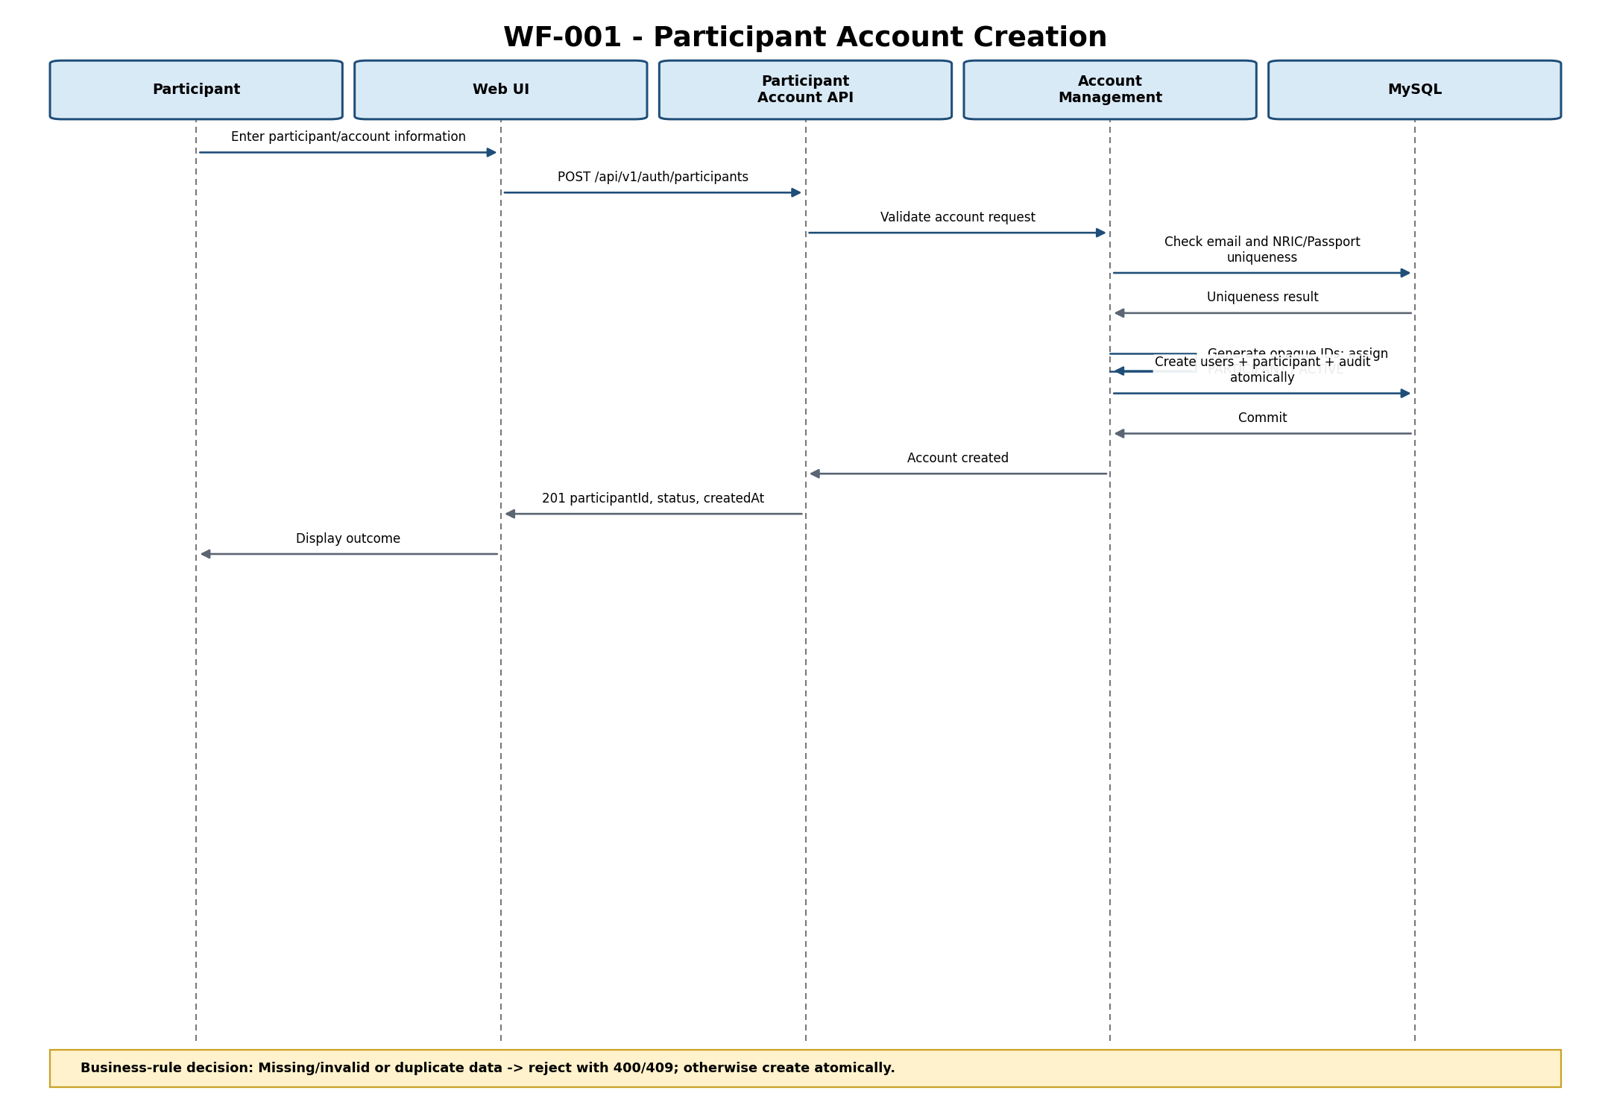
Figure 8-1 — Participant Account Creation Sequence
Interaction Description: Missing/invalid or duplicate data -> reject with 400/409; otherwise create atomically.
Related Requirements: BP-001; FR-001; FR-008; DR-001; DR-007; VE-014; VE-015
Design Gaps / Inconsistencies: None blocking code generation.

8.3 Sequence Diagram — Participant Authentication
Workflow / Scenario: WF-002 — Participant Authentication. Primary actor: Participant.
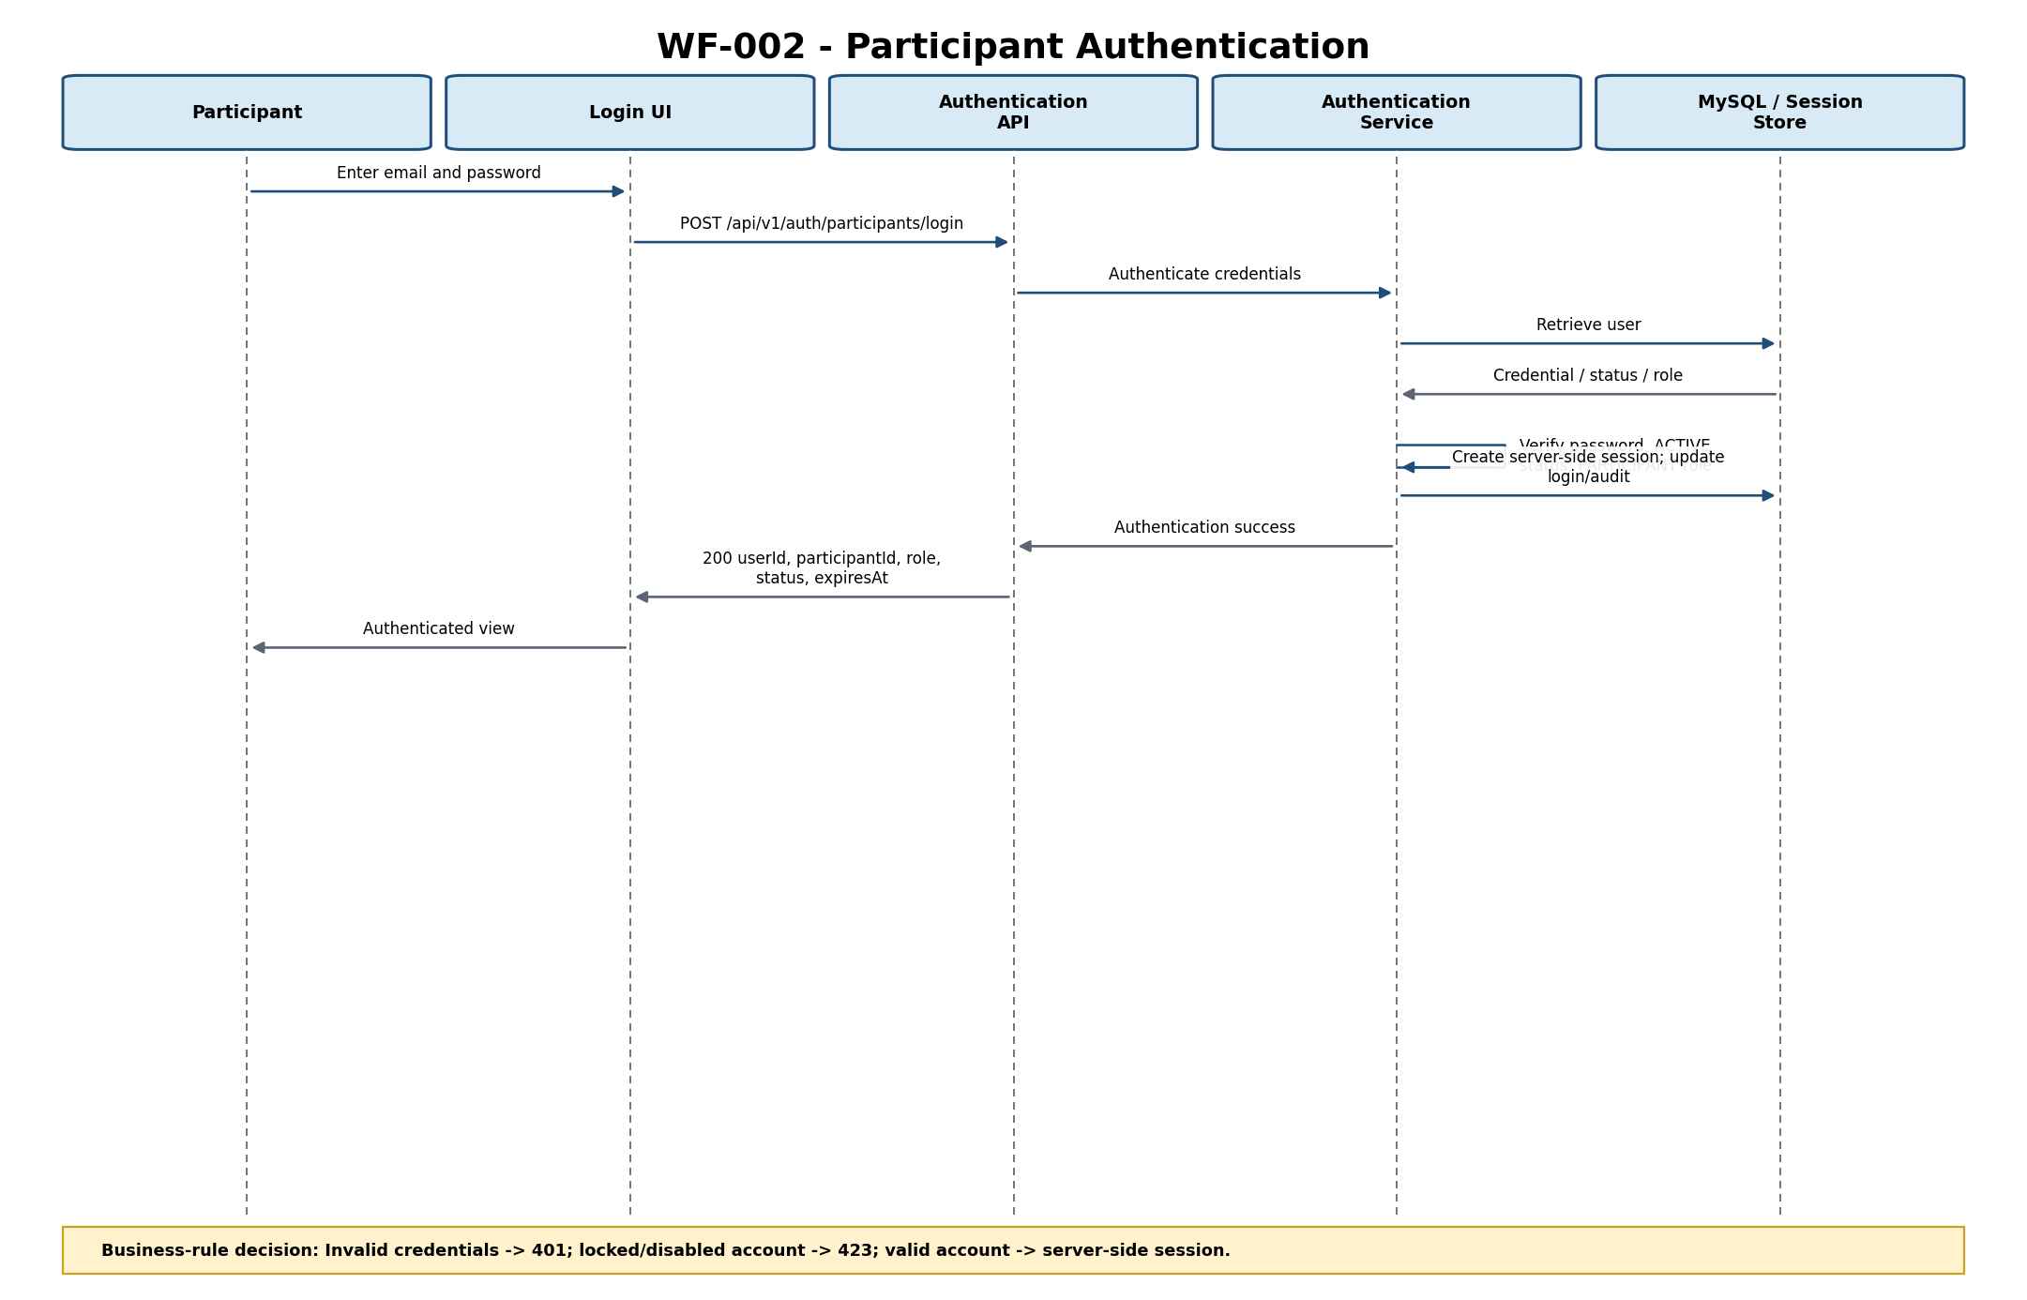
Figure 8-2 — Participant Authentication Sequence
Interaction Description: Invalid credentials -> 401; locked/disabled account -> 423; valid account -> server-side session.
Related Requirements: BP-002; FR-002; BR-001; VE-016; NFR-003
Design Gaps / Inconsistencies: None.

8.4 Sequence Diagram — System Administrator Bootstrap
Workflow / Scenario: WF-003 — System Administrator Bootstrap. Primary actor: Static-Key Holder.
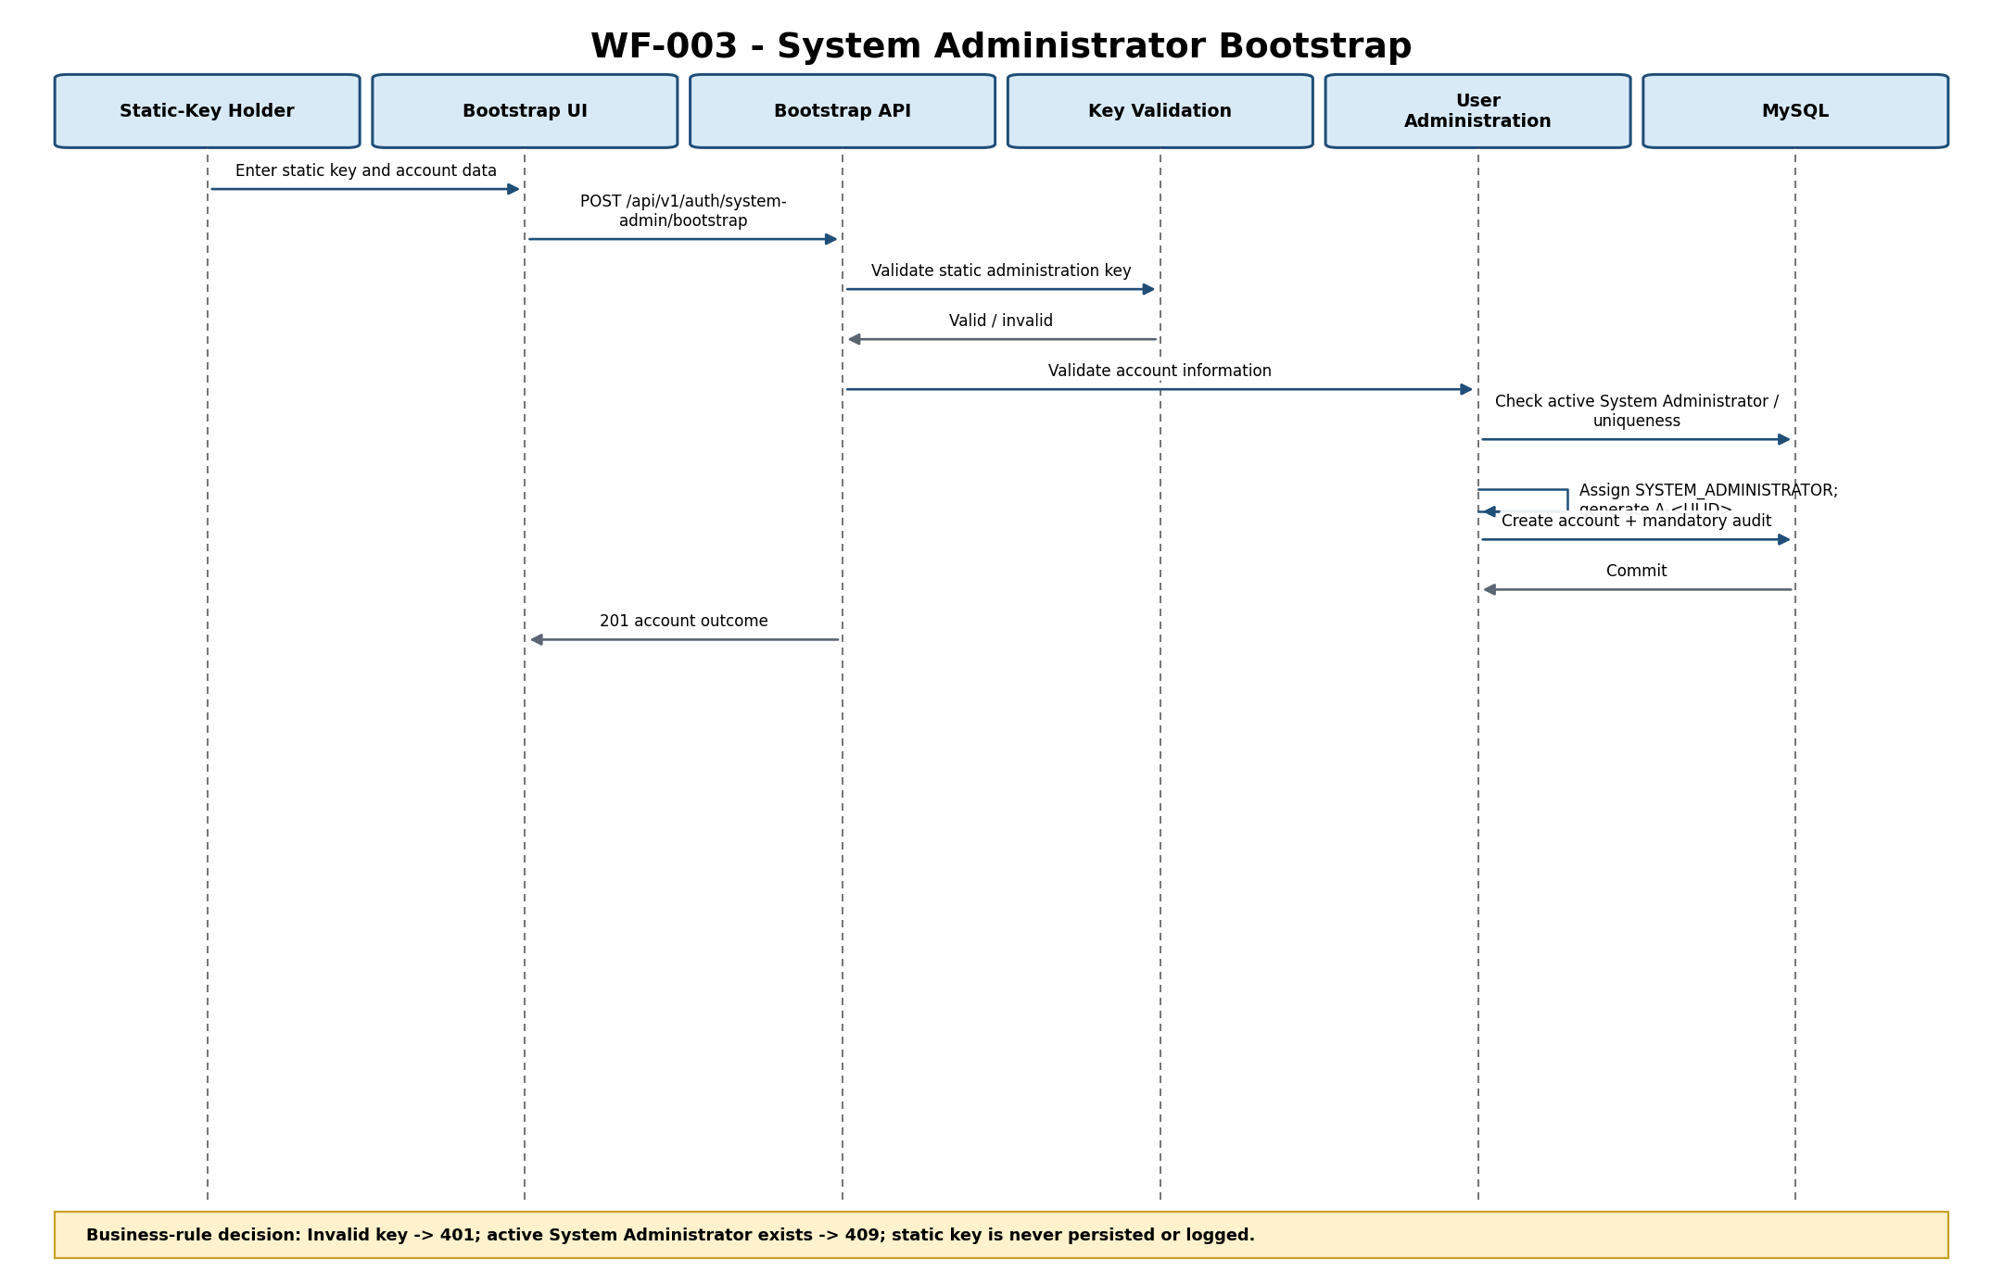
Figure 8-3 — System Administrator Bootstrap Sequence
Interaction Description: Invalid key -> 401; active System Administrator exists -> 409; static key is never persisted or logged.
Related Requirements: BP-003; FR-035; BR-021; VE-018; VE-019; NFR-003
Design Gaps / Inconsistencies: GOV-002 remains a production governance item for static-key ownership, storage, distribution, rotation/replacement, revocation and auditability.

8.5 Sequence Diagram — System Administrator Authentication
Workflow / Scenario: WF-004 — System Administrator Authentication. Primary actor: System Administrator.
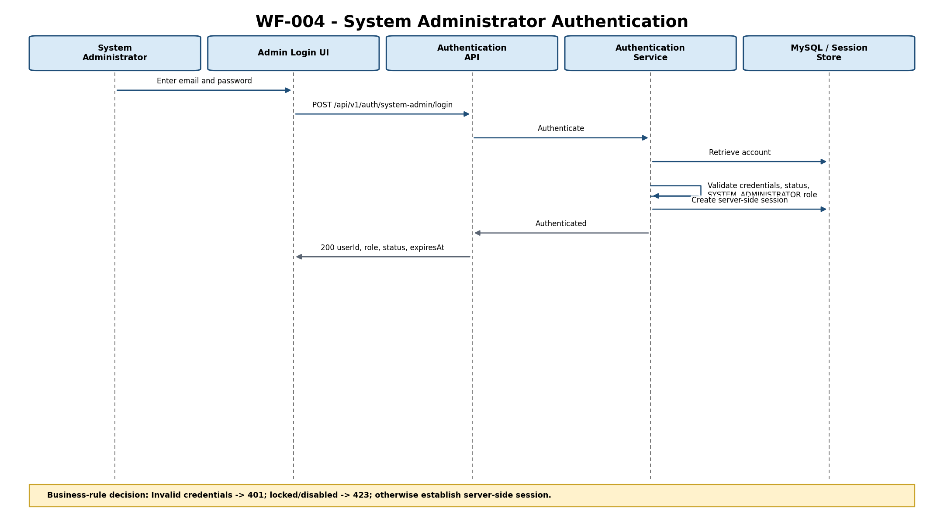
Figure 8-4 — System Administrator Authentication Sequence
Interaction Description: Invalid credentials -> 401; locked/disabled -> 423; otherwise establish server-side session.
Related Requirements: BP-004; FR-034; FR-028; VE-017; NFR-003
Design Gaps / Inconsistencies: None specific to authentication.

8.6 Sequence Diagram — Administrative User Creation
Workflow / Scenario: WF-005 — Administrative User Creation. Primary actor: System Administrator.
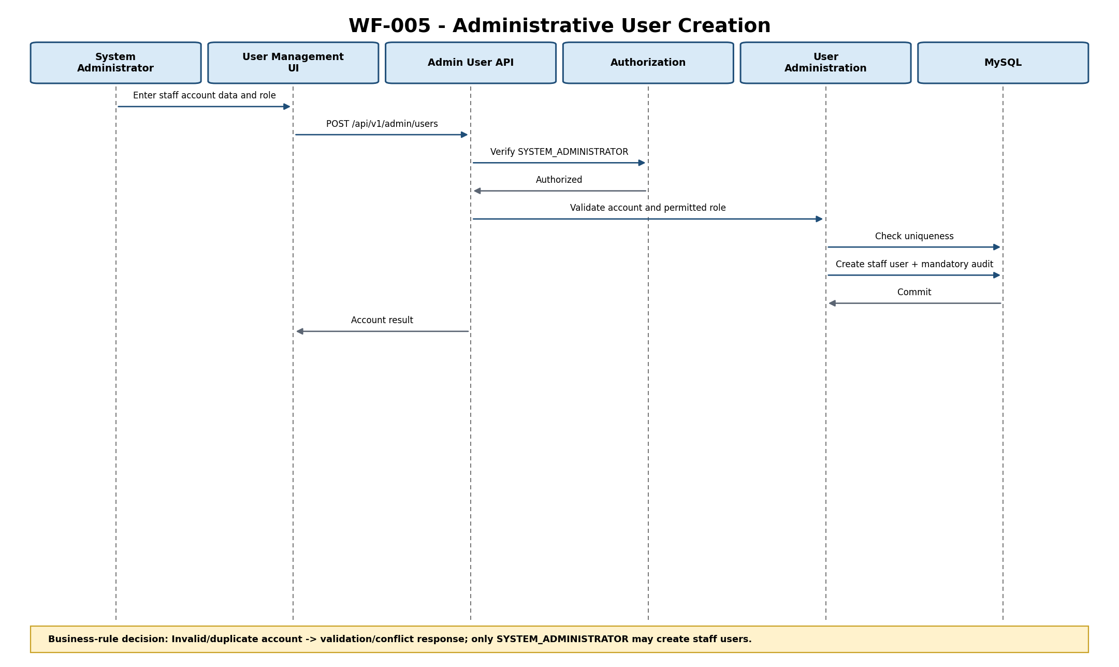
Figure 8-5 — Administrative User Creation Sequence
Interaction Description: Invalid/duplicate account -> validation/conflict response; only SYSTEM_ADMINISTRATOR may create staff users.
Related Requirements: FR-029; FR-028; DR-007; DR-008
Design Gaps / Inconsistencies: None.

8.7 Sequence Diagram — Staff Authentication
Workflow / Scenario: WF-006 — Staff Authentication. Primary actor: Training Administrator / Trainer.
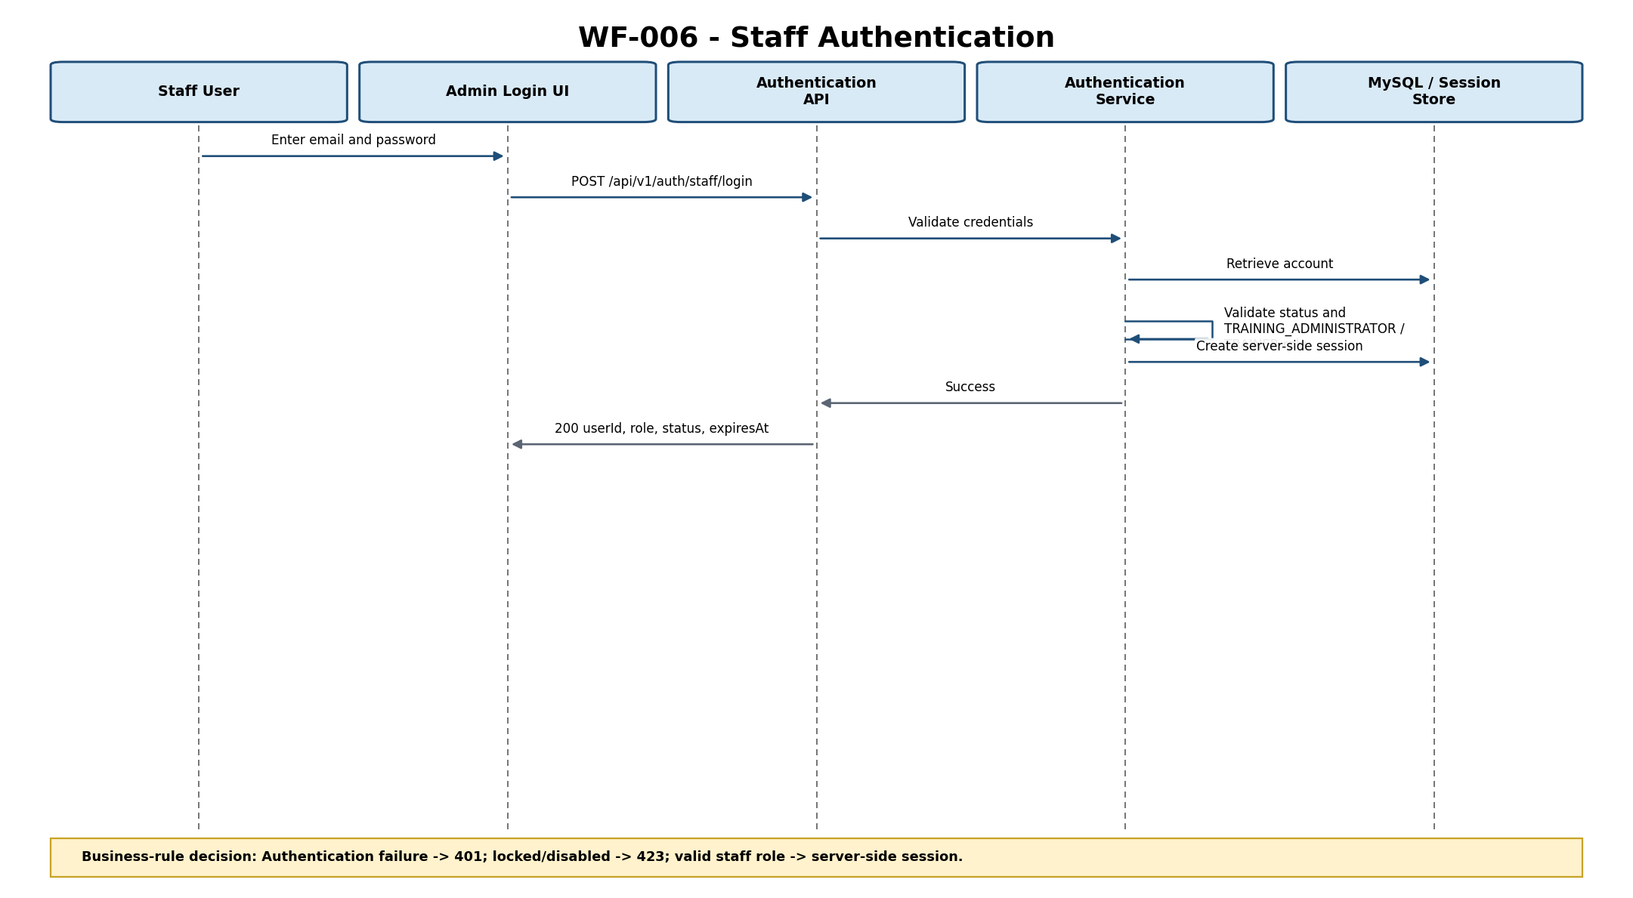
Figure 8-6 — Staff Authentication Sequence
Interaction Description: Authentication failure -> 401; locked/disabled -> 423; valid staff role -> server-side session.
Related Requirements: FR-033; FR-028; VE-017; NFR-002; NFR-003
Design Gaps / Inconsistencies: None.

8.8 Sequence Diagram — Browse Available Programs
Workflow / Scenario: WF-007 — Browse Available Programs. Primary actor: Participant.
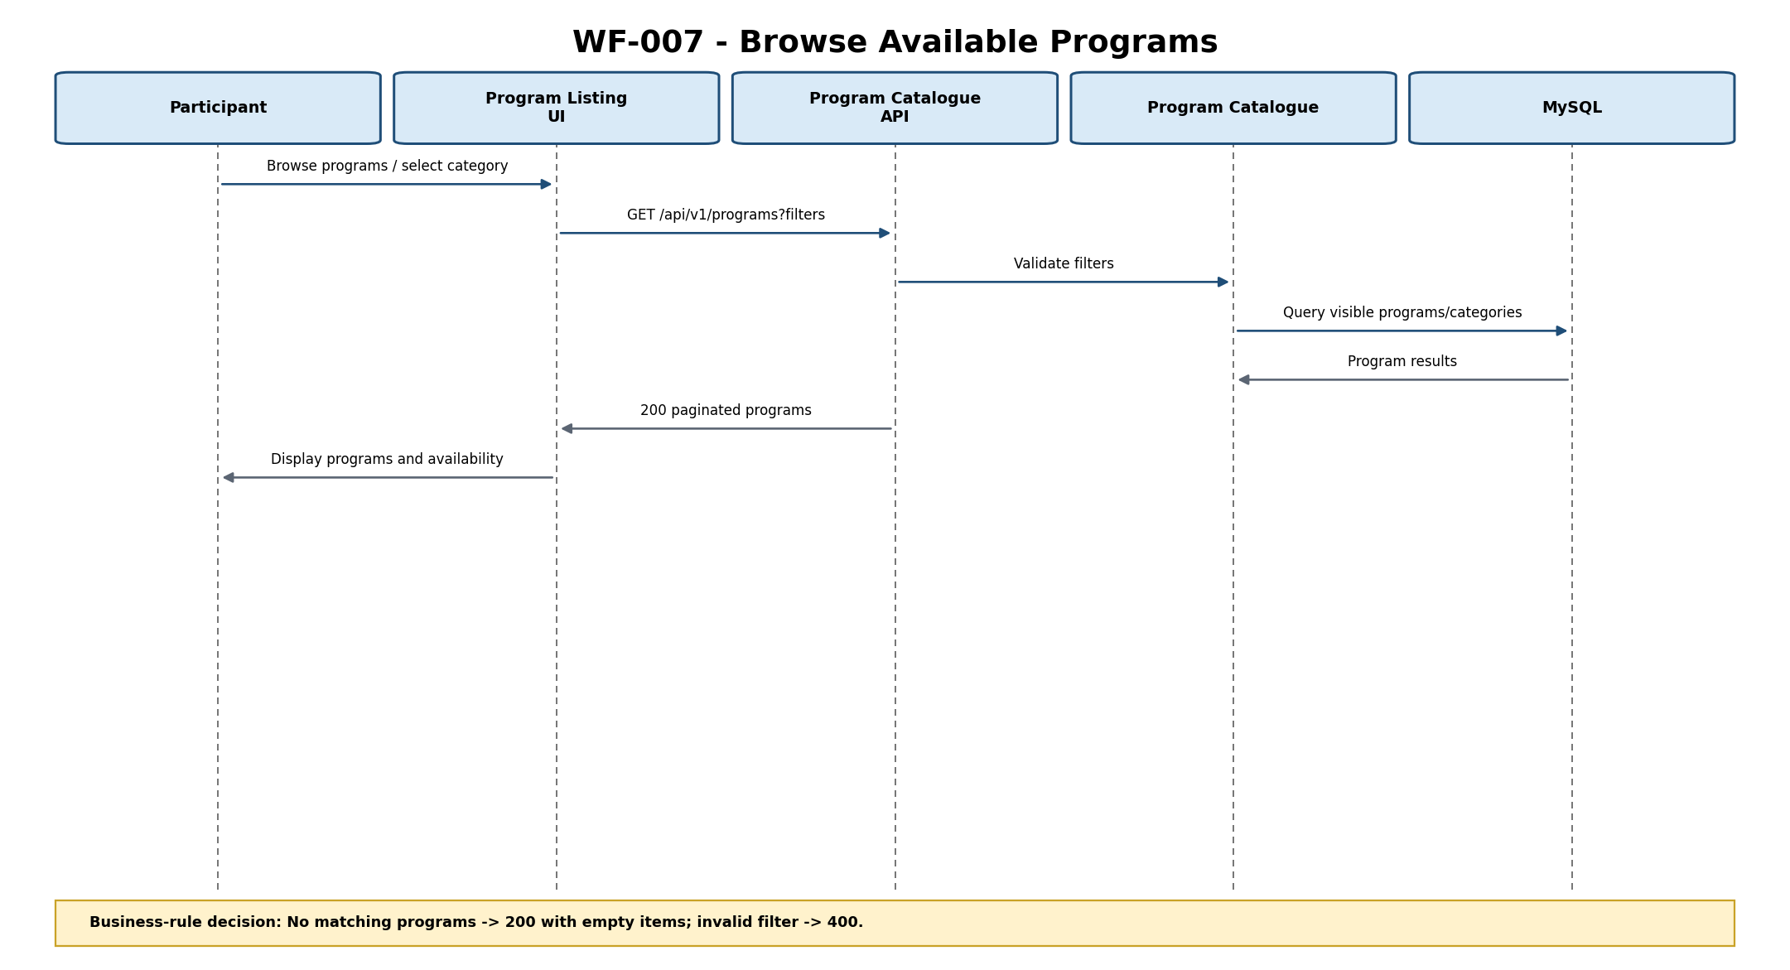
Figure 8-7 — Browse Available Programs Sequence
Interaction Description: No matching programs -> 200 with empty items; invalid filter -> 400.
Related Requirements: BP-007; FR-003; FR-004; FR-032; BR-014; VE-012; DR-002; DR-003
Design Gaps / Inconsistencies: None.

8.9 Sequence Diagram — View Program Details
Workflow / Scenario: WF-008 — View Program Details. Primary actor: Participant.
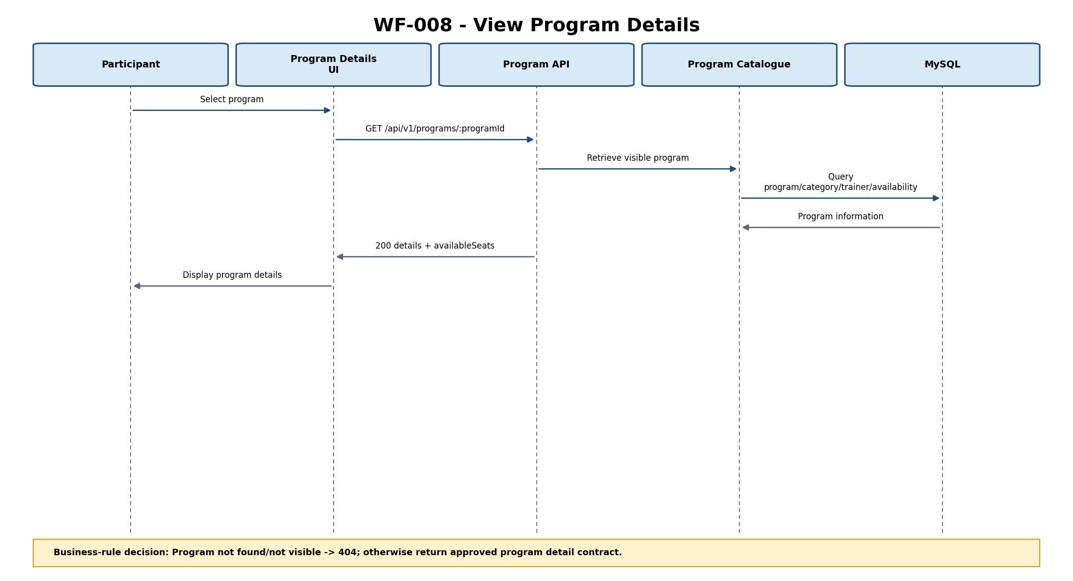
Figure 8-8 — View Program Details Sequence
Interaction Description: Program not found/not visible -> 404; otherwise return approved program detail contract.
Related Requirements: BP-008; FR-005; FR-006; FR-030; DR-002
Design Gaps / Inconsistencies: None.

8.10 Sequence Diagram — Register for Program
Workflow / Scenario: WF-009 — Register for Program. Primary actor: Participant.
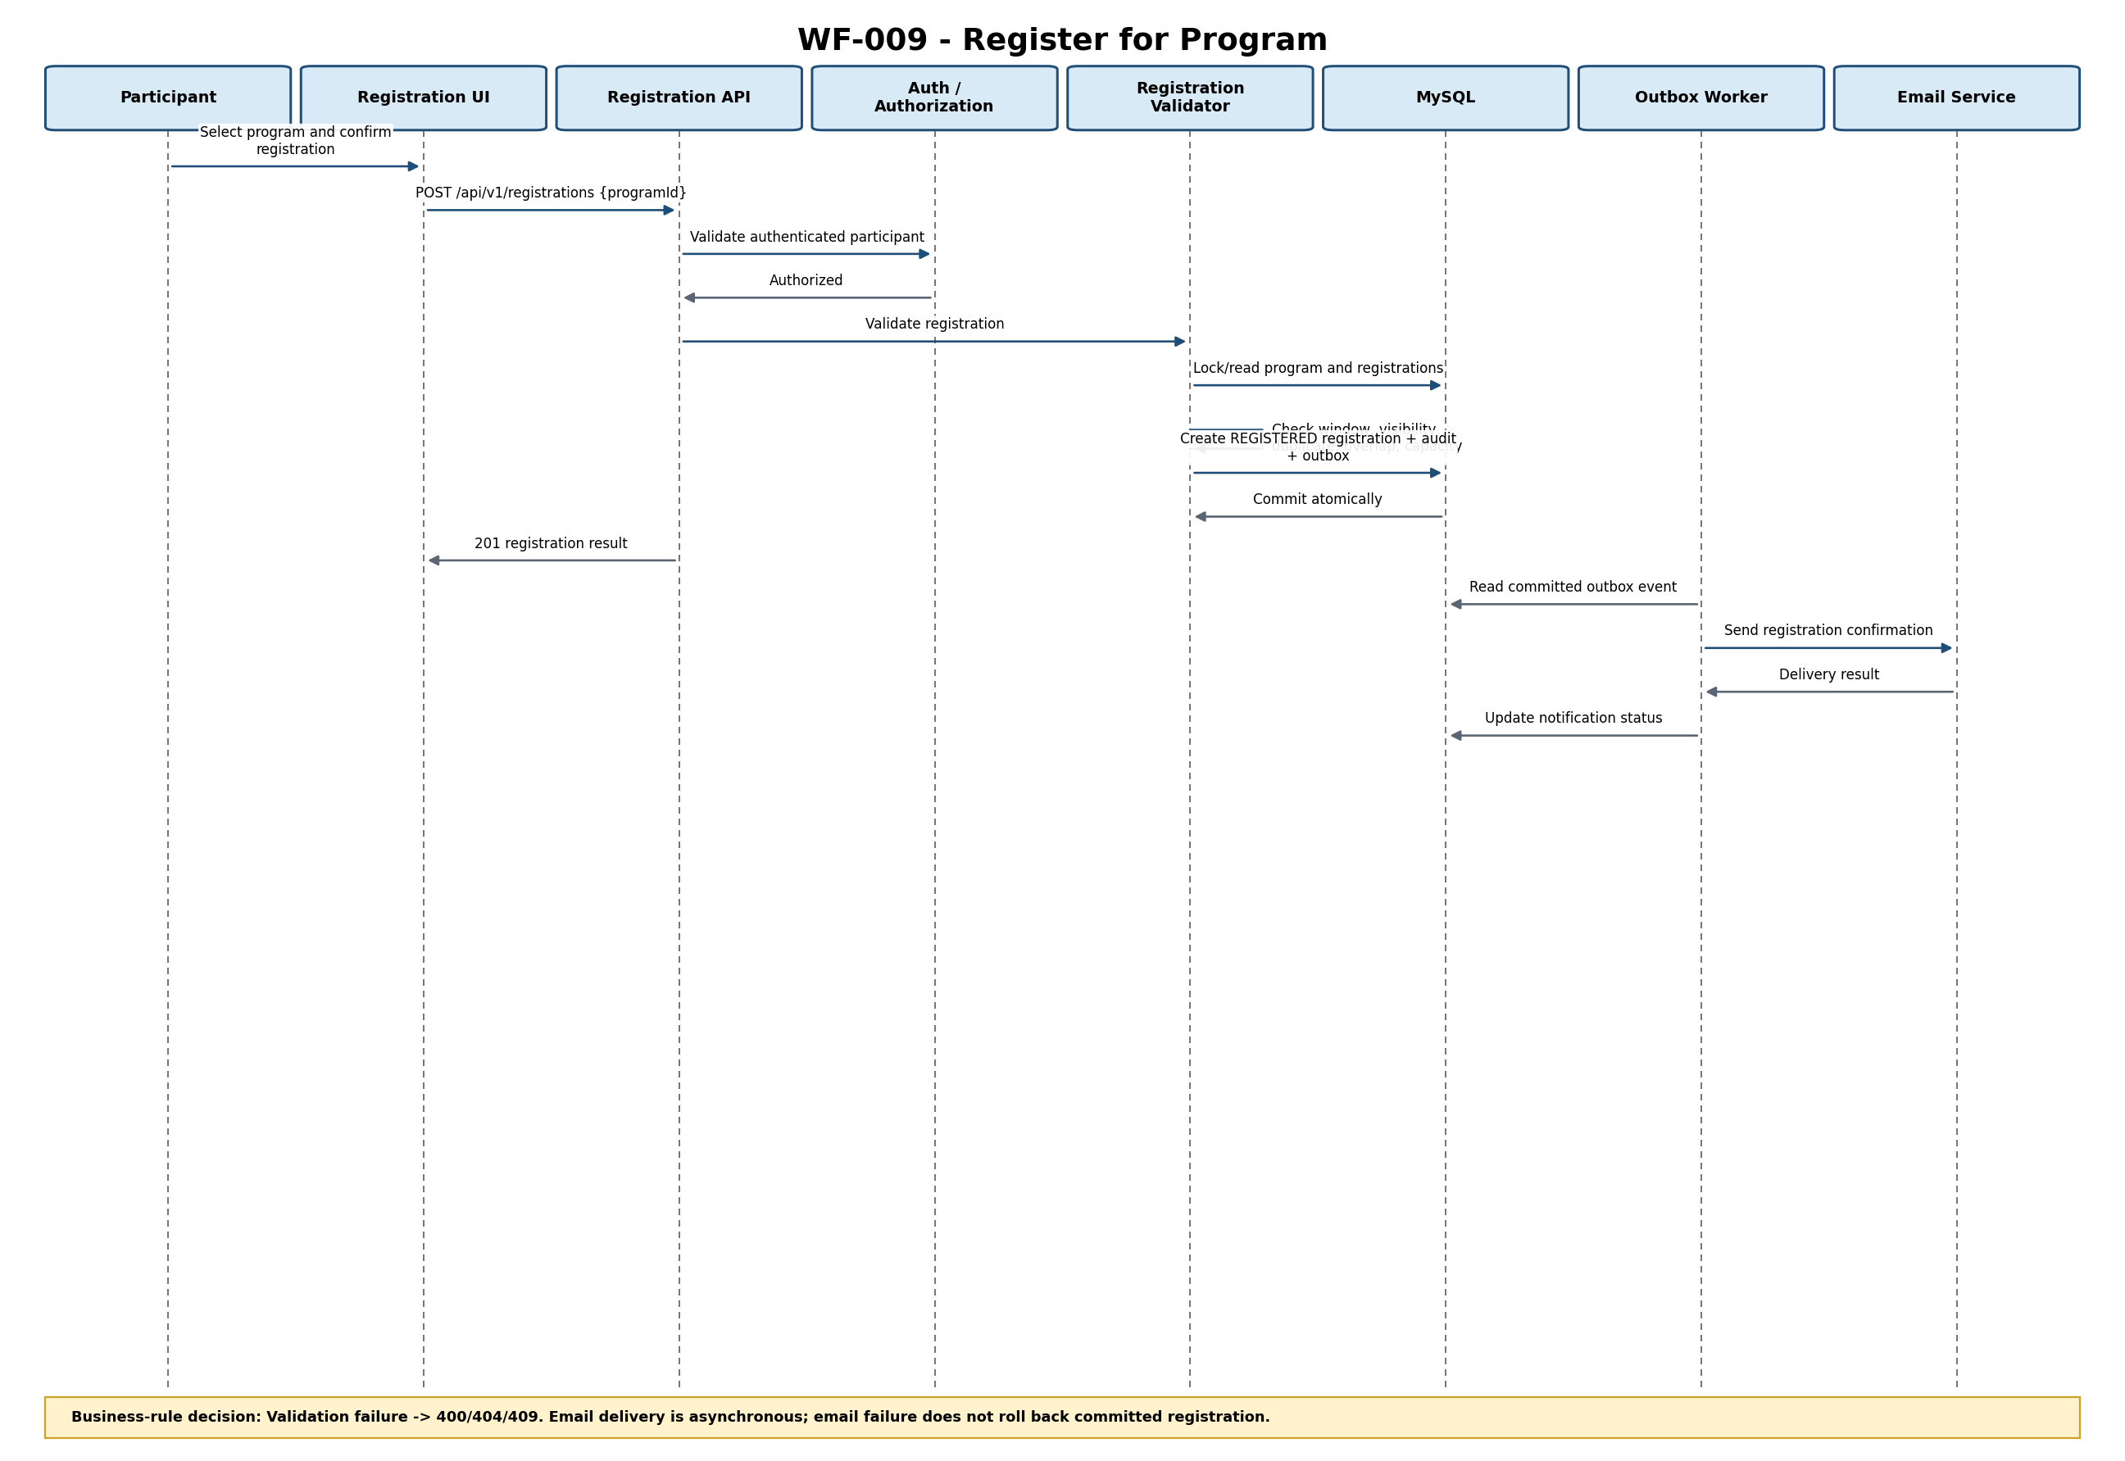
Figure 8-9 — Register for Program Sequence
Interaction Description: Validation failure -> 400/404/409. Email delivery is asynchronous; email failure does not roll back committed registration.
Related Requirements: FR-007 to FR-014; FR-030; FR-031; BR-001 to BR-009; BR-012; BR-013; VE-001 to VE-011; DR-001; DR-002; DR-004
Design Gaps / Inconsistencies: Historical CANCELLED registration does not block re-registration; only active REGISTERED uniqueness applies.

8.11 Sequence Diagram — Cancel Registration
Workflow / Scenario: WF-010 — Cancel Registration. Primary actor: Participant.
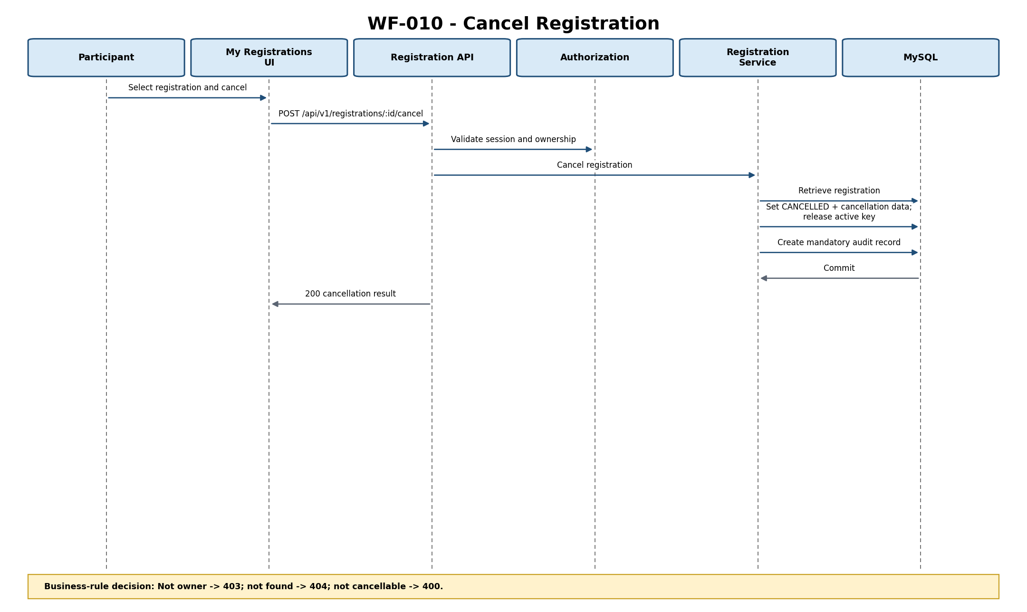
Figure 8-10 — Cancel Registration Sequence
Interaction Description: Not owner -> 403; not found -> 404; not cancellable -> 400.
Related Requirements: BP-010; FR-016; FR-017; BR-010; BR-011; BR-018; VE-007
Design Gaps / Inconsistencies: None blocking.

8.12 Sequence Diagram — Manage Training Programs
Workflow / Scenario: WF-011 — Manage Training Programs. Primary actor: Training Administrator.
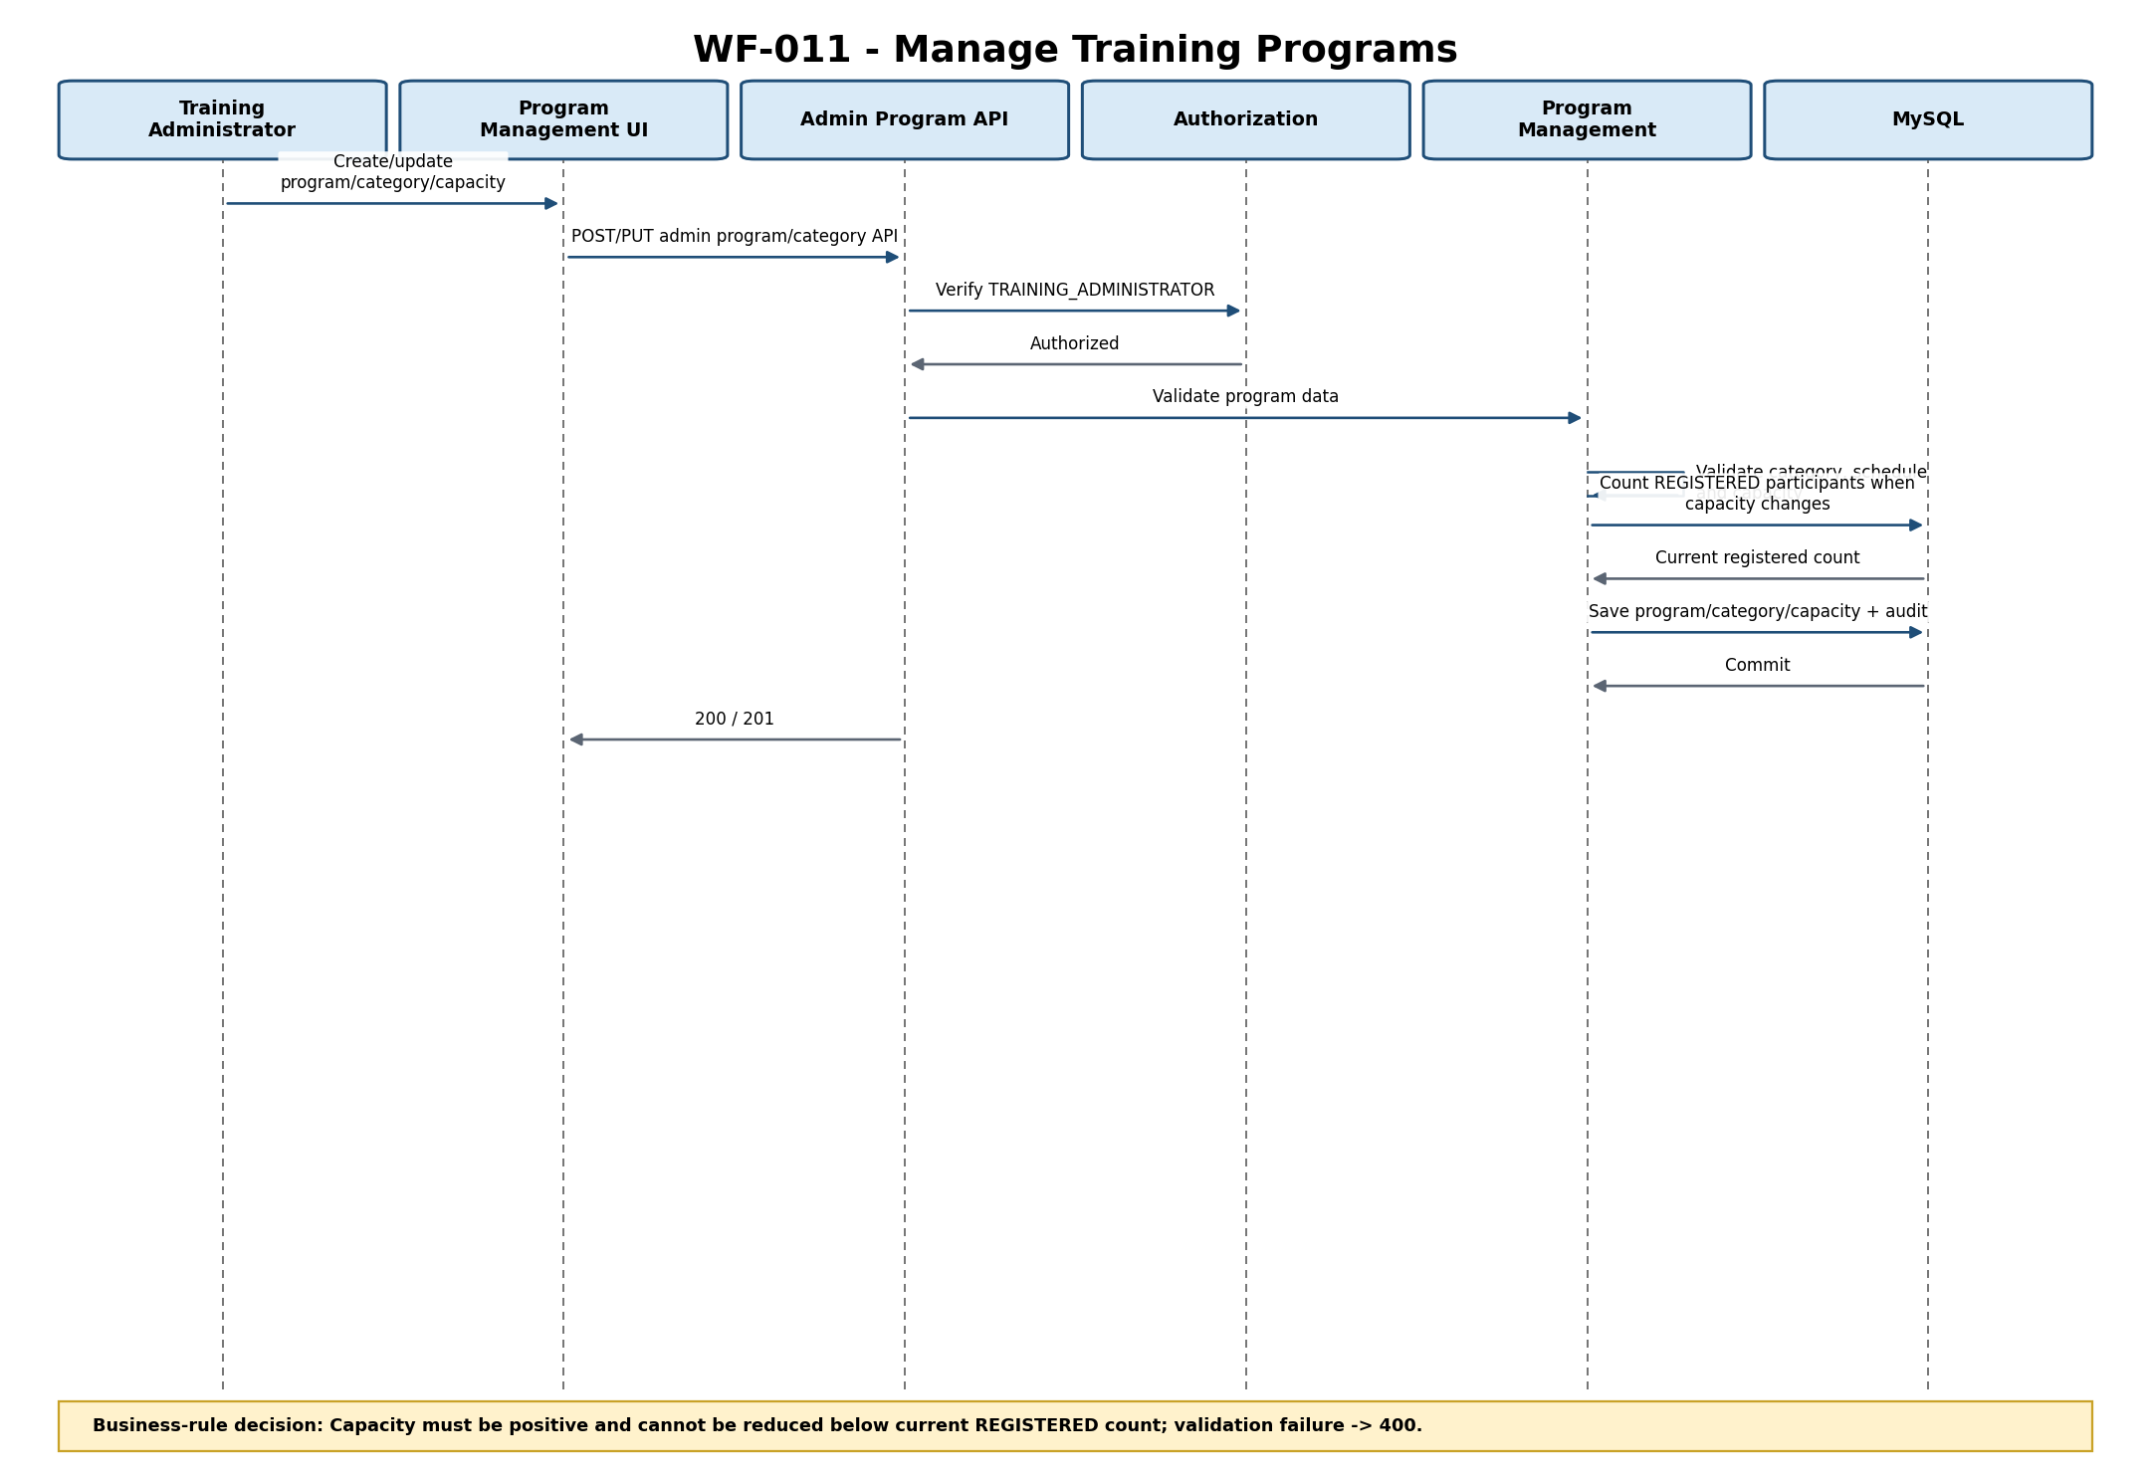
Figure 8-11 — Manage Training Programs Sequence
Interaction Description: Capacity must be positive and cannot be reduced below current REGISTERED count; validation failure -> 400.
Related Requirements: BP-011; FR-018 to FR-021; BR-003; BR-014; BR-015; NFR-005
Design Gaps / Inconsistencies: None.

8.13 Sequence Diagram — Registration Administration - View Only
Workflow / Scenario: WF-012 — Registration Administration - View Only. Primary actor: Training Administrator.
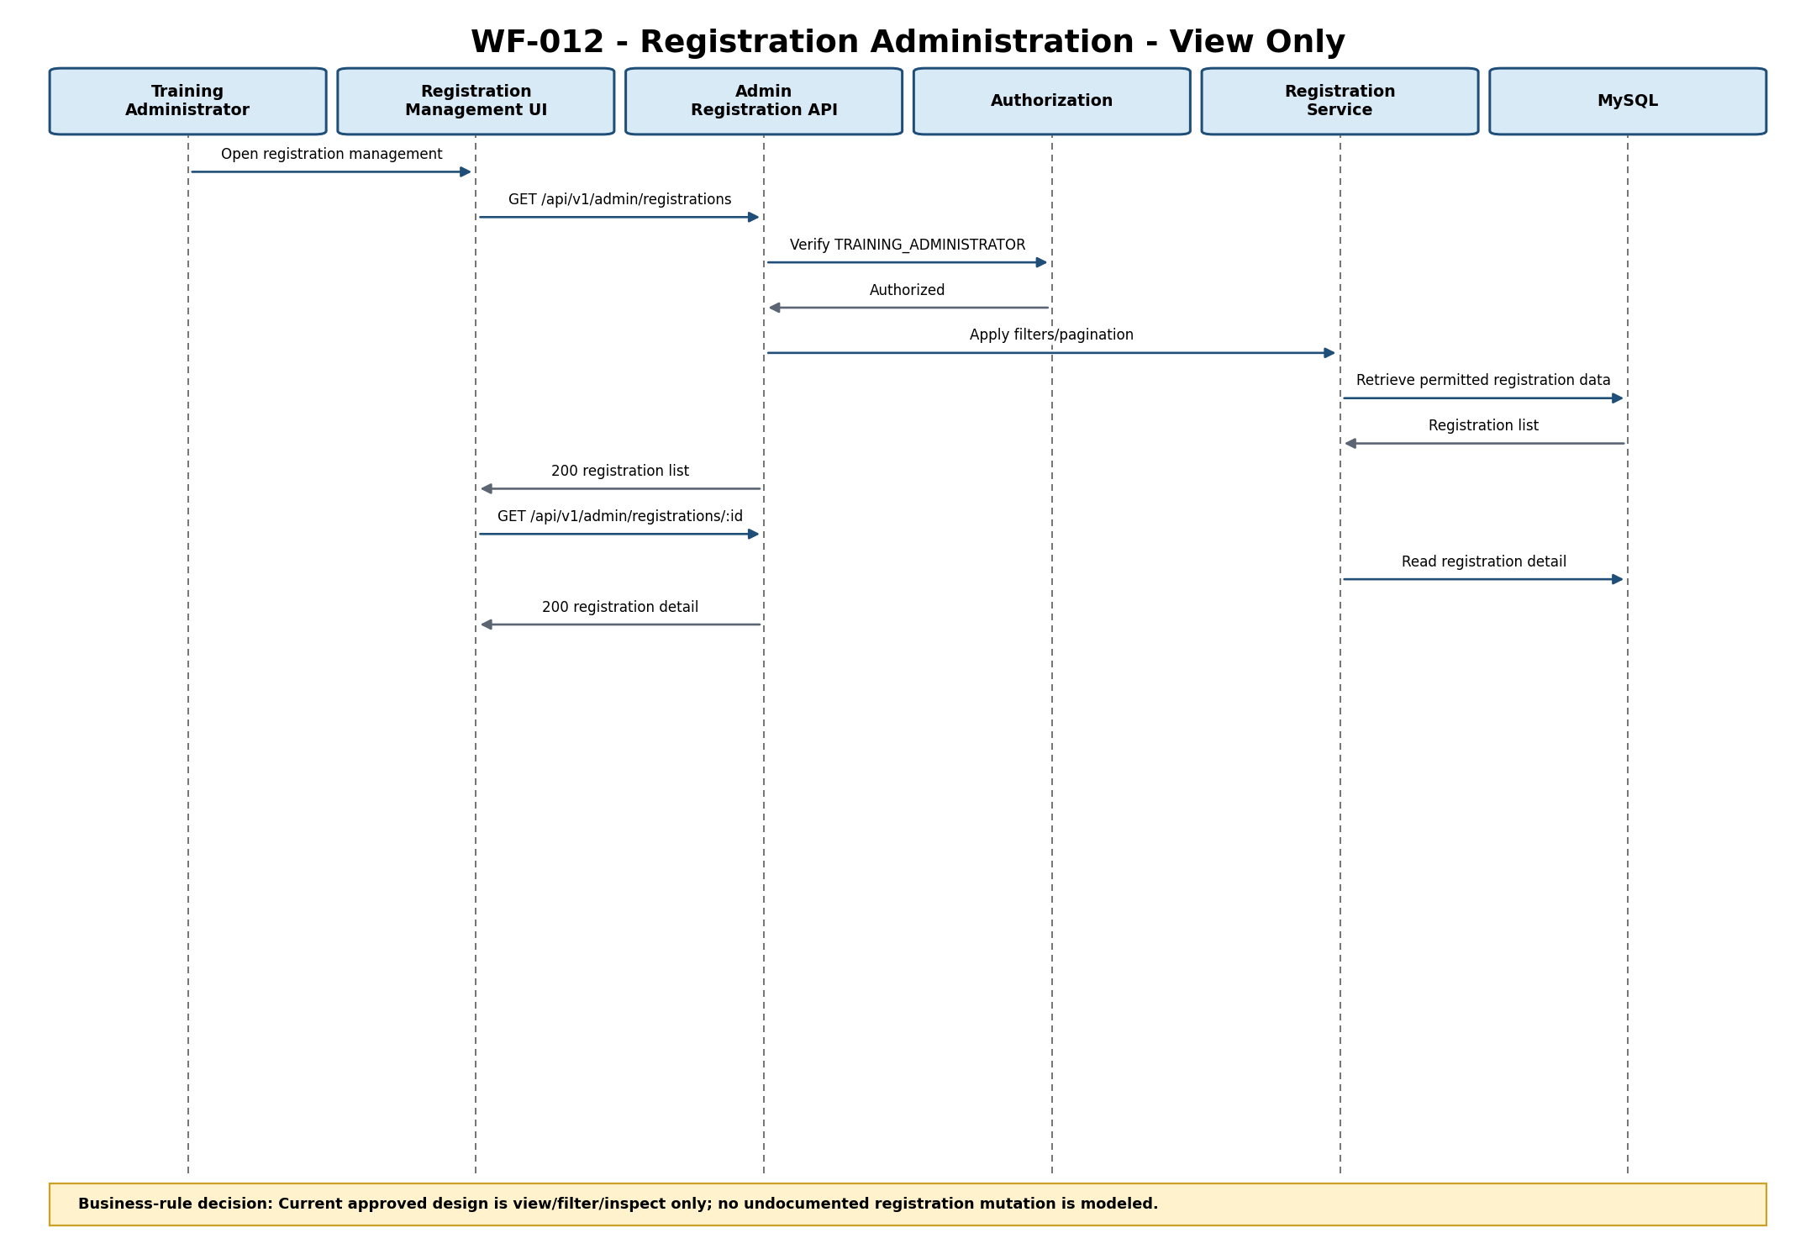
Figure 8-12 — Registration Administration - View Only Sequence
Interaction Description: Current approved design is view/filter/inspect only; no undocumented registration mutation is modeled.
Related Requirements: BP-012; FR-022; FR-028; VE-009
Design Gaps / Inconsistencies: Future Training Administrator registration mutations require controlled requirements/design change.

8.14 Sequence Diagram — Record Attendance
Workflow / Scenario: WF-013 — Record Attendance. Primary actor: Trainer.
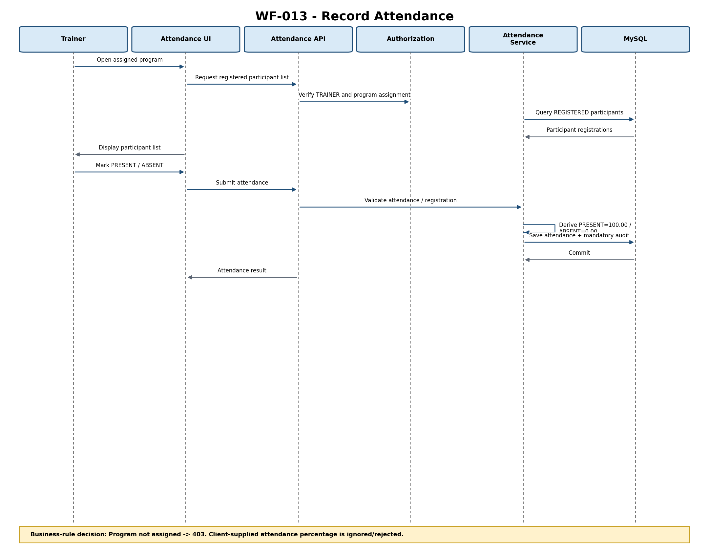
Figure 8-13 — Record Attendance Sequence
Interaction Description: Program not assigned -> 403. Client-supplied attendance percentage is ignored/rejected.
Related Requirements: BP-013; FR-023; FR-024; BR-015; BR-016; DR-005
Design Gaps / Inconsistencies: None.

8.15 Sequence Diagram — Certificate Eligibility and Issuance
Workflow / Scenario: WF-014 — Certificate Eligibility and Issuance. Primary actor: Training Administrator.
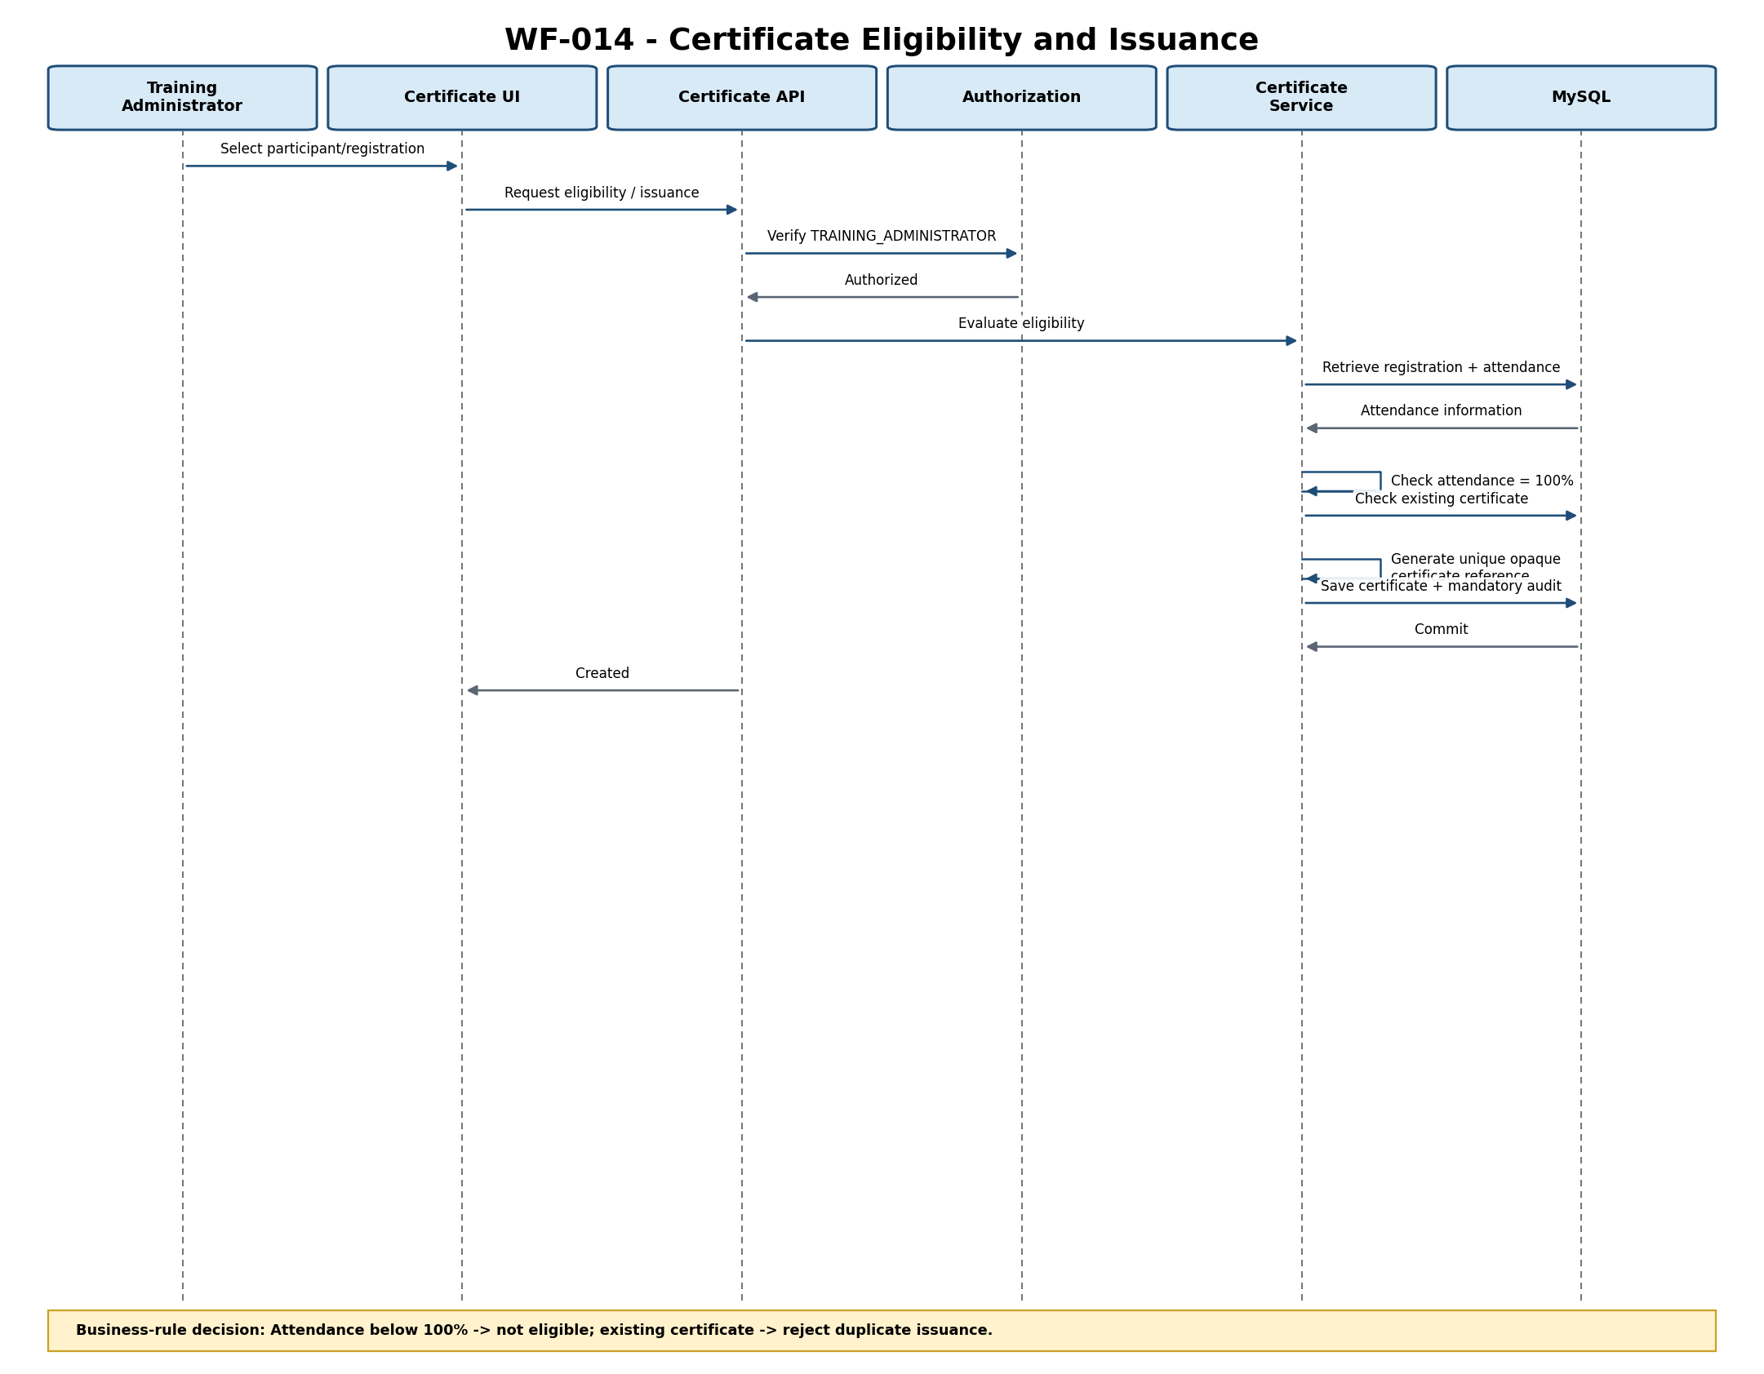
Figure 8-14 — Certificate Eligibility and Issuance Sequence
Interaction Description: Attendance below 100% -> not eligible; existing certificate -> reject duplicate issuance.
Related Requirements: BP-014; FR-025; FR-026; BR-017; VE-013; DR-006
Design Gaps / Inconsistencies: Final business-facing certificate document/number format remains subject to business confirmation.

8.16 Sequence Diagram — Generate Operational Reports
Workflow / Scenario: WF-015 — Generate Operational Reports. Primary actor: Training Administrator.
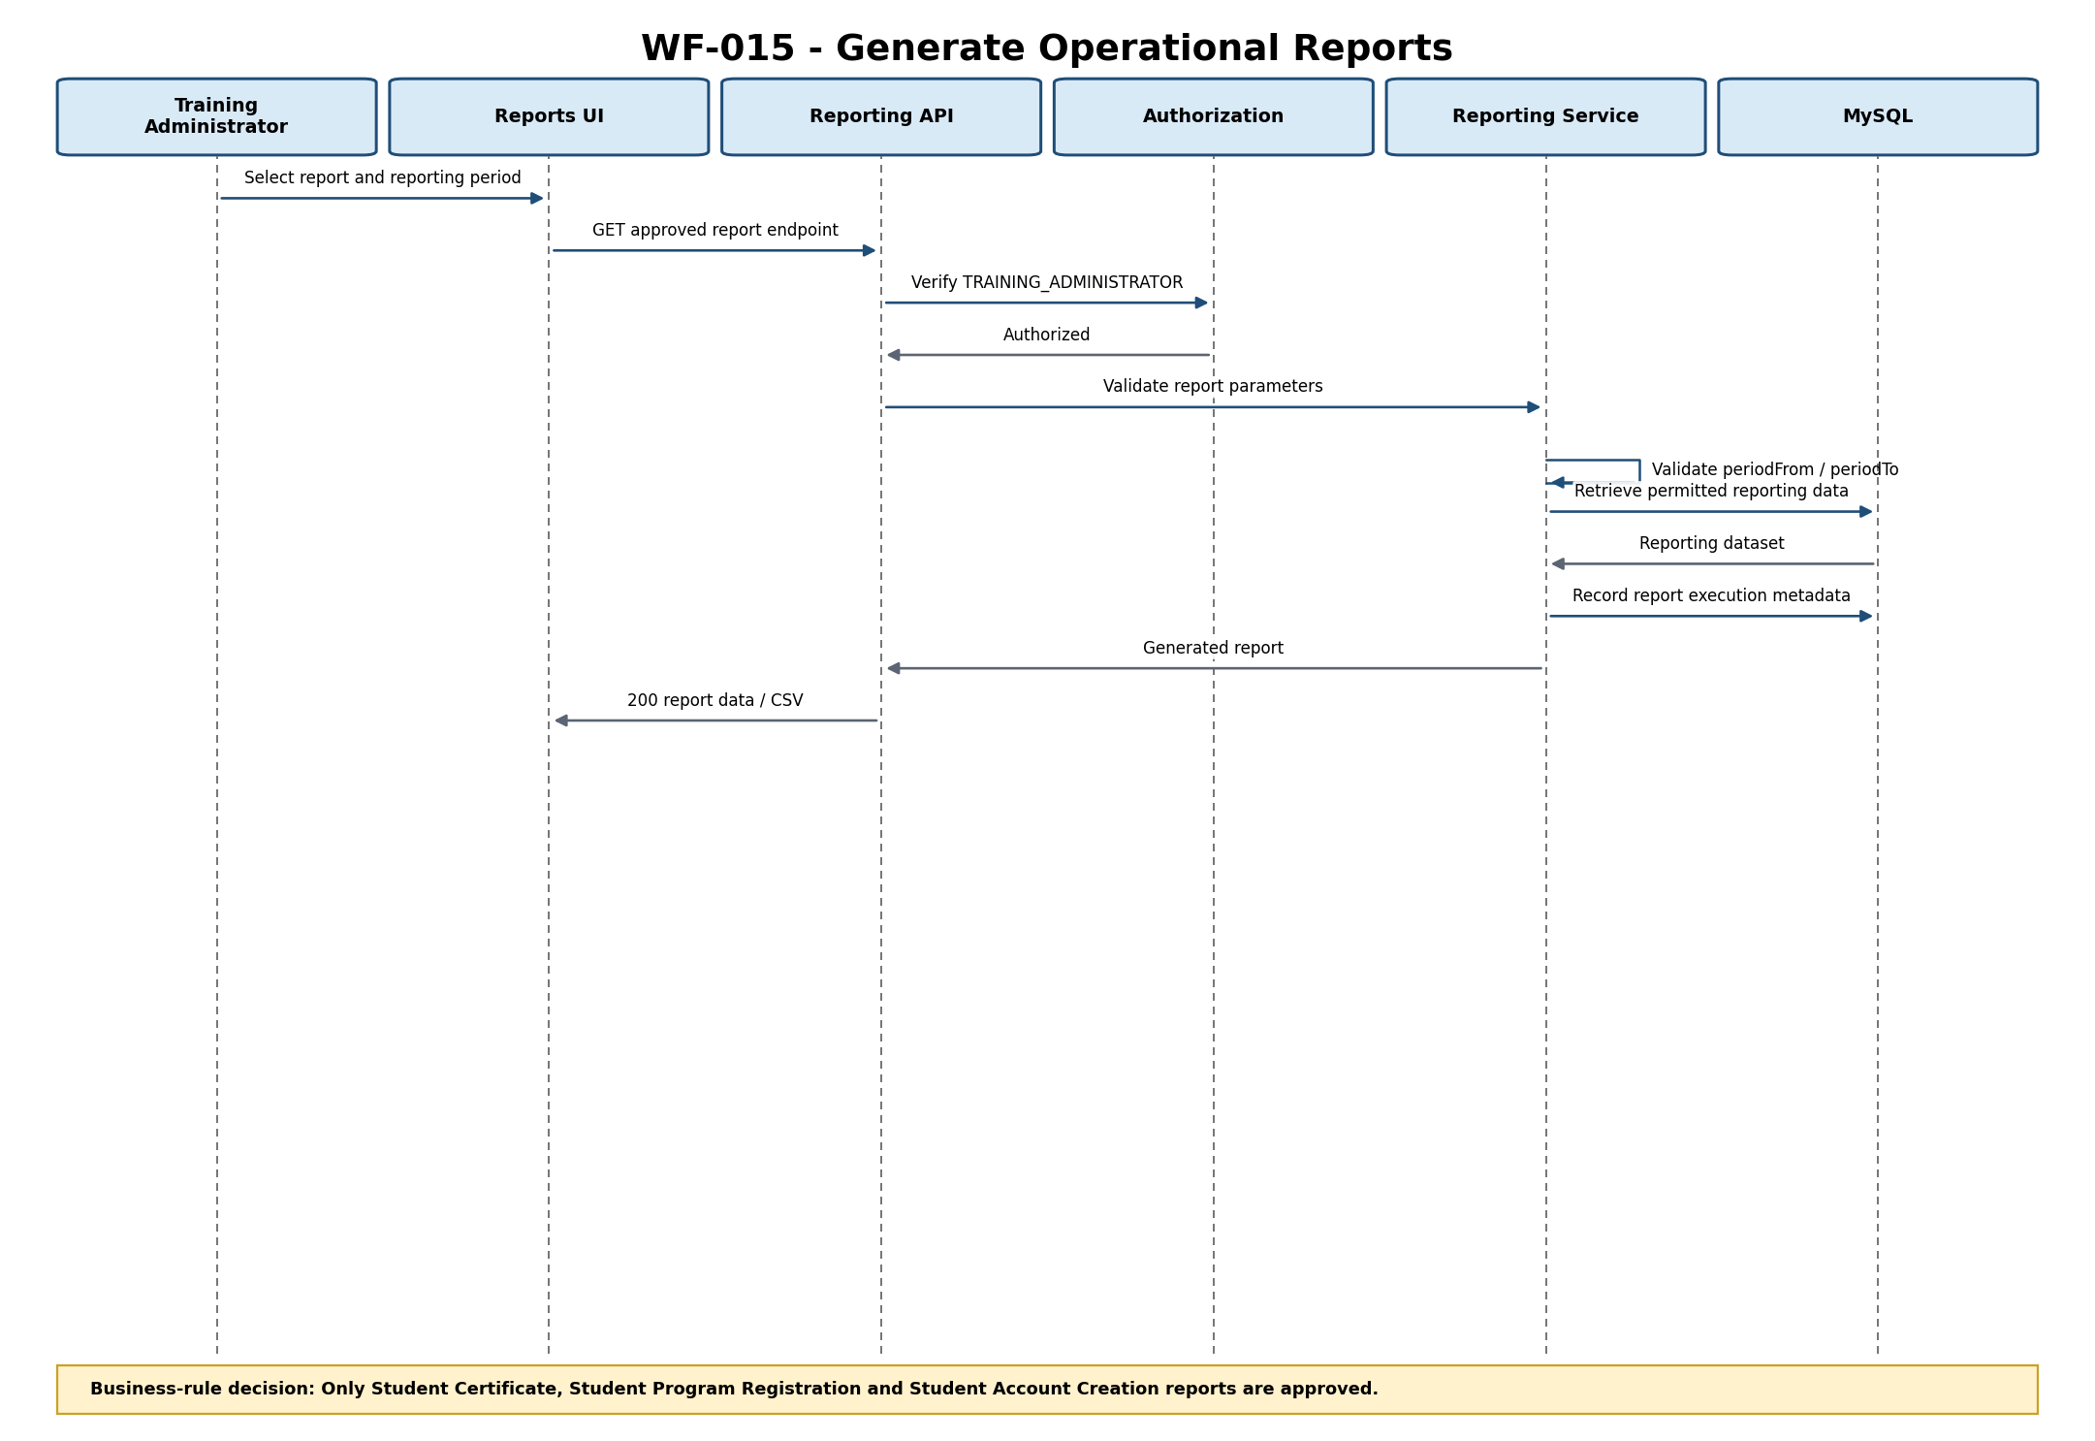
Figure 8-15 — Generate Operational Reports Sequence
Interaction Description: Only Student Certificate, Student Program Registration and Student Account Creation reports are approved.
Related Requirements: BP-015; FR-027; FR-028; DR-009; NFR-002; NFR-010
Design Gaps / Inconsistencies: No code-generation blocker; CSV is an output format, not an additional report.

8.17 Cross-Workflow Security Interaction
Purpose: Common security interaction for protected state-changing operations; this is not an additional business workflow.
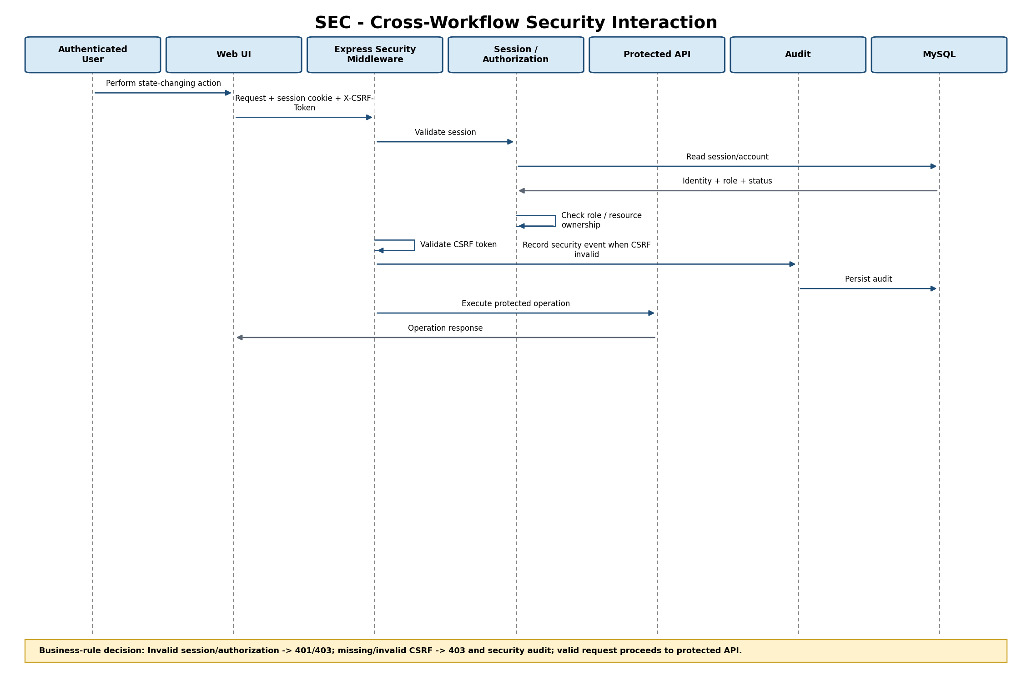
Figure 8-16 — Cross-Workflow Security Interaction
Interaction Description: Invalid session/authorization -> 401/403; missing/invalid CSRF -> 403 and security audit; valid request proceeds to protected API.
Related Requirements: NFR-001; NFR-002; NFR-003; NFR-010
Design Gaps / Inconsistencies: Common technical sequence only; not an additional business workflow.

8.18 Sequence Design Consistency Summary
The sequence diagrams are aligned to the approved Bootstrap Web UI, Express.js Web/API Layer, authentication/authorization controls, application/business modules, repository/data-access layer and MySQL data store. Registration additionally uses the approved notification outbox/worker and external Email / Notification Service. No payment, bank-transfer, HR integration, waiting-list, administrator registration approval, multi-session program, or undocumented registration-administration mutation is introduced.
Remaining items are governance or deliberately deferred scope: Malaysian privacy/compliance confirmation is a production-release gate; System Administrator static-key governance requires confirmation; approval-role segregation requires organizational confirmation; Training Administrator registration mutation beyond read-only viewing is deferred; and final business-facing certificate format/numbering remains subject to business confirmation.

9. UI Design
The following wireframes are synchronized with Training Management System UI Wireframe Specification v1.2 and represent the approved UI baseline for implementation.

9.1 UI-001 — Participant Account Creation
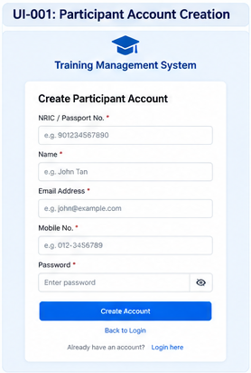
Figure 9-1 — Rendered UI-001 Wireframe

9.2 UI-002 — Participant Login
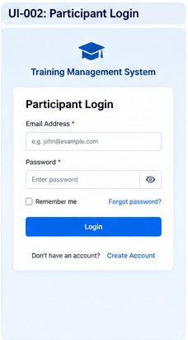
Figure 9-2 — Rendered UI-002 Wireframe

9.3 UI-003 — Program Listing
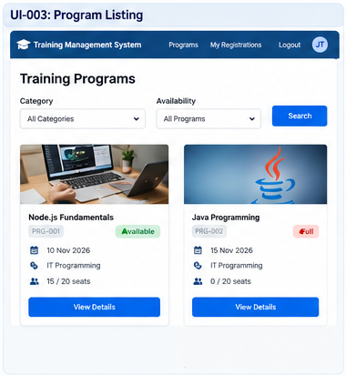
Figure 9-3 — Rendered UI-003 Wireframe

9.4 UI-004 — Program Details
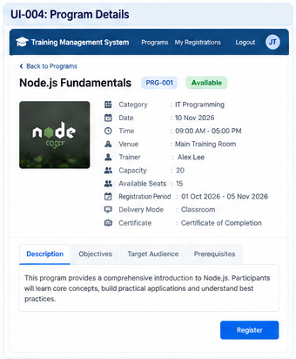
Figure 9-4 — Rendered UI-004 Wireframe

9.5 UI-005 — Registration Confirmation
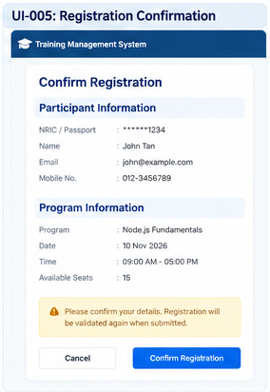
Figure 9-5 — Rendered UI-005 Wireframe

9.6 UI-006 — My Registrations
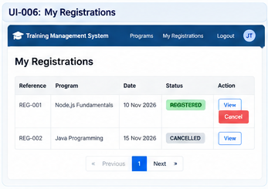
Figure 9-6 — Rendered UI-006 Wireframe

9.7 UI-007 — System Administrator Bootstrap

System Administrator Bootstrap
Static Administration Key * | [ password / secret input ]
Username * | [____________________________]
Name * | [____________________________]
Email Address * | [____________________________]
Password * | [____________________________]
[ Create System Administrator ]
Figure 9-7 — Rendered UI-007 Wireframe

9.8 UI-008 — Administrative Login
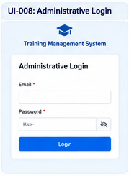
Figure 9-8 — Rendered UI-008 Wireframe

9.9 UI-009 — User Account Management
Design rule: the Create Staff Account action opens a form requiring Username, Name, Email Address, Password and Role. Username is administrator-supplied and unique; account_identifier is server-generated A-<ULID>.
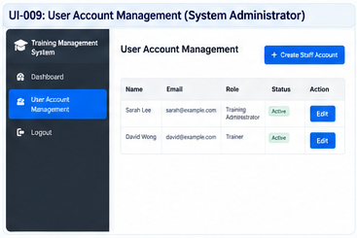
Figure 9-9 — Rendered UI-009 Wireframe

9.10 UI-010 — Program Management
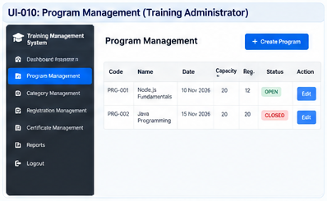
Figure 9-10 — Rendered UI-010 Wireframe

9.11 UI-011 — Category Management
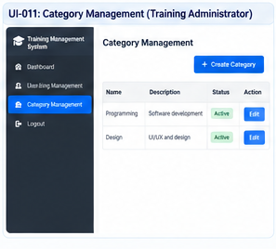
Figure 9-11 — Rendered UI-011 Wireframe

9.12 UI-012 — Registration Management
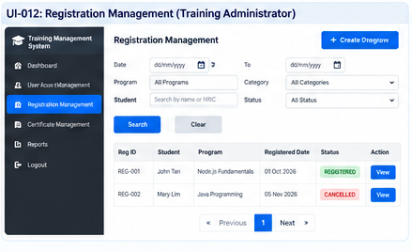
Figure 9-12 — Rendered UI-012 Wireframe

9.13 UI-013 — Attendance Management
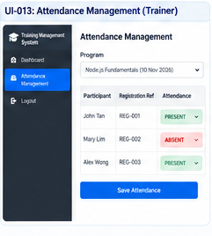
Figure 9-13 — Rendered UI-013 Wireframe

9.14 UI-014 — Certificate Management
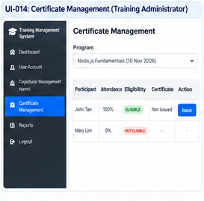
Figure 9-14 — Rendered UI-014 Wireframe

9.15 UI-015 — Reports
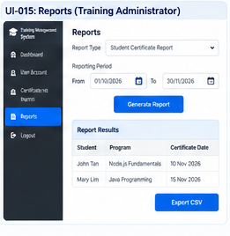
Figure 9-15 — Rendered UI-015 Wireframe

10. Non-Functional Design
The following design decisions translate the approved NFRs into implementation-level controls without changing their targets.
NFR ID | Design Decision
NFR-001 | Enforce authenticated access and server-side authorization for participant information; participants can access only their own registration information.
NFR-002 | Implement role-based authorization for Participant, Training Administrator, Trainer and System Administrator.
NFR-003 | Protect authentication credentials, the static administration key and sensitive information using Argon2id password hashing, secure database-backed sessions/cookies, CSRF controls, secret externalization and security-event controls.
NFR-004 | Handle participant personal information in accordance with applicable Malaysian privacy and organizational requirements. Technical baseline includes least privilege, NRIC/Passport masking, access classification and the confirmed indefinite participant/registration retention requirement; compliance confirmation remains a production release gate.
NFR-005 | Use transactional database operations, validation, integrity constraints and controlled updates to maintain consistent and accurate program, registration, attendance and certificate information.
NFR-006 | Design deployment and database/infrastructure controls to support at least 99% service availability on a 24/7 basis, excluding approved planned maintenance. Availability acceptance is a production/release quality gate and does not block code generation.
NFR-007 | Use indexed queries, bounded result sets, efficient DB access and asynchronous notification delivery. The 95% / 2-second target for normal requests under 100 concurrent logged-in users is retained as a recommended technical performance target pending final technical confirmation; registration is included, while report generation and external email delivery are excluded. Performance testing may be executed against this target, but formal acceptance of the target is not a code-generation blocker.
NFR-008 | Use consistent navigation, responsive Bootstrap layouts and straightforward program-to-registration navigation.
NFR-009 | Centralize validation responses and expose actionable validation messages to users.
NFR-010 | Maintain an audit history of significant administrative changes and registration actions.
NFR-011 | Size the application/database design against 2,000 Year-1 students and 100 concurrent logged-in users.
NFR-012 | Support organization-approved desktop and mobile web browsers using responsive Bootstrap UI.
NFR-013 | Keep business rules and validation behavior maintainable through centralized service/validation components with minimal unrelated impact.

11. Integrations
ID | Design Decision / Status | Related Requirement | Resolution / Implementation Baseline
DEC-001 | Privacy and personal-data control baseline | NFR-004 / GOV-001 | Governance pending — implement privacy-by-design, masked NRIC/Passport display, least privilege and controlled correction. Participant and registration data remains retained indefinitely as required by BR-018, subject to applicable law and organizational privacy/retention policy. Compliance/legal sign-off remains a release gate.
DEC-002 | System Administrator bootstrap/static-key governance | FR-035 / BR-021 / NFR-003 / GOV-002 | Governance pending — bootstrap only when no active System Administrator exists; static key is deployment-secret managed, never logged or stored in source; bootstrap is audited; rotation/replacement/revocation is controlled by deployment/security governance.
DEC-003 | Role segregation | NFR-002 / GOV-003 | Closed for current scope — no approval workflow exists in the current release. Each account has one primary role. Organizational approval-role segregation applies to document governance, not an application business workflow.
DEC-004 | Certificate format/content | FR-025 / FR-026 / BR-017 | Business confirmation remains deferred for certificate document/PDF template, exact contents, business-facing numbering format and signatory. Code generation covers eligibility and issuance records. For the current implementation, an opaque unique certificate reference (UUID/ULID-compatible value) is generated at issuance and stored in certificate_number; it is unique, immutable after issuance and satisfies the mandatory certificate-number field without inventing a business serial format.
DEC-005 | Performance target | NFR-007 / DEC-008 | Recommended technical target — 95% of normal requests within 2 seconds under 100 concurrent logged-in users; registration included; report generation and external email delivery excluded. Final technical confirmation of this target remains pending; performance testing may use it as the test baseline, but target acceptance does not block code generation.
DEC-006 | Credential storage | NFR-003 / DR-007 | Closed technical baseline — Argon2id password hashing with unique salts; server-side database-backed sessions; secure HttpOnly/SameSite cookies; CSRF protection; failed-login lockout controls; secrets externalized; no plaintext or reversible credential storage.
DEC-007 | Technology baseline | Architecture / technology constraints | Closed technical baseline — Node.js 24 LTS, Express.js 5.2.x, Bootstrap 5.3.x, MySQL 8.4 LTS, server-rendered HTML/Bootstrap/browser JS, mysql2 pool.
DEC-008 | API/data contract baseline | Architecture / implementation readiness | Closed technical baseline — REST-style JSON under /api/v1; every implemented endpoint has an explicit method/path, field-level request rules, field-level response shape, HTTP statuses, authentication, authorization and shared error/pagination/time/CSRF rules; report periodFrom/periodTo are mandatory; correlation IDs are returned on every response.
DEC-009 | Testing baseline | NFR-013 / UAT coverage | Closed technical baseline — unit, API, repository/transaction, MySQL integration, RBAC/security, concurrency, migration and performance tests against the approved traceability matrix.
DEC-010 | Training Administrator registration-management action set | FR-022 | Business clarification remains deferred — the Requirements Analysis permits Training Administrator registration-management actions but does not enumerate specific mutations. For code generation, OP-016 is limited to viewing registrations; no undocumented mutation is invented. No mutation endpoint is exposed. Any future permitted mutation requires controlled requirements/design change. This does not block code generation of the confirmed current-release scope.
DEC-011 | Registration re-registration after cancellation | BR-007 / BR-010 / BR-018 / NFR-005 | Controlled current-release design decision — a CANCELLED historical registration does not block a later registration for the same program. The active-registration uniqueness key therefore applies only to REGISTERED rows. Historical cancellation records remain retained. This resolves the ambiguity between the duplicate-registration rule and cancellation behavior without changing the retained registration history. Business confirmation may change this through controlled requirements/design change before production, but it does not block code generation.
DEC-012 | Attendance percentage calculation | BR-015 / BR-016 / BR-017 / NFR-005 | Closed technical baseline — each program has one scheduled occurrence. Attendance percentage is derived server-side as 100.00 for PRESENT and 0.00 for ABSENT. Client-supplied percentage is not authoritative. This directly supports the confirmed 100% attendance certificate eligibility rule and avoids introducing an unsupported multi-session calculation model.
DEC-013 | Unified authenticated account identity | FR-001 / FR-002 / FR-028 / NFR-003 / DR-007 / DR-008 | Closed technical baseline — all authenticated principals use the users table as the authentication/session/audit identity. Participant account creation creates a users record with canonical role code PARTICIPANT and a participant profile linked by participants.user_id in one transaction. Participant credentials, account status and last-login information are maintained in users; participant-facing profile data remains in participants. sessions.user_id and audit_records.actor_user_id therefore support Participant, Trainer, Training Administrator and System Administrator consistently. The participant-account defaults and one-to-one relationship are finalized in DEC-014, while system-originated audit attribution is finalized in DEC-015. No separate participant credential store is used.
DEC-014 | Participant account identifier, username and role defaults | FR-001 / DR-007 / NFR-002 / NFR-003 | Closed technical baseline — participant self-registration uses defined server-side generation rules: account_identifier=P-<ULID> and username=participant-<ULID>; both values are unique, opaque and immutable and are not deterministic values derived from participant input. role_id and role_name use only the canonical code PARTICIPANT; account_status is initialized to ACTIVE; role_assigned_at equals created_at; permissions, access_scope and permitted_responsibilities are derived from the PARTICIPANT role. Role display labels are UI-only and are not persisted as alternate role codes. The users row, linked participants row and account-creation audit event are created in one transaction: validate uniqueness, generate user_id/account_identifier/username, resolve role defaults, create users, create participants, create audit event, then commit; any failure rolls back the complete transaction. For System Administrator, Training Administrator and Trainer accounts, account_identifier=A-<ULID> is server-generated, unique, opaque and immutable; usernames for these roles remain administrator-supplied and unique. Authentication API responses expose the canonical role in the role field; role_name remains the canonical persisted database field.
DEC-015 | Reserved technical audit actor | DR-008 / NFR-010 / NFR-003 | Closed technical baseline — system-originated audit events use a reserved users record with canonical role code SYSTEM_ADMINISTRATOR, account_status=DISABLED, authentication_method=SYSTEM and non-interactive access. The technical audit actor cannot authenticate, is excluded from normal user-management APIs, is not an active System Administrator, and is provisioned by the initial migration with generated opaque user/account identifiers and a generated unusable password_hash value. No known/default password is stored, no usable interactive credential is issued, and authentication middleware rejects the account because it is DISABLED and SYSTEM. The actor exists only to satisfy the mandatory audit_records.actor_user_id FK for system-originated events.
DEC-016 | Student Account Creation Report Created By derivation | DR-009 / FR-027 / NFR-010 | Closed technical baseline — Created By is a business-facing report presentation value derived from the successful account-creation audit event and is not stored as a duplicate participant-profile field. For participant self-registration, Created By is the fixed value SELF-REGISTRATION; the corresponding audit actor is the reserved technical audit actor. SELF-REGISTRATION is never written to audit_records.actor_user_id. For administrator-created Training Administrator/Trainer accounts, Created By is the authenticated creator account_identifier derived from audit_records.actor_user_id. The audit actor identity and the report presentation value therefore remain distinct and type-safe.

12. Requirement Traceability

12.1 Functional Requirement Traceability
Requirement ID | Design Element | Entity | Operation/API | Validation
FR-001 | Participant Account Module | Participant | OP-001 | VE-014, VE-015
FR-002 | Authentication Module | Participant / User Role | OP-002 | VE-016
FR-003 | Program Catalogue | Training Program | OP-007 | VE-012
FR-004 | Category Filtering | Program Category | OP-007 | —
FR-005 | Program Details | Training Program | OP-008 | VE-006
FR-006 | Availability Display | Training Program | OP-008 | VE-003, VE-006
FR-007 | Registration Module | Registration | OP-009 | VE-008
FR-008 | Participant Data | Participant | OP-001 / OP-009 | VE-001, VE-002
FR-009 | Registration Validation | Registration | OP-009 | VE-001, VE-002
FR-010 | Duplicate Validation | Registration | OP-009 | VE-004
FR-011 | Capacity Validation | Program / Registration | OP-009 | VE-003
FR-012 | Schedule Validation | Registration / Program | OP-009 | VE-005
FR-013 | Registration Creation | Registration | OP-009 | VE-011
FR-014 | Notification | Registration / Email | OP-009 | —
FR-015 | My Registrations | Registration | OP-010 | Authorization
FR-016 | Cancellation | Registration | OP-011 | VAL-022 / VE-007
FR-017 | Registration Immutability | Registration | OP-011 | VE-007
FR-018 | Program Management | Training Program | OP-012 | Program validation
FR-019 | Program Update | Training Program | OP-013 | Program validation
FR-020 | Category Management | Program Category | OP-014 | Category validation
FR-021 | Program Capacity Management | Training Program | OP-015 / PUT /api/v1/admin/programs/:programId | Capacity validation / VAL-033
FR-022 | Registration Administration | Registration | OP-016 / admin registration view | VE-009, VAL-032
FR-023 | Attendance | Attendance | OP-017 | Registration/role validation
FR-024 | Attendance Maintenance | Attendance | OP-017 | Registration validation
FR-025 | Certificate Issuance | Certificate | OP-018 | VE-013
FR-026 | Certificate Maintenance | Certificate | OP-018 | VE-013
FR-027 | Reporting | Report / Reporting Data | OP-019–OP-021 | Authorization
FR-028 | RBAC | User Role / Access | Authorization layer | VE-009
FR-029 | Admin User Creation | User Role / Access | OP-005 | Account validation
FR-030 | Program Availability | Training Program | OP-009 | VE-006
FR-031 | Registration Error Handling | Registration | OP-009 | VE-001–VE-011
FR-032 | No Programs Message | Program Catalogue | OP-007 | VE-012
FR-033 | TA/Trainer Login | User Role / Access | OP-006 | VE-017
FR-034 | System Administrator Login | User Role / Access | OP-004 | VE-017
FR-035 | Static Key Bootstrap | User Role / Access | OP-003 | VE-018, VE-019
Physical MySQL schema | Approved — implementation baseline
Complete API contracts | Approved — implementation baseline
Authentication / security | Approved — implementation baseline
Permission matrix | Approved — implementation baseline
Testing baseline | Approved — implementation baseline
Design gaps | Dispositioned — technical design items required for the confirmed code-generation scope are closed. DG-001 to DG-005 remain explicit production/release governance or deferred-feature gates, DG-006 is closed technical design, DG-007 is a scoped business clarification, and DEC-011 through DEC-016 explicitly close the current-release re-registration, attendance calculation, unified authenticated account identity, participant account defaults/role codes, technical audit actor and report Created By behavior. None of these items blocks code generation. Compliance/privacy approval remains a production-release gate only and does not block code generation.

12.2 NFR Traceability
Requirement ID | Design Element | Primary Control
NFR-001 | Authorization / Participant access | Resource ownership and access control
NFR-002 | RBAC | Role/access component
NFR-003 | Authentication / Secret Protection | Credential hashing, session security, static-key protection and secret controls
NFR-004 | Privacy | Privacy-by-design, NRIC/Passport masking, access classification and retention
NFR-005 | Database / Transactions | Integrity constraints and transactions
NFR-006 | Design deployment so availability is not dependent on a single application process; database and infrastructure availability controls shall support the 99% target. | Availability controls
NFR-007 | API / DB design | Performance optimization
NFR-008 | UI architecture | Responsive navigation
NFR-009 | Validation layer | Consistent error responses
NFR-010 | Audit Module | Audit records
NFR-011 | Capacity architecture | 2,000 students / 100 concurrent baseline
NFR-012 | Bootstrap UI | Responsive browser support
NFR-013 | Business/service layer | Centralized rules and validation
Physical Database Schema | Developed — baseline version
Permission Matrix | Developed — approved
Security / Authentication Baseline | Developed — approved
Code Generation Baseline | Developed — approved

13. Design Gaps and Governance Dispositions
ID | Design / Governance Item | Related Requirement | Disposition / Impact
DG-001 | Malaysian privacy/compliance confirmation | NFR-004 / GOV-001 | Production release gate only. Technical privacy controls, masking, access control and retention baseline are defined. Compliance/Privacy confirmation is not required to start code generation and shall be completed before production release; it does not block code generation.
DG-002 | System Administrator static-key governance | FR-035 / BR-021 / NFR-003 / GOV-002 | Production operational governance gate. Deployment-secret storage, non-source-controlled handling, bootstrap audit and one-active-admin rule are defined for code generation. Operational ownership/rotation/revocation confirmation is required before production release, not before code generation.
DG-003 | Approval-role segregation | Governance / GOV-003 | Governance/document-approval item, not an application workflow. The current release has no approval feature. Formal document sign-off may require independent approvers, but this does not block code generation.
DG-004 | Certificate document format/content | DEC-004 | Deferred feature decision. 100% attendance eligibility and issuance-record implementation are closed for code generation. Certificate document/PDF template and exact document contents are excluded until business confirmation; this does not block the current implementation baseline.
DG-005 | 95% / 2-second performance target | NFR-007 / DEC-008 | Recommended technical target pending final technical confirmation. Performance tests should verify 95% of normal requests within 2 seconds under 100 concurrent logged-in users; report generation and external email delivery are excluded. Formal acceptance of this target is a production/release governance item and does not block code generation.
DG-006 | Credential representation | NFR-003 / DR-007 | Closed technical design. Argon2id, unique salts, server-side sessions, secure cookies, CSRF controls and secret externalization are defined; no plaintext/reversible credentials.
DG-007 | Training Administrator registration-management action set | FR-022 | Deferred business clarification. The Requirements Analysis does not enumerate the permitted registration-management mutations. OP-016 code-generation scope is limited to viewing registrations; no unsupported mutation endpoint is implemented. Any future permitted mutation requires controlled requirements/design change. This is a scoped business clarification and does not block code generation of the confirmed current-release scope.

13.1 Design Gap and Governance Handling
Design gaps shall not be silently resolved by implementation. Items that affect production compliance, operational governance or deferred document output are explicitly controlled as release gates and do not block code generation for the approved current-release implementation scope. Any business rule or interface required by the code-generation scope is closed in this SDD through a controlled design decision. Later governance decisions shall be incorporated through controlled document change and traceability update.

13.2 Final Implementation Decisions
Authentication: server-side database-backed sessions; secure, HttpOnly, SameSite=Lax cookies; 30-minute idle timeout; 8-hour absolute timeout; logout invalidates the session; disabled/locked accounts cannot authenticate.
Password security: Argon2id hashing with unique salts; minimum 12 characters; password must contain at least one uppercase, one lowercase, one digit and one non-alphanumeric character; five failed attempts within 15 minutes trigger a 15-minute lockout; credentials are never logged.
Account model: Participant, Training Administrator, Trainer and System Administrator are the four application roles represented by users, using canonical role codes PARTICIPANT, TRAINING_ADMINISTRATOR, TRAINER and SYSTEM_ADMINISTRATOR. Each account has one primary role. Participant account creation creates the users record with defined server-side account_identifier and username generation rules, role PARTICIPANT, ACTIVE status and role-derived permissions/access scope/responsibilities, plus exactly one linked participants profile in one atomic transaction; participant users must have exactly one participant profile and non-PARTICIPANT users must have none; sessions and audit records reference users.user_id for every authenticated principal. Account statuses are ACTIVE, INACTIVE, LOCKED and DISABLED. Only ACTIVE accounts may authenticate. A non-PARTICIPANT account must not have a participant profile. Canonical role-code rule: role_id, role_name and API role values use only PARTICIPANT, TRAINER, TRAINING_ADMINISTRATOR or SYSTEM_ADMINISTRATOR; human-readable role labels are UI-only.
Registration: status values are REGISTERED and CANCELLED. Participant cancellation is permitted before the scheduled start time, releases the active-registration key, retains the historical registration row and permits later re-registration subject to normal validation. Registration data cannot be edited after submission. The database enforces one active REGISTERED record per participant/program through a generated active-registration key. OP-016 provides Training Administrator registration viewing only in the confirmed code-generation scope; no undocumented administrative cancellation or other mutation is introduced.
Program lifecycle: DRAFT → OPEN → CLOSED → COMPLETED; CANCELLED may be entered from DRAFT, OPEN or CLOSED. OPEN is required for participant registration. Status transition matrix: DRAFT→OPEN/CANCELLED; OPEN→CLOSED/CANCELLED; CLOSED→COMPLETED/CANCELLED; COMPLETED and CANCELLED are terminal. Capacity reaching the configured limit does not create a waiting list; the program remains visible with availability shown as full.
Program change control: reducing capacity below current registered participants is rejected; changes to date/time re-run overlap and registration-window validation; cancellation retains registrations and prevents new registration. Participant notification for program changes is outside the current release unless explicitly added through requirements change control.
Attendance: one attendance record per registration; status values PRESENT or ABSENT; percentage is automatically 100 for PRESENT and 0 for ABSENT. Only Trainer may record attendance for registered participants. Participant ID and Program ID stored with attendance must match the referenced registration. Attendance changes are audited transactionally.
Certificate: eligibility is exactly 100% attendance. One certificate may be issued per registration. Certificate Type, Certificate Title, eligibility information, attendance/completion percentage, completion date and issuance information are maintained as required by DR-006. Certificate Number/Reference is mandatory once issued; its numbering format/sequence remains deferred. Certificate document/PDF generation, template, exact contents and signatory details remain deferred and are not implemented.
Reports: three required reports are available only to the Training Administrator: Student Certificate Report, Student Program Registration Report and Student Account Creation Report. The code-generation contract defines role-authorized filtering, pagination and HTML/web presentation; CSV export is included as an implementation convenience within the same three confirmed reports and does not create an additional business report requirement or expand report scope. Standard report columns are fixed in the report specifications: Certificate Report — Certificate Number, Student Name/ID, Program Code/Name, Category, Program Date, Attendance %, Certificate Status, Issue Date and Issued By; Registration Report — Registration ID, Student ID/Name, Program Code/Name, Category, Program Date, Registration Date, Registration Status, Cancellation Date and Cancellation Reason; Account Creation Report — Student ID, Name, Email, Mobile, Account Status, Created Date, Created By and Last Login. Created By is a business-facing report presentation value derived from the successful account-creation audit event under DEC-016: SELF-REGISTRATION for participant self-registration, or the authenticated creator account identifier for administrator-created accounts. SELF-REGISTRATION is never stored as audit_records.actor_user_id; the underlying participant self-registration audit event uses the reserved technical audit actor. Full NRIC/Passport is excluded from standard reports and masked values are used where operationally required. Report execution and download are auditable.
API error contract: { code, message, details, timestamp, correlationId }. Validation failures return 400, authentication failures 401, authorization failures 403, not found 404, conflicts 409, unexpected server failures 500. Error messages do not expose secrets or unnecessary personal data.
Pagination: list endpoints default to 20 records, maximum 100. Supported list operations provide deterministic sorting with an explicit allow-list and server-side filtering. Program listing supports category and availability filters; registration lists support date/program/category/student/status; report lists support approved report-specific filters. No unbounded list endpoint is exposed.
Time handling: all persisted timestamps are stored in UTC using DATETIME values representing UTC. Program schedule DATE/TIME fields are interpreted in the configured business timezone (Asia/Kuala_Lumpur for the current Malaysia deployment); registration-window DATETIME values are stored as UTC instants after conversion from business-local input. The timezone is externalized configuration and UI displays business-local time.
Delete policy: application APIs do not hard-delete participant, registration, attendance, certificate or audit records. Participant and registration data shall be retained indefinitely as required by BR-018, subject to applicable Malaysian law and organizational privacy/retention policy. Compliance/privacy approval is a production release gate and does not block code generation. Archival/disposal, if later required by approved policy, must be handled through controlled requirements/document change so it does not silently alter the current business retention requirement.
Email: SMTP over TLS, 10-second timeout, up to three retries with exponential backoff. The registration transaction creates the notification outbox record before commit. The worker processes only committed outbox records. Failed email delivery is recorded and must not falsely report registration failure.
Configuration/secrets: all environment-specific values are externalized. Database credentials, SMTP credentials, session secrets and static administration key are stored in the environment/deployment secret store and never committed to source control.
Code structure: src/config, middleware, routes, controllers, services, validators, repositories, models, auth, views, public assets, jobs, utils and tests. Controllers are thin; services own business rules; repositories own persistence; validators are reusable and server-side.
Testing: Jest for unit/API tests, Supertest for HTTP integration tests, MySQL integration tests using an isolated test database, security/RBAC test suites, concurrency tests for active-registration uniqueness and final-seat capacity, migration tests, CSRF tests, OP-016 registration-view authorization tests, outbox retry/failure tests and performance tests at the approved 100-concurrent-user baseline.
Baseline Area | Approved Choice | Code Generation Rule
Runtime | Node.js 24 LTS | Approved implementation runtime
Web framework | Express.js 5.2.x | Approved HTTP/API framework
UI framework | Bootstrap 5.3.x | Approved responsive UI framework
Database | MySQL 8.4 LTS | Approved relational database
DB access | mysql2 connection pool | Direct parameterized SQL/data-access baseline
Views | Express server-rendered HTML templates + Bootstrap + browser JavaScript/fetch | No separate frontend application in current release
Authentication | Server-side sessions + secure cookies for all four application roles; canonical role codes are PARTICIPANT, TRAINER, TRAINING_ADMINISTRATOR and SYSTEM_ADMINISTRATOR; all authenticate through users.user_id | Database-backed sessions; sessions.user_id references users.user_id for every authenticated principal
Password hashing | Argon2id | No plaintext/reversible password storage
API format | REST-style JSON under /api/v1 | Standard request/response/error contract
Testing | Jest + Supertest + MySQL integration environment | Unit, API, integration, security, RBAC, concurrency, migration, CSRF, notification-outbox and performance tests
Database migrations | Versioned SQL migrations applied sequentially; reviewed and tested in DEV/SIT/UAT before PROD. No ad-hoc production schema changes. | Approved implementation governance
Certificate document output | Eligibility and issuance record is in approved code-generation scope. PDF/document generation and business-facing certificate numbering format/content are deferred pending business confirmation. The technical certificate_number is nevertheless generated at issuance as a unique opaque UUID/ULID-compatible reference and stored immutably; no business serial-number algorithm is invented. | Approved issuance-record baseline; deferred document-format feature; defined server-side unique opaque certificate-reference generation remains implemented
Notification processing | Transactional outbox written with the business transaction; background worker sends SMTP/TLS messages, retries up to three times with backoff and records permanent failure. | Approved integration pattern
CSRF | Server-generated CSRF token for state-changing cookie-authenticated requests; failed validation returns 403 and is audited. | Approved browser security control

14. Design Readiness

14.1 Requirements Covered
Area | Status
Business objectives | Covered
Scope | Covered
Actors | Covered
Business processes | Covered
Functional requirements FR-001–FR-035 | Covered
NFR-001–NFR-013 | Design mapped
Business rules BR-001–BR-021 | Covered
Validation VE-001–VE-019 | Covered
Data requirements DR-001–DR-009 | Covered
Email integration | Covered
Payment integration | Correctly excluded
HR integration | Correctly excluded
Program categories | Covered
Registration | Covered
Capacity | Covered — capacity configuration is implemented through the program update contract with transactional validation and available-seat re-derivation.
Cancellation | Covered
Attendance | Covered
Certificate eligibility | Covered
Certificate issuance | Covered
Reporting | Covered
RBAC | Covered
Auditability | Covered
Physical data mapping DR-001–DR-009 | Completed — every mandatory business data field is mapped to a physical/derived field; active-registration uniqueness, certificate issuance requirements, audit mandatory fields and report-period constraints are defined; participant account identifiers/role defaults, one-to-one participant linkage and technical audit actor mapping are explicitly defined.
Complete API request/response contracts | Completed — every implemented endpoint defines method/path, explicit Auth / Purpose, field-level Request Contract, field-level Response / HTTP Contract, HTTP statuses, authentication, authorization and shared error/pagination/time/CSRF rules. Report periodFrom/periodTo are mandatory; participant identity is server-derived for participant registration resources; certificate issuance has a defined server-side unique opaque certificate-reference generation rule; participant POST registration has an explicit programId request contract; participant authentication/session/audit identity is unified through users.user_id; participant account defaults and canonical role codes are finalized in DEC-014 and the technical audit actor in DEC-015.
Endpoint-level authorization | Completed — endpoint/resource ownership matrix aligned with API contracts. Training Administrator has access to the three approved reports and may view operational registration data within OP-016; no undocumented registration mutation is exposed.
CSRF protection | Completed — server-issued CSRF token rendered into authenticated HTML and supplied via X-CSRF-Token for state-changing requests
Notification outbox | Completed — committed registration creates outbox record transactionally; worker handles asynchronous delivery/retry/failure
Audit schema | Completed — previous/new values, access scope, classification, correlation and transaction behavior included
Report execution metadata | Completed — report execution data model and authorization/audit rules defined
Migration strategy | Completed — versioned migrations with DEV/SIT/UAT/PROD promotion controls defined
Environment configuration | Completed — DEV/SIT/UAT/PROD baseline defined
Formal SDD sign-off | Defined — approval matrix recorded in Section 14.5
Design gaps | Dispositioned — technical design items required for the confirmed code-generation scope are closed. DG-001 to DG-005 remain explicit production/release governance or deferred-feature gates, DG-006 is closed technical design, DG-007 is a scoped business clarification, and DEC-011 through DEC-016 explicitly close the current-release re-registration, attendance calculation, unified authenticated account identity, participant account defaults/role codes, technical audit actor and report Created By behavior. None of these items blocks code generation. Compliance/privacy approval remains a production-release gate only and does not block code generation.

14.2 Design Artifacts
Artifact | Status
Architectural Diagram | Developed — baseline version
ERD | Developed — baseline version
DFD | Developed — Level 0 and registration flow
Sequence Diagrams | Developed — major workflows
UI Wireframes | Developed — baseline wireframes
API Operation Catalogue | Developed — logical API design
Validation Matrix | Developed
NFR Design Matrix | Developed
Requirement Traceability | Developed
Business Owner Approval | Pending formal concurrence — organizational baseline/release governance; does not block technical code-generation readiness
Solution Architect / Technical Lead Approval | Ready for approval
QA / Test Lead Approval | Ready for approval
Security Review | Pending governance review — does not block technical code-generation readiness; required before production release
Compliance / Privacy Review | Pending — production release gate only; does not block technical code-generation readiness
Operations / Delivery Review | Ready for approval

14.3 Unresolved Design Gaps
- No implementation design blocker remains for the confirmed current-release code-generation scope. DG-001, DG-002, DG-003, DG-004 and DG-005 are explicitly classified as production/release governance or deferred-feature gates and do not block code generation. DG-006 is technically closed. DG-007 is a scoped business clarification for unspecified Training Administrator registration-management mutations and does not block code generation because no undocumented mutation is implemented.

14.4 Untraceable Design Elements
No unresolved technical design element remains within the confirmed current-release code-generation scope. DG-001, DG-002, DG-003, DG-004 and DG-005 remain explicitly classified as production/release governance or deferred-feature gates and do not block code generation. DG-006 is technically closed. DG-007 remains a scoped business clarification for unspecified Training Administrator registration-management mutations. Re-registration behavior, attendance calculation, unified authenticated account identity, participant account generation/defaults/canonical role codes, technical audit attribution, report Created By derivation and account-creation transaction behavior and API contract column alignment, including authentication/bootstrap request and response separation, are explicitly dispositioned in DEC-011 through DEC-016; the technical certificate reference generation mechanism remains explicitly dispositioned in DEC-004. None of these decisions blocks code generation. Compliance/privacy approval remains a production-release gate only and does not block code generation. RBAC scope for /api/v1/admin/users, BIGINT primary-key generation, non-participant account identifiers, registration-confirmation UI sequencing, authentication role response naming, public program-detail data minimization and FR-016 cancellation traceability are explicitly closed in this baseline.

14.5 SDD Review, Approval and Final Design Status
SYSTEM DESIGN: COMPLETE — TECHNICAL CODE-GENERATION BASELINE FOR CONFIRMED CURRENT-RELEASE SCOPE
The design covers the confirmed business scope, 35 functional requirements, 13 NFRs, 21 business rules, validation conditions, DR-001–DR-009, email integration, field-level API contracts, endpoint authorization, CSRF, notification outbox, audit controls, reporting metadata, migration strategy, environment baseline and testing baseline. Physical schema constraints, participant registration API input, unified authentication/session/audit identity, re-registration behavior, transaction handling, attendance derivation, certificate issuance and technical certificate-reference generation are explicitly dispositioned and internally consistent. The final remediation also explicitly defines BIGINT primary-key generation, non-participant account identifiers, authentication role response naming, public program-detail data minimization, registration confirmation sequencing and user-management RBAC.
Technical Code-Generation Readiness: READY — CONFIRMED CURRENT-RELEASE SCOPE
The design is the controlled System Design baseline for code generation of the confirmed current-release scope. Technical code-generation readiness is distinct from formal organizational sign-off: the implementation baseline is sufficiently defined for code generation, while business-owner concurrence and other governance reviews remain tracked separately. Certificate document/PDF presentation, business-facing certificate number format and signatory content remain deferred until business confirmation; however, the current implementation generates a unique opaque certificate reference for issued certificates so the mandatory certificate-number field has a defined server-side unique opaque generation rule. Unspecified Training Administrator registration-management mutations remain excluded until controlled requirements clarification. Privacy/compliance approval, static-key governance, security review, performance-target acceptance and other production governance gates remain required before production release but do not block code generation of the confirmed current-release scope.

14.6 Final Baseline Gate
Requirements Baseline v2.4
│
▼
┌─────────────────────────────────┐
│ SSD v1.15 Code Generation Gate │
│ Physical DB + Field-Level APIs │
│ Security + RBAC + Workflows │
│ NFR + Testing + Traceability │
└─────────────────────────────────┘
│
▼
┌──────────────────────────────────────────┐
│ CODE GENERATION READY — CONFIRMED SCOPE │
└──────────────────────────────────────────┘
│
▼
┌──────────────────────────────────────────┐
│ Production Release Gates │
│ Privacy / Static-Key Governance / SoD │
│ Compliance approval: release gate only │
│ Certificate Format / Numbering Approval │
│ Performance Acceptance │
└──────────────────────────────────────────┘

