TRAINING MANAGEMENT SYSTEM
UI Wireframe Specification
Professional Baseline v1.3

Source of Truth | Training Management System Requirements Analysis v2.5
Design Baseline | Software Design Document v1.16
Architecture Baseline | Architecture Diagrams v1.2
Workflow Baseline | Sequence Diagrams v1.0
Technology Constraints | Node.js, Express.js, Bootstrap, MySQL
Scope Control | Approved current-release functionality only; no unsupported functionality introduced
Status | Current Controlled UI Wireframe Baseline — Username contract aligned

Prepared for Development, QA, UAT, Delivery and Architecture Review

Document Governance and Version History

Document Control
Control Item | Controlled Value
Document Title | Training Management System — UI Wireframe Specification
Current Version | 1.3
Current Status | Current Controlled UI Wireframe Baseline — Username contract aligned
Requirements Baseline | Training Management System Requirements Analysis v2.5
Design Baseline | Training Management System Software Design Document v1.16
Architecture Baseline | Architecture Diagrams v1.2
Workflow Baseline | Sequence Diagrams v1.0
Technology Constraints | Node.js, Express.js, Bootstrap, MySQL
Intended Consumers | Development, QA, UAT, Delivery and Architecture Review
Classification | Internal / Project Controlled

Version History
Version | Date / Stage | Description of Change | Status
1.2 | Prior Controlled Baseline | UI wireframe baseline derived from Requirements v2.4 and SDD v1.15 before the administrative Username contract remediation. | Superseded
1.3 | 2026-10-07 | Aligned the wireframe baseline to Requirements v2.5 and SDD v1.16; corrected UI-007 System Administrator Bootstrap and UI-009 User Account Management to require administrator-supplied Username where approved; preserved Participant login as Email Address + Password and the server-generated/internal participant username; added explicit document governance and version history. No unrelated UI scope introduced. | Current Controlled UI Wireframe Baseline
Change-control rule: any material change to approved UI behavior, actor permissions, authentication identifiers, request fields or workflow scope requires impact assessment against the current Requirements and SDD baselines and an updated version-history entry before implementation use.

UI Wireframe Visual Overview
The following master rendering provides a consolidated visual overview of UI-001 through UI-015 using an HTML/CSS/Bootstrap-inspired presentation. The individual screen renderings are repeated in their corresponding detailed sections for implementation and review convenience.
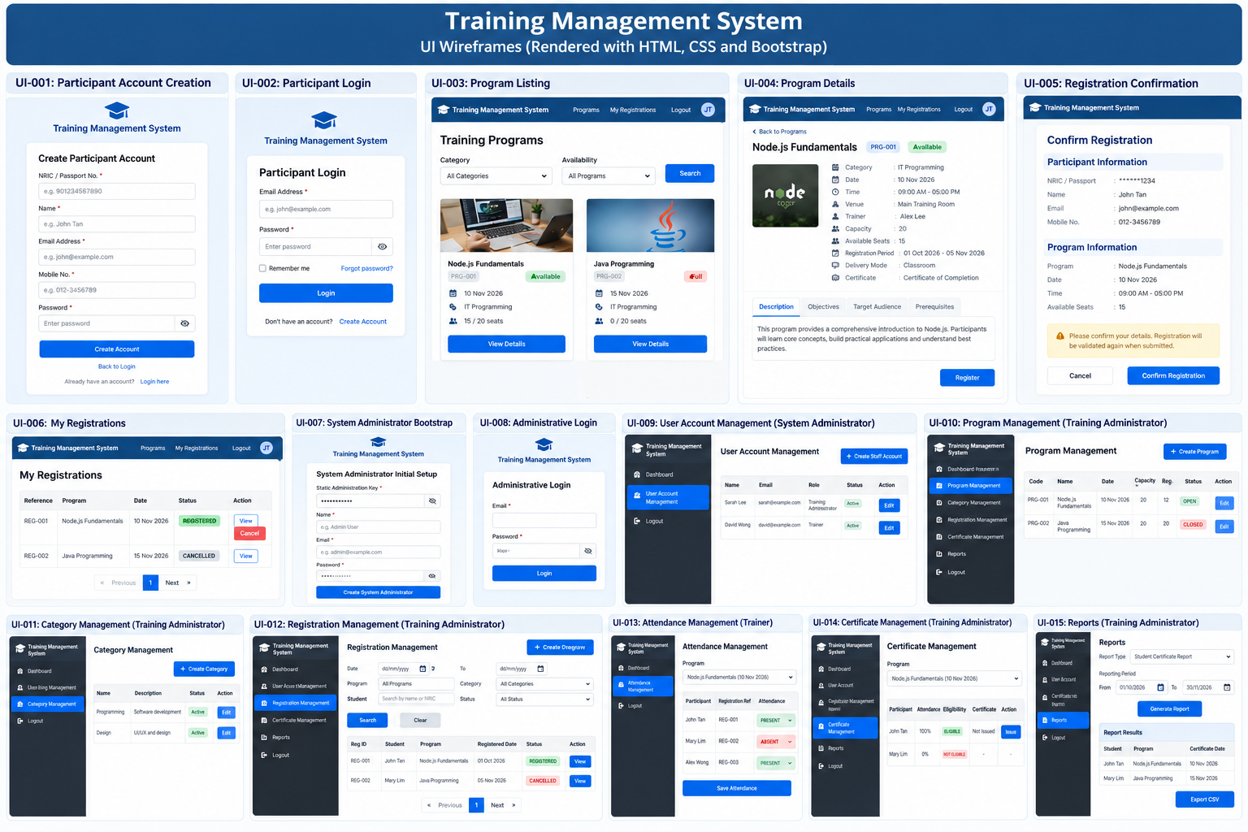
Figure 1 - Master UI Wireframe Overview (UI-001 to UI-015)

1. Purpose and Design Principles
This document converts the approved UI baseline into a structured, implementation-ready wireframe specification. It preserves the approved actors, workflows, validation boundaries, security controls and current-release scope.
Design principles
- Use only approved requirements and design decisions as the basis for UI behavior.
- Do not introduce payment, bank transfer, waiting list, HR integration, administrator registration approval, multi-session programs or undocumented registration mutations.
- Apply role-based navigation and server-side authorization to protected functions.
- Mask NRIC/Passport values on ordinary participant-facing screens and standard reports.
- Use server-side validation, CSRF protection for state-changing authenticated requests, and controlled pagination/filtering for list views.

2. Screen List
ID | Screen | Actor | Workflow
UI-001 | Participant Account Creation | Participant | WF-001
UI-002 | Participant Login | Participant | WF-002
UI-003 | Program Listing | Participant | WF-007
UI-004 | Program Details | Participant | WF-008
UI-005 | Registration Confirmation | Participant | WF-009
UI-006 | My Registrations | Participant | WF-010 / registration viewing
UI-007 | System Administrator Bootstrap | Static-key holder | WF-003
UI-008 | Administrative Login | System Administrator / Training Administrator / Trainer | WF-004 / WF-006
UI-009 | User Account Management | System Administrator | WF-005
UI-010 | Program Management | Training Administrator | WF-011
UI-011 | Category Management | Training Administrator | WF-011
UI-012 | Registration Management | Training Administrator | WF-012
UI-013 | Attendance Management | Trainer | WF-013
UI-014 | Certificate Management | Training Administrator | WF-014
UI-015 | Reports | Training Administrator | WF-015

3. Detailed UI Wireframes

UI-001 — Participant Account Creation
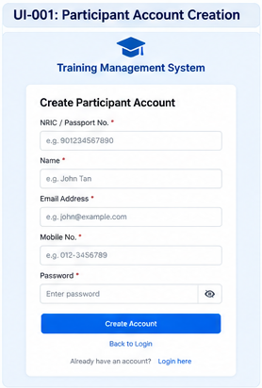
Figure 2 - Rendered UI-001 Wireframe
Purpose | Create a participant account.
Actor | Prospective Participant
Related Requirements | BP-001; FR-001; FR-008; DR-001; DR-007; VE-014; VE-015
Related Workflow | WF-001

+--------------------------------------------------------------+
| TRAINING MANAGEMENT SYSTEM |
+--------------------------------------------------------------+
| CREATE PARTICIPANT ACCOUNT |
| NRIC / Passport No. * [_______________________________] |
| Name * [_______________________________] |
| Email Address * [_______________________________] |
| Mobile No. * [_______________________________] |
| Password * [_______________________________] |
| |
| [ Create Account ] [ Back to Login ] |
| Validation / outcome message area |
+--------------------------------------------------------------+

Input fields
- NRIC/Passport number
- Name
- Email address
- Mobile number
- Password
Actions
- Create Account
- Back to Login
Validation messages / conditions
- Required-field and format validation
- Password policy validation
- Duplicate email validation
- Duplicate NRIC/Passport validation
Navigation: Account creation -> success -> Participant Login.
Design note: Participant username, account identifier, PARTICIPANT role and ACTIVE status are server-generated/assigned; the participant does not enter them.

UI-002 — Participant Login
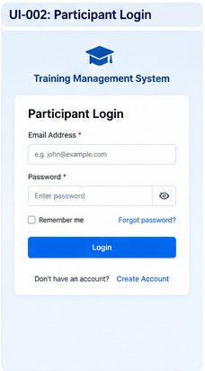
Figure 3 - Rendered UI-002 Wireframe
Purpose | Authenticate an existing participant.
Actor | Participant
Related Requirements | BP-002; FR-002; BR-001; VE-016; NFR-003
Related Workflow | WF-002

+--------------------------------------------------------------+
| TRAINING MANAGEMENT SYSTEM |
+--------------------------------------------------------------+
| PARTICIPANT LOGIN |
| Email Address * [_____________________________________] |
| Password * [_____________________________________] |
| |
| [ Login ] |
| Don't have an account? [ Create Account ] |
| Authentication message |
+--------------------------------------------------------------+

Input fields
- Email address
- Password
Actions
- Login
- Create Account
Validation messages / conditions
- Email is required
- Password is required
- Invalid credentials
- Account locked or disabled
Navigation: Login -> Program Listing on success.
Design note: Authentication validates credentials, ACTIVE status and PARTICIPANT role before creating a server-side session.

UI-003 — Program Listing
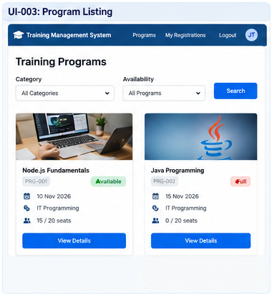
Figure 4 - Rendered UI-003 Wireframe
Purpose | Browse available training programs.
Actor | Participant
Related Requirements | BP-007; FR-003; FR-004; FR-032; BR-014; VE-012; DR-002; DR-003
Related Workflow | WF-007

+----------------------------------------------------------------+
| TRAINING MANAGEMENT SYSTEM Login / My Registr. |
+----------------------------------------------------------------+
| TRAINING PROGRAMS |
| Category: [ All Categories v ] |
| Availability: [ ... v ] |
| |
| Code | Program Name | Date | Seats |
| PRG-001 | Node.js Fundamentals | 10/11/26 | 15 / 20 |
| PRG-002 | Java Programming | 15/11/26 | FULL |
| |
| [ Previous ] Page 1 [ Next ] |
| Select Program -> [ View Details ] |
+----------------------------------------------------------------+

Input fields
- Category filter
- Availability filter
Actions
- Filter
- Paginate
- View Details
Validation messages / conditions
- Invalid filter values
- No programs available
Navigation: Program Listing -> Program Details.
Design note: Visible programs are returned as a paginated list with capacity and available-seat information.

UI-004 — Program Details
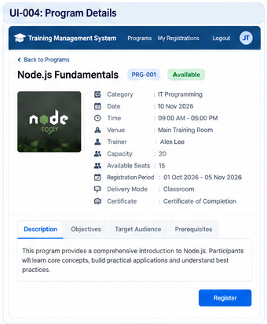
Figure 5 - Rendered UI-004 Wireframe
Purpose | Review a selected program and its current availability.
Actor | Participant
Related Requirements | BP-008; FR-005; FR-006; FR-030; DR-002
Related Workflow | WF-008

+----------------------------------------------------------------+
| PROGRAM DETAILS |
+----------------------------------------------------------------+
| Program Code: PRG-001 |
| Program Name: Node.js Fundamentals |
| Category: IT Programming |
| Description: [......................................] |
| Learning Objectives: [......................................] |
| Target Audience: [......................................] |
| Prerequisites: [Optional] |
| Trainer: [Trainer Name] |
| Date/Time: [Date] [Start-End] |
| Venue / Delivery: [......................................] |
| Capacity: 20 Available Seats: 15 |
| Registration: [Opening] - [Closing] |
| Certificate: [Certificate information] |
| |
| [ Back ] [ REGISTER ] |
+----------------------------------------------------------------+

Input fields: No direct editable participant input on this view except where actions open a controlled form.
Actions
- Back
- Register
Validation messages / conditions
- Program unavailable or not visible
- Registration unavailable/full/closed as applicable
Navigation: Program Listing -> Program Details -> Login if needed -> Registration Confirmation.
Design note: Program detail includes the approved description, objectives, audience, prerequisites, category, trainer, schedule, venue/delivery mode, capacity, available seats, registration window and certificate information.

UI-005 — Registration Confirmation
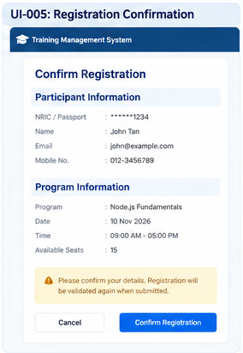
Figure 6 - Rendered UI-005 Wireframe
Purpose | Review selected program and read-only participant information before registration submission.
Actor | Participant
Related Requirements | FR-007–FR-014; FR-030; FR-031; BR-001–BR-009; BR-012; BR-013; VE-001–VE-011
Related Workflow | WF-009

+----------------------------------------------------------------+
| CONFIRM REGISTRATION |
+----------------------------------------------------------------+
| PARTICIPANT INFORMATION |
| NRIC / Passport: ******1234 [Read Only] |
| Name: Participant Name [Read Only] |
| Email: participant@email [Read Only] |
| Mobile: 01X-XXXXXXX [Read Only] |
| |
| PROGRAM |
| Program: Node.js Fundamentals |
| Date/Time: 10/11/2026 09:00 - 17:00 |
| Availability: 15 seats |
| |
| Registration is validated again when submitted. |
| [ Cancel ] [ Confirm Registration ] |
| Validation / registration outcome |
+----------------------------------------------------------------+

Input fields: No direct editable participant input on this view except where actions open a controlled form.
Actions
- Cancel
- Confirm Registration
Validation messages / conditions
- Authenticated participant required
- Registration window must be open
- Program must be visible/open
- No active duplicate registration
- No schedule overlap
- Capacity must be available
Navigation: Program Details -> Registration Confirmation -> My Registrations / success outcome.
Design note: Participant data is server-derived and read-only; NRIC/Passport is masked. Registration, mandatory audit and notification outbox are committed transactionally; email delivery is asynchronous.

UI-006 — My Registrations
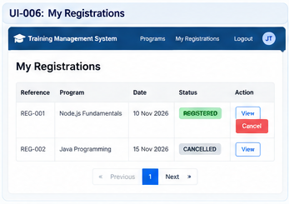
Figure 7 - Rendered UI-006 Wireframe
Purpose | View own registrations and cancel an eligible registration.
Actor | Participant
Related Requirements | FR-015; FR-016; FR-017; BR-010; BR-011; BR-018
Related Workflow | WF-010

+----------------------------------------------------------------+
| MY REGISTRATIONS |
+----------------------------------------------------------------+
| Reference | Program | Date | Status | Action |
| REG-001 | Node.js | 10/11/26 | REGISTERED | View/Cancel|
| REG-002 | Java | 15/11/26 | CANCELLED | View |
| [ Previous ] Page 1 [ Next ] |
+----------------------------------------------------------------+
| CANCEL REGISTRATION |
| Program: Node.js Fundamentals |
| Cancellation Reason: [____________________________________] |
| [ Keep Registration ] [ Confirm Cancellation ] |
+----------------------------------------------------------------+

Input fields
- Cancellation reason (when cancelling)
Actions
- View
- Cancel
- Confirm Cancellation
Validation messages / conditions
- Registration not found
- Cancellation not permitted
- Unauthorized
- Cancellation successful
Navigation: My Registrations -> View / Cancel -> refreshed registration list.
Design note: Cancellation is permitted before the scheduled start time. Historical registration remains as CANCELLED and may later be re-registered subject to normal validation.

UI-007 — System Administrator Bootstrap

System Administrator Bootstrap
Static Administration Key * | [ password / secret input ]
Username * | [____________________________]
Name * | [____________________________]
Email Address * | [____________________________]
Password * | [____________________________]
[ Create System Administrator ]
Figure 8 - Rendered UI-007 Wireframe
Purpose | Create the initial System Administrator account using the configured static administration key.
Actor | Authorized static-key holder
Related Requirements | BP-003; FR-035; BR-021; VE-018; VE-019; NFR-003
Related Workflow | WF-003
Identity Design Rule | Username is administrator-supplied, required and unique. account_identifier is server-generated and is not entered in the UI.

+--------------------------------------------------------------+
| SYSTEM ADMINISTRATOR INITIAL SETUP |
+--------------------------------------------------------------+
| Static Administration Key * [___________________________] |
| Username * [___________________________] |
| Name * [___________________________] |
| Email * [___________________________] |
| Password * [___________________________] |
| |
| [ Create System Administrator ] |
| Bootstrap outcome / validation |
+--------------------------------------------------------------+

Input fields
- Static administration key
- Username
- Name
- Email
- Password
Actions
- Create System Administrator
Validation messages / conditions
- Static key required/invalid
- Account information invalid
- Duplicate account information
- Active System Administrator already exists
Navigation: Bootstrap -> Administrative Login on success.
Design note: The key is validated against the deployment secret and must not be persisted or logged.

UI-008 — Administrative Login
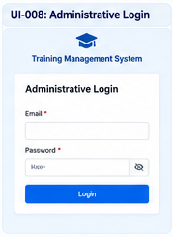
Figure 9 - Rendered UI-008 Wireframe
Purpose | Authenticate System Administrator, Training Administrator or Trainer.
Actor | System Administrator / Training Administrator / Trainer
Related Requirements | FR-028; FR-033; FR-034; VE-017; NFR-002; NFR-003
Related Workflow | WF-004 / WF-006

+--------------------------------------------------------------+
| TRAINING MANAGEMENT SYSTEM |
+--------------------------------------------------------------+
| ADMINISTRATIVE LOGIN |
| Email * [___________________________________________] |
| Password * [___________________________________________] |
| |
| [ Login ] |
| Authentication message |
+--------------------------------------------------------------+

Input fields
- Email
- Password
Actions
- Login
Validation messages / conditions
- Required credentials
- Invalid credentials
- Inactive/locked/disabled account
- Role not permitted
Navigation: Successful login -> role-authorized administrative function.
Design note: Role-specific authorization determines permitted post-login functions.

UI-009 — User Account Management

User Account Management
Username * | [____________________________]
Name * | [____________________________]
Email Address * | [____________________________]
Password * | [____________________________]
Role * | [ Training Administrator / Trainer ]
[ Create User Account ]
Figure 10 - Rendered UI-009 Wireframe
Purpose | Create Training Administrator or Trainer accounts.
Actor | System Administrator
Related Requirements | FR-028; FR-029; DR-007; DR-008
Related Workflow | WF-005
Identity Design Rule | Username is administrator-supplied, required and unique. account_identifier is server-generated and is not entered in the UI.

+----------------------------------------------------------------+
| SYSTEM ADMINISTRATOR > USER ACCOUNT MANAGEMENT |
+----------------------------------------------------------------+
| CREATE STAFF ACCOUNT |
| Username * [___________________________________________] |
| Name * [___________________________________________] |
| Email * [___________________________________________] |
| Password * [___________________________________________] |
| Role * [ Training Administrator / Trainer v] |
| |
| [ Create Account ] |
| Account creation outcome / validation |
+----------------------------------------------------------------+

Input fields
- Username
- Name
- Email
- Password
- Role
Actions
- Create Account
Validation messages / conditions
- Required fields
- Permitted role only
- Duplicate account information
- Password rules
Navigation: Administrative Login -> User Account Management.
Design note: Only System Administrator may create Training Administrator and Trainer accounts.

UI-010 — Program Management
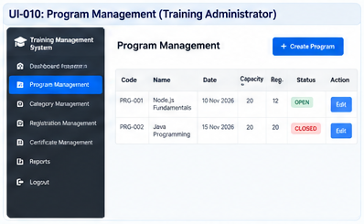
Figure 11 - Rendered UI-010 Wireframe
Purpose | Create and update training programs, including capacity.
Actor | Training Administrator
Related Requirements | BP-011; FR-018; FR-019; FR-021; BR-003; BR-014; BR-015; NFR-005
Related Workflow | WF-011

+----------------------------------------------------------------+
| TRAINING ADMINISTRATOR > PROGRAM MANAGEMENT |
+----------------------------------------------------------------+
| [ Create Program ] |
| Code | Name | Category | Date | Capacity | Registered | Status |
| ... | ... | ... | ... | 20 | 12 | OPEN |
| [ View / Edit ] |
+----------------------------------------------------------------+
| CREATE / UPDATE PROGRAM |
| Code * [____________________________] |
| Name * [____________________________] |
| Description * [____________________________] |
| Objectives * [____________________________] |
| Target Audience * [____________________________] |
| Prerequisites [____________________________] |
| Category * [__________________________ v] |
| Trainer * [__________________________ v] |
| Training Date * [____________] |
| Start / End Time * [________] [________] |
| Venue [____________________________] |
| Delivery Mode * [__________________________ v] |
| Capacity * [________] |
| Registration Window* [____________] - [____________] |
| Status * [__________________________ v] |
| Certificate Type [____________________________] |
| [ Cancel ] [ Save ] |
+----------------------------------------------------------------+

Input fields
- Approved program fields
- Capacity
- Registration window
- Status
Actions
- Create Program
- View/Edit
- Save
- Cancel
Validation messages / conditions
- Required program fields
- Valid category and active Trainer
- End time after start time
- Valid registration window
- Capacity > 0
- Capacity cannot be reduced below REGISTERED count
Navigation: Administrative Login -> Program Management -> Create/Edit.
Design note: Program lifecycle and capacity rules are enforced server-side and transactionally.

UI-011 — Category Management
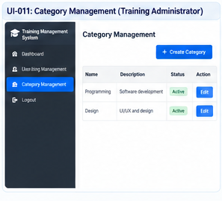
Figure 12 - Rendered UI-011 Wireframe
Purpose | Maintain training program categories.
Actor | Training Administrator
Related Requirements | FR-020
Related Workflow | WF-011

+---------------------------------------------------------------+
| TRAINING ADMINISTRATOR > CATEGORY MANAGEMENT |
+---------------------------------------------------------------+
| [ Create Category ] |
| Name | Description | Status | Action |
| Programming | Software development | Active | Edit |
| |
| CATEGORY DETAILS |
| Name * [__________________________________________] |
| Description [__________________________________________] |
| Status * [_______________________________________ v] |
| [ Cancel ] [ Save ] |
+---------------------------------------------------------------+

Input fields
- Name
- Description
- Status
Actions
- Create Category
- Edit
- Save
- Cancel
Validation messages / conditions
- Required category fields
- Invalid/duplicate category information as applicable
Navigation: Administrative Login -> Category Management.
Design note: Category management supports the approved create/update program-management workflow.

UI-012 — Registration Management
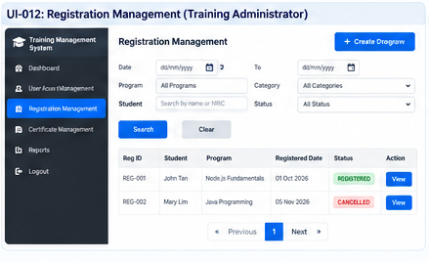
Figure 13 - Rendered UI-012 Wireframe
Purpose | View, filter and inspect operational registrations.
Actor | Training Administrator
Related Requirements | BP-012; FR-022; FR-028; VE-009
Related Workflow | WF-012

+--------------------------------------------------------------------+
| TRAINING ADMINISTRATOR > REGISTRATION MANAGEMENT |
+--------------------------------------------------------------------+
| FILTERS |
| Date: [ From ] [ To ] Program: [________________________ v] |
| Category: [________________ v] Student: [____________________] |
| Status: [________________ v] [ Search ] [ Clear ] |
| |
| Reg ID | Student | Program | Registered Date | Status | Action |
| ... | ... | ... | ... | ... | View |
| [ Previous ] Page 1 [ Next ] |
+--------------------------------------------------------------------+
| REGISTRATION DETAIL - READ ONLY |
| Registration Reference: ... Student: ... |
| Program: ... Registration Date: ... |
| Status: ... Cancellation Date: ... |
| Cancellation Reason: ... |
| [ Back ] |
+--------------------------------------------------------------------+

Input fields
- Date range
- Program
- Category
- Student
- Status
Actions
- Search
- Clear
- View
- Back
Validation messages / conditions
- Invalid filter values
- Registration not found
- Unauthorized access
Navigation: Administrative Login -> Registration Management -> Registration Detail.
Design note: Current baseline is strictly read-only: View / Filter / Inspect only. No administrator cancellation, approval, rejection or edit action is introduced.

UI-013 — Attendance Management
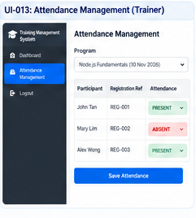
Figure 14 - Rendered UI-013 Wireframe
Purpose | Record attendance for registered participants in an assigned program.
Actor | Trainer
Related Requirements | BP-013; FR-023; FR-024; BR-015; BR-016; DR-005
Related Workflow | WF-013

+----------------------------------------------------------------+
| TRAINER > ATTENDANCE |
+----------------------------------------------------------------+
| Program: [ Assigned Program v ] |
| Date: [ Training Date ] |
| |
| Participant Registration Ref Attendance |
| Participant A REG-001 [ PRESENT v ] |
| Participant B REG-002 [ ABSENT v ] |
| Participant C REG-003 [ PRESENT v ] |
| |
| [ Save Attendance ] |
| Save outcome / validation |
+----------------------------------------------------------------+

Input fields
- Assigned program
- Attendance status PRESENT/ABSENT
Actions
- Save Attendance
Validation messages / conditions
- Program must be assigned to Trainer
- Participant must be REGISTERED
- One attendance record per registration
- Only PRESENT or ABSENT permitted
Navigation: Administrative Login -> Attendance Management.
Design note: Attendance percentage is server-derived: PRESENT = 100.00 and ABSENT = 0.00; the client does not supply percentage.

UI-014 — Certificate Management
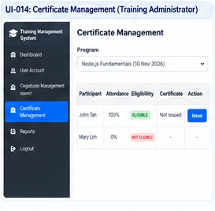
Figure 15 - Rendered UI-014 Wireframe
Purpose | Evaluate certificate eligibility and record certificate issuance.
Actor | Training Administrator
Related Requirements | FR-025; FR-026; BR-017; DR-006
Related Workflow | WF-014

+----------------------------------------------------------------+
| TRAINING ADMINISTRATOR > CERTIFICATE MANAGEMENT |
+----------------------------------------------------------------+
| Program: [ Selected Program v ] |
| Participant | Attendance | Eligibility | Certificate | Action |
| Student A | 100% | ELIGIBLE | Not Issued | Issue |
| Student B | 0% | NOT ELIGIBLE | -- | -- |
+----------------------------------------------------------------+
| CERTIFICATE ISSUANCE |
| Participant: Student A [Read Only] |
| Program: Node.js Fundamentals [Read Only] |
| Attendance: 100% [Read Only] |
| Eligibility: ELIGIBLE [Read Only] |
| Certificate Type: [.................................] |
| Completion Date: [.................................] |
| [ Cancel ] [ Record Certificate Issuance ] |
+----------------------------------------------------------------+

Input fields
- Program selection
- Certificate Type
- Completion Date
Actions
- Issue
- Record Certificate Issuance
- Cancel
Validation messages / conditions
- Attendance must equal 100%
- Only one certificate per registration
- Registration/participant/program integrity must be valid
Navigation: Administrative Login -> Certificate Management -> Issuance.
Design note: Current release records issuance only. Certificate PDF/document generation, template/signatory details and business-facing numbering format are deferred.

UI-015 — Reports
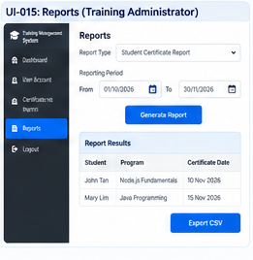
Figure 16 - Rendered UI-015 Wireframe
Purpose | Generate one of the three approved Training Administrator reports.
Actor | Training Administrator
Related Requirements | FR-027
Related Workflow | WF-015

+----------------------------------------------------------------+
| TRAINING ADMINISTRATOR > REPORTS |
+----------------------------------------------------------------+
| Report Type * [ Student Certificate Report v ] |
| Reporting Period * |
| From: [ DD/MM/YYYY ] To: [ DD/MM/YYYY ] |
| Additional approved report-specific filters |
| [...........................................................] |
| [ Generate Report ] |
+----------------------------------------------------------------+
| REPORT RESULTS |
| [Report Name] Period: [From] - [To] |
| Approved report columns |
| ... |
| [ Previous ] Page 1 [ Next ] [ Export CSV ] |
+----------------------------------------------------------------+

Input fields
- Report type
- Period From
- Period To
- Approved report-specific filters
Actions
- Generate Report
- Paginate
- Export CSV
Validation messages / conditions
- Report type required
- From/To required
- Valid reporting period
- Approved filters only
Navigation: Administrative Login -> Reports -> Results / CSV export.
Design note: Only Student Certificate Report, Student Program Registration Report and Student Account Creation Report are approved. CSV is an implementation convenience within those reports.

4. Navigation Structure
PUBLIC
|
+-- Create Participant Account (UI-001)
| +-- Participant Login (UI-002)
|
+-- Program Listing (UI-003)
| +-- Program Details (UI-004)
| +-- Login if needed
| +-- Registration Confirmation (UI-005)
|
+-- Administrative Login (UI-008)
PARTICIPANT
+-- Program Listing (UI-003)
| +-- Program Details (UI-004)
| +-- Registration Confirmation (UI-005)
+-- My Registrations (UI-006)
TRAINING ADMINISTRATOR
+-- Program Management (UI-010)
+-- Category Management (UI-011)
+-- Registration Management (UI-012)
+-- Certificate Management (UI-014)
+-- Reports (UI-015)
TRAINER
+-- Attendance Management (UI-013)
SYSTEM ADMINISTRATOR
+-- User Account Management (UI-009)
INITIAL SYSTEM SETUP
+-- System Administrator Bootstrap (UI-007)

5. Requirements and Workflow Traceability
Screen | Key Requirements | Workflow
UI-001 — Participant Account Creation | Create a participant account. | WF-001
UI-002 — Participant Login | Authenticate an existing participant. | WF-002
UI-003 — Program Listing | Browse available training programs. | WF-007
UI-004 — Program Details | Review a selected program and its current availability. | WF-008
UI-005 — Registration Confirmation | Review selected program and read-only participant information before registration submission. | WF-009
UI-006 — My Registrations | View own registrations and cancel an eligible registration. | WF-010
UI-007 — System Administrator Bootstrap | Create the initial System Administrator account using the configured static administration key. | WF-003
UI-008 — Administrative Login | Authenticate System Administrator, Training Administrator or Trainer. | WF-004 / WF-006
UI-009 — User Account Management | Create Training Administrator or Trainer accounts. | WF-005
UI-010 — Program Management | Create and update training programs, including capacity. | WF-011
UI-011 — Category Management | Maintain training program categories. | WF-011
UI-012 — Registration Management | View, filter and inspect operational registrations. | WF-012
UI-013 — Attendance Management | Record attendance for registered participants in an assigned program. | WF-013
UI-014 — Certificate Management | Evaluate certificate eligibility and record certificate issuance. | WF-014
UI-015 — Reports | Generate one of the three approved Training Administrator reports. | WF-015

6. Common UI Interaction and Security Rules
Common rules
- Protected screens use role-based navigation and server-side authorization; hiding a button in the browser is not an authorization control.
- All state-changing cookie-authenticated requests require the server-issued CSRF token.
- List endpoints use server-side filtering, deterministic sorting and pagination; unbounded list retrieval is not exposed.
- Validation is displayed near the relevant field where practical, with page-level messages for business-rule failures.
- Standard backend outcomes are represented consistently: 400 validation, 401 authentication, 403 authorization, 404 not found, 409 conflict and 500 unexpected server error.
- NRIC/Passport is masked on ordinary participant-facing screens and standard reports; full values are restricted to authorized administrative contexts.
- UI displays program/business times in the configured business-local timezone while persisted timestamps follow the approved UTC design.

7. Design Gaps and Inconsistencies
ID | Item | UI Disposition
DG-001 | Malaysian privacy/compliance confirmation | Implement approved masking/access-control baseline; final compliance/privacy approval remains a production-release gate.
DG-002 | System Administrator static-key governance | UI-007 is implementable. Operational ownership, rotation, revocation and compromise handling require production governance confirmation.
DG-007 | Training Administrator registration mutation | UI-012 remains read-only. Do not add Edit, Approve, Reject or Cancel actions.
Deferred | Certificate document output | UI-014 records issuance only. Do not introduce certificate PDF/template/signatory/business-numbering functionality.
Governance | Formal organizational approvals | Do not alter UI scope; approvals remain governance/release matters.

Scope exclusions: No payment processing, bank transfer, waiting list, HR integration, administrator registration approval, multi-session program functionality or undocumented registration-management mutation is included.

8. Conclusion
The resulting wireframe specification is aligned to Requirements Analysis v2.4, Software Design Document v1.15, Architecture Diagrams v1.2 and Sequence Diagrams v1.0. It expands the approved baseline into a professional screen-by-screen interaction specification without expanding the approved business scope.

