AI ASSISTED CODING ASSISTANT - 4.5
Name: Mohammed Adnan Awaise
HT No: 2303A52244
Batch: 36

Task-1:
Task 1: Statistical Summary for Survey Data
❖ Scenario:
You are a data analyst intern working with survey responses stored as
numerical lists.
❖ Task:
Use Google Gemini in Colab to generate a Python function that reads a list
of numbers and calculates the mean, minimum, and maximum values.
Prompt:
Generate a Python function that takes a list of numbers as input and calculates the mean, minimum, and maximum values. Also show sample output.
Code:
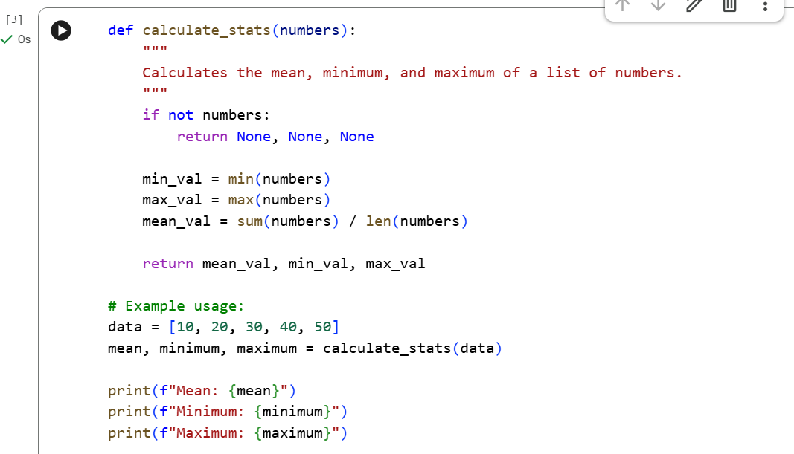
Output:

Explanation:
This code summarizes a list of numbers by identifying its boundaries and its center.
- Boundary Detection: The min() and max() functions scan the entire list to find the smallest and largest values.
- Mean Calculation: The code uses sum(numbers) / len(numbers) to divide the total of all values by the count of items in the list.
- Crash Prevention: The if not numbers check ensures the code returns None instead of crashing if an empty list is provided.
- Result Packing: It returns all three values at once, which are then "unpacked" into the variables mean, minimum, and maximum for easy printing.
Task 2: Armstrong Number – AI Comparison
❖ Scenario:
You are evaluating AI tools for numeric validation logic.
❖ Task:
Generate an Armstrong number checker using Gemini and GitHub
Copilot.
Compare their outputs, logic style, and clarity.
❖ Expected Output:
➢ Side-by-side comparison table
➢ Screenshots of prompts and generated code
Gemini Prompt:
Write a Python program to check whether a number is an Armstrong number.
Code:
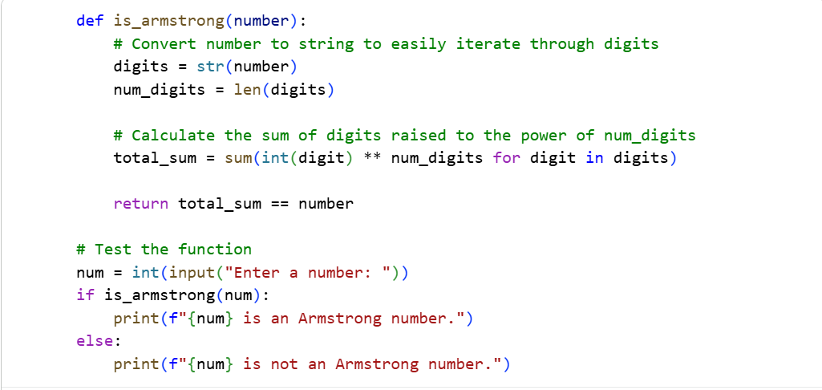
Output:
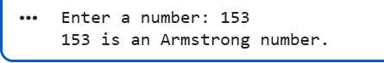
GitHub Copilot:
#Armstrong Number Checker
Code:
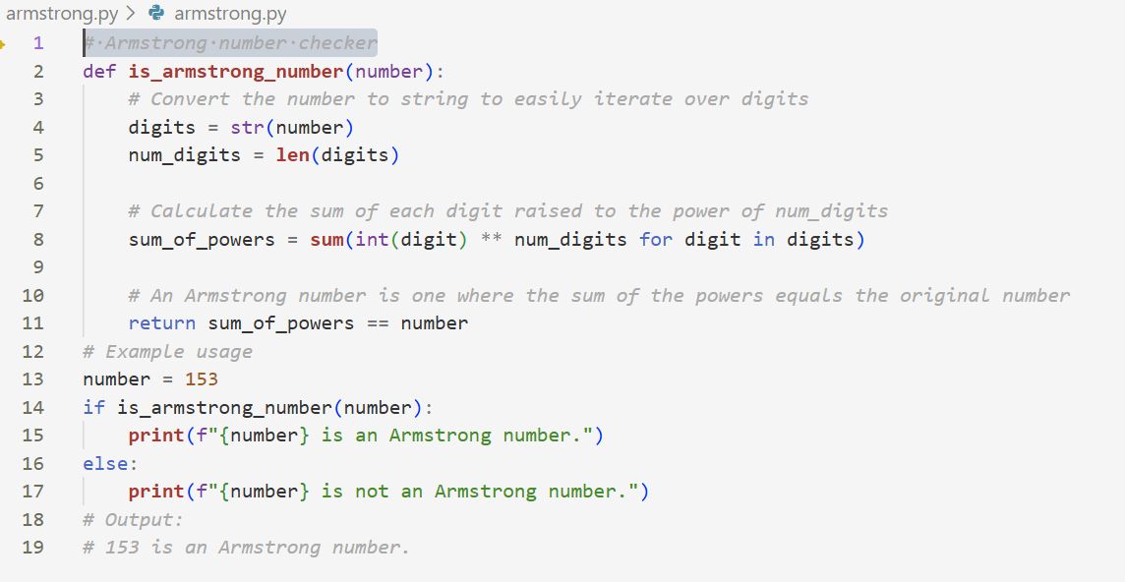
Output:
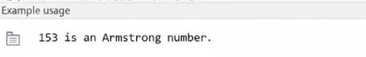
Comparison table:
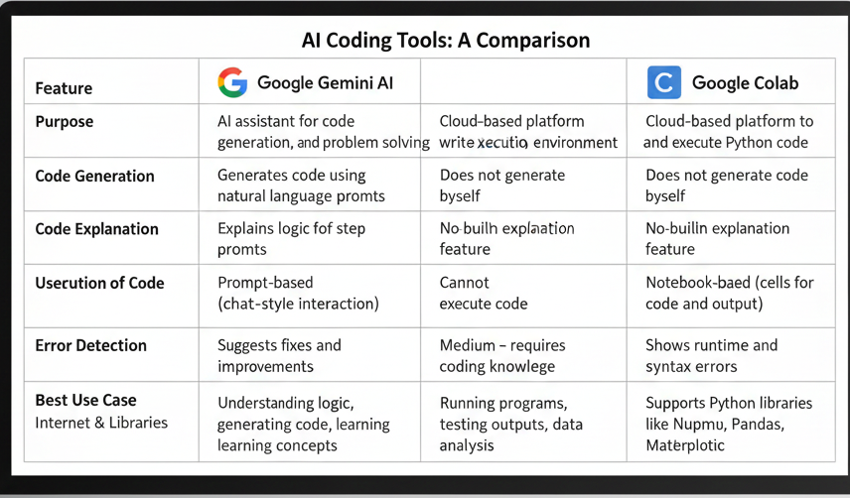
Task 3: Leap Year Validation Using Cursor AI
❖ Scenario:
You are validating a calendar module for a backend system.
❖ Task:
Use Cursor AI to generate a Python program that checks whether a given
year is a leap year.
Use at least two different prompts and observe changes in code.
❖ Expected Output:
➢ Two versions of code
➢ Sample inputs/outputs
➢ Brief comparison
Prompt 1:
Write a Python program to check whether a given year is a leap year.
Code:
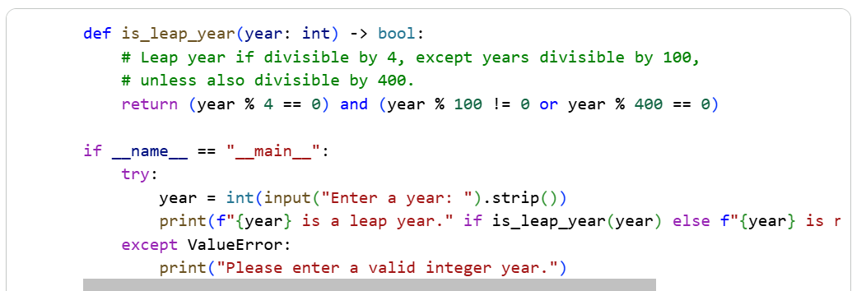
Output:
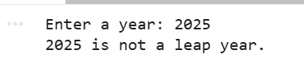
Prompt 2:
Generate a well-commented Python program to validate leap year with input and output examples.
Code:
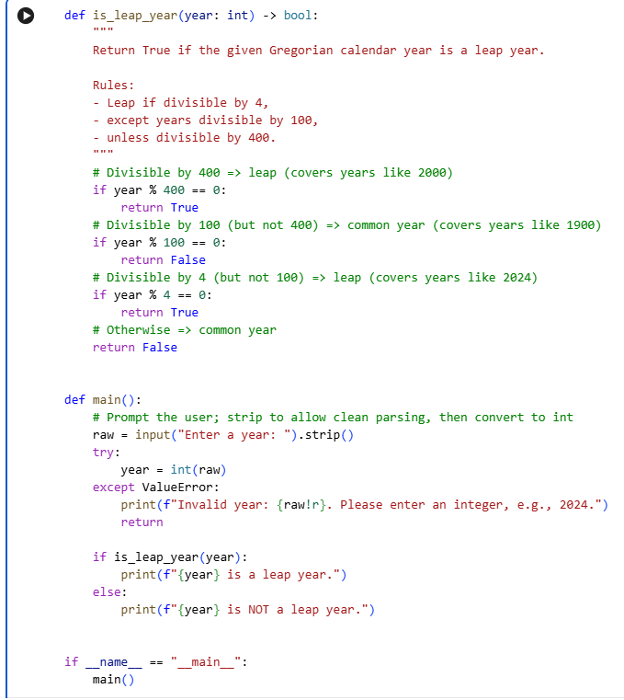
Output:
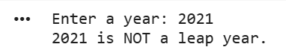
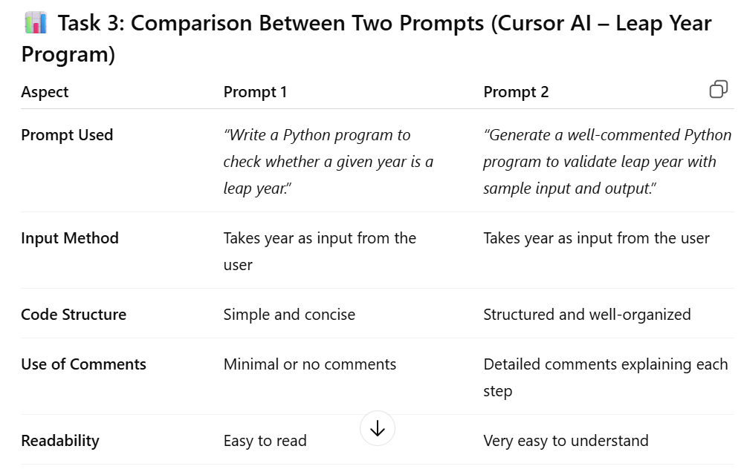
Task 4: Student Logic + AI Refactoring (Odd/Even Sum)
❖ Scenario:
Company policy requires developers to write logic before using AI.
❖ Task:
Write a Python program that calculates the sum of odd and even numbers
in a tuple, then refactor it using any AI tool.
❖ Expected Output:
➢ Original code
➢ Refactored code
➢ Explanation of improvements
My code(Input&Output):
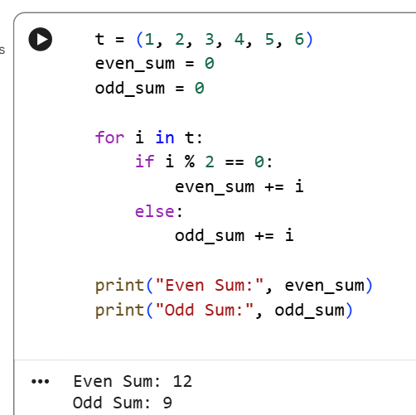
Refactored Code(Input&Output):
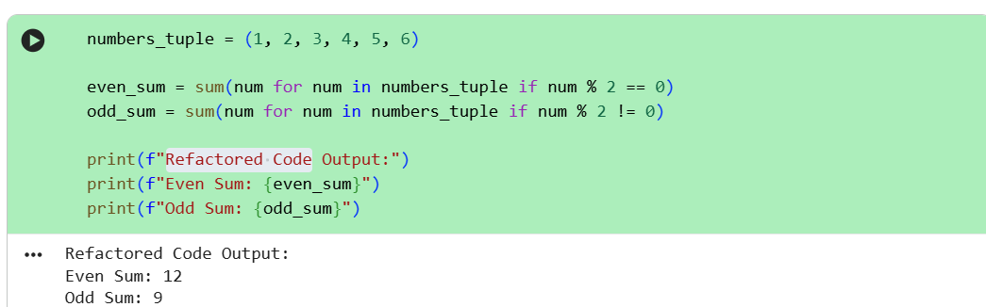

Improvements in AI-Refactored Code:
- The refactored code reduces the number of lines by using Python’s built-in sum() function.
- Generator expressions replace manual loops, making the code more efficient.
- Readability is improved by using concise and expressive syntax.
- The logic becomes easier to maintain and modify in future.
- The output remains the same while the code quality is enhanced.

