
AGROWISH
Only for course Teacher
 |  | Needs  Improvement | Developing | Sufficient | Above Average | Total Mark
Allocate mark & Percentage |  | 25% | 50% | 75% | 100% | 15
Clarity | 3
Content Quality | 6
Spelling & Grammar | 3
Organization and Formatting | 3
Total obtained mark
Comments

Semester: Fall 2026
Name | ID | Batch | Section
Tasdid Al-Amin | 241-35-108 | 42 | B1
Adnan Ul-Islam | 241-35-081 | 42 | B1
Tasnim Jahan Rifa | 241-35-116 | 42 | B1

Course Code: SE-331
Course Name: Software Engineering Design Capstone Project Capstone Project Course Teacher Name: Rahat Uddin Azad Designation: Lecturer
Submission Date: 13/10/2026

1. Introduction
This Software Requirements Specification (SRS) defines the problem, purpose, scope, constraints, users, elicitation basis, functional and non-functional requirements, system design diagrams, AI feature design, and team responsibilities for agroWish. agroWish is a Bangla-first AI-assisted agricultural decision-support web platform intended to help farmers in Bangladesh evaluate farming options using their land conditions, season, weather context, water, budget, and available resources.

1.1 Problem Statement
Farmers often make crop and farm-management decisions using personal experience, local advice, input sellers, agricultural officers, social media, or separate information sources. These sources can be useful, but the advice may not consider all conditions of a particular farm at the same time. Soil type, land size, location, season, weather, water availability, budget, and existing resources can change which crop or activity is appropriate.
Farmers may also have underused resources such as ponds, livestock, poultry, crop residues, organic material, or available water. Potential combinations—such as crops with fish or livestock activities—depend on compatibility, local conditions, investment, safety, and knowledge. General lists of farming ideas do not necessarily tell a farmer which option is realistic for their own situation or how costs and possible returns compare.
agroWish proposes to combine structured farmer inputs, agricultural knowledge, transparent recommendation rules, and suitable Machine Learning components where data supports them. It will provide crop and variety suggestions within the supported data scope, identify potentially compatible resource-based and integrated-farming options, and present waste-to-value possibilities only when supported by reliable knowledge. It will explain recommendations in Bangla and show assumptions, uncertainty, and when expert verification is needed.
Why AI is needed. The core problem is a multi-factor recommendation task: the system must consider several farmer-specific conditions together, rank or filter options, and explain why an option may fit. A curated database alone can list agricultural facts, but personalized ranking and a Bangla question-answering assistant benefit from recommendation logic, ML where labelled data is adequate, and retrieval-grounded language generation where feasible. The system must not claim that AI can guarantee crop yield or profit.

1.2 Purpose
The primary objectives of the software are:
- Allow farmers to create a profile and enter land, soil, location, water, season, budget, goals, and available-resource information.
- Recommend suitable crops for supported conditions and recommend varieties only where adequate regional and seasonal information is available.
- Consider season and available weather context when evaluating agricultural options.
- Identify resource-based farming opportunities using resources the farmer already has.
- Identify potentially suitable integrated farming combinations involving supported crops, fish, poultry, or livestock, subject to compatibility checks.
- Suggest possible waste-to-value uses for supported agricultural by-products or unused resources, with safety constraints.
- Estimate major production costs and compare potential returns when reference data is available, clearly labelling estimates and assumptions.
- Provide a Bangla-first AI assistant that explains recommendations, uses supported agricultural knowledge where feasible, and flags uncertainty or the need for expert verification.
- Allow authorized administrators to maintain supported agricultural knowledge and reference data.

1.3 Scope
The system will:
- Provide a web-based interface with farmer registration, login, profile, and farm-condition forms.
- Collect supported details about land size, soil type, location, season, weather context, water availability, budget, current crops, pond, fish, poultry, livestock, and other resources.
- Provide crop recommendations and where data supports it, crop-variety recommendations.
- Use transparent rules and an evaluated ML model if a suitable labelled dataset is available.
- Identify resource-based and potentially compatible integrated-farming options.
- Provide supported waste-to-value suggestions with safety and knowledge checks.
- Estimate costs and compare options using recorded reference values and stated assumptions.
- Provide Bangla explanations and agricultural question-answering through curated knowledge and, if feasible, a retrieval-augmented AI assistant.
- Store recommendation history and provide authorized administration of knowledge/reference data.
The system will not:
- Guarantee maximum profit, crop yield, market price or farming success.
- Replace agricultural officers, researchers, veterinarians, fisheries experts or other qualified professionals.
- Recommend every crop, variety, region, livestock species or farming combination from the first release.
- Recommend unsafe uses of waste or resources when reliable suitability information is not available.
- Automatically operate farm machinery, irrigation equipment or other physical systems.
- Require IoT sensors for the initial prototype.
- Buy or sell crops, livestock, fish, or agricultural inputs. (optional)
- Treat generated AI text as verified agricultural fact without suitable evidence.

2. Design and Implementation Constraints

2.1 Programming Language
Language / Technology | Use | Justification / Constraint
Python | Data preparation, AI/recommendation service, evaluation | Useful data/ML ecosystem including Pandas, NumPy, and Scikit-learn. Final model depends on data availability.
JavaScript / TypeScript with React | Web client and Bangla-first user interface | Component-based interface for farm forms, recommendations, comparisons, and AI assistant.
Node.js and Express.js | Application backend / REST API (proposed) | Can manage authentication, farmer data, API requests, and integration with the Python service.
HTML and CSS | Structure and styling of the web client | Supports responsive layouts and readable farmer-facing forms.
LLM API / RAG framework (conditional) | Bangla Q&A and grounded explanations | Used only if budget, service availability, Bangla quality, and grounding checks are acceptable.

2.2 Database and Servers
- Relational database: MySQL is selected for users, farmer profiles, farm conditions, resources, recommendation history, and reference data. The implementation should use MySQL unless the team documents an approved change.
- Backend API: Node.js/Express is proposed to expose a REST API to the React client and connect to the Python recommendation service.
- AI service: Python can run as a separate service or clearly separated backend module for preprocessing, recommendation logic and evaluation.
- Knowledge retrieval: FAISS or ChromaDB may be used if semantic retrieval/RAG is implemented and a suitable collection of agricultural documents is available.
- File/document storage: approved agricultural knowledge documents should retain source metadata; uploaded user data should be access-restricted if the feature is implemented.
- Development tools: Visual Studio Code, Git/GitHub, and Postman may be used for implementation, version control, and API testing.
- Deployment: a free-tier or low-cost hosting arrangement is preferred for the academic prototype; the final provider depends on availability and service limits.

2.3 AI Model and Services
Component | Approach | Justification | Baseline for Comparison
Crop recommendation | Filter/rank crop options with transparent agricultural rules; test an ML classifier/recommender if labelled data supports it. | Multi-factor personalization across soil, season, water, location, and budget. | Rule-based recommendation with a documented test set.
Crop variety recommendation | Match selected crop varieties to supported region, season, and condition records. | Avoids recommending varieties without adequate evidence. | Curated lookup/rule matching for the supported crop subset.
Resource / integrated farming | Compatibility rules and scoring based on resource availability and requirements. | Prevents implausible combinations and provides explainable reasons. | Explicit compatibility rules and reviewed test cases.
Waste-to-value | Knowledge retrieval and safety/compatibility rules for supported by-products. | Potential uses vary by material, processing, and local conditions. | Curated, source-backed recommendations; no unsupported generation.
Cost / potential return | Transparent calculations using reference cost/yield/price assumptions; regression only if adequate data exists. | Allows comparison while showing uncertainty. | Manual calculation on a small documented set of reference examples.
Bangla assistant / RAG | LLM/API with retrieved agricultural knowledge if feasible; otherwise curated FAQ/templates. | Supports Bangla explanations while grounding answers in available information. | Prewritten answers and retrieval-only results where available.

2.4 Other Constraints
- Time: one fourteen-week semester; every selected feature must be buildable and testable within the semester.
- Data: a reliable, sufficiently labelled dataset may be limited. The team must document sources, coverage, missing values, and the supported crop/resource scope.
- Cost: free-tier tools and hosting are preferred; API quotas and usage costs may limit external AI calls and concurrent users.
- Geography: recommendations must be limited to the regions and agricultural conditions supported by the available data; nationwide suitability must not be assumed.
- Language: farmer-facing explanations should prioritize clear Bangla and avoid unexplained technical terms.
- Safety and ethics: the system must not promise returns, invent sources, or provide unsupported hazardous advice. Important uncertain recommendations should advise verification by a qualified expert.
- Privacy: farmer profiles and farm information should be restricted to the account owner and authorized administrators; test datasets should avoid unnecessary personal information.

3. User Classes and Characteristics
User Class | Description | Permissions / Needs
Farmer (End User) | Farmer seeking help choosing crops or using existing resources; may have limited digital literacy or prefer Bangla. | Register/login; manage own profile; enter land/soil/season/water/budget/resources; request recommendations; view Bangla explanations, cost estimates, assumptions, warnings, and own history.
System Administrator | Authorized project/team user maintaining supported data, user roles, and agricultural knowledge. | Manage roles and reference data; add/update/remove knowledge entries; monitor service failures and data quality; restricted access to user data.
Agricultural Expert / Reviewer (optional) | Agricultural officer, researcher, or knowledgeable reviewer, if one is available during validation. | Review selected recommendations or knowledge entries and provide feedback. This is a proposed validation role, not a promised live service.
Project Evaluator / Tester | Course teacher or project evaluator using a controlled demonstration or test account. | Review documented test cases, system behavior, limitations, and the end-to-end workflow; use anonymized/demo data where possible.

User Characteristics
- The primary user may prefer Bangla and may have limited experience using digital platforms.
- Forms should use familiar agricultural terms, clear units, examples, and simple validation messages.
- Some farmers may not know exact soil measurements or costs; approximate inputs may be allowed but uncertainty must be explained.
- The system should explain why an option fits and what missing information could change the result.
- Administrator tools may use more technical terminology than the farmer-facing interface.

4. Requirement Elicitation
This section documents the basis used to identify and refine agroWish requirements. The project proposal and the team’s initial requirements define the project direction. The team reports having discussions with five farmers; the questions and recorded responses are included as evidence in this section. Findings below should reflect only the information actually recorded, and no response or conclusion should be invented.

4.1 Elicitation Techniques
Technique | Participants / Source | When | Purpose / Status
Proposal and problem analysis | agroWish proposal and project team | Initial specification stage | Used to identify the problem, objectives, AI scope, and initial requirements.
Team requirement walkthrough | All project members | To be recorded during the project | Review feasibility, requirement wording, dependencies, and priorities.
Agricultural document/data review | Official/credible agricultural publications, extension materials, datasets, and source documents | During dataset and knowledge-base preparation | Identify supported crops, seasons, compatibility guidance, safe practices, and reference costs. Exact sources must be recorded.
Semi-structured farmer interview / contextual inquiry | Volunteer farmers or representative users, if access is available | Recommended early validation activity; actual date to be filled after completion | Understand current decision process, resource constraints, Bangla terminology, and desired output.
Expert review | Agricultural officer, agronomist, fisheries/livestock expert, if available | Recommended before finalizing high-impact advice | Validate crop/resource compatibility, waste-to-value suggestions, and risk notices.
Usability test | Representative users and project team | During prototype testing | Check whether users can enter conditions and understand recommendation explanations.

4.2 Elicitation Evidence
The team reports discussions with five farmers. The team prepared a set of questions and recorded the farmers’ answers. The questions and answers are presented as separate evidence items below. Add the actual discussion date(s) and anonymized participant roles if known; do not include unnecessary personal details.
Other evidence—such as agricultural expert review, verified dataset/source inventory, and prototype usability tests—will be added only if and when it becomes available. For every interview or review, record the date, participant role, method, consent status where relevant, key points, and requirement IDs affected.
Evidence Item | Current Status | What to Add When Available
Farmer discussion questions | The team reports preparing and asking questions during discussions with five farmers. | Insert the picture of the page containing the questions. Add discussion date(s) if known.
Farmers’ recorded answers | The team reports recording answers from five farmers. | Insert the picture of the page containing the answers. Keep the text legible and anonymize names if needed.
Project proposal / initial requirements | Available as the basis of this SRS. | Attach or cite the final approved proposal/version.
Agricultural expert review | Not confirmed. | Include feedback only if a qualified reviewer actually reviews the system or recommendations.
Dataset and agricultural knowledge sources | To be confirmed during implementation. | Record source title/organization, date/version, coverage, permitted use, and limitations.
Prototype usability and recommendation tests | To be collected after the prototype exists. | Add test tasks, participant roles, results, issues, and fixes after tests occur.

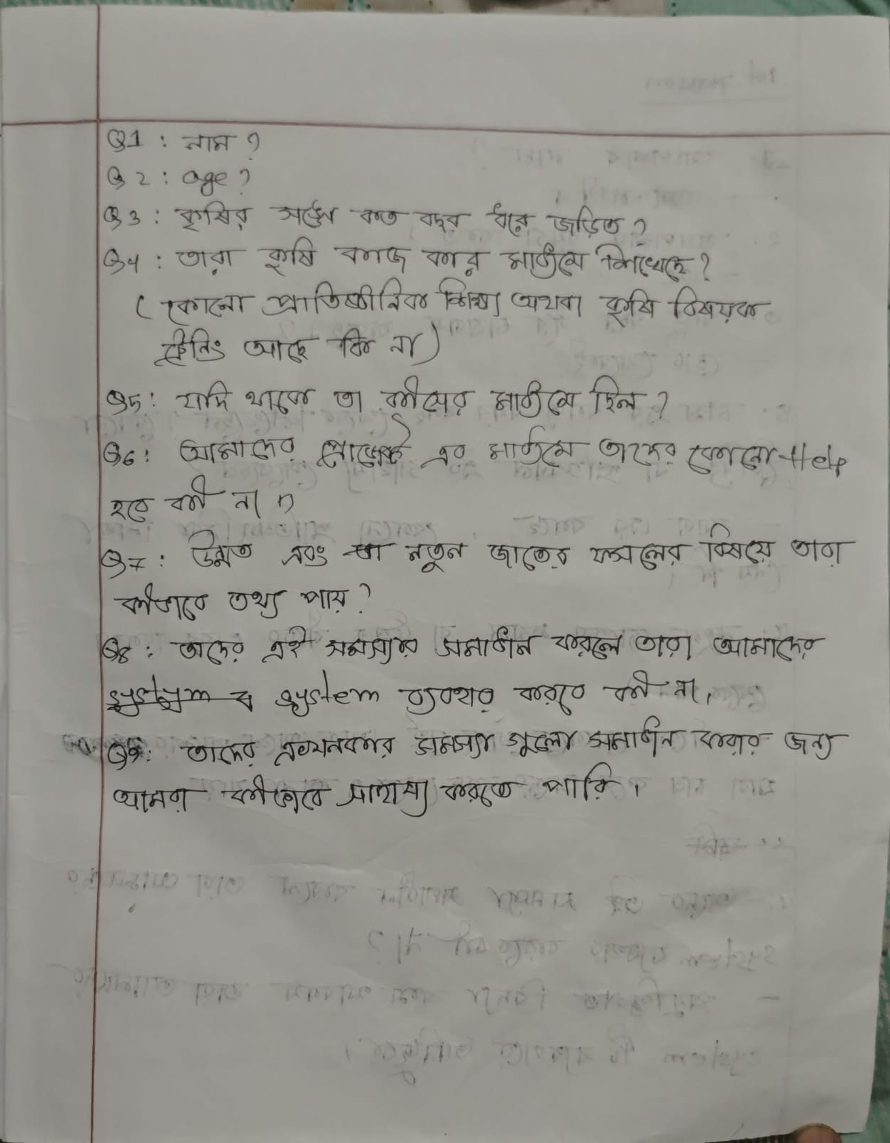

Figure 4.1: Questions Asked to Farmers — page containing the questions here.

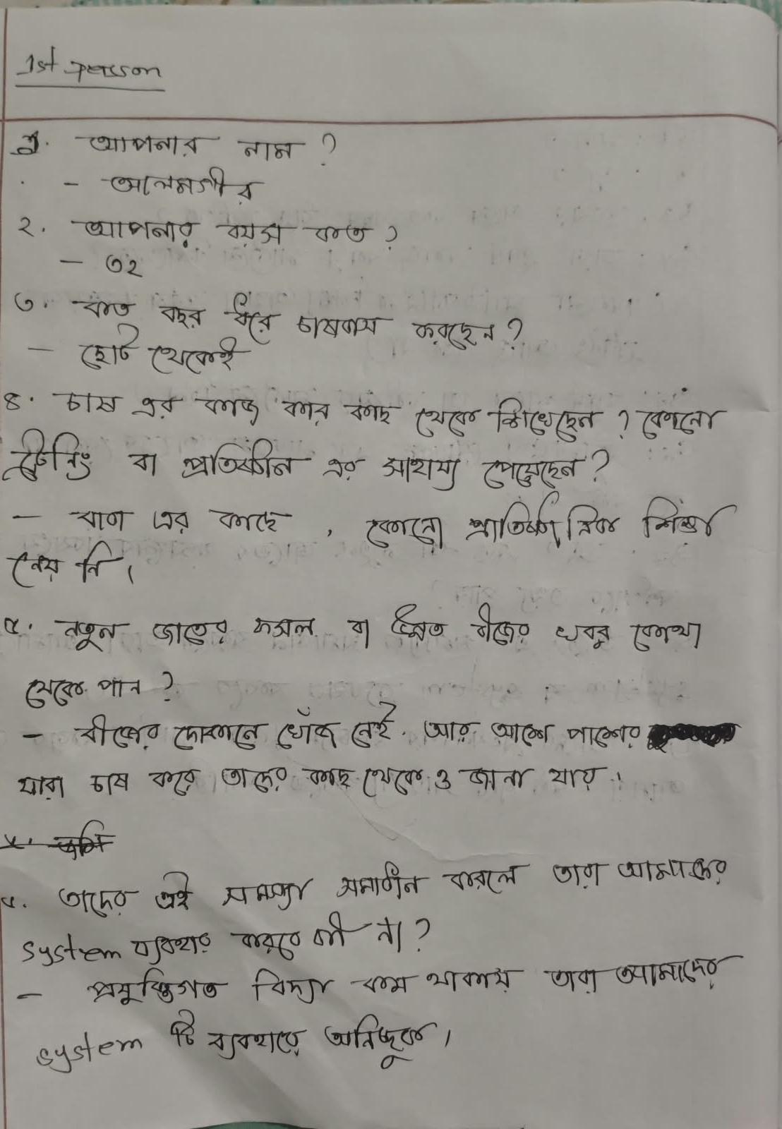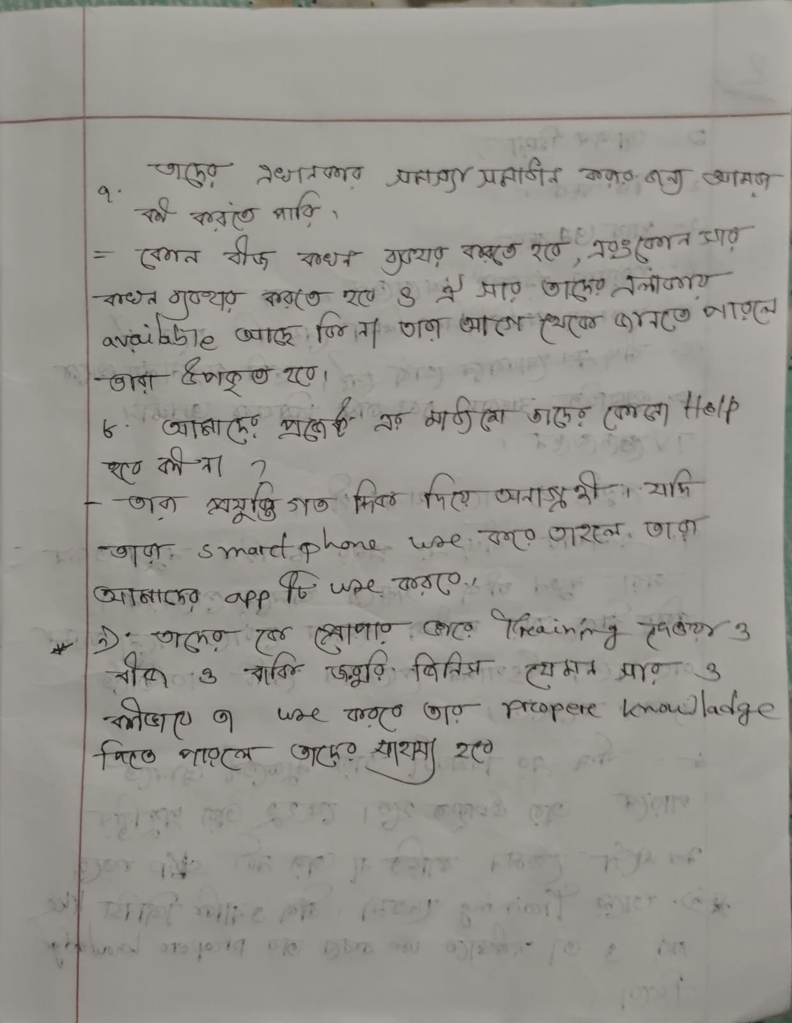

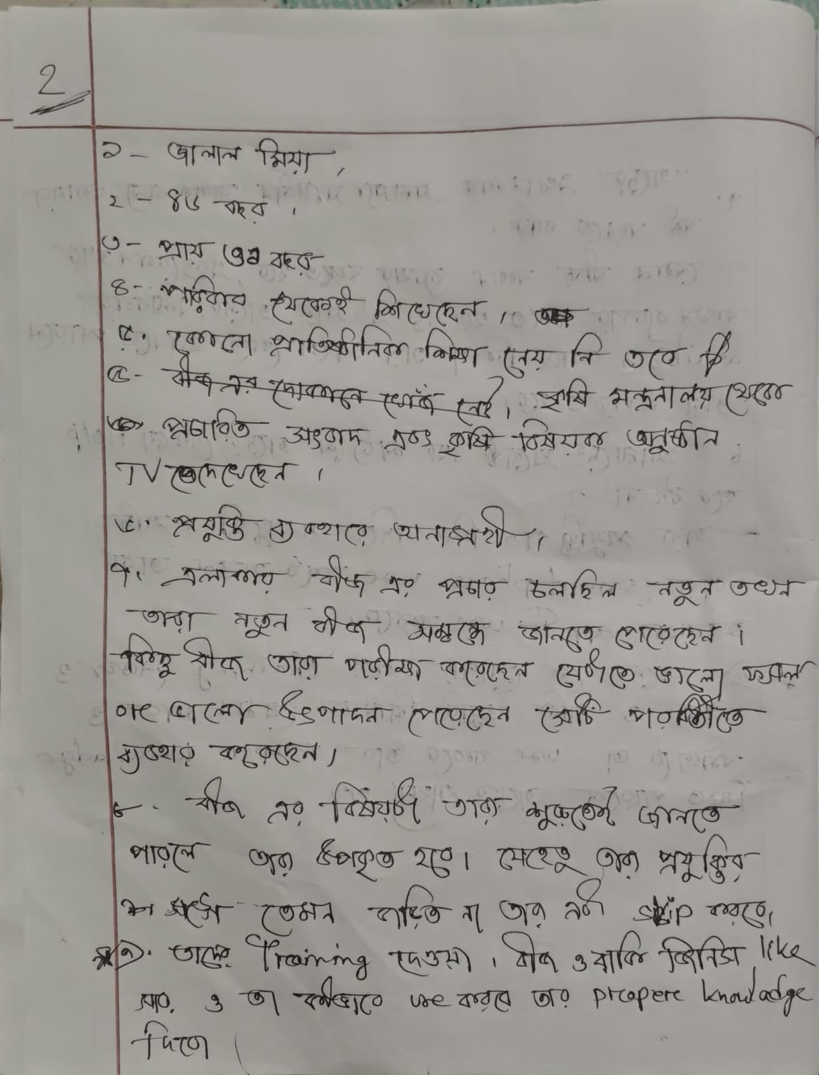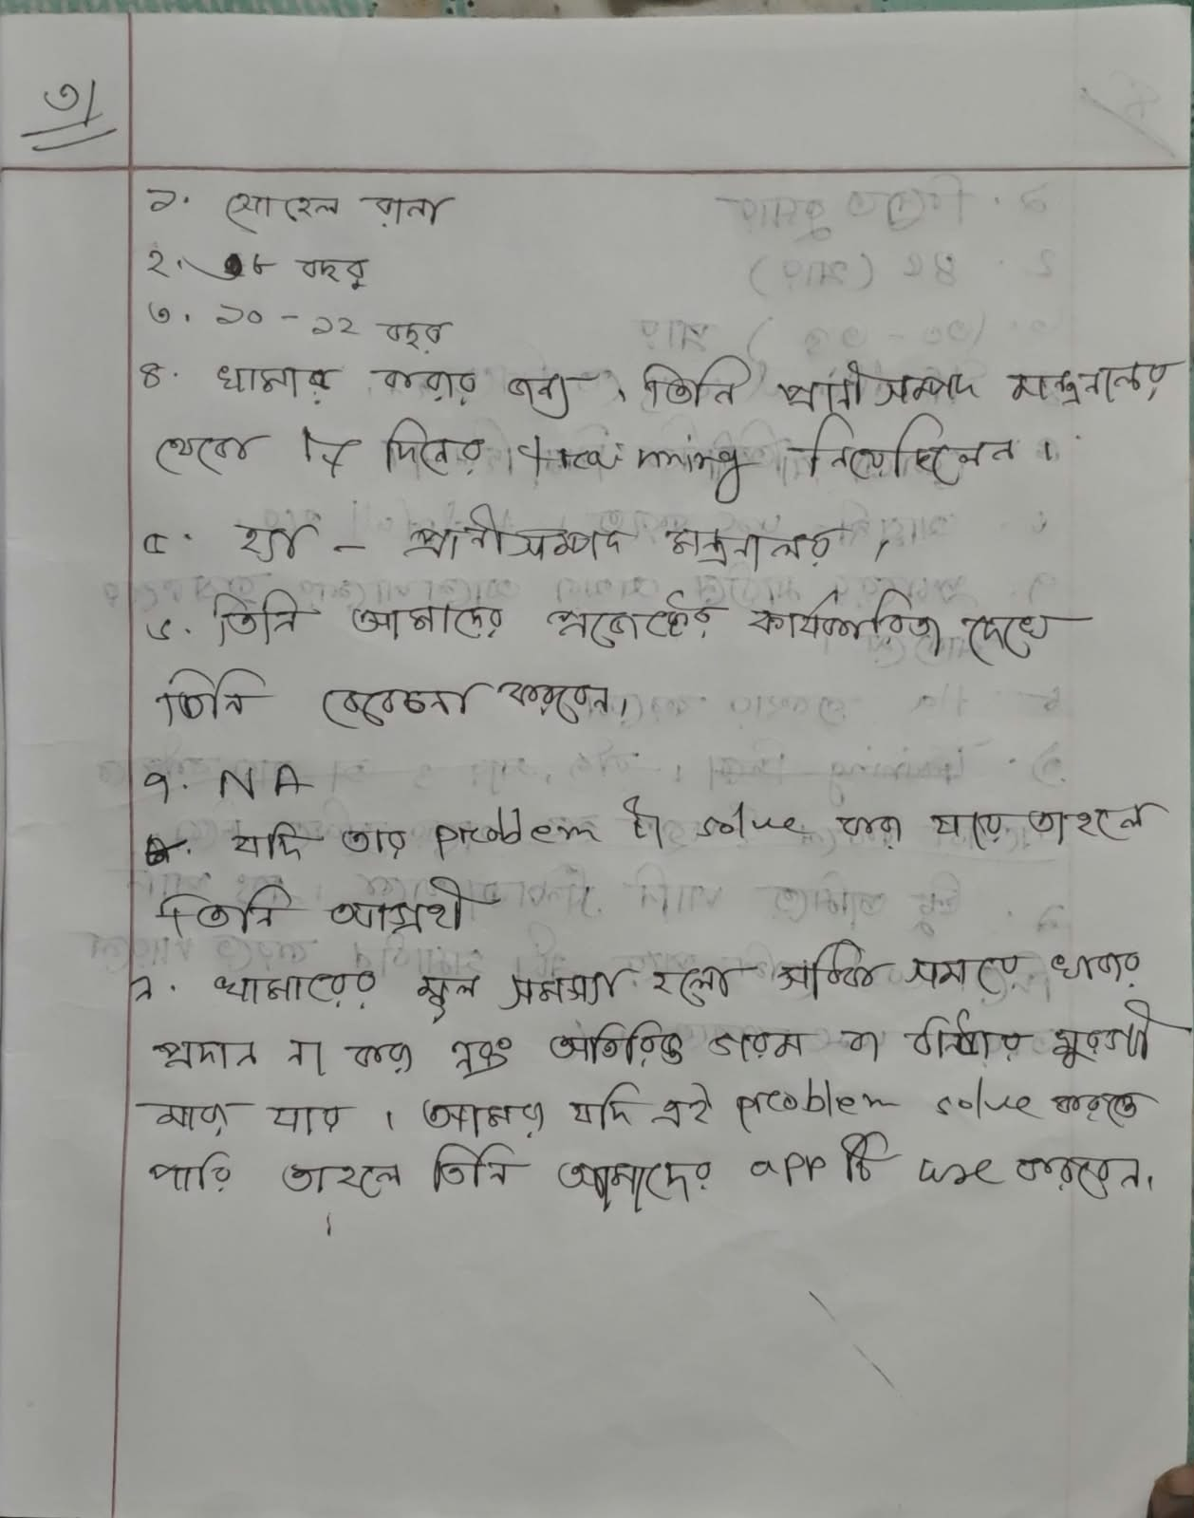

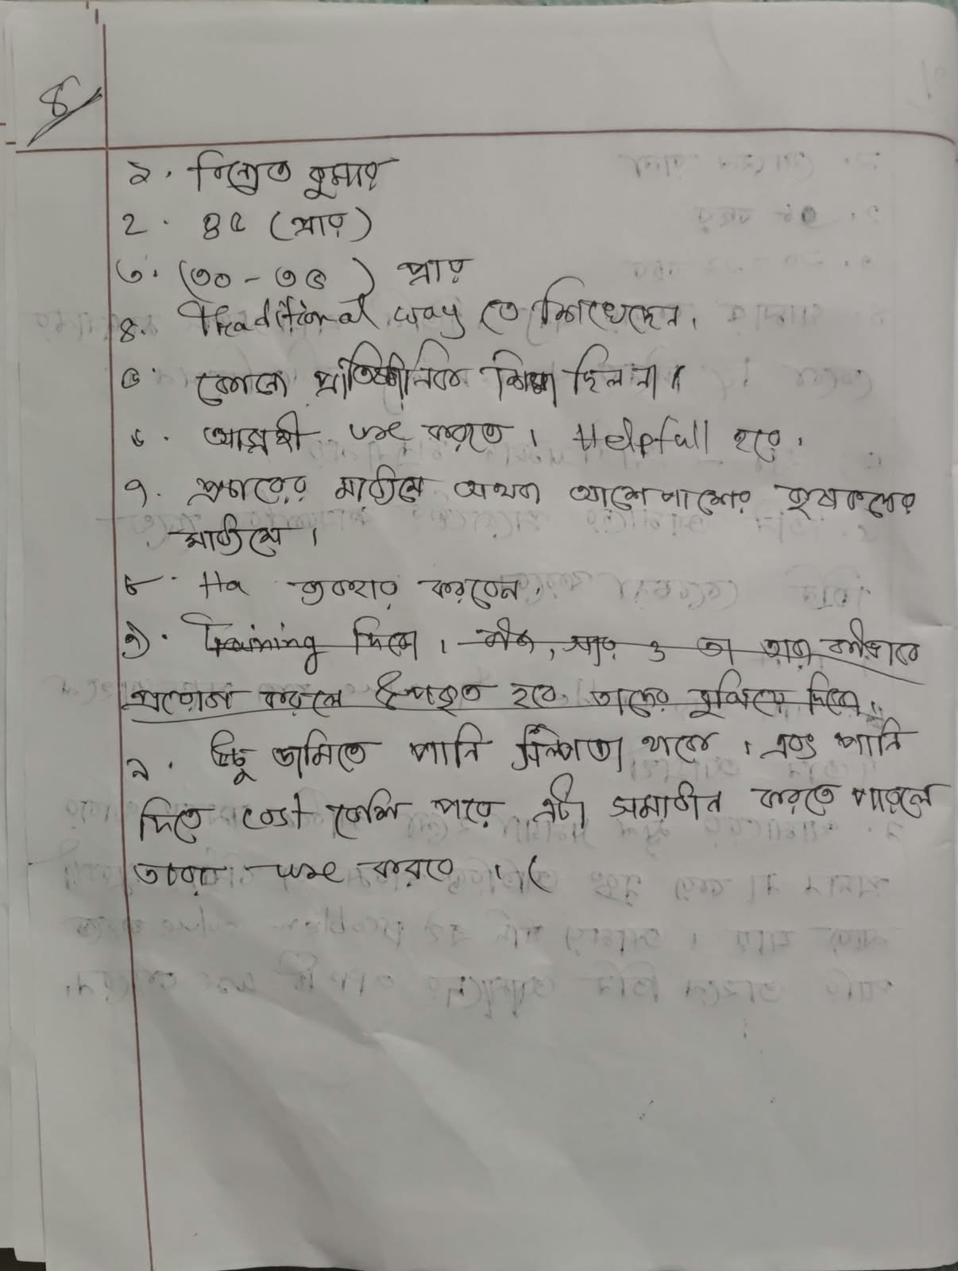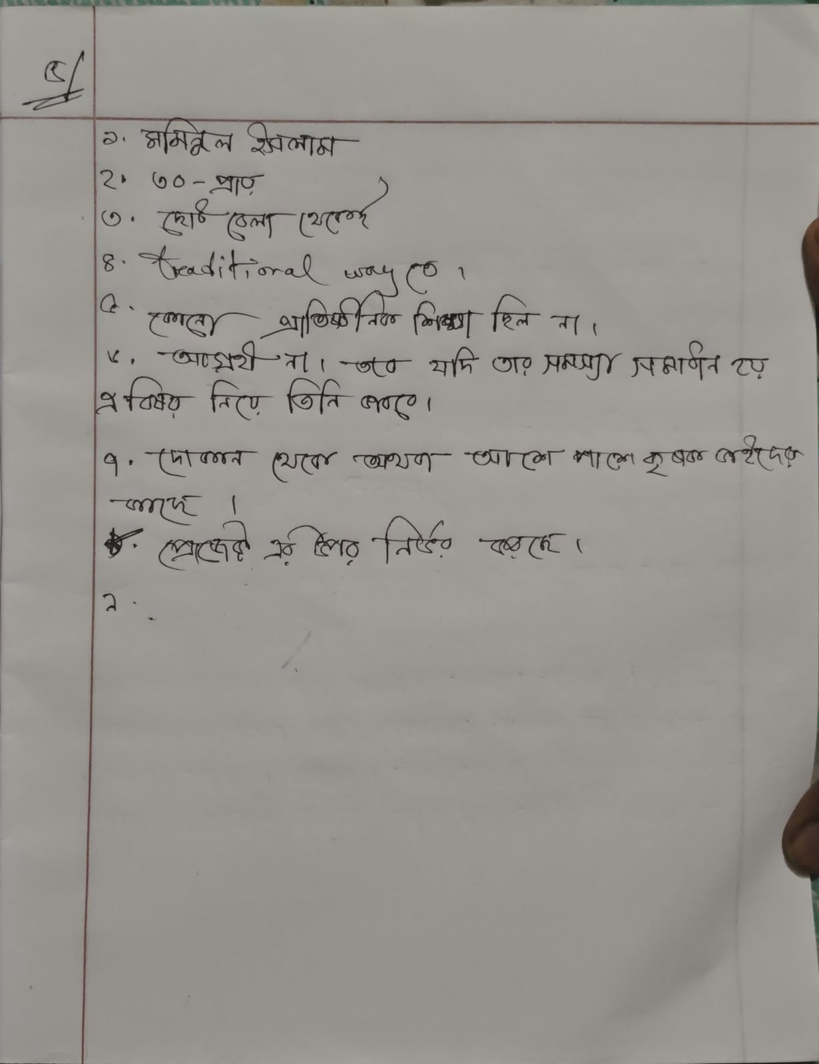

Figure 4.2: Farmers’ Recorded Answers — page containing the answers here.

4.3 Key Findings
Analyze the recorded responses from the five farmer discussions and identify only themes that are supported by their answers. The following project-level considerations are already reflected in the current requirements; revise them if the recorded evidence supports a different priority:
- Personalization is central: recommendations should consider multiple farm-specific conditions together.
- Resource awareness matters: land, water, pond, existing crops, livestock, poultry, budget, and by-products can affect suitable options.
- Integrated farming needs compatibility checks; a combination must not be assumed suitable for every farm.
- Waste-to-value suggestions require reliable knowledge and safety constraints.
- Cost and potential-return values vary by location, season, market, and management; outputs must show assumptions and uncertainty.
- Bangla interaction is a core usability requirement for farmers who are not comfortable with English-first software.
- AI needs a knowledge boundary: if evidence is missing or weak, the system should say so and recommend expert verification.
- The first release must limit its coverage to data and knowledge the team can reasonably support and evaluate.

4.4 Requirement Changes After Elicitation
The table below records refinements made to turn the initial agroWish concept into requirements that can be tested. The changes are based on project scope analysis and should be updated where the five farmers’ actual recorded answers provide additional evidence.
ID / Area | Change | Before | Refined Requirement | Source / Reason
FR-05 | Qualified | Recommend crop varieties. | Recommend varieties only when suitable regional/seasonal data exists. | Avoid unsupported variety-level claims.
FR-08 | Refined | Suggest integrated farming. | Check compatibility, resources, costs, and supported knowledge before suggesting combinations. | Not every combination is suitable.
FR-09 | Qualified | Suggest waste-to-value opportunities. | Suggest only supported and safety-checked uses. | Prevent unsafe or speculative recommendations.
FR-10/11 | Refined | Estimate cost and compare options. | Show ranges/assumptions where data supports them; label values as estimates. | Costs and returns vary and may be incomplete.
FR-13/14/20 | Clarified | Bangla AI recommendations and Q&A. | Use Bangla explanations, retrieved knowledge where feasible, and safe fallback behavior. | Accessibility and grounding.
Scope | De-scoped | Potentially broad agriculture coverage. | Start with a documented subset of crops, resources, and regions. | Fourteen-week semester and data limitations.

Summary of impact: agroWish retains its central goal of helping farmers make resource-aware agricultural decisions and explore suitable crop, integrated-farming, and waste-to-value options. The first release must be limited to options supported by available data, safety checks, and the fourteen-week semester. Optional or data-dependent features should not be treated as guaranteed first-release deliverables.

5. Functional Requirements (FR)
Users: F = Farmer; A = Administrator; E = Expert/Reviewer (optional); T = Project Tester/Evaluator. Assignee codes are a proposed allocation only: M1 = Md Adnan Ul Islam; M2 = Most Tasnim Jahan Rifa; M3 = Tasdid Al Amin. Confirm names, student IDs, and assignments with the actual team.
ID | Requirement Name | Description | Users | Priority | Assignee
FR-01 | User Registration and Login | The system shall let users register and log in using credentials stored securely; passwords shall not be stored as plain text. | F, A | High | M2
FR-02 | Role-Based Access Control | The system shall restrict features and data by role, including farmer and administrator; optional reviewer access must be explicitly authorized. | All | High | M2
FR-03 | Farmer Profile Management | The system shall allow a farmer to create, view, and update their own profile and location information. | F | High | M2
FR-04 | Farm Condition Input | The system shall collect supported land size, soil type, location, season, water availability, and other relevant farm conditions. | F | High | M3
FR-05 | Budget and Goal Input | The system shall allow farmers to enter a budget and farming goals to filter or rank suitable options. | F | High | M3
FR-06 | Existing Resource Inventory | The system shall allow farmers to record existing crops, pond, fish, poultry, livestock, water, organic material, and other supported resources. | F | High | M3
FR-07 | Input Validation | The system shall validate required fields, units, ranges, and inconsistent values before processing recommendations. | F, A | High | M2
FR-08 | Crop Recommendation | The system shall recommend suitable crops based on the farmer's supported conditions and available agricultural data. | F | High | M1
FR-09 | Crop Variety Recommendation | The system shall recommend varieties only when sufficient supported information exists for the relevant crop, season, and region. | F | High | M1
FR-10 | Season and Weather Context | The system shall consider entered season and available weather information when generating recommendations. | F | High | M1
FR-11 | Resource-Based Planning | The system shall analyze existing farm resources and prioritize feasible options that use those resources appropriately. | F | High | M1
FR-12 | Integrated Farming Recommendation | The system shall identify potentially suitable integrated farming combinations only after checking compatibility and resource requirements. | F | High | M1
FR-13 | Waste-to-Value Recommendation | The system shall suggest possible uses of agricultural by-products or unused resources only when supported by reliable knowledge and safety rules. | F | High | M1
FR-14 | Estimated Production Cost | The system shall estimate supported major costs, such as seed, fertilizer, feed, irrigation, labor, or other relevant inputs, when reference data exists. | F | High | M1
FR-15 | Potential Return Comparison | The system shall compare farming options using available cost and potential-return information, showing assumptions and uncertainty. | F | High | M1
FR-16 | Budget-Based Recommendation | The system shall prioritize or filter options according to the farmer's stated budget. | F | High | M1
FR-17 | Bangla Recommendation Display | The system shall present recommendations and important explanations in clear Bangla. | F | High | M3
FR-18 | Bangla AI Agricultural Assistant | The system shall allow farmers to ask agricultural questions in Bangla and receive responses within the supported knowledge scope. | F | High | M1
FR-19 | Recommendation Explanation | The system shall explain the main factors supporting a recommendation and identify important assumptions or missing inputs. | F | High | M1
FR-20 | Knowledge Retrieval / Grounding | Where retrieval/RAG is implemented, the system shall use relevant supported agricultural knowledge to ground answers and explanations. | F | High | M1
FR-21 | Uncertainty and Estimate Notice | The system shall label cost, yield, and potential-return values as estimates and shall not present them as guaranteed outcomes. | F | High | M1
FR-22 | Expert Verification Notice | The system shall advise expert verification when evidence is insufficient, suitability cannot be established, or advice is high-impact. | F | High | M1
FR-23 | Recommendation Alternatives | The system should present more than one meaningful option when the available data supports a valid comparison. | F | Medium | M1
FR-24 | Recommendation History | The system shall store recommendations so a farmer can review their own previous results. | F | Medium | M2
FR-25 | Knowledge Management | The system shall allow authorized administrators to add, update, or remove supported agricultural knowledge and reference data. | A | Medium | M2
FR-26 | Crop / Resource Data Management | The system shall allow authorized administrators to maintain supported crop, variety, season, resource compatibility, and cost reference records. | A | Medium | M2
FR-27 | Access to Own Data | The system shall restrict farmer profile and recommendation history to the owner and authorized roles. | F, A | High | M2
FR-28 | AI Fallback | If the AI or retrieval service is unavailable, the system shall show a clear fallback message and use only safe, pre-reviewed guidance if available. | F | High | M1
FR-29 | Source / Knowledge Indicator | Where retrieved knowledge is used, the system shall show available source information or state that supporting information could not be retrieved. | F | Medium | M1
FR-30 | Processing Status | The system shall inform the farmer when a recommendation is processing, ready, or unable to complete. | F | Medium | M3
FR-31 | Logout and Session Handling | The system shall allow users to log out and handle sessions securely. | F, A | High | M2
FR-32 | Recommendation Feedback | The system should allow farmers to indicate whether a recommendation was useful if this feature is included in the prototype. | F | Low | M3
FR-33 | Audit of Knowledge Updates | The system should record administrator knowledge-data updates, including who changed the item and when, where feasible. | A | Medium | M2
FR-34 | Recommendation Traceability | The system shall retain enough input, rule/model version, and knowledge-reference information to explain a result where those records are available. | A, T | Medium | M1
FR-35 | Safe No-Result Response | If no suitable option can be supported by the available data, the system shall explain the limitation rather than fabricate a recommendation. | F | High | M1

6. Non-Functional Requirements
ID | Category | Requirement
NFR-01 | Performance | Under normal prototype conditions, ordinary page interactions should respond within three seconds. Recommendation processing should show status and a clear message if it takes longer. A two-minute end-to-end target should be validated only after the dataset and AI services are selected.
NFR-02 | Reliability | Invalid or missing inputs shall be flagged before processing. AI/API failure shall not silently produce an invented recommendation; the system shall use a safe fallback or show a limitation.
NFR-03 | Usability | The farmer-facing interface shall use simple Bangla, clear labels, familiar units, actionable guidance, and visible assumptions/warnings.
NFR-04 | Security | Passwords shall be securely hashed. Authentication, role-based authorization, input validation, and secure server-side handling of API credentials shall be implemented.
NFR-05 | Privacy | Farmer data shall not be exposed to other farmers. Personal data should not be shared with third parties without a valid basis and appropriate consent. Test data should be anonymized where practical.
NFR-06 | AI Quality | The team shall evaluate each implemented AI component on a documented test set. Metrics and targets shall be selected based on the data and model; no unverified accuracy percentage shall be claimed.
NFR-07 | Traceability / Auditability | Where available, each recommendation should be traceable to the relevant input values, rules/model version, and supporting knowledge sources.
NFR-08 | Maintainability | Agricultural reference data and knowledge documents should be maintainable separately from unrelated application logic; components should have clear interfaces.
NFR-09 | Portability | The application should run consistently in documented development and demonstration environments. Docker may be used if feasible within the semester.
NFR-10 | Safety of Wording | No output shall guarantee profit, yield, or success. Uncertain or high-impact recommendations shall contain suitable caveats and expert-verification guidance.
NFR-11 | Compatibility | The web interface should work on current desktop and mobile browsers at common screen sizes.
NFR-12 | Language | Bangla shall be the primary farmer-facing language. Technical terms should be minimized or explained.
NFR-13 | Fallback / Availability | If external AI, weather, or retrieval services are unavailable, the system shall communicate the limitation and use a safe supported fallback where possible.
NFR-14 | Data Quality and Provenance | Agricultural data and knowledge items shall record source information and coverage where available. Unsupported or stale reference values should be identified during maintenance.

6.1 AI Quality Evaluation
The team shall evaluate each implemented recommendation component using documented test cases and an appropriate baseline. Where a labelled dataset is available, classification/ranking metrics may be used as appropriate. Integrated-farming and waste-to-value suggestions should be checked against source-backed compatibility and safety cases. Record the test-set size, sources, results, error cases, and limitations after testing; do not claim performance results before tests are completed.

7. System Design Diagrams
The following design models are for the proposed agroWish prototype. They may be refined when the team finalizes the supported data, implementation architecture, and database.

7.1 Use Case Diagram

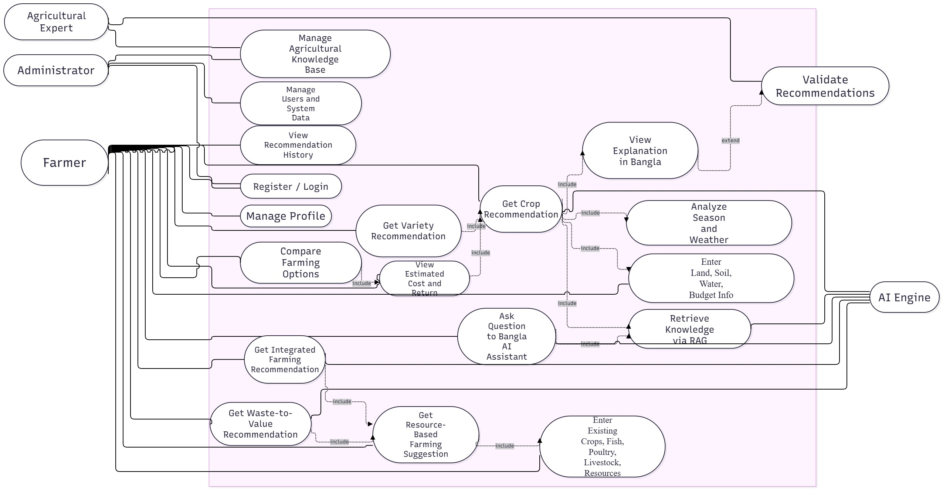
The farmer is the primary actor and uses the system to manage farm information, request recommendations, compare options, and ask agricultural questions. The administrator maintains supported knowledge and reference data. AI and retrieval services support the recommendation workflow where implemented. Expert/reviewer participation is optional and should not be shown as a guaranteed production service.
  - Use Case Descriptions
Actors
Farmer: Primary end-user who creates an account, authenticates, records farming data, and receives recommendations and cost/profit estimates.
Admin: System administrator responsible for logging in, updating crop data, and managing the agricultural information repository.

Use Cases

Create Farmer Account: Registers a new farmer user in the system.

Authenticate Farmer: Logs a farmer into the system after credential validation.

Capture Farming Data: Allows a farmer to input or upload data related to their farm operations.

Analyze Farming Conditions: Processes captured data to assess current environmental and crop conditions.

Recommend Crops and Practices: Generates crop and practice recommendations based on analysis.

Estimate Farming Costs: Calculates the expected costs associated with suggested practices.

Estimate Potential Profits: Projects potential profits from recommended crop choices and practices.

Provide Integrated Suggestions: Aggregates all recommendations, cost, and profit estimates into a single integrated suggestion set.

Deliver Recommendations in Bangla: Translates and presents the integrated suggestions in Bangla for local farmers.

Admin Login: Authenticates administrator credentials.

Update Crop Data: Enables admins to add or modify crop-related information in the system.

Manage Agricultural Information: Oversees the overall management of agricultural data and resources.

Validate Credentials: Auxiliary process that verifies user credentials during authentication.

Translate Content: Auxiliary process that translates content into Bangla.

Relationships between Actors and Use Cases

Farmer → Create Farmer Account: Farmer registers a new account.

Farmer → Authenticate Farmer: Farmer logs into the system.

Farmer → Capture Farming Data: Farmer records farm data.

Farmer → Analyze Farming Conditions: Farmer initiates analysis of their data.

Farmer → Recommend Crops and Practices: Farmer receives crop and practice suggestions.

Farmer → Estimate Farming Costs: Farmer obtains cost estimates.

Farmer → Estimate Potential Profits: Farmer views projected profits.

Farmer → Provide Integrated Suggestions: Farmer accesses consolidated recommendations.

Farmer → Deliver Recommendations in Bangla: Farmer receives Bangla-translated suggestions.

Admin → Admin Login: Admin logs into the administrative console.

Admin → Update Crop Data: Admin updates crop datasets.

Admin → Manage Agricultural Information: Admin manages overall agricultural resources.

7.3 Activity Diagram
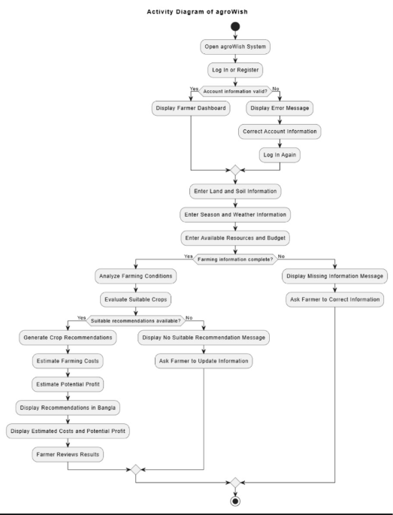
The process validates inputs before recommendation generation. Cost and return comparison is conditional on available reference data. If a reliable recommendation cannot be supported, the workflow ends with a limitation or expert-verification message rather than a fabricated result.

7.4 Entity Relationship Diagram (ERD)
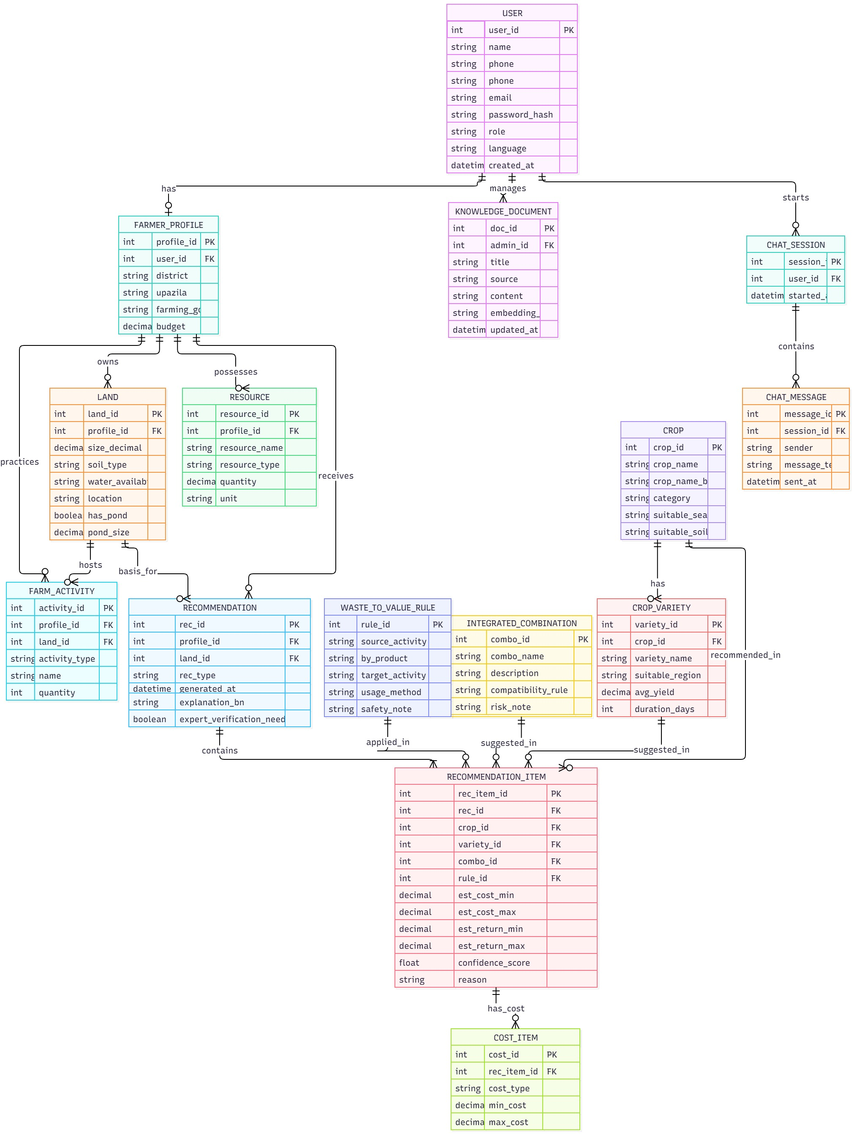
The following entities describe the proposed relational data model. Additional entities may be required after implementation decisions.
Entity | Attributes | Purpose
User | user_id (PK), full_name, email, password_hash, role, created_at | Account and access role for farmer/admin and optional reviewer.
FarmProfile | profile_id (PK), user_id (FK), location, land_size, soil_type, water_availability, season, budget | Current farm conditions relevant to recommendations.
Resource | resource_id (PK), user_id (FK), resource_type, quantity, unit, notes | Pond, crops, livestock, poultry, organic material, water, and other supported resources.
Recommendation | recommendation_id (PK), user_id (FK), request_data, recommendation_type, explanation_bn, uncertainty_note, model_version, created_at | Generated recommendation and the conditions used.
FarmOption | option_id (PK), recommendation_id (FK), crop_or_activity, estimated_cost, potential_return_min/max, assumptions | Each option presented for comparison.
CropReference | crop_id (PK), crop_name, region, season, soil_conditions, water_needs, source_id | Supported crop information used by recommendation logic.
VarietyReference | variety_id (PK), crop_id (FK), variety_name, region, season, suitability_notes, source_id | Variety data where adequate regional information exists.
KnowledgeItem | knowledge_id (PK), topic, source_name, source_date, content, coverage, updated_at | Curated agricultural information and source provenance.
KnowledgeSource | source_id (PK), title, organization, publication_date, url_or_reference, license_notes | Source metadata for data and knowledge items.
CostReference | cost_id (PK), region, season, activity, item, amount, unit, source_id, valid_date | Cost assumptions used for estimates and comparisons.
Feedback (optional) | feedback_id (PK), recommendation_id (FK), user_id (FK), rating, comment, created_at | Optional user feedback.
AuditLog (optional) | log_id (PK), user_id (FK), action, target, logged_at | Records administrative changes and sensitive access where implemented.

Core Relationships

Relationship | Cardinality | Explanation
User → FarmProfile | 1:1 or 1:N | A user has one current profile; profile history may make it one-to-many if versioning is implemented.
User → Resource | 1:N | A farmer can record multiple resources; each resource record belongs to one user.
User → Recommendation | 1:N | A farmer can receive multiple recommendations over time.
Recommendation → FarmOption | 1:N | A recommendation can contain multiple options for comparison.
CropReference → VarietyReference | 1:N | A crop can have multiple supported variety records.
KnowledgeSource → KnowledgeItem | 1:N | A source can support multiple knowledge items.
KnowledgeSource → CostReference | 1:N | A source may support multiple cost records.
Recommendation → Feedback | 1:N | A recommendation may receive zero or more feedback entries.
User → AuditLog | 1:N | A user may generate multiple audit events if logging is implemented.

7.5 AI Feature Design

Data
- Structured agricultural data: crop, variety, season, soil, water, location, resource compatibility, and cost reference information for the selected scope.
- Knowledge documents: credible agricultural guidance and extension materials with source name, date/version, and coverage recorded.
- Farmer inputs: land size, soil type, season, location, water, budget, goals, and available resources.
- Data preparation: standardize units and labels, inspect duplicates, handle missing values, document source provenance, and keep evaluation cases separate from model development where practical.
- Limitation: the initial dataset may be small or uneven; support only the crops and activities that can be documented and evaluated.

Model

AI Feature | Proposed Method | Evaluation / Baseline
Crop recommendation | Rule-based filtering plus a suitable ML classifier/ranker only if labelled data is adequate. | Compare with transparent rule baseline; evaluate on documented cases.
Variety recommendation | Lookup/matching over supported crop-variety records. | Check region/season coverage and expert-reviewed suitability where possible.
Resource/integrated farming | Compatibility rules and ranking based on available resources and requirements. | Test compatible, incompatible, and insufficient-evidence cases.
Waste-to-value | Knowledge retrieval plus suitability and safety rules. | Use source-backed test cases; do not generate unsupported uses.
Cost/return | Transparent calculations using reference values and stated assumptions. | Compare with reference examples; report missing price/cost data.
Bangla assistant | Curated FAQ or retrieval-grounded LLM/API if feasible. | Review relevance, clarity, source faithfulness, uncertainty, and unsafe claims.

Pipeline
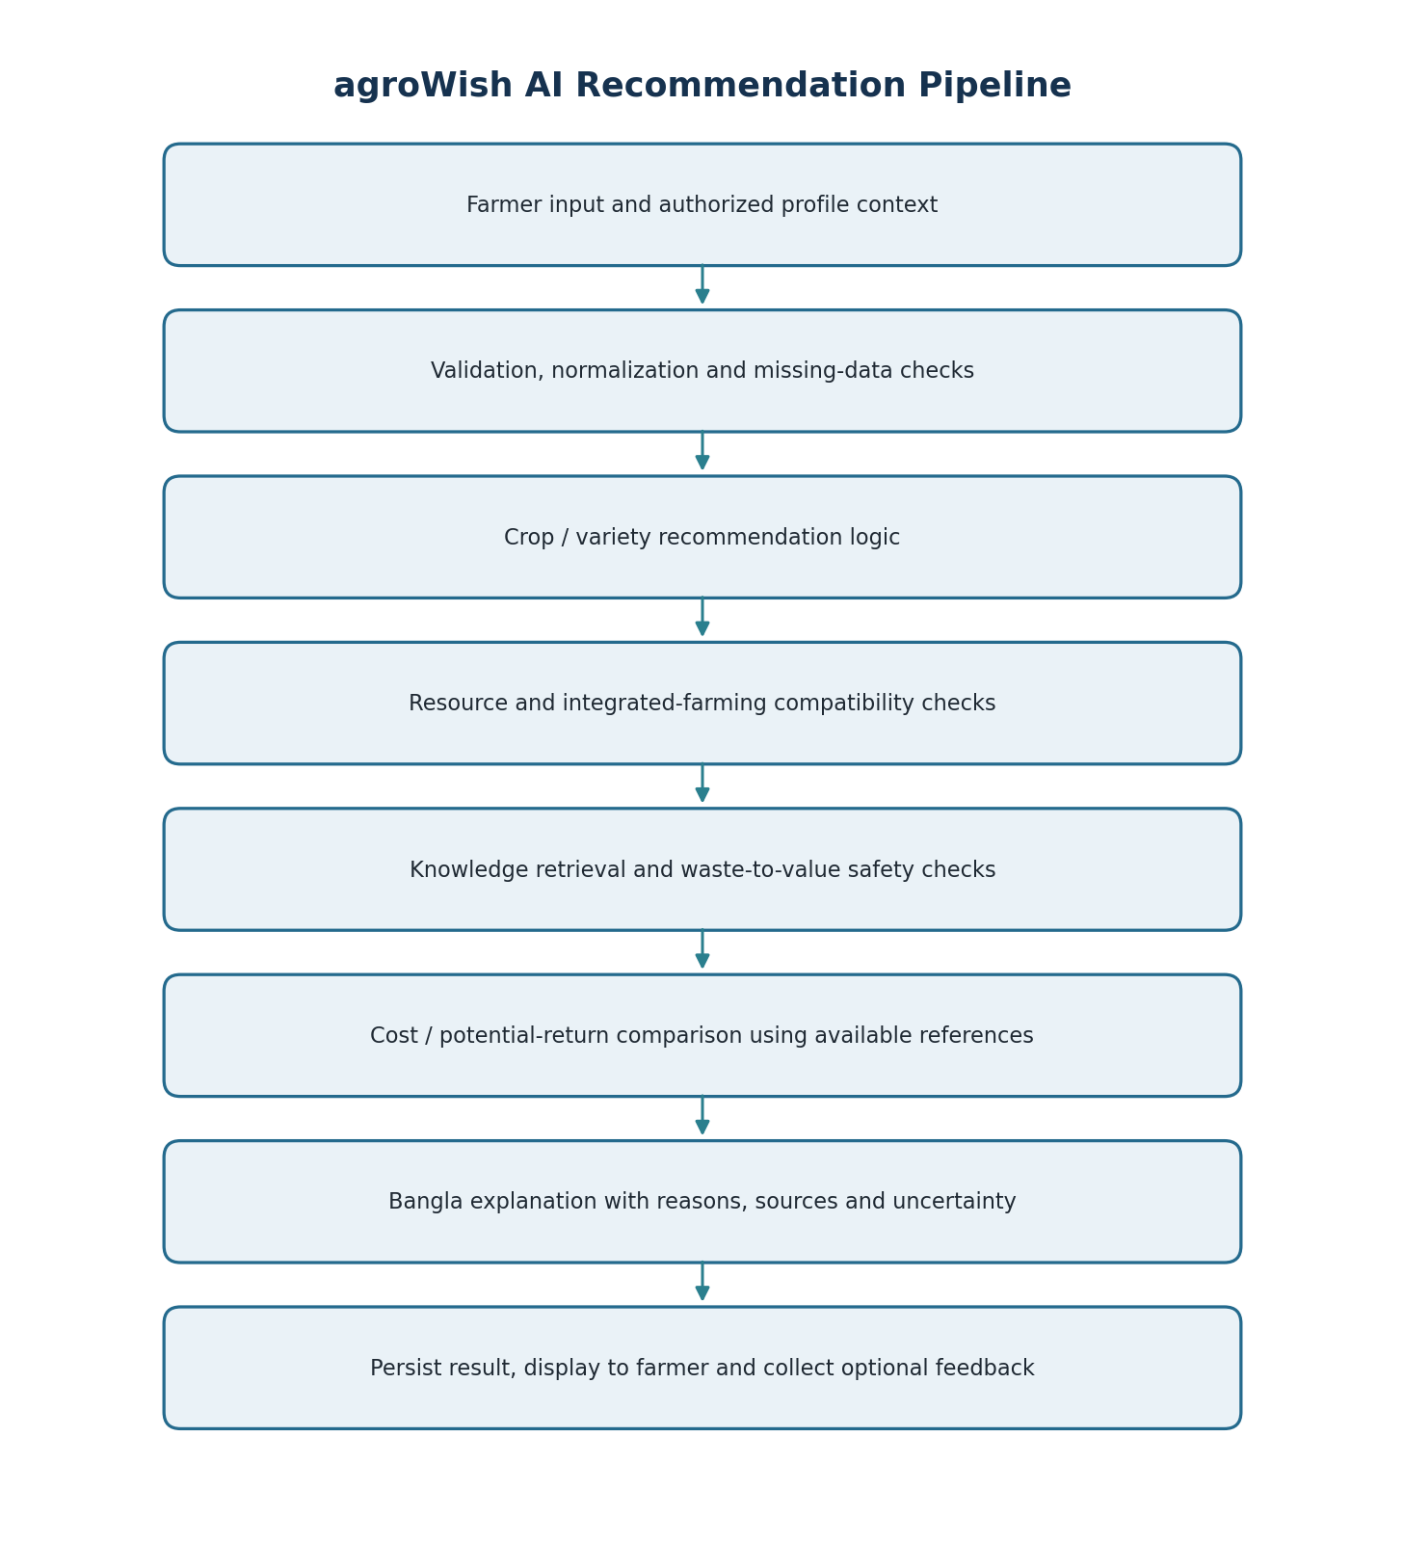

Integration
- The React web client submits farmer inputs to the Node.js/Express REST API.
- The backend validates and stores the request, then calls the Python recommendation service through a defined API or service interface.
- The AI service applies supported crop/resource logic, reads relevant reference data, and returns structured options with reasons and limitations.
- The backend stores the result and returns it to the frontend for Bangla display.
- If an LLM/API is used, credentials must remain on the server and must not be exposed in browser code.
- The final architecture may be simplified if the semester, hosting limits, or dataset make a separate service impractical.

Evaluation and Fallback
- Crop recommendations: evaluate on documented conditions and compare results with supported agricultural guidance.
- Integrated farming and waste-to-value: test supported, unsupported, incompatible, and insufficient-evidence cases.
- Cost estimates: test units, arithmetic, assumptions, and reference-date limitations.
- Bangla assistant: review answer relevance, clarity, faithfulness to available sources, and safe handling of uncertain questions.
- If the AI service fails, show a clear message and use only safe pre-reviewed guidance where available.
- If retrieval finds no relevant support, state that evidence is unavailable and advise verification rather than inventing a source.
- Record the dataset, test cases, metrics, limitations, and observed failures in the final project report.

8. Team Member Responsibility Matrix
The assignments below are a proposed starting allocation based on the project roles. Update them to match actual work. Student IDs are intentionally left for confirmation rather than copied from unverified information.
Member | Name / Student ID | Primary Responsibilities
Member 1 (M1) | Md Adnan Ul Islam  Student ID: [Confirm] | AI and recommendation lead: crop/variety recommendation logic; resource-based and integrated-farming compatibility; waste-to-value rules; cost/return comparison; agricultural knowledge retrieval and Bangla assistant; evaluation, uncertainty, and safety handling.
Member 2 (M2) | Most Tasnim Jahan Rifa  Student ID: [Confirm] | Backend/data lead: database schema; registration/login and role handling; REST API; profile/resource storage; administrator data management; AI-service integration; input validation, privacy, and API testing.
Member 3 (M3) | Tasdid Al Amin  Student ID: [Confirm] | Frontend/usability lead: Bangla-first React interface; farmer input forms; recommendation and comparison views; assistant interface; validation messages; responsive layout and usability testing.

Shared Responsibilities
- All members contribute to elicitation, scoping, requirement review, test design, integration testing, documentation review, and final demonstration.
- Track actual tasks and decisions using GitHub issues/commits or another agreed project record.
- Review agricultural sources for reliability, date, relevance, and safety before using them in recommendations.
- The final demonstration should show one end-to-end workflow: entering farm conditions and resources, receiving a Bangla recommendation, comparing options, and viewing uncertainty/knowledge notices.

Appendix A: Requirement Traceability Summary
Project Objective | Related Requirements
Personalized crop/variety recommendation | FR-04, FR-08 to FR-10, FR-19, AIR-01, AIR-02
Resource-based and integrated farming | FR-06, FR-11, FR-12, AIR-03, AIR-04
Waste-to-value opportunity | FR-13, FR-20 to FR-22, AIR-05, AIR-08, AIR-11
Cost and potential-return comparison | FR-14 to FR-16, FR-21, AIR-06, AIR-10
Bangla agricultural assistant | FR-17 to FR-20, FR-28 to FR-29, AIR-07 to AIR-09
Responsible, secure use | FR-02, FR-07, FR-21, FR-22, FR-27 to FR-35, NFR-04 to NFR-14

Appendix B: Items the Team Must Complete or Confirm
These are the items that cannot responsibly be invented by the report writer. Keep the relevant headings/points in the report and add your actual information before final submission.
Missing / To Confirm | What you need to add or verify
Additional elicitation evidence | The team reports discussions with five farmers. Insert the question and answer page photos in Section 4.2; add dates, anonymized participant roles, consent status where relevant, and a response-based summary if known. Do not invent findings.
Student IDs, batch, section | Confirm the exact ID, batch, and section for all three members from official records.
Agricultural data sources | List the actual dataset/document name, source organization, date/version, regions/crops covered, license/usage terms, and known limitations.
Selected technology stack | Confirm whether the final database is MySQL or PostgreSQL; whether the backend is Node/Express; whether Python is separate; and whether LLM/RAG/vector database is actually included.
Supported initial scope | Specify the first supported crops, regions/seasons, resources, and integrated-farming cases that the team will implement and test.
Evaluation results | After implementation, add the actual test-set size, metrics, comparison with baseline, results, error cases, and limitations. Do not insert targets as achieved results.
Expert validation | If an agricultural expert reviews the system, record the actual feedback and resulting requirement changes. If not, state that validation was not performed.
Architecture and diagrams | Update diagrams if the actual system differs from the proposed React + backend + Python service structure.
Timeline and task ownership | Confirm the semester schedule and revise M1/M2/M3 responsibility allocation based on actual contributions.
References / citations | Add a references section listing every agricultural dataset, knowledge document, API, and external source actually used in the project.

Appendix C: Suggested Evidence Appendix Layout
- Appendix C1 — Farmer interview/survey notes (only if conducted; anonymize participants).
- Appendix C2 — Agricultural expert review sheet or feedback (only if conducted).
- Appendix C3 — Agricultural dataset and knowledge-source inventory.
- Appendix C4 — Prototype test cases and actual evaluation results.
- Appendix C5 — Additional diagrams, screenshots, or sample recommendation output.
End of Software Requirements Specification

