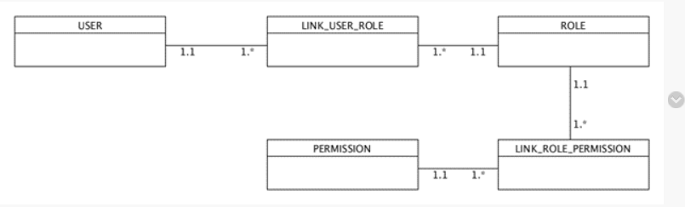

A USER may have many ROLE.

A ROLE may have many PERMISSION.

USER must be linked to ROLE.

ROLE must be linked to PERMISSION.

