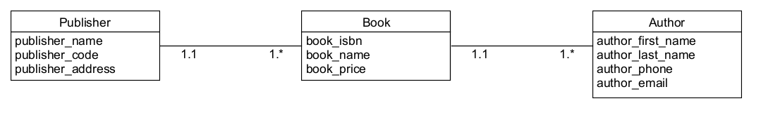

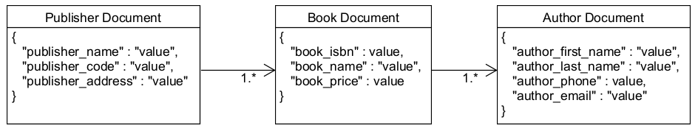

PUBLISHER can have many BOOK

BOOK can have many AUTHOR

PUBLISHER must include NAME, CODE, ADDRESS

BOOK must include ISBN, NAME, PRICE

AUTHOR must include FIRST_NAME, LAST_NAME, PHONE, EMAIL

PUBLISHER must link to BOOK

BOOK must link to AUTHOR

