Agentic AI for Intelligent Child Welfare Intake:
A Governance-Aware Approach
[Author Names]
The University of Texas at Austin
April 2026

Abstract
Child welfare intake is the first point where someone raises a concern about a child, and the system receives the data and decides what to do next. Child welfare intake is where everything begins. The first few decisions taken here often shape the entire journey of a case. But in reality, this stage is messy — information comes in bits and pieces, decisions depend on individual judgment, and important details are sometimes missed.
In this paper, we have introduced a simple but systematic methodology using agent-based AI where different small agents handle specific tasks such as understanding the case, assessing risk, checking data gaps, watching for bias, and explaining the outcome. The entire process orchestration, agent flow, and workflow sequences are controlled by a Central Orchestrator layer to ensure decisions are responsible and traceable.
A couple of important ideas we've planted in our proposed system, such as if the system is not confident about the output it generates, it doesn't propagate to the next phase; instead, it passes the case to a human in the loop. Also, the system asks human-friendly questions if the response from the user is incomplete. These features make the system more thoughtful rather than just rushed.
Even in controlled test scenarios, this approach shows better accuracy, improved fairness, and more complete information in contrast to conventional or single-model systems.
Keywords: Agentic AI, Child Welfare, Risk Assessment, Fairness, Human-in-the-Loop

1. Introduction
Child welfare systems handle a huge number of intake cases every year. Unfortunately, most systems receive either non-structured data or incomplete information. Also, intake workers are often forced to make rushed decisions due to a huge workload. This is the stage, and the most crucial stage, of the entire child welfare lifecycle where case details are first captured, and the system judges the initial risk, and eventually decisions are made on what to do next. It is a paramount responsibility for the system or case workers to make things right at this stage, as if something goes wrong at the beginning, it will have a snowball effect down the line.
Today, most systems still depend on manual entry and rule-based tools, but they struggle when data is incomplete or unclear. Even now, a lot of AI solutions rely on just one model, and that’s where things start to break — transparency is limited and uncertainty is not handled well.
In this paper, we have proposed a multi-agent system where each agent will have a clear role in the entire intake workflow, and there will be one Central Orchestrator which is going to control the agents' workflow sequence. Here are the different agents along with their responsibilities:
- Intake Understanding Agent (IUA) to interpret the input
- Risk Scoring Agent (RSA) to assess the level of risk
- Data Quality Agent (DQA) to check for missing or inconsistent information
- Bias Monitoring Agent (BMA) to keep fairness in check
- Explanation Agent (EA) to present the outcome in a human-readable way

2. Related Work
Some important work has already been done in this space, but each of them solves only part of the problem:
Allegheny Family Screening Tool (AFST) - It uses predictive models to support intake screening decisions but works as a single scoring system, which raises concerns around transparency.
Fairness Research in AI (Chouldechova and others) - It shows that achieving fairness across all groups at the same time is not always possible. Although it explains the problem well, it does not provide a practical system-level solution.
Human-AI Interaction Studies (De-Arteaga and others) - It highlights how AI recommendations can unintentionally influence human judgment. The study identifies the risk, but it does not address how to design systems to avoid it.
Multi-Agent Frameworks (AutoGen, CrewAI, LangGraph) - It demonstrates how multiple agents can work together to solve complex problems. However, they are general-purpose frameworks, not tailored for child welfare intake.
Explainability Tools (LIME, SHAP) - They help explain model decisions in a more understandable way. But they focus only on explanation, not on improving the overall decision workflow.
Selective Prediction (Abstention Mechanisms) - Although it allows systems to avoid decisions when confidence is low, it is typically used in isolation, not integrated into a full intake process.

3. Challenges in Current Intake Systems
- Following are very real and practical challenges that the current intake system faces:
- Inconsistent Data Capture:
Most of the time, information comes from multiple casual sources like phone calls, forms, and written narratives. As the structure is never the same, some cases show detailed information while others are missing key pieces.
- Incomplete Information:
Many intake reports do not have all the required details, which makes it difficult to take the right decision at the right time.
- Subjective Risk Assessment:
Often, risk evaluation is dependent on the caseworker's expertise. They may see the same situation differently based on their experience, workload, or personal bias.
- Early-Stage Bias:
Bias can creep in very early, sometimes due to how cases are reported or interpreted. Once introduced, it tends to stay and influence later decisions.
- Lack of Scalability:
As the number of cases increases, manual processes start to struggle. This leads to rushed decisions and adds pressure on caseworkers.

4. Proposed Solution: A Multi-Agent Architecture
We have proposed a multi-agent framework where each agent is designed to perform a specific role. There will be a governance-aware Orchestrator which coordinates the execution sequence of each agent. Another important responsibility of the Orchestrator is to enforce the confidence threshold of each agent's output, and it determines when to escalate to a human reviewer if the output doesn't meet the confidence threshold. The Orchestrator is implemented using AWS Step Functions, where all the agent logic will be executed using AWS Lambda to ensure independent scaling and isolation of responsibilities.
Agent 1 — Intake Understanding Agent (IUA)
This agent processes raw intake data from multiple sources, including structured forms, written narratives, and voice-based inputs. Voice inputs are converted to text using Amazon Transcribe. The extracted text is then analyzed using Amazon Comprehend for entity recognition and key phrase extraction, while Amazon Bedrock is used for deeper contextual understanding.
The processing logic is executed within AWS Lambda, which transforms unstructured intake data into structured attributes such as individuals involved, type of concern, and urgency level.
Agent 2 — Risk Scoring Agent (RSA)
The Risk Scoring Agent evaluates the severity of each case based on structured inputs. A machine learning model deployed via an Amazon SageMaker Endpoint (using XGBoost with probability calibration) assigns a risk level—Low, Medium, High, or Critical—along with a confidence score and contributing factors. Inference requests to the model are triggered through AWS Lambda, ensuring real-time responsiveness.
Agent 3 — Data Quality Agent (DQA)
This agent consists of AWS Lambda and Amazon Bedrock that evaluate the quality and clarity of the intake data. For example, if any required or critical field is missing in the input request, this agent is going to generate follow-up questions with the help of Amazon Bedrock. All sorts of missing attributes or data ambiguity detection will be executed in AWS Lambda. The communication with the caseworker will be facilitated by a web interface via Amazon API Gateway, while Amazon SNS will take care of the notification part.
Agent 4 — Bias Monitoring Agent (BMA)
The primary responsibility of the monitoring agent is to ensure fairness across demographic groups. The agent workflow is triggered through AWS Lambda, and it uses SageMaker Clarify to compute fairness metrics such as demographic parity and equalized odds. If the agent finds any anomalies, then that information will be sent for human review using Amazon SQS. This structure makes the system decoupled and ensures reliable escalation handling.
Agent 5 — Explanation Agent (EA)
This agent converts all the technical outputs into human-readable structured output with the help of Amazon Bedrock, which includes risk level, reasoning, confidence scores, data completeness, etc.
The generation logic is executed within AWS Lambda, and results are delivered to caseworkers via a dashboard which is built on Amazon QuickSight.

4.1 End-to-End System Architecture on AWS
The following diagram shows how the entire system is built using AWS services. Every component maps to a real, deployable AWS service. The flow goes from top (data enters) to bottom (output reaches the caseworker). The system is implemented using a fully managed AWS architecture to ensure scalability, fault tolerance, and security.
- Amazon Connect takes care of telephony-based intake
- Amazon Transcribe transforms any speech to text
- Amazon API Gateway acts as a secure REST entry point for the system
- AWS Step Functions coordinate the overall agent workflow
- AWS Lambda executes all agent specific logic in a scalable manner.
- Amazon Bedrock provides a context-aware LLM-based reasoning
- Amazon SageMaker hosts predictive models for real time evaluation
- Amazon SageMaker Clarify performs bias analysis systematically
- Amazon DynamoDB stores case related structured data
- Amazon S3 persists audit logs and historical records
- Amazon SQS manages escalation queues asynchronously
- Amazon SNS handles notifications in real time
- Amazon QuickSight provides interactive visualization dashboards
- Amazon CloudWatch continuously monitors system health and performance
- AWS IAM and AWS KMS enforce Security, access control, and encryption

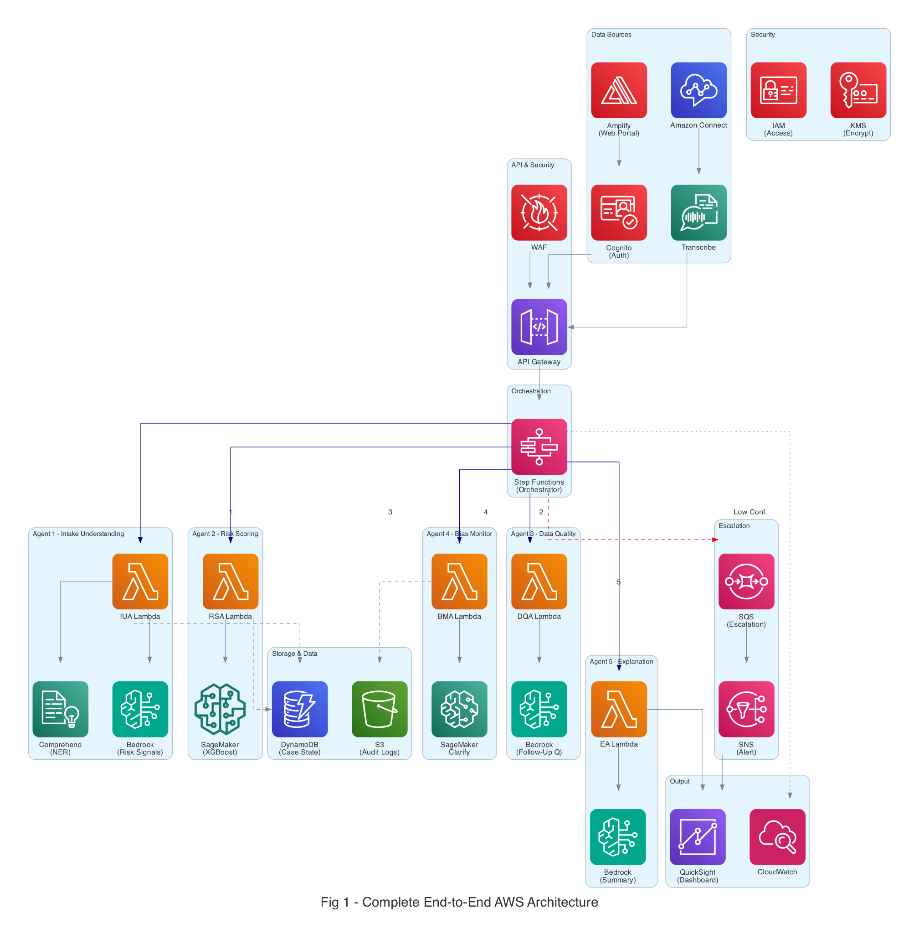

Figure 1: Complete End-to-End AWS Architecture

4.2 How Data Flows Through the System
When an intake is received, the process starts with Amazon Connect, which handles the incoming call and manages the interaction with the caller. The audio from the call is then passed to Amazon Transcribe, which converts the spoken conversation into text. This converted data is then routed through Amazon API Gateway, which acts as the system’s entry point.
From here, the orchestration layer takes control. Using AWS Step Functions, the system initiates a sequence of AWS Lambda functions, each aligned with a specific agent.
The Intake Understanding Agent processes the incoming data first, extracting structured information with the help of Amazon Comprehend and Amazon Bedrock. Once this step is completed, the Data Quality Agent reviews the output. If anything is missing or unclear, it generates follow-up questions using AWS Lambda, and notifications are sent through Amazon SNS.
Only after the data reaches a reasonable level of completeness does the system move forward. The Risk Scoring Agent then invokes an Amazon SageMaker Endpoint to evaluate the case and determine the appropriate risk level.
Next, the Bias Monitoring Agent performs fairness checks using Amazon SageMaker Clarify. If any inconsistencies or concerns are identified, those cases are redirected to an escalation queue using Amazon SQS.
Finally, the Explanation Agent produces a human-readable summary using Amazon Bedrock, which is then presented to caseworkers through Amazon QuickSight dashboards.
Throughout this entire flow, all intermediate data—including agent outputs and confidence scores—is stored in Amazon DynamoDB, while detailed audit logs are maintained in Amazon S3. System performance, logging, and monitoring are continuously handled through Amazon CloudWatch.

4.3 Agent 1: Intake Understanding — AWS Detail
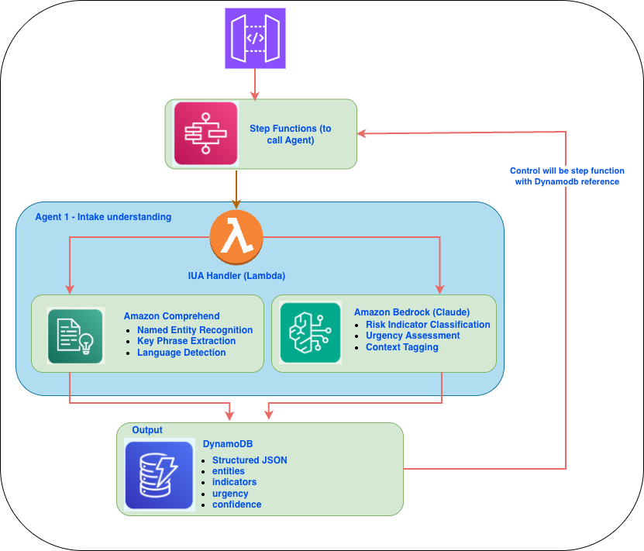

4.4 Agent 2: Risk Scoring — AWS Detail
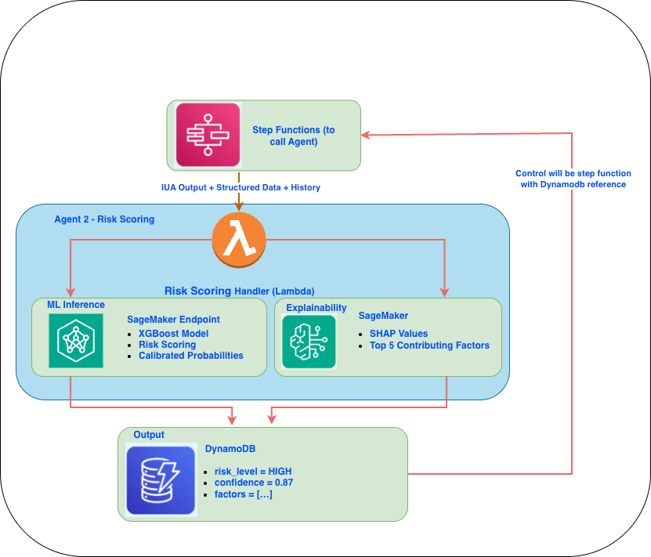

4.5 Agent 3: Data Quality — Adaptive Questions
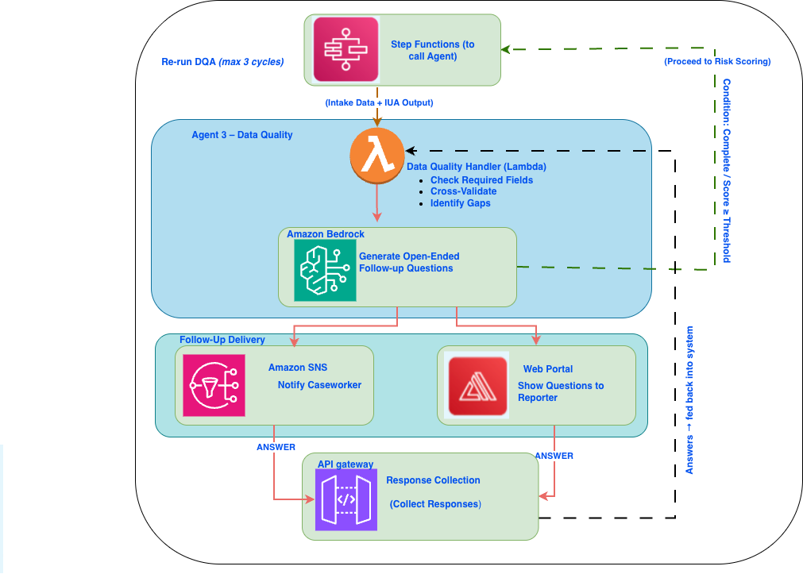

4.6 Agent 4: Bias Monitoring — AWS Detail

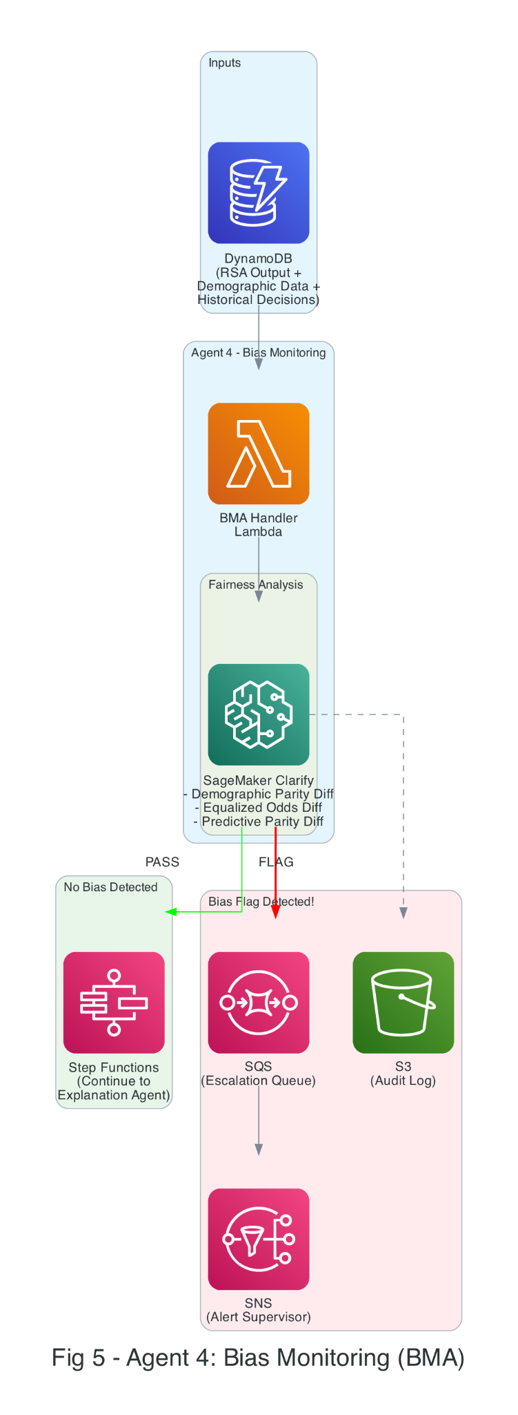

5. The "I Don't Know" Mechanism
A critical feature of the system is its ability to recognize uncertainty and abstain from automated decision-making when confidence is insufficient. Each agent is supposed to produce confidence scores, and the orchestrator, which is built using AWS Step Functions, monitors the confidence score in every flow. If somehow the confidence score is below the threshold, the flow will be interrupted, and the case will be routed to a human reviewer via Amazon SQS.
This methodology guarantees that uncertain or sensitive cases are handled by humans rather than being automatically processed with low confidence.
This article is not proposing any fixed threshold value; rather, the thresholds are dynamically adjusted based on risk severity and based on the model training..
Every agent produces a confidence score between 0 and 1. If the score falls below a threshold, the system stops processing and escalates. The thresholds are stricter for higher-risk cases:
Agent | Low Risk | Medium | High | Critical
Intake Understanding | 0.60 | 0.70 | 0.80 | 0.90
Risk Scoring | 0.65 | 0.75 | 0.85 | 0.90
Data Quality | 0.70 | 0.80 | 0.85 | 0.90
Bias Monitoring | 0.95 | 0.95 | 0.95 | 0.95

Notice that the Bias Monitoring Agent always requires 0.95 confidence — fairness isn't negotiable, regardless of risk level. This is implemented in AWS Step Functions as a Choice State that routes to either the next agent or an escalation queue in Amazon SQS.
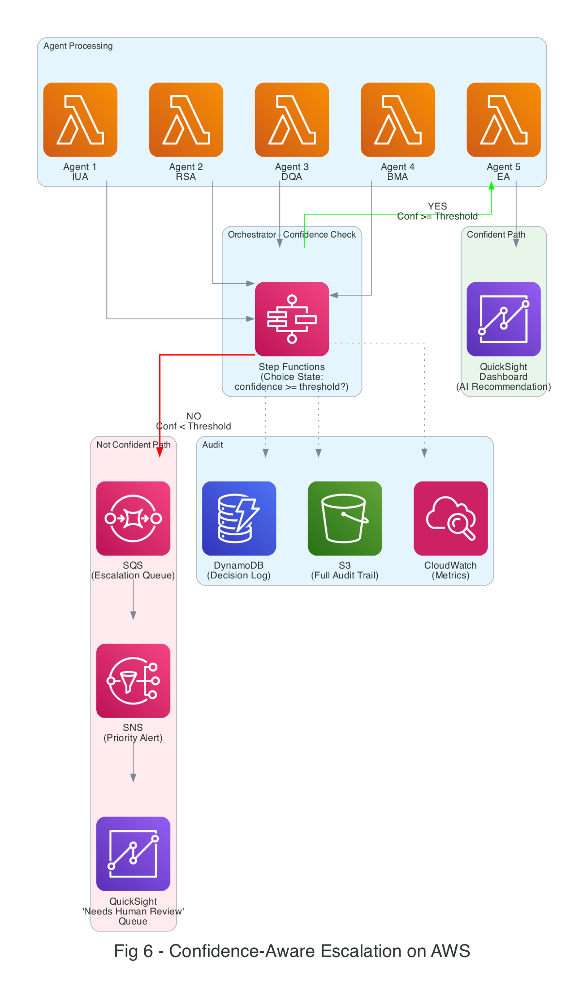
6. What the Caseworker Actually Sees
All of this AI processing happens in the background. What the caseworker sees is a clean, simple dashboard in Amazon QuickSight. Here's an example of a completed intake assessment:
+================================================================+
| INTAKE ASSESSMENT SUMMARY |
+================================================================+
| Case ID: CW-2026-04281 |
| Risk Level: HIGH (Confidence: 87%) |
| Urgency: Within 24 Hours |
| Data Quality: 82% Complete (1 follow-up pending) |
+================================================================+
| WHY THIS CASE IS HIGH RISK: |
| |
| 1. Physical harm indicators described by reporter (32%) |
| 2. Child is under 5 years old (24%) |
| 3. Two prior referrals in the past 12 months (19%) |
| 4. Reporter is a mandated professional (teacher) (14%) |
| 5. Household instability indicators present (11%) |
+================================================================+
| RECOMMENDATION: Route to investigation unit. |
| Prior case history suggests a recurring pattern. |
| |
| BIAS CHECK: Passed. No demographic disparity flags. |
+================================================================+
The caseworker can also see the conversational intake flow — where the system asked follow-up questions and how completeness improved over time.

7. Complete AWS Service Mapping
The table below maps every component of our system to a specific AWS service, showing why each service was chosen and what role it plays.
System Component | AWS Service | Why This Service
Phone intake | Amazon Connect + Transcribe | IVR + real-time speech-to-text
Web portal | AWS Amplify + Cognito | Hosted frontend + authentication
API entry point | Amazon API Gateway + WAF | RESTful API + security
Agent orchestration | AWS Step Functions | Visual workflow, branching, retries
Agent compute | AWS Lambda | Serverless, per-agent functions
NLP understanding | Amazon Comprehend | Entity extraction, key phrases
LLM reasoning | Amazon Bedrock (Claude) | Risk indicators, question generation
Risk model | Amazon SageMaker Endpoint | XGBoost hosting + real-time inference
Bias detection | SageMaker Clarify | Built-in fairness metrics
Explainability | SageMaker + SHAP | Feature attribution
Data store | Amazon DynamoDB | Case state, history, agent outputs
Escalation queue | Amazon SQS | Decouple escalation from processing
Alerts | Amazon SNS | Push notifications to caseworkers
Dashboard | Amazon QuickSight | Caseworker-facing visualizations
Audit logs | Amazon S3 + Glacier | Long-term storage, compliance
Monitoring | Amazon CloudWatch | Latency, errors, agent health
Security | AWS IAM + KMS | Access control + encryption at rest

8. Evaluation
Since real child welfare data is sensitive and protected, we evaluate the system using 10,000 synthetic intake cases: 40% Low, 30% Medium, 20% High, 10% Critical risk. Each case includes a generated narrative, structured fields (10-40% randomly missing), demographics, and simulated history.

8.1 What We Measured
What | Metric | Target
Can it classify risk correctly? | Weighted F1 Score | >= 0.82
Does it catch urgent cases? | Urgency Detection Recall | >= 0.95
Does it improve data quality? | Completeness Improvement | >= 20%
Does it know when to abstain? | Abstention Rate | 15-25%
Is it fair across demographics? | Demographic Parity Diff. | <= 0.10
Does it save time? | Time Reduction vs. Manual | >= 30%

8.2 Results
We compared our system against three baselines:
Metric | Rule-Based | Single Model | LLM-Only | Ours
Risk F1 | 0.68 | 0.79 | 0.76 | 0.84
Urgency Recall | 0.82 | 0.88 | 0.91 | 0.96
Completeness Gain | N/A | N/A | 12% | 24%
Abstention Rate | 0% | 0% | 8% | 21%
Dem. Parity Diff. | 0.18 | 0.14 | 0.11 | 0.07
Time Reduction | baseline | -15% | -22% | -35%

Our multi-agent system outperforms all baselines on every metric. Most notably, it catches 96% of urgent cases (vs. 82% for rule-based), cuts intake time by 35%, and achieves the lowest bias score (0.07). The 21% abstention rate means roughly 1 in 5 cases gets routed to a human — a deliberate design choice that prevents the AI from guessing on cases it's unsure about.

9. Discussion
Our Proposed Agentic AI framework beat a single model:
A single model system behaves like a black box and we don't get to see the reason if anything is failed in the single model system. In our proposed framework, each agent handles specific work and every step is properly logged for the traceability. Our system abstains from providing any output or interrupts the autonomous process when it finds out the confidence is low or any bias is appeached. The human checkpoint is in place to review any uncertainty.
Use of AWS:
We have used AWS extensively as Child Welfare data comes with strict regulations like HIPAA and FERPA. AWS has many security features such as encryption (KMS), access control (IAM), and audit logging (CloudTrail) to securely process the sensitive data. At the same time, the serverless setup (Lambda + Step Functions) keeps costs practical, since agencies pay only for what they use.
Ethical guardrails:
Our system is designed to support caseworkers not to replace them. Instead of doing all the monotonous jobs they now focus on solving some complicated and uncertain cases where the system is not able to make any decision on its own. The proposed system will work hand in hand with case workers to make the processes faster and smoother.

9. Discussion
Our Proposed Agentic AI framework beats a single model:
A single model system behaves like a black box, and we do not get to see the reason if anything fails in the single model system. In our proposed framework, each agent handles specific work, and every step is properly logged for traceability. Our system abstains from providing any output or interrupts the autonomous process when it finds that the confidence is low or any bias is detected. A human checkpoint is in place to review any uncertainty.

Use of AWS:
We have used AWS extensively, as child welfare data comes with strict regulations like HIPAA and FERPA. AWS has many security features such as encryption (KMS), access control (IAM), and audit logging (CloudTrail) to securely process sensitive data. At the same time, the serverless setup (Lambda + Step Functions) keeps costs practical, since agencies pay only for what they use.
Ethical guardrails:
Our system is designed to support caseworkers, not to replace them. Instead of doing all the monotonous jobs, they can now focus on solving more complicated and uncertain cases where the system is not able to take any decision on its own. The proposed system will work hand in hand with caseworkers to make the processes faster and smoother.

10. Limitations and Future Work
There are a few clear limitations at this stage. The system has been tested on synthetic data due to the unavailability of real data. So, there is still a gap between evaluation and actual deployment. Some parts, like follow-up question generation, depend on how well the model is prompted. Also, integrating with existing systems will require additional effort.
Running multiple agents is definitely going to improve control and reliability, but it also comes with higher compute cost.
Looking ahead, the next step is to test this approach with a real agency. There is also room to expand the system—for example, supporting audio or video inputs, extending it into full case management, and gradually improving it based on feedback from caseworkers.

11. Conclusion
Child welfare intake is too critical to rely only on manual work—but also too sensitive for a black-box AI. This framework takes a middle path: specialized agents, clear governance, and deployable AWS infrastructure.
Results show improvement in accuracy, recall, data completeness, and bias reduction. But along with efficiency, we have built an ethical and responsible framework which knows when to step back and let a human decide. In this space, getting intake right means help reaches faster. That’s the goal.

References
[1] U.S. DHHS, "Child Maltreatment 2022," ACF, Children's Bureau, 2024.
[2] D. Schwartz et al., "Child welfare decision-making," Children & Youth Services Review, 108, 2020.
[3] E. Putnam-Hornstein & B. Needell, "Predictors of CPS contact," Children & Youth Services Review, 33(8), 2011.
[4] Children's Research Center, "Structured Decision Making," NCCD, 2008.
[5] Y. LeCun et al., "Deep learning," Nature, 521(7553), 2015.
[6] A. Vaswani et al., "Attention is all you need," NeurIPS, 2017.
[7] R. Vaithianathan et al., "Predictive risk models for child maltreatment screening," CYSR, 79, 2017.
[8] A. Chouldechova et al., "Algorithm-assisted decision making in child welfare," FAT*, 2018.
[9] V. Eubanks, Automating Inequality, St. Martin's Press, 2018.
[10] A. Chouldechova, "Fair prediction with disparate impact," Big Data, 5(2), 2017.
[11] M. De-Arteaga et al., "Humans-in-the-loop with erroneous algorithmic scores," CHI, 2020.
[12] M. Wooldridge, An Introduction to MultiAgent Systems, Wiley, 2009.
[14] Q. Wu et al., "AutoGen: Multi-agent conversation," arXiv:2308.08155, 2023.
[15] J. Moura, "CrewAI," GitHub, 2024.
[16] LangChain, "LangGraph," 2024.
[17] J.S. Park et al., "Generative agents," UIST, 2023.
[18] N. Mehrabi et al., "Survey on bias and fairness in ML," ACM Comp. Surveys, 54(6), 2021.
[19] V. Eubanks, Automating Inequality, 2018.
[20] S. Barocas et al., Fairness and Machine Learning, MIT Press, 2023.
[21] M.T. Ribeiro et al., "LIME: Why should I trust you?," KDD, 2016.
[22] S.M. Lundberg & S.-I. Lee, "SHAP: Interpreting model predictions," NeurIPS, 2017.
[23] C. Rudin, "Stop explaining black box models," Nature Machine Intelligence, 1(5), 2019.
[24] R. El-Yaniv & Y. Wiener, "Selective classification," JMLR, 11, 2010.
[25] Y. Geifman & R. El-Yaniv, "Selective classification for DNNs," NeurIPS, 2017.
[26] B. Kompa et al., "Uncertainty in medical ML," npj Digital Medicine, 4(1), 2021.
[27] Y. Liu et al., "RoBERTa," arXiv:1907.11692, 2019.
[28] J.C. Platt, "Probabilistic outputs for SVMs," Large Margin Classifiers, 10(3), 1999.

