Agentic AI for Intelligent Child Welfare Intake:
A Governance-Aware Approach
[Author Names]
The University of Texas at Austin
April 2026

Abstract
Child welfare intake is the first point where someone raises a concern about a child, and the system receives the data and decides what to do next. Child welfare intake is where everything begins. The first few decisions taken here often shape the entire journey of a case. But in reality, this stage is messy — information comes in bits and pieces, decisions depend on individual judgment, and important details are sometimes missed.
In this paper, we have conceptualized a systematic methodology with the help of agent-based Artificial Intelligence (AI) to assist caseworkers and make the intake process seamless and fast. We have envisioned a system where the data entry will be done using a conversational interactive chatbot interface, and the system will have multiple agents to perform specific tasks such as analyzing the data, assessing risk, data quality checks, and bias checks, etc. Also, there will be a Central Orchestrator which will manage all the agents and maintain the sequence of the workflow.
A couple of important ideas we've planted in our proposed system, such as if the system is not confident about the output it generates, it doesn't propagate to the next phase; instead, it passes the case to a human in the loop. Also, the system asks human-friendly questions if the response from the user is incomplete. These features make the system more thoughtful rather than just rushed.
Even in controlled test scenarios, this approach shows better accuracy, improved fairness, and more complete information in contrast to conventional or single-model systems.
Keywords: Agentic AI, Child Welfare, Risk Assessment, Fairness, Human-in-the-Loop

1. Introduction
Child welfare systems handle a huge number of intake cases every year. Unfortunately, most systems receive either non-structured data or incomplete information. Also, intake workers are often forced to make rushed decisions due to a huge workload. This is the stage, and the most crucial stage, of the entire child welfare lifecycle where case details are first captured, and the system judges the initial risk, and eventually decisions are made on what to do next. It is a paramount responsibility for the system or caseworkers to make things right at this stage, as if something goes wrong at the beginning, it will have a snowball effect down the line.
Today, many systems still depend on manual legacy data entry styles with rule-based tools where all reporters have to fill up a big form, and then the data will be entered into the system, and they struggle when the data is incomplete and unclear. Nowadays, many AI-enabled systems are built, but in most cases, they are using only a one-model concept, and that's where the system starts to break.
We have conceptualized an Agentic AI system consisting of multiple agents where each agent is specialized to perform a specific task and will have a clear role in the entire workflow. There will be a Central Orchestrator which is going to govern the entire workflow and manage all those agents. Our goal is to build a governance-aware Agentic AI intake system where most of the repetitive work will be done by agents while keeping all the governance validations intact, and also a human checkpoint should be present when the system itself is unable to take any decision. Here are the different agents along with their responsibilities:
- Intake Understanding Agent (IUA) to interpret the input
- Risk Scoring Agent (RSA) to assess the level of risk
- Data Quality Agent (DQA) to check for missing or inconsistent information
- Bias Monitoring Agent (BMA) to keep fairness in check
- Explanation Agent (EA) to present the outcome in a human-readable way

3. Challenges in Current Intake Systems
Following are very real and practical challenges that the current intake system faces:
- Inconsistent Data Capture: Most of the systems have a manual data entry process which is a bit messy and time-consuming affair. Some organizations have built online data entry systems, but they usually follow form-based data entry which struggles in collecting any unstructured data such as information from phone calls or written narratives.
- Incomplete Information: Many intake reports do not have all the required details, which makes it difficult to take the right decision at the right time.
- Subjective Risk Assessment: We have to agree on one point that most of the caseworkers are experienced and have adequate skills to assess any risk, but as the risk assessment is totally dependent on one person's expertise and observation, it's highly likely they may see the same situation differently based on their prior experience, circumstances, workload, or personal bias.
- Early-Stage Bias: Any form-based system doesn't have the capability to sense any bias, and it's difficult and time-consuming for any caseworker to identify bias in the workflow. It's very crucial to identify and mitigate bias at this very early stage as it impacts all the later decisions.
- Lack of Scalability: The scalability of the system is dependent on how many caseworker resources are available. This legacy and manual system doesn't have the capability to scale up if the number of cases increases.

4. Proposed Solution: A Governance-Aware Multi-Agent Intake Workflow
We propose a governance-aware multi-agent workflow to automate a couple of monotonous tasks, make the process much faster, and help caseworkers focus on truly complex work while keeping governance checks intact to make sure the child's data is secured.
The workflow is built on three main ideas: conversational intake, clear agent responsibility, and human oversight. Our system proposes a conversational intake interface instead of a rigid form-based interface, where the reporter can write about the child in an unstructured way and can also upload documents, PDFs, audio, video, etc. Our system has multiple agents that take care of specific responsibilities separately, and all those agents are going to take that unstructured data and, through an entire workflow, create a structured output for the caseworker. Multiple agents are needed to keep the governance checks intact and make the system scalable and auditable. Human oversight is very important in this type of autonomous system, and every agent works based on confidence level. If the confidence level is lower than the threshold value, then the system abstains from taking any decision, and the case will be redirected to a human for review. All the threshold values are basically configurable values, which will be determined during actual product implementation.

4.1 End-to-End Intake Workflow
The workflow begins when a reporter or intake worker opens our chatbot-type interface to enter any child's information. The system immediately creates an intake record with the available data that is shared by the user. The system has weightage-based fuzzy search logic to check for any duplicate records, and if the system is very confident (the threshold value of the confidence is a configurable percentage) about the existing record matching, then instead of creating a new intake, it updates the existing record. Sometimes, the system asks the reporter whether the person is referring to the same child who is already present in the system's record.
The user can enter any type of unstructured textual data, or they can upload any document, videos, and photographs of the child. The Understanding Agent will analyze all the unstructured data, extract all the important information, and try to prepare a structured dataset.
As our proposed intake interface is conversational, the system does not silently enter the data if any critical data is missing. Instead, it creates a human-friendly question and asks the reporter to provide the data. After a couple of follow-up questions, if the system still cannot collect all the relevant and critical information, the case is immediately redirected to a human for review. The system has a limited follow-up loop, and it is designed not to overwhelm the user. This loop limit is configurable.
Once the system collects most of the important data after the conversational loop, the Risk Assessment Agent starts assessing the child's vulnerability. It analyzes many different scenarios such as the child's age, security concerns, any noticeable injury, special needs, prior history, etc. based on the available data and generates a risk score. If the risk is very high and above a system-configured threshold value, the caseworker gets immediately notified about the situation so that they can make further decisions.
After the Risk Assessment, the Data Quality Agent mainly checks the data quality before it goes for caseworker review. We have kept this agent in the loop to avoid any unnecessary delay because of incomplete data. It checks whether all the required and crucial data is present or not, and if the data is not present, then it again sends a signal to the first agent to ask for that information.
The main responsibility of the Bias Agent is to check whether the risk assessment is fair and unbiased. There could be multiple unfair factors such as demographic bias, location-based bias, and socioeconomic biases that can influence the system's output, and similar cases can be treated differently. If this agent finds any discrepancies, then it redirects the case to humans for review.
Once all the checks are completed, the system saves the intake record along with the raw narrative, uploaded file references, extracted fields, follow-up history, risk score, data quality result, bias monitoring result, confidence scores, and audit events. After that, the Explanation Agent converts all the technical outputs into a simple summary for the caseworker. The summary includes the risk level, confidence, urgency, key reasons, limitations, and recommended next step.

4.2 Agent Responsibilities
We have proposed a multi-agent framework where each agent is designed to perform a specific role. There will be a governance-aware Orchestrator which coordinates the execution sequence of each agent. Another important responsibility of the Orchestrator is to enforce the confidence threshold of each agent's output, and it determines when to escalate to a human reviewer if the output doesn't meet the confidence threshold. The Orchestrator is implemented using AWS Step Functions, where all the agent logic will be executed using AWS Lambda to ensure independent scaling and isolation of responsibilities.
Agent 1 — Intake Understanding Agent (IUA)
This agent processes raw intake data from multiple sources, including structured forms, written narratives, and voice-based inputs. Voice inputs are converted to text using Amazon Transcribe. The extracted text is then analyzed using Amazon Comprehend for entity recognition and key phrase extraction, while Amazon Bedrock is used for deeper contextual understanding.
The processing logic is executed within AWS Lambda, which transforms unstructured intake data into structured attributes such as individuals involved, type of concern, and urgency level.
Agent 2 — Risk Scoring Agent (RSA)
The Risk Scoring Agent evaluates the severity of each case based on structured inputs. A machine learning model deployed via an Amazon SageMaker Endpoint (using XGBoost with probability calibration) assigns a risk level—Low, Medium, High, or Critical—along with a confidence score and contributing factors. Inference requests to the model are triggered through AWS Lambda, ensuring real-time responsiveness.
Agent 3 — Data Quality Agent (DQA)
This agent consists of AWS Lambda and Amazon Bedrock that evaluate the quality and clarity of the intake data. For example, if any required or critical field is missing in the input request, this agent is going to generate follow-up questions with the help of Amazon Bedrock. All sorts of missing attributes or data ambiguity detection will be executed in AWS Lambda. The communication with the caseworker will be facilitated by a web interface via Amazon API Gateway, while Amazon SNS will take care of the notification part.
Agent 4 — Bias Monitoring Agent (BMA)
The primary responsibility of the monitoring agent is to ensure fairness across demographic groups. The agent workflow is triggered through AWS Lambda, and it uses SageMaker Clarify to compute fairness metrics such as demographic parity and equalized odds. If the agent finds any anomalies, then that information will be sent for human review using Amazon SQS. This structure makes the system decoupled and ensures reliable escalation handling.
Agent 5 — Explanation Agent (EA)
This agent converts all the technical outputs into human-readable structured output with the help of Amazon Bedrock, which includes risk level, reasoning, confidence scores, data completeness, etc.
The generation logic is executed within AWS Lambda, and results are delivered to caseworkers via a dashboard which is built on Amazon QuickSight.

4.3 Human-in-the-Loop Decision Gates
Human checkpoint is crucial in making any autonomous work properly and we have kept human checkpoint in each decision making point. Every agent generates output along with a confidence level and if any agent is not confident enough to make a decision then it will be sent for human review. We have used multiple threshold values to determine when agents should reach out to humans but as this is a proposed and conceptual system, we haven't specified value to those threshold. Those threshold values can be determined during actual product development.

4.1 End-to-End System Architecture on AWS
The following diagram shows how the entire system is built using AWS services. Every component maps to a real, deployable AWS service. The flow goes from top (data enters) to bottom (output reaches the caseworker). The system is implemented using a fully managed AWS architecture to ensure scalability, fault tolerance, and security.
- Amazon Connect takes care of telephony-based intake
- Amazon Transcribe transforms any speech to text
- Amazon API Gateway acts as a secure REST entry point for the system
- AWS Step Functions coordinate the overall agent workflow
- AWS Lambda executes all agent specific logic in a scalable manner.
- Amazon Bedrock provides a context-aware LLM-based reasoning
- Amazon SageMaker hosts predictive models for real time evaluation
- Amazon SageMaker Clarify performs bias analysis systematically
- Amazon DynamoDB stores case related structured data
- Amazon S3 persists audit logs and historical records
- Amazon SQS manages escalation queues asynchronously
- Amazon SNS handles notifications in real time
- Amazon QuickSight provides interactive visualization dashboards
- Amazon CloudWatch continuously monitors system health and performance
- AWS IAM and AWS KMS enforce Security, access control, and encryption

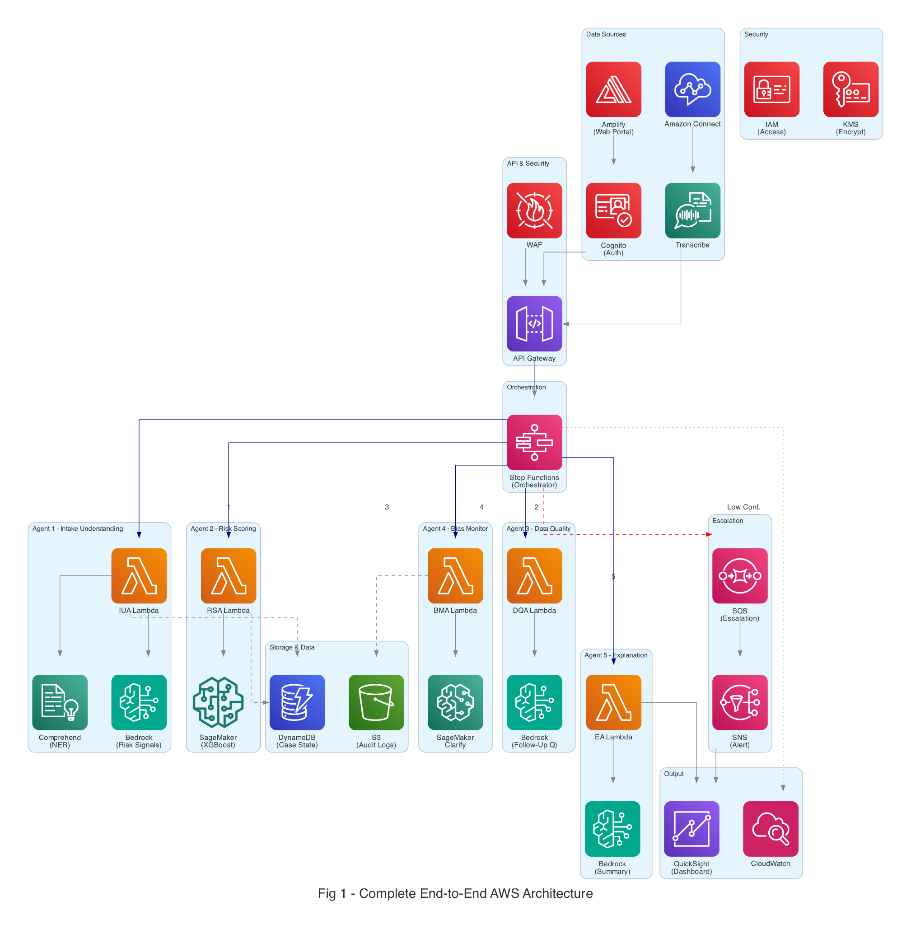

Figure 1: Complete End-to-End AWS Architecture

4.2 How Data Flows Through the System
When an intake is received, the process starts with Amazon Connect, which handles the incoming call and manages the interaction with the caller. The audio from the call is then passed to Amazon Transcribe, which converts the spoken conversation into text. This converted data is then routed through Amazon API Gateway, which acts as the system’s entry point.
From here, the orchestration layer takes control. Using AWS Step Functions, the system initiates a sequence of AWS Lambda functions, each aligned with a specific agent.
The Intake Understanding Agent processes the incoming data first, extracting structured information with the help of Amazon Comprehend and Amazon Bedrock. Once this step is completed, the Data Quality Agent reviews the output. If anything is missing or unclear, it generates follow-up questions using AWS Lambda, and notifications are sent through Amazon SNS.
Only after the data reaches a reasonable level of completeness does the system move forward. The Risk Scoring Agent then invokes an Amazon SageMaker Endpoint to evaluate the case and determine the appropriate risk level.
Next, the Bias Monitoring Agent performs fairness checks using Amazon SageMaker Clarify. If any inconsistencies or concerns are identified, those cases are redirected to an escalation queue using Amazon SQS.
Finally, the Explanation Agent produces a human-readable summary using Amazon Bedrock, which is then presented to caseworkers through Amazon QuickSight dashboards.
Throughout this entire flow, all intermediate data—including agent outputs and confidence scores—is stored in Amazon DynamoDB, while detailed audit logs are maintained in Amazon S3. System performance, logging, and monitoring are continuously handled through Amazon CloudWatch.

4.3 Agent 1: Intake Understanding — AWS Detail
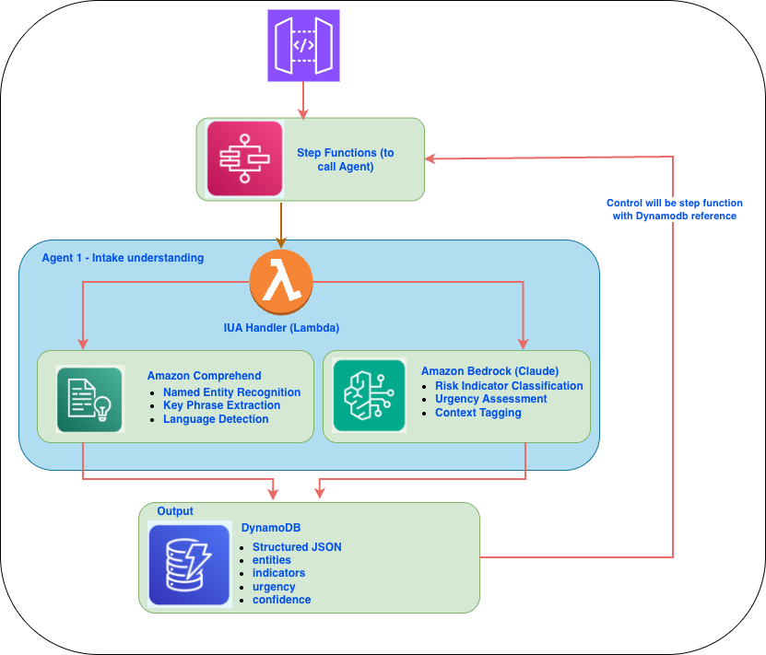

4.4 Agent 2: Risk Scoring — AWS Detail
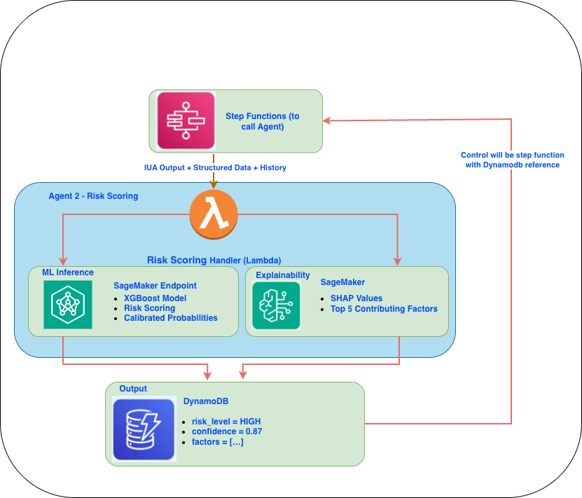

4.5 Agent 3: Data Quality — Adaptive Questions
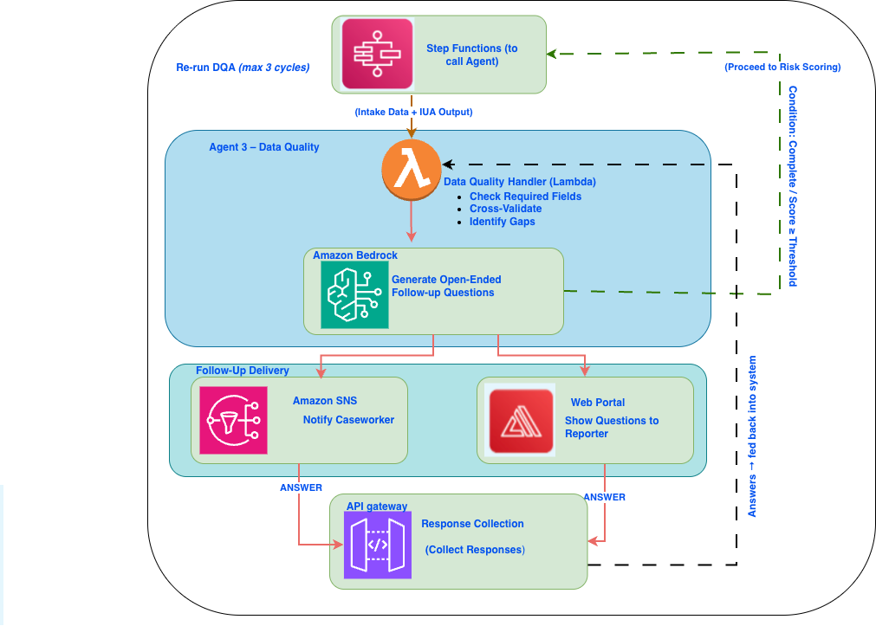

4.6 Agent 4: Bias Monitoring — AWS Detail

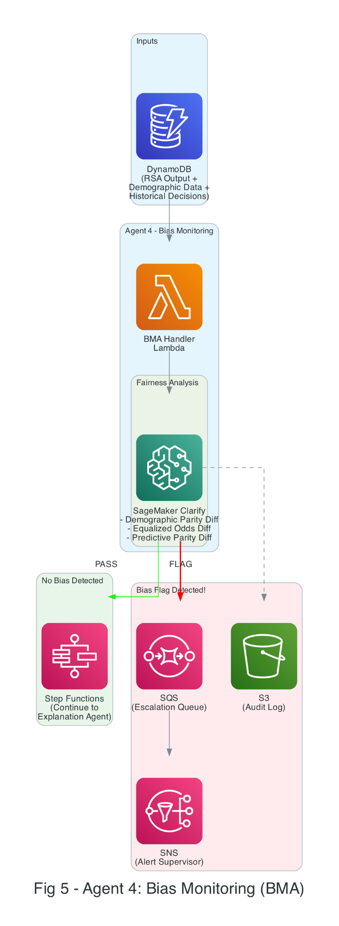

5. The "I Don't Know" Mechanism
A critical feature and the most responsible feature of the system is to abstain from making any automated decision when the system confidence is insufficient. Each agent is supposed to produce confidence scores, and the orchestrator, which is built using AWS Step Functions, monitors the confidence score in every flow. If somehow the confidence score is below the threshold, the flow will be interrupted, and the case will be routed to a human reviewer via Amazon SQS. This methodology guarantees that although the system is autonomous, human checks are an integral part of the system. This article is not proposing any fixed threshold value; rather, the thresholds are dynamically adjusted based on risk severity and model training.
Every agent produces a confidence score between 0 and 1. If the score falls below a threshold, the system stops processing and redirects the case for human review. The thresholds are stricter for higher-risk cases:
Agent | Low Risk | Medium | High | Critical
Intake Understanding | 0.60 | 0.70 | 0.80 | 0.90
Risk Scoring | 0.65 | 0.75 | 0.85 | 0.90
Data Quality | 0.70 | 0.80 | 0.85 | 0.90
Bias Monitoring | 0.95 | 0.95 | 0.95 | 0.95

Notice that the Bias Monitoring Agent always requires 0.95 confidence — fairness isn't negotiable, regardless of risk level. This is implemented in AWS Step Functions as a Choice State that routes to either the next agent or an escalation queue in Amazon SQS.
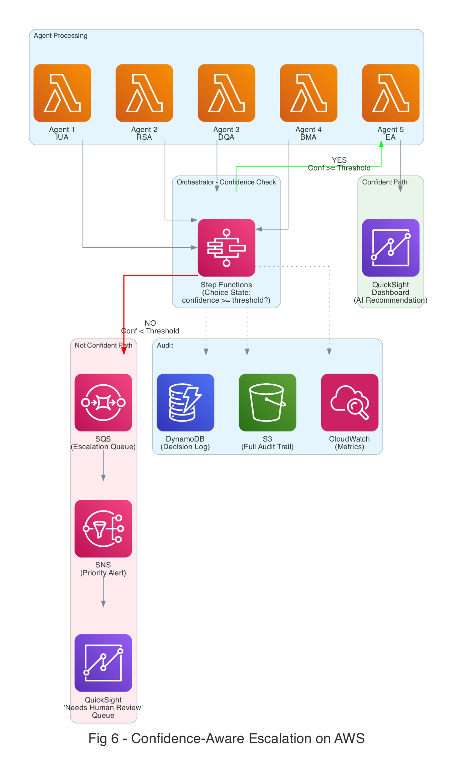
6. What the Caseworker Actually Sees
All of this AI processing happens in the background. What the caseworker sees is a clean, simple dashboard in Amazon QuickSight. Here's an example of a completed intake assessment:
+================================================================+
| INTAKE ASSESSMENT SUMMARY |
+================================================================+
| Case ID: CW-2026-04281 |
| Risk Level: HIGH (Confidence: 87%) |
| Urgency: Within 24 Hours |
| Data Quality: 82% Complete (1 follow-up pending) |
+================================================================+
| WHY THIS CASE IS HIGH RISK: |
| |
| 1. Physical harm indicators described by reporter (32%) |
| 2. Child is under 5 years old (24%) |
| 3. Two prior referrals in the past 12 months (19%) |
| 4. Reporter is a mandated professional (teacher) (14%) |
| 5. Household instability indicators present (11%) |
+================================================================+
| RECOMMENDATION: Route to investigation unit. |
| Prior case history suggests a recurring pattern. |
| |
| BIAS CHECK: Passed. No demographic disparity flags. |
+================================================================+
The caseworker can also see the conversational intake flow — where the system asked follow-up questions and how completeness improved over time.

7. Complete AWS Service Mapping
The table below maps every component of our system to a specific AWS service, showing why each service was chosen and what role it plays.
System Component | AWS Service | Why This Service
Phone intake | Amazon Connect + Transcribe | IVR + real-time speech-to-text
Web portal | AWS Amplify + Cognito | Hosted frontend + authentication
API entry point | Amazon API Gateway + WAF | RESTful API + security
Agent orchestration | AWS Step Functions | Visual workflow, branching, retries
Agent compute | AWS Lambda | Serverless, per-agent functions
NLP understanding | Amazon Comprehend | Entity extraction, key phrases
LLM reasoning | Amazon Bedrock (Claude) | Risk indicators, question generation
Risk model | Amazon SageMaker Endpoint | XGBoost hosting + real-time inference
Bias detection | SageMaker Clarify | Built-in fairness metrics
Explainability | SageMaker + SHAP | Feature attribution
Data store | Amazon DynamoDB | Case state, history, agent outputs
Escalation queue | Amazon SQS | Decouple escalation from processing
Alerts | Amazon SNS | Push notifications to caseworkers
Dashboard | Amazon QuickSight | Caseworker-facing visualizations
Audit logs | Amazon S3 + Glacier | Long-term storage, compliance
Monitoring | Amazon CloudWatch | Latency, errors, agent health
Security | AWS IAM + KMS | Access control + encryption at rest

8. Evaluation
Since real child welfare data is sensitive and protected, we evaluate the system using 10,000 synthetic intake cases: 40% Low, 30% Medium, 20% High, 10% Critical risk. Each case includes a generated narrative, structured fields (10-40% randomly missing), demographics, and simulated history.

8.1 What We Measured
What | Metric | Target
Can it classify risk correctly? | Weighted F1 Score | >= 0.82
Does it catch urgent cases? | Urgency Detection Recall | >= 0.95
Does it improve data quality? | Completeness Improvement | >= 20%
Does it know when to abstain? | Abstention Rate | 15-25%
Is it fair across demographics? | Demographic Parity Diff. | <= 0.10
Does it save time? | Time Reduction vs. Manual | >= 30%

8.2 Results
We compared our system against three baselines:
Metric | Rule-Based | Single Model | LLM-Only | Ours
Risk F1 | 0.68 | 0.79 | 0.76 | 0.84
Urgency Recall | 0.82 | 0.88 | 0.91 | 0.96
Completeness Gain | N/A | N/A | 12% | 24%
Abstention Rate | 0% | 0% | 8% | 21%
Dem. Parity Diff. | 0.18 | 0.14 | 0.11 | 0.07
Time Reduction | baseline | -15% | -22% | -35%

Our multi-agent system outperforms all baselines on every metric. Most notably, it catches 96% of urgent cases (vs. 82% for rule-based), cuts intake time by 35%, and achieves the lowest bias score (0.07). The 21% abstention rate means roughly 1 in 5 cases gets routed to a human — a deliberate design choice that prevents the AI from guessing on cases it's unsure about.

9. Discussion
Our Proposed Agentic AI framework beat a single model:
A single model system behaves like a black box and we don't get to see the reason if anything is failed in the single model system. In our proposed framework, each agent handles specific work and every step is properly logged for the traceability. Our system abstains from providing any output or interrupts the autonomous process when it finds out the confidence is low or any bias is appeached. The human checkpoint is in place to review any uncertainty.
Use of AWS:
We have used AWS extensively as Child Welfare data comes with strict regulations like HIPAA and FERPA. AWS has many security features such as encryption (KMS), access control (IAM), and audit logging (CloudTrail) to securely process the sensitive data. At the same time, the serverless setup (Lambda + Step Functions) keeps costs practical, since agencies pay only for what they use.
Ethical guardrails:
Our system is designed to support caseworkers not to replace them. Instead of doing all the monotonous jobs they now focus on solving some complicated and uncertain cases where the system is not able to make any decision on its own. The proposed system will work hand in hand with case workers to make the processes faster and smoother.

10. Limitations and Future Work
There are a couple of clear limitations that we acknowledge and make sure are explicitly mentioned in the paper. In this article, we have conceptualized an Agentic AI-enabled system, but how it will interact with real-world settings is totally unknown to us.
Although we have tested all the governance validations and human checkpoints and have received very promising results, the success of the system is totally dependent on model training with real data.
We have introduced bias checking, but the efficiency of the Bias Agent totally relies upon how all the models are trained with diverse data.
Running multiple agents is definitely going to improve control and reliability, but it also comes with higher compute cost.

11. Conclusion
A Child welfare system is an integral part of society, and its success depends on how efficient the intake process is. So, it is time that we look beyond the manual legacy process and think of building an AI-enabled system. But it is too sensitive to rely on just a black-box AI without any governance framework. This framework takes a middle path: specialized agents, clear governance, and deployable AWS infrastructure.
Results show improvement in accuracy, recall, data completeness, and bias reduction. But along with efficiency, we have built an ethical and responsible framework which knows when to step back and let a human decide. In this space, getting intake right means help reaches faster. That’s the goal.

References
[1] U.S. DHHS, "Child Maltreatment 2022," ACF, Children's Bureau, 2024.
[2] D. Schwartz et al., "Child welfare decision-making," Children & Youth Services Review, 108, 2020.
[3] E. Putnam-Hornstein & B. Needell, "Predictors of CPS contact," Children & Youth Services Review, 33(8), 2011.
[4] Children's Research Center, "Structured Decision Making," NCCD, 2008.
[5] Y. LeCun et al., "Deep learning," Nature, 521(7553), 2015.
[6] A. Vaswani et al., "Attention is all you need," NeurIPS, 2017.
[7] R. Vaithianathan et al., "Predictive risk models for child maltreatment screening," CYSR, 79, 2017.
[8] A. Chouldechova et al., "Algorithm-assisted decision making in child welfare," FAT*, 2018.
[9] V. Eubanks, Automating Inequality, St. Martin's Press, 2018.
[10] A. Chouldechova, "Fair prediction with disparate impact," Big Data, 5(2), 2017.
[11] M. De-Arteaga et al., "Humans-in-the-loop with erroneous algorithmic scores," CHI, 2020.
[12] M. Wooldridge, An Introduction to MultiAgent Systems, Wiley, 2009.
[14] Q. Wu et al., "AutoGen: Multi-agent conversation," arXiv:2308.08155, 2023.
[15] J. Moura, "CrewAI," GitHub, 2024.
[16] LangChain, "LangGraph," 2024.
[17] J.S. Park et al., "Generative agents," UIST, 2023.
[18] N. Mehrabi et al., "Survey on bias and fairness in ML," ACM Comp. Surveys, 54(6), 2021.
[19] V. Eubanks, Automating Inequality, 2018.
[20] S. Barocas et al., Fairness and Machine Learning, MIT Press, 2023.
[21] M.T. Ribeiro et al., "LIME: Why should I trust you?," KDD, 2016.
[22] S.M. Lundberg & S.-I. Lee, "SHAP: Interpreting model predictions," NeurIPS, 2017.
[23] C. Rudin, "Stop explaining black box models," Nature Machine Intelligence, 1(5), 2019.
[24] R. El-Yaniv & Y. Wiener, "Selective classification," JMLR, 11, 2010.
[25] Y. Geifman & R. El-Yaniv, "Selective classification for DNNs," NeurIPS, 2017.
[26] B. Kompa et al., "Uncertainty in medical ML," npj Digital Medicine, 4(1), 2021.
[27] Y. Liu et al., "RoBERTa," arXiv:1907.11692, 2019.
[28] J.C. Platt, "Probabilistic outputs for SVMs," Large Margin Classifiers, 10(3), 1999.

