Response to MDPI Round-4 Review Comments
Answers the nine active comments in 'MDPI_Round4_Review_Comments.docx', in their original order and wording. Branch model-finetuning, built 2026-09-26. Internal working document; not for submission.
Every number is read from a recorded artefact named in the table that shows it. This round adds round4_analysis.json, computed from preserved outputs and the deterministic CHAT pipeline with no model call. Claims about the data are checked by assertion when this document is built.

Summary
Table 1. Each comment and the answer in one line.
ID | Severity | Answer
P-1 | Submission | Template supplied; facts are the authors' to fill. Not invented
P-2 | Moderate | Per-child table from CHAT headers added: age, sex, sessions, partner. What is unavailable is stated
P-3 | Moderate | Every promised item mapped to its source; confusion matrices were missing and are now generated
R2-1 | Major | Same-universe analysis done (85 segments; 54 judgeable). Does not reproduce main-batch agreement → narrow the causal wording
R2-2 | Major | Frame rebuilt by episode identity: 136 pool kept, 136 non-pool dropped (6.6%); uneven by child → describe the 121 as post-audit, from the original frame
R2-3 | Major | Child-cluster paired bootstrap, 4 fields × 2 comparators. MARS > random on 3/4 fields; never > strongest; lower on domain
R2-4 | Moderate | Metric divides by all slots; renamed 'missed-value rate'; answerable-field and overall model-null rates added
R2-5 | Moderate | Cap came from the specification, not tuned. Model-free sensitivity: the cap splits rather than drops turns; limitation wording supplied
R2-6 | Minor | Random baseline = analytical expectation over reviewable candidates (37.7%, not 32.5%); strongest-generator fallback defined

Two results that change what the manuscript says
- R2-6 / R2-3: the published random baseline counted outputs MARS could not select. Corrected, MARS's mean margin over random falls from +11.0 to +5.8 points. The direction is unchanged.
- R2-2: Round 3's advice to present the 121 as the unqualified primary unseen-episode estimate is withdrawn in favour of the reviewer's wording.

P-1 · Submission Requirement · Complete remaining non-deferred manuscript declarations
The comment, as written
Location: Back matter — Funding; Author Contributions; Conflicts of Interest
Reviewer concern: These statements remain placeholders in v7. They are separate from the temporarily deferred ethics, citation, end-to-end, and repository items.
Required action: Before submission, replace the remaining placeholders with the final funding statement, CRediT author-contribution statement, and conflict-of-interest declaration, using only information that is factually accurate.
Status: Pending

Response
Short answer
These three statements contain facts only the authors hold, so they cannot be completed from the study artefacts, and they have not been invented here. The manuscript builder still carries the placeholder (make_manuscript.py:1984, "[TO COMPLETE BEFORE SUBMISSION]"). Below is the exact structure MDPI expects, with every factual slot left in brackets for the authors to fill.
Template (fill every bracket; delete any sentence that is not true)
Funding: "This research received [no external funding / funding from [funder name] under grant [number]]. [The funder had no role in study design, data analysis, interpretation or the decision to publish.]"
Author Contributions (CRediT): Conceptualization, [initials]; Methodology, [ ]; Software, [ ]; Validation, [ ]; Formal analysis, [ ]; Investigation, [ ]; Data curation, [ ]; Writing—original draft, [ ]; Writing—review and editing, [ ]; Visualization, [ ]; Supervision, [ ]; Project administration, [ ]. "All authors have read and agreed to the published version of the manuscript." Annotators and the adjudicator either appear here or in Acknowledgments, according to their role.
Conflicts of Interest: "The authors declare no conflicts of interest." or a specific declaration.
Use of generative AI (MDPI policy): a statement naming the tools used in preparing the manuscript and code, and confirming author responsibility for the content. This is separate from the LLMs studied, which are already described in Methods.

Status after this round: author action required. Nothing in the analysis depends on it.

P-2 · Moderate · Corpus characteristics are acknowledged but not yet actually reported
The comment, as written
Location: Section 2.12; Section 4.9; planned Supplementary Material 5
Reviewer concern: The manuscript now appropriately states that participant-level characteristics will be verified rather than inferred, but the actual age/developmental/language or per-corpus characteristics table has not yet been added. The child-level sample is small, so readers still lack the descriptive context needed to judge generalizability.
Required action: Add the verified corpus-characteristics table using repository metadata that is legitimately available under the source terms. Include only characteristics that can be directly supported; do not infer missing participant attributes.
Status: Partially resolved

Response
Short answer
Added: a per-child table built only from metadata in the released CHAT files. Every value below is read from each session's @ID header (age, sex), the @Types header, or counted from the transcript. Nothing is inferred. Script: round4_analysis.py (corpus_characteristics). Totals reconcile with the manuscript: 85 sessions, 75,003 utterances.
Table 2. Corpus characteristics, per child, as recorded in the CHAT headers. Age = child age at the first and last recorded session (years;months). Source: round4_analysis.json.
Corpus | Child | Sessions | Age span | Sex | @Types | Utterances | Child utts | Partner
Flusberg | brett | 10 | 5;08–7;05 | male | long, toyplay, ASD | 10,337 | 4,133 | mother
Flusberg | jack | 12 | 6;09–8;10 | male | long, toyplay, ASD | 11,830 | 4,120 | mother
Flusberg | mark | 13 | 7;07–9;08 | male | long, toyplay, ASD | 18,660 | 6,251 | mother
Flusberg | rick | 11 | 4;07–7;05 | male | long, toyplay, ASD | 10,171 | 3,465 | mother
Flusberg | roger_flusberg | 10 | 3;09–5;06 | male | long, toyplay, ASD | 7,317 | 3,416 | mother
Flusberg | stuart | 8 | 3;04–4;07 | male | long, toyplay, ASD | 5,668 | 1,634 | mother
Rollins | carl | 4 | 2;08–3;07 | male | long, toyplay, ASD | 2,037 | 885 | investigator
Rollins | josh | 4 | 2;05–3;01 | male | long, toyplay, ASD | 1,482 | 592 | investigator
Rollins | mars | 5 | 3;01–3;11 | male | long, toyplay, ASD | 3,882 | 1,324 | investigator
Rollins | roger_rollins | 4 | 2;06–3;03 | male | long, toyplay, ASD | 1,405 | 538 | investigator
Rollins | sid | 4 | 2;02–3;05 | male | long, toyplay, ASD | 2,214 | 831 | investigator

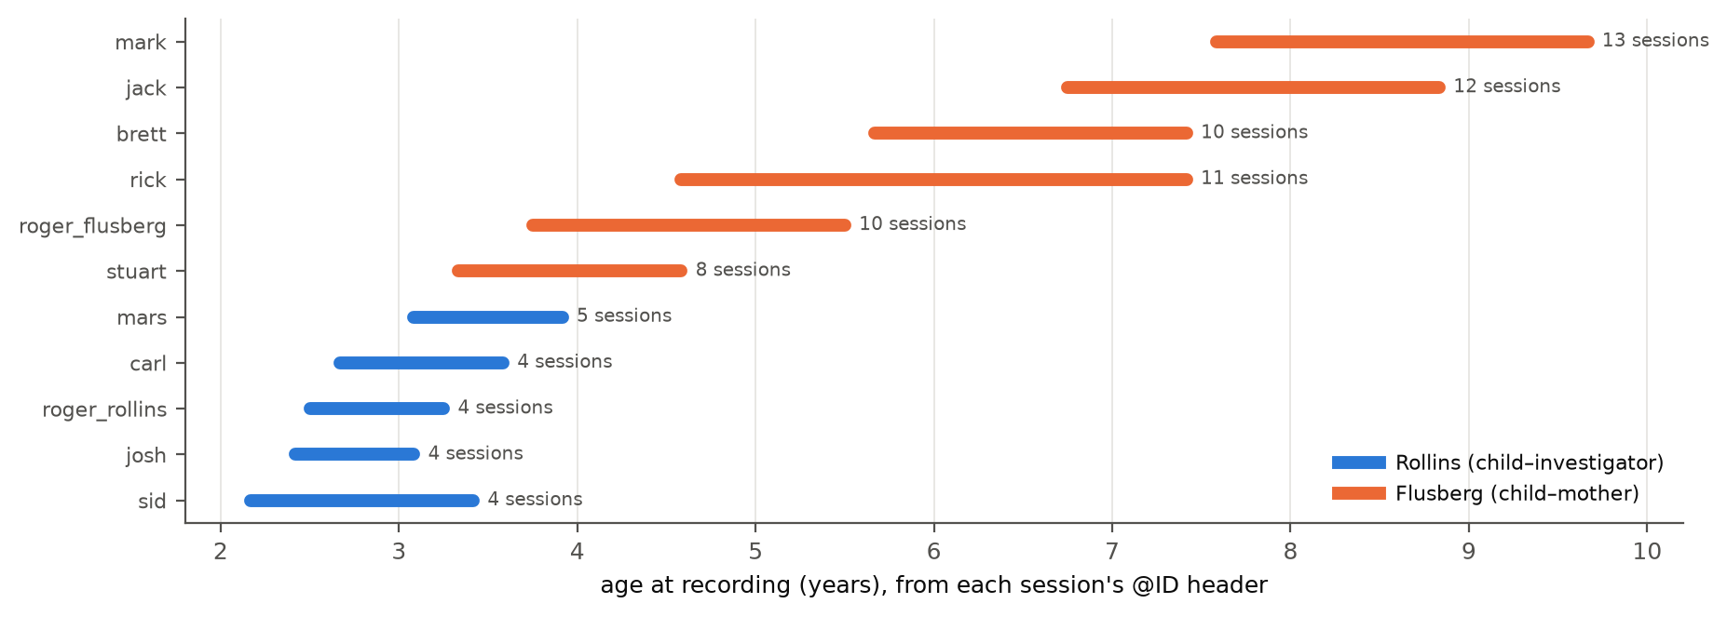
Figure 1. Age span covered by each child's sessions. The two corpora do not overlap much in age: the Rollins children were recorded between 2 and 4 years, the Flusberg children mostly between 3½ and 10.
Supporting argument
- Not available in the released files, and so not reported: standardised developmental, cognitive or language scores, diagnostic instrument results, race/ethnicity and socioeconomic information. The table should say so explicitly rather than leave the columns out silently.
- Diagnosis is a corpus label. @Types: long, toyplay, ASD is the corpus-level designation used by ASDBank; the files do not document per-child diagnostic procedures. Describe it as "children described in the source corpus as autistic" rather than as a verified diagnosis.
- All eleven children are recorded as male. This limits generalisability and belongs in Section 4.9.
- Two children share the pseudonym "Roger" (Rollins 2;06–3;03; Flusberg 3;09–5;06). The metadata cannot establish whether they are the same child, so they are treated as distinct, as throughout the study. State this.

P-3 · Moderate · Promised supplementary methodological material must be fully populated
The comment, as written
Location: Supplementary Materials 1–7 (excluding repository/archival-link details)
Reviewer concern: The manuscript now specifies a strong supplementary structure, but several methodological claims still depend on those materials actually being provided: the final codebook and schema rules, exact prompts/configuration, adequacy-router decision logic, extended reliability/confusion-matrix results, extended generator and MARS analyses, and authorization/access-control verification details.
Required action: Before submission, confirm that every promised non-repository supplementary item is present, internally consistent with the main text, and sufficient for an independent reviewer to understand the method and reproduce the reported calculations where the source-data license permits.
Status: Pending

Response
Short answer
Every promised non-repository item has a source in the project, and one gap was closed this round: the extended reliability results lacked confusion matrices, which are now generated. The supplementary documents themselves (S1–S7) are assembled by the authors from these sources; this round checked that each source exists and agrees with the main text.
Table 3. Supplementary content the manuscript promises, and where each item comes from.
Promised content | Source in the project | Status
Final codebook and schema rules | docs/annotation_codebook.md; src/backend/schemas/observation_schema.py (allowed values) | present
Exact prompts and configuration | src/backend/ml/extraction/prompts.py; generator/judge roster, thresholds and seeds in mars_run_summary.json | present
Adequacy-router decision logic | src/backend/ml/adequacy_router.py; docs/lld/Adequacy_Router.md; Round-3 Figure 10 | present
Extended reliability and confusion matrices | reliability_current.json, reliability_round1.json, round_comparison.json; confusion matrices in round4_analysis.json (Figure below) | gap closed this round
Extended generator and MARS analyses | round3_analysis.json, round4_analysis.json, mars_evaluation.json, mars_selection_analysis.json | present; MARS intervals replaced (R2-3)
Authorization / access-control verification | 10 test suites, 120 passed (run record 2026-09-26); Round-3 Q9 table | present
Corpus characteristics (S5) | round4_analysis.json (P-2 table) | added this round

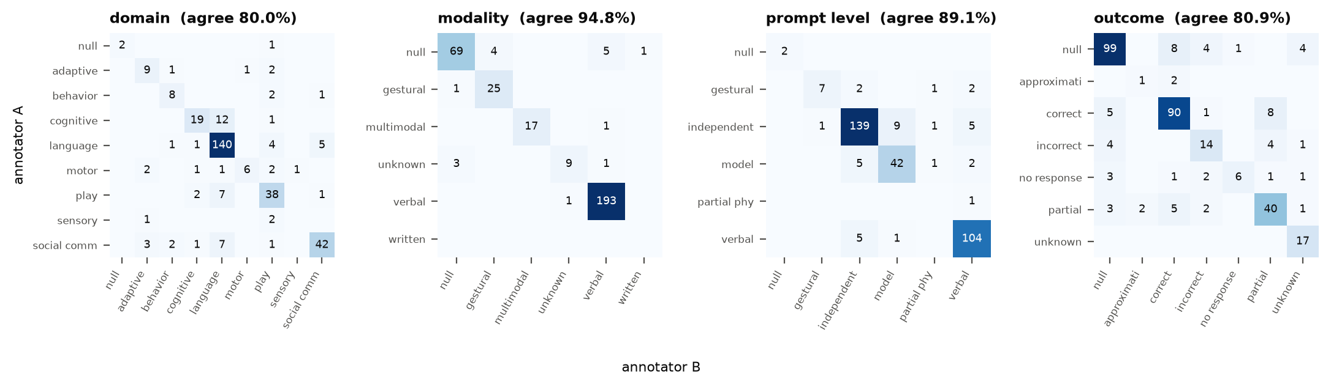
Figure 2. Annotator A × annotator B, 330 segments, final pre-adjudication state (the state in which κ = 0.801 is computed). Observed agreement on each field matches reliability_current.json (checked by the script).
Status after this round: sources complete; assembly of the S-files is an author step. One consistency rule for that step: each S-file should cite the artefact name used here, so that a reviewer can trace any supplementary number to the same file as the main text.

R2-1 · Major · The evaluation branch does not isolate model-tractability conditioning
The comment, as written
Location: Sections 2.12–2.13; 3.3; 4.4
Reviewer concern: The model-conditioned main batch comes from the 2,442-segment universe built with a 273-per-child ceiling, whereas the separately frozen evaluation branch comes from the larger 3,371-segment universe built with a 455-per-child ceiling. Therefore, the lower agreement outside the main batch reflects both removal of the generator-judgeability filter and a changed candidate universe/distribution. The current interpretation can read as though the decline is caused specifically by removing model-tractability conditioning.
Required action: Preferred option: add a same-universe, unconditioned sensitivity analysis if the existing artifacts allow it without redesigning the study. Otherwise, narrow the wording throughout Methods/Results/Discussion to state that agreement was lower in the independently sampled higher-cap evaluation branch that did not use model tractability for inclusion. Do not attribute the entire difference causally to removal of tractability conditioning.
Status: Open

Response
Short answer
The preferred option was feasible and is done, with no model re-run. Matching episodes by stable identity shows that 85 of the 121 overlap-excluded evaluation segments also belong to the 2,442-segment universe of the main batch. Of those, 54 would also have passed the batch's judgeability filter. The result supports narrowing the wording rather than the causal reading: qwen2.5:7b scores 38.0% on the same-universe, judgeable segments against 43.1% on the main batch. So restoring both the universe and the filter does not restore main-batch agreement. The higher-cap-only segments score 43.1%, so the change of universe does not lower agreement either.
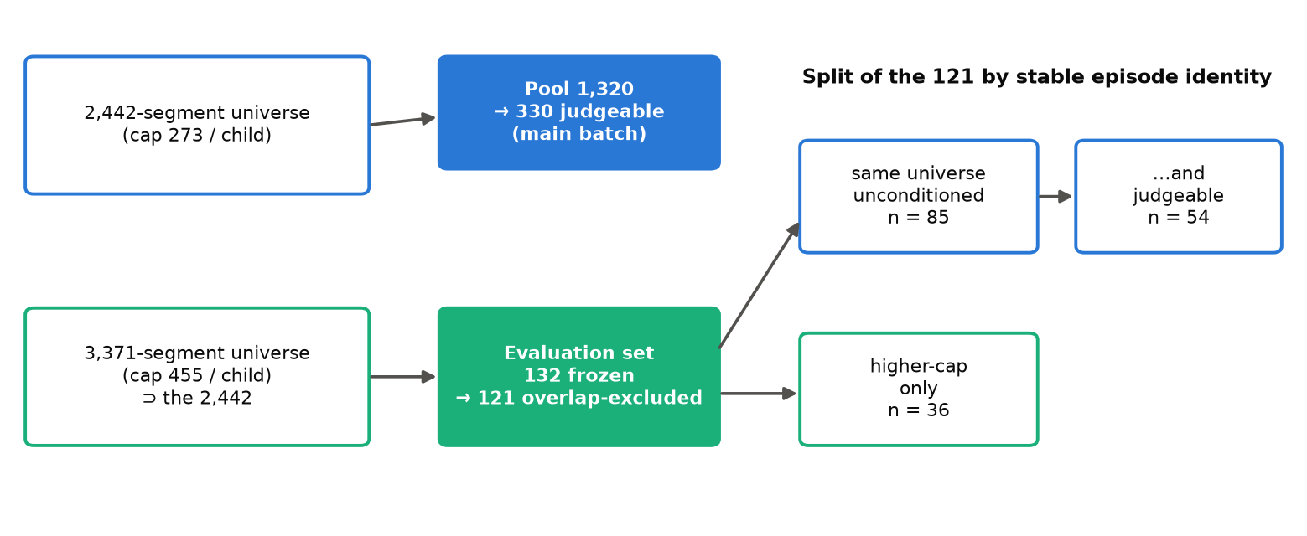
Figure 3. How the 121 overlap-excluded evaluation segments split by universe and by the batch's judgeability rule. Pool episodes are excluded from all evaluation groups, so the same-universe group is the part of the 2,442 universe the main batch never sampled.
Table 4. Merged categorical agreement, point estimate [95% child-cluster CI], 10,000 replicates. Source: round4_analysis.json (same_universe.groups).
Group | llama3.2 | qwen2.5:3b | qwen2.5:7b | qwen3:14b
Main batch (n = 330) | 30.8% [24.2%, 37.1%] | 20.4% [17.9%, 22.9%] | 43.1% [35.1%, 50.7%] | 42.0% [33.3%, 50.6%]
Same universe, judgeable (n = 54) | 25.0% [17.7%, 31.8%] | 14.8% [9.3%, 20.3%] | 38.0% [29.0%, 47.8%] | 38.9% [30.2%, 48.8%]
Same universe, unconditioned (n = 85) | 23.5% [18.5%, 28.7%] | 13.2% [8.7%, 17.7%] | 39.4% [31.2%, 47.7%] | 41.2% [31.0%, 51.9%]
Higher-cap only (n = 36) | 36.8% [28.7%, 46.0%] | 11.1% [6.6%, 17.4%] | 43.1% [36.6%, 52.8%] | 41.7% [33.1%, 52.0%]
All 121 (n = 121) | 27.5% [21.7%, 32.8%] | 12.6% [8.8%, 17.2%] | 40.5% [33.4%, 47.4%] | 41.3% [31.7%, 50.4%]

Table 5. Differences in merged agreement, percentage points [95% CI]; children resampled jointly for both groups. * marks an interval excluding zero.
Contrast | llama3.2 | qwen2.5:3b | qwen2.5:7b | qwen3:14b
Main − same universe, judgeable | +5.8 [+0.2, +12.2] * | +5.6 [+0.8, +11.2] * | +5.1 [-2.8, +13.9] | +3.2 [-0.1, +6.3]
Main − same universe, unconditioned | +7.3 [+2.0, +12.1] * | +7.2 [+3.0, +11.9] * | +3.7 [-0.7, +9.2] | +0.9 [-3.9, +5.6]
Higher-cap only − same universe | +13.3 [+6.1, +22.4] * | -2.1 [-6.9, +3.7] | +3.6 [-4.4, +14.5] | +0.5 [-7.4, +9.4]
Main − all 121 | +3.4 [-0.8, +7.5] | +7.8 [+3.8, +11.6] * | +2.6 [-2.4, +8.6] | +0.7 [-4.4, +5.7]

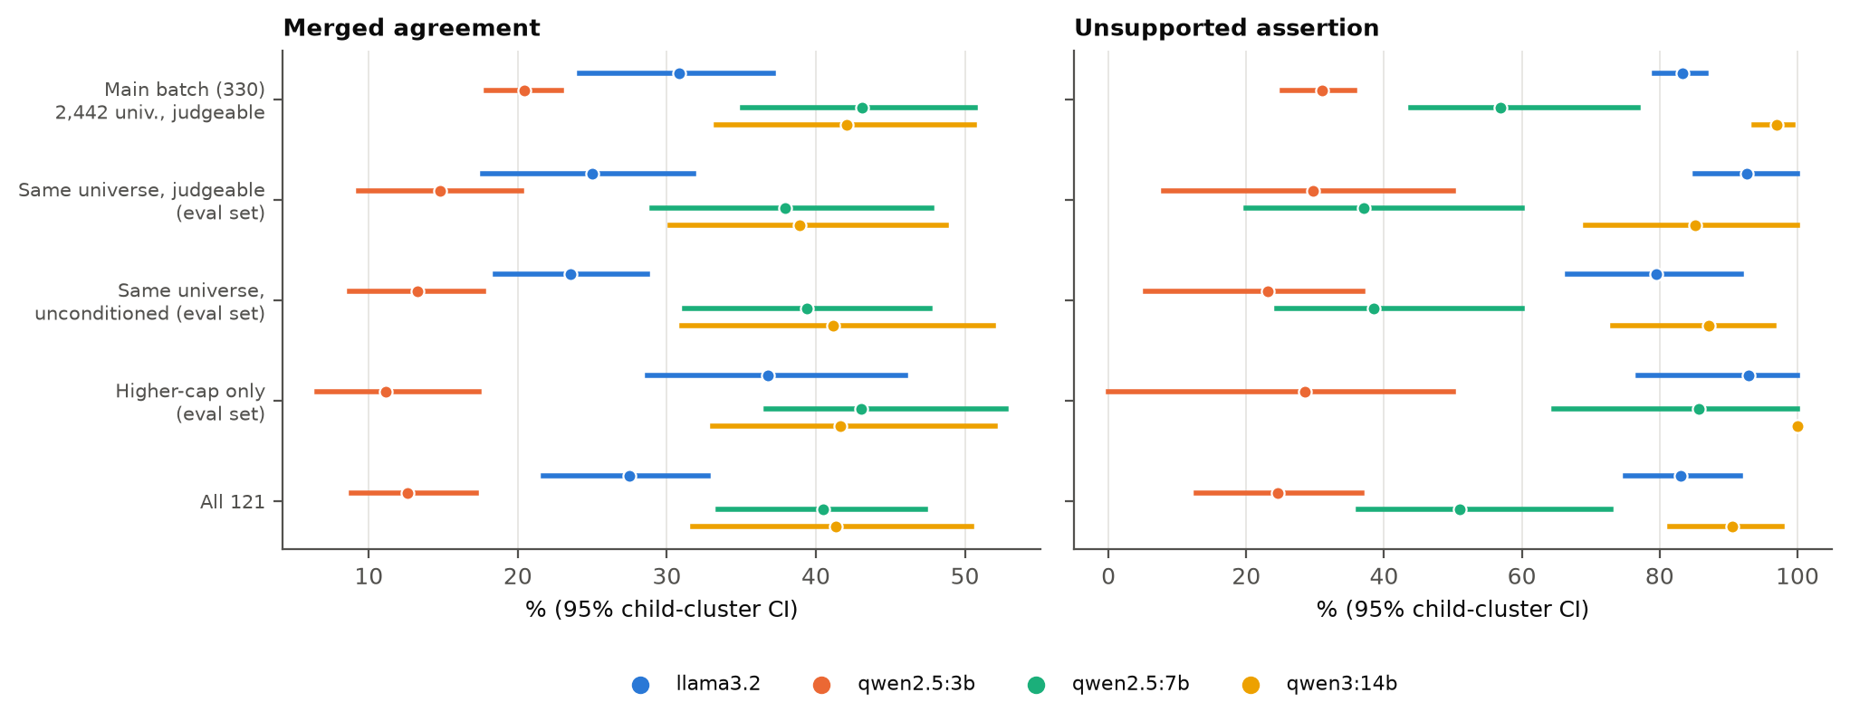
Figure 4. Agreement and unsupported assertion by group, all four generators. Intervals for the evaluation-set groups are wide (36–85 segments).
Supporting argument
- Why the same-universe group is a fair comparator. The 1,320-segment pool was a seeded random draw of 120 segments per child from the 2,442. The remainder of that universe was therefore exchangeable with the pool within each child. The evaluation segments that fall in it are an unconditioned sample of the same universe, drawn without reference to model output.
- The judgeability reconstruction is consistent with the original filter. The batch rule (at least one populated field from each of the three original generators) passes 78 of 121 evaluation segments (64.5%), close to the main batch's own yield of 330 of 506 (65.2%).
- What remains of the gap is not attributable to either design feature. For qwen2.5:7b and qwen3:14b the main-batch advantage over the same-universe judgeable group is not distinguishable from zero. For llama3.2 and qwen2.5:3b it is (see the table). Other differences between the arms cannot be separated in this design: the main-batch reference labels came from two annotation rounds with a codebook introduced between them, while the evaluation set was annotated under the final codebook from the start, at a different time.
- Caveats. Judgeability was computed from the evaluation run's generator outputs, not by re-running the batch procedure, and generation is not guaranteed to be identical across runs. Both runs recorded five of the eight extracted fields. The subgroups are small, so the absence of a difference is not evidence of equality.
Suggested manuscript wording (Methods 2.13 / Results 3.3 / Discussion 4.4)
"Agreement was lower in the independently sampled, higher-cap evaluation branch, which did not use model tractability for inclusion. The two branches differ in candidate universe, inclusion condition and annotation round, so the difference should not be attributed to any single factor. A same-universe sensitivity analysis (85 evaluation segments from the main batch's 2,442-segment universe, 54 of which met the batch's judgeability condition) did not reproduce main-batch agreement. Neither removal of tractability conditioning nor the change of candidate universe accounted for the difference on its own."
Remove any sentence that says the decline is caused by removing model-tractability conditioning.

R2-2 · Major · The identifier defect may have distorted the evaluation sampling frame beyond the 11 observed overlaps
The comment, as written
Location: Section 2.13; Figure 3; Sections 3.2, 4.4, and 4.9
Reviewer concern: The post-hoc audit correctly identified 11 evaluation episodes that overlap the original pool because segment identifiers were cap-dependent rather than stable episode identities. Removing those 11 makes the analyzed 121 episodes non-overlapping with the pool, but it does not by itself prove that the original 2,051-record sampling frame was equivalent to the intended true non-pool frame. The faulty identifier exclusion could also have wrongly excluded some genuine non-pool episodes while retaining some pool episodes.
Required action: Using the now-available stable episode identity matching, reconstruct the intended exclusion frame diagnostically. Quantify how many true pool episodes were wrongly retained and how many true non-pool episodes were wrongly excluded by the original identifier-based filter. Do not redraw the sample after seeing results. Unless the frame distortion is shown to be negligible, describe the 121 as a post-audit overlap-excluded analysis from the originally frozen sampling frame rather than an unqualified primary unseen-episode sample.
Status: Open

Response
Short answer
Done, diagnostically, without redrawing. Episodes were matched by stable identity (session plus source start line), and the intended frame was rebuilt. The reconstructed ID-based frame reproduces the frozen 132-segment draw exactly, which confirms that the audited frame is the one that was used. The ID rule wrongly retained 136 true pool episodes and wrongly excluded 136 true non-pool episodes, 6.6% of the intended 2,051. The distortion is uneven across children (roger_rollins: 36.7% of its intended frame swapped), so it is not negligible at child level. The 121 should be described as the reviewer proposes.
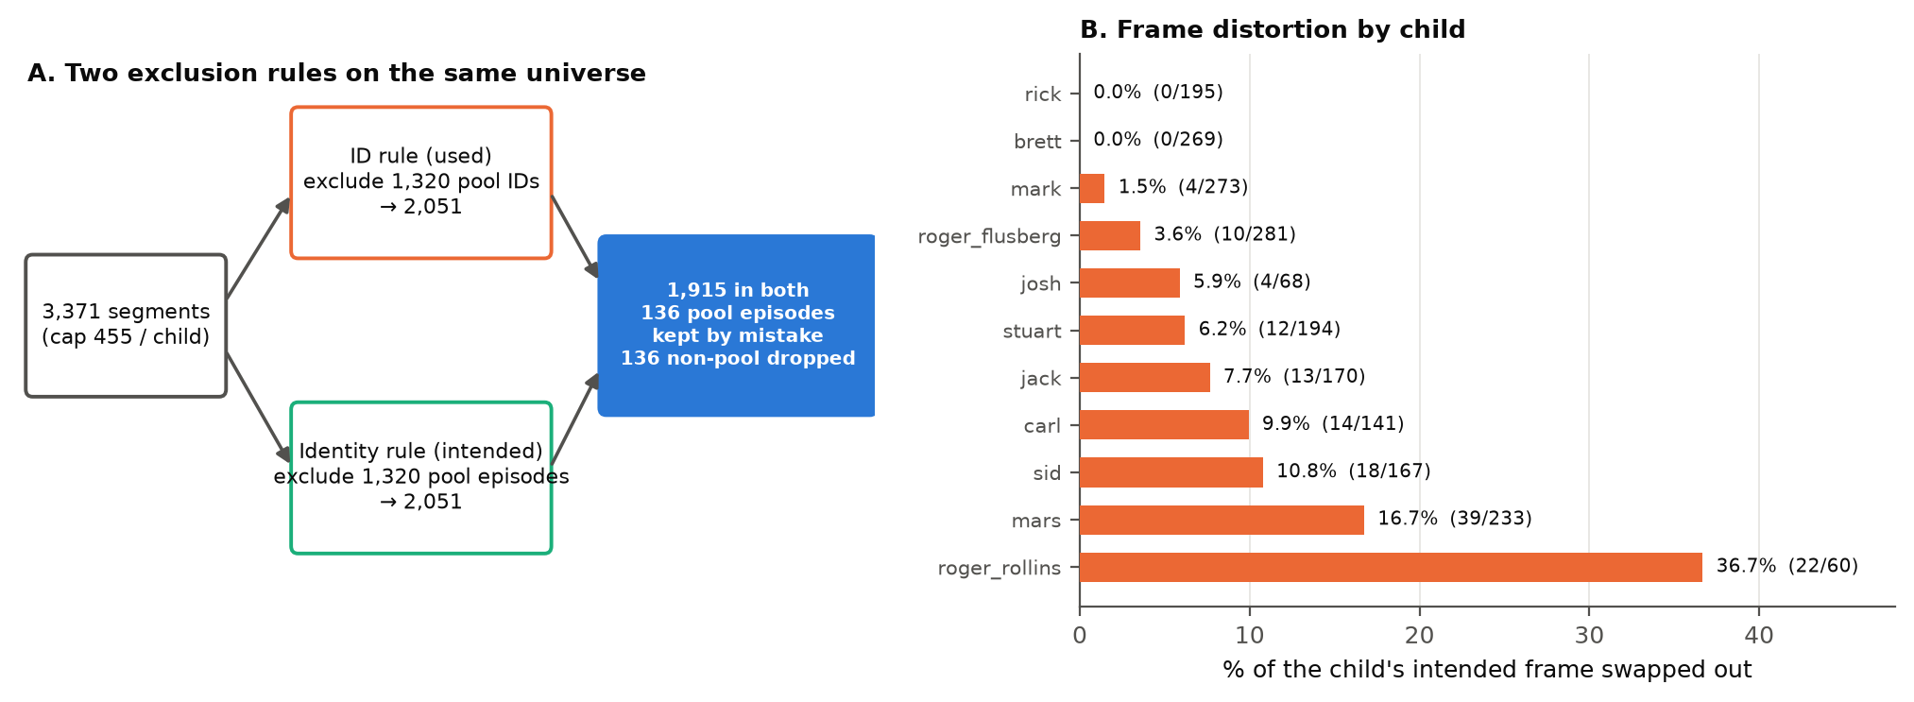
Figure 5. A: the used and intended frames have the same size because the ID rule swaps one-for-one. Each pool ID it removes names some episode of the same child, and each pool episode it keeps has lost its ID to another. B: share of each child's intended frame that was swapped.
Table 6. Frame audit per child. Source: round4_analysis.json (frame_audit.per_child).
Child | Intended frame | In both | Pool kept (wrong) | Non-pool dropped (wrong) | Coverage
brett | 269 | 269 | 0 | 0 | 100.0%
carl | 141 | 127 | 14 | 14 | 90.1%
jack | 170 | 157 | 13 | 13 | 92.3%
josh | 68 | 64 | 4 | 4 | 94.1%
mark | 273 | 269 | 4 | 4 | 98.5%
mars | 233 | 194 | 39 | 39 | 83.3%
rick | 195 | 195 | 0 | 0 | 100.0%
roger_flusberg | 281 | 271 | 10 | 10 | 96.4%
roger_rollins | 60 | 38 | 22 | 22 | 63.3%
sid | 167 | 149 | 18 | 18 | 89.2%
stuart | 194 | 182 | 12 | 12 | 93.8%
Total | 2,051 | 1,915 | 136 | 136 | 93.4%

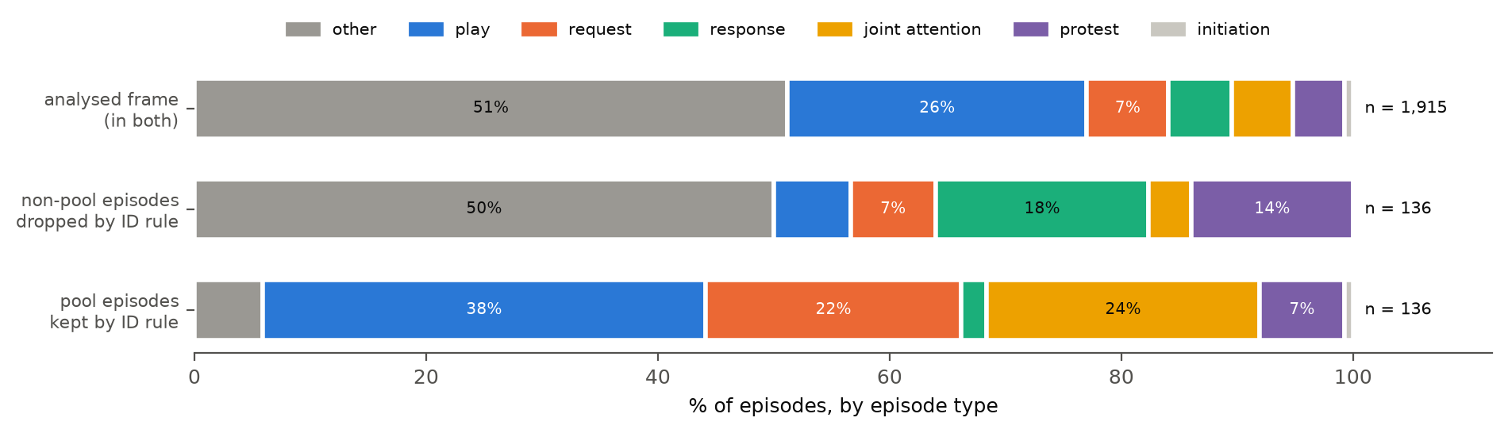
Figure 6. Composition by episode type. The dropped non-pool episodes are richer in response and protest episodes; the wrongly kept pool episodes are richer in play, joint-attention and request episodes. The analysed frame differs little from the intended frame overall.
How much could the distortion move the estimates?
The 121 were re-weighted to each frame's episode-type mix within child, once to the analysed frame and once to the intended frame. The difference between the two isolates the frame distortion from ordinary sampling noise.
Table 7. Frame effect on the 121-segment estimates (intended-frame weighting minus analysed-frame weighting), percentage points. Source: round4_analysis.json (poststratified_121.episode_type_7).
Generator | Merged agreement | Unsupported assertion | Whole-record
llama3.2 | +0.0 | -0.5 | +0.0
qwen2.5:3b | +0.1 | -0.5 | +0.0
qwen2.5:7b | -0.1 | +1.1 | -0.1
qwen3:14b | +0.1 | -0.2 | +0.0

On observable episode type, the distortion moves merged agreement by at most 0.1 points and unsupported assertion by at most 1.1 points. That is small next to the intervals. Two limits keep this from proving the distortion negligible: re-weighting corrects only for what is observed, and some intended cells have no sampled segment to weight (mars: 41.2% of its intended frame is in episode types absent from its sample).
Supporting argument
- Why no redraw. Redrawing from the corrected frame after results were seen would select a sample with knowledge of the outcome. The audit quantifies the defect instead, as the reviewer asks.
- Consistency with Round 3. Stable identity finds the same 11 pool episodes among the 132 that text matching found in Round 3.
- Revision of Round-3 advice. Round 3 recommended the 121 as the primary unseen-episode estimate. Given this audit, it should be presented as the reviewer proposes, with the qualification in the wording below.
- Why text alone is not an identity. Two episodes of one session can render to identical text (e.g. runs of unintelligible xxx . turns), so the audit keys on source line numbers.
Suggested manuscript wording (Section 2.13, Figure 3, Sections 3.2, 4.4, 4.9)
"A post-hoc audit using stable episode identity found that the identifier-based exclusion retained 136 pool episodes and excluded 136 non-pool episodes (6.6% of the intended frame; up to 36.7% for one child). Eleven of the 132 frozen evaluation segments were pool episodes. We therefore report a post-audit overlap-excluded analysis (n = 121) from the originally frozen sampling frame, alongside the original 132. The sample was not redrawn. Re-weighting to the intended frame's episode-type composition changed estimates by less than 1.1 percentage points, but differences on unobserved characteristics cannot be excluded."

R2-3 · Major · MARS uncertainty analysis should preserve clustering by child
The comment, as written
Location: Section 2.16; Section 3.5
Reviewer concern: The manuscript correctly uses child-cluster bootstrap intervals for annotation reliability and generator performance because multiple segments come from the same child. However, the MARS selector comparisons use a segment-level paired bootstrap on the 142 genuinely reranked segments. This treats within-child observations as independent and may underestimate uncertainty. In addition, the comparison against the strongest-generator policy reports a confidence interval for domain but not all four fields.
Required action: Recompute the paired MARS comparisons using a child-cluster paired bootstrap, retaining all eligible reranked segments for each sampled child. Report confidence intervals for all four fields against both the random-candidate comparator and the strongest-generator comparator. Update the interpretation if any conclusion changes.
Status: Open

Response
Short answer
Recomputed with a child-cluster paired bootstrap on all four fields, against both comparators. The bootstrap uses 10,000 replicates. It resamples the 11 children and keeps all of each child's reranked segments (4–21 per child, 142 in total). One conclusion changes in size, not direction. MARS still beats a random candidate and still does not beat the strongest generator. Its margin over random roughly halves once the random comparator is limited to candidates MARS could select (mean +5.8 points instead of +11.0; R2-6).
Table 8. Primary comparisons (definitions in R2-6), 142 reranked segments. Differences are observed point estimates with 95% child-cluster paired intervals, percentage points. * excludes zero. Source: round4_analysis.json (mars_clustered).
Field | MARS | Random (expected) | MARS − random | Strongest (fallback) | MARS − strongest
domain | 33.1% | 28.2% | +4.9 [+0.2, +9.7] * | 45.8% | -12.7 [-17.9, -6.9] *
modality | 74.7% | 65.8% | +8.8 [+2.4, +15.3] * | 76.8% | -2.1 [-7.0, +3.7]
prompt level | 33.8% | 29.9% | +3.9 [-0.2, +7.8] | 37.3% | -3.5 [-10.1, +2.4]
outcome | 32.4% | 26.8% | +5.6 [+1.2, +9.0] * | 28.2% | +4.2 [+0.0, +8.7]

Table 9. Sensitivity: the published comparator definitions, before (segment-level bootstrap, as printed in the manuscript) and after (child-cluster). Intervals only for the published segment-level column.
Field | vs random: segment-level | vs random: child-cluster | vs strongest: segment-level | vs strongest: child-cluster
domain | [-0.7, +16.2] | +10.8 [+5.1, +15.4] * | [-19.7, -6.3] * | -12.7 [-17.9, -6.8] *
modality | [+9.9, +28.2] * | +19.0 [+10.0, +25.4] * | [-8.5, +2.8] | -2.8 [-7.6, +2.2]
prompt level | [+5.6, +21.8] * | +10.3 [+5.1, +15.2] * | [-9.2, +4.2] | -2.1 [-8.6, +4.3]
outcome | [-1.4, +12.7] | +4.0 [-1.7, +8.5] | [-2.8, +7.0] | +2.1 [-4.1, +7.5]

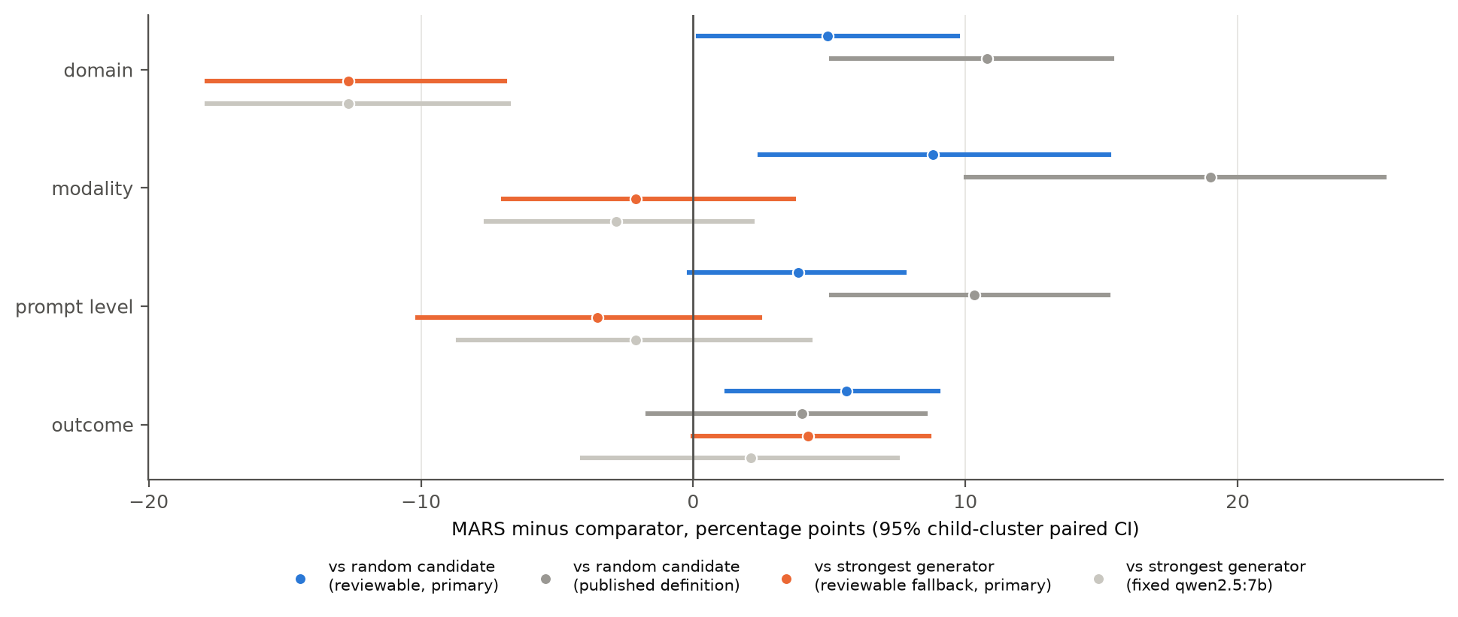
Figure 7. MARS minus each comparator, per field, with child-cluster paired intervals. Primary definitions in colour; published definitions in grey.
What changes in the interpretation
- Against a random candidate (primary definition): the interval excludes zero for domain, modality, outcome, and includes zero for prompt_level. Under the published definition it excluded zero for domain, modality, prompt_level.
- Against the strongest generator: MARS is lower on domain (-12.7 [-17.9, -6.9] *). On the other fields the interval includes zero. No field shows MARS above the strongest generator.
- Clustering did not widen every interval. The child-level intervals are narrower than the segment-level ones for some fields. That happens when between-child variation in the difference is small relative to within-child noise. It is a property of these data, not an error, and it is why the reviewer's request was worth doing rather than assuming the direction.
- A second correction. The earlier script reported the mean of the bootstrap replicates as the difference. The tables now report the observed difference (for the strongest-generator comparison the change is at most 0.0 points).
Suggested manuscript wording (Sections 2.16, 3.5)
"Paired differences between MARS and each comparator were estimated with a child-cluster paired bootstrap (10,000 replicates): children were resampled with replacement, all of a sampled child's reranked segments were retained, and both policies were scored on the same resample."
"On the 142 reranked segments, MARS agreed with the reference standard more often than the expected random reviewable candidate on 3 of 4 fields, and did not exceed the strongest-generator policy on any field (domain: -12.7 [-17.9, -6.9] percentage points)."

R2-4 · Moderate · The term “mean field abstention” is potentially misleading under the implemented scorer
The comment, as written
Location: Sections 2.14 and 2.17; Table 7; Section 3.4
Reviewer concern: The scorer collapses omitted output and explicit model null into the same None representation. When the gold label is null, model null is counted as correctly_null; when the gold label is populated, model null is counted as missing/abstained. Consequently, the reported mean field abstention metric is not the model's overall frequency of declining to answer. It is closer to the rate of null/missing output on gold-populated opportunities. Using it to discuss overall model 'willingness to answer' can therefore overstate what the metric measures.
Required action: Rename the metric to a definition that matches its denominator, for example 'null/missing rate on gold-populated fields' or 'abstention on answerable opportunities.' If the manuscript wishes to characterize overall willingness to abstain, additionally report the total frequency of model-null/omitted output regardless of the gold label.
Status: Open

Response
Short answer
Agreed, and the definition is slightly different from the one in the comment. The reported metric divides by all scored field slots, not by gold-populated ones: per field, missing ÷ N, then averaged over the four fields (paper_metrics.summarise_scored). For qwen2.5:7b on the main batch that is 168/1320 = 12.7%. It counts only cases where the reference records a value and the model gives none. Rename it and report two companion rates, so that each name matches its denominator.
Table 10. Three null-output rates per generator, main batch (1,320 field slots) and 132 set (528). Source: round4_analysis.json (abstention).
Generator | Missed-value rate (reported) | Null on gold-populated fields | Overall model-null rate | Same three, 132 set
llama3.2 | 8.2% | 9.6% | 10.7% | 22.0% / 24.9% / 23.9%
qwen2.5:3b | 48.1% | 56.5% | 58.4% | 63.4% / 72.0% / 72.0%
qwen2.5:7b | 12.7% | 15.0% | 19.2% | 15.0% / 17.0% / 20.8%
qwen3:14b | 2.9% | 3.5% | 3.4% | 3.2% / 3.7% / 4.2%

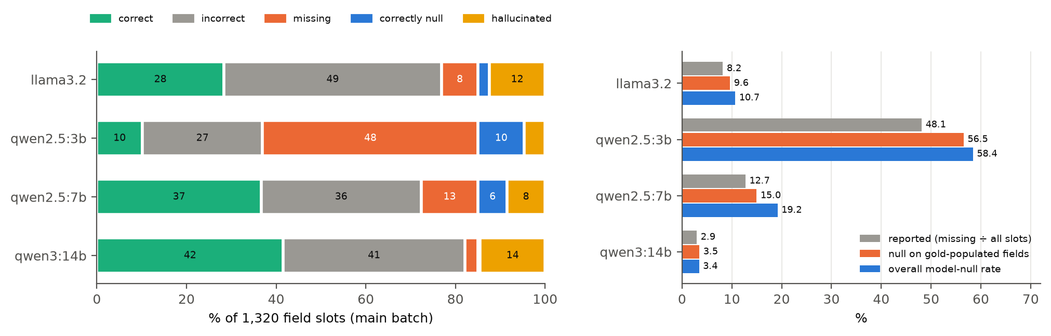
Figure 8. A: where each generator's field slots fall. Model null is the orange plus blue segments. B: the three rates side by side. The reported metric is the smallest of the three by construction.
Definitions to use
- Missed-value rate (renamed from "mean field abstention"): share of all field slots where the reference standard records a value and the model returns null or omits the field. Denominator: all scored slots.
- Null rate on answerable fields: missing ÷ (slots where the reference records a value). This is the reviewer's "abstention on answerable opportunities".
- Overall model-null rate: (missing + correctly null) ÷ all slots. This is the model's frequency of declining to fill a field whatever the reference says, and the only one of the three that describes willingness to answer.
- Omission vs explicit null. The scorer merges them, as the reviewer says. The recorded outputs show how rare omission is: 88 absent field keys against 1,760 explicit nulls across all recorded candidates. Say that omission is scored as null and that it is uncommon.
Suggested manuscript wording (Sections 2.14, 2.17; Table 7; Section 3.4)
"Missed-value rate is the proportion of all scored field slots in which the reference standard recorded a value and the model returned null or omitted the field; omitted fields are scored as null. We also report the null rate on answerable fields (denominator: slots with a reference value) and the overall model-null rate (all slots, regardless of the reference)."
Replace any sentence that uses the old metric to describe overall willingness to answer with the overall model-null rate.

R2-5 · Moderate · The eight-turn episode cap is consequential and should be justified or limited explicitly
The comment, as written
Location: Section 2.12
Reviewer concern: The segmentation procedure is now reproducible, but 4,710 of 9,018 episodes reached the eight-turn maximum. This means the cap is not merely a rare guardrail; it actively truncates more than half of the constructed episodes. Longer context could plausibly change whether prompts, outcomes, or other fields appear unsupported.
Required action: Explain how the eight-turn maximum was selected. If a sensitivity analysis is feasible using existing artifacts, report it. If not, explicitly acknowledge the high cap-hit rate as a task-definition limitation and note that extraction and gold-null frequencies may differ under longer context windows. A full re-annotation is not required solely for this point unless other evidence shows the cap materially biases the conclusions.
Status: Open

Response
Short answer
How it was chosen: the eight-turn maximum is a design parameter from the system's technical specification, fixed before the corpora were segmented, and never tuned on the data. Section 5.7.3 ("Phase 2: Deidentification & Segment Selection") of Technical_Specification_Autism_AI_System.docx states the target as "1,000-3,000 segments, each consisting of 2-8 consecutive utterance turns with context". The specification was committed on 2026-08-24, a day before the segmenter that sets MAX_EPISODE_TURNS = 8 (data/pipeline/segment_episodes.py, commit 6767d65). The specification gives no rationale for the value 8. The intent was to bound annotation burden and model input length, but that is design intent, not documented justification. It was not selected empirically, and the manuscript should say so. A model-free sensitivity analysis was feasible with existing artefacts and is reported below. So is the association between the cap and gold nulls in the annotated sets.
Table 11. Re-segmentation of the same 85 sessions under larger caps. No model involved. Source: round4_analysis.json (episode_cap.resegmentation).
Maximum | Episodes | At cap | Mean turns | 90th pct | Longest | Utterances covered
8 | 9,018 | 52.2% | 6.3 | 8 | 8 | 55,160 / 75,003
12 | 7,211 | 33.0% | 7.8 | 12 | 12 | 55,251 / 75,003
16 | 6,403 | 22.0% | 8.7 | 16 | 16 | 55,407 / 75,003
24 | 5,744 | 10.1% | 9.7 | 24 | 24 | 55,564 / 75,003
no cap | 5,255 | 0.0% | 10.6 | 22 | 154 | 55,691 / 75,003

Table 12. Reference-standard null share by field, and qwen2.5:7b unsupported-assertion rate, for capped and shorter episodes. Descriptive; not adjusted for other differences between the groups.
Set | Episodes | n | domain | modality | prompt | outcome | qwen2.5:7b unsupported
Main batch | 8 turns (capped) | 187 | 0.0% | 23.0% | 0.0% | 32.6% | 64.4%
Main batch | < 8 turns | 143 | 2.1% | 23.8% | 1.4% | 37.8% | 48.4%
132 set | 8 turns (capped) | 77 | 0.0% | 26.0% | 0.0% | 14.3% | 61.3%
132 set | < 8 turns | 55 | 1.8% | 29.1% | 1.8% | 25.4% | 40.6%

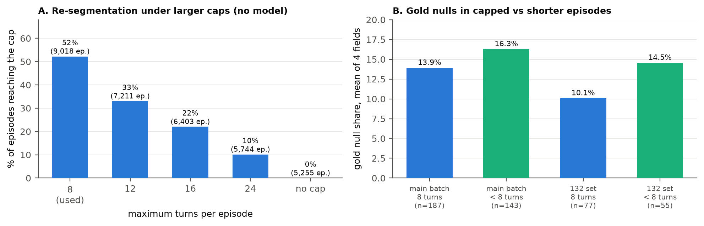
Figure 9. A: raising the cap reduces, but does not remove, cap-hitting; long child–adult exchanges continue for dozens of turns. B: capped episodes carry fewer reference nulls than shorter ones in both annotated sets.
Supporting argument
- The cap splits long exchanges; it does not discard them. With no cap, episodes cover 55,691 utterances; with the cap of 8, 55,160. Only 531 utterances (0.7% of the corpus) leave coverage. The rest of a long exchange becomes the next episode. What the cap removes is context across the split, not transcript content.
- The direction of the risk is visible in the data. Capped episodes have fewer reference nulls (domain and prompt level are never null in them in either set). This is consistent with longer context making fields more often supported. It is also consistent with capped episodes being systematically different exchanges, and the design cannot separate the two. qwen2.5:7b's unsupported-assertion rate is higher on capped episodes, on small denominators.
- Why not re-annotate. Re-annotation under a longer window would be a different task definition and a new reference standard. The reviewer does not require it for this point, and nothing above shows the cap reversing a conclusion.
Suggested manuscript wording (Section 2.12 and Limitations 4.9)
"The eight-turn maximum was fixed in the system specification (Section 5.7.3) before segmentation, to bound annotation burden and model input length; it was not tuned on the data. It was reached by 52.2% of episodes, so it actively truncates long exchanges. The truncated turns form subsequent episodes rather than being discarded (1.0% fewer utterances covered than without a cap), but context across those boundaries is lost. In the annotated sets, capped episodes had fewer reference nulls than shorter episodes, so both extraction behaviour and reference-null frequencies may differ under longer context windows."

R2-6 · Minor · The random-candidate comparator needs an exact reproducible definition
The comment, as written
Location: Sections 2.18 and 3.5
Reviewer concern: The manuscript reports a 32.5% random-candidate baseline on the genuinely reranked subset but does not state whether this came from one seeded draw, repeated random draws, or an analytical expectation over available candidates. The seed/replication rule is also not stated. The 'strongest-generator' comparator should likewise be defined precisely when the nominal strongest generator is not among the reviewable candidates for a segment.
Required action: State exactly how the random baseline was calculated and make it reproducible. Prefer an analytical expected-random result or repeated seeded draws over a single arbitrary draw. Also define the strongest-generator policy for segments where that generator has no reviewable candidate.
Status: Open

Response
Short answer
The published 32.5% was a Monte Carlo estimate: the mean of 2,000 seeded uniform draws (seed 20260916) over all three generators' outputs for each segment. It equals the analytical expectation over those three outputs (32.5%). But the paired intervals were taken against one further draw (seed 20260917), and the comparator included outputs that MARS could never select. Both are fixed by the definitions below.
Table 13. Comparator definitions, and their mean accuracy over the four fields on the 142 reranked segments. Source: round4_analysis.json (mars_clustered.mean).
Comparator | Definition | Mean
Random candidate (primary) | Analytical expectation: for each segment, the share of MARS's distinct reviewable candidates (SUCCESS/PARTIAL, after MARS deduplication) that match the reference; averaged over segments. No random draw, so no seed is needed. | 37.7%
Random candidate (published) | Same expectation, over all three generators' outputs, including outputs MARS's admission gate rejects and counting agreeing generators separately. | 32.5% (published 32.5%)
Strongest generator (primary) | qwen2.5:7b if it has a reviewable candidate; otherwise the next generator with one, in the fixed order qwen2.5:7b > llama3.2 > qwen2.5:3b (the order of main-batch merged agreement). A policy realisable at runtime. | 47.0%
Strongest generator (published) | qwen2.5:7b's output always, even where MARS's gate rejected it (6 of 142 segments). | 47.4%
MARS | The candidate MARS selected. | 43.5%

Supporting argument
- Why restrict to reviewable candidates. MARS chooses among the candidates that pass its admission gate. A comparator that may pick an output MARS was never offered is not measuring selection. It mixes selection with admission, and it lowers the random baseline, which flatters MARS.
- Why an expectation, not draws. The expectation is exact and reproducible without a seed. Pairing per segment is still possible, because each segment has an expected hit rate. The child-cluster intervals in R2-3 pair MARS's hit with that expectation.
- The strongest-generator edge case is small but real. qwen2.5:7b lacked a reviewable candidate on 6 segments. The two definitions differ by 0.4 points on the mean.
- One disclosure. The generator order used for the fallback, like the choice of qwen2.5:7b as strongest, comes from the same main-batch data. State this.
Suggested manuscript wording (Sections 2.18, 3.5)
"The random-candidate comparator is the analytical expected agreement of a uniform choice among the distinct reviewable candidates MARS received for each segment. The strongest-generator comparator uses qwen2.5:7b, the generator with the highest main-batch merged agreement; where it had no reviewable candidate (6 of 142 segments), the next generator in that order with a reviewable candidate is used."
Replace the 32.5% baseline with 37.7%, and report the published definition as a sensitivity analysis.

Recommended order of resolution, with status
Table 14. The reviewer's order, unchanged, with what this round did.
# | Comment | Next action (reviewer) | Status
1 | R2-2 | Audit the true evaluation sampling frame using stable episode identity. | Done; wording supplied
2 | R2-1 | Correct or narrow the main-batch vs evaluation-branch interpretation. | Done; same-universe analysis + wording
3 | R2-3 | Recompute MARS uncertainty with child-cluster paired bootstrap. | Done; all 4 fields, both comparators
4 | R2-4 | Rename/clarify the abstention metric; add overall model-null frequency. | Done
5 | R2-5 | Justify the eight-turn cap or add the limitation. | Done; sensitivity + limitation
6 | R2-6 | Define the random and strongest-generator policies precisely. | Done; baseline corrected
7 | P-2 / P-3 | Finish corpus characteristics and supplementary materials. | Table added; sources complete; S-file assembly by authors
8 | P-1 | Complete the manuscript declarations. | Author action

How this document was produced
uv run python -m tests.eval.extraction.round4_analysis # no model calls; needs exp-data/ locally
uv run python docs/paper/make_round4_response.py

