Technical Specification
Governance-Aware Human-in-the-Loop AI System
for Structuring Longitudinal Autism Intervention Observations
and Generating Evidence-Linked Progress Reports

Version 1.0 | August 2026 | CONFIDENTIAL

Table of Contents
1. Executive Summary
2. System Overview & Architecture
3. Data Source & Processing Pipeline
4. Observation Schema & Annotation Design
5. AI/ML Component Specifications
5.1 Extraction Model (Fine-tuned LLM)
5.2 Deterministic Validation Engine
5.3 Confidence & Abstention Routing
5.4 Adequacy & Representation Assessment
5.5 Deterministic Analytics Engine
5.6 Grounded Reporting LLM
5.7 Model Training Plan (Data-to-Model Pipeline)
6. Application Workflow & Authorization Model
6.1 Role-Based Access Control
6.2 Child Workspace Lifecycle
6.3 Observation Intake & Clarification
6.4 Schedule & Notification Engine
6.5 Interventionist Dashboard
7. Software Architecture & Technology Stack
8. Evaluation Framework
9. Security, Privacy & Compliance
10. Deployment & Operations
11. Risks, Limitations & Mitigations
12. Implementation Roadmap
Appendix A: Data Cohort Summary
Appendix B: CHAT Format Reference

1. Executive Summary
This document specifies the technical design for a governance-aware, human-in-the-loop AI system that transforms natural-language autism intervention observations into validated structured records, assesses longitudinal evidence adequacy, generates deterministic progress indicators, and produces evidence-linked professional reports. The system is designed to support interventionist review of longitudinal evidence while preserving human authority, evidence provenance, and explicit abstention when data are insufficient.
The architecture enforces a strict separation of concerns: a domain-adapted foundation model handles language understanding (extraction); deterministic code enforces schema validation, analytics computation, and adequacy checks; and a separately constrained reporting LLM translates validated evidence into readable professional language. The AI is positioned as an evidence-organization and communication layer, not an autonomous clinical decision-maker.

Key Design Principles
Human Authority: The interventionist defines goals, controls access, reviews evidence, and makes all intervention decisions. The AI cannot diagnose, recommend treatment, or modify goals.
Separation of Concerns: Language understanding (LLM) is separated from deterministic validation, analytics, and access control. No single model controls the full pipeline.
Explicit Abstention: When evidence is inadequate, the system withholds analytics rather than forcing conclusions. Abstention is a first-class output.
Full Provenance: Every generated statement is traceable through metrics, structured records, and original immutable observations. Corrections create new versions.
Governance by Design: Role-based access, audit logging, and bounded agent responsibilities are architectural requirements, not optional features.

2. System Overview & Architecture
The system comprises four architectural layers: a presentation layer for role-specific user interfaces; an application/orchestration layer managing authentication, authorization, scheduling, and workflow control; an AI/ML layer containing the extraction model, validation engine, adequacy router, analytics engine, and reporting LLM; and a persistence layer storing immutable observations, versioned structured records, goal/schedule configurations, audit trails, and model version metadata.
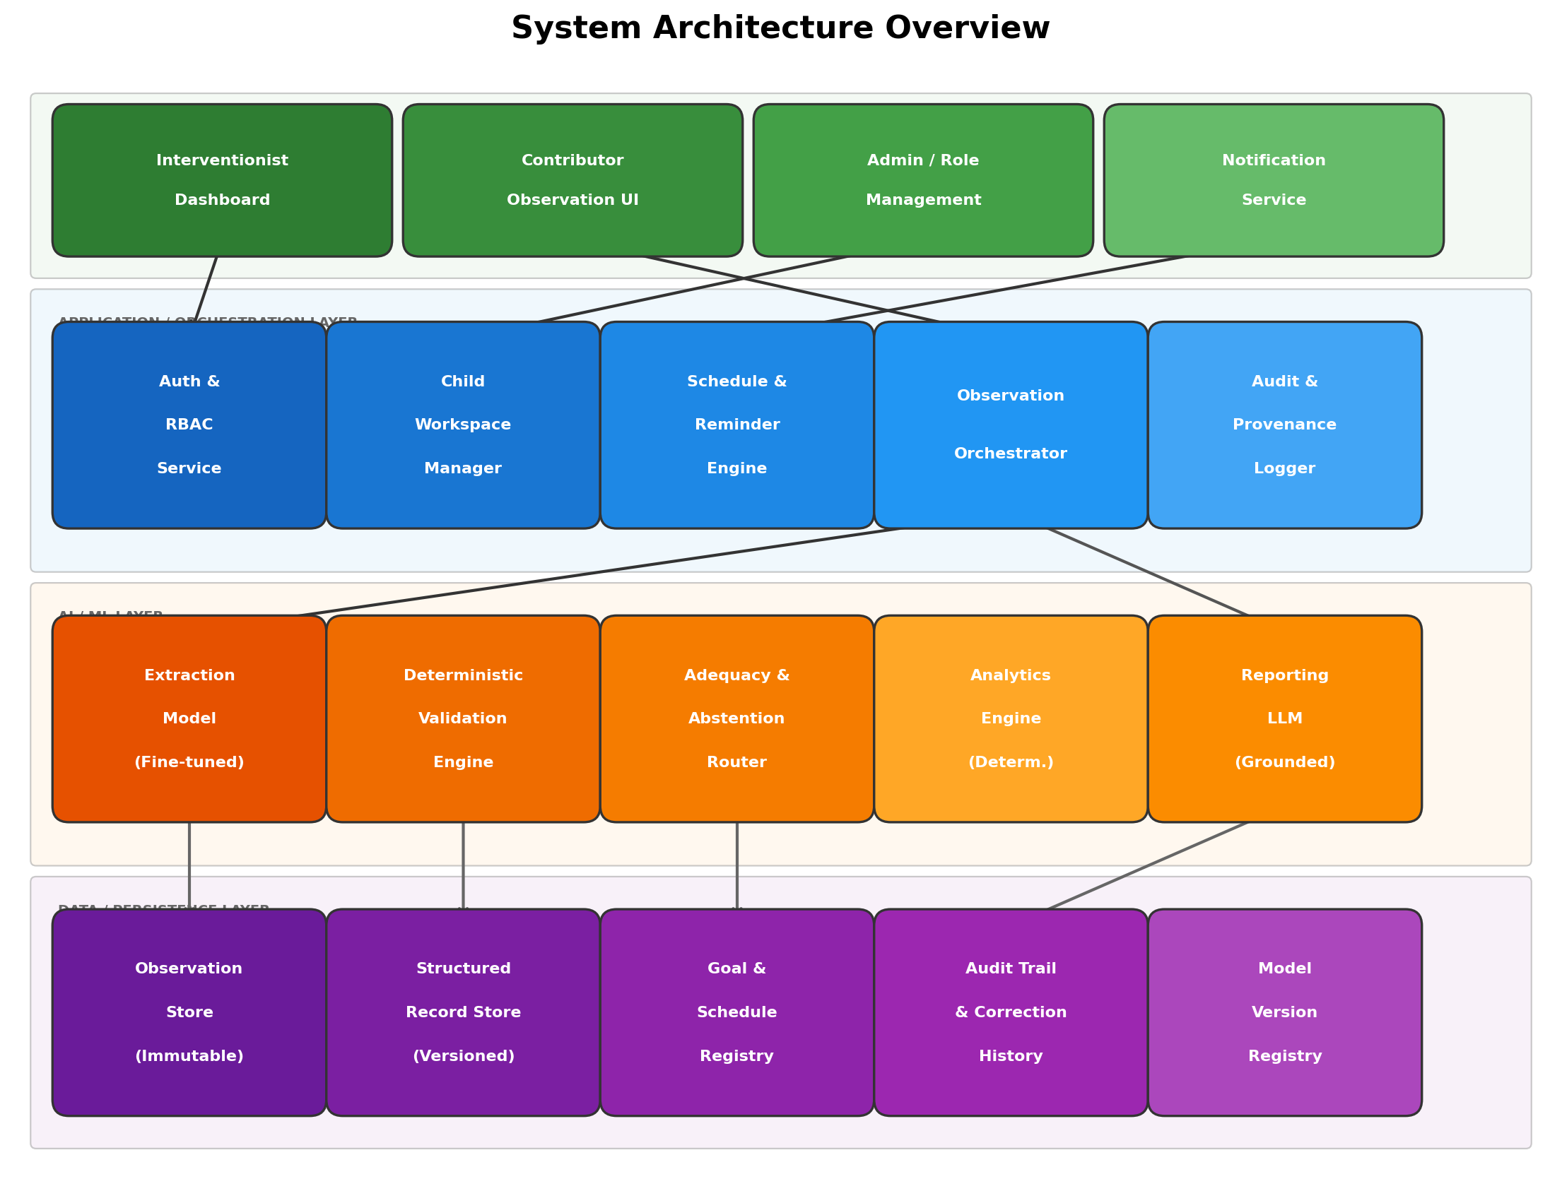
Figure 1: System Architecture Overview — Four-layer design separating presentation, orchestration, AI/ML, and persistence concerns.

Component Inventory
Layer | Component | Type | Responsibility
Presentation | Interventionist Dashboard | Web UI | Professional review, correction, drill-down, report viewing
Presentation | Contributor Observation UI | Web UI | Conversational observation entry, clarification response
Presentation | Admin / Role Management | Web UI | Child workspace, actor invitation, schedule config
Presentation | Notification Service | Backend | Email/SMS reminders for missed submissions
Application | Auth & RBAC Service | Backend | Authentication, role-based access, child-level authorization
Application | Child Workspace Manager | Backend | Child profile, goal definition, review period management
Application | Schedule & Reminder Engine | Backend | Observation cadence, due-date tracking, overdue detection
Application | Observation Orchestrator | Backend | Routes observations through extraction, validation, routing
Application | Audit & Provenance Logger | Backend | Immutable event log for all system actions
AI/ML | Extraction Model | Fine-tuned LLM | Maps free text to schema-constrained structured records
AI/ML | Deterministic Validation Engine | Rule Engine | Schema enforcement, type/value/range checks
AI/ML | Adequacy & Abstention Router | Rule Engine | Goal-aware evidence sufficiency assessment
AI/ML | Analytics Engine | Deterministic | KPI computation from validated structured records
AI/ML | Reporting LLM | Constrained LLM | Translates evidence packets into professional reports
Data | Observation Store | Database | Immutable original free-text observations
Data | Structured Record Store | Database | Versioned structured records with correction history
Data | Goal & Schedule Registry | Database | Goal definitions, schedule expectations, version history
Data | Audit Trail | Append-only Log | All system events, corrections, model versions
Data | Model Version Registry | Metadata Store | Model IDs, configs, hashes for reproducibility

3. Data Source & Processing Pipeline

3.1 Source Corpora
Model development uses deidentified real-world longitudinal observation data from two ASDBank English corpora hosted on TalkBank. Both corpora use the CHAT transcription format (Codes for the Human Analysis of Transcripts) and contain behavioral annotations, speech act codes, gestural descriptions, and activity/setting metadata.
Attribute | Rollins Corpus | Flusberg Corpus | Combined | Notes
DOI | doi:10.21415/T5KK53 | (TalkBank ASDBank) | — | Publicly accessible
Children | 5 (Carl, Roger, Sid, Mars, Josh) | 6 (Jack, Rick, Mark, Brett, Stuart, Roger) | 11 | Pseudonymous identifiers
Sessions | 20 | 65 | 85 | Longitudinal
Total Utterances | ~18,000 | ~57,000 | 75,003 | Staging dataset
Interaction Type | Child–Investigator | Child–Parent (Mother) | — | Different dyads
Key Annotations | %spa (speech acts), %act | %spa, %act, %gpx, %com | — | Rich behavioral context
Dates | Relative age only | Exact dates available | — | Flusberg enables temporal analysis
Language | English | English | English | —
Country | United States | United States | United States | —

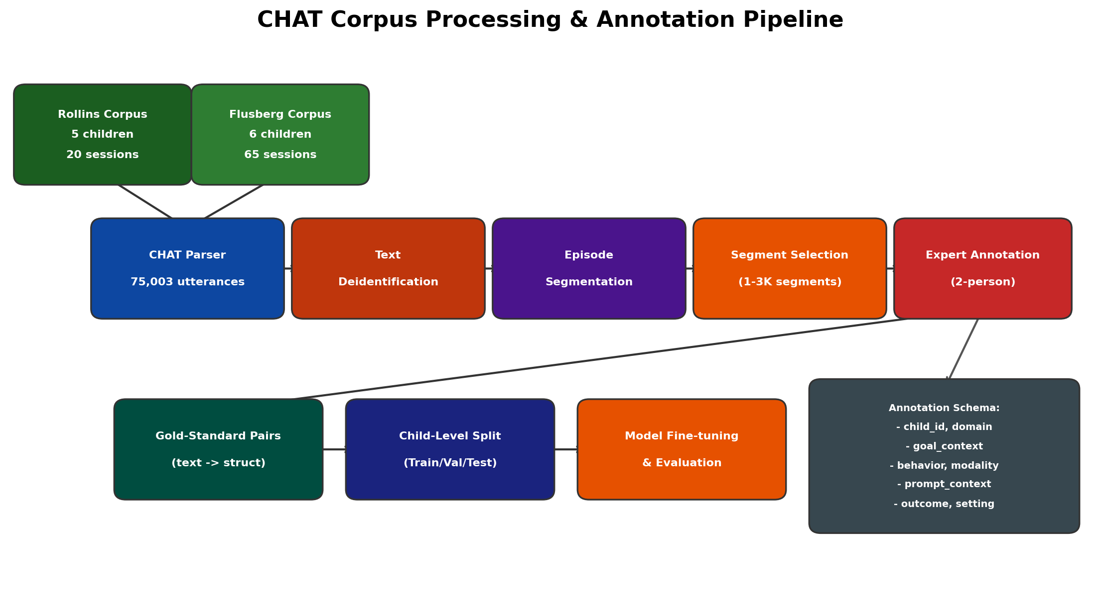
Figure 2: CHAT Corpus Processing & Annotation Pipeline — From raw CHAT transcripts through deidentification, segmentation, expert annotation, and child-level splitting for model development.

3.2 CHAT Format Structure
Each .cha file contains header metadata (@-lines) and timestamped utterance records. Key tiers include:
*CHI / *INV / *MOT: Speaker utterance lines (child, investigator, mother)
%spa: Speech act codes (e.g., $DCC:YQ = yes/no question, $NIA:RP = request)
%act: Action descriptions (e.g., "hands him the toy", "opens the barn door")
%gpx: Gestural/proxemic annotations (e.g., "reaches upward", "brushes away toy")
%mor: Morphological analysis (POS tagging, lemmatization)
%gra: Grammatical relations (dependency parse)
%tim: Timestamps within the session
@Activities: Session activity context (e.g., farm, book, toyplay)

3.3 Data Processing Steps
CHAT Parsing: Parse all 85 .cha files into a unified utterance-level dataset (75,003 rows) with columns: corpus, child_id, session_id, source_file, date, relative_month, speaker_code, activity_or_setting, utterance_seq, utterance_raw, spa, act, gpx, tim, com.
Text Deidentification: Remove or replace any residual direct identifiers in transcript text. Source child aliases have been replaced with analytic IDs, but in-text names and contextual identifiers require a separate deidentification pass before the manuscript can claim identifier removal.
Episode Segmentation: Identify coherent behavioral episodes (multi-turn interaction sequences centered on a communicative or behavioral event) suitable for annotation.
Behavioral Segment Selection: Select 1,000–3,000 meaningful behavioral segments representing diverse goals, settings, communication modalities, and prompt/support patterns.
Expert Annotation: Two-person expert annotation of selected segments against the structured schema (Section 4), with adjudication for disagreements.
Child-Level Splitting: Split gold-standard pairs at the child level (not utterance level) into train, validation, and held-out test partitions to prevent leakage.

3.4 Known Data Limitations
- Small independent sample: n=11 children limits generalizability claims.
- No explicit intervention goals in source data: goal contexts must be annotated by domain experts, not extracted from the transcripts themselves.
- Rollins provides only relative age (no exact dates), limiting temporal analysis for that subset.
- Contributor overlap: some pseudonym overlap between corpora (e.g., "Roger") requires careful disambiguation.
- Single language (English), single country (US), limited demographic diversity.

4. Observation Schema & Annotation Design
The extraction target is a domain-defined structured schema, not a free-form summary. Fields are populated only when supported by the source text. Unsupported fields remain explicitly unknown rather than being filled with plausible guesses.

4.1 Candidate Schema Fields
Field | Type | Required | Example Values | Source
child_id | String (analytic) | Yes | R01, F03 | Header metadata
session_id | String | Yes | 020800, 070315 | Filename
domain | Categorical | Yes | functional_communication, social_interaction, play, behavior_regulation | Expert annotation
goal_context | Categorical | Yes | requesting, joint_attention, imitation, turn_taking, labeling | Expert annotation
behavior | Categorical | Yes | request_attempt, response, initiation, imitation_attempt | Transcript + annotation
modality | Categorical | Yes | verbal, gesture, vocalization, combined, none | Transcript tiers
prompt_context | Free text (constrained) | No | "investigator verbal question", "physical prompt", "model" | Transcript %act/%spa
prompt_level | Ordinal | No | independent, verbal, gestural, model, physical, full_physical | Expert annotation
outcome | Categorical | No | access_to_requested_item, social_response, no_response, partial | Transcript sequence
setting | Categorical | Yes | clinic, home, school, community | Header @Activities
contributor_role | Categorical | Yes | investigator, parent, teacher, therapist | Header @Participants
observation_date | Date or relative | Yes | 2007-03-15, age 2;08 | Header @Date or @ID
duration_seconds | Integer | No | 45, 120 | Timestamp deltas
confidence | Float [0,1] | Auto | 0.92 | Model output
abstention_reason | Categorical | Auto | ambiguous_text, insufficient_detail, contradictory | System routing

4.2 Annotation Protocol
Source data remains completely real. Only research labels (domain, goal_context, behavior, prompt_level, outcome) are added by human annotators following the annotation guide. Annotators are instructed never to add information that is merely plausible but not supported by the transcript.
1. Recruit 2+ qualified annotators (BCBAs, SLPs, or autism intervention professionals).
2. Develop annotation guide with field definitions, allowed values, examples, and ambiguity rules.
3. Pilot annotation on ~50 segments; measure agreement, refine guide.
4. Independently annotate selected segments (target: 1,000–3,000).
5. Double-annotate a prespecified subset (minimum 20%) for inter-annotator agreement.
6. Adjudicate disagreements according to the annotation guide.
7. Report agreement by field (Cohen kappa for categorical, ICC for ordinal/continuous).
8. Freeze schema before held-out evaluation.

5. AI/ML Component Specifications
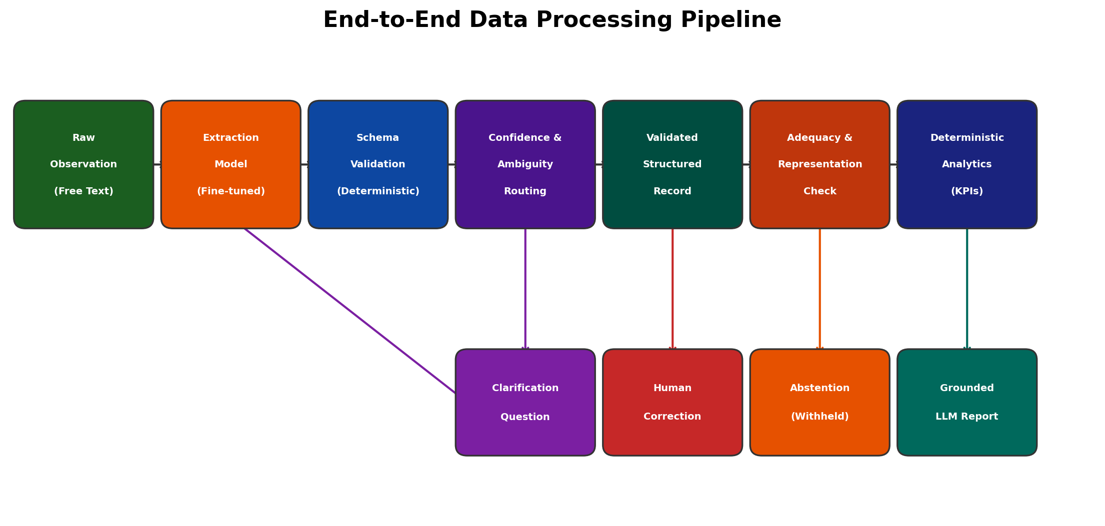
Figure 3: End-to-End Data Processing Pipeline — From raw observation through extraction, validation, routing, analytics, and report generation.

5.1 Extraction Model (Fine-tuned LLM)
A pretrained foundation model is adapted via supervised fine-tuning to map natural-language observations to the canonical structured schema. The model produces schema-constrained JSON output, not free-form narrative.
Parameter | Specification
Task | Structured information extraction from narrative observation text
Base Model | [TBD — e.g., Claude Haiku 4.5, Llama 3, Mistral, or domain-specific biomedical LM]
Adaptation Method | Supervised fine-tuning (full or LoRA/QLoRA) on expert-annotated pairs
Input | Raw observation text + goal context + contributor role + setting
Output | Schema-constrained JSON record (all fields from Section 4.1)
Training Data | Expert-annotated gold-standard pairs, child-level split
Validation | Development set for hyperparameter selection; held-out test set for final evaluation
Baselines | Zero-shot schema-constrained, few-shot prompted (same base model), rule-based if feasible
Decoding | Constrained generation / structured output mode; temperature and top-p TBD
Safety Constraint | Must not generate values not present in source text (unsupported inference penalty)

5.2 Deterministic Validation Engine
The validation layer sits between model output and persisted records. It enforces the canonical schema deterministically — no LLM involvement in validation decisions.
- Schema compliance: field names, data types, required vs. optional fields.
- Permitted values: categorical fields checked against canonical value lists.
- Numeric validation: ranges, formats, logical constraints (e.g., duration > 0).
- Cross-field logic: e.g., if modality=verbal then utterance text should be non-empty.
- Goal identifier validation: referenced goals must exist in the child workspace.
- Provenance requirement: each field must trace to a source text span or be marked unknown.
- Routing rules: Accept (all checks pass) → Clarify (recoverable ambiguity) → Abstain (unresolvable) → Reject (unusable).

5.3 Confidence & Abstention Routing
Extraction-level abstention uses uncertainty-aware routing. A field or record can be withheld when the model lacks sufficient support, the source text is ambiguous, or the candidate value fails validation. The system prioritizes a smaller set of reliable fields over a complete record with invented details.
Route | Condition | Action
Accept | All required fields populated, validation passes, confidence above threshold | Persist structured record
Clarify | Material field ambiguous but recoverable from contributor | Ask one focused follow-up question (max N turns)
Retain with Unknown | Non-critical field unsupported; critical fields valid | Persist with explicit unknown markers
Interventionist Review | Critical field uncertain or cross-field logic fails | Flag for professional review before persistence
Reject | Input unusable (irrelevant, malformed, empty) | Do not persist; log rejection reason

5.4 Adequacy & Representation Assessment
Analytics-level abstention is separate from extraction-level abstention. Even if every individual observation is correctly structured, the accumulated evidence may be insufficient for a requested longitudinal analysis. Checks are goal-aware:
- Coverage: minimum observation count over the intended review period.
- Timeliness: observations distributed across the review period, not clustered.
- Setting representation: required settings (e.g., home + school for cross-setting goals) must have observations from each.
- Contributor representation: evidence not disproportionately from a single contributor.
- Field completeness: goal-relevant fields (e.g., prompt_level for independence goals) must be populated in sufficient observations.
- Consistency: internal contradictions flagged (not auto-resolved).

5.5 Deterministic Analytics Engine
All numerical progress indicators are calculated by deterministic code from validated structured records. No LLM involvement in metric computation.
KPI Category | Example Metrics | Denominator | Prerequisites
Observation Completion | Expected vs. received submissions | Configured schedule | Schedule configured
Frequency/Rate | Behavior occurrences per session or period | Sessions/opportunities | Min. observation count
Independence | % responses without prompting | Total responses | Prompt-level field populated
Prompting Pattern | Distribution across prompt levels over time | Total prompted responses | Prompt-level field populated
Cross-Setting | Behavior rate at home vs. school | Setting-specific sessions | Observations from each required setting
Trend/Change | Rate change across review period segments | Time-segmented observations | Temporal coverage check passes
Missing Data | % observations with unknown fields | Total observations | Always displayable

5.6 Grounded Reporting LLM
A second LLM receives a constrained evidence packet and translates it into professional language. It does not decide what happened, calculate metrics, or override abstention.
Parameter | Specification
Task | Translate validated evidence + precomputed metrics into readable professional report
Input (Evidence Packet) | Validated structured records, deterministic KPIs, quality flags, abstention status, goal context
Output | Structured professional report with section headings, per-goal summaries, and uncertainty markers
Model | [TBD — may differ from extraction model]
Constraints | Must reproduce precomputed numbers exactly; must preserve abstention; cannot diagnose, prescribe, or recommend
Prohibited Content | Diagnostic statements, treatment recommendations, causal claims, goal modifications, unsupported generalizations
Validation | Post-generation check: numeric fidelity, factual support, prohibited content scan
Traceability | Each report statement linked to supporting metric or structured record

5.7 Model Training Plan (Data-to-Model Pipeline)
This section defines the concrete plan for training the extraction model using the provided ASDBank CHAT data. The plan maps the actual Rollins and Flusberg corpora through preprocessing, annotation, splitting, fine-tuning, and frozen evaluation.
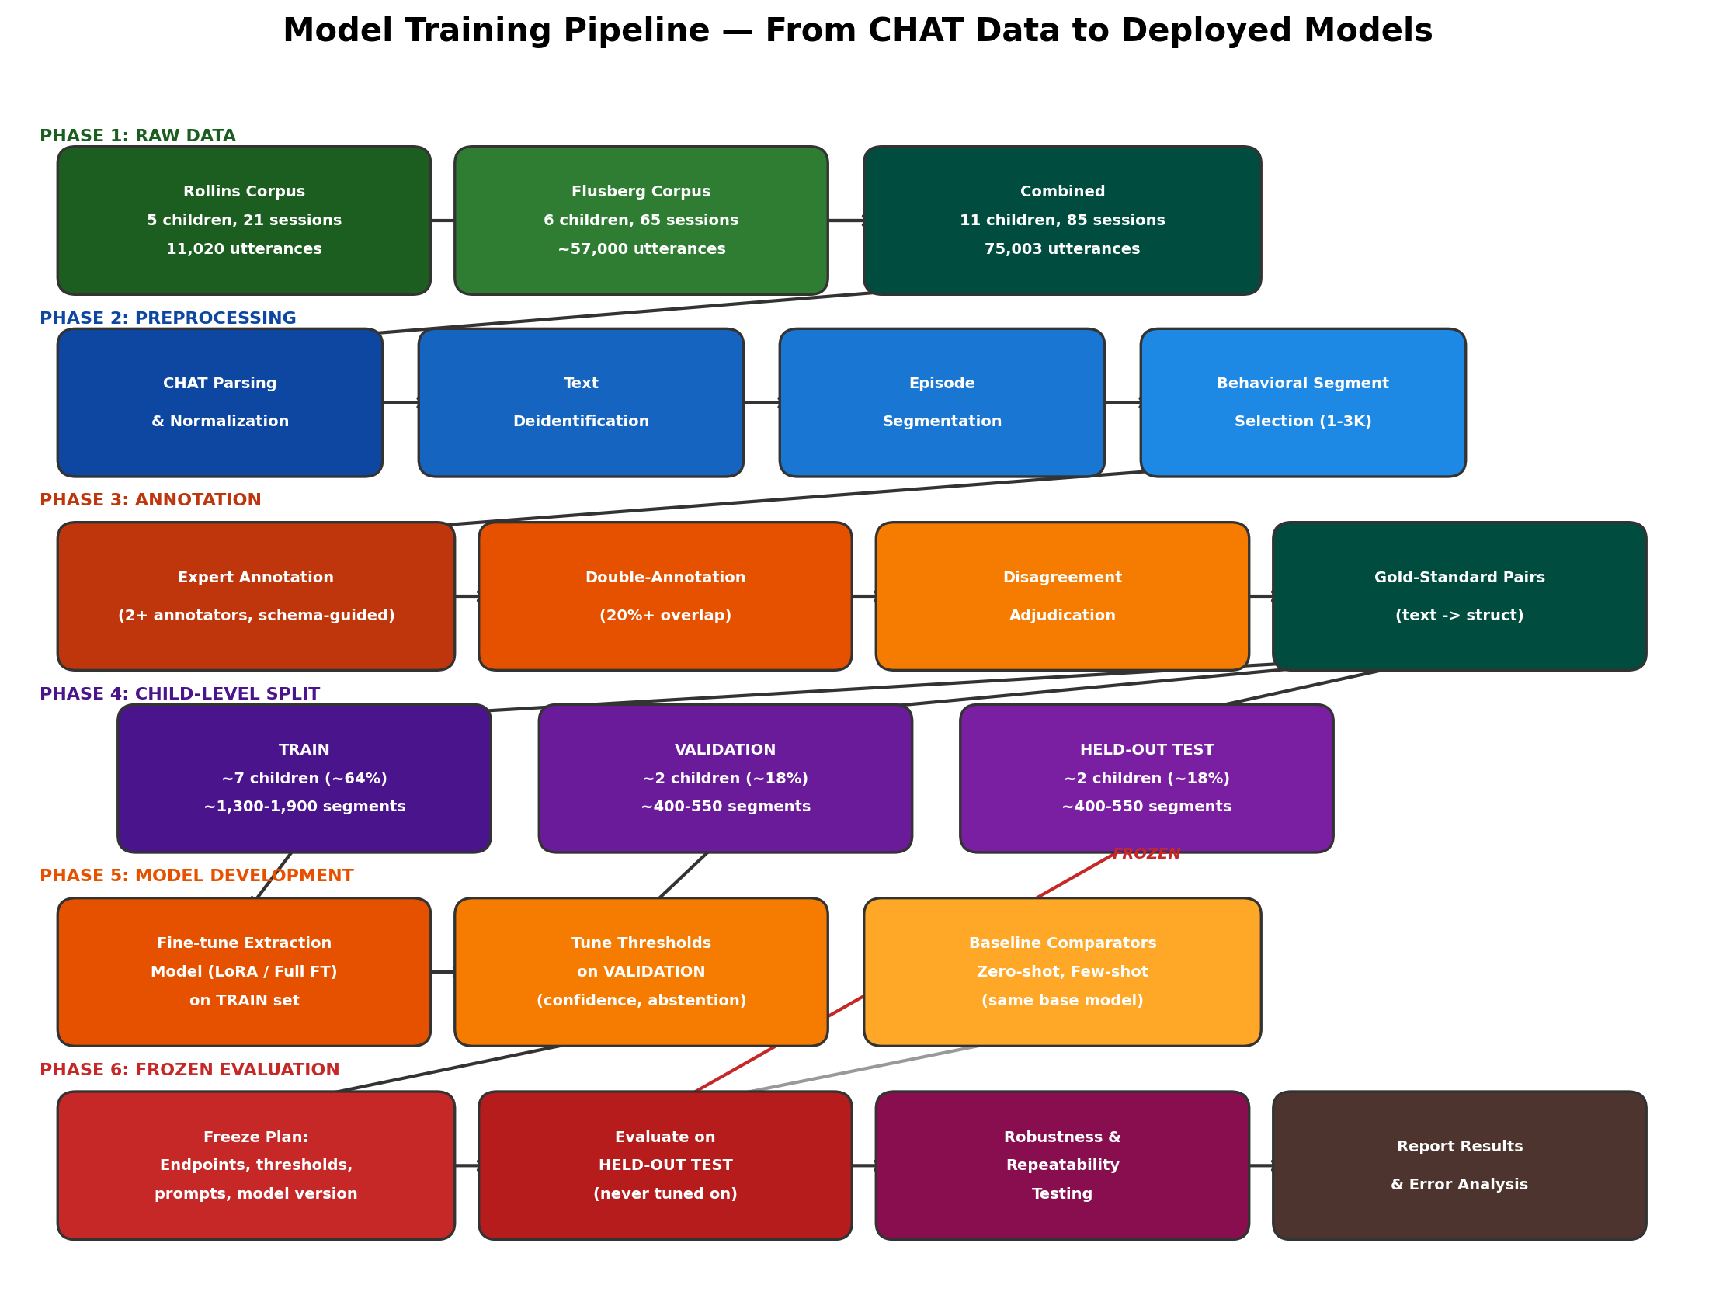
Figure 7: Model Training Pipeline — Six-phase progression from raw CHAT transcripts through preprocessing, expert annotation, child-level splitting, model fine-tuning, and frozen held-out evaluation.

5.7.1 Actual Data Inventory
The following table summarizes the actual data available for model training, derived from the provided CHAT files.
Child | Corpus | Sessions | Total Utterances | Child Utterances | Annotations Available
Carl | Rollins | 4 | 2,037 | 885 | %spa, %act, %gpx
Roger | Rollins | 4 | 1,405 | 538 | %spa, %act, %gpx
Sid | Rollins | 4 | 2,214 | 831 | %spa, %act, %gpx
Mars | Rollins | 5 | 3,882 | 1,324 | %spa, %act, %gpx
Josh | Rollins | 4 | 1,482 | 592 | %spa, %act, %gpx
Jack | Flusberg | 12 | ~8,500 | ~3,500 | %spa, %act, %gpx, dates
Rick | Flusberg | 11 | ~7,800 | ~3,200 | %spa, %act, %gpx, dates
Mark | Flusberg | 13 | ~11,000 | ~4,500 | %spa, %act, %gpx, dates
Brett | Flusberg | 10 | ~9,200 | ~3,800 | %spa, %act, %gpx, dates
Stuart | Flusberg | 8 | ~4,500 | ~1,800 | %spa, %act, dates
Roger* | Flusberg | 9 | ~5,500 | ~2,200 | %spa, %act, dates
TOTAL | Combined | 85 | ~75,003 | ~27,189 | —

* Roger appears in both corpora (different children with same pseudonym); these must be treated as distinct analytic IDs.

5.7.2 Phase 1: CHAT Parsing & Normalization
All 85 .cha files are parsed into a unified long-format dataset. Each utterance row preserves the speaker code, raw text, all dependent tiers (%spa, %act, %gpx, %mor, %gra, %tim), header metadata (child age, activity, session date where available), and source file reference.
- Parse @-headers: extract child ID, age, sex, activity, date, participant roles.
- Parse *-lines: extract speaker, utterance text, special markers ([+ trn], xxx, 0).
- Parse %-tiers: link each dependent tier to its parent utterance.
- Normalize speaker codes: CHI (child), INV (investigator, Rollins), MOT (mother, Flusberg).
- Assign analytic child IDs: disambiguate cross-corpus name collisions (e.g., Roger_R vs Roger_F).
- Compute relative time: for Rollins, derive from age field; for Flusberg, from @Date headers.
- Output: unified staging CSV with 75,003 rows and 15+ columns.

5.7.3 Phase 2: Deidentification & Segment Selection
Before annotation, residual identifiers are removed and behavioral segments are identified.
- Text deidentification: scan utterance text and %act/%gpx tiers for residual names, locations, or other PII. Replace with placeholder tokens. Manual review of flagged cases.
- Episode boundary detection: identify coherent multi-turn interaction sequences centered on a communicative or behavioral event (e.g., a request-response cycle, an imitation attempt, a joint attention episode).
- Segment selection criteria: (a) child-initiated or child-response turns, (b) presence of behavioral annotation (%act, %gpx, or %spa), (c) diversity across goal domains, settings, and communication modalities, (d) representative distribution across all 11 children.
- Target: 1,000-3,000 segments, each consisting of 2-8 consecutive utterance turns with context.

5.7.4 Phase 3: Expert Annotation
Selected segments are annotated by domain experts using the schema from Section 4. The source transcript is completely real; only the structured research labels are added.
Example — mapping real CHAT data to structured annotation:
Source (Real CHAT Transcript) | Annotated Structured Record
*CHI: xxx . [+ trn]  %spa: $NIA:RP:VNR  %gpx: reaches upward  *INV: you want the toy ?  %spa: $DCC:YQ  %act: hands him the toy  *CHI: 0 . [+ trn]  %spa: $DCC:AN:NO  %gpx: brushes away toy | child_id: R05_Sid  domain: functional_communication  goal_context: requesting  behavior: request_attempt  modality: gesture  prompt_context: investigator verbal question  prompt_level: verbal  outcome: rejected_offered_item  setting: clinic  contributor_role: investigator
*CHI: xxx . [+ trn]  %spa: $NIA:RP:VNR  %gpx: reaches upward  *INV: you want the book ?  %spa: $DCC:YQ  %act: hands him the book  *CHI: 0 . [+ trn]  %spa: $DCC:AA:CO  %act: takes the book and sits down | child_id: R05_Sid  domain: functional_communication  goal_context: requesting  behavior: request_successful  modality: gesture  prompt_context: investigator verbal question  prompt_level: verbal  outcome: access_to_requested_item  setting: clinic  contributor_role: investigator

5.7.5 Phase 4: Child-Level Data Splitting
Data separation occurs at the child level, never at the utterance or segment level. All segments from one child remain in the same partition to prevent leakage.
Partition | Children | Approx. % | Purpose | Access Rule
Train | ~7 children (mix of Rollins + Flusberg) | ~64% | Model fine-tuning | Used freely during development
Validation | ~2 children | ~18% | Hyperparameter tuning, threshold selection, model comparison | Used during development, not for final claims
Held-Out Test | ~2 children (ideally 1 from each corpus) | ~18% | Final frozen evaluation | NEVER inspected until analysis plan is frozen

- Duplicate/near-duplicate audit before splitting: identify copied templates, repeated boilerplate.
- Contributor overlap analysis: same investigator/mother style across children must be measured.
- Stratification considerations: balance goal domains, settings, and corpus source across partitions.
- Cluster-aware statistics: confidence intervals use child-level resampling, not observation-level.

5.7.6 Phase 5: Model Fine-Tuning
The extraction model is fine-tuned on TRAIN data and tuned on VALIDATION data.
Parameter | Plan
Base Model Candidates | Claude Haiku 4.5 (via API fine-tuning if available), Llama 3.1 8B (self-hosted, LoRA), Mistral 7B, or biomedical LM variant
Input Format | System prompt with schema definition + goal context + raw multi-turn CHAT transcript segment
Output Format | JSON object conforming to the annotation schema (Section 4.1)
Fine-Tuning Method | LoRA (rank 16-64) or QLoRA for parameter-efficient adaptation; full fine-tuning if compute allows for small models
Training Objective | Supervised next-token prediction on input-output pairs; structured output mode to constrain generation
Hyperparameters | Learning rate: 1e-5 to 5e-5; batch size: 4-16; epochs: 3-10 with early stopping on validation loss
Model Selection Criterion | Field-level F1 on validation set; unsupported-field rate as secondary safety criterion
Baseline Comparators | (1) Zero-shot with schema prompt, (2) Few-shot with 3-5 examples from training set, (3) Rule-based extraction from %spa/%act codes if feasible
Decoding Settings | Constrained generation / JSON mode; temperature 0.0-0.3; top-p 0.95; max tokens per schema

5.7.7 Phase 6: Frozen Evaluation
Before the held-out test set is opened, the following are frozen: primary endpoints, metrics, prompts, thresholds, model version, decoding settings, and statistical procedures. Any post-freeze deviation is documented and reported as exploratory.
1. Freeze evaluation plan: document primary endpoint (field-level F1), secondary endpoints (unsupported-field rate, abstention accuracy), model version, and all thresholds.
2. Run frozen model on held-out test set: extract structured records from all test segments.
3. Compute field-level metrics: precision, recall, F1, exact match per schema field. Report child-level cluster-aware 95% confidence intervals.
4. Compare fine-tuned vs. baselines: paired analysis on same test segments.
5. Error analysis: categorize failures (wrong goal linkage, prompt-level confusion, unsupported inference, omission, setting errors).
6. Run robustness suite: adversarial inputs, boundary cases, privacy probes.
7. Run repeatability test: process same inputs 5-10 times, measure field stability.
8. Report proportion of errors caught by deterministic validation before persistence.

5.7.8 Training Constraints & Mitigations
Small n (11 children): Frame as proof-of-concept. Use leave-one-child-out cross-validation on development data as supplementary analysis. Do not overclaim generalizability.
No explicit goals in source data: Goals are annotated by experts, not extracted from transcripts. This is a legitimate research annotation, not synthetic data generation.
Annotation cost: Target 1,000-3,000 segments. Pilot on ~50 segments first to calibrate annotator agreement and estimate time per segment.
Rollins lacks exact dates: Use age-based relative ordering for Rollins; Flusberg provides exact dates for temporal validation.
Contributor style leakage: Same investigator/mother across sessions may inflate performance. Measure and report contributor overlap; consider sensitivity analysis.

6. Application Workflow & Authorization Model

6.1 Role-Based Access Control
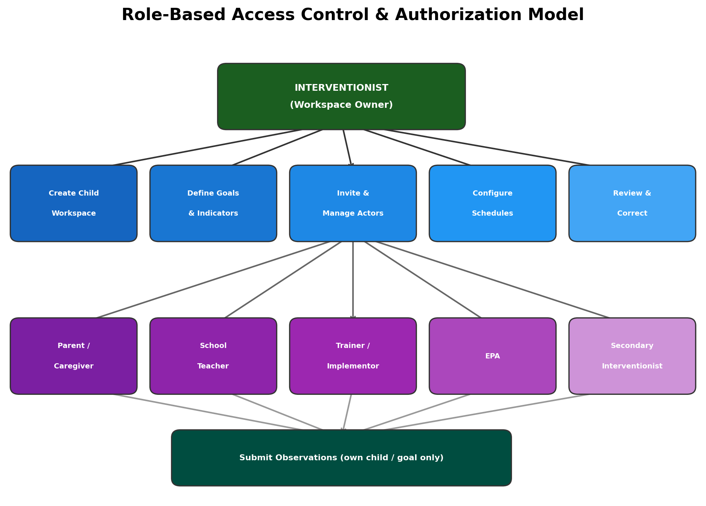
Figure 8: Role-Based Access Control & Authorization Model — Interventionist as workspace owner with full authority; contributors with observation-only access.
Action | Interventionist | Parent/Caregiver | Teacher | Trainer | EPA | Sec. Interventionist
Create child workspace | Yes | — | — | — | — | —
Define/modify goals | Yes | — | — | — | — | —
Invite/revoke actors | Yes | — | — | — | — | —
Configure schedules | Yes | — | — | — | — | —
Submit observations | Yes | Own child | Own child | Own child | Own child | Own child
View own submissions | Yes | Yes | Yes | Yes | Yes | Yes
View cross-setting analytics | Yes | — | — | — | — | If permitted
View/correct structured records | Yes | — | — | — | — | If permitted
View professional reports | Yes | — | — | — | — | If permitted
Approve/flag reports | Yes | — | — | — | — | —

6.2 Child Workspace Lifecycle
For each child, the interventionist creates a protected workspace containing background information, active goals, observable indicators, review period, and authorized contributors. Goals and observation expectations originate from the interventionist.

6.3 Observation Intake & Clarification
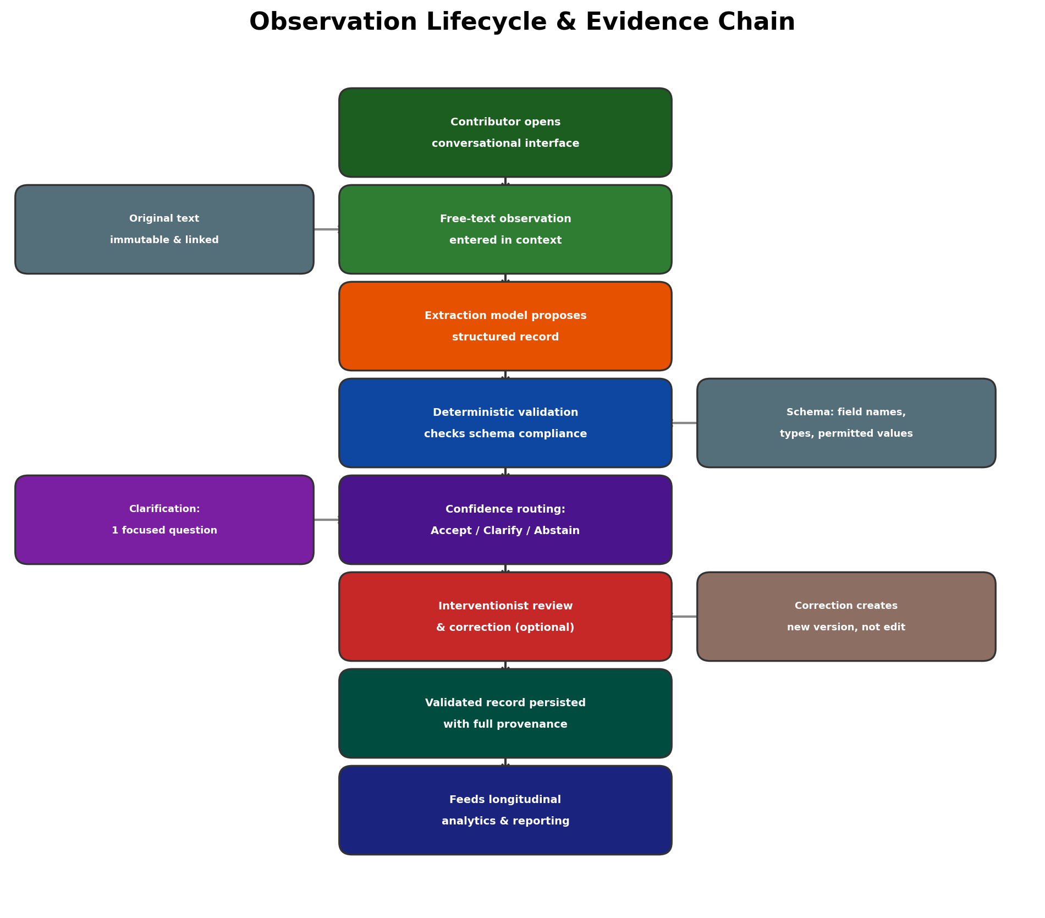
Figure 9: Observation Lifecycle & Evidence Chain — From contributor entry through extraction, validation, routing, correction, and persistence.
Contributors enter observations through a conversational interface in the context of the assigned child and active goal. The system may ask one narrowly scoped follow-up question at a time when a material detail is ambiguous but recoverable. The contributor can answer, indicate unknown, or decline. The original conversational text is retained as immutable source evidence.

6.4 Schedule & Notification Engine
- Cadence types: calendar-based (daily, N times per week) or event-based (after each session).
- Configuration: actor, child, linked goal(s), setting, cadence, time window, grace period.
- Overdue detection: when due time passes without a qualifying observation, mark as overdue.
- Notifications: email (and SMS if approved) to responsible actor and interventionist.
- Escalation: bounded reminder count; further follow-up deferred to interventionist.
- Audit: all notification events, delivery attempts, and subsequent submissions logged.
- Schedule versioning: changes affect future expectations without rewriting history.

6.5 Interventionist Dashboard
The dashboard is the primary synthesis surface, organized around professional review. It displays:
- Child and active review period overview.
- Long- and short-term goals with observable indicators.
- Authorized contributors and their reporting expectations.
- Expected vs. received observations; overdue submissions.
- Missing or unresolved fields in structured records.
- Representation and adequacy warnings.
- Goal-linked deterministic KPIs and longitudinal charts (only when evidence passes checks).
- Grounded LLM report with drill-down to supporting evidence.
- Abstention state with identified evidence gaps (replaces blank charts).

7. Software Architecture & Technology Stack
The following technology stack is recommended. Final selections will be confirmed during the development phase based on team expertise, licensing, and infrastructure constraints.
Component | Recommended Technology | Rationale
Frontend | React / Next.js with TypeScript | Component-based UI, SSR for dashboard, type safety
Backend API | Python (FastAPI) or Node.js (Express) | Strong ML ecosystem (Python) or full-stack JS
Authentication | OAuth 2.0 / OpenID Connect (Auth0 or Keycloak) | Standards-based, role mapping, invitation flow
Database (Primary) | PostgreSQL with row-level security | Child-level access control, JSONB for structured records
Database (Audit) | Append-only log (PostgreSQL or dedicated event store) | Immutable audit trail
Extraction Model Serving | vLLM / TGI / Cloud LLM API | Depends on base model; structured output support required
Reporting LLM | Cloud LLM API (e.g., Claude API) | Constrained prompting, structured output
Notification | SendGrid (email), Twilio (SMS if approved) | Reliable delivery, delivery status tracking
Orchestration | Celery / Bull (task queue) or event-driven | Async observation processing pipeline
Deployment | Docker / Kubernetes on cloud (AWS/GCP/Azure) | Environment isolation, scalability
CI/CD | GitHub Actions | Automated testing, schema validation, deployment
Monitoring | Structured logging + Grafana / CloudWatch | Observability, model performance tracking

8. Evaluation Framework
The system is evaluated at five primary levels plus four cross-cutting dimensions. The evaluation plan is frozen before the held-out test set is opened.
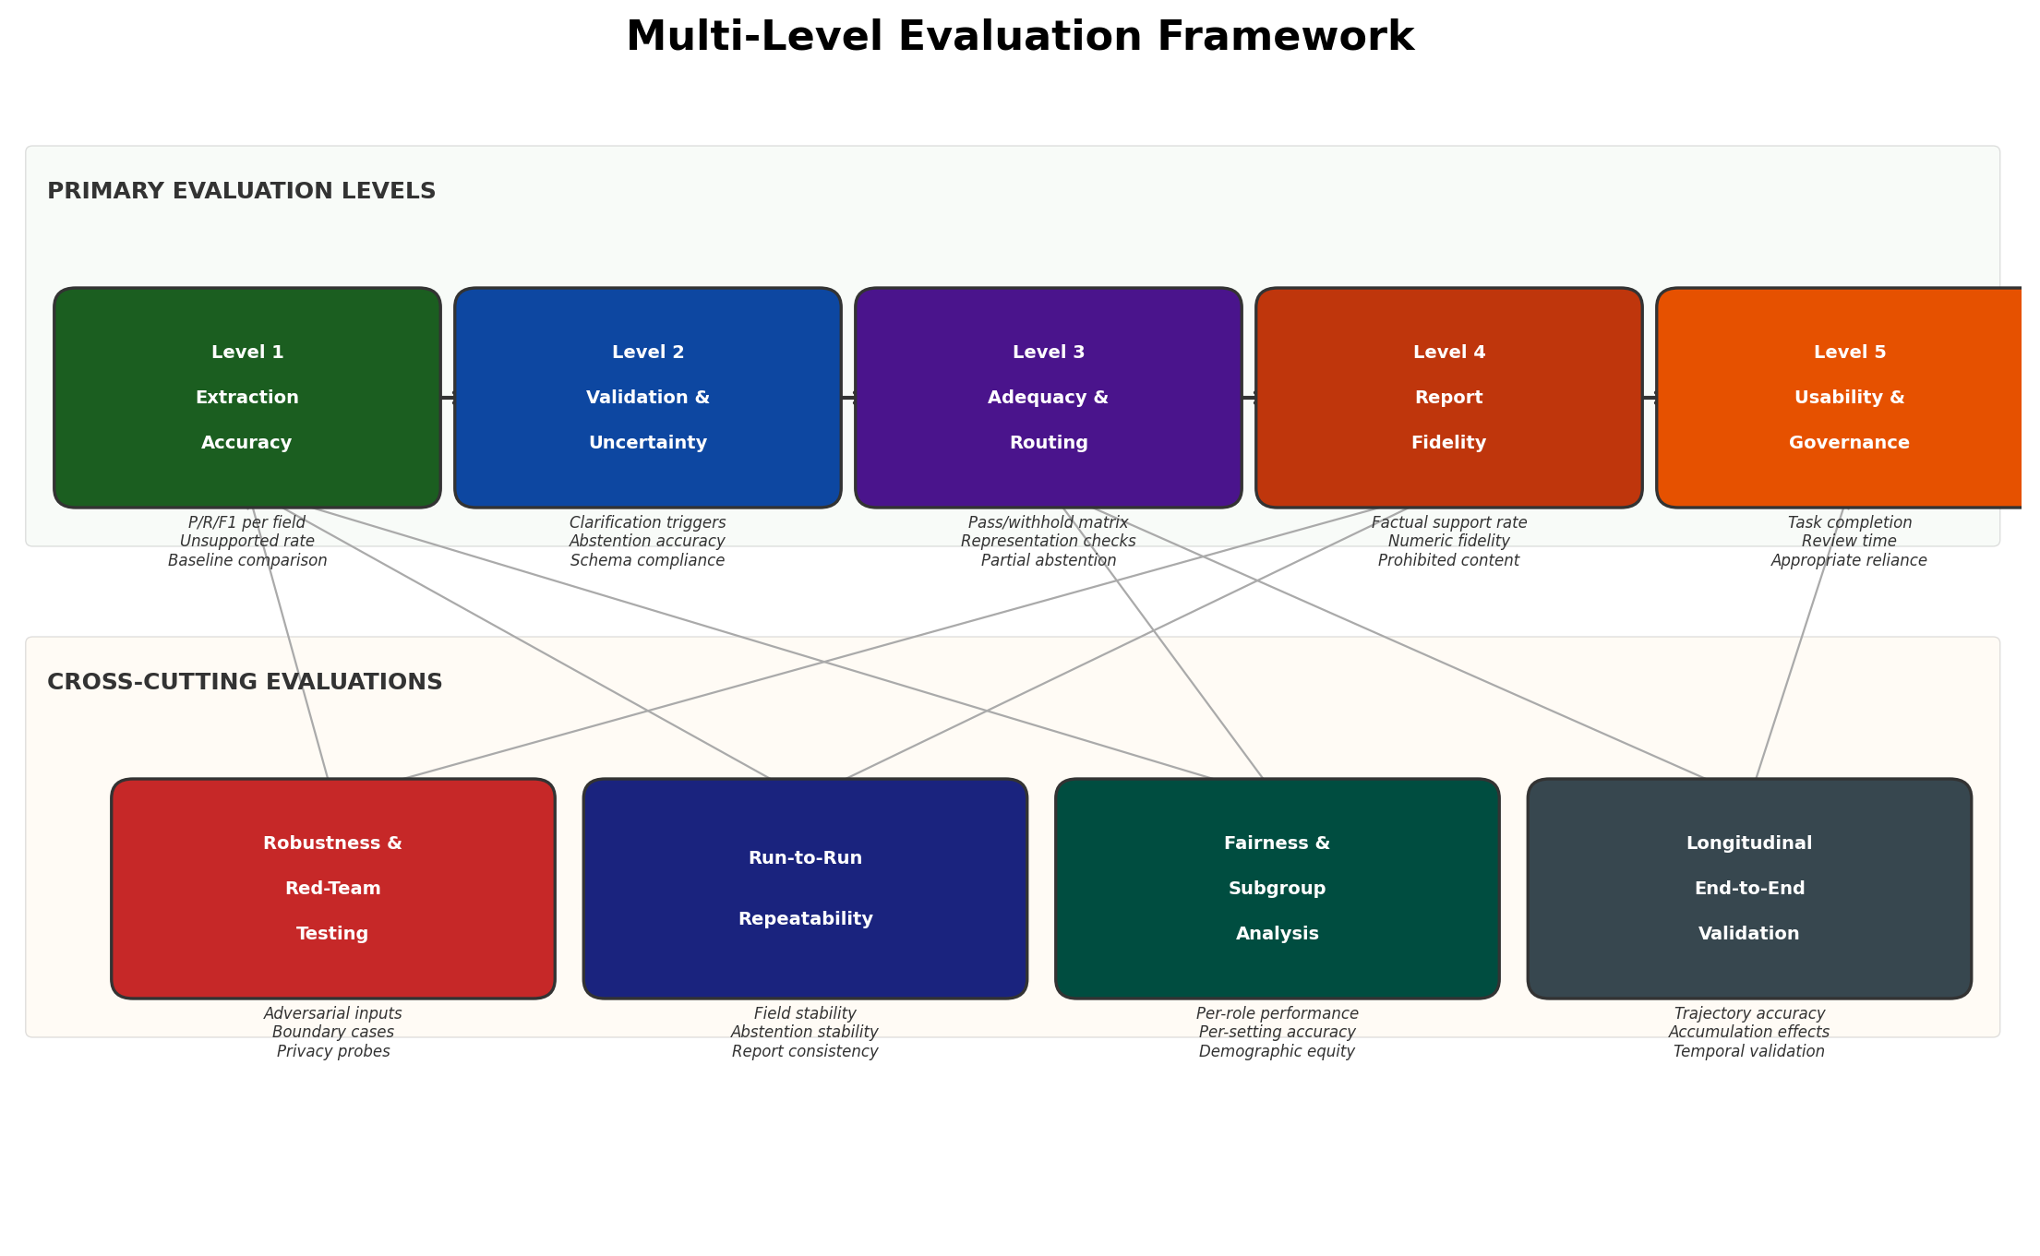
Figure 10: Multi-Level Evaluation Framework — Five primary evaluation levels and four cross-cutting assessment dimensions.

Level 1: Extraction Accuracy
- Precision, recall, F1 per schema field on held-out test set.
- Unsupported-field generation rate (safety-critical metric).
- Fine-tuned vs. zero-shot vs. few-shot baseline comparison.
- Numeric error measures for continuous/ordinal fields.
- Child-level cluster-aware confidence intervals.

Level 2: Validation & Uncertainty
- Clarification trigger accuracy (appropriate vs. unnecessary questions).
- Abstention accuracy at extraction level.
- Schema compliance rate before vs. after validation.
- Rate of validation-caught errors vs. errors reaching persistence.

Level 3: Adequacy & Routing
- Pass/withhold confusion matrix against expert routing labels.
- Sensitivity for unsafe-to-analyze cases (must not generate unsupported analytics).
- Specificity for eligible cases (avoid over-abstention).
- Partial abstention accuracy for multi-goal cases.

Level 4: Report Fidelity
- Factual support rate (every statement traceable to evidence).
- Numeric fidelity (precomputed values reproduced exactly).
- Abstention preservation (withheld analytics not reconstructed narratively).
- Prohibited content rate (diagnosis, treatment, causality, goal changes).
- Expert ratings of clarity, readability, and usefulness.

Level 5: Usability & Governance
- Task completion, critical errors, task time.
- Conventional vs. AI-assisted review comparison (within-participant, counterbalanced).
- Evidence identification accuracy, missing-evidence recognition.
- Appropriate reliance (not just acceptance/satisfaction).
- Usability scale scores, workload measures, qualitative themes.

Cross-Cutting Evaluations
Robustness & Red-Team Testing: Prespecified adversarial inputs: spelling noise, very short/vague notes, negation, contradictions, requests for diagnosis/treatment, instruction override attempts, PII injection.
Run-to-Run Repeatability: Repeated processing of identical inputs under frozen configuration. Measure field-level stability, abstention consistency, report factual invariance.
Fairness & Subgroup Analysis: Performance stratified by contributor role, setting, child age band, and available demographic variables. Small cells suppressed for privacy.
End-to-End Longitudinal Validation: Complete pipeline processing of held-out child-goal trajectories. Accumulation effects, temporal coverage, cross-setting analytics accuracy.

9. Security, Privacy & Compliance
Authentication: All users authenticate via OAuth 2.0/OIDC. Session tokens are managed server-side. Invitation-based enrollment with email verification.
Authorization: Child-level row-based access control enforced at both UI and API layers. Negative tests verify cross-child access denial, expired/revoked accounts, URL manipulation.
Encryption: TLS 1.3 for all data in transit. AES-256 encryption at rest for databases and object storage.
Data Minimization: Deidentified data only in model training. Model receives minimum context needed for task.
Audit Trail: Append-only log of all system events: access, modifications, model invocations, corrections, notifications.
Model Data Handling: If using external model APIs: confirm data processing agreements, retention policies, and geographic processing restrictions.
Secret Management: API keys, model credentials, and database passwords in dedicated secret manager (e.g., AWS Secrets Manager).
Ethics & IRB: Study requires ethical oversight determination. Deidentification does not exempt from formal review.

10. Deployment & Operations
The controlled-environment prototype supports the prespecified research workflows. It is not presented as a production-ready clinical or educational platform.
- Environment separation: development, staging, production.
- Containerized deployment (Docker) for reproducibility.
- Model version pinning: extraction and reporting models frozen for evaluation.
- Configuration hashes stored with generated artifacts for reproducibility.
- Health checks for all services (API, database, model endpoints, notification).
- Structured logging with correlation IDs across the pipeline.
- Backup and recovery procedures for databases.
- Controlled model update process: retrain, evaluate against frozen protocol, version, deploy.

11. Risks, Limitations & Mitigations
Risk | Impact | Likelihood | Mitigation
Small sample size (n=11 children) | High | Certain | Frame as proof-of-concept; do not overclaim generalizability; plan external validation
Annotation disagreement on novel schema | Medium | Likely | Pilot annotation, iterative guide refinement, inter-annotator agreement measurement
LLM generates unsupported inferences | High | Likely | Deterministic validation layer; unsupported-field penalty; human correction
Extraction model overfits to small training set | High | Likely | Child-level splitting; leakage/duplicate audit; baseline comparison
Over-abstention reduces system utility | Medium | Possible | Threshold tuning on dev set; partial abstention; track withholding rate
Contributors fail to respond to clarifications | Low | Likely | Bounded clarification turns; retain with unknown; graceful degradation
Interventionists over-rely on AI outputs | High | Possible | Appropriate-reliance evaluation; source-evidence drill-down; abstention visibility
Residual identifiers in transcript text | High | Possible | Dedicated deidentification pass before model training; manual review
External model API data retention concerns | Medium | Possible | Data processing agreements; self-hosted options; retention audit
Run-to-run instability in safety-relevant fields | Medium | Possible | Repeatability testing; field-level stability monitoring; constrained decoding

12. Implementation Roadmap
Phase | Duration | Key Deliverables | Dependencies
Phase 1: Data Preparation | 4–6 weeks | - CHAT parser pipeline  - Text deidentification  - Episode segmentation  - Behavioral segment selection  - Utterance staging dataset | Raw CHAT files; deidentification protocol
Phase 2: Schema & Annotation | 6–8 weeks | - Final annotation schema  - Annotation guide  - Pilot annotation & agreement  - Full annotation (1-3K segments)  - Gold-standard pairs | Phase 1 complete; recruited annotators
Phase 3: Model Development | 6–8 weeks | - Child-level data splits  - Leakage/duplicate audit  - Base model selection  - Fine-tuning pipeline  - Baseline comparators  - Validation engine | Phase 2 complete; compute resources
Phase 4: Application Build | 8–12 weeks | - Auth & RBAC  - Child workspace & goals  - Observation intake UI  - Schedule engine  - Dashboard & drill-down  - Reporting LLM integration | Phase 3 model available; tech stack confirmed
Phase 5: Evaluation | 4–6 weeks | - Freeze evaluation plan  - Held-out test evaluation  - Robustness/red-team testing  - Repeatability testing  - Interventionist usability study  - Comparative workflow study | All prior phases complete; recruited interventionists
Phase 6: Manuscript & Release | 4–6 weeks | - Results analysis  - Manuscript completion  - Repository preparation  - Reproducibility artifacts | Evaluation complete; results frozen

Estimated total timeline: 32–46 weeks (8–12 months)

Appendix A: Data Cohort Summary

Rollins Corpus — Children & Sessions
Child (Pseudonym) | Sessions | Age Range | Activities
Carl | 3 (020800, 030700, 021100) | 2;08 – 3;07 | farm, toyplay
Roger | 3 (020800, 021000, 030300) | 2;06 – 3;03 | toyplay
Sid | 3 (020200, 021100, 030500) | 2;02 – 3;05 | book, toyplay
Mars | 5 (030100, 030300, 030600, 030800, 031100) | 3;01 – 3;11 | toyplay
Josh | 4 (020500, 020800, 030100, 021100) | 2;05 – 3;01 | toyplay

Flusberg Corpus — Children
Child (Pseudonym) | Sessions | Interaction Type
Jack | 12 | Child–Mother (longitudinal, dated)
Rick | 11 | Child–Mother (longitudinal, dated)
Mark | 13 | Child–Mother (longitudinal, dated)
Brett | 10 | Child–Mother (longitudinal, dated)
Stuart | 8 | Child–Mother (longitudinal, dated)
Roger | 9 | Child–Mother (longitudinal, dated)

Appendix B: CHAT Format Reference
CHAT (Codes for the Human Analysis of Transcripts) is the standard transcription format used by the CHILDES and TalkBank projects. Key conventions relevant to this project:

Header Lines (@)
@UTF8: Character encoding declaration
@Begin / @End: Transcript boundaries
@Participants: Speaker codes and roles (CHI=child, INV=investigator, MOT=mother)
@ID: Speaker metadata including age (e.g., 2;08 = 2 years, 8 months), sex, role
@Activities: Session activity (e.g., farm, book, toyplay)
@Types: Corpus type markers (e.g., long, toyplay, ASD)
@Date: Session date (Flusberg corpus)

Utterance and Annotation Tiers
Main utterance lines begin with * (speaker code). Dependent tiers begin with % and provide linguistic, behavioral, or contextual annotations for the preceding utterance.

Speech Act Codes (%spa)
The %spa tier uses the INCA-A coding system. Key code families include:
$DCC: Directive/Compliance — questions and commands (YQ=yes/no question)
$DJF: Descriptive/Judgmental — statements and labels (ST=statement, AC=acknowledge)
$NIA: Negotiation of Immediate Activity — requests and turn-taking (RP=request, TO=turn offer)
$NMA: Naming/Calling — attention-getting (CL=call)
$MRK: Marker — conversational markers (MK=marker)
$DRE: Dramatic Enactment — pretend play narration (ST=statement)

Document Control
Field | Value
Document Title | Technical Specification — Governance-Aware AI System for Autism Intervention
Version | 1.0
Date | August 23, 2026
Status | Draft — For Review
Classification | Confidential
Based on | JMIR AI Draft V3 (Operational Workflow) + ASDBank Rollins & Flusberg Corpora

