A Governance-Aware Evaluation Framework for Language-Model Extraction in Autism Intervention Monitoring: Annotation Reliability, Unsupported Inference, Multi-Model Selection, and Reporting Governance
WORKING DRAFT — NOT SUBMISSION READY. This document is assembled automatically from recorded evaluation artefacts for internal review. Ethics statements are incomplete, no frontier-model comparison has been run, and several system components are unevaluated. Sections that cannot be supported by measurement are listed under 'Not measured' rather than omitted.
Generated from 61 recorded artefacts; every figure in this document is derived from data in this repository and no number is typed by hand.

Abstract
Background. Structured longitudinal records of autism intervention progress are difficult to assemble because contributor observations are heterogeneous natural language. Large language models can structure such text, but their use in a clinical monitoring pathway requires a reference standard and explicit governance.
Methods. We derived 330 behavioural segments from two public ASDBank CHAT corpora (11 children, 85 sessions, 75,003 utterances), which stand as a proxy for the contributor-written observations the application is designed to receive; no corpus of real intervention notes is publicly available. Two annotators independently authored structured field values from the transcripts. Analysis of their disagreements identified three underspecified field definitions; these were resolved in a written codebook and the affected segments were re-annotated blind, with an untreated control field retained to separate the effect of the codebook from that of re-annotation. Surviving conflicts were adjudicated by consensus. Three local generators were scored against the resulting gold standard, and a multi-judge reranking stage (MARS) was evaluated against both a random-selection and a best-generator baseline.
Results. Mean Cohen's kappa rose from 0.610 to 0.801 across the four categorical fields. The three fields the codebook addressed improved by +0.29 to +0.48 with paired intervals excluding zero, while the untreated control field did not move (−0.041, interval spanning zero). All 330 segments entered the gold standard. The strongest generator produced a fully correct record on 4.5% of segments against an oracle ceiling of 6.1%. Where the gold standard records no supporting evidence for a field, generators asserted a value on up to 97% of opportunities. A larger, more recent generator added afterwards was no more accurate and had the highest unsupported-assertion rate of any model tested; across the roster, unsupported assertion tracked willingness to answer rather than capability. On a model-independent held-out set of 132 segments, adjudicated to the same standard, every generator was less accurate than on the batch (−1.9 to −8.0 points), while unsupported-assertion rates and their ordering across generators were unchanged. Reranking selected better than chance but did not improve on always using the strongest generator.
Conclusions. The contribution is the evaluation framework — explicit null annotation, a controlled codebook revision, oracle-bounded selection analysis, and a governance check separate from schema conformance — and what applying it to this pipeline exposed. Low inter-annotator agreement in this task was largely definitional rather than a matter of annotator inconsistency, and was measurably repaired by a written codebook under a controlled design. The generators evaluated are not adequate for the extraction task, and increasing model size within the locally served models evaluated did not resolve the extraction failure: the largest model tested achieved accuracy comparable to the strongest smaller model while producing the highest unsupported-assertion rate. Candidate selection cannot compensate for candidate quality. All extraction results are a component evaluation on proxy data and do not establish that extraction works on real intervention notes. These are the boundaries the application enforces: no extracted record reaches longitudinal analytics without professional verification, and progress reports are rendered deterministically rather than generated.

Introduction
Interventionists working with autistic children depend on observations contributed by parents, teachers and support staff. Those observations arrive as unstructured natural language, in heterogeneous formats, from contributors with different vocabularies and different levels of training. Reviewing them longitudinally against a defined goal is correspondingly difficult, and the difficulty grows with the length of the intervention.
Large language models can convert such text into structured records, and this is an attractive application: the task is well defined, the volume is high, and the clinician's time is the scarce resource. But the same capability that structures an observation can also create one. A model asked for a prompt level will supply a prompt level, whether or not the source text supports one, and a structured record containing an unsupported clinical field is more dangerous than no record at all: it is downstream-readable, it aggregates into analytics, and nothing in its form marks it as invented.
Evaluating whether a model does this requires a human reference standard that records not only what the text supports but also what it does not. That requirement exposes a second problem. Annotation rules for behavioural constructs are themselves unstable: two trained annotators reading the same transcript may apply a field definition differently, and their disagreement is easily mistaken for annotator inconsistency when it is in fact an underspecified scheme. A reference standard built on an unstable scheme cannot support conclusions about a model.
A third question follows from the first two. Where several models extract from the same text and disagree, a selection mechanism might recover the better candidate. Whether it does, and whether selection can compensate for weak candidates at all, is an empirical question that has been little examined in clinical extraction settings.
This study addresses all three. We construct an adjudicated gold standard over behavioural segments from two public autism corpora, treating the instability of the annotation scheme as an object of measurement rather than a nuisance; we quantify how often local extraction models assert field values the source text does not support; and we evaluate a multi-judge reranking stage against both a no-judgement and a best-single-model baseline.
The primary contribution is the evaluation framework itself: a set of measurement procedures for deciding what a language model may be permitted to do in a longitudinal clinical-monitoring pipeline. Four elements make it up, each answering a question a conventional accuracy report leaves open.
- An annotation protocol with explicit nulls, under which an annotator records that the text supports no value for a field. This is what makes unsupported assertion measurable at all: without a gold null there is no opportunity against which to count an invented value.
- A controlled codebook revision, in which a written codebook is applied to the fields whose definitions the conflict analysis implicated while an untreated control field is left alone, so that an agreement gain can be attributed to the codebook rather than to the act of re-annotating.
- A selection analysis bounded by an oracle ceiling, which reports what any selector could have recovered from a given roster before asking what a particular selector did recover, and a model-independent held-out set that quantifies how far the evaluation batch was itself conditioned on model behaviour.
- A governance check on generated reports that is separate from schema conformance, testing prohibited content, grounding of every numeric assertion in the evidence packet, and preservation of abstention state — whether a withheld analysis is reported as withheld.
Everything else here is subordinate to that framework and is reported because the framework was applied to it. The annotation scheme, the four local generators, the reranking stage and the reporting layer are the objects measured, not parallel contributions; the governance-aware application is the setting that motivates the measurements and supplies the boundaries they inform. None of the measured components performs well, and that is the point: the framework's value is that it says so, and says where. It exposes failure at the annotation layer, at the extraction layer and at the reporting layer, and reports each.

Methods

Corpus and batch construction
Behavioural segments were derived from the Rollins (child-investigator) and Flusberg (child-parent) ASDBank CHAT corpora: 11 children, 85 sessions, 75,003 utterances. Parsing, de-identification and episode segmentation produced 9,018 episodes. A child- and episode-type-balanced selection capped at 273 per child yielded 2,442 behavioural segments (162 to 273 per child), from which the annotation pool was drawn.
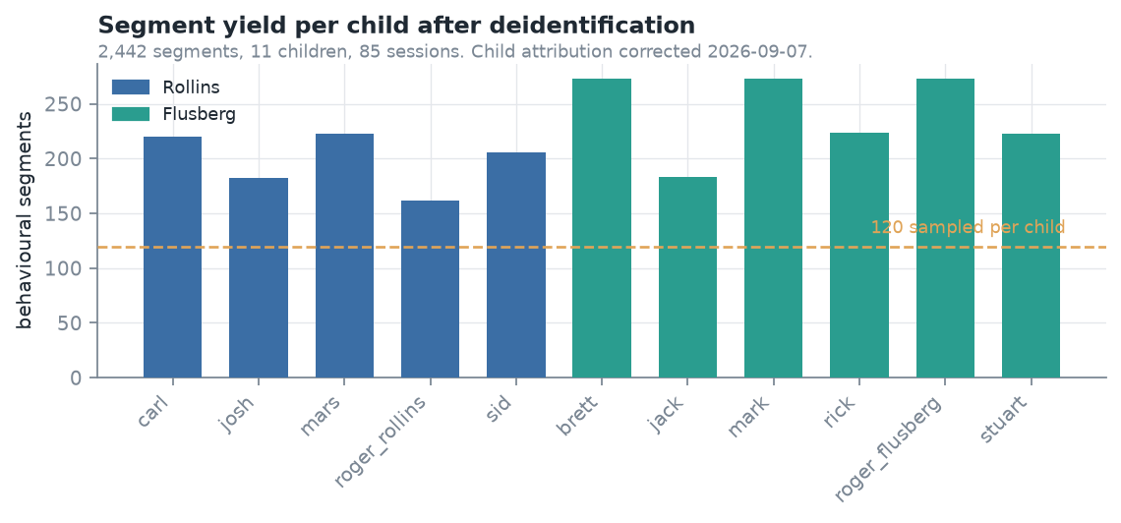
Figure 1. Corpus composition: behavioural segments per child, by source corpus.
These transcripts are a proxy for the application's intended input, not a sample of it. The application ingests observations written by parents, teachers, support staff and intervention professionals through its own interface; what is evaluated here is archival research recordings of child-investigator and child-parent interaction, transcribed in CHAT format and segmented into behavioural episodes. The two differ in at least three respects that could each affect extraction: authorship, since a transcript records what was said rather than what an observer chose to report; register, since a contributor writes retrospective prose about a child while a transcript is verbatim dialogue; and provenance, since a contributor writes with a goal in mind and a transcript has no such framing. The corpora were chosen because they are autism interaction data with permissive research access and enough structure to annotate consistently, which is what a reference standard requires, and because no corpus of real intervention observations is publicly available.
Every extraction result reported below is therefore a component evaluation on proxy data. Nothing here establishes that extraction works on intervention notes as written by contributors, and no such claim is made; transfer to the application's input distribution is assumed, and measuring it requires observations the study does not have.
The annotation batch was built in three stages, of which only candidate generation calls models: a stratified pool of 120 segments per child; three local generators extracting from every pooled segment; and retention only of segments where all three produced an admissible response. Two admission predicates are distinguished — the MARS runtime gate (SUCCESS or PARTIAL) and the wider 'judgeable' policy the batch was built under — because admitting only the former would retain the segments each model found easy.
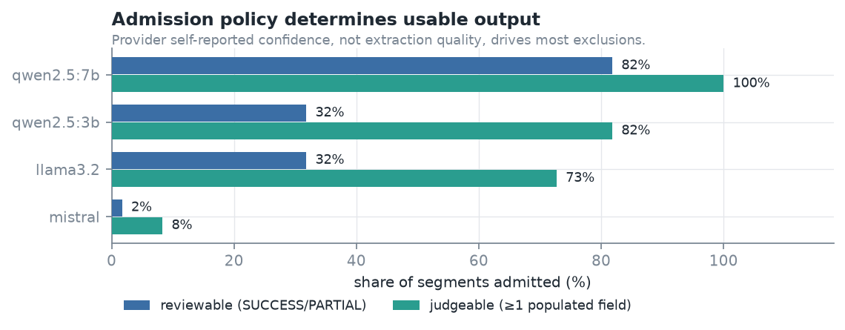
Figure 2. Admission policy: the two predicates and what each retains.
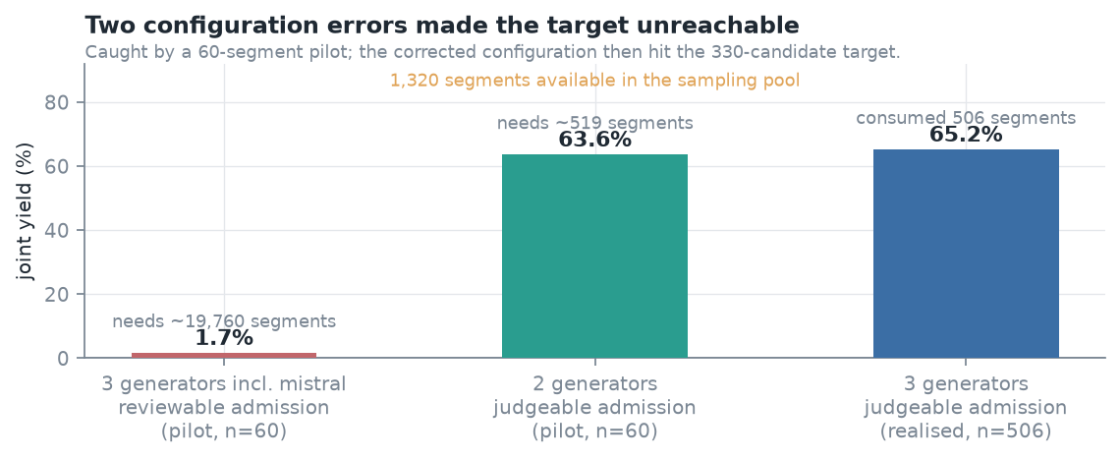
Figure 3. Joint yield under a require-all policy. A 60-segment pilot projected 519 segments would be consumed to reach 330; the realised run consumed 506.
The batch is frozen at this point and is not regenerated. Generator outputs are replayed from it wherever they are needed downstream, so the reranking evaluation selected from exactly the candidates the annotators saw. Reranking is an offline evaluation method applied to these recorded outputs, not a stage in the application's request path.
Stage 3 conditions membership on model behaviour, and this is the principal threat to external validity in the study. Requiring all three generators to have produced an admissible response is what gives every batch item a complete candidate set, without which the three-way comparison and the oracle ceiling are not defined. The cost is that accuracy measured on the batch is accuracy on segments every model could at least attempt. Whether it generalises to an unselected sample is not answered by this batch and is addressed below.

Model-independent held-out set
To separate extraction performance from the batch's selection criterion, a second set was drawn without reference to any model's behaviour: 132 segments, 12 per child across all 11 children, stratified and frozen before any generator was run over it.
The exclusion rule is deliberately stricter than removing the 330 annotated segments. The entire original stratified pool of 1,320 is excluded, because batch construction consumed 506 pool segments to retain 330 and no record survives of which 176 were rejected. Sampling the pool remainder would therefore have enriched the set with segments a generator had already failed on — conditioning in the opposite direction, and harder to argue away than the original. The held-out set is drawn from the same balanced selection with a higher cap of 455 per child, which yields 3,371 segments; excluding the entire 1,320-segment pool leaves 2,051 eligible segments. Of the 132 held-out segments, 81 fall inside the 2,442-segment selection and 51 outside it.
Two rules govern its use. Generators are run only after the annotation is complete, because a set inspected for model performance before it is annotated is not held out. And a model that produces no admissible response is recorded as an abstention, with the segment retained — dropping it would reintroduce exactly the conditioning the set exists to avoid.
The same round supplies a second quantity. Both annotators work from the final codebook from the first segment rather than reaching it after a round of disagreement, so the agreement obtained is a first-pass kappa under the final protocol rather than a within-annotator repeat. That is the comparison the two-round result cannot supply about itself, and it tests whether the codebook generalises beyond the disagreements it was written from.
State of the held-out round at the time of writing: annotation complete for both annotators; generator runs complete for 4 of 4 generators; reference standard adjudicated. Reliability, accuracy and unsupported-assertion rates over it are all reported below.
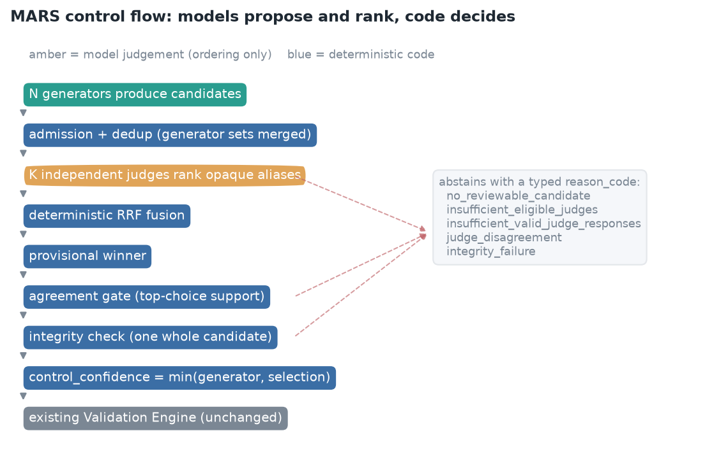
Figure 4. MARS control flow: models propose and rank, deterministic code decides, and each abstention carries a typed reason code. This is the offline evaluation pipeline, not the application's request path.

Reliability statistics
Cohen's kappa is computed per field over the value categories, with explicit nulls treated as a category rather than as missing data:
kappa = (p_o - p_e) / (1 - p_e)
Kappa is not pooled across fields by concatenating labels. The fields draw on different category sets and share literal labels — 'verbal' and 'gestural' occur in both the modality and prompt-level vocabularies — so a pooled confusion matrix would chance-correct against a distribution no annotator drew from. Pooling the four fields in this study gives 0.694 against a mean per-field kappa of 0.610, an inflation of 0.084 that is an artefact of the pooled category count.
Kappa is bounded above by the annotators' marginal distributions. Where one annotator uses a category the other never uses, those items cannot agree at any level of care:
p_o_max = sum_i min(p_i., p_.i)
kappa_max = (p_o_max - p_e) / (1 - p_e)
forced disagreements = n (1 - p_o_max)
Segments are nested within children: the 330 segments come from 11 children, 30 each, across multiple sessions. Two segments from one child share that child's language, the partner's style and the session's activity, and are not independent draws. Intervals are therefore obtained by resampling children with replacement, each drawn child contributing all of its segments. With 11 clusters this is a small number to resample and the intervals are correspondingly wide; that width is information about the design rather than a defect of the estimator. Segment-level intervals are retained throughout as a sensitivity analysis and are reported alongside. Every conclusion in this paper holds under both.
Reporting kappa alongside kappa_max separates a definitional problem — a low kappa close to its ceiling — from a judgement problem, a low kappa far below it. Intervals are 10,000-replicate percentile bootstraps resampling segments; the Fleiss-Cohen-Everitt large-sample variance is computed alongside as a cross-check and agreed to within 0.005 on every bound of every field.

Annotators
[TO COMPLETE BEFORE SUBMISSION] The reference standard rests on two autism intervention specialists, and a reviewer cannot judge its credibility without knowing who they are. This section must state, for each annotator: professional role and qualification; years of relevant experience; prior experience with structured behavioural coding; what preparation they received for this task and from whom; and any relationship to the study or its authors that bears on independence.
What the artefacts already establish, and what this section must therefore not contradict: both annotators independently annotated all 330 segments of the main batch and all 132 segments of the held-out set — neither worked from a subset — and surviving conflicts were adjudicated by the two of them jointly, with decisions splitting 89/90 between their respective values. The same pair helped identify the three underspecified definitions and then annotated under the codebook that resolved them, which is recorded as a limitation rather than presented as independence.

Two-round protocol and the control field
Three field definitions were identified as underspecified: whether gestural modality covers physical manipulation or only communicative gesture; whether correct/incorrect apply absent an identifiable target; and whether an adult utterance preceding a child response is a prompt or the antecedent that creates the opportunity. These were resolved in a written codebook and the affected segments re-issued blind, in a fresh order, with all five fields re-annotated.
The comparison was specified before round 2 existed. Domain is re-annotated alongside every other field but no codebook rule touches it, so it carries the same practice and regression effects and none of the instruction. It is the control.
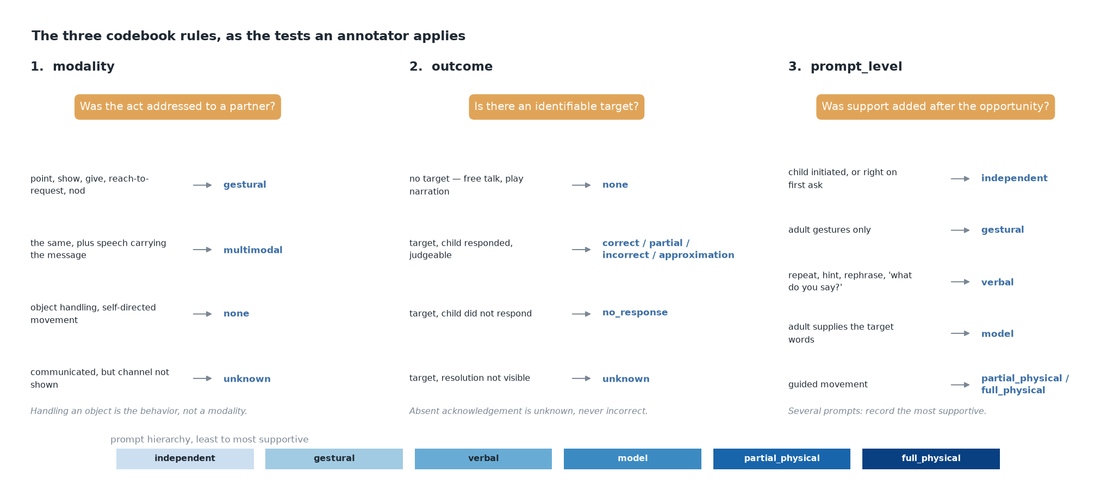
Figure 5. The three codebook rules, as the decision tests an annotator applies.
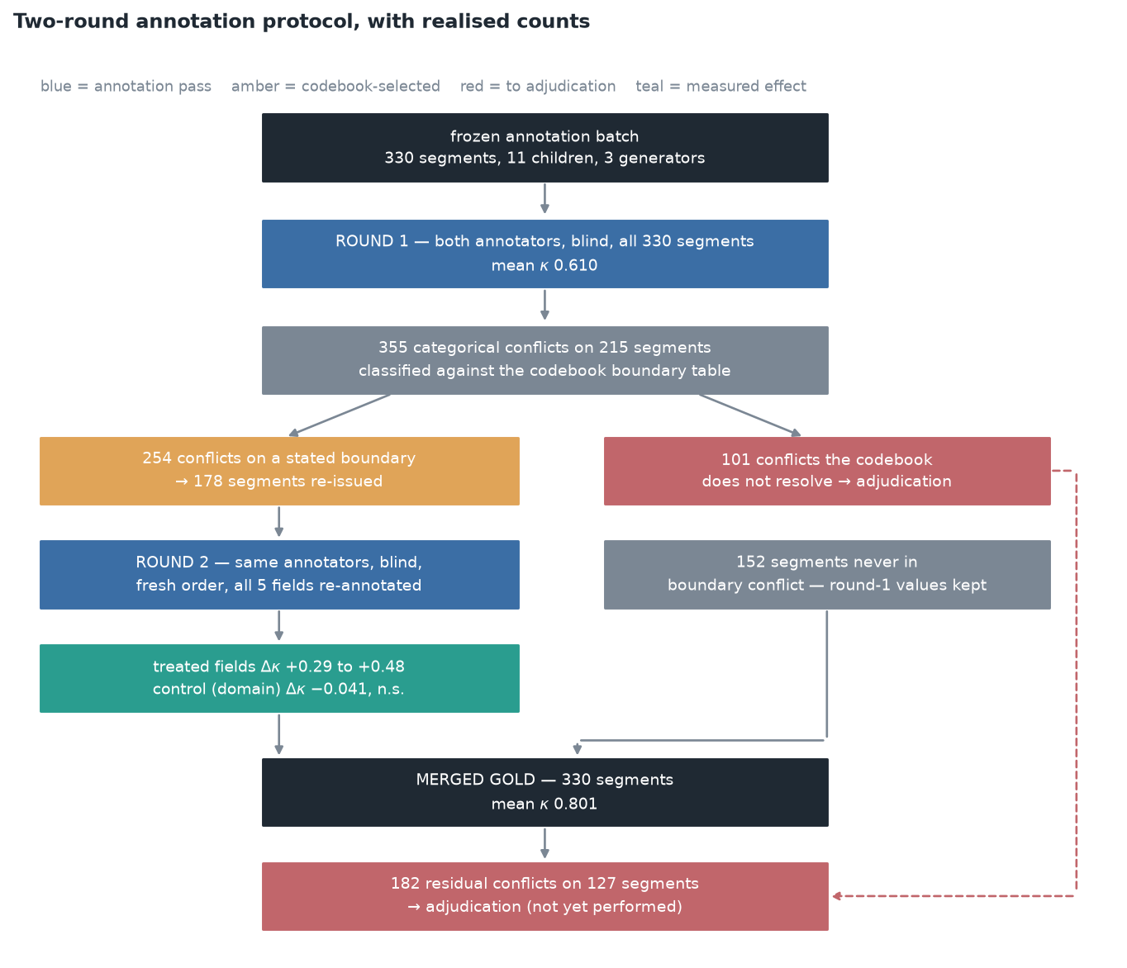
Figure 6. Two-round annotation protocol with realised counts; every segment is accounted for where it leaves.

Ethical considerations
All source data is archival, publicly deposited, and was collected by third parties: the ASDBank English Rollins Corpus (doi:10.21415/T5KK53) and the ASDBank English Flusberg Corpus (doi:10.21415/T5459F), both components of ASDBank within TalkBank. No child data was collected for this work, no children or families were recruited or contacted, and no clinical care was delivered, influenced or withheld on the basis of any system output. The system was not deployed in any care setting and no interventionist used it during the work reported here.
One category of human-generated data does arise. Two autism intervention specialists produced the annotations, and their agreement with one another — including how it changed between rounds — is analysed and reported. Their labels are research data about a coding scheme rather than about the annotators, and no individual annotator is identified or characterised by performance; the round-1 to round-2 comparison is nonetheless a measurement taken on people doing a task, and whether that makes them research participants, expert consultants or neither is a determination for the reviewing institution rather than for the authors. It is put to the Board explicitly rather than assumed.
Transcripts pass through a de-identification stage before any model sees them, replacing participant names, street addresses, numeric dates, national identifiers and telephone numbers with bracketed placeholders across utterance text and every dependent tier. The stage is roster- and header-driven rather than named-entity recognition, and it over-redacts: each of the ten child pseudonyms is also an ordinary English word, so 82 [NAME] placeholders appear across 62 of the 330 annotated segments and some are redacted common words. Child identifiers throughout are the pseudonymous labels carried by the public corpora.
[TO COMPLETE BEFORE SUBMISSION] A determination request has been submitted to the Institutional Review Board at the University of Texas at Austin; the determination had not been returned at the time of writing. The expected form is an exemption or a non-human-subjects research determination on the grounds that the work analyses existing, publicly available, de-identified records. This section must state the determination as issued, with institution, determination wording, and protocol number, before submission, and the determination must address all three categories separately: the archival child corpora, the specialist annotation and adjudication, and any human involvement in testing the application. The licence terms of both corpora and the scope of depositor consent for secondary computational analysis must also be confirmed and stated.

Results

Annotation reliability
Table 1. Round-1 reliability and the ceiling the marginals allow (n = 330 segments from 11 children). The reported interval resamples children; the segment-level interval is the sensitivity analysis.
Field | kappa | 95% CI (children) | 95% CI (segments) | kappa_max | kappa / kappa_max
domain | 0.751 | [0.704, 0.790] | [0.697, 0.803] | 0.921 | 0.816
modality | 0.570 | [0.434, 0.696] | [0.517, 0.624] | 0.622 | 0.916
prompt_level | 0.595 | [0.519, 0.675] | [0.516, 0.667] | 0.839 | 0.709
outcome | 0.524 | [0.467, 0.577] | [0.458, 0.589] | 0.758 | 0.691

Modality has both the lowest ceiling (0.622) and the highest ratio to it (0.916): the annotators reached 92% of the agreement their own category usage permitted. One annotator recorded 'none' 75 times; the other recorded it zero times. 80 of the 91 observed disagreements on that field were forced by the marginals before a transcript was read.
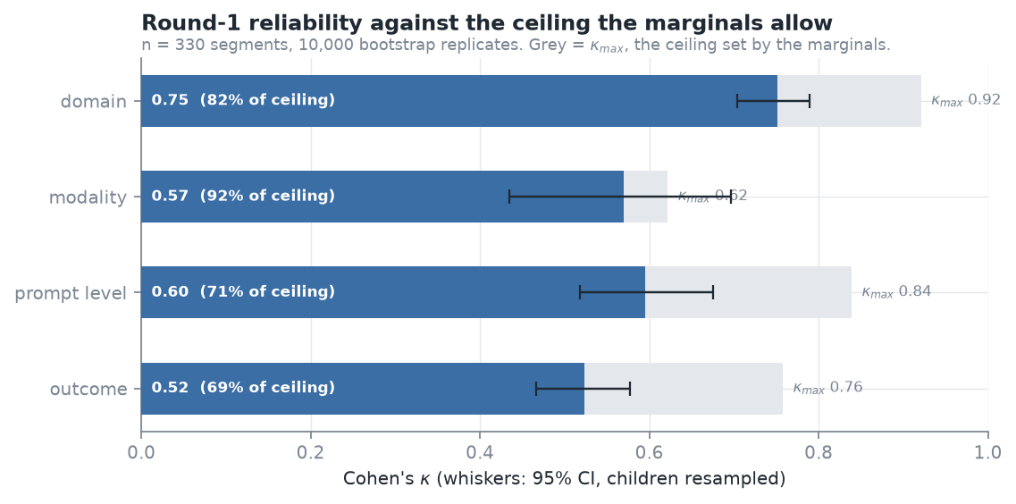
Figure 7. Round-1 kappa against the ceiling set by the annotators' marginal distributions.
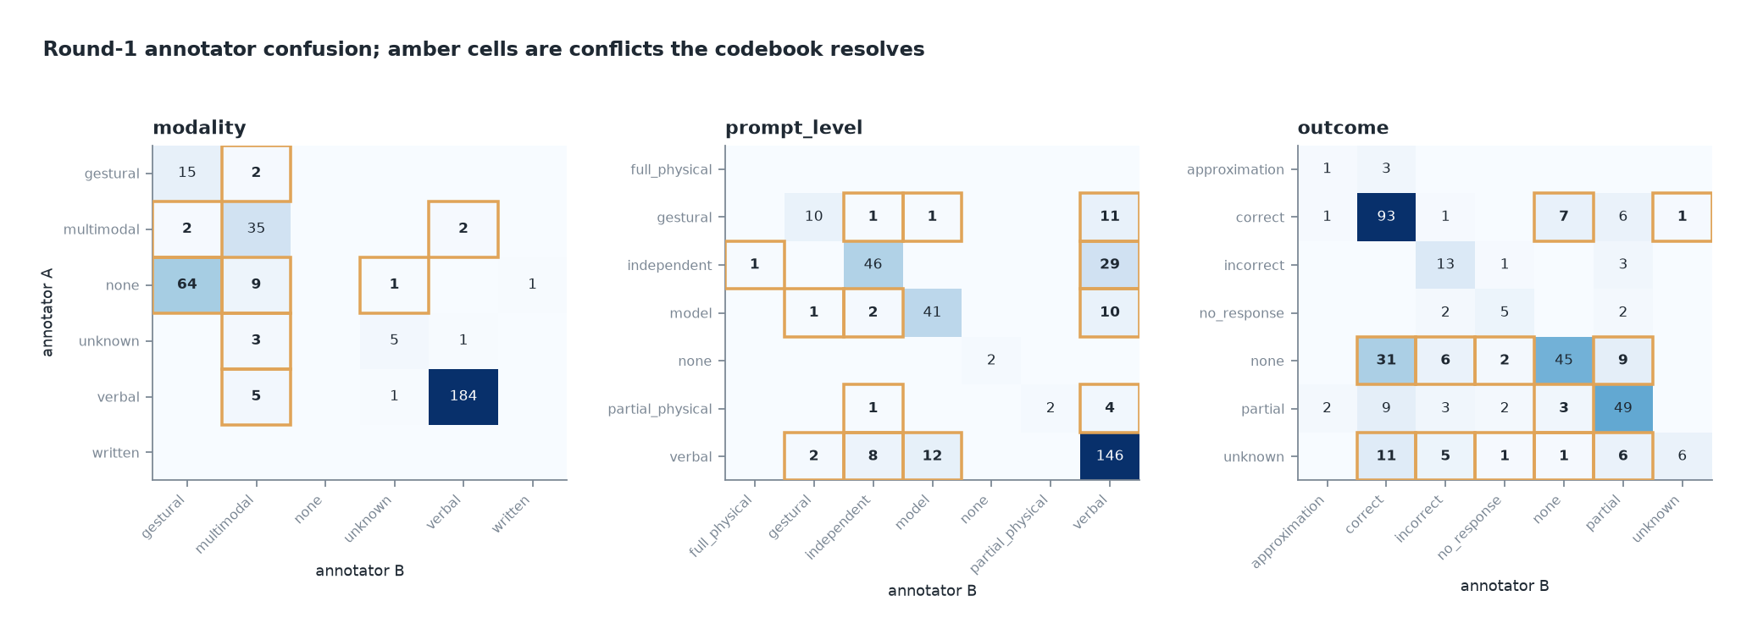
Figure 8. Annotator confusion; amber cells mark conflicts the codebook resolves. The empty 'none' column in modality is the marginal mismatch.
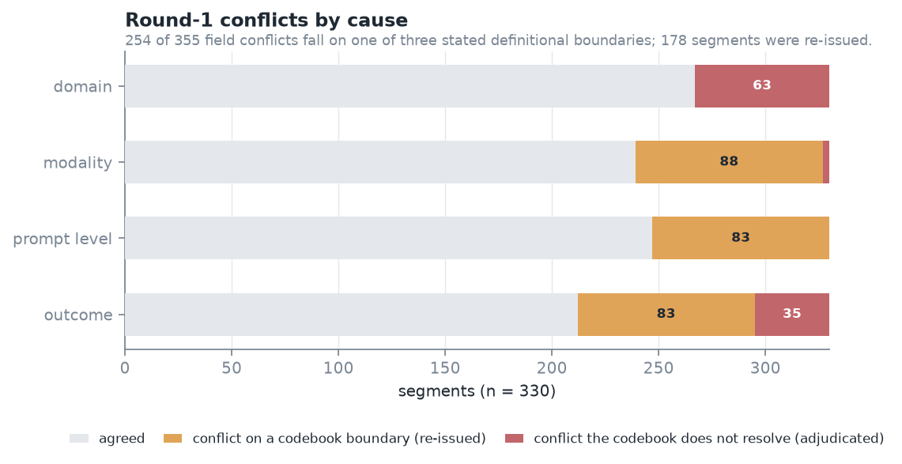
Figure 9. Round-1 conflicts by cause. 254 of 355 fall on one of three stated definitional boundaries.
Table 2. Change in kappa over the re-issued segments, treated fields against the untreated control. Asterisk marks an interval excluding zero; both resampling units agree on every field.
Field | Arm | Round 1 | Round 2 | Change | 95% CI (children) | 95% CI (segments)
domain | control | 0.732 | 0.691 | -0.041 | [-0.142, +0.068] | [-0.141, +0.052]
modality | treated | 0.385 | 0.866 | +0.481 | [+0.337, +0.583] * | [+0.397, +0.565] *
prompt_level | treated | 0.281 | 0.574 | +0.293 | [+0.191, +0.435] * | [+0.137, +0.447] *
outcome | treated | 0.284 | 0.628 | +0.344 | [+0.160, +0.562] * | [+0.217, +0.464] *

All three treated fields improved with intervals excluding zero; the untreated control field did not. The substantially larger changes in the treated fields, together with the absence of improvement in the control, are consistent with an effect of the clarified definitions rather than a general re-annotation effect. The control is not identical to the treated fields in difficulty or category distribution, so it bounds rather than eliminates that alternative explanation. The proposed mechanism is visible in the ceilings: kappa_max on modality moved from 0.622 to 0.948 as the annotators' category vocabularies aligned, which is what a definition should do and what the round-1 diagnosis predicted.
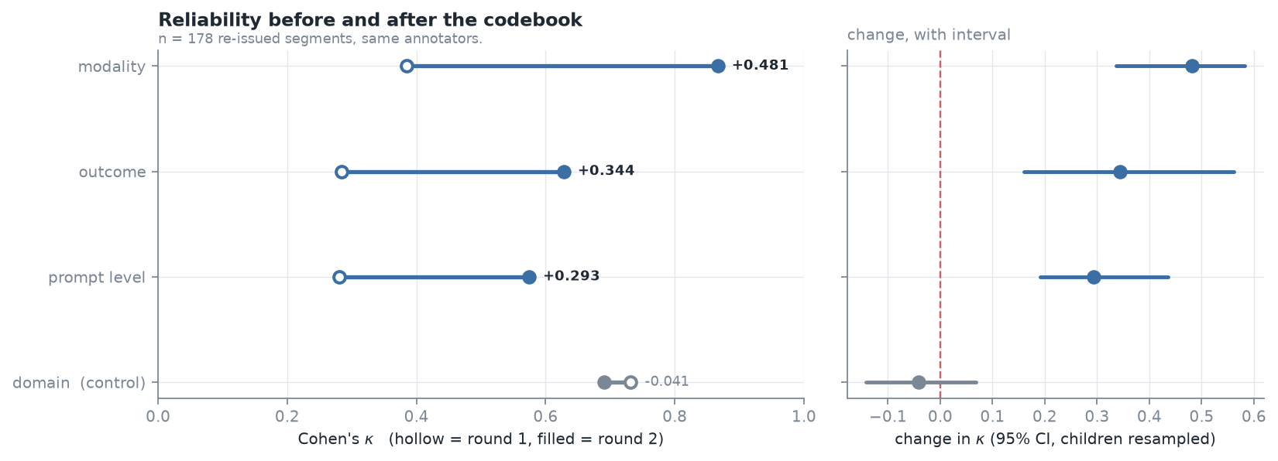
Figure 10. Reliability before and after the codebook, with the paired interval on each change. The control field is shown in grey.

Held-out round: first-pass reliability
The 132 held-out segments were annotated by the same two annotators working from the final codebook from the first segment, rather than reaching it after a round of disagreement. Both returned complete sheets with no empty cells and no cell errors.
Table 3. Agreement across the three annotation rounds. The held-out round is a first pass under the final protocol on segments never selected for model tractability.
Round | Protocol | n | Mean kappa | domain (untreated)
Round 1 | no codebook | 330 | 0.610 | 0.751
Merged | after codebook re-annotation | 330 | 0.801 | 0.718
Held-out | codebook from the first segment | 132 | 0.910 | 0.879

Table 4. Held-out reliability by field (n = 132 segments from 11 children).
Field | kappa | 95% CI (children) | kappa_max | kappa / kappa_max
domain | 0.879 | [0.806, 0.936] | 0.960 | 0.916
modality | 0.929 | [0.822, 1.000] | 0.986 | 0.943
prompt_level | 0.916 | [0.820, 1.000] | 0.983 | 0.932
outcome | 0.914 | [0.877, 0.950] | 0.943 | 0.970

Mean kappa on the held-out round is 0.910, against 0.610 before the codebook and 0.801 after re-annotation. Every field reaches at least 0.879, and each sits above 0.91 of the ceiling its marginals allow — the vocabulary mismatch that dominated round 1 is absent.
This round has no internal control, and the figure should not be read as a codebook effect alone. The untreated control field also improved, from 0.751 in round 1 to 0.879 here, despite no codebook rule addressing it. By the time these segments were annotated the two annotators had worked through 508 segments and two rounds of adjudication, and the held-out segments were not filtered for generator tractability, so they may differ in difficulty. Accumulated annotator experience, segment composition, and the codebook are confounded here, and this design cannot separate them.
The causal evidence for the codebook remains the round-2 comparison, where the treated and untreated fields were annotated in the same sitting by the same annotators and only the treated fields moved. What the held-out round establishes is narrower and still useful: the final protocol is workable from a cold start, it yields first-pass agreement well above the level the original instructions produced, and it supplies a reference standard for segments whose membership was never conditioned on model behaviour.

How much the evaluation set was conditioned on model behaviour
The held-out set makes the size of the selection effect measurable directly, without any gold standard: the same generators can be run on both sets and their admission rates compared. The main batch retained only segments where all three produced an admissible response; the held-out set retained everything.
Table 5. Generator admission on the model-conditioned batch against the unbiased held-out sample.
Generator | Admitted, batch | Admitted, held-out | Change
llama3.2:latest | 40.3% | 31.8% | -8.5
qwen2.5:3b | 30.6% | 16.7% | -13.9
qwen2.5:7b | 78.8% | 78.0% | -0.8
qwen3:14b | 98.5% | 98.5% | +0.0
All 4 jointly admissible | 41/330 (12.4%) | 3/132 (2.3%) | -10.2

All 4 generators are jointly admissible on 12.4% of the batch and 2.3% of the held-out sample — roughly a fivefold difference, and a direct measure of how much easier the evaluated segments were. The effect is concentrated in the weaker models, which lose 8 to 14 points, while the two larger ones are essentially unchanged.
That stability is not the reassurance it appears to be. Admission measures whether a model returned something, not whether what it returned was supported, so a model that rarely declines is insensitive to segment difficulty by construction. The largest generator admits 98.5% of both sets — identical to the first decimal — and is the same model that asserts values on 97% of the occasions where the gold standard records that the transcript supports none. Robustness on this measure and willingness to answer are not separable, and the apparently more robust model is the less safe one.
This does not invalidate the batch results, which are correctly described as accuracy on segments every model could attempt. It does bound how far they generalise, and it is the reason the held-out sample exists.

Accuracy on the held-out set
The held-out reference standard is now adjudicated, so the selection effect can be stated as a difference in accuracy rather than in admission. Both sides are scored against their own model-independent adjudicated gold, over the same 4 categorical fields under the same matching rule; the only difference between them is how the segments were chosen.
Table 6. Merged mean field accuracy — the mean over the four categorical fields — on the model-conditioned batch (n = 330) against the model-independent held-out set (n = 132).
Generator | Batch | Held-out | Change (pts)
llama3.2:latest | 30.8% | 26.5% | -4.3
qwen2.5:3b | 20.4% | 12.5% | -8.0
qwen2.5:7b | 43.1% | 38.8% | -4.3
qwen3:14b | 42.0% | 40.2% | -1.9

Every generator is less accurate on segments that were not selected for model tractability. The direction is the same for all 4, which is what a selection effect predicts and what a chance difference does not; the magnitude ranges from 1.9 to 8.0 points and is largest for the weakest generator (qwen2.5:3b). The batch figures are therefore optimistic estimates, and the held-out figures are the ones that describe performance on segments drawn without reference to any model.
Table 7. Unsupported assertion on both sets: values asserted where the gold standard records that the transcript supports none.
Generator | Batch | Held-out | Change (pts)
llama3.2:latest | 83.2% | 84.1% | +0.9
qwen2.5:3b | 31.0% | 28.6% | -2.4
qwen2.5:7b | 56.9% | 50.8% | -6.1
qwen3:14b | 97.0% | 92.1% | -4.9

The unsupported-assertion finding survives the move to an unbiased sample. Rates are of the same order on both sets and the ordering across generators is unchanged: qwen3:14b, the largest and most recent model in the roster, again asserts an unsupported value on the highest proportion of occasions — 92.1% of the opportunities the held-out gold standard provides. Accuracy degrades when the segments stop being easy; the propensity to assert what the text does not support does not improve.
Whole-record correctness on the held-out set is 4.5% for the best generator against an oracle ceiling of 6.1%, leaving 1.5 points to any selector. The corresponding four-generator batch figures are 4.5%, 8.8% and 4.2 points. The held-out ceiling is the lower of the two: the segments on which the generators disagree productively are themselves partly a product of how the batch was selected.
Both reference standards were adjudicated by the same two annotators, so this comparison isolates the effect of segment selection and not of who settled the conflicts.

Gold standard
Substantive disagreement affected 127 of 330 segments, not 322. The larger figure is the number of segments adjudication touched, and the two must not be read as the same quantity. Of the 503 fields adjudicated, 321 were free-text behavior descriptions, which differ by exact string match on almost every segment even where the two annotators describe the same event in different words; resolving those is a choice between two adequate wordings rather than a substantive judgement. Categorical disagreement — the quantity that bears on reliability — affected 182 fields across 127 segments. Because a segment undecided on any field is excluded from the gold standard entirely, the wording rows still had to be settled, which is why only 8 segments required no adjudication at all.
Table 8. Adjudication load, by the kind of conflict.
Quantity | n
Categorical field conflicts (domain, modality, prompt_level, outcome) | 182
Segments with at least one categorical conflict | 127
Free-text behavior conflicts (exact match) | 321
Total fields adjudicated | 503
Segments requiring any adjudication | 322
Segments requiring none (agreed on every field) | 8

Table 9. Composition of the adjudicated gold standard.
Property | Value
Segments in gold | 330 of 330
Excluded (unresolved) | 0
Adjudicator | consensus:annotator_a+annotator_b (both annotators, jointly, working from docs/annotation_codebook.md)
Null values in gold | domain 3, modality 77, prompt_level 2, outcome 115

Generator behaviour
Self-reported provider status is not a usable guide to whether a model produced anything. Across 496 abstentions from the three generators, 494 (99.6%) still carried at least one populated field. One generator self-reported 'abstained' on 197 of 330 segments while populating domain on 97.0% of them; another reported mean confidence 0.86 alongside the sparsest output in the roster.
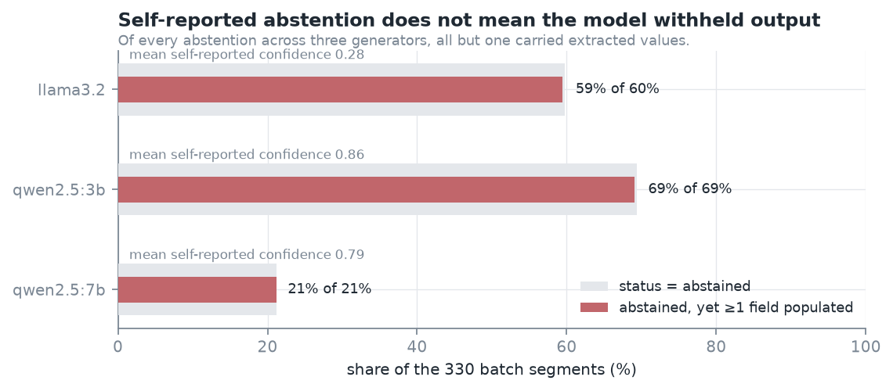
Figure 11. Self-reported status against actual field population.
The generators diverge almost everywhere. Unanimity across all three is rare: 4.5% of segments on domain, 15.2% on modality, 12.1% on outcome, 6.1% on prompt_level. Divergence of this magnitude is what makes selection a live question rather than a formality.
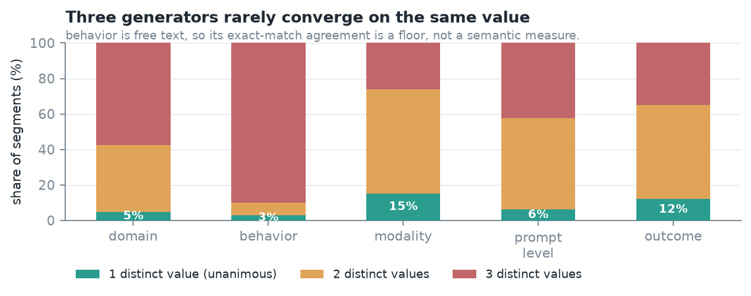
Figure 12. Candidate divergence across the three generators.
Taking the union across generators raises field population above the best single generator by 16.1 points on outcome and 8.5 on prompt_level. These are populated fields, not correct ones; whether the additional values are supported by the transcript is what the annotation measures.
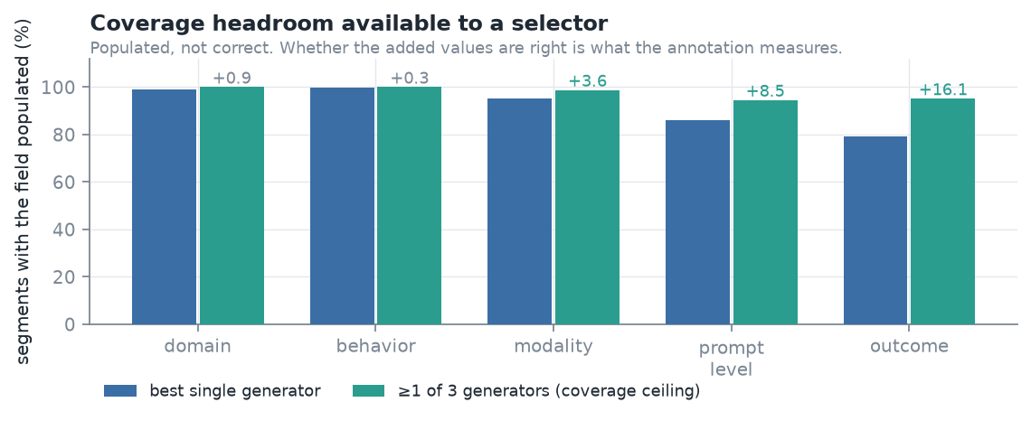
Figure 13. Coverage headroom available to an oracle selector, in populated fields rather than correct ones.
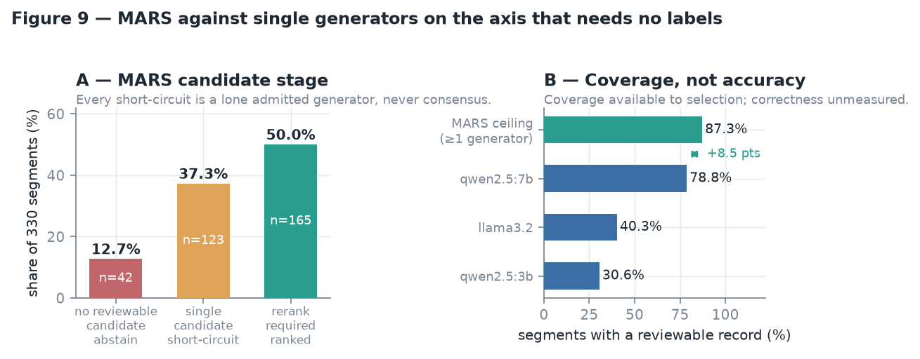
Figure 14. MARS candidate-stage branch distribution: 12.7% abstain before any judge is consulted, 37.3% short-circuit, 50.0% present a genuine ranking decision.

Agreement with the reference standard
Results in this section are reported as agreement with the adjudicated reference standard rather than as accuracy. The distinction is not cosmetic. A generator is being compared to a value two annotators settled between them on a task where, on first pass and before any codebook existed, those two annotators independently chose the same value on 64% to 81% of segments depending on the field. Calling the resulting percentage accuracy implies a fixed correct answer that the task does not supply; agreement names what was measured.
Two quantities are reported separately wherever the split is informative, because they are different abilities that fail for different reasons. Agreement where the standard records a value is how often a generator chose the value the annotators settled on. Agreement where the standard records none is how often it correctly recorded nothing on a segment the annotators judged to support no value. Merging them into one figure conceals the result that on modality the generators reach the level the annotators themselves reached, and conceals that the same generators assert values freely where the transcript supports none. No merged per-field figure is reported for a generator, because on that question it hides more than it states. Where one number per generator is unavoidable — the held-out comparison, which needs a single scale on which the two sets can be compared — the mean over the four fields is used and is labelled as merged.
The extraction provider is asked for eight fields. Five were scored against the adjudicated gold standard — behavior and the four categorical fields — and three were not: goal_context, prompt_context and duration_seconds have no reference standard in this study, so nothing below constrains how often a model invents them. The extractor as a whole is therefore not evaluated, and the figures that follow describe five of its eight outputs.
The three unevaluated fields are confined accordingly. None enters a KPI, none enters an adequacy check, and none is rendered by the deterministic reporter; they are present in the evidence packet, where the experimental generative reporting path could quote them, which is a further reason that path is not operational. Like every extracted field they also reach longitudinal analytics only inside a record an interventionist has verified or corrected. These boundaries are enforced in code and covered by tests rather than asserted here.
Table 10. Agreement where the reference standard records a value (n = 330 segments; free-text behavior excluded). The final row is how often the two annotators independently chose the same value on first pass, before the codebook — a reference level for the task, not a like-for-like comparison, since the annotators were compared with each other and the generators with the settled value.
Generator | domain | modality | prompt_level | outcome
llama3.2:latest | 18.0% | 63.6% | 28.3% | 28.4%
qwen2.5:3b | 8.0% | 22.9% | 3.7% | 17.7%
qwen2.5:7b | 42.5% | 70.4% | 28.1% | 34.9%
Two annotators, first pass | 80.9% | 72.4% | 74.9% | 64.2%

Table 11. Agreement where the reference standard records no value — how often a generator correctly recorded nothing. Only fields with enough such segments to rate are shown; domain and prompt_level have 3 and 2 respectively.
Generator | modality (n=77) | outcome (n=115)
llama3.2:latest | 6.5% | 24.3%
qwen2.5:3b | 80.5% | 60.0%
qwen2.5:7b | 59.7% | 32.2%

The split is the finding. On modality, where the standard records a value, the strongest generator agrees with it on 70.4% of segments against the 72% the two annotators reached with each other — essentially the level of a second human before training. On the same field, where the standard records no value, that generator records nothing on only 59.7% of segments. One figure covering both cases would sit between them and describe neither.
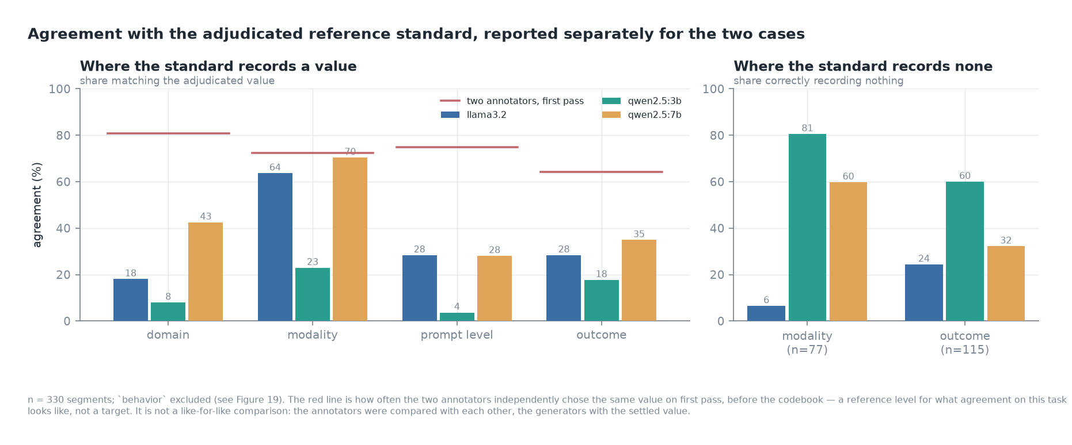
Figure 15. Agreement with the adjudicated reference standard, reported separately for segments where the standard records a value and segments where it records none. The red line is the agreement the two annotators reached with each other on first pass.
Agreement and coverage must be read together. qwen2.5:3b returns nothing on 277 of 330 segments for prompt_level, so its 3.7% there is not comparable to the others as a quality figure.
Table 12. Values asserted where the gold standard records that the transcript supports none. Domain and prompt_level are omitted: gold records only 3 and 2 nulls for them, too few to rate.
Generator | modality (n=77) | outcome (n=115)
llama3.2:latest | 72 (93.5%) | 87 (75.6%)
qwen2.5:3b | 15 (19.5%) | 46 (40.0%)
qwen2.5:7b | 31 (40.3%) | 78 (67.8%)

This is the measurement the explicit null convention was designed to permit, and it bears directly on the requirement that an extraction provider must not generate field values unsupported by source text.
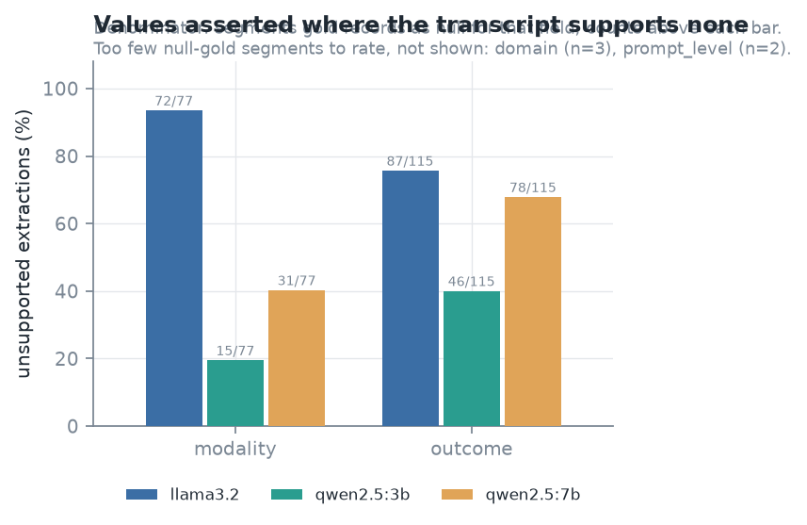
Figure 16. Values asserted where the transcript supports none.
Table 13. Whole-record accuracy (all four categorical fields acceptable) and the ceiling available to selection.
Selector | Accuracy
llama3.2:latest | 1.5%
qwen2.5:3b | 0.3%
qwen2.5:7b | 4.5%
Oracle ceiling (best candidate per segment) | 6.1%
Headroom available to reranking | 1.5%

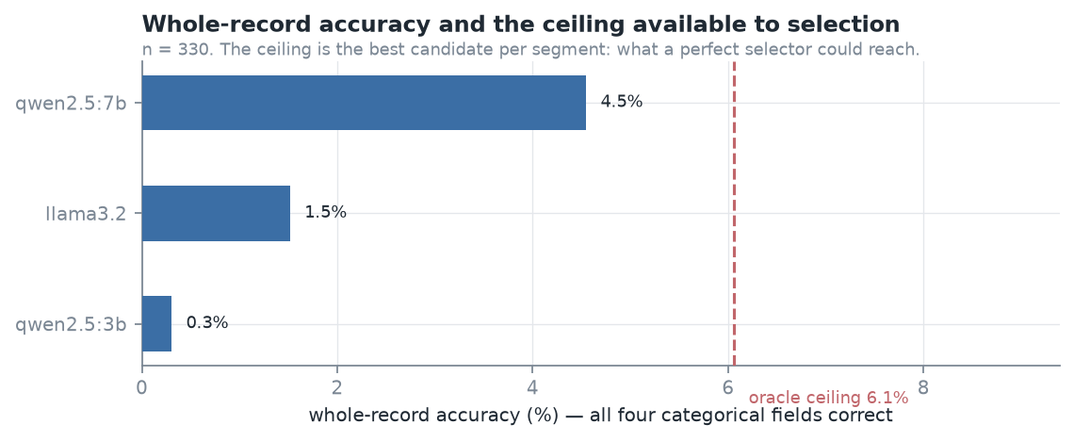
Figure 17. Whole-record accuracy and the oracle ceiling. Headroom for any selector is 1.5 points — five segments of 330.
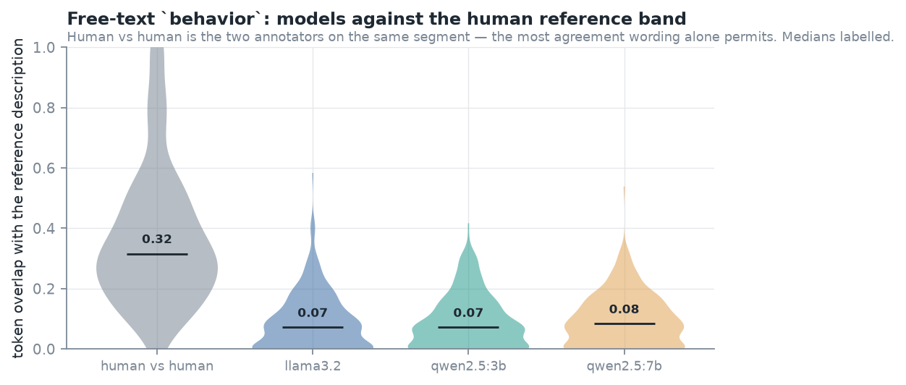
Figure 18. Free-text behavior against the human reference band. The two annotators reach a median overlap of 0.316 on the same segment; models sit near 0.08.

A larger, more recent generator
The three generators above are small local models, which invites the objection that the failures reported are failures of model size rather than of the task. A fourth generator, qwen3:14b, was therefore run over the same 330 segments and scored against the same gold standard. Because gold holds values authored from the transcript rather than judgements of model output, this cost no additional annotation — which is what the model-independent annotation design was for. The fourth generator contributed no candidates to the MARS run or to the three-generator ceiling reported above, and is reported separately for that reason.
Table 14. Four generators against the same adjudicated gold (n = 330). Accuracy and abstention are means across the four categorical fields; unsupported assertion is pooled over the segments gold records as null.
Generator | Mean accuracy | Abstention | Unsupported assertions
llama3.2:latest | 30.8% | 8.2% | 164/197 (83%)
qwen2.5:3b | 20.4% | 48.1% | 61/197 (31%)
qwen2.5:7b | 43.1% | 12.7% | 112/197 (57%)
qwen3:14b | 42.0% | 2.9% | 191/197 (97%)

The larger, more recent model is not more accurate. Its merged mean over the four fields is statistically indistinguishable from the best of the smaller models, and its whole-record accuracy is lower. Split, the picture is sharper rather than better: where the standard records a value it agrees more often than any other generator on three fields of four, and it reaches that by declining almost nothing. It is, however, markedly less safe: on modality it asserts a value on 76 of the 77 segments where the gold standard records that the transcript supports none, and on outcome 111 of 115.
Within the four-model roster evaluated here, lower abstention coincided with higher unsupported assertion: the model abstaining on 48% of fields asserted unsupported values on 31% of opportunities, and the model abstaining on 3% asserted them on 97%. The ordering is consistent across all four, but four models is a descriptive observation rather than evidence of a general relationship, and it is offered as such. The weakest generator in the roster appears safest only because it so often declines. This property would be important in any future clinical or intervention-monitoring pathway, and it is not one that model selection ordinarily optimises for.
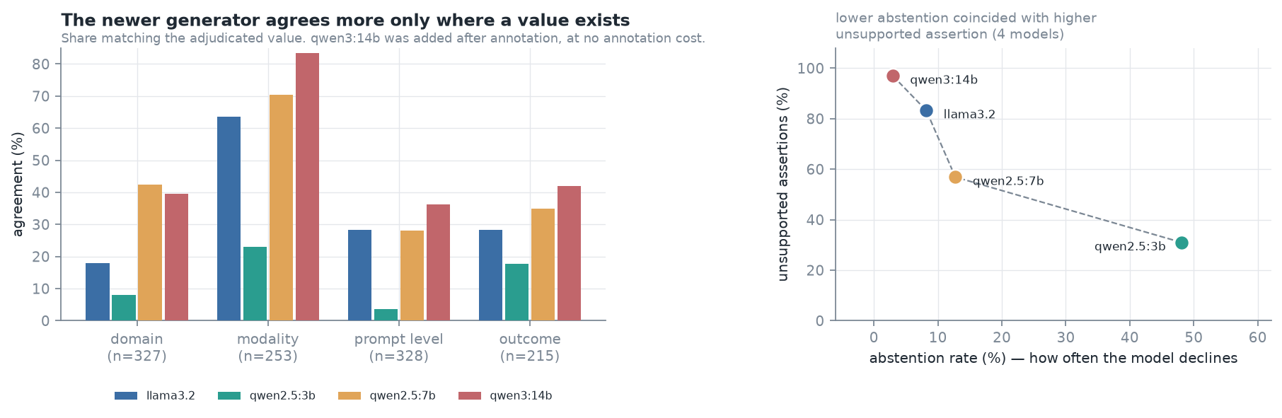
Figure 19. Left: agreement where the reference standard records a value, across four generators. Right: unsupported assertion against abstention rate — the other half of the split, since a generator that never declines asserts a value wherever the standard records none. The four models are consistently ordered; with four points this is a descriptive observation, not an estimated relationship.
Adding the fourth generator raised the oracle ceiling from 6.1% to 8.8%, so the roster did gain genuine diversity, while no single generator improved on the best of the original three.

Multi-judge reranking (MARS)
MARS is an evaluation method, not a deployed component. It runs offline over recorded generator outputs and is not intended for the application's request path; the deployed configuration uses a single extraction provider and the reranking provider is not reachable from the application's provider factory. Its purpose here is to establish what candidate selection could contribute given a set of generators, which is a question about the generators rather than a feature of the system. Every MARS figure reported below therefore describes an offline experiment, and none describes system behaviour in use.
Judges: llama3.2:latest, qwen2.5:3b, qwen2.5:7b, mistral:latest, qwen3:14b. Agreement threshold 0.5, minimum eligible judges 2. Judge eligibility removes any model that generated a candidate for the segment, leaving three eligible judges on 124 rerank segments and two on 41. The maximum per-judge discard rate in the reported run was 1.8%.
An earlier run of this configuration reported 205 successes and looked unremarkable. In it, one judge — a reasoning model whose chain of thought consumed the entire token budget before an answer was emitted — was discarded as unparseable on 165 of 165 rerank segments while still appearing on the panel. The run was discarded and the runner now reports a per-judge discard rate so the failure cannot recur silently.
Table 15. MARS outcomes (n = 330).
Outcome | n | Share
Record returned | 265 | 80.3%
judge disagreement | 21 | 6.4%
no reviewable candidate | 42 | 12.7%
insufficient valid judge responses | 2 | 0.6%

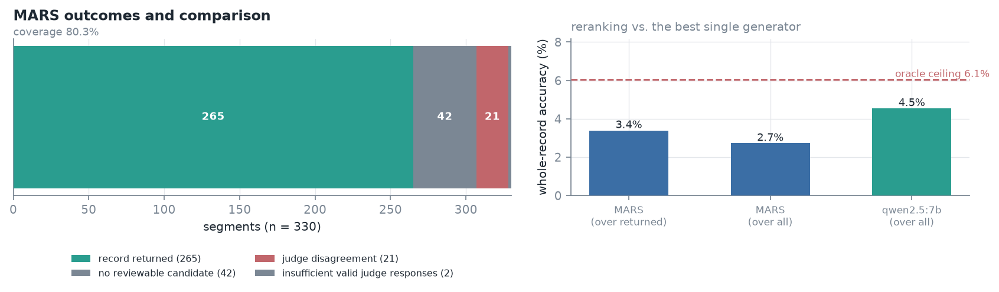
Figure 20. MARS outcome profile and whole-record accuracy against the best single generator.
Whole-record accuracy over every returned record is the wrong instrument for asking whether reranking helps: it includes the 123 single-candidate short-circuits where no selection occurred, and it fires on 4.5% of segments. Selection is therefore measured on the 142 judged segments, field by field.
Table 16. Per-field accuracy of three selection policies (142 judged segments).
Selector | domain | modality | prompt_level | outcome | Mean
Best generator | 45.8% | 77.5% | 35.9% | 30.3% | 47.4%
MARS | 33.1% | 74.7% | 33.8% | 32.4% | 43.5%
Random candidate | 22.3% | 55.6% | 23.5% | 28.5% | 32.5%

Table 17. Paired differences, 10,000 bootstrap replicates over segments. Asterisk marks an interval excluding zero.
Field | MARS − random candidate | MARS − best generator
domain | +7.8 [-0.7, +16.2] | -12.7 [-19.7, -6.3] *
modality | +19.0 [+9.9, +28.2] * | -2.8 [-8.5, +2.8]
prompt_level | +13.5 [+5.6, +21.8] * | -2.1 [-9.2, +4.2]
outcome | +5.7 [-1.4, +12.7] | +2.1 [-2.8, +7.0]

Two findings point in opposite directions. Reranking carried real signal: MARS selected better than a random candidate on every field, significantly so on modality and prompt_level. It did not beat the simplest informed policy: against always using the strongest generator it was 3.9 points worse on average and significantly worse on domain.
MARS selected the strongest generator on 58% of judged segments. On domain that model leads the roster by 32 points, so the 42% of selections that go elsewhere carry an expected cost of roughly 14.7 points against an observed deficit of 12.7. The judges rank candidates, while the accuracy difference lives in which model produced them. This is a property of a roster with a dominant generator, not a general result about reranking.
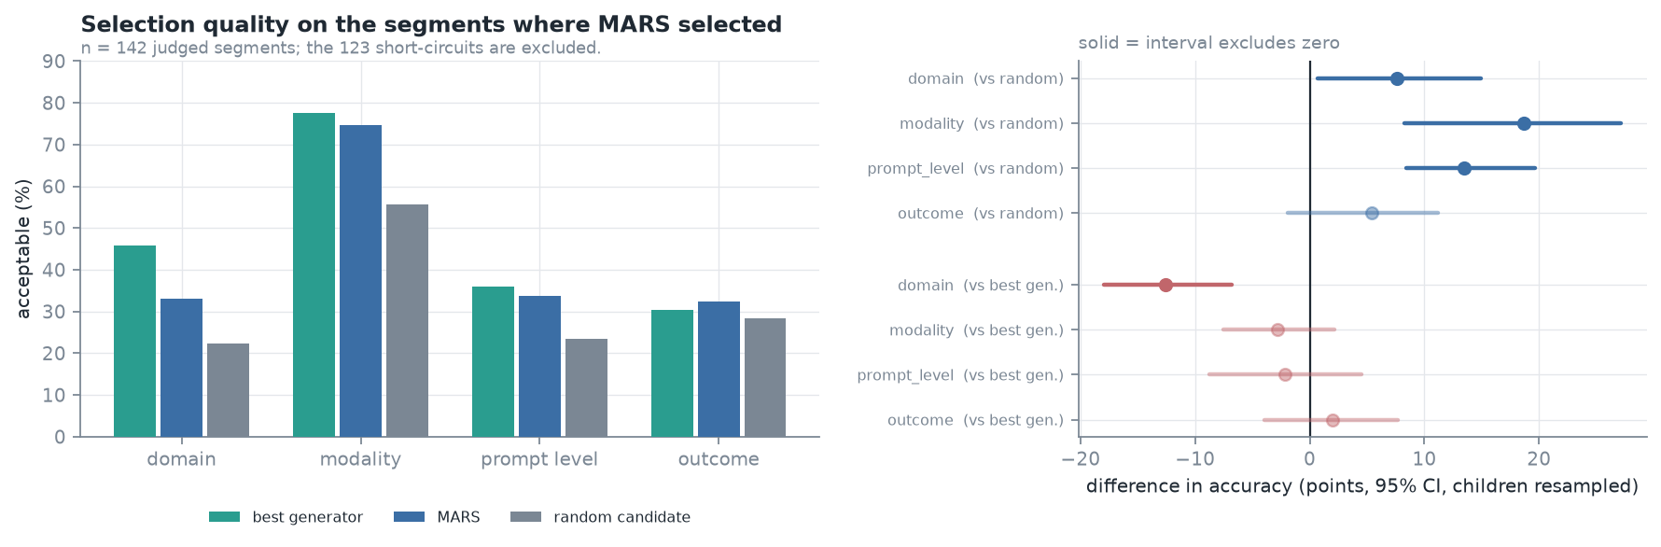
Figure 21. Selection quality on the judged segments, against both baselines, with paired intervals.

Reporting layer
Initial prompt-only generation did not reliably conform to the report schema. Because that behaviour could reflect decoding configuration rather than model capability, generation was repeated using the model server's native schema-constrained decoding. All 11 outputs then conformed structurally, and these constrained outputs form the reporting evaluation reported here.
Schema constraint guarantees the shape of the output, not the truth of the values inside it. Structural conformance and governance conformance are therefore measured separately, under three headings: content safety, evidence grounding, and abstention preservation.
Table 18. Reporting-layer evaluation (11 reports, one per child, qwen2.5:7b). Rates are pooled over assertions and references rather than averaged over reports.
Property | Result
Content safety — reports containing prohibited diagnostic, treatment, causal or prognostic content | 0 of 11
Evidence grounding — numeric assertions absent from the evidence packet | 8 of 122 (6.6%)
Evidence grounding — invalid evidence references | 2 of 836 (0.2%)
Evidence grounding — reports with no ungrounded value | 3 of 11
Abstention preservation — reports passing deterministic governance validation | 0 of 11

Schema-constrained decoding produced structurally conformant reports for all 11 children. Structural conformance did not, however, imply governance conformance. Across the 11 reports the model made 122 numerical assertions, of which 8 were not present in the supplied evidence packet, and produced 2 invalid evidence references out of 836. No report contained prohibited diagnostic, treatment, causal or prognostic content. Nevertheless, none of the 11 passed deterministic governance validation, because analytics intentionally withheld by the adequacy router — cross-setting and cross-contributor comparisons — were not acknowledged as unavailable. The model did not fabricate these analyses; it silently omitted their absence. The distinction matters because a reader cannot tell a deliberately withheld analysis from one that was simply not attempted.
Deterministic governance validation, as used here, checks the evidence and governance contract rather than output structure: prohibited content, acknowledgement of insufficient evidence, and acknowledgement of each withheld metric. A failure is not malformed output.
Because the generative reporting layer fails this contract, it is not the operational reporting path. The application renders progress reports deterministically: the sections are assembled from the evidence packet in code, so every figure in a report is a figure the analytics engine computed, and every indicator the adequacy router withheld is named together with the reason it was withheld — the check the generative layer failed on all 11 reports. The reporting model is available only under an explicit configuration switch, its output is stored and displayed marked as experimental, and the default is not to call it. The negative result above therefore stands as reported rather than being superseded by a remediation: the layer was not modified and re-evaluated, it was removed from the operational path.

Discussion

Principal results
Three findings, in the order the pipeline produces them. First, low inter-annotator agreement on behavioural fields was largely definitional rather than a matter of annotator care: modality's round-1 kappa of 0.570 was 92% of the ceiling the annotators' own category usage permitted, and 254 of 355 categorical conflicts fell on three enumerable definitional boundaries. A written codebook, evaluated under a design with an untreated control field, was followed by improvements of +0.29 to +0.48 on the treated fields and no change in the control.
Second, the extraction models assert clinical field values the source text does not support, at high rates. Where the gold standard records that a transcript supports no modality, one generator asserted one on 93.5% of occasions; on outcome, another did so on 67.8%. This is the measurement the explicit null convention was designed to permit, and it would be more consequential than accuracy in any future clinical or intervention-monitoring pathway, because an unsupported value is indistinguishable in form from a supported one once written. The corpora analysed here are archival research transcripts, not observations collected through such a pathway, so this is an argument about the failure mode rather than a demonstration of clinical impact.
These rates are not an artefact of how the evaluation set was built. The batch retained only segments every generator could attempt, which makes its accuracy figures optimistic, and the model-independent held-out set measures by how much: accuracy falls for every generator on segments selected without reference to any model. The unsupported-assertion rates do not fall with it. They are of the same order on both sets and preserve their ordering across the roster, so the propensity to assert what the source does not support is a property of the models rather than of the segments they were given — which is what makes it the more consequential of the two failures.
Increasing model size within the locally served models evaluated did not resolve this failure. A larger and more recent generator, added after annotation and scored against the same gold, matched the best smaller model on accuracy while asserting unsupported values on 97% of opportunities — the highest rate in the roster. Across the four generators the relationship between abstention and unsupported assertion was consistently ordered, which locates the safety property in a model's willingness to decline rather than in its capability. With four models, all locally served and none at frontier scale, this is a descriptive observation about the roster evaluated rather than a general claim about model size.
The reporting-layer failure was not primarily one of prohibited content generation. The constraint design prevented diagnosis, treatment recommendation, causal inference and prognostic claims in all evaluated reports. The failure concerned instead the preservation of abstention state: when upstream governance withheld an analysis, the reporting model omitted the analysis without communicating that it had been withheld. Safe downstream reporting therefore requires preservation of both available evidence and unavailable evidence states — a model can appear restrained, declining to invent the withheld comparison, while still breaking the governance contract by not reporting that anything was withheld.
Third, multi-model selection contains real signal but cannot rescue weak candidates. Reranking selected better than chance on every field, significantly on two, yet did not beat the simplest informed policy of always using the strongest generator. With an oracle ceiling of 6.1% on whole-record correctness, the total headroom available to any selector on this roster was 1.5 percentage points.

The status of the governance thresholds
The adequacy router decides when to withhold an analysis using numeric rules: a minimum observation count for an adequate state, a field-completeness floor, a temporal-clustering ceiling, minimum counts of distinct settings and contributors, and a goal-coverage floor. These are configurable prototype governance thresholds, not validated clinical cutoffs. They are deterministic, inspectable and stable across runs, which is what makes the system's withholding behaviour auditable; determinism is not evidence that the particular numbers are the right ones. No expert-consensus procedure set them, no sensitivity analysis was run over them, and no outcome was measured against them. They are defaults a deploying site would be expected to revisit, and the claim attached to them is that withholding is governed and reproducible, not that these are the thresholds at which evidence becomes clinically sufficient.

Consequences for the application: a mandatory verification gate
The accuracy results bound what an extracted record may be allowed to do. A deterministic validator establishes that a value is schema-conformant; it cannot establish that the value is a correct reading of the source text, and a wrong value drawn from the correct enumeration is indistinguishable in form from a right one. At 43.1% mean categorical-field accuracy and 4.5% whole-record accuracy for the strongest generator, a record that has passed validation and nothing else is not evidence. Admitting such records to a longitudinal store would let the analytics engine compute a faithful trend over incorrect evidence, and the trend would carry no mark distinguishing it from one computed over reviewed evidence.
The application therefore treats professional verification as a mandatory gate rather than an available action. A structured record carries a review state, and longitudinal analytics reads only the two states that represent a human decision: verified, meaning an interventionist read the record and accepted it as written, and corrected, meaning an interventionist rewrote it. The state set by the pipeline when deterministic validation passes is not among them. A record the adequacy router sent for review because the evidence was inadequate cannot be verified as written at all; it must be corrected or rejected, so that accepting a record cannot silently undo an abstention. Verification changes review state and not content, so it creates no new version, but it records which interventionist accepted the record and when, and the act is written to the audit trail.
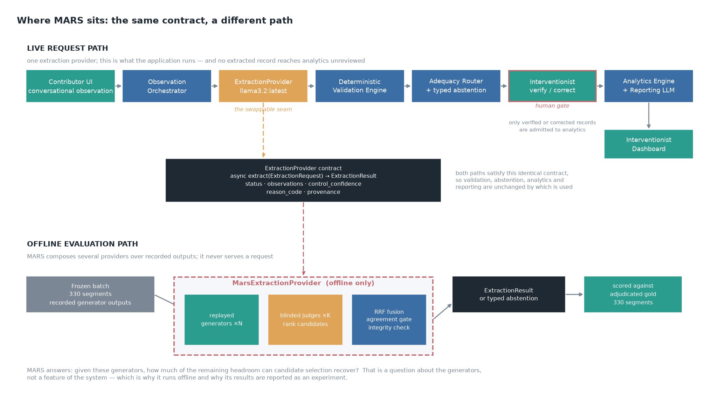
Figure 22. Where extraction sits. The upper band is the application's request path, with the verification gate marked: no extracted record reaches longitudinal analytics without an interventionist accepting or rewriting it. The lower band is the offline evaluation path, which satisfies the same provider contract but serves no request.
This is a design property of the prototype, enforced in the analytics query and covered by tests, not a demonstration that interventionists catch the errors the models make. Whether professionals reviewing machine-drafted records detect wrong-but-plausible values, and at what cost in review time, was not measured here; automation bias in this workflow remains an open question and is the evaluation the gate most needs next.

Comparison with prior work
[TO COMPLETE BEFORE SUBMISSION] This section must situate the three findings against published work and is not yet written. It should cover at minimum: reported inter-annotator agreement for behavioural and communicative coding schemes, and whether kappa is commonly reported alongside its marginal-imposed ceiling; iterative codebook development in content analysis, and whether controlled before/after designs with an untreated field have been used to evaluate a codebook revision; prior measurement of unsupported or fabricated field values in clinical information extraction, and how explicit null annotation compares with the alternatives; and evaluations of multi-model selection or LLM-as-judge reranking in health applications, particularly any that report negative or roster-conditional results.
Fourteen specific claims require citation rather than assertion, enumerated with the kind of source each needs in `docs/paper/prior_work_specification.md`. Eight are established methods the paper must not appear to claim — maximum attainable kappa under fixed marginals, the Fleiss-Cohen-Everitt variance, the interpretive bands, the cluster bootstrap, the exact McNemar test, the agreement-reporting guideline, and both corpora. Six are positioning claims where the section must establish what is new: controlled evaluation of a codebook revision, explicit null annotation as a way to make unsupported assertion measurable, abstention as a hazard rather than a cost, negative results in multi-model selection, governance around generative components, and schema-constrained decoding.

Conclusions
What this paper offers is a way of measuring whether a language model may be trusted with a clinical-monitoring task, and a demonstration of what that measurement returns when applied honestly to a pipeline its authors built. The framework is the contribution; the pipeline is the specimen.
The evaluation exposed failure at three layers. The annotation scheme was unstable in ways that a reported kappa alone would have concealed, and a written codebook measurably repaired it. The extraction models were not adequate for the task, and their most consequential failure was not inaccuracy but the assertion of unsupported clinical fields. Candidate selection did not compensate, and on this roster could not have: the ceiling was 6.1%. The reporting layer produced no prohibited content and still failed its governance contract on every report, by omitting that an analysis had been withheld.
The practical implication for systems of this kind is that abstention and unsupported-assertion rates belong in the primary evaluation rather than in a safety appendix, and that a model-independent gold standard with explicit nulls is what makes them measurable. The generators evaluated here are small local models, and a stronger model may extract more accurately; whether it asserts fewer unsupported values is a separate question that this design is equipped to answer and that we regard as the more important one.

Limitations
- Evaluation-set membership is conditioned on model output, and the effect is large. The batch retained only segments where all three generators produced an admissible response; on the model-independent held-out sample all three are jointly admissible on 2.3% of segments against 12.4% of the batch. Reported batch accuracy, unsupported-assertion rates and the oracle ceiling therefore describe segments the models could attempt. The held-out reference standard has since been adjudicated, and every generator is less accurate on it, so the batch figures are optimistic by a measured margin rather than by an unknown one.
- Two annotators, one pair, one corpus. Cohen's kappa describes this pair, and the codebook rules were written after observing where this pair diverged.
- Agreement is not validity. Two annotators converging on a stated rule is reliability; whether the rule is correct is settled at adjudication and by argument, not by any statistic.
- Adjudication did not fall evenly between the annotators on the held-out round. Of its 133 settled fields, 79 adopted annotator B's value and 54 annotator A's (exact binomial p = 0.037), and on the 17 categorical judgements the codebook does not settle the split was 13 to 4 (p = 0.049). The main batch split 89/90. With 17 decisions the second figure is fragile, but the claim that neither annotator dominated holds for the batch and not for the held-out round.
- Conflicts were adjudicated by the two annotators jointly rather than by an independent third party. Decisions split 89/90 between their respective values, indicating neither dominated, which bounds but does not eliminate the concern.
- Round 2 is a within-annotator repeat under instruction, not an independent replication. What two fresh annotators working under the codebook would achieve was not measured.
- The generative reporting layer is disabled by default rather than repaired. Whether the governance failure is remediable by prompt or decoding changes was not tested, so the negative result bounds the layer as configured and evaluated here and not generative reporting in general.
- Reranking is an offline evaluation method, not a deployed component, and is not intended to become one. It runs over recorded generator outputs to establish what candidate selection could contribute given a roster; the running application uses a single extraction provider. No claim about system behaviour in use follows from the MARS results, and no four-generator reranking run has been performed at all.
- The generator roster is four local models. Adding a larger, more recent one did not improve accuracy, which weakens but does not eliminate the objection that a frontier model might. No frontier model was evaluated; that comparison is blocked on corpus terms for third-party API processing.
- The MARS selection finding is roster-conditional: it follows from one generator dominating domain by 32 points. The finding is 'reranking loses to a dominant generator', not 'reranking does not work'.
- The corpora are archival child-investigator and child-parent transcripts, not contributor observations submitted through the system's own interface. The extraction results are a component evaluation on proxy data: they differ from the intended input in authorship, register and provenance, and transfer to the deployed distribution is assumed, not demonstrated. Extraction is not validated on real intervention notes.
- Five of the eight fields the extractor generates were evaluated. goal_context, prompt_context and duration_seconds have no reference standard here, so the extractor as a whole is not validated; the three are excluded from every KPI, adequacy check and deterministically rendered report.
- The adequacy thresholds are configurable prototype governance defaults, not validated clinical cutoffs. They were not set by an expert-consensus procedure and no sensitivity analysis over them was run, so the claim is that withholding is deterministic and auditable, not that these are the right numbers.
- No independent professional evaluated the integrated application. Development testing shows it functions; it does not show that interventionists can use it effectively, that it reduces review burden, or that it improves recognition of missing evidence rather than inducing automation bias. Every benefit attributed to the workflow in this paper is intended or potential, never demonstrated.
- De-identification replaces names by roster and header match rather than by named-entity recognition, and over-redacts: 82 [NAME] placeholders appear across 62 of the 330 annotated segments, some of which are ordinary words that match a child pseudonym.

Not measured
Recorded so that no reader infers more than exists. The evaluation code for several of these exists and is tested; it reports that the quantity is unavailable rather than producing a number.
- • Frontier-model comparison (claude-*): blocked on corpus terms for third-party API processing and on IRB determination.
- • Reporting-layer groundedness under a frontier model, or under any model without schema-constrained decoding.
- • Deterministic analytics, adequacy/abstention routing, validation engine: unit-tested as software, not evaluated as research (no result artefacts).
- • Clinical or usability evaluation: no interventionist used the system.
- • Whether reranking would pay on a balanced generator roster.
- • Whether the codebook, rather than accumulated annotator experience, accounts for the first-pass agreement observed on the held-out round -- that round has no untreated control.
- • A frontier-scale generator: the four models evaluated are all locally served.
- • Accuracy or unsupported-assertion rates for goal_context, prompt_context and duration_seconds: three of the eight extracted fields have no reference standard in this study.
- • Extraction accuracy on observations of the kind the application is designed to receive -- contributor-written intervention notes. The evaluated corpora are archival research transcripts and stand in as a proxy.
- • Whether interventionists reviewing machine-drafted records detect wrong-but-plausible field values, and at what cost in review time. The verification gate is enforced; its effectiveness is unmeasured.
- • Any usability, workflow or workload effect of the integrated application: no independent professional has used it.
- • The sensitivity of the adequacy decisions to the threshold values chosen.

Appendix: superseded pilot
A defect in child attribution assigned every segment to an unknown child. A pilot annotation set drawn before the fix landed 28 of its 31 items on a single child and none on the Flusberg corpus. Its field accuracies are reproduced here as motivation only and are explicitly not treated as a baseline; they are superseded by the adjudicated gold standard reported above.
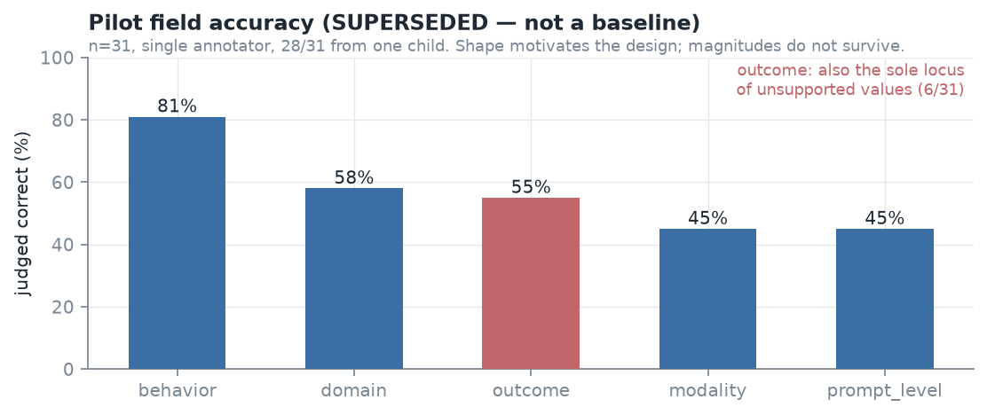
Figure 23. Pilot field accuracy (superseded). Retained for provenance, not as a result.

Reproducibility
All results derive from 61 recorded artefacts, of which 38 are pinned by SHA-256 checksum. The reproduction sequence is recorded in docs/paper/artifacts.md. Tests re-derive every number in the manuscript from its artefact and fail if prose and data disagree. Fixed seeds: sheet ordering 42 and 4242, bootstrap 20260915/20260916 at 10,000 replicates.

Data availability
[TO COMPLETE BEFORE SUBMISSION] The source corpora are publicly available from ASDBank/TalkBank under their own terms and are not redistributed here. The derived artefacts — the frozen annotation batch, both annotators' values for both rounds, the adjudicated gold standard, all computed statistics and the analysis code — are recorded in this repository. State the repository location, licence, and whether the gold standard will be released, before submission.

Author contributions, conflicts of interest, and AI use
[TO COMPLETE BEFORE SUBMISSION] Author contributions and conflict of interest declarations are required and are not yet written.
AI use is disclosed as follows. The extraction and judge models are the object of study and are described in Methods. Separately, substantial portions of the evaluation tooling and drafting of this manuscript were produced with AI assistance. No AI system authored, selected, or altered a gold-standard value, an adjudication decision, or a reported statistic: every annotation and every adjudication is human, statistics are computed by code from recorded artefacts, and automated tests re-derive each reported number from its artefact. The exact disclosure wording required by the journal must be confirmed at submission.

References
[TO COMPLETE BEFORE SUBMISSION] No reference list has been compiled. Required at minimum: both corpus DOIs, the kappa and maximum-kappa literature, the asymptotic variance estimator, agreement reporting guidance, and the prior work identified in the Comparison section.

