Response to Round 2 Clarification Questions for Manuscript Finalization
Answers the questions in 'Round 2- Clarification Questions for Manuscript Finalization.docx'. That round followed the strict-reviewer assessment ('JMIR_Strict_Reviewer_Critical_Issues_Prioritized.docx') and the point-by-point response to it ('Reviewer_Response.docx'). Branch model-finetuning, HEAD 2d83b77, built 2026-09-24. Internal working document; not for submission.
Each question is reproduced verbatim, with its original numbering, order and bullet structure, and the answer follows it. Every metric is read from the recorded artefact named beside it. Every date is either an artefact's own timestamp or a commit time, and each table says which.

Summary
Table 1. What each question asked, and what the answer changes in the manuscript.
# | Question | Answer | Manuscript consequence
1 | Operational Extractor Selection — Qwen 2.5 7B | Selected before the held-out set existed, by a rule written before any gold label. The held-out set played no part. But it was never the application's operational extractor | Replace "operational extractor" with "best-performing / evaluated generator". Do not claim it was selected for safety
2 | Final Reproducibility and Public-Release Plan | ASDBank is password-protected, so no transcript-derived text can be public. A three-tier release with a Zenodo DOI is feasible. Transcript text is already in the pushed git history | Data Availability statement drafted below. Needs a TalkBank confirmation, a clean public repo, a tag, licences and a DOI
Opt. | Optional confirmation (verification gate) | All three changes landed in commit 63a73a6 on 2026-09-21; tests pass at HEAD | Cite via the release tag; commit hash in the supplement

Decisions only the authors can make
- Check the GitHub repository's visibility and collaborator access today (Section 2).
- Choose option A or B for how qwen2.5:7b is described (Section 1). A is recommended.
- Confirm the target journal: JMIR AI or AI (MDPI).
- Approve the repository and archive plan, the tag name, and the licences (Section 2).
- Send TalkBank the tiered plan and ask for written confirmation (Section 2).

1. Operational Extractor Selection — Qwen 2.5 7B
The question, as asked
Question:
Please confirm the exact chronology and selection rule used when Qwen 2.5 7B was chosen as the operational extraction model.
Specifically, please clarify:
- Was Qwen 2.5 7B selected before the 132-segment held-out set was fully adjudicated and scored?
- At the time of selection, which results were available?
- 330-segment main-batch results?
- MARS results?
- Qwen 3 14B results?
- Held-out annotation/reliability results?
- Held-out generator performance results?
- What exact criterion or combination of criteria was used to select Qwen 2.5 7B?
- Highest categorical agreement on the main batch?
- Whole-record agreement?
- Unsupported-assertion behavior?
- Abstention behavior?
- Operational simplicity compared with MARS?
- Other considerations?
- Is there a commit, configuration file, design note, run artifact, or dated decision record showing when Qwen 2.5 7B became the intended operational extractor?
- Please confirm whether the held-out set was used only for subsequent validation and did not influence the original model-selection decision.
Why we need this:
After held-out adjudication, Qwen 3 14B has slightly higher merged agreement than Qwen 2.5 7B on the held-out set, while Qwen 2.5 7B has a substantially safer unsupported-assertion profile. A reviewer may therefore ask whether Qwen 2.5 7B was selected before or after seeing the held-out results.
We want to describe the chronology accurately and avoid any appearance of post-hoc model selection. If Qwen 2.5 7B was selected before held-out scoring, that strengthens the study because the held-out set can then be presented as an independent validation set rather than part of the selection process.

Response
Short answer
Yes, it was identified before the held-out set existed, and the held-out results played no part in it. qwen2.5:7b ranked first on the 330-segment main batch when that batch was scored, on 2026-09-15 23:54 UTC. The ranking came from a rule written on 2026-09-07, before any gold label existed. qwen2.5:7b was named in committed code on 2026-09-16 15:41 UTC. The held-out set was frozen about 1.5 hours after that, and its first performance number did not appear until 2026-09-22 13:51 UTC, six days later.
One premise needs correcting before this goes into the manuscript: qwen2.5:7b was never made the application's operational extractor. The running application's default is llama3.2:latest (src/backend/config.py:27, unchanged since commit fa11861 on 2026-08-28). What qwen2.5:7b holds is three research roles: best single generator on the main batch, the comparator MARS is measured against, and the model used in the reporting-layer experiment. The manuscript should say that, not "operational extractor". Options are given at the end of this section.
Q Was Qwen 2.5 7B selected before the 132-segment held-out set was fully adjudicated and scored?
Yes. The ordering below is taken from artefact timestamps and commit times, not from memory.
Table 2. When qwen2.5:7b was identified, compared with every held-out milestone. All times UTC.
Event | When | Source
Best-generator rule written (argmax over generators) | 2026-09-07 16:11 UTC | commit 04a2b36, mars_evaluation.py
Main batch scored; qwen2.5:7b ranks first | 2026-09-15 23:54 UTC | scored_against_gold.json generated_at
qwen2.5:7b named 'strongest generator' in code | 2026-09-16 15:41 UTC | commit 7a4b725
Held-out set frozen (did not exist before this) | 2026-09-16 17:11 UTC | holdout_set.json generated_at
Held-out double annotation completed | 2026-09-18 14:57 UTC | commit f404ca0
Held-out generator outputs produced (unscorable: no gold) | 2026-09-18 15:35 UTC | holdout_batch.json generated_at
Held-out adjudication completed | 2026-09-22 02:57 UTC | commit 7d2e744
First held-out performance number | 2026-09-22 13:51 UTC | scored_holdout.json generated_at

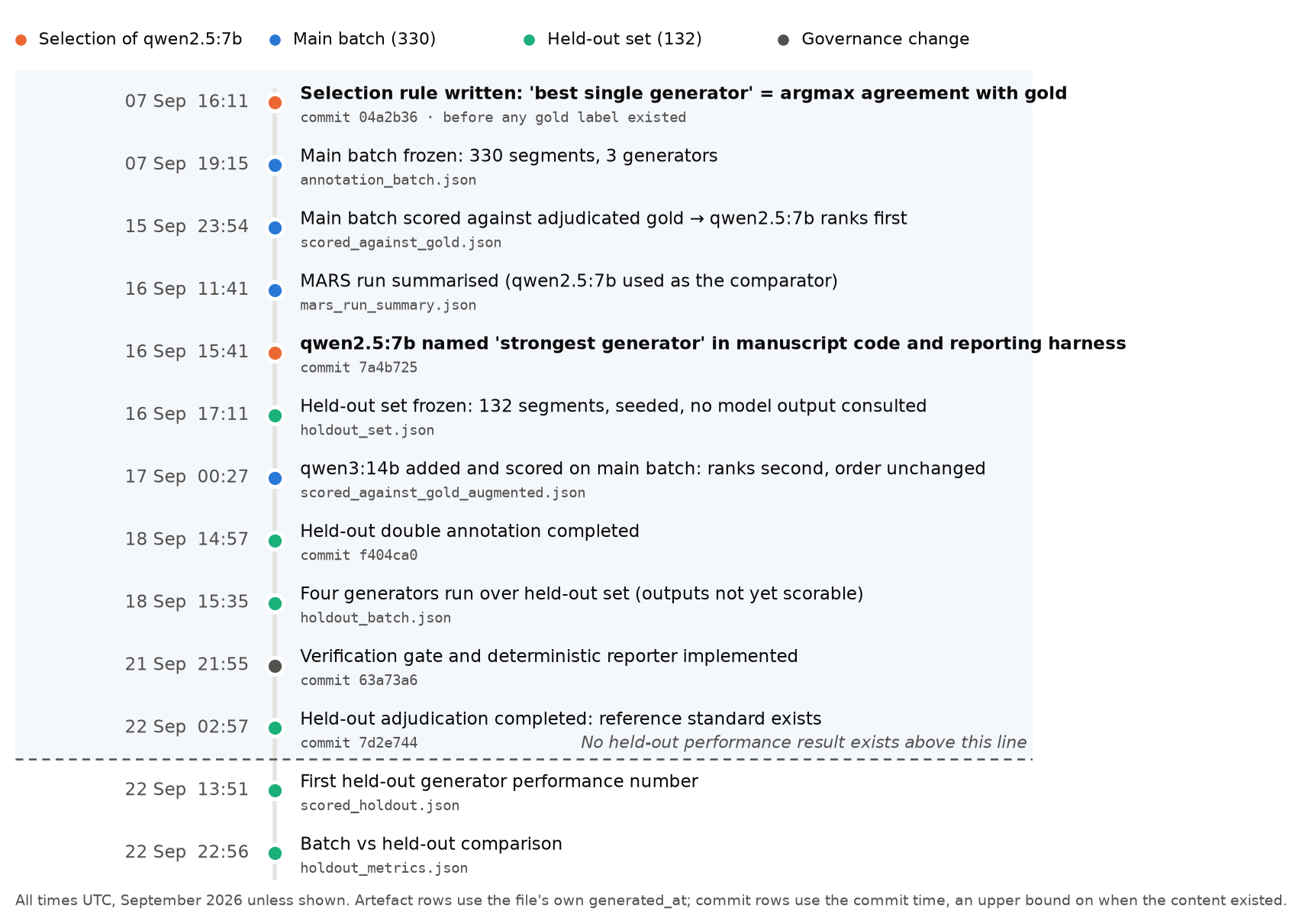
Figure 1. The chronology. qwen2.5:7b (orange, bold) was identified and named before the held-out set was frozen. Everything above the dashed line happened before any held-out performance result existed.
Q At the time of selection, which results were available?
"At the time of selection" is dated two ways. The first is when the ranking was first computable (2026-09-15 23:54 UTC). The second is when qwen2.5:7b was first named in committed code (2026-09-16 15:41 UTC). The table uses both.
Table 3. Which results existed when qwen2.5:7b was selected.
Result (as listed in the question) | Available? | First timestamp | Note
330-segment main-batch results? | Yes | 2026-09-15 23:54 UTC | Three-generator roster at the time: llama3.2, qwen2.5:3b, qwen2.5:7b
MARS results? | At naming only | 2026-09-16 11:41 UTC | After the ranking, before the naming commit. MARS uses the best generator as its comparator. It cannot change which generator is best
Qwen 3 14B results? | No | 2026-09-17 00:27 UTC | Added afterwards. Ranked second on the main batch (42.0% vs 43.1%), so the ranking did not change
Held-out annotation/reliability results? | No | 2026-09-18 14:57 UTC | The held-out set itself did not exist until 2026-09-16 17:11 UTC
Held-out generator performance results? | No | 2026-09-22 13:51 UTC | Needs held-out gold, which was completed on 2026-09-22

Q What exact criterion or combination of criteria was used to select Qwen 2.5 7B?
The rule is one sentence: use the single generator with the highest agreement against the adjudicated main-batch reference standard. It exists in code in two forms:
- Original form, written 2026-09-07 (commit 04a2b36, before any gold label existed). mars_evaluation.build_evaluation() takes the argmax of each generator's share of fully correct records, i.e. whole-record agreement.
- Later form, 2026-09-16 (commit 7a4b725). mars_selection_analysis.py:224 takes the argmax of mean agreement over the four categorical fields, i.e. merged mean agreement.
Both forms pick qwen2.5:7b on the main batch, so the choice does not depend on which form is used. Each criterion listed in the question is answered below.
Table 4. Each candidate criterion in the question, and whether it was used. Main batch, n = 330. Source: holdout_metrics.json (batch side).
Criterion | Used? | Evidence
Highest categorical agreement on the main batch? | Yes: the criterion | qwen2.5:7b 43.1%; llama3.2 30.8%; qwen2.5:3b 20.4%. qwen3:14b, added later, 42.0%
Whole-record agreement? | Yes: the original form of the criterion | qwen2.5:7b 4.5%; llama3.2 1.5%; qwen2.5:3b 0.3%. qwen3:14b 3.0%
Unsupported-assertion behavior? | No | Not a criterion, and it could not have been one: qwen2.5:3b has the lowest rate (31.0% vs 56.9%). A safety criterion would have chosen qwen2.5:3b
Abstention behavior? | No | Not a criterion. Mean abstention: qwen2.5:7b 12.7%, qwen3:14b 2.9%, qwen2.5:3b 48.1%
Operational simplicity compared with MARS? | No: this is a result, not a criterion | The best single generator is the baseline MARS is tested against. 'MARS did not beat always using the strongest generator' is a finding reported after the fact. It was not a reason for the choice
Other considerations? | None recorded | No design note gives any further reason. The reporting harness uses the same model (DEFAULT_MODEL = "qwen2.5:7b", tests/eval/reporting/groundedness.py:67) without a written rationale. The authors should confirm it was simply 'reuse the strongest generator'

A correction to the question's own framing
The question's rationale says qwen2.5:7b "has a substantially safer unsupported-assertion profile". That holds against qwen3:14b (97.0% batch, 92.1% held-out) and llama3.2 (83.2%, 84.1%). It does not hold against qwen2.5:3b (31.0%, 28.6%), which is the safest of the four on both sets.
So the manuscript must not say qwen2.5:7b was chosen for safety. The accurate statement is that it was chosen on agreement, and that among the two highest-agreement generators it asserts unsupported values far less often.

Q Is there a commit, configuration file, design note, run artifact, or dated decision record showing when Qwen 2.5 7B became the intended operational extractor?
Yes for the selection itself; see the table below. There is no dated record designating qwen2.5:7b as the operational extractor, because no such designation was ever made.
Table 5. Dated records that support the chronology. A commit time is an upper bound on when its content existed: several commits in this history are bulk commits.
Record | Type | When (UTC) | What it shows
mars_evaluation.py @ 04a2b36 | Commit | 2026-09-07 16:11 UTC | The best-generator rule existed eight days before any gold label
scored_against_gold.json | Run artefact (SHA-256 pinned) | 2026-09-15 23:54 UTC | The scoring that makes qwen2.5:7b first
mars_selection_analysis.py:224, groundedness.py:67 @ 7a4b725 | Commit | 2026-09-16 15:41 UTC | qwen2.5:7b named as the strongest generator and set as the reporting model
holdout_set.json | Run artefact (pinned) | 2026-09-16 17:11 UTC | selection_rule: "No model output was consulted. Frozen before any generator is run over it."
src/backend/config.py:27 @ fa11861 | Configuration | 2026-08-28 13:54 UTC | The application default is llama3.2:latest, not qwen2.5:7b

The pinned artefacts are covered by docs/paper/artifact_manifest.json. Anyone can confirm the timestamps are unaltered by running uv run python docs/paper/verify_artifacts.py.
Q Please confirm whether the held-out set was used only for subsequent validation and did not influence the original model-selection decision.
Confirmed. The held-out set was used only for later validation. Four independent facts support this:
- Order of events. The selection rule (2026-09-07) and its outcome (2026-09-15/16) both predate the held-out set (frozen 2026-09-16 17:11 UTC) and its first result (2026-09-22).
- How the held-out set was drawn. It was stratified by child, seeded (20260916) and drawn from segments outside the annotation pool. No model output was consulted, so the held-out data cannot encode a preference for any generator.
- Nothing moved after the held-out results. holdout_metrics.py recomputes a held-out 'best generator' figure and reports it. Nothing reads that figure back: no configuration, prompt or manuscript role changed after 2026-09-22.
- The held-out result does not uniformly favour qwen2.5:7b. On merged agreement qwen3:14b is ahead (40.2% vs 38.8%). A post-hoc choice would have picked whichever model looked best on held-out data. The pre-specified choice was kept even though it no longer leads on that metric.
What the held-out set says about the choice
Table 6. Each criterion on both sets. Winner in bold. Batch n = 330, held-out n = 132, same scoring policy (4 categorical fields, behavior excluded). Source: holdout_metrics.json.
Generator | Merged, batch | Merged, held-out | Whole-record, batch | Whole-record, held-out | Unsupported, batch | Unsupported, held-out
llama3.2 | 30.8% | 26.5% | 1.5% | 0.0% | 164/197 (83.2%) | 53/63 (84.1%)
qwen2.5:3b | 20.4% | 12.5% | 0.3% | 0.0% | 61/197 (31.0%) | 18/63 (28.6%)
qwen2.5:7b | 43.1% | 38.8% | 4.5% | 4.5% | 112/197 (56.9%) | 32/63 (50.8%)
qwen3:14b | 42.0% | 40.2% | 3.0% | 3.8% | 191/197 (97.0%) | 58/63 (92.1%)

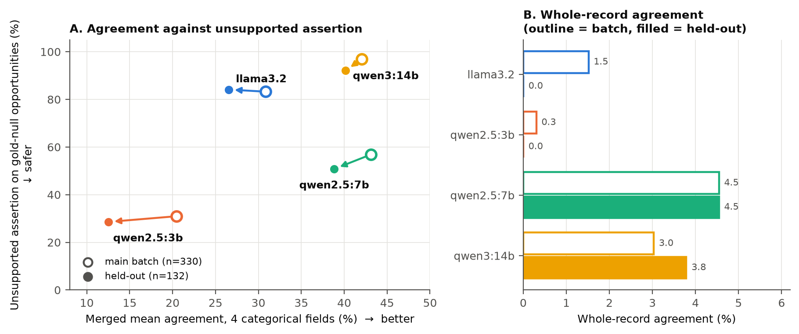
Figure 2. Batch (outline) against held-out (filled) for all four generators. A: arrows run from batch to held-out; lower-right is better. qwen3:14b sits highest on unsupported assertion on both sets. B: qwen2.5:7b has the highest whole-record agreement on both sets.
On the held-out set, qwen3:14b leads merged agreement by 1.3 points over 132 segments. qwen2.5:7b leads whole-record agreement (4.5% vs 3.8%) and asserts unsupported values on 32 of 63 gold-null opportunities, against 58 of 63 for qwen3:14b. No paired significance test has been run on the 1.3-point gap. The manuscript should describe it as a small difference in one direction, not as a reversal of the ranking.
What the manuscript should say
Suggested Methods wording (adjust names to the manuscript's conventions)
"Before any reference labels existed, we specified that the single-generator baseline would be the generator with the highest agreement with the adjudicated reference standard on the annotation batch. When the batch was scored (15 September 2026), this rule selected qwen2.5:7b under both whole-record and mean categorical-field agreement. qwen3:14b, added to the roster afterwards, ranked second. The model-independent held-out set was drawn after this choice, by a seeded rule that consulted no model output. It was adjudicated and scored six days later and was used only to validate the choice, never to make it."
"On the held-out set, qwen3:14b's mean agreement was 1.3 points higher than qwen2.5:7b's. qwen2.5:7b retained the higher whole-record agreement and a substantially lower unsupported-assertion rate (32/63 vs 58/63 gold-null opportunities)."
Do not write "operational extractor", and do not write "selected for safety".

Decision needed from the authors: what to call qwen2.5:7b
Table 7. Options for the 'operational extractor' wording.
Option | What changes | Chronology consequence
A (recommended). Describe qwen2.5:7b as the best-performing generator and the evaluated configuration. State that the application's extractor is configurable and currently defaults to llama3.2 | Wording only | None. Every statement is already true and dated
B. Make qwen2.5:7b the application default now | One line in config.py plus a dated commit | The change would be made after the held-out results were known. It must be disclosed as a post-held-out deployment decision, justified by whole-record agreement and unsupported assertion. It cannot be described as the original selection

2. Final Reproducibility and Public-Release Plan
The question, as asked
Question:
Please confirm the intended final reproducibility package for publication.
Specifically, please provide:
- Intended public repository or archive location
- GitHub, Zenodo, OSF, another archive, or combination
- Intended release tag/version
- Intended software/artifact license
- Which of the following can be released publicly:
- source code
- schemas
- prompts
- annotation codebook
- adequacy-router rules
- deterministic analytics definitions
- reporting schema
- evaluation scripts
- MARS code/configuration
- artifact manifest
- SHA-256 hashes
- aggregated metrics/results
- adjudicated annotation labels
- held-out labels
- preserved model outputs
- de-identified ASDBank-derived segment text
- Are there any TalkBank/ASDBank license or redistribution restrictions that prevent us from publishing source-derived text, annotation files containing transcript content, or model outputs that reproduce source text?
- If source-derived material cannot be redistributed, what reproducibility substitute should we make public?
- hashes
- segment identifiers
- scripts that recreate the dataset for authorized users
- schemas/codebooks
- aggregate metrics
- synthetic examples
- other permitted artifacts
- Please confirm whether the final release can be frozen and cited with a permanent identifier or DOI.
Why we need this:
The study already has strong internal reproducibility infrastructure, including frozen outputs, versioned prompts, exact model digests, deterministic downstream analysis, artifact manifests, and SHA-256 hashes. The remaining issue is not additional experimentation; it is defining what can legally and practically be made public.
Because the target journal is AI (MDPI), reproducibility and transparent technical reporting are important. We need the Data Availability and Reproducibility sections to distinguish clearly between:
what exists internally,
what can be publicly released, and
what cannot be redistributed because of corpus licensing or privacy restrictions.
We should not make any public-release claim until these boundaries are confirmed.

Response
Short answer
Checking TalkBank's current terms settles most of this question. ASDBank is password-protected. TalkBank's rules state that "password-protected data cannot be posted on other websites or servers or shared with anyone who does not already have password access". So no transcript-derived text can go into a public release, de-identified or not. Code, schemas, prompts, rules, hashes and aggregate metrics can all be public, and so can categorical labels under opaque IDs. The release can be frozen with a Zenodo DOI.
An urgent issue this raised: transcript text is already on a third-party server. The git history pushed to github.com/adnimbuslab/agentic-autism-intervention-progress-tracking contains the batch JSONs and the returned annotation and adjudication sheets, which include *CHI:/*MOT:/*INV: lines. This response did not check the repository's visibility or its collaborator list, and it should be checked before anything else. Even if the repository is private, it cannot become the public release: deleting the files in a new commit leaves them in history. The public release needs a clean repository or export.
Please confirm the target journal. This round names "AI (MDPI)". Every earlier document, the reviewer assessment and the manuscript title all say JMIR AI. The two journals have different data-availability and AI-disclosure templates.
Q Intended public repository or archive location — GitHub, Zenodo, OSF, another archive, or combination
What exists: one GitHub remote, adnimbuslab/agentic-autism-intervention-progress-tracking, holding the full working history including restricted files. No Zenodo or OSF record exists.
Recommendation: GitHub and Zenodo together. Use a new, clean public GitHub repository, or a public mirror of the current one with rewritten history, for the code and Tier A artefacts. Archive the tagged release on Zenodo through its GitHub integration. That produces a version DOI and a concept DOI, and the integration requires a public repository, which is one more reason the release must be the clean copy. OSF adds nothing here unless the authors want a preregistration-style project page.
Decision: the authors.
Q Intended release tag/version
What exists: exactly one tag, research-prototype-v1.0, created on commit f9a53c6 on 2026-08-26. That was before any annotation, gold label, generator scoring or held-out work, so it must not be cited as the study release.
Recommendation: a new annotated tag, e.g. manuscript-v1.0.0, on the commit that builds the submitted manuscript. Tag revisions after review as manuscript-v1.1.0 and so on. The Zenodo concept DOI then resolves to the latest version, and each version DOI stays fixed. Current HEAD is 2d83b77. It is not yet the release commit, because the Section 2 release audit and the [TO COMPLETE] markers are still open.
Q Intended software/artifact license
What exists: no LICENSE file anywhere in the repository.
Table 8. Recommended licences by artefact type. The choice of code licence depends on institutional IP policy; check it before choosing.
Artefact type | Recommended licence | Why
Source code, scripts | Apache-2.0 (or MIT) | Permissive; Apache-2.0 adds an explicit patent grant. Code contains no corpus data once audited
Codebook, schemas, prompts, documentation, aggregate metrics, figures | CC BY 4.0 | Standard for research outputs; allows reuse with attribution
Anything derived from ASDBank text (Tier B) | Not relicensable | Inherits TalkBank's terms: CC BY-NC-SA, and shared only with password holders. The authors cannot grant broader rights than they hold

Q Which of the following can be released publicly:
Each item is placed in one of three tiers. Tier A is public and DOI-archived. Tier B is shared on request, only with people who already have ASDBank password access. Tier C is never posted.
Table 9. The 16 items in the question, in the question's order.
Item | Tier | Condition and location
source code | A · public | No licence file exists yet. Before release, audit the 13 test and source files that contain CHAT speaker lines, and the files that cite real segment IDs (e.g. tests/phase4/test_mars_envelope.py, src/backend/ml/extraction/mars/provider.py). Keep synthetic fixtures; replace anything that is corpus text
schemas | A · public | src/backend/schemas/observation_schema.py, EXTRACTION_TOOL_SCHEMA
prompts | A · public | src/backend/ml/extraction/prompts.py (PROMPT_VERSION 1.0.0). The scan found no transcript excerpt in it
annotation codebook | A · public after edit | docs/annotation_codebook.md has three worked examples that cite real segment IDs and quote the child's words (lines ~100-110). Paraphrase them or replace them with synthetic examples
adequacy-router rules | A · public | adequacy_router.py, config.py, docs/lld/Adequacy_Router.md
deterministic analytics definitions | A · public | src/backend/ml/analytics_engine.py
reporting schema | A · public | src/backend/ml/schemas.py, deterministic reporter in reporting_client.py
evaluation scripts | A · public | tests/eval/**. Runnable end to end only with the corpus, which is the point of Tier B/C
MARS code/configuration | A · public after audit | src/backend/ml/extraction/mars/, mars_run_summary.json. docs/lld/Mars_Reranking_Specs.md cites real segment IDs
artifact manifest | A · public | Keep an entry for every file, including restricted ones: path, size and hash
SHA-256 hashes | A · public | Safe to publish for restricted files too. A hash reveals nothing about the text, and it lets authorized users prove their regeneration is identical
aggregated metrics/results | A · public | paper_metrics.json, holdout_metrics.json, reliability_*.json, round_comparison.json, mars_evaluation.json, mars_selection_analysis.json. The scan found no transcript lines
adjudicated annotation labels | Split: A / B | Categorical fields (domain, modality, prompt_level, outcome) under opaque IDs: public. Free-text behavior: Tier B. 93 of 330 of the main-batch behavior labels quote the child's words. Adjudication rationales: Tier B
held-out labels | Split: A / B | As above. 25 of 132 of the held-out behavior labels quote the child's words
preserved model outputs | Split: A / B / C | Per-segment verdicts (scored_*.json: correct / incorrect / missing): public. Raw outputs are stored inside annotation_batch*.json and holdout_batch.json beside the transcript text: Tier C as files. Their content without transcript text could go to Tier B
de-identified ASDBank-derived segment text | C · not public | ASDBank is password-protected. De-identification removes identifiers but does not change the access rule

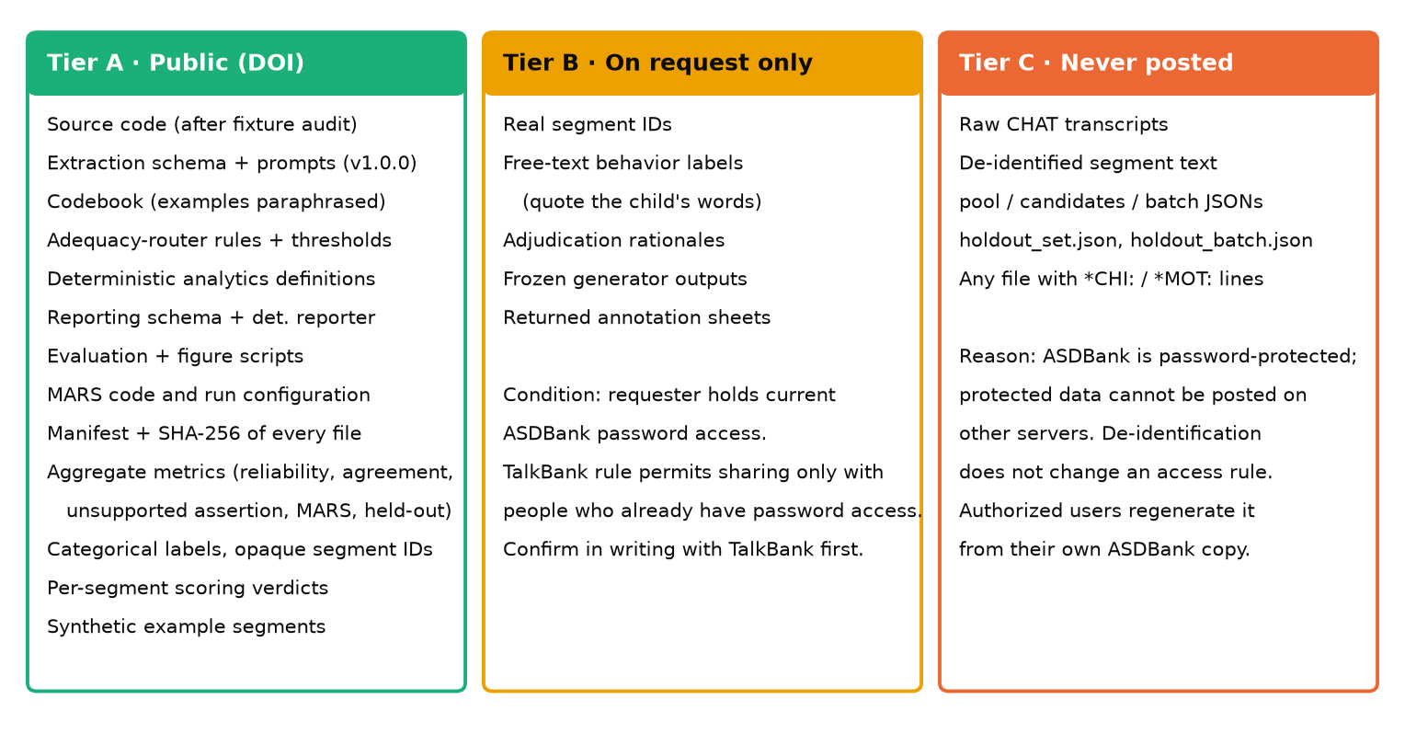
Figure 3. The proposed release boundary. Tier A is the public DOI package. Tier B goes on request only to people with ASDBank password access, after TalkBank confirms this. Tier C is never posted, and authorized users regenerate it from their own corpus copy.
Q Are there any TalkBank/ASDBank license or redistribution restrictions that prevent us from publishing source-derived text, annotation files containing transcript content, or model outputs that reproduce source text?
Yes. Checked on 2026-09-24 against TalkBank's live pages:
Table 10. TalkBank / ASDBank terms that bind this release.
Term (quoted) | Source | Consequence here
ASDBank requires login: "For access to ASD materials, click the green Login button… to set up your TalkBank account." | talkbank.org/asd/ | ASDBank data is password-protected, not open access
"Password-protected data cannot be posted on other websites or servers or shared with anyone who does not already have password access." | talkbank.org/0share/rules.html | No public release of segment text, annotation sheets that contain transcripts, or raw model outputs stored with transcripts. Sharing with existing password holders is allowed (Tier B)
"The use of TalkBank data is governed by the Creative Commons CC BY-NC-SA 3.0 copyright license." (The ASDBank page says CC BY-NC-SA 4.0.) | rules.html; asd/ | Non-commercial and share-alike for anything derived. The version number differs between the two pages; ask TalkBank which applies
"Users cannot upload TalkBank data to web-based systems unless those systems include assurance that they will not keep the data." | rules.html | Covers the GitHub remote holding transcript text, and any future frontier-API arm
"…the data themselves cannot be included in models." / NC excludes "large language models" in commercial products | rules.html | Not relevant to this paper (no training). It is relevant to the deferred fine-tuning phase and must be resolved before that phase starts
"When using TalkBank corpora in published articles, you need to cite your sources by following these rules." | rules.html | Cite both corpora by DOI (Rollins 10.21415/T5KK53; Flusberg 10.21415/T5459F) plus the TalkBank references the rules page lists

Model outputs that reproduce source text fall under the same rule as the text itself. A behavior string that quotes the child is transcript content wherever it is stored. Categorical values (e.g. modality = verbal) and correct/incorrect verdicts reproduce no source text and can go in Tier A.
Recommended step before submission: get it in writing
Email TalkBank (the ASDBank contact on talkbank.org). Describe the three tiers in Figure 3 and ask for written confirmation of three things: (1) Tier A may be public; (2) Tier B may be shared on request with verified password holders; (3) which CC BY-NC-SA version applies. Quote that reply in the Data Availability statement. It turns a reading of the rules into a recorded permission.

Q If source-derived material cannot be redistributed, what reproducibility substitute should we make public?
All of the substitutes listed should be released. Together they let an authorized reader rebuild the exact dataset and let any reader re-derive every reported number.
Table 11. Reproducibility substitutes, in the question's order.
Substitute | Release? | Detail
hashes | Yes | SHA-256 for every artefact, restricted ones included (the manifest already pins 38 of 61)
segment identifiers | Yes, as opaque IDs | Real IDs embed corpus filenames and child pseudonyms (e.g. <child>_flusberg_…cha_seg_020). Publish SHA-256(real_id). Authorized users compute the same value from their regenerated segments
scripts that recreate the dataset for authorized users | Yes | data/pipeline/ (parse → de-identify → segment → select), build_annotation_batch, build_holdout_set (seed 20260916). Deterministic given the corpus
schemas/codebooks | Yes | Codebook after the example edit above
aggregate metrics | Yes | All paper tables and figures regenerate from these plus the verdicts
synthetic examples | Yes, recommended | A small synthetic CHAT set that runs the whole pipeline without the corpus. The test fixtures are a starting point
other permitted artifacts | Yes | Per-segment verdicts, categorical labels, figures, and the manuscript-consistency tests that tie each reported number to its artefact

One limit, which must be stated rather than engineered around. Generator outputs cannot be regenerated bit-for-bit, because no generation seed was set. An authorized user can rebuild the identical segments and verify them by hash. To get the identical model outputs, they need the frozen outputs from Tier B. Everything downstream of those outputs is deterministic.
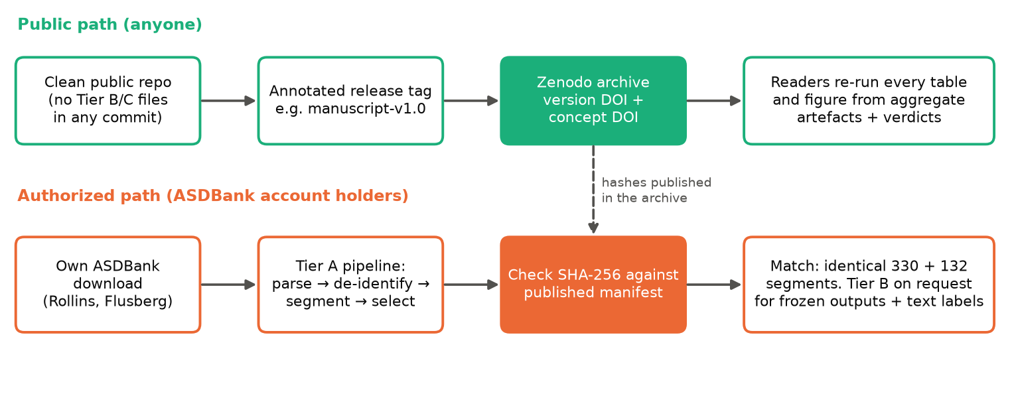
Figure 4. Two reproduction paths. Public: from the DOI archive to every table and figure. Authorized: from the reader's own ASDBank copy to the identical segment set, checked against the published hashes.
Q Please confirm whether the final release can be frozen and cited with a permanent identifier or DOI.
Yes. A Zenodo record is immutable once published, and it receives a version DOI plus a concept DOI for all versions. Cite the version DOI in the manuscript. Minting it needs three things first: (1) the clean public repository, (2) the release tag, and (3) the Tier A audit. A DOI can be reserved on Zenodo before publication, so it can go into the manuscript before the record goes live.
Draft Data Availability statement (to finalize after TalkBank confirms)
Draft
"The source transcripts are available to registered users from ASDBank (TalkBank) at https://doi.org/10.21415/T5KK53 (Rollins) and https://doi.org/10.21415/T5459F (Flusberg). Under TalkBank's terms they are not redistributed. The code, extraction schema and prompts, annotation codebook, adequacy-router rules, analytics and reporting definitions, evaluation scripts, categorical reference labels and per-segment scoring verdicts (keyed by hashed segment identifiers), aggregate results, and a manifest with SHA-256 hashes of every artefact are archived at [Zenodo DOI] (release [tag]) under Apache-2.0 (code) and CC BY 4.0 (other materials). Researchers with ASDBank access can regenerate the exact segment sets with the released scripts and verify them against the published hashes. Free-text labels and frozen model outputs are available from the corresponding author to researchers who hold ASDBank access."

Optional confirmation if easy to retrieve
The question, as asked
If convenient, please also confirm the final implementation state of the mandatory human-verification gate, specifically the commit or version in which:
- VERIFIED status was introduced,
- analytics were restricted to VERIFIED or CORRECTED records,
- the deterministic reporter became the default operational reporting path.
Why:
We already have the technical details, but a final commit/version reference would make the manuscript's implementation chronology cleaner and easier to reproduce.

Response
Short answer
All three changes arrived together in one commit: 63a73a6, 2026-09-21 21:55 UTC (2026-09-21 17:55:27 −04:00). Full hash 63a73a61fd96c7c6b5738f682f8c0c6ae86ddb2b. No later commit changed any of the three. Their tests pass at current HEAD 2d83b77: 55 passed in test_analytics_gate.py, test_reporting_client.py and test_structured_records.py, run on 2026-09-24.
Table 12. Where each change was made. All three are in commit 63a73a6.
Change (as asked) | Code | Test that pins it
VERIFIED status was introduced, | src/backend/models/observation.py (RecordStatus.VERIFIED, verified_by, verified_at); alembic/versions/004_add_verified_record_status.py; POST /records/{record_id}/verify | tests/phase3/test_structured_records.py
analytics were restricted to VERIFIED or CORRECTED records, | src/backend/services/analytics_service.py: status.in_([VALIDATED, CORRECTED]) → status.in_([VERIFIED, CORRECTED]) | tests/phase4/test_analytics_gate.py (compiles the query; asserts the admitted set)
the deterministic reporter became the default operational reporting path. | src/backend/config.py: reporting_mode = "deterministic"; src/backend/ml/reporting_client.py: _build_deterministic_sections | tests/phase4/test_reporting_client.py::TestOperationalReportingMode

For the manuscript: cite the release tag and DOI from Section 2, which will contain 63a73a6. The commit hash can go in a footnote or the supplementary artefact list. Note one ordering detail: the gate was implemented at 21:55 UTC on 2026-09-21, about five hours before held-out adjudication was completed. It governs analytics, not extraction, so it has no bearing on the Section 1 chronology.

How this document was produced
Rebuild it with the command below. The questions are re-read from the round-2 document, and every number is re-read from its artefact, so a changed artefact changes this response instead of leaving it out of date.
uv run python docs/paper/make_round2_response.py
uv run python docs/paper/verify_artifacts.py # confirms the pinned artefacts are unaltered
External sources consulted on 2026-09-24: TalkBank data-usage rules (https://talkbank.org/0share/rules.html), data access levels (https://talkbank.org/0share/access.html), and the ASDBank home page (https://talkbank.org/asd/). Re-check them on the submission date, since these pages can change.

