Response to MDPI Round-8 Review Comments
Answers the two open comments in 'R8_review comments.docx', in their original order and wording. Branch model-finetuning, built 2026-09-27. Internal working document; not for submission.
Every number is read from round8_analysis.json, computed from the deterministic CHAT pipeline, recorded sample files and git history, with no model call and no redraw. Claims about the data are checked by assertion when this document is built.

Summary
Table 1. Each comment and the answer in one line.
ID | Severity | Answer
R8-1 | Moderate | Early-session enrichment present: mean position 0.28 (2,442) and 0.34 (3,371) vs 0.50 available; main batch 0.27, evaluation 121 0.39. Limitation wording supplied
R8-2 | Minor / Moderate | Criteria fixed in committed code before the 11 reports were recorded; unchanged since. Sentence and commit IDs supplied

R8-1 · Moderate · Deterministic universe construction may create temporal/session-order sampling bias
The comment, as written
Location: Sections 2.12-2.13 and 4.9
Reviewer concern: Within each child-by-episode-type stratum, the universe builder retains the earliest episodes in transcript order until the per-child ceiling is reached. Because the source corpora are longitudinal, this can preferentially retain earlier visits or sessions when an episode type contains more observations than the allocated capacity. The lower-cap main universe (273 per child) and higher-cap evaluation universe (455 per child) may therefore differ not only in size but also in how far they extend through each child's longitudinal record. The manuscript appropriately avoids causal attribution between branches, but the temporal representativeness of the constructed universes is not yet characterized.
Required action: Report a simple session/longitudinal-coverage diagnostic, such as the number or proportion of sessions represented per child and the distribution of relative session position in the 2,442-segment universe, 3,371-segment universe, 330 main batch, and preferably the post-audit 121 evaluation set. If early-session enrichment is present, acknowledge it in the Limitations. Do not redraw the frozen samples. A new model experiment is unnecessary unless the diagnostic reveals a substantial imbalance.
Status: Open

Response
Short answer
Early-session enrichment is present and is substantial in the lower-cap universe. Across all segmented episodes the mean relative session position is 0.50 (0 = a child's first visit, 1 = the last). The 2,442-segment universe has mean 0.28, with 52.5% of its segments in the earliest quarter of each child's record against 23.4% available, and it omits 15 of the 85 sessions entirely. The 3,371-segment universe is less skewed (mean 0.34; 84/85 sessions). The two branches therefore also differ in longitudinal reach: the main batch has mean 0.27 and the post-audit 121 0.39. The largest shifts, and all whole-session omissions, are in the Flusberg children with 8–13 sessions; the Rollins children (4–5 sessions) keep every session in both universes but are still shifted earlier in the 2,442 universe. Nothing was redrawn.
Definition. Each child's sessions are ordered by the child's age in the CHAT @ID header (available for all 85 sessions). Session k of n has relative position k / (n − 1). Each episode takes its session's position. The reference is all 9,018 segmented episodes: what the universe builder could have retained.
Table 2. Longitudinal coverage by set. Shift = mean over children of (child's mean position in the set − child's mean position over all episodes); negative = earlier. Source: round8_analysis.json (session_coverage.sets).
Set | n | Sessions represented | Children with all sessions | Mean position | Earliest quarter | Latest quarter | Shift vs all
All segmented episodes (9,018) | 9,018 | 85/85 | 11/11 | 0.503 | 23.4% | 26.0% | ref.
2,442 universe (cap 273/child) | 2,442 | 70/85 | 7/11 | 0.284 | 52.5% | 7.1% | -0.206
3,371 universe (cap 455/child) | 3,371 | 84/85 | 10/11 | 0.337 | 48.2% | 14.4% | -0.147
Annotation pool (1,320) | 1,320 | 70/85 | 7/11 | 0.283 | 52.1% | 7.1% | -0.211
Main batch (330) | 330 | 60/85 | 5/11 | 0.273 | 53.9% | 6.7% | -0.222
Frozen evaluation set (132) | 132 | 58/85 | 4/11 | 0.406 | 35.6% | 17.4% | -0.089
Post-audit evaluation set (121) | 121 | 57/85 | 3/11 | 0.385 | 38.8% | 17.4% | -0.110

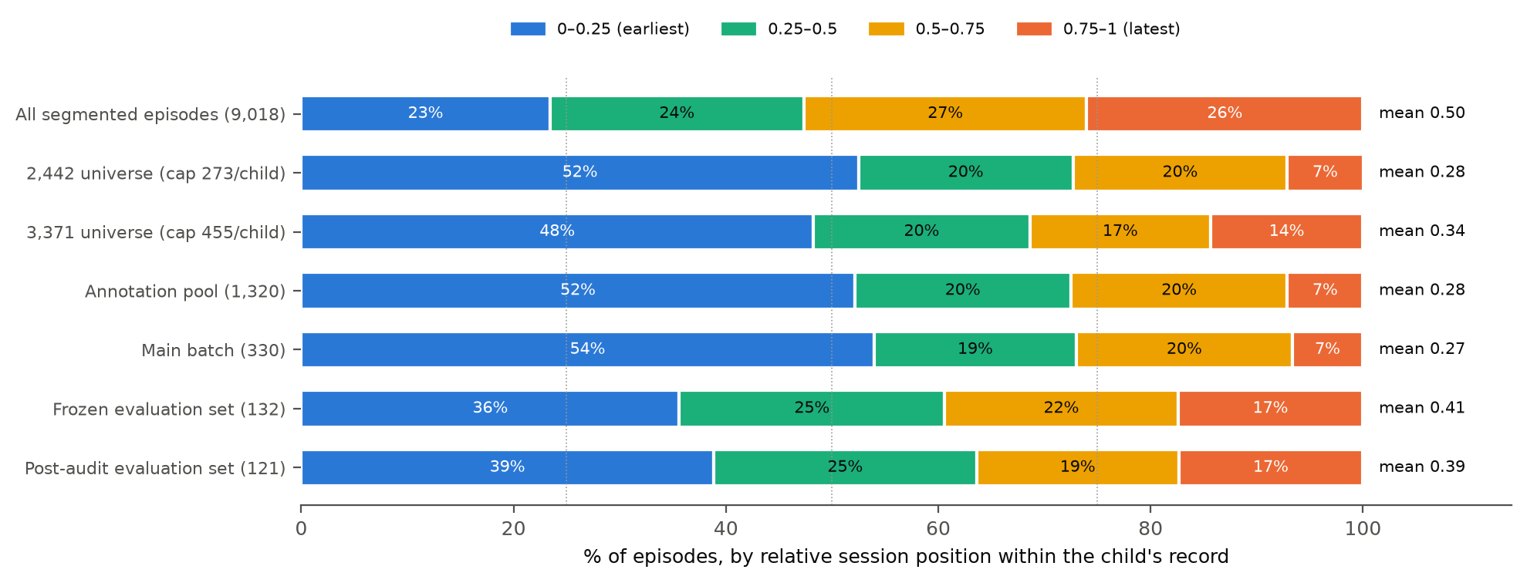
Figure 1. Share of each set's episodes by relative session position quarter. All segmented episodes are spread evenly; the 2,442 universe, the pool and the main batch concentrate in each child's earliest quarter.
Table 3. Per child: sessions represented / total · mean relative position. Source: round8_analysis.json (session_coverage.sets.*.per_child).
Child | All episodes | 2,442 universe | 3,371 universe | Main batch 330 | Evaluation 121
mark | 13/13 · 0.48 | 8/13 · 0.18 | 12/13 · 0.21 | 6/13 · 0.25 | 5/13 · 0.17
jack | 12/12 · 0.49 | 7/12 · 0.15 | 12/12 · 0.23 | 6/12 · 0.13 | 7/12 · 0.30
rick | 11/11 · 0.52 | 11/11 · 0.25 | 11/11 · 0.23 | 7/11 · 0.26 | 6/11 · 0.18
brett | 10/10 · 0.50 | 7/10 · 0.22 | 10/10 · 0.25 | 6/10 · 0.28 | 7/10 · 0.38
roger_flusberg | 10/10 · 0.56 | 8/10 · 0.31 | 10/10 · 0.37 | 7/10 · 0.34 | 6/10 · 0.39
stuart | 8/8 · 0.52 | 8/8 · 0.30 | 8/8 · 0.31 | 7/8 · 0.21 | 7/8 · 0.42
mars | 5/5 · 0.56 | 5/5 · 0.28 | 5/5 · 0.42 | 5/5 · 0.26 | 4/5 · 0.53
carl | 4/4 · 0.47 | 4/4 · 0.38 | 4/4 · 0.47 | 4/4 · 0.39 | 4/4 · 0.55
josh | 4/4 · 0.46 | 4/4 · 0.44 | 4/4 · 0.46 | 4/4 · 0.37 | 4/4 · 0.56
roger_rollins | 4/4 · 0.36 | 4/4 · 0.31 | 4/4 · 0.36 | 4/4 · 0.19 | 3/4 · 0.28
sid | 4/4 · 0.52 | 4/4 · 0.35 | 4/4 · 0.52 | 4/4 · 0.33 | 4/4 · 0.48

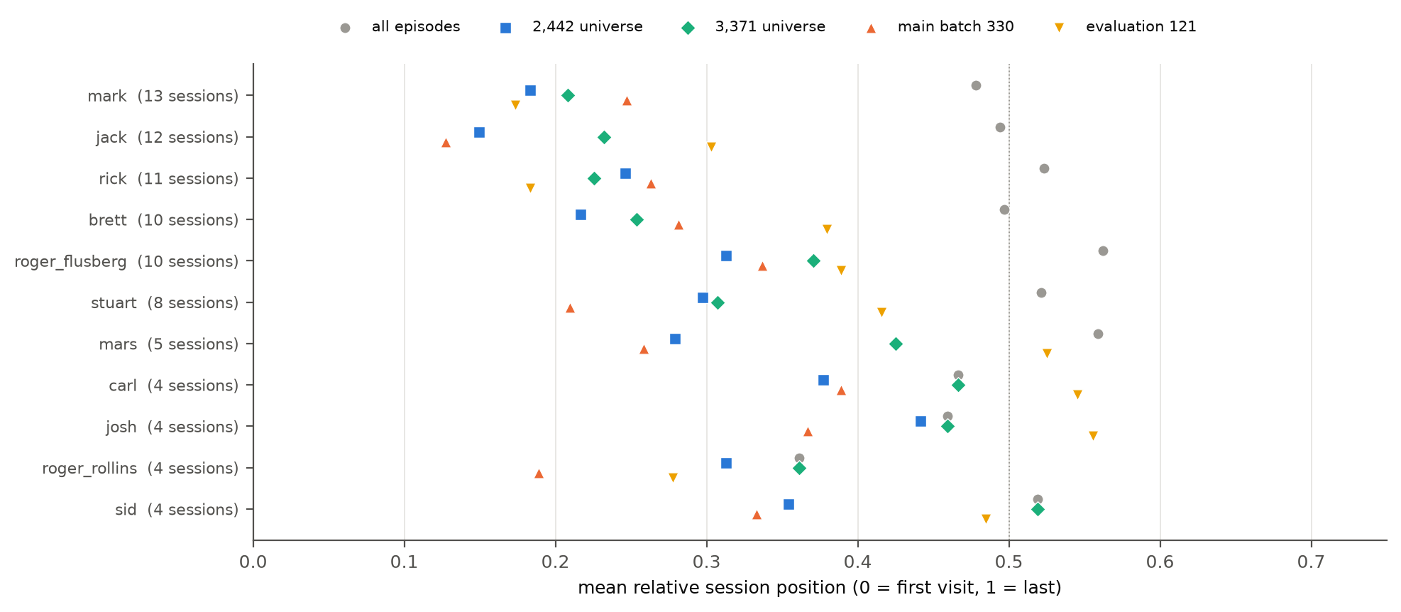
Figure 2. Mean relative session position per child. Grey circles are all segmented episodes; the universes and samples sit to the left, most strongly for the Flusberg children with long records.
Supporting argument
- Mechanism, as the reviewer describes. Within each child × episode-type stratum the builder keeps episodes in transcript order until the per-type allocation is reached (data/pipeline/select_segments.py, _select_for_child). Where a type has more episodes than its allocation, later sessions are cut. Children with long records (brett, jack, mark, rick, roger_flusberg, stuart) lose the most, including whole sessions.
- Why the 121 is later than its universe (0.39 vs 0.34). The frozen set was drawn at random from the 3,371 universe after pool episodes were removed, and the pool is itself early-heavy (mean 0.28), so removing it leaves a later frame.
- What this does and does not imply. It characterises which part of each child's record the estimates describe. It does not by itself show that extraction agreement differs by session position; that was not tested, and no model was run. It adds a further documented difference between the main and evaluation branches, consistent with the manuscript's existing refusal to attribute the between-branch difference to any single cause.
Suggested manuscript wording (Sections 2.12–2.13, Results, and 4.9)
Methods 2.12 (add): "Because the universe builder retains episodes in transcript order within each child × episode-type stratum, we characterised longitudinal coverage: each child's sessions were ordered by age, and each episode was assigned its session's relative position (0 = first visit, 1 = last)."
Results (add): "All segmented episodes had mean relative session position 0.50. The 2,442-segment universe was enriched for early sessions (mean 0.28; 52.5% of segments in the earliest quarter of each child's record; 70 of 85 sessions represented), and the 3,371-segment universe less so (mean 0.34; 84 of 85 sessions). The main batch (mean 0.27) and the post-audit evaluation set (mean 0.39) therefore differ in longitudinal reach as well as in universe (Table X). The enrichment was largest in children with eight or more sessions."
Limitations 4.9 (add): "Both universes over-represent each child's earlier sessions, the lower-cap universe markedly so, because episodes were retained in transcript order within strata. Estimates therefore describe earlier visits more than later ones, and the main and evaluation branches differ in longitudinal coverage. Whether extraction agreement varies with session position was not tested."

Decision for the authors
The reviewer asks for a new model experiment only if the diagnostic shows a substantial imbalance. The skew in the 2,442 universe is large. Options, none taken here: (a) acknowledge in Limitations only, as drafted above; (b) additionally stratify the existing scored outputs (330 and 121) by session position — no model run, no redraw — to show whether agreement differs between earlier and later sessions.

R8-2 · Minor / Moderate · Chronology of the generative-report governance validator should be stated
The comment, as written
Location: Sections 2.19, 3.6, and 4.6
Reviewer concern: The 0/11 generative-report governance result is scientifically important because it directly motivated removal of generative reporting from the operational path. The validator is now well defined, but the manuscript does not state whether the four pass/fail criteria were fixed before generating or inspecting the 11 reports, or whether some criteria were formalized after reviewing the outputs.
Required action: Add one sentence specifying the chronology. If the validator and criteria were frozen before report generation/evaluation, state that explicitly and preferably identify the corresponding artifact or version. If they were formalized after reviewing the reports, describe the experiment as a formative or post-hoc governance evaluation rather than implying prospectively fixed acceptance criteria. No new generative run is required.
Status: Open

Response
Short answer
The criteria were fixed in version-controlled code before any of the 11 model-generated reports was recorded, and were not changed afterwards. The governance validator validate_report (src/backend/ml/reporting_client.py) was committed on 25 Aug 2026 (75eb1d5) and its logic is unchanged in every later commit. The grounding scorer (tests/eval/reporting/groundedness.py) was committed on 16 Sep 2026 (7a4b725); the report file recorded in that same commit contains 0 model-generated reports (all 11 were deterministic fallbacks), so no model prose had been scored when the scorer was fixed. The 11 model-generated reports were first recorded on 17 Sep 2026 (9ecc330), 0/11 passing; that commit changed only how totals are summed and printed.
Table 4. What each criterion is, where it is implemented, and when its logic entered version control. Source: round8_analysis.json (validator_timeline).
Criterion | Pass/fail rule | Implemented in | Logic fixed
Prohibited content | no diagnostic, treatment, causal or prognostic pattern in the prose | validate_report | 25 Aug 2026 (75eb1d5)
Abstention / governance preservation | every withheld metric (and insufficient evidence) acknowledged | validate_report | 25 Aug 2026 (75eb1d5)
Numeric grounding | every number in the prose appears in the evidence packet at printed precision | groundedness.py | 16 Sep 2026 (7a4b725)
Evidence-reference validity | every cited record ID exists in the packet | groundedness.py | 16 Sep 2026 (7a4b725)

Table 5. Every commit touching the validator, the scorer or the recorded result. 'Logic changed' ignores comment lines.
Artefact | Commit | Date | Logic changed / content
validate_report | 75eb1d5 | 25 Aug 2026 | yes
validate_report | f9a53c6 | 26 Aug 2026 | no
validate_report | dc46399 | 27 Aug 2026 | no
validate_report | fa11861 | 28 Aug 2026 | no
validate_report | f8eded1 | 7 Sep 2026 | no
validate_report | 9ecc330 | 17 Sep 2026 | no
validate_report | 63a73a6 | 21 Sep 2026 | no
grounding scorer | 7a4b725 | 16 Sep 2026 | yes
grounding scorer | 9ecc330 | 17 Sep 2026 | no
grounding scorer | 63a73a6 | 21 Sep 2026 | no
recorded report run | 7a4b725 | 16 Sep 2026 | 0 LLM / 11 fallback; 0 pass
recorded report run | 9ecc330 | 17 Sep 2026 | 11 LLM / 0 fallback; 0 pass

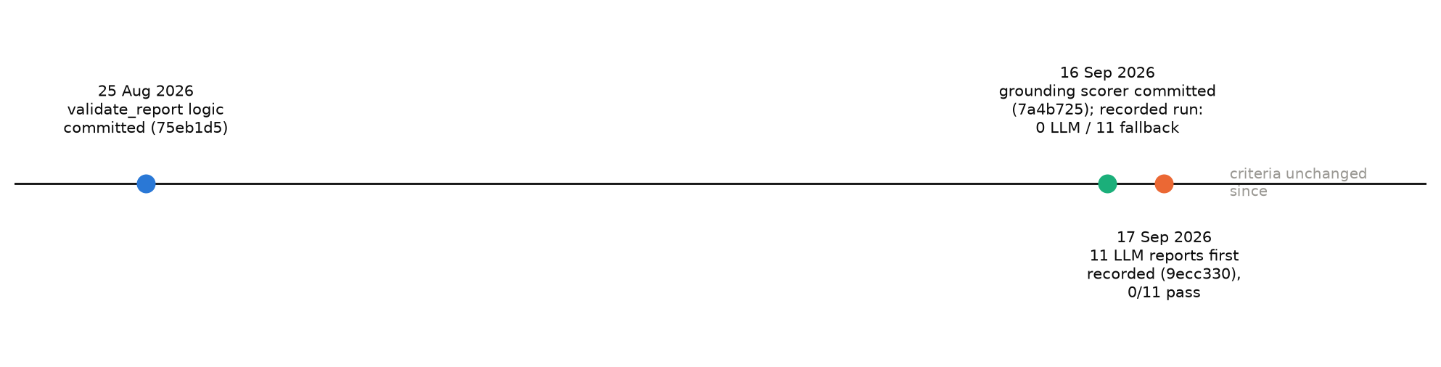
Figure 3. Order of events from git history: validator, then scorer (recorded with 0 model-generated reports), then the 11 model-generated reports.
Supporting argument and limits
- The 0/11 result comes from `validate_report`, the oldest of the artefacts: every report failed on unacknowledged withheld metrics (cross-setting and cross-contributor comparison).
- Earlier attempts. Before the recorded run the reporting call failed structurally (prompt-only formatting on the /v1 endpoint); schema-constrained decoding was adopted to fix structure, before any governance result existed (docs/paper/clarification_answers_round2.md, Q7). Those attempts fell back to the template and were not scored.
- The one calibration that was made (matching numbers at printed precision) was calibrated on the deterministic template, whose prose is grounded by construction, not on model output; it is documented in the scorer and precedes the model-generated run.
- Limit. Commit dates bound when code and results entered version control, not when a run executed; the result file carries no run timestamp. The ordering of commits is therefore the evidence offered; the exact time of the run within 16–17 September is not recorded.
Suggested manuscript wording (Section 2.19)
"The four pass/fail criteria were fixed in version-controlled code before the 11 reports were generated and were not modified afterwards: the governance validator (prohibited content; acknowledgement of insufficient evidence and of each withheld metric) was committed on 25 Aug 2026, and the numeric-grounding and evidence-reference scorer on 16 Sep 2026, when no model-generated report had yet been recorded (commits 75eb1d5, 7a4b725; reports recorded in 9ecc330)."

How this document was produced
uv run python -m tests.eval.extraction.round8_analysis # no model calls; needs exp-data/ locally
uv run python docs/paper/make_round8_response.py

