Governance-Aware Human-in-the-Loop AI for Structuring Longitudinal Autism Intervention Evidence and Generating Evidence-Linked Reports: Development and Component Evaluation Study
Original Paper - JMIR AI

Ambar Nath Saha
Artificial Intelligence in Healthcare, Independent Research, Halifax, CAN 2. Information Technology, Cognizant Technology Solutions Canada, Inc., Halifax, Canada
Debashis Patra
Artificial Intelligence and Machine Learning, The University of Texas at Austin, Austin, USA
Corresponding author: Ambar Nath Saha, ambar.sah@gmail.com

Abstract
Background: Longitudinal autism intervention review is often a manual synthesis task. An intervention specialist may receive observations from parents, teachers, caregivers, trainers, and other people who interact with a child across home, school, intervention, and community settings. These observations are commonly recorded as free-text notes that differ in vocabulary, detail, timing, and context. To understand whether meaningful patterns are emerging over time, the specialist must read these observations individually, reconcile what different contributors have seen, identify missing evidence, and relate the accumulated information back to intervention goals. As the volume of observations grows, this process becomes increasingly time-consuming and difficult to perform consistently. Large language models (LLMs) could help organize such evidence, but directly allowing a generative model to convert notes into longitudinal conclusions introduces important risks: unsupported fields may be created, ambiguous information may appear certain, missing or unrepresentative evidence may be overlooked, and fluent summaries may imply conclusions that the source material does not justify. A safer approach therefore requires AI to support evidence preparation while preserving explicit reference standards, deterministic governance, provenance, abstention, and professional authority.
Objective: This study developed a governance-aware, human-in-the-loop application to support longitudinal autism intervention review and evaluated the AI components that determine whether unstructured observations can safely enter a structured evidence pathway. The system was designed to reduce the burden of organizing distributed observations, make evidence gaps visible, support review of deterministic longitudinal indicators, and allow report statements to be traced back to source evidence, while keeping diagnostic, treatment, goal-setting, and intervention decisions under human professional control.
Methods: The application implements interventionist-owned child workspaces, role- and child-specific authorization, interventionist-defined goals, goal-linked observation schedules, missed-submission handling, conversational observation entry and clarification, immutable source observations, versioned correction, deterministic validation, evidence-adequacy and representation routing, partial or full abstention, deterministic longitudinal analytics, evidence-linked reporting, and audit trails. To evaluate the observation-structuring layer, 2 public ASDBank corpora yielded 2,442 behavioral segments from 11 children across 85 sessions. Two autism intervention specialists independently annotated a 330-segment main batch. Analysis of their disagreements identified 3 underspecified coding boundaries, which were formalized in a written codebook. The affected segments were then independently re-annotated using the revised codebook, in a newly randomized order and without access to the Round 1 annotations; domain was retained as an untreated control. Remaining disagreements were resolved by consensus. A separate model-independent set of 132 segments was independently annotated using the final codebook. No model was trained or fine-tuned. Four locally served instruction-tuned LLMs were evaluated against the adjudicated main-batch gold standard. MARS, an offline multi-judge reranking framework, was evaluated using the original 3-generator candidate roster. The strongest single generator identified through offline evaluation was selected for the operational extraction path. A separate Qwen 2.5 7B reporting LLM generated professional-facing reports using native JSON-schema constrained decoding, with deterministic governance validation applied downstream.
Results: Mean Cohen κ across the 4 categorical annotation fields increased from 0.610 in Round 1 to 0.801 after the codebook process, while the model-independent held-out first pass achieved a mean κ of 0.910. The 3 fields addressed by the codebook improved by 0.293 to 0.481, whereas the untreated control changed by −0.041. Qwen 2.5 7B was the strongest single generator, achieving 43.1% mean categorical-field accuracy and 4.5% whole-record accuracy on the model-conditioned main batch. Qwen 3 14B achieved similar mean accuracy (42.0%) but asserted values in 191 of 197 (97%) opportunities in which the gold standard indicated that the source supported no value. Among 142 segments requiring genuine reranking, MARS achieved 43.5% mean field accuracy, compared with 47.4% for always selecting the strongest generator and 32.5% for random candidate selection. Eleven schema-constrained reports contained no prohibited diagnostic, treatment, causal, or prognostic content; however, 8 of 122 (6.6%) numeric assertions were absent from the evidence packet, and 0 of 11 reports passed governance validation because analyses deliberately withheld upstream were not explicitly acknowledged downstream. The complete application workflow was also exercised repeatedly through manual end-to-end testing in a controlled development environment and functioned as intended across the implemented operational paths; this testing assessed functional behavior rather than clinical usability or effectiveness.
Conclusions: The findings suggest that trustworthy AI support for longitudinal autism intervention review cannot be reduced to the accuracy of a single language model. Reliable human definitions were required before model performance could be interpreted; a larger model was not necessarily safer; reranking could not overcome weak candidate quality; and structurally constrained report generation still failed to preserve all upstream governance decisions. These findings support an architecture in which generative AI performs bounded language tasks inside a broader evidence-governance system. The resulting application combines explicit null handling, deterministic validation, versioned evidence, adequacy and representation checks, abstention, deterministic analytics, traceability, and interventionist review so that AI can help organize the longitudinal evidence without assuming professional decision authority. The system remains a controlled-development research application; it is not claimed to be production-ready or to improve clinical or child outcomes.
Keywords: autism; large language model; natural language processing; information extraction; human-in-the-loop; longitudinal monitoring; abstention; trustworthy AI; evidence provenance; digital health

Introduction

Background and Unmet Workflow Need
Longitudinal autism intervention review rarely depends on a single observation or a single setting. A parent may notice a change during a morning routine, a teacher may see something different in the classroom, a caregiver or trainer may observe the same goal under another set of demands, and an intervention specialist may see the child under more structured conditions. Each observation can be meaningful, but none necessarily tells the whole story. Prior autism research has shown that parent and teacher reports can differ across home and school contexts, and that multi-informant evidence can therefore matter for planning and interpretation [1,2]. School-based longitudinal monitoring has likewise demonstrated the value of repeated measures across caregivers, teachers, and clinicians [3]. More recent digital-phenotyping work reflects the broader move toward scalable longitudinal measurement in autism while emphasizing that digital signals should complement rather than replace professional interpretation [4].
The burden falls on the intervention specialist who has to turn these scattered observations into a coherent longitudinal picture. In practice, that often means locating notes from different people, reading them one by one, deciding whether two descriptions refer to the same behavior, distinguishing a genuinely new pattern from a repeated observation, noticing when an expected setting has gone silent, and relating the accumulated evidence back to individualized goals. Free text is valuable because it lets contributors describe what actually happened in their own words, including context that a rigid checklist may never anticipate. At the same time, free text is difficult to compare over weeks or months because contributors differ in vocabulary, reporting frequency, familiarity with intervention terminology, and level of detail. The central workflow problem is therefore not simply how to collect more observations; it is how to help an intervention specialist organize, compare, and trust them without stripping away the context that made them useful.
Conversational AI and large language models (LLMs) create an obvious opportunity because they can transform natural-language observations into structured information and can summarize large amounts of text. Recent work has explored these capabilities for health documentation, structured history taking, clinical information extraction, and professional workflow support [5-9]. In autism, a proof-of-concept conversational platform has shown that AI-supported structured history taking is feasible when the system remains bounded to referral-support functions [5]. Across clinical text domains, credible evaluations have relied on task-specific reference standards and human review rather than assuming that a general-purpose language model is automatically trustworthy in a specialized workflow [6,7]. These studies motivate the use of LLMs for evidence organization, but they also sharpen the harder question addressed here: once an AI system has converted a narrative into structured data, how do we know which parts are truly supported, which parts should remain unknown, and when the available observations are too incomplete or unbalanced to justify a longitudinal conclusion?

Why Governance Must Extend Beyond the LLM
The risk appears at the moment natural language is converted into structured evidence. A model asked for a prompt level, modality, or outcome can return a plausible value even when the observation never supplied enough information to support one. In a chat window, an unsupported statement may still look like a model-generated answer. In a database, however, the same unsupported value can look like a fact: it can be counted, trended, compared across settings, and repeated in a professional-facing report. For a longitudinal system, that distinction matters. A single invented field can be propagated faithfully by every downstream calculation even though the error began at extraction.
For that reason, abstention is not an optional confidence label; it is part of the evidence model. Selective-prediction research in clinical extraction has shown that withholding uncertain predictions can improve reliability when a wrong answer is more costly than no answer [11], and recent reviews of LLM abstention in health care similarly note that language models are often biased toward producing an answer even when uncertainty is high [12]. In longitudinal autism intervention review, withholding can be necessary at two different levels. A single observation may not support a particular field, and a collection of individually valid observations may still be inadequate for a requested comparison because one setting, contributor, time period, or goal is underrepresented. A system that can abstain only at the model-output level therefore remains incomplete.
Governance must consequently extend beyond the LLM itself. Trustworthy medical AI guidance increasingly treats traceability, robustness, usability, and human involvement as lifecycle requirements rather than interface decorations added after a model is built [13-15]. In the present context, that means the intervention specialist must remain able to see the original observation, understand how it was structured, correct the evidence record, see why a metric was withheld, and make the final intervention decision. Permissions, provenance, evidence sufficiency, versioning, deterministic analytics, and report validation cannot be delegated to a generative model simply because the model is fluent.

Study Contribution and Novelty
This study therefore approached the problem from the intervention specialist's workflow outward rather than from the language model inward. We developed a complete, controlled-environment application centered on an interventionist-owned child workspace. The intervention specialist defines goals, observable indicators, review periods, authorized contributors, settings, and observation expectations. Parents, teachers, caregivers, trainers, and other authorized contributors can then record what they observed in ordinary language. The system preserves those narratives as source evidence, uses AI only where language understanding or communication is required, and relies on deterministic services for authorization, validation, evidence-adequacy checks, analytics, versioning, and audit logic. The professional report is generated from validated evidence and precomputed metrics rather than from an unconstrained reading of raw notes.
The AI work reported in this paper is an important component of that larger application, but it is not the application itself. Our initial development plan considered supervised foundation-model adaptation. The available labeled data were not sufficient for the intended fine-tuning strategy, so the research path changed rather than forcing a weak training experiment. We instead compared several pretrained, locally served instruction-tuned models, created an interventionist-adjudicated reference standard with explicit null states, evaluated an offline multi-judge reranking framework (MARS), and tested a separate reporting LLM under deterministic governance. This shift allowed us to examine questions that are directly relevant to the safety of the full workflow: whether the annotation scheme was stable enough to judge a model, whether models invented values where the human reference recorded none, whether reranking could rescue weak candidates, and whether downstream reporting preserved information that the governance layer had deliberately withheld.
The novelty of the work is therefore not a claim that one LLM can understand autism intervention or decide whether a child is improving. It is the integration of distributed observation capture, explicit evidence semantics, professional correction, evidence-adequacy checks, deterministic longitudinal analytics, abstention, provenance, and evidence-linked reporting into one human-governed pathway. The intended benefit is practical: reduce the amount of manual evidence organization required of intervention specialists, make missing or unrepresentative evidence visible before it becomes a conclusion, and preserve a traceable path from a professional-facing statement back to the observation that supports it. In this design, AI helps assemble the evidence; it does not inherit the authority to interpret a child's needs or decide an intervention.

Objectives
The study had two linked objectives. First, we sought to build the complete controlled-environment application needed to support this longitudinal workflow from observation capture through professional review. Second, we evaluated the components most likely to undermine evidence integrity if they failed. We asked whether two autism intervention specialists could establish a sufficiently stable reference standard; how accurately locally served LLMs populated the structured schema and how often they asserted values that the source did not support; whether offline MARS reranking improved candidate selection over random and best-single-generator policies; whether deterministic adequacy routing could preserve unavailable-analysis states; and whether the reporting LLM remained grounded in the evidence packet and explicitly communicated abstention. The study did not test treatment decisions, clinical effectiveness, diagnostic performance, or child outcomes.

Methods

Study Design and Reporting Approach
This was a staged development and component-evaluation study built around one end-to-end question: can distributed natural-language observations be moved through a longitudinal review workflow without allowing uncertainty to disappear as the information becomes more structured? The development arm produced a functioning, role-based application for controlled research use. The empirical arm then examined the points in that workflow where AI could distort the evidence: the human reference standard, structured extraction, offline candidate reranking, and professional-facing report generation. Repeated manual end-to-end testing was used during development to exercise the integrated application and correct defects until the implemented paths operated as intended in the controlled environment. That testing established functional operation of the workflow; it was not designed as an independent usability, security-certification, or clinical-effectiveness study.
The manuscript follows an IMRD structure, with Methods and Results aligned to the major stages of the system and evaluation. Reporting of implementation context and technical design was informed by iCHECK-DH [16]. FUTURE-AI and DECIDE-AI informed the discussion of traceability, human oversight, staged validation, and appropriate claims [14,15]. Because no live AI-supported treatment decisions were evaluated, the study is not presented as a clinical DECIDE-AI evaluation.
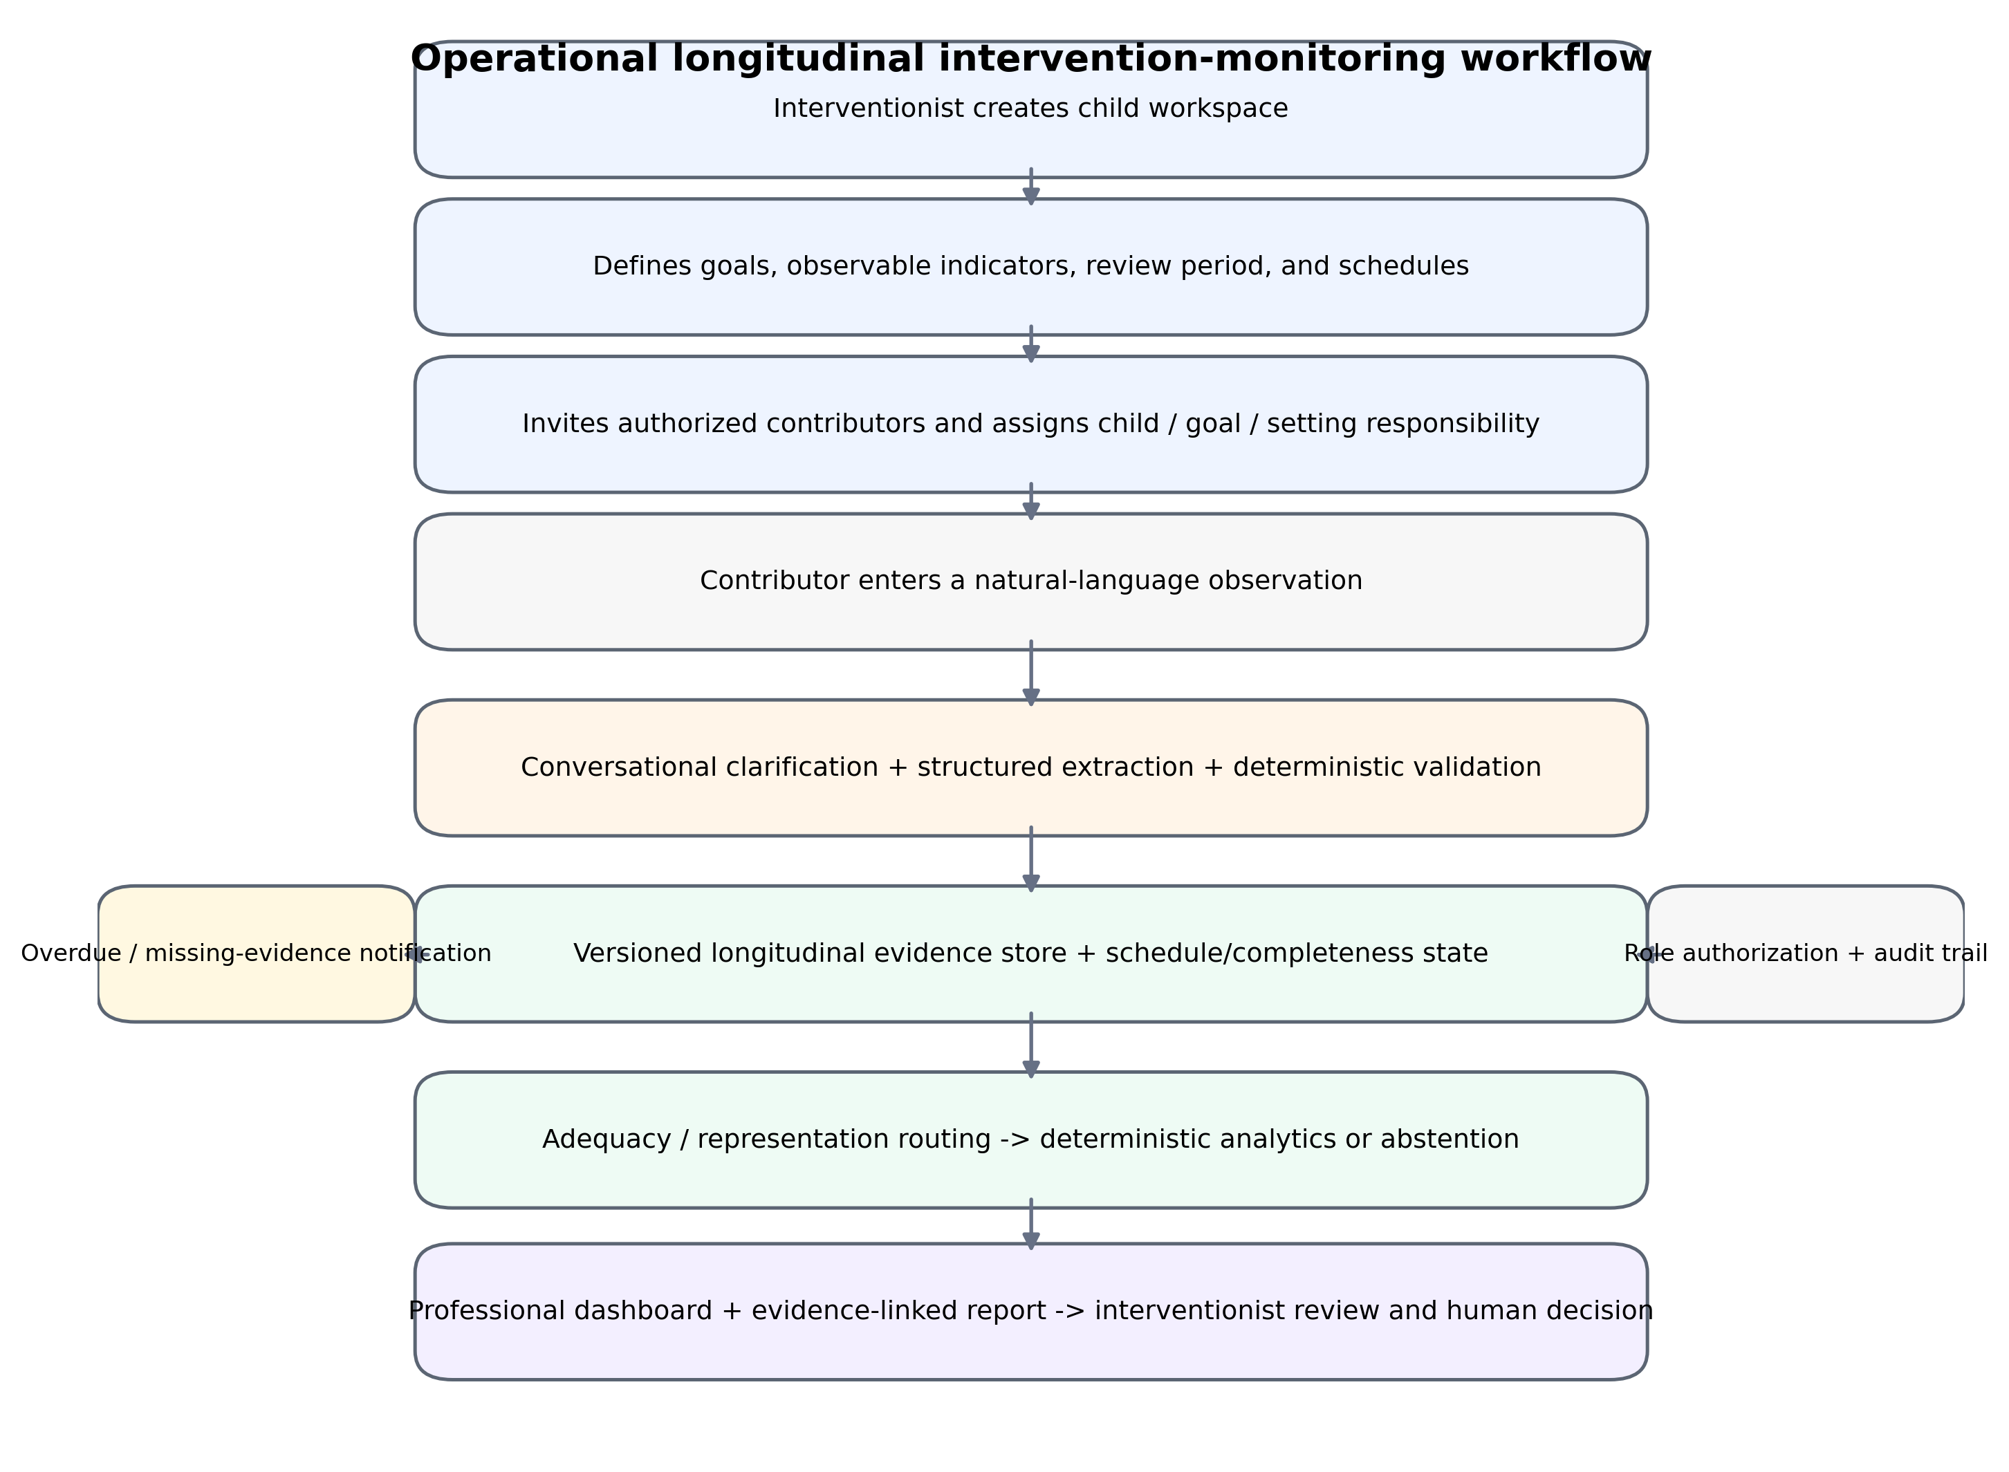
Figure 1. Operational application workflow. Observation scheduling and completeness are treated as evidence-governance functions, and professional synthesis remains interventionist-facing.
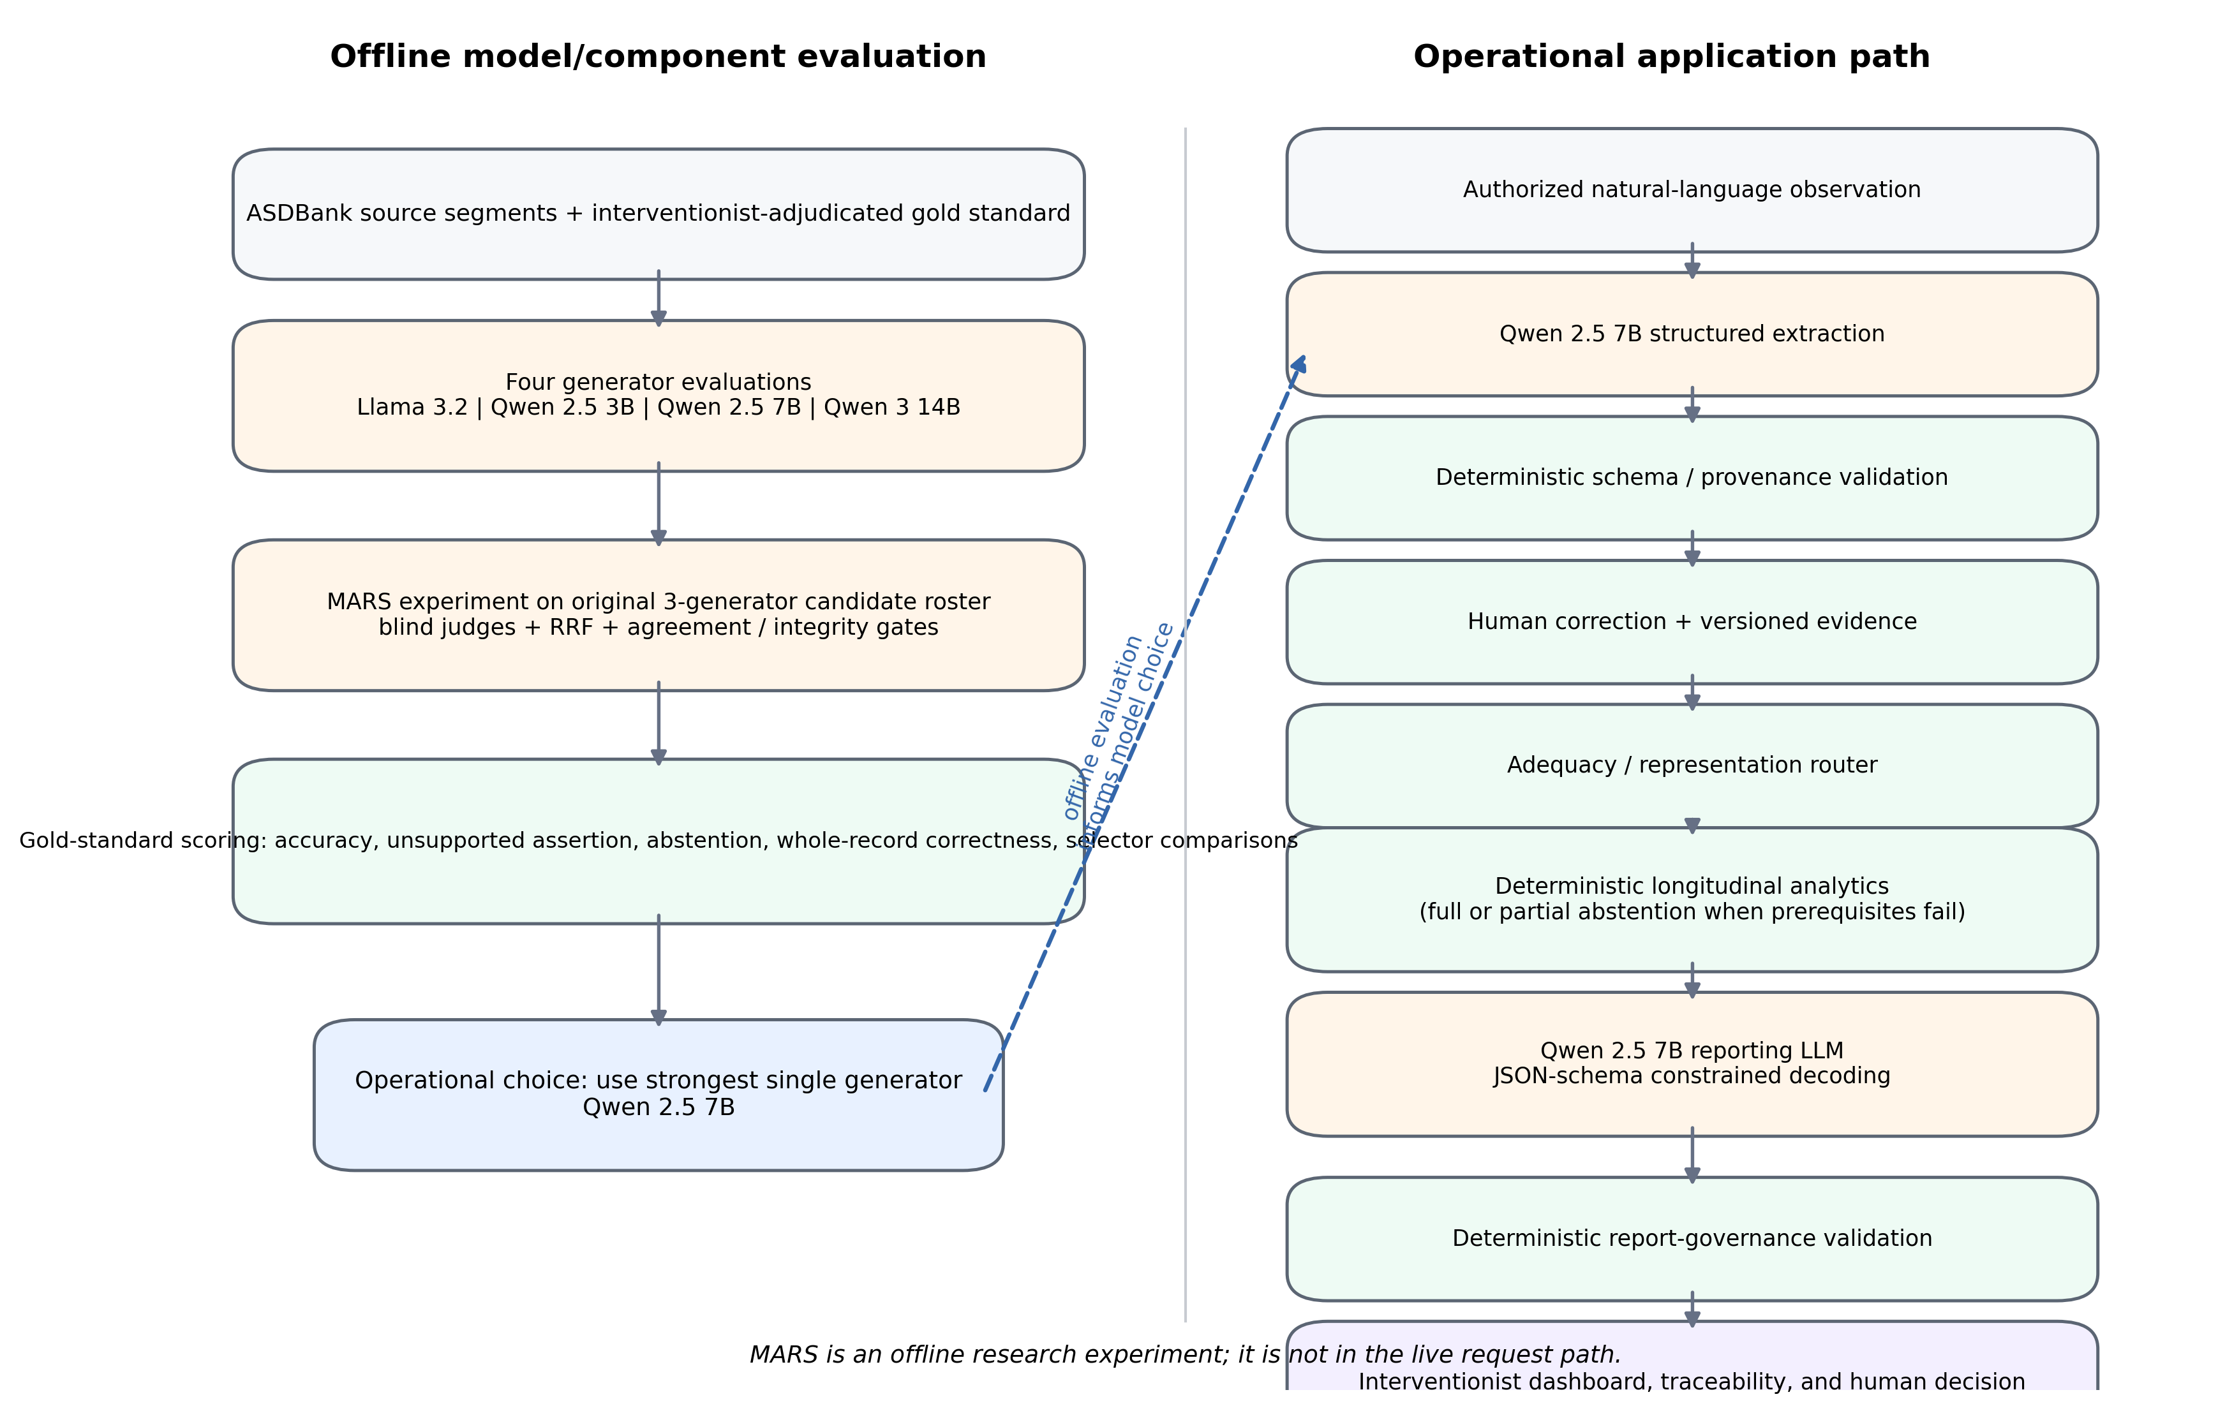
Figure 2. Separation of offline model/component evaluation from the operational application path. MARS was evaluated offline and is not in the live request path. The strongest single generator, Qwen 2.5 7B, was selected for operational extraction.

Intended Use and Explicit Nonuse
The intended use begins before any model is called. An intervention specialist creates the monitoring context for a child: the goals under review, the people who are expected to observe those goals, the settings in which observations matter, and the period over which evidence will be reviewed. Authorized contributors then submit natural-language observations within that context. The application organizes the observations into governed structured records, tracks whether expected evidence actually arrived, determines which descriptive analyses are supportable, and presents the intervention specialist with an evidence-linked view of the review period. The final interpretation remains a professional act. The intervention specialist decides, in context, whether a goal or strategy should continue, change, pause, or end.
The application is intentionally narrower than a diagnostic or treatment system. It is not designed to diagnose autism, determine eligibility for services, prescribe or recommend treatment, create or modify intervention goals autonomously, replace standardized assessment instruments, rank children, infer causes of behavior, or make a final judgment that a child has clinically improved. Giving someone permission to submit an observation does not give that person professional decision authority. These boundaries are enforced through role-based authorization, evidence contracts, deterministic routing, and reporting constraints rather than being left as informal instructions to an LLM.

Application Roles, Authorization, and Child Workspaces
The intervention specialist is the owner of each child workspace because the monitoring plan has to begin with a professional question, not with whatever data happen to be available. For each review period, the specialist defines active long- and short-term goals, observable indicators, authorized contributors, relevant settings, and expected observation cadence. Potential contributors can include parents or caregivers, teachers or educational support staff, trainers or home implementors, secondary professionals, and other explicitly approved observers. Access is both child-specific and role-specific: a contributor can submit evidence for the child and context to which they are assigned, but cannot discover unrelated child records, redefine goals, change permissions, or see professional analytics unless explicitly authorized.
Authorization is treated as part of the evidence history. Invitation, activation, role assignment, permission changes, and revocation are versioned events. Revocation blocks future access without erasing prior submissions or audit history, because evidence already used in a review should not disappear when a relationship changes. Users associated with more than one child remain scoped to the children for whom they hold active authorization. Permission checks are enforced at both the user-interface and service/API layers so that hiding a control on screen is never mistaken for access control.
Table 1. Core authorization and visibility model implemented in the controlled-development application.
Application function | Interventionist / owner | Contributor roles | Secondary professional
Create/manage child workspace | Allowed | Not allowed | Only if explicitly authorized
Define/edit goals and review context | Allowed | Not allowed | Only within professional permission
Invite/revoke contributors | Allowed | Not allowed | Not allowed by default
Configure setting/cadence responsibilities | Allowed | Not allowed | Not allowed by default
Submit natural-language observations | Allowed | Assigned child/goals only | If assigned
Answer clarification questions | Allowed | Own submission only | Own submission only unless authorized otherwise
Correct AI-structured evidence | Allowed | Not allowed by default | Professional permission only
View adequacy warnings, KPIs, trends, report | Allowed | Not allowed | Professional permission only
Make goal/intervention decisions | Human professional authority | No | According to professional authority

Goal-Linked Scheduling, Missing Evidence, and Notifications
Longitudinal review depends not only on what was submitted but also on what was expected and never arrived. Observation schedules are therefore tied to the child, goal or goal set, contributor role, setting, and cadence rather than being defined globally for the child. Recurring schedules can represent regular home or school observations, while event-based expectations can represent an observation after an intervention session. This scheduling state gives the system a denominator for completeness: a missing expected observation is a gap in evidence, whereas a submitted observation with an unknown field is evidence that exists but is incomplete in a different way.
When an expected submission becomes overdue, the application records an evidence-availability event and can notify the responsible contributor and intervention specialist through configured channels. The reminder communicates only that expected evidence is missing; it does not interpret the absence as failure, lack of progress, or deterioration. Schedule changes are versioned prospectively so that changing next month's cadence does not silently rewrite the historical expectations against which earlier completeness was judged.

Conversational Observation Capture and Clarification
Contributors enter observations through a conversational interface opened inside the assigned child and goal context. The application already knows facts such as child identifier, contributor role, observation date, session identifier, and setting, so these are supplied by the system rather than guessed by the LLM. The contributor can therefore focus on describing what happened in ordinary language. The original narrative is retained immutably and remains linked to every structured version derived from it.
If a material detail is ambiguous and could reasonably be clarified by the observer, the system can ask a narrow follow-up question about that observation. The clarification process is intentionally bounded: contributors are not asked to diagnose the child, speculate about causes, recommend treatment, or decide whether a goal should change. If the missing detail cannot be recovered, the corresponding field remains unknown or unsupported. Completing the schema is never treated as more important than preserving what the observer actually knows.

Human Verification, Versioned Evidence, and Professional Review
AI interpretation is not treated as final evidence. The intervention specialist can inspect the source observation beside the structured record and correct any field that was misinterpreted. A correction creates a new evidence version rather than overwriting the source narrative or silently replacing history. Downstream adequacy decisions, metrics, and reports are then regenerated from the corrected evidence. The audit trail records who made the change, when it was made, the previous and new values, and the associated model or configuration when available. Corrections may later support offline research, but they do not trigger uncontrolled online learning.
The professional dashboard is designed to keep evidence quality visible alongside apparent progress. It shows the goals and review period, expected versus received observations, overdue or unresolved evidence, quality and representation warnings, and - only when prerequisites are met - deterministic KPIs and trends. A withheld analysis is displayed as an explicit abstention state with a reason rather than as an empty chart that could be misread as 'no change.' Report statements can be traced to a metric or structured record and then back to the original observation. Cross-setting analytics and the professional report are not automatically exposed to contributors simply because they supplied one piece of the evidence.

Data Source, Corpus Construction, and De-identification
To evaluate the observation-structuring components without exposing private intervention records, we used archival public data from the ASDBank English Rollins and Flusberg corpora within TalkBank [18-22]. The Rollins material contains child-investigator interactions and the Flusberg material contains longitudinal child-parent interactions. Across both corpora, 11 children, 85 sessions, and 75,003 utterances were available. CHAT transcripts were parsed, de-identified, and segmented into behavioral episodes, yielding 2,442 segments, with 162 to 273 segments per child.
Before any model processed the text, participant names, street addresses, numeric dates, national identifiers, and telephone numbers were replaced with placeholders across utterance text and dependent tiers. The procedure was driven by participant rosters and transcript headers rather than by a named-entity recognition model. This conservative strategy can over-redact when a child pseudonym is also an ordinary English word. Rather than assuming that such preprocessing is harmless, we report this as a limitation because redaction can alter the linguistic context available to a model.
The main evaluation batch was deliberately constructed to support complete candidate comparisons. A stratified pool of 120 segments per child (1,320 total) was created, and the original 3 candidate generators were run over that pool. Segments were retained under a wider 'judgeable' policy when all 3 generators returned at least one populated extracted field, even if a provider status suggested abstention. This consumed 506 pool segments to obtain the frozen 330-segment main batch (30 per child). We used the wider rule because a model that says 'abstain' while still filling clinical fields has still produced content that needs to be judged. However, conditioning batch membership on generator behavior makes the main batch easier than an unconstrained sample and therefore limits external validity.
To measure that selection effect rather than merely acknowledge it, we created a separate model-independent held-out set of 132 segments (12 per child) from the 2,051 segments outside the entire original pool. The held-out sample was frozen before generator runs, and every segment was retained even when a model failed to produce admissible output. At manuscript freeze, both intervention specialists had completed independent annotation and all 4 generator runs had been recorded, but adjudication of 133 conflicting fields was still incomplete. Accordingly, the held-out set contributes first-pass reliability and model-admission comparisons, but not held-out extraction accuracy or unsupported-assertion rates.
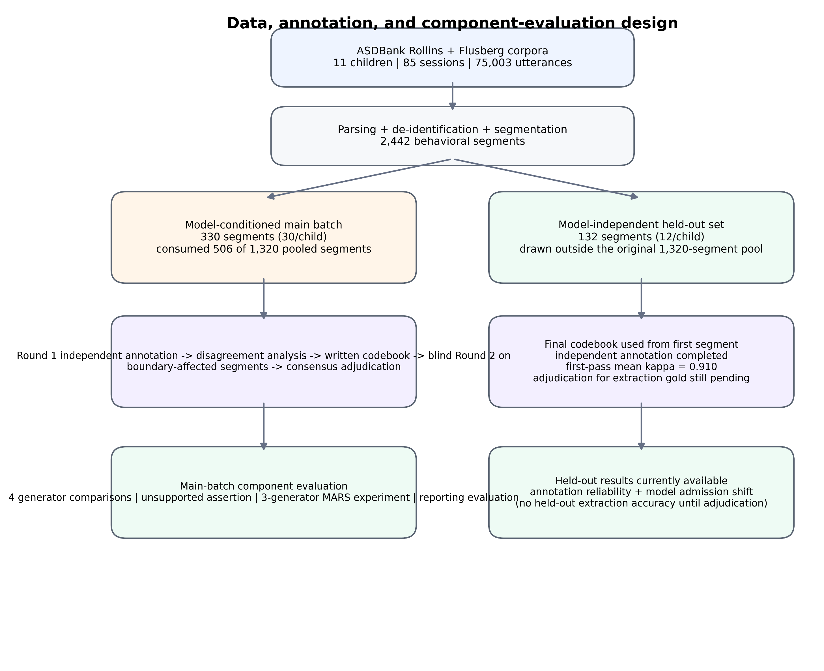
Figure 3. Corpus, annotation, and component-evaluation design. The main batch supports the adjudicated gold standard and reported model/MARS analyses; held-out extraction accuracy awaits adjudication.

Structured Observation Schema and Interventionist Reference Standard
The production observation schema asks the extraction model for 8 fields: behavior, domain, duration_seconds, goal_context, modality, outcome, prompt_context, and prompt_level. The evaluation study focused on the 5 fields for which an interventionist reference standard was created: behavior as free text and 4 categorical fields - domain, modality, prompt_level, and outcome. The other 3 extracted fields were not included in the annotation batch and therefore were not scored. Separately, 5 fields already known to the application - child_id, contributor_role, observation_date, session_id, and setting - are supplied by the application and are never generated by the model.
Table 2. Annotated extraction schema and null semantics.
Field | Allowed values / form | Evaluation treatment
domain | social_communication; language; play; behavior; motor; cognitive; adaptive; sensory; null | Categorical, scored
behavior | Free text | Reported separately by token-overlap distribution
modality | verbal; gestural; sign; aac; written; multimodal; unknown; null | Categorical, scored
prompt_level | independent; gestural; verbal; model; partial_physical; full_physical; unknown; null | Categorical, scored
outcome | correct; incorrect; approximation; no_response; partial; unknown; null | Categorical, scored

A key design choice was to preserve three different forms of 'not having a value.' JSON null means the source text supports no value for that field; this is itself a substantive reference-standard judgment. The categorical value unknown means that the phenomenon occurred but its subtype cannot be determined from the text. A missing field means that the model did not return a value and is treated as missing output or abstention during scoring. Keeping these states separate is what makes unsupported assertion measurable: if human annotators concluded that the source supports no value, a model should not receive credit for filling the field with a plausible guess.
Two autism intervention specialists independently annotated all 330 segments in the main batch. Round-1 disagreement analysis revealed that several conflicts were not simply differences in professional judgment; they arose because 3 decision boundaries had not been defined precisely enough. Those boundaries concerned whether gestural modality includes ordinary object manipulation or only communicative gesture directed toward a partner, whether correct/incorrect can be assigned when no identifiable target exists, and whether an adult utterance preceding a child response is itself a prompt or the antecedent that creates the opportunity. These issues were translated into explicit written codebook rules. Domain was re-annotated at the same time but received no new rule, allowing it to serve as an untreated control for practice or regression-to-the-mean effects.
Round 1 produced 355 categorical conflicts across 215 segments. Of these, 254 conflicts fell on the 3 codebook boundaries and affected 178 segments. Those 178 segments were then independently re-annotated using the revised codebook, in a newly randomized order and without access to the Round-1 annotations. The remaining 152 segments retained their Round-1 categorical values. Residual categorical disagreements were resolved through consensus discussion between the same 2 specialists, and free-text behavior wording was reconciled so that each segment had a complete reference record. The resulting adjudicated gold standard contains all 330 main-batch segments.
The same 2 specialists also independently annotated all 132 held-out segments using the final codebook from the first item. This round asks a different question from Round 2: can the final protocol be applied consistently to a model-independent set without first selecting segments according to generator tractability? It does not isolate the codebook's causal effect because the annotators had accumulated experience by that stage, but it provides a useful first-pass reliability check on the final rules.

Annotation Reliability and Statistical Analysis
Cohen kappa was calculated separately for each categorical field, with explicit null treated as a category [17]. Kappa values were not pooled across fields because the fields use different vocabularies and share literal labels; pooling would chance-correct against a category distribution no annotator actually used. Maximum attainable kappa under the observed marginal distributions was also calculated to distinguish disagreement caused by incompatible category usage from disagreement within a shared vocabulary [23].
Because multiple segments came from each child, primary reliability confidence intervals used 10,000-replicate bootstrap resampling of children, with each sampled child contributing all of that child's segments. Segment-level intervals were retained as a sensitivity analysis. Codebook effects were estimated as paired changes in kappa on the re-issued segments and interpreted alongside the untreated domain control. MARS selector differences were evaluated on the same judged segments using paired 10,000-replicate bootstrap intervals. The analysis emphasizes effect sizes, failure modes, and interval estimates rather than relying solely on dichotomous significance testing.

Offline LLM Generator Evaluation
No model learned from the annotation dataset. We did not fine-tune, LoRA/QLoRA-adapt, or otherwise update any model weights. Every generator and judge was a pretrained instruction-tuned checkpoint used with prompts only. The interventionist annotations were used after generation to build the reference standard and score model behavior; they were never shown to a generator or judge as training examples. This distinction matters because the study evaluates extraction behavior, offline selection, and governance rather than supervised domain adaptation.
Table 3. Locally served model roster used in component evaluation.
Model role | Model digest / size | Quantization | Context
Generator: Llama 3.2 | a80c4f17acd5 / 3.2B | Q4_K_M | 131,072
Generator: Qwen 2.5 3B | 357c53fb659c / 3.1B | Q4_K_M | 32,768
Generator: Qwen 2.5 7B | 845dbda0ea48 / 7.6B | Q4_K_M | 32,768
Generator added after original MARS: Qwen 3 14B | bdbd181c33f2 / 14.8B | Q4_K_M | 40,960
Judge-only: Mistral | 6577803aa9a0 / 7.2B | Q4_K_M | 32,768

All models were served locally with Ollama 0.33.3 on the same Apple M5 Pro system (15 cores, 24 GB unified memory, macOS 26.6.2, Python 3.12.12), using the integrated Apple GPU and shared unified memory. Running every model on the same machine avoided hardware differences as an explanation for performance differences. Qwen 3 14B occupied approximately 9.6 GB and long runs sometimes terminated under memory pressure; resumable checkpointing was therefore used. This affected wall-clock execution but not the preserved outputs used in the reported analysis.
The extraction prompt was versioned as 1.0.0 and deliberately made room for 'no supported value' as a correct answer. The system prompt listed the target fields and categorical values, instructed the model to use null when the text did not clearly support a field, prohibited fabrication and unsupported inference, and discouraged diagnostic, treatment, or causal claims. Each segment produced one forced record_observation tool call. Temperature, top_p, top_k, maximum tokens, and generation seed were not explicitly set and therefore used server defaults where applicable. Because the raw generation step was not seeded, re-running the models is not guaranteed to reproduce the same text or fields. For reproducibility of the reported study, the original generator outputs were frozen and replayed for all downstream scoring and MARS analyses.
Generator performance was evaluated in ways intended to reflect both usefulness and safety. We measured acceptable field extraction (the correct categorical value or a correct null), whole-record correctness across the 4 categorical fields, missing output/abstention, and unsupported assertion when the gold standard explicitly recorded null. Free-text behavior was analyzed separately using Jaccard similarity over lowercased whitespace-delimited word sets. Behavior was excluded from binary whole-record correctness because the default 0.5 lexical-overlap threshold was not reached by most human-human descriptions of the same event; otherwise wording differences would dominate the result.

Offline MARS Multi-Judge Reranking Experiment
MARS was evaluated offline to test whether multiple model candidates could be ranked more effectively than simply accepting one generator's output. It was never placed in the operational request path. The reported candidate roster comprised Llama 3.2, Qwen 2.5 3B, and Qwen 2.5 7B. Qwen 3 14B was evaluated later against the same gold standard and served as a judge in the reported MARS run, but it did not contribute candidate extractions to that run. Accordingly, the paper reports a 3-generator MARS experiment and does not imply that a 4-generator reranking result exists.
At runtime, a candidate was 'reviewable' if the provider status was SUCCESS or PARTIAL, at least one observation existed, and at least behavior or domain was populated. Candidate records were deduplicated using a deterministic hash of normalized extracted fields. Zero reviewable candidates caused abstention; one candidate short-circuited directly to output without judging; 2 or more candidates triggered reranking. A model was not permitted to judge a segment if that exact model had generated one of its candidates, preventing self-evaluation. The full judge roster was Llama 3.2, Qwen 2.5 3B, Qwen 2.5 7B, Mistral, and Qwen 3 14B, leaving 3 eligible judges on 124 rerank segments and 2 on 41.
Judges saw the source transcript and anonymized candidate records, each presented in a per-judge order. They did not see generator identity, generator confidence or status, the codebook, the gold labels, or other judges' rankings. Each judge returned a complete ordering of opaque candidate aliases. Valid rankings were fused with reciprocal rank fusion, score(c)=sum_j 1/(60+rank_j(c)). The provisional winner then had to be among the modal first choices; a modal tie caused abstention, and first-choice support had to be at least 0.5. This threshold was configured rather than empirically tuned. With 3 judges it behaves as majority rule; with 2 judges, a 1-1 split is rejected as a tie before the threshold is consulted. Finally, the selected record had to pass an integrity check showing that it was one intact candidate rather than a field-wise blend.
Judge inference used temperature 0, a 2,048-token budget, and one generation per judge. An earlier run used a 256-token budget and was discarded after Qwen 3 14B consumed the budget during reasoning and failed to emit parseable rankings on all 165 rerank cases. The corrected run recorded per-judge discard rates, with a maximum of 1.8%. The discarded run is preserved for provenance but contributes no performance result.

Operational Extraction Model Selection
The offline experiments were used to simplify, rather than complicate, the operational application. Qwen 2.5 7B was the strongest single generator on mean categorical-field accuracy and had the highest whole-record accuracy among the original generators. MARS showed that the judges could detect some candidate-quality signal, but it did not outperform the simpler policy of always using the strongest generator. The operational path was therefore configured around Qwen 2.5 7B as a single extractor, while MARS remains an offline research method for understanding candidate diversity, judge behavior, and the limits of reranking when the candidate pool itself is weak.

Deterministic Validation, Extraction Abstention, and Versioning
A generated structure is not allowed to become longitudinal evidence merely because it conforms to JSON. Deterministic code parses the candidate against a versioned schema, checks allowed field names and categorical values, preserves app-known provenance, and routes failures to clarification, professional review, null/unknown representation, or abstention according to their type. Provider self-reported status is not treated as authoritative. Across 496 abstentions from the original 3 generators, 494 (99.6%) still contained at least one populated field, illustrating why a model's statement that it 'abstained' is not sufficient evidence that it actually withheld content.
In the MARS experiment, generator confidence and selection confidence were kept conceptually separate. Selection confidence was derived from first-choice judge support, and when both quantities existed the control confidence was the lower of the selected generator's confidence and the MARS selection confidence. Single-candidate short circuits did not invent a selection-confidence value. In the operational single-generator path, deterministic evidence rules remain more important than self-reported model confidence because confidence was poorly calibrated in the evaluated roster.

Longitudinal Adequacy, Representation, and Deterministic Analytics
Once validated observations accumulate, the system asks a different question from extraction: is there enough evidence to support the longitudinal analysis being requested? A deterministic adequacy router checks 6 dimensions - observation coverage, temporal distribution, contributor representation, setting representation, active-goal coverage, and field completeness. The current configuration requires at least 5 records for an adequate state, uses 3 records as the lower boundary for limited evidence in critical-failure cases, requires at least 0.70 field completeness, and flags temporal clustering when more than 0.80 of observations fall within one temporal cluster. Contributor and setting representation pass when at least 2 distinct roles or settings are represented, and goal coverage passes when at least half of active goals are observed.
The router returns one of three states: insufficient, limited, or adequate. Zero observations are insufficient. A critical failure of coverage or field completeness with fewer than 3 observations is also insufficient; otherwise a critical failure is limited. More than 2 failed checks or fewer than 3 observations yields limited, while at least 5 observations with no failed checks yields adequate. An insufficient review causes full analytics abstention. Limited and adequate reviews may proceed, but individual KPIs can still abstain if their own prerequisites are not met. This allows partial abstention: the system may legitimately show a within-setting trend while withholding a cross-setting comparison because the second setting was never represented.
Table 4. Deterministic analytics implemented in the application and behavior in the 11-child reporting evaluation.
KPI family / result | Implementation rule | Reporting-evaluation status
Observation count and domain/modality/prompt/outcome distributions | Counts non-null validated values; no imputation | Computed for 11/11
Contributor and setting distributions | Counts validated app-known provenance | Computed for 11/11
Independence rate | prompt_level=independent / records with any prompt_level | Computed for 11/11
Positive outcome rate | Versioned deterministic mapping over validated outcomes | Computed for 11/11
Missing-data rate | Reports field absence as its own metric | Computed for 11/11
Prompt-support and outcome trends | Split dated records into first and second halves; report deterministic difference | Computed for 11/11
Cross-setting comparison | Requires >1 represented setting | Withheld for 11/11
Cross-contributor comparison | Requires >1 represented contributor | Withheld for 11/11

Missing fields are never silently filled in or treated as negative observations. They are excluded from the denominator of the affected metric, and missingness is reported through separate data-quality indicators. In the 11-child reporting evaluation, contributor and setting metadata had to be derived from corpus structure rather than from real intervention submissions. Each child's packet therefore contained only one derived setting and contributor role. All 11 reviews were consequently classified as limited, and cross-setting and cross-contributor comparisons were withheld by design.

Grounded Reporting LLM and Governance Validation
The reporting LLM sits at the end of the evidence pipeline, not at the beginning of the analysis. A separate Qwen 2.5 7B instance (digest 845dbda0ea48) receives a constrained evidence packet containing the review context, active goals, validated structured records, record identifiers and versions, deterministic KPI results, adequacy checks, quality flags, contributor and setting summaries, counts, and explicit abstention states. It does not calculate new progress metrics from raw notes. Importantly, a withheld KPI remains present in the packet with abstained=true and a reason, so failure to communicate that withholding can be detected rather than disappearing silently.
The reporting model was served through Ollama's native /api/chat endpoint with an 8,192-token context and a JSON Schema enforced as a native decoding constraint. An earlier prompt-only configuration used the OpenAI-compatible /v1 endpoint, where the native format constraint was not enforced; all 11 generations then failed structural conformance and fell back to a deterministic template. We treated that result as a configuration failure rather than evidence that the model could not follow the intended schema. Under native schema-constrained decoding, all 11 evaluated reports were structurally conformant. The context window was also increased from 4,096 to 8,192 after one child's evidence packet exceeded the smaller limit.
Structural validity was not considered equivalent to trustworthy reporting. A deterministic validator therefore checks for prohibited diagnostic, treatment, causal, prognostic, deficit/normality, or goal-modification language; verifies that insufficient evidence is acknowledged when applicable; verifies that each withheld KPI is acknowledged; and, in the evaluation instrument, checks numeric grounding and evidence-reference validity. Every numeric assertion must match a value present in the evidence packet at the printed precision, and every evidence reference must resolve to an allowed record identifier. After the governance failure described in Results, no post hoc prompt tuning or rerun was performed; the negative result was preserved rather than optimized away.

Controlled-Environment Application Architecture and Functional Verification
The application was implemented as a web-based controlled research system that separates identity and authorization, persistent evidence storage, scheduling and completeness services, deterministic validation and analytics, local model serving, professional dashboard views, and audit logging. That separation is deliberate: no single LLM call is expected to carry the responsibilities of access control, evidence sufficiency, longitudinal calculation, and professional communication. For the reported experiments, research models were served locally so that the ASDBank data were not sent to a third-party model API. Sensitive secrets and runtime configuration were kept separate from research artifacts, and model/configuration identifiers were associated with generated artifacts when available.
The implemented workflow spans workspace creation, goal definition, contributor invitation and revocation, role-scoped access, schedule configuration, natural-language observation capture, clarification, structured extraction, human correction and versioning, overdue-state handling, adequacy routing, full or partial abstention, deterministic metrics, report generation, evidence drill-down, and audit history. Multiple rounds of manual end-to-end testing were performed during development. Successful and denied paths were exercised, defects were corrected, and the tested flows were repeated until they behaved as intended in the controlled environment. Because this was developer functional verification rather than a prespecified independent usability study, we do not report a participant-level usability score, clinical workflow effect, or statistical pass rate.
The present system should therefore be understood as a functioning research application, not as production-ready clinical or educational software. Enterprise identity federation, institutional interoperability, formal penetration and security certification, multiregion resilience, disaster recovery, regulatory clearance, large-scale load testing, and prospective longitudinal monitoring were outside the scope of this study. Broader evaluation with practicing intervention specialists in real-world settings is required before routine deployment.

Ethical Considerations, Data Protection, and Reproducibility
The model-evaluation data came from archival public corpora collected by third parties. No child was recruited or contacted for this study, and no care was delivered, changed, or withheld on the basis of any system output. Manual application testing took place in a controlled development environment and did not constitute live clinical decision support. Public source data were de-identified before model processing, and only the contextual metadata necessary for the research task were used.
[TO COMPLETE BEFORE SUBMISSION: Insert the final ethics/IRB determination verbatim, including reviewing institution, protocol or determination number, date, and any applicable consent/waiver or corpus-license conditions. Do not characterize the status before the formal determination is issued.]
Reproducibility is anchored to preserved artifacts rather than to the assumption that stochastic model generation can be recreated exactly. The recorded evaluation state is associated with repository commit 6163d13 (full hash 6163d1306049c401ed0b25bf8c6d2bc986f40194) dated September 19, 2026. The environment used Python 3.12.12, Ollama 0.33.3, anthropic 1.2.0, openai 3.5.0, and pydantic 2.13.4, with the complete dependency lock maintained in the repository. The artifact manifest contains 51 recorded artifacts, 33 pinned by SHA-256. Sheet ordering, held-out sampling, bootstrap analyses, and the MARS run used fixed recorded seeds; generator inference itself did not use a generation seed, so the original outputs are preserved and replayed for all reported downstream analyses.
[TO COMPLETE BEFORE SUBMISSION: Insert public/archive repository URL, release tag, license, archival DOI if created, and the final data-sharing statement. Protected data, private credentials, and secrets must not be released.]

Results

Controlled Application Implementation and Functional Verification
The complete workflow described in Methods was implemented and exercised repeatedly in the controlled development environment. Manual end-to-end testing covered workspace and goal management, role-scoped contribution, contributor invitation and revocation, scheduling and overdue states, conversational observation capture, clarification, structured extraction, correction and versioning, adequacy routing, analytics eligibility and abstention, report generation, evidence traceability, and audit history. Development defects encountered during these runs were corrected and the affected flows were retested until the implemented paths operated as expected. These results establish that the intended workflow functions as a connected system in the controlled environment; they do not establish professional usability, clinical effectiveness, security certification, or production readiness.
The operational architecture uses Qwen 2.5 7B as the single extraction generator selected from the offline comparison. MARS remains outside the live request path. This separation is a direct consequence of the evaluation rather than an architectural omission: the offline reranker did not outperform the strongest single generator, so the live application retained the simpler path while preserving MARS as evidence about candidate quality and the limits of model selection.

Corpus, Main Batch, and Held-Out Set
Parsing and segmentation produced 2,442 behavioral segments from 11 children across 85 sessions. The main annotation/evaluation batch contained 330 segments, 30 per child, and the model-independent held-out set contained 132 segments, 12 per child. To obtain the 330 cases in which all original generators produced judgeable content, 506 segments had to be consumed from the 1,320-segment stratified pool. That attrition is important because it shows that the main batch represents inputs the models could at least attempt, not the full range of segments encountered in the corpus.
Table 5. Main and held-out evaluation sets.
Characteristic | Main batch | Held-out set
Children | 11 | 11
Segments | 330 | 132
Segments per child | 30 | 12
Selection | Conditioned on original 3-generator judgeable output | No generator-based selection
Annotation | Round 1 -> codebook-guided Round 2 -> consensus adjudication | Final codebook from first item; independent annotation complete
Current use | Gold standard + generator/MARS/report evaluation | First-pass reliability + admission shift; extraction gold pending adjudication

Annotation Reliability, Codebook Effect, and Gold Standard
Round 1 immediately exposed a problem that would have made any model score difficult to interpret: the human reference itself was not yet sufficiently stable. Mean kappa across domain, modality, prompt_level, and outcome was 0.610, with field-specific values of 0.751, 0.570, 0.595, and 0.524, respectively. For modality, however, the observed kappa of 0.570 represented 91.6% of the maximum attainable kappa (0.622) under the annotators' marginal category use. One specialist used the category none 75 times while the other used it zero times, and 80 of 91 modality disagreements were therefore forced by the incompatible category usage before transcript-specific judgment was considered. Across all categorical fields, 254 of 355 Round-1 conflicts fell on the 3 predefined codebook boundaries.
Table 6. Round-1 categorical annotation reliability; confidence intervals resample children.
Field | Kappa | 95% CI | kappa_max | Kappa / max
Domain | 0.751 | 0.704-0.790 | 0.921 | 0.816
Modality | 0.570 | 0.434-0.696 | 0.622 | 0.916
Prompt level | 0.595 | 0.519-0.675 | 0.839 | 0.709
Outcome | 0.524 | 0.467-0.577 | 0.758 | 0.691

After the codebook rules were introduced, the treated fields improved while the untreated control did not. On the re-issued segments, modality increased from 0.385 to 0.866 (change +0.481; child-bootstrap 95% CI 0.337-0.583), prompt_level from 0.281 to 0.574 (+0.293; 95% CI 0.191-0.435), and outcome from 0.284 to 0.628 (+0.344; 95% CI 0.160-0.562). Domain, which received no new rule, changed from 0.732 to 0.691 (-0.041; 95% CI -0.142 to 0.068). The merged main-batch mean kappa was 0.801. The contrast suggests that a substantial part of the original disagreement came from underspecified definitions rather than from general inconsistency between the specialists.
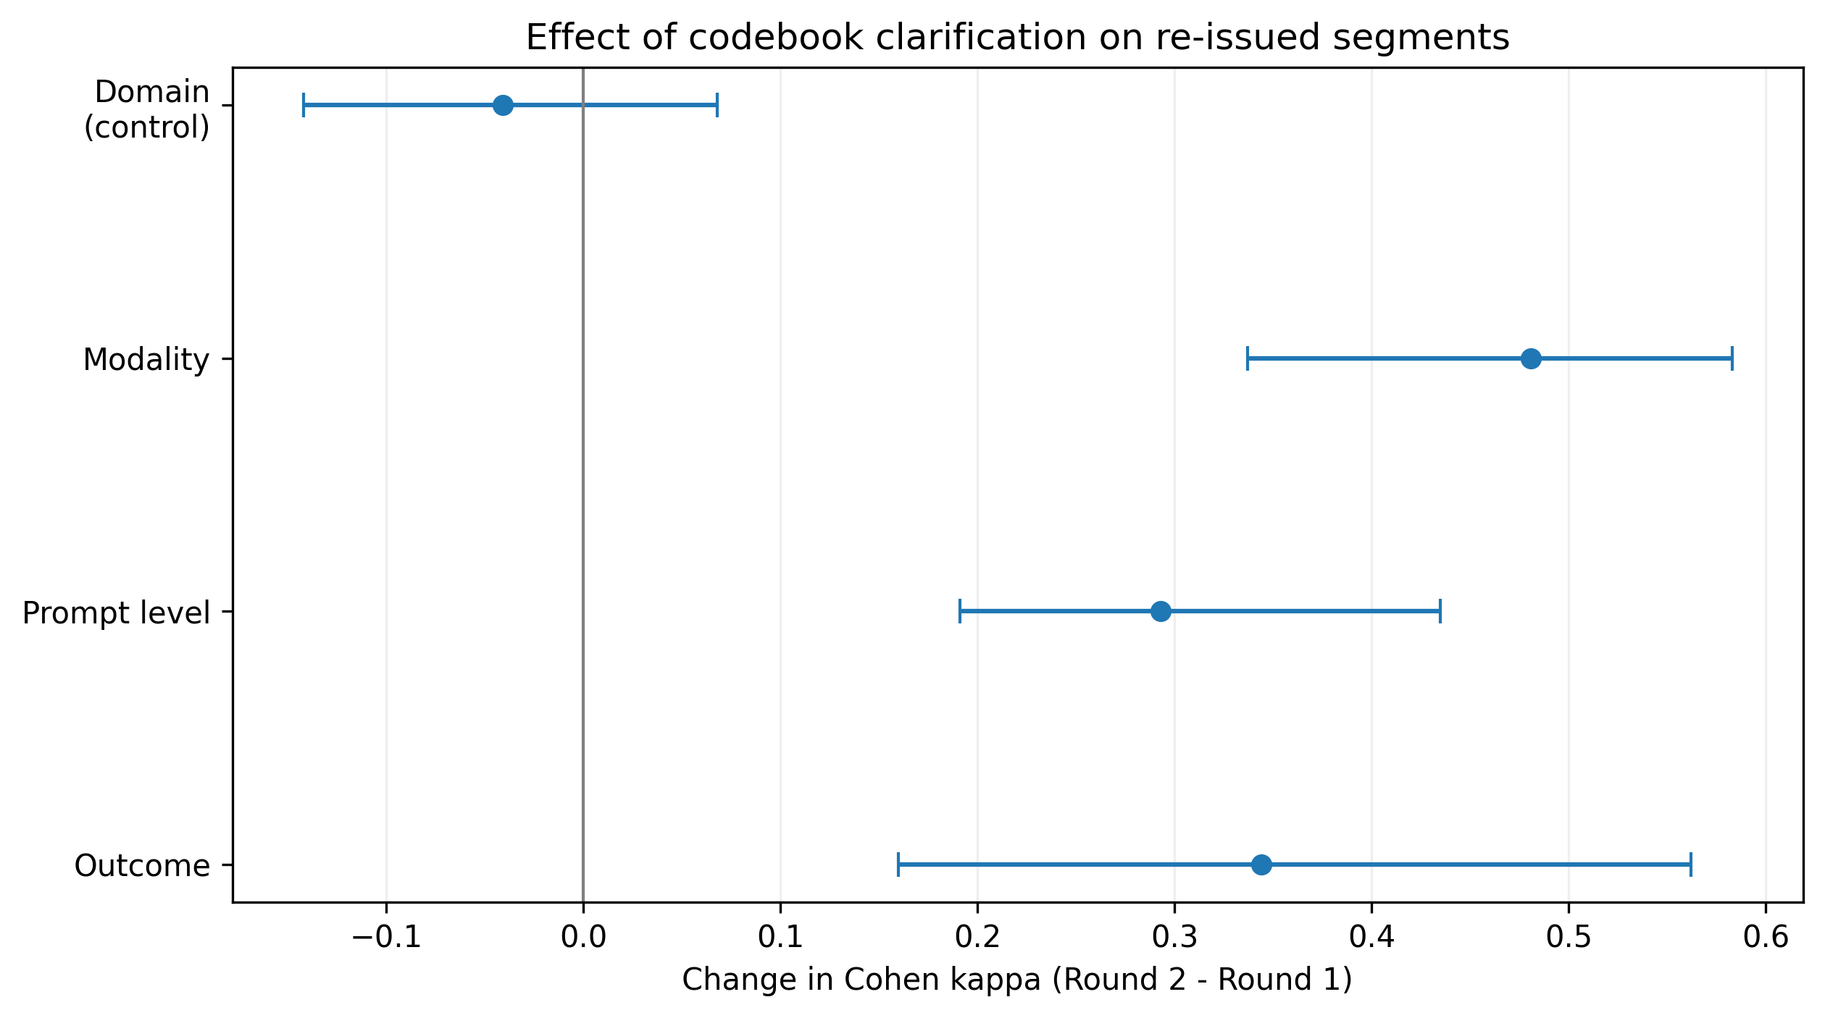
Figure 4. Paired change in Cohen kappa after codebook clarification on re-issued segments. Domain was the untreated control.
All 330 main-batch segments entered the adjudicated gold standard. Substantive categorical disagreement affected 127 segments (182 categorical field conflicts). Free-text behavior created a different kind of disagreement: 321 behavior fields differed by exact wording even when the specialists could be describing the same event. Those wording rows still had to be reconciled to create complete reference records, so adjudication touched 503 fields across 322 segments. That larger number should not be read as 322 substantive clinical disagreements.
On the 132 model-independent held-out segments, first-pass kappa under the final codebook was 0.879 for domain, 0.929 for modality, 0.916 for prompt_level, and 0.914 for outcome, for a mean of 0.910. This provides evidence that the final protocol can be applied consistently on a sample that was not selected for generator tractability. Because the same specialists had accumulated experience by this stage, the result should not be interpreted as a pure codebook effect.
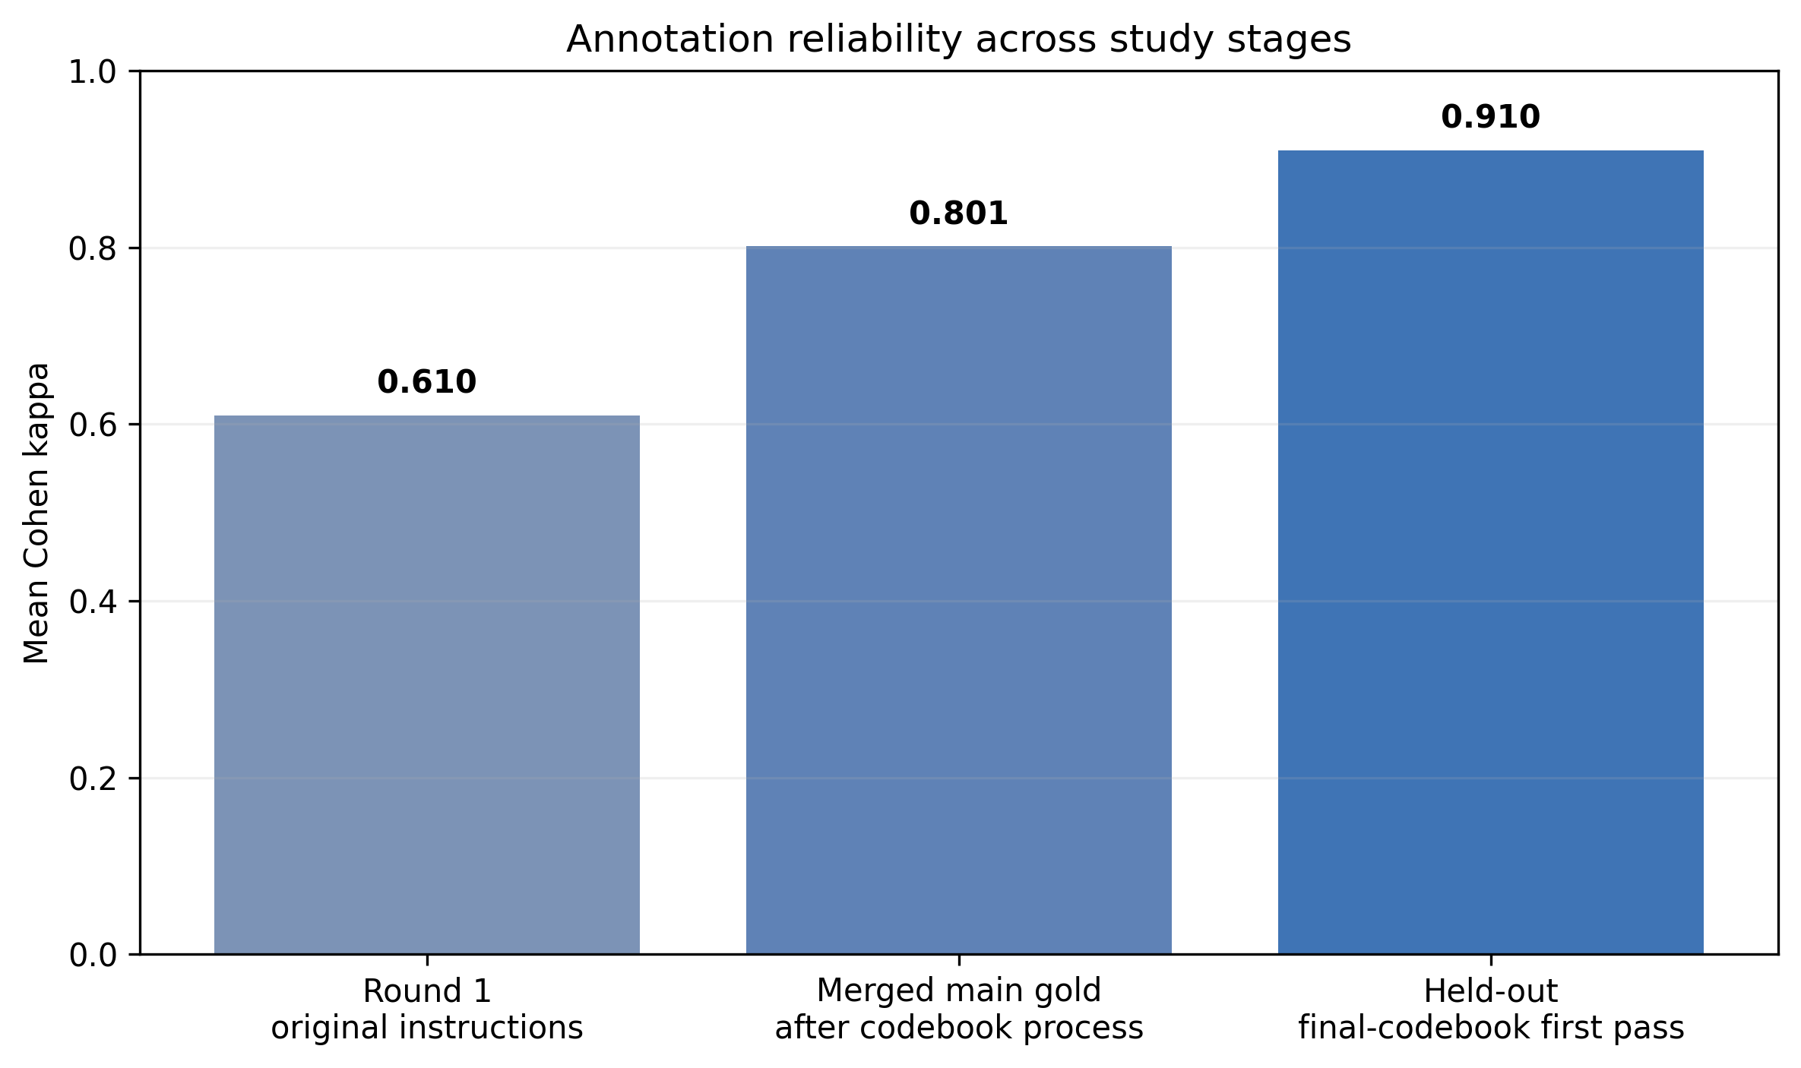
Figure 5. Mean categorical annotation reliability across Round 1, the merged main gold standard, and the model-independent held-out first pass.

Selection Effect in the Model-Independent Held-Out Set
Even before held-out adjudication was complete, the held-out sample revealed how strongly model behavior had shaped the main batch. All 4 generators were jointly admissible on 41 of 330 main-batch segments (12.4%) but only 3 of 132 held-out segments (2.3%), a 10.2-percentage-point decline and roughly a fivefold difference. The loss was concentrated in the weaker models: Llama 3.2 admission fell by 8.5 points and Qwen 2.5 3B by 13.9 points, while Qwen 2.5 7B and Qwen 3 14B were essentially unchanged. High admission should not be confused with high quality; a model that almost never declines can look robust on admission while still asserting unsupported values.
Table 7. Generator admission on the model-conditioned main batch versus the model-independent held-out sample.
Generator | Main batch | Held-out | Change
Llama 3.2 | 40.3% | 31.8% | -8.5 pp
Qwen 2.5 3B | 30.6% | 16.7% | -13.9 pp
Qwen 2.5 7B | 78.8% | 78.0% | -0.8 pp
Qwen 3 14B | 98.5% | 98.5% | 0.0 pp
All 4 jointly | 12.4% | 2.3% | -10.2 pp

Held-out adjudication was still incomplete at manuscript freeze. A total of 133 conflicting fields across 105 held-out segments remained: 102 free-text behavior wording differences, 14 conflicts already covered by an existing codebook rule, and 17 genuine judgment calls (12 domain, 2 modality, 2 outcome, and 1 prompt_level). Without a finalized held-out gold standard, it would be inappropriate to report held-out extraction accuracy, whole-record accuracy, or unsupported-assertion rates.

Generator Extraction Performance and Unsupported Assertion
Among the 4 evaluated generators, Qwen 2.5 7B had the highest mean acceptable extraction across the categorical fields (43.1%), followed closely by Qwen 3 14B (42.0%), then Llama 3.2 (30.8%) and Qwen 2.5 3B (20.4%). For the original 3-generator roster, Qwen 2.5 7B achieved 42.4% domain accuracy, 67.9% modality accuracy, 28.2% prompt_level accuracy, and 33.9% outcome accuracy. Whole-record correctness across all 4 categorical fields remained low: 4.5% for Qwen 2.5 7B, 1.5% for Llama 3.2, and 0.3% for Qwen 2.5 3B. Even an oracle that always chose the correct candidate whenever one of the 3 generators had produced it could reach only 6.1%, leaving 1.5 percentage points of whole-record headroom for reranking. Adding Qwen 3 14B raised the scoring oracle ceiling to 8.8%, but no 4-generator MARS experiment was performed.
Table 8. Main-batch extraction performance against the adjudicated gold standard (n=330).
Generator | Mean categorical accuracy | Mean field abstention | Unsupported assertion on 197 gold-null opportunities
Llama 3.2 | 30.8% | 8.2% | 164/197 (83%)
Qwen 2.5 3B | 20.4% | 48.1% | 61/197 (31%)
Qwen 2.5 7B | 43.1% | 12.7% | 112/197 (57%)
Qwen 3 14B | 42.0% | 2.9% | 191/197 (97%)

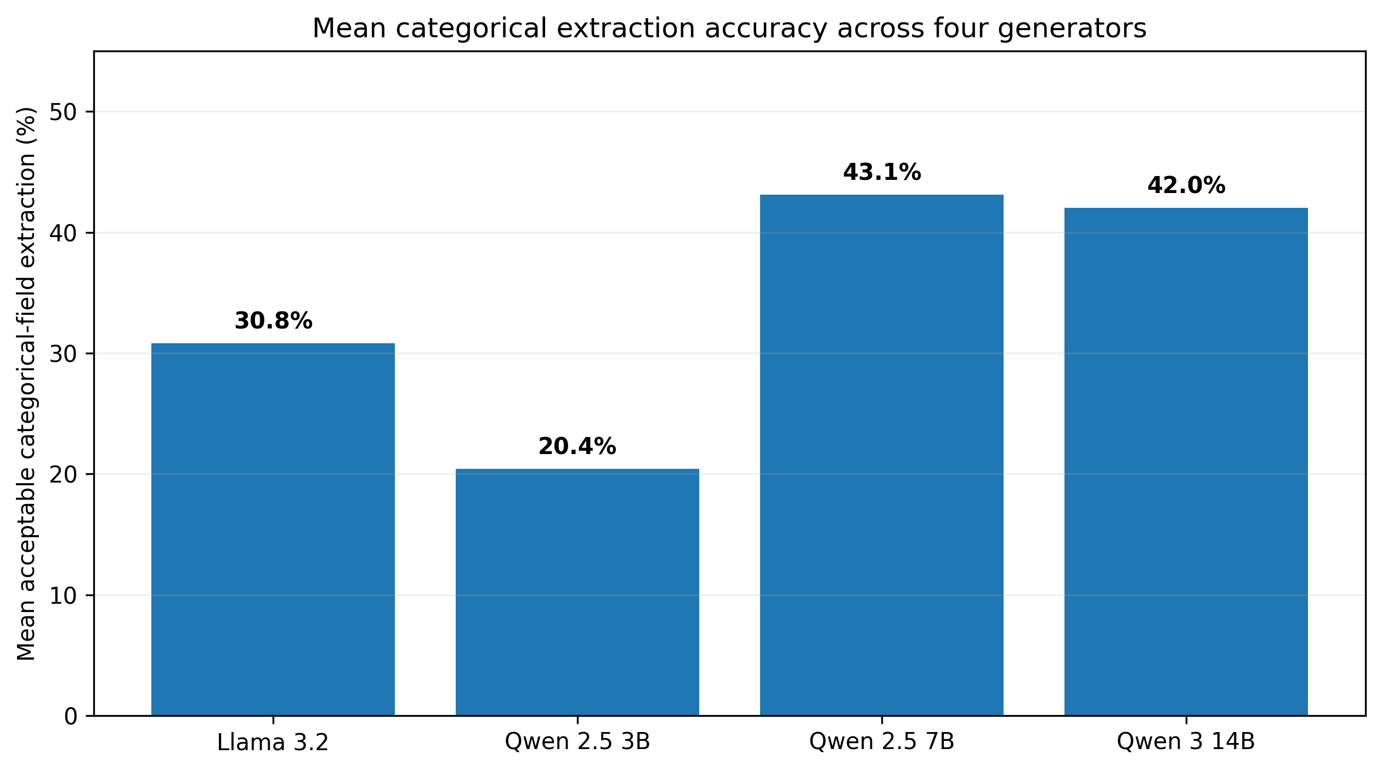
Figure 6. Mean acceptable categorical-field extraction across the four locally served generators.
Accuracy alone did not describe the safety profile. Among 77 main-batch segments where the gold standard recorded no supported modality, Llama 3.2 nevertheless asserted a modality in 72 (93.5%), Qwen 2.5 3B in 15 (19.5%), Qwen 2.5 7B in 31 (40.3%), and Qwen 3 14B in 76 (98.7%). Among 115 gold-null outcomes, the corresponding unsupported assertion counts were 87 (75.6%), 46 (40.0%), 78 (67.8%), and 111 (96.5%). Within this small 4-model roster, models that abstained less also tended to assert unsupported values more often. With only 4 models, this is a descriptive pattern rather than evidence of a general relationship, but it demonstrates why 'always answering' cannot be treated as a safety advantage.
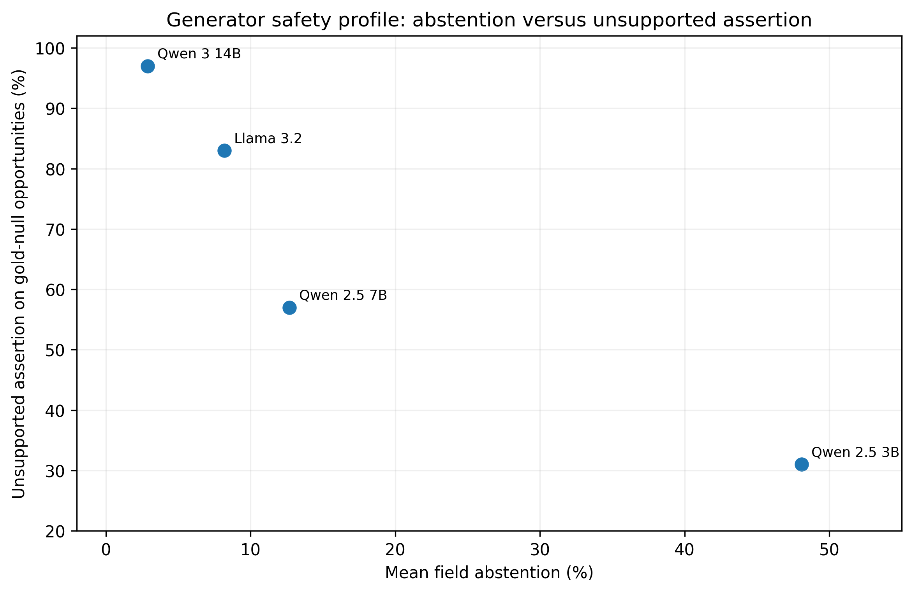
Figure 7. Generator safety profile. Models that answered more often also produced more unsupported values on gold-null opportunities in this four-model roster.
Free-text behavior showed a second limitation of strict automated scoring. Median Jaccard word-set overlap was 0.316 between the two human specialists, compared with 0.083 for Qwen 2.5 7B against gold and 0.071 for both Llama 3.2 and Qwen 2.5 3B. Because two specialists describing the same event often chose different wording, behavior was not included in binary whole-record accuracy. The token-overlap analysis is therefore best read as a simple lexical reference band, not as a semantic correctness test.

Offline MARS Candidate-Selection Performance
Across the 330 main-batch segments, MARS returned a record for 265 (80.3%). It abstained because no reviewable candidate existed on 42 (12.7%), because judges disagreed on 21 (6.4%), and because too few valid judge responses remained on 2 (0.6%). The candidate stage short-circuited on 123 segments with only one reviewable candidate and triggered reranking on 165. Field-level selector accuracy was evaluated on 142 segments where a genuine, usable ranking decision occurred.
On those 142 segments, MARS achieved 43.5% mean field accuracy, compared with 47.4% for always using the strongest generator and 32.5% for random candidate selection. MARS beat random selection on every field and the paired improvement was clearest for modality (+19.0 points; 95% CI 9.9-28.2) and prompt_level (+13.5; 95% CI 5.6-21.8). Against the strongest-generator policy, however, MARS was -12.7 points on domain (95% CI -19.7 to -6.3), -2.8 on modality, -2.1 on prompt_level, and +2.1 on outcome. The judges were therefore detecting real differences among candidates, but they could not compensate for a candidate roster in which one generator was substantially stronger and the oracle ceiling itself was low.
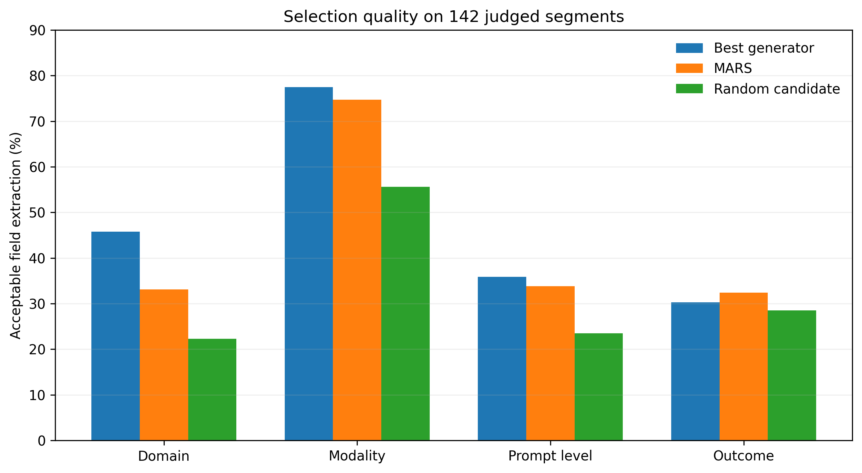
Figure 8. Per-field selection accuracy on the 142 genuinely judged segments. MARS improved on random selection but did not outperform always using the strongest generator.

Adequacy Routing, Deterministic Analytics, and Reporting Governance
For each of the 11 child-level reporting packets, the deterministic adequacy router classified the evidence as limited rather than insufficient or adequate. The main reason was structural: each packet contained only one derived setting and one derived contributor role because those metadata came from corpus structure rather than from a real multi-contributor intervention workflow. Twelve KPI families were still computable for every child, but cross-setting and cross-contributor comparisons were withheld for all 11. Crucially, the withheld KPI objects and their reasons remained in the evidence packet so that the reporting model was expected to communicate not only what could be said, but also what had intentionally not been calculated.
Under native JSON-schema constrained decoding, all 11 Qwen 2.5 7B reports conformed structurally, and none contained prohibited diagnostic, treatment, causal, or prognostic language. Structural success did not guarantee evidentiary success: 8 of 122 numeric assertions (6.6%) were absent from the supplied evidence packet, and 2 of 836 evidence references (0.2%) were invalid. Most importantly, 0 of 11 reports passed deterministic governance validation because the model failed to state that cross-setting and cross-contributor analyses had been deliberately withheld. The model did not fabricate those comparisons; it silently dropped the fact that they were unavailable. No post-result prompt remediation or rerun was performed.
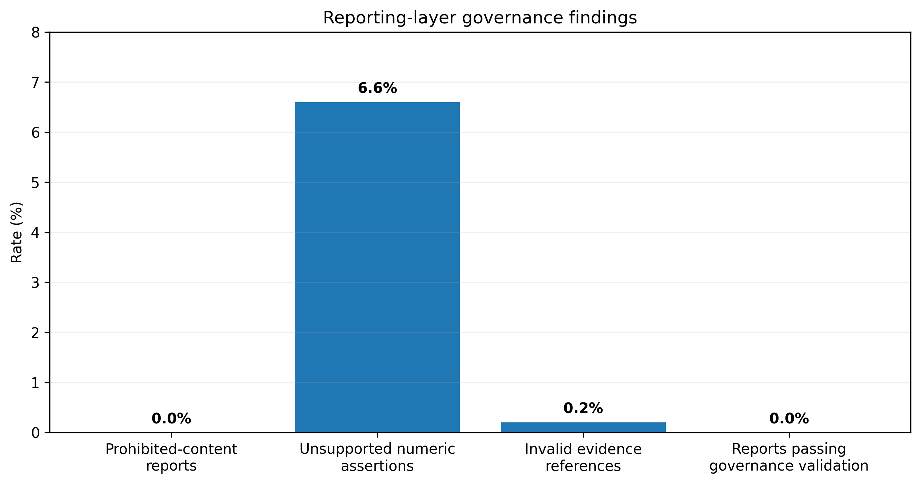
Figure 9. Reporting-layer governance findings. Structural validity and absence of prohibited content did not guarantee preservation of upstream abstention state.

Discussion

Principal Findings
The starting problem for this study was not model accuracy; it was the burden of reconstructing a child's longitudinal story from observations written by many people in many places. We therefore built the system around the intervention specialist's need to know not only what was observed, but also who observed it, in what setting, whether expected evidence is missing, whether the available data are sufficient for a requested comparison, and whether a report statement can be traced back to its source. The component evaluations then tested the places where AI could quietly undermine that chain. Taken together, the results support one central conclusion: trustworthy longitudinal evidence preparation is a property of the whole workflow, not of a single language model.
The first lesson came before model evaluation. The annotation study showed that a weak reference standard can make a model look better or worse for reasons that have little to do with the model itself. Round-1 modality kappa was only 0.570, yet that value already represented 91.6% of the agreement permitted by the specialists' mismatched category use. Most categorical conflicts clustered around 3 definitional boundaries. When those boundaries were written explicitly into the codebook, all 3 treated fields improved substantially while the untreated domain control did not. The held-out first-pass mean kappa of 0.910 suggests that the resulting protocol is workable beyond the specific segments that triggered the revision, although accumulated annotator experience remains a confounder.
The second lesson was that a model's willingness to fill a field is not evidence that the field is supported. Qwen 3 14B, the largest and newest generator in the evaluated roster, achieved mean categorical accuracy similar to Qwen 2.5 7B but asserted values on 97% of opportunities in which the gold standard recorded no supported value. For a longitudinal application, this failure is especially consequential. If an unsupported modality, prompt level, or outcome is stored as evidence, downstream analytics may calculate a perfectly reproducible trend from something that never occurred in the source observation. The safety objective is therefore not simply 'maximize populated fields'; it is also 'leave unsupported fields unfilled.'
The third lesson came from MARS. Multiple judges were not useless: they selected better candidates than chance, especially for modality and prompt_level. But reranking could not manufacture a correct record when no generator had proposed one, and the 3-generator whole-record oracle ceiling was only 6.1%. Because the strongest single generator already outperformed the MARS policy, adding live multi-model complexity would not have been justified by the measured benefit. The operational application therefore uses Qwen 2.5 7B as a single extractor and retains MARS as an offline research tool. This is an example of an evaluation simplifying a system rather than automatically making it more complex.
The reporting experiment exposed a different kind of failure - one that would be easy to miss if evaluation stopped at valid JSON. Schema-constrained decoding solved the formatting problem, and the reporting model avoided overtly prohibited clinical claims. Yet none of the 11 reports preserved all upstream abstention states. When cross-setting and cross-contributor comparisons had been intentionally withheld, the model usually omitted them without telling the reader they were unavailable. That distinction matters to an intervention specialist: silence can look like 'nothing noteworthy' when the true message is 'there was not enough representative evidence to make this comparison.' This result is why the architecture treats abstention as data that must survive every downstream layer and validates the report after generation.

Why the Holistic Workflow Matters for Interventionists
The practical value of the application lies in reducing a form of work that is easy to underestimate because it happens between formal intervention sessions. An intervention specialist may need to read a parent's note, a teacher's update, a caregiver's observation, and a trainer's session description; remember what each person reported previously; notice that the school observation expected this week never arrived; decide whether a behavior occurred independently or with prompting; and then compare the accumulated evidence with the child's goals. None of those tasks is conceptually exotic, but together they create a large, repetitive evidence-organization burden. The system is designed to make that burden more visible and more manageable without turning professional judgment into an automated score.
This is also why the benefit extends beyond the intervention specialist. Parents, teachers, caregivers, and trainers can continue to describe what they actually saw in natural language instead of learning a large clinical-style form. The system can structure those observations, preserve the original wording, and flag what is missing without asking the contributor to become a clinician. The intervention specialist receives a versioned evidence record, data-quality context, and traceable metrics rather than an opaque AI summary. For the broader autism-support community, the potential value is not autonomous decision-making; it is a more organized way for observations from different parts of a child's life to reach the professional who must interpret them.
The workflow also respects the fact that different settings can legitimately tell different stories. Parent-teacher differences are well documented in autism [1,2]. A home-specific goal should not be judged invalid because there is no school evidence, while a goal intended to generalize across settings should not be declared successful on the basis of home observations alone. By tying adequacy to goals, settings, contributors, and expected evidence, the application treats contextual variation as information rather than noise and prevents absence of evidence from being mistaken for evidence of absence.

Defining the Reference Standard Before Judging the Model
Recent JMIR and clinical-NLP studies have emphasized task-specific human evaluation, gold-standard construction, and human-in-the-loop review rather than assuming that a general LLM benchmark transfers directly to a clinical workflow [6,8-10]. CLEVER, for example, uses blinded expert preference evaluation to reduce model-identity bias [10]. Our annotation results add an earlier prerequisite to that logic: before experts can judge a model, the experts themselves need a sufficiently precise task definition. A low kappa caused by incompatible category definitions is a different problem from low kappa among annotators who are applying the same definitions. Reporting the marginal-imposed ceiling alongside observed agreement made that distinction visible in our data.
The explicit-null convention was equally important because it turned a vague concern about hallucination into a measurable error. Many extraction studies ask whether a model matches a populated target. A longitudinal evidence store also needs to know when there is no supported target at all. Null, unknown, and missing output have different meanings and different downstream consequences. By annotating those states separately, we could measure not only whether a model chose the wrong category but whether it invented a category where the source supported none.

Comparison With Prior Work
Prior work on LLM-assisted clinical information extraction has shown that language models can be useful when the task, source domain, schema, and evaluation reference are tightly specified. Edwards et al combined LLM extraction with human-in-the-loop review for free-text clinical summaries [6]. Eryilmaz et al demonstrated structured extraction from clinical documents using synthetic training data [7]. Carenzo et al evaluated an LLM discharge-summary pipeline in a secure environment and explicitly positioned feasibility as a step that still required larger powered validation [8]. These studies reinforce an important principle for the present work: usefulness is workflow-specific, and evidence of general language ability is not a substitute for evaluation inside the intended task.
Our system extends that workflow-specific perspective in three ways. First, the target is not a static document but a longitudinal evidence stream that can accumulate errors over time. Second, the application treats operational evidence availability - schedules, missing submissions, contributor and setting representation, and review-period coverage - as part of whether an analysis is valid. Third, the evaluation measures unsupported structure and tests whether abstention survives downstream into professional reporting. These differences matter because a structured monitoring system can repeatedly aggregate one unsupported extraction long after the original note has been forgotten.
The work is also distinct from recent autism-focused conversational AI research. The ASIST proof-of-concept study evaluated structured autism history taking and referral support and appropriately called for broader validation before routine use [5]. Our application addresses a later and different workflow: intervention goals already exist, observations accumulate over time from multiple authorized people, and the intervention specialist must synthesize that evidence longitudinally. The system does not screen for autism and does not recommend intervention. Its role is to prepare and govern the evidence that a professional will review.
Selective prediction research has long argued that abstention can be preferable to an incorrect prediction in clinical abstraction [11], and recent LLM-focused work has renewed that argument for health care [12]. Our results suggest that abstention should be viewed as an end-to-end state rather than a property of the extractor alone. A field can be withheld at extraction, a metric can be withheld because the evidence is inadequate, and the final report must still communicate that withholding. The 0/11 reporting-governance result demonstrates that a model can avoid fabricating a comparison and still break the governance contract by failing to tell the reader that the comparison was intentionally unavailable.
Trustworthy-AI frameworks emphasize traceability, robustness, usability, and meaningful human involvement [13-15]. The architecture operationalizes those principles in concrete workflow choices: the source narrative is immutable, corrections are versioned, analytics are deterministic, abstention is reason-coded, and the intervention specialist can trace a report statement back to the underlying evidence. These design choices do not prove that the system is clinically trustworthy in routine practice. They make the assumptions, boundaries, and failure states visible enough to be tested rather than hidden inside a generative model.

Human Authority, Appropriate Reliance, and Automation Bias
Human-in-the-loop design is meaningful only when the human can intervene at the layer where the error originated. Asking an intervention specialist to edit a polished report while leaving an incorrect structured record untouched would preserve the underlying mistake and allow it to reappear in later calculations. For that reason, the application gives the professional access to the source observation and the structured evidence, records corrections as new versions, and regenerates dependent analytics and reports from the corrected record. The professional is not merely the last person in the chain; the professional remains the authority over the evidence and its interpretation.
The eventual success of the application should therefore not be judged by speed or interface preference alone. A future professional evaluation should ask whether the system reduces evidence-organization effort while preserving or improving recognition of missing evidence, incorrect extraction, unsupported conclusions, and abstention. A faster review that produces more uncritical acceptance of AI output would be a safety failure, not a success. This is why the current paper separates functional application verification from the future question of appropriate reliance among a broader group of practicing intervention specialists.

Limitations
The study has several limitations, and each marks a boundary on what can be concluded. First, the 330-segment main evaluation batch was conditioned on generator judgeability. The held-out admission comparison shows that this selection effect is substantial: all 4 models were jointly admissible on 12.4% of the main batch but only 2.3% of the model-independent held-out set. Main-batch accuracy and unsupported-assertion rates therefore describe a selected input distribution that the models were able to attempt. Held-out extraction performance should not be inferred until the remaining held-out annotation conflicts are adjudicated.
Second, ASDBank provides archival child-investigator and child-parent transcripts rather than the natural-language observations that parents, teachers, caregivers, trainers, and intervention staff would submit through the application. Likewise, the date, setting, and contributor metadata used in the 11-child reporting evaluation were derived from corpus structure rather than from a true multi-contributor intervention workflow. The present experiments therefore test important evidence-processing behaviors, but transportability to the intended real-world observation distribution remains unproven.
Third, the reference standard was created by 2 autism intervention specialists, and residual disagreements were resolved by consensus between the same pair rather than by an independent third adjudicator. The controlled Round-2 design provides evidence that the codebook corrections addressed real definitional ambiguity, but it does not establish that every autism profession, program, or setting would apply the schema identically. Free-text behavior was evaluated only with simple Jaccard word overlap, so semantic correctness of that field remains to be assessed with a more appropriate human or semantic method.
Fourth, the generator roster contained 4 locally served open-weight models and no frontier-scale external model. The findings therefore characterize the evaluated roster, not all LLMs. Raw generator inference also used server-default stochastic settings without a fixed seed. Exact regeneration of model outputs is therefore not guaranteed, although every reported downstream result is reproducible from the preserved outputs. Fifth, the MARS experiment used only the original 3-generator candidate roster, which contained one clearly stronger generator. A different or more balanced candidate set could create more headroom for reranking, and no 4-generator MARS experiment was performed.
Sixth, the reporting evaluation comprised only 11 child-level reports and produced an important negative result: none preserved all withheld-analysis states. The reporting layer should therefore not be described as validated safe. Seventh, repeated manual application testing establishes that the controlled workflow functions as implemented, but it was performed as development verification rather than as independent professional usability, security, performance, or clinical validation. Finally, the study did not evaluate treatment decisions, intervention effectiveness, diagnostic performance, child outcomes, prospective real-world adoption, demographic fairness, or production-scale reliability. Those questions require different data, participants, and study designs.

Future Work
The most immediate analytic priority is to complete adjudication of the 132-segment model-independent held-out set and then score the already-frozen generator outputs. That analysis will show how much the model-conditioned main batch inflated apparent extraction performance and whether unsupported assertion changes when the inputs are less tractable. The reporting layer should be improved only in a way that preserves the original negative result: any prompt or schema remediation should be evaluated prospectively as a second configuration rather than replacing the first result. Future offline work can also test whether a stronger or more balanced generator roster provides enough oracle headroom to make MARS worthwhile.
The larger next step is prospective evaluation with practicing autism intervention specialists using controlled longitudinal cases and, eventually, real contributor-authored observations. That evaluation should measure more than speed. Relevant outcomes include correction burden, recognition of missing or unrepresentative evidence, source-traceability use, review time, workload, and appropriate reliance on AI-generated structure and reporting. External validation should include settings and contributors that better match the intended workflow and, where ethically appropriate, multilingual observations. Any future study of intervention decisions or child outcomes would require a separate protocol, ethics approval, and substantially stronger evidence than the present development and component evaluation.

Conclusions
This study presents a governance-aware, human-in-the-loop application designed to help intervention specialists turn distributed natural-language observations into review-ready longitudinal evidence. The system begins with professional goals and expected observations, allows authorized contributors to describe what they see in ordinary language, preserves the source narrative, structures only supported information, keeps corrections and provenance visible, withholds analyses when the evidence is inadequate, computes longitudinal indicators deterministically, and links professional-facing reports back to the underlying evidence. The AI components sit inside that workflow rather than defining it.
The component evaluations explain why those boundaries are necessary. Human coding rules had to be stabilized before model performance was interpretable; locally served generators frequently asserted unsupported values; the largest evaluated model was not the safest; multi-judge reranking did not outperform the strongest single generator; and a structurally valid reporting LLM still failed to preserve all withheld-analysis states. These findings argue for a role in which AI helps organize and communicate evidence while professional authority remains with the intervention specialist. The controlled-development application provides a concrete foundation for broader professional and real-world validation, but it is not evidence of clinical effectiveness, production readiness, or improved child outcomes.

Acknowledgments
[TO COMPLETE BEFORE SUBMISSION: Acknowledge the autism intervention specialists, data custodians, and other contributors only with permission and without disclosing unnecessary personal information.]

Funding
[TO COMPLETE BEFORE SUBMISSION: Insert the actual funding statement. If accurate, state that no external funding was received and disclose material in-kind computing/model support.]

Data Availability
The source ASDBank/TalkBank corpora are publicly available under their own access and licensing terms and are not redistributed with this manuscript. The study repository records the frozen annotation batch, annotator outputs, adjudicated main-batch gold standard, preserved model outputs, evaluation metrics, prompts/schemas, deterministic rules, and analysis scripts to the extent permitted. The 132-segment held-out gold standard will not be represented as final until adjudication is complete.
[TO COMPLETE BEFORE SUBMISSION: Insert repository/archive URL, release identifier, license, and any controlled-access terms.]

Authors' Contributions
[TO COMPLETE BEFORE SUBMISSION: Insert CRediT-style contributions after the author list is final.]

Conflicts of Interest
[TO COMPLETE BEFORE SUBMISSION: Insert complete conflict-of-interest declarations for all authors. Use “None declared” only if accurate.]

Generative AI Use
Generative AI systems were used in two distinct ways. First, the locally served extraction, judge, and reporting models described in Methods were objects of the research. Second, generative AI tools, including ChatGPT (OpenAI) and Claude (Anthropic), were used during software-development assistance, technical ideation, and manuscript drafting/editing. Human authors defined the study, reviewed the code and analyses, performed or supervised all human annotation/adjudication, verified reported statistics against recorded artifacts, checked cited sources, and remain accountable for the manuscript. No generative AI system authored or adjudicated a gold-standard label. In accordance with JMIR policy, the authors will retain the relevant AI-use records and provide the required detailed disclosure or multimedia appendix at submission.

Abbreviations
Abbreviation | Definition
AI | artificial intelligence
API | application programming interface
HITL | human-in-the-loop
IRB | institutional review board
KPI | key performance indicator
LLM | large language model
MARS | offline multi-judge reranking stage
NLP | natural language processing
RRF | reciprocal rank fusion

Multimedia Appendices for Submission
- Multimedia Appendix 1: Full operational workflow, authorization matrix, role/access lifecycle, scheduling, missed-submission, and notification specification.
- Multimedia Appendix 2: Final observation schema, value dictionary, annotation codebook, null/unknown/missing rules, and representative deidentified examples.
- Multimedia Appendix 3: Extraction prompts/tool schema, exact model digests/configuration, MARS judge prompt and algorithm, and preserved inference configuration.
- Multimedia Appendix 4: Adequacy-router rules, deterministic KPI definitions, abstention rules, and reporting evidence-packet/report schema.
- Multimedia Appendix 5: Extended annotation reliability tables, confusion matrices, adjudication counts, free-text behavior analysis, and held-out adjudication/results when complete.
- Multimedia Appendix 6: Extended generator, unsupported-assertion, MARS, and reporting-layer results with artifact identifiers.
- Multimedia Appendix 7: Controlled-development functional test matrix and representative deidentified screenshots.
- Multimedia Appendix 8: Reproducibility manifest, repository release details, AI-use disclosure materials, and the completed reporting checklist(s), including iCHECK-DH items applicable to the implementation description.

References
1. Murray DS, Ruble LA, Willis H, Molloy CA. Parent and teacher report of social skills in children with autism spectrum disorders. Lang Speech Hear Serv Sch. 2009;40(2):109-115. doi:10.1044/0161-1461(2008/07-0089). PMID:18952814.
2. Stadnick N, Chlebowski C, Brookman-Frazee L. Caregiver-teacher concordance of challenging behaviors in children with autism spectrum disorder served in community mental health settings. J Autism Dev Disord. 2017;47(6):1780-1790. doi:10.1007/s10803-017-3101-9. PMID:28343342.
3. Dang K, Bent S, Lawton B, et al. Integrating autism care through a school-based intervention model: a pilot study. J Clin Med. 2017;6(10):97. doi:10.3390/jcm6100097. PMID:29048365.
4. Aikat V, Carpenter KLH, Krishnappa Babu PR, et al. Autism digital phenotyping in preschool- and school-age children. Autism Res. 2025;18(6):1217-1233. doi:10.1002/aur.70032. PMID:40176346.
5. Sadeghi Esfahlani S, et al. Feasibility and acceptability of an AI-driven conversational platform for structured autism history taking and referral support: mixed methods proof-of-concept study. JMIR Form Res. 2026;10:e100237. doi:10.2196/100237.
6. Edwards A, Pardiñas AF, Kirov G, Rees E, Camacho-Collados J. Large language model-supported identification of intellectual disabilities in clinical free-text summaries: mixed methods study. JMIR AI. 2025;4:e72256. doi:10.2196/72256. PMID:40966546.
7. Eryilmaz B, et al. Extracting medical information from unstructured clinical text using large language models to enhance health care interoperability: proof-of-concept study. J Med Internet Res. 2026;28:e92413. doi:10.2196/92413.
8. Carenzo C, Goldsmith K, Arribas M, et al. Real-world implementation of large language models for writing clinical discharge summaries within a secure data environment: development and expert evaluation study. JMIR AI. 2026;5:e88816. doi:10.2196/88816.
9. Lilan S, Mochama B, Osborn T, et al. Automated fidelity monitoring of lay-delivered mental health interventions using large language models: development and pilot validation of shamiriAI in Kenya. JMIR AI. 2026;5:e95063. doi:10.2196/95063.
10. Kocaman V, Kaya MA, Feier AM, Talby D. Clinical large language model evaluation by expert review (CLEVER): framework development and validation. JMIR AI. 2025;4:e72153. doi:10.2196/72153.
11. Swaminathan A, Lopez I, Wang W, et al. Selective prediction for extracting unstructured clinical data. J Am Med Inform Assoc. 2024;31(1):188-197. doi:10.1093/jamia/ocad182.
12. Presacan O, Nik A, Ojha J, Thambawita V, Ionescu B, Riegler MA. When silence is safer: a review and decision-theoretic framework for LLM abstention in healthcare. npj Digit Med. 2026. doi:10.1038/s41746-026-02882-1.
13. Goisauf M, Cano Abadia M, Akyuz K, et al. Trust, trustworthiness, and the future of medical AI: outcomes of an interdisciplinary expert workshop. J Med Internet Res. 2025;27:e71236. doi:10.2196/71236. PMID:40455564.
14. Lekadir K, Frangi AF, Porras AR, et al. FUTURE-AI: international consensus guideline for trustworthy and deployable artificial intelligence in healthcare. BMJ. 2025;388:e081554. doi:10.1136/bmj-2024-081554.
15. Vasey B, Nagendran M, Campbell B, et al. Reporting guideline for the early-stage clinical evaluation of decision support systems driven by artificial intelligence: DECIDE-AI. Nat Med. 2022;28:924-933. doi:10.1038/s41591-022-01772-9.
16. Perrin Franck C, Babington-Ashaye A, Dietrich D, et al. iCHECK-DH: guidelines and checklist for the reporting on digital health implementations. J Med Internet Res. 2023;25:e46694. doi:10.2196/46694. PMID:37163336.
17. Cohen J. A coefficient of agreement for nominal scales. Educ Psychol Meas. 1960;20(1):37-46. doi:10.1177/001316446002000104.
18. MacWhinney B. Understanding spoken language through TalkBank. Behav Res Methods. 2019;51(4):1919-1927. doi:10.3758/s13428-018-1174-9. PMID:30511153.
19. Rollins PR. Early pragmatic accomplishments and vocabulary development in preschool children with autism. Am J Speech Lang Pathol. 1999;8(2):181-190. doi:10.1044/1058-0360.0802.181.
20. Tager-Flusberg H, Calkins S, Nolin T, Baumberger T, Anderson M, Chadwick-Dias A. A longitudinal study of language acquisition in autistic and Down syndrome children. J Autism Dev Disord. 1990;20(1):1-21. doi:10.1007/BF02206853. PMID:2139024.
21. Rollins PR. ASDBank English Rollins Corpus. TalkBank. doi:10.21415/T5KK53.
22. Tager-Flusberg H. ASDBank English Flusberg Corpus. TalkBank. doi:10.21415/T5459F.
23. Umesh UN, Peterson RA, Sauber MH. Interjudge agreement and the maximum value of kappa. Educ Psychol Meas. 1989;49(4):835-850. doi:10.1177/001316448904900407.
24. Croxford E, Gao Y, First E, et al. Evaluating clinical AI summaries with large language models as judges. npj Digit Med. 2025;8:640. doi:10.1038/s41746-025-02005-2.
25. Fraile Navarro D, Coiera E, Hambly TW, et al. Expert evaluation of large language models for clinical dialogue summarization. Sci Rep. 2025;15:1195. doi:10.1038/s41598-024-84850-x.

