Response to MDPI Round-5 Review Comments
Answers the three open comments in 'Round5_Review_Feedback.docx', in their original order and wording. Branch model-finetuning, built 2026-09-26. Internal working document; not for submission.
Every number is read from a recorded artefact named in the table that shows it. This round adds round5_analysis.json, computed from preserved outputs and the deterministic CHAT pipeline with no model call. Claims about the data are checked by assertion when this document is built.

Summary
Table 1. Each comment and the answer in one line.
ID | Severity | Answer
R5-1 | Moderate | Per-child counts reported (6–12). Episode-weighted estimand kept as primary and stated; equal-child sensitivity added. Agreement robust; 121-set unsupported-assertion gap not
R5-2 | Moderate | Capped-vs-shorter reference-null analysis moved into Methods/Results, by field; Limitations refers back
R5-3 | Minor | Reviewer's Conclusion phrase adopted; top-two ordering stated as not stable

One result that changes what the manuscript says
- R5-1: under equal-child weighting, the qwen3:14b − qwen2.5:7b unsupported-assertion difference on the 121-set is +20.6 [-7.6, +45.9] points; its interval includes zero. Under the primary estimand it excludes zero. Both are reported.

R5-1 · Moderate · Equal-child weighting after overlap exclusion
The comment, as written
Location: Section 2.13; Section 3.3; Section 4.9
Reviewer concern: The original frozen evaluation set contained 12 segments per child, but 11 overlapping episodes were subsequently removed. Although the remaining 121-segment analysis still includes all 11 children, the manuscript does not report how many segments remain for each child. The post-audit point estimates may therefore give greater weight to children who lost fewer overlapping episodes.
Required action: Report the retained number of evaluation episodes per child after overlap exclusion. Then either (a) add an equal-child-weighted sensitivity estimate for the central 121-set metrics, or (b) explicitly state that the primary post-audit estimand is episode-weighted and justify that choice. This is expected to be a robustness check rather than a redesign of the study.
Status: Open

Response
Short answer
Retained episodes per child range from 6 (roger_rollins) to 12; six children keep all 12. We keep the episode-weighted estimand as primary, state it explicitly, and add an equal-child-weighted sensitivity estimate for the three central metrics. Merged and whole-record agreement are robust (every model moves by at most 1.1 points). Unsupported assertion is not: under equal-child weighting the qwen3:14b − qwen2.5:7b paired difference on the 121-set is +20.6 [-7.6, +45.9] points and its interval includes zero, because per-child reference-null denominators are small. This is reported as found.
Table 2. Retained evaluation episodes per child after overlap exclusion, weights under each estimand, and reference-null slots (the unsupported-assertion denominator). Source: round5_analysis.json (child_weighting_121.per_child).
Child | Frozen | Removed | Retained | Episode weight | Equal-child weight | Reference-null slots
brett | 12 | 0 | 12 | 9.9% | 9.1% | 2
carl | 12 | 1 | 11 | 9.1% | 9.1% | 9
jack | 12 | 0 | 12 | 9.9% | 9.1% | 3
josh | 12 | 0 | 12 | 9.9% | 9.1% | 8
mark | 12 | 0 | 12 | 9.9% | 9.1% | 1
mars | 12 | 2 | 10 | 8.3% | 9.1% | 8
rick | 12 | 0 | 12 | 9.9% | 9.1% | 0
roger_flusberg | 12 | 0 | 12 | 9.9% | 9.1% | 4
roger_rollins | 12 | 6 | 6 | 5.0% | 9.1% | 8
sid | 12 | 1 | 11 | 9.1% | 9.1% | 10
stuart | 12 | 1 | 11 | 9.1% | 9.1% | 0
Total | 132 | 11 | 121 | 100% | 100% | 53

Table 3. Central 121-set metrics, episode-weighted (primary, as recorded in round4_analysis.json) and equal-child-weighted (sensitivity), %. Equal-child: metric within each child, then the unweighted mean of children; 95% child-cluster percentile bootstrap, 10,000 replicates. Unsupported assertion is defined for 9 of 11 children. Source: round5_analysis.json (child_weighting_121.per_model).
Model | Merged: episode | Merged: child [CI] | Unsupp.: episode | Unsupp.: child [CI] | Whole: episode | Whole: child [CI]
llama3.2 | 27.5 | 26.9 [21.4, 32.4] | 83.0 | 84.6 [76.3, 93.1] | 0.0 | 0.0 [0.0, 0.0]
qwen2.5:3b | 12.6 | 13.7 [9.0, 19.1] | 24.5 | 25.7 [13.3, 38.0] | 0.0 | 0.0 [0.0, 0.0]
qwen2.5:7b | 40.5 | 39.7 [33.1, 46.7] | 50.9 | 66.6 [45.9, 87.5] | 5.0 | 4.6 [0.0, 9.9]
qwen3:14b | 41.3 | 40.2 [31.4, 49.6] | 90.6 | 87.1 [74.6, 97.5] | 4.1 | 3.8 [0.0, 9.8]

Table 4. Paired difference qwen3:14b − qwen2.5:7b on the 121-set, percentage points [95% child-cluster CI]. Episode-weighted: round3_analysis.json (holdout_sensitivity.excluding_all_pool_episodes). Equal-child: round5_analysis.json.
Metric | Episode-weighted (primary) | Equal-child-weighted (sensitivity)
Merged agreement | +0.8 [-2.6, +3.9] | +0.5 [-2.8, +3.7]
Unsupported assertion | +39.6 [+14.8, +53.7] * | +20.6 [-7.6, +45.9]
Whole-record agreement | -0.8 [-3.5, +1.7] | -0.8 [-3.3, +1.5]

* interval excludes zero.
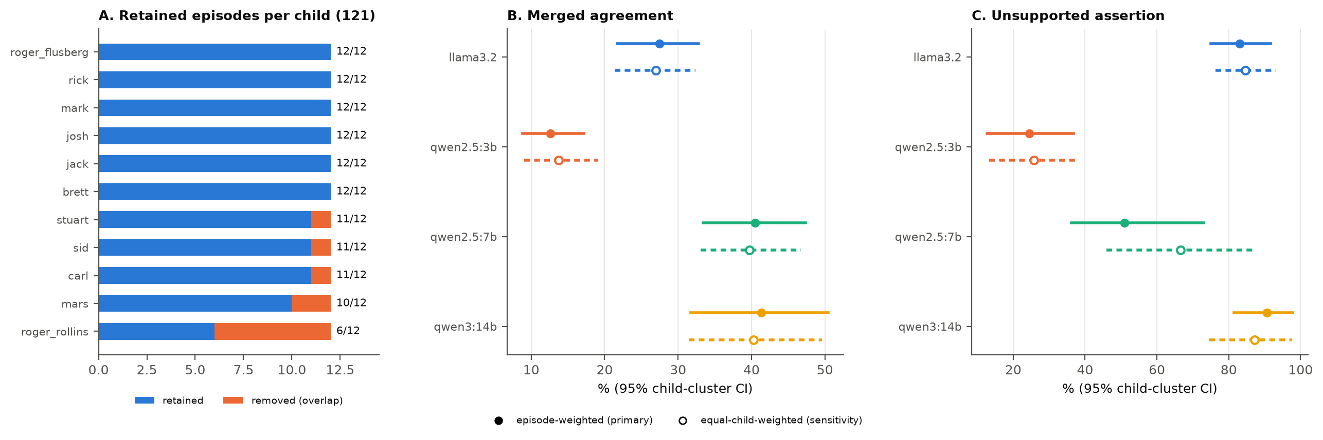
Figure 1. A: retained versus removed evaluation episodes per child. B, C: episode-weighted (filled, solid) and equal-child-weighted (open, dashed) estimates with 95% child-cluster intervals on the 121-set.
Supporting argument
- Where the weight moves. Under episode weighting roger_rollins contributes 5.0% of the estimate; under equal-child weighting every child contributes 9.1%. Children who kept all 12 episodes drop from 9.9% to 9.1%.
- Agreement metrics. Merged and whole-record agreement change by about a point or less for every model, and the qwen3:14b − qwen2.5:7b merged-agreement difference stays small with an interval including zero under both weightings.
- Unsupported assertion. Its denominator is reference-null slots, not episodes, so the recorded value is weighted by reference-null slot. On the 121-set those slots are few and uneven by child (rick, stuart: none, so the rate is undefined and the child is left out; others 1–10). Equal-child weighting gives a child with one slot the same weight as a child with ten, which is why qwen2.5:7b moves from 50.9% to 66.6% and the paired difference loses its interval. The main-batch paired difference (330 segments) is not affected by this comment.
- Why episode weighting stays primary. It is the estimand used for the main batch (330) and the original 132 in every earlier round, so the 121 remains directly comparable with them. No other rationale for the choice is documented; the authors may add one.
Suggested manuscript wording (Section 2.13 Methods; Section 3.3 Results; Section 4.9)
Methods 2.13: "After overlap exclusion, 121 of the 132 frozen evaluation episodes remained, with 6 to 12 episodes per child (Table X). The primary post-audit estimand is episode-weighted: metrics are pooled over retained episodes (for unsupported assertion, over reference-null field slots), as for the main batch and the original 132-episode set. As a sensitivity analysis we computed each metric within child and averaged children with equal weight, with 95% child-cluster bootstrap intervals; unsupported assertion is undefined for children with no reference-null slots, and such children were omitted from that average."
Results 3.3: "Equal-child weighting changed merged and whole-record agreement by at most 1.1 percentage points for any model (Table Y). For unsupported assertion, which was defined for 9 children on 1–10 reference-null slots each, the qwen3:14b − qwen2.5:7b difference was +39.6 [+14.8, +53.7] percentage points under episode weighting and +20.6 [-7.6, +45.9] under equal-child weighting."
Limitations 4.9: "On the post-audit 121-episode set, the unsupported-assertion comparison between the two strongest generators was sensitive to how children were weighted, reflecting few reference-null opportunities per child."

R5-2 · Moderate · Reference-null difference appears first in Limitations
The comment, as written
Location: Section 4.9, with corresponding Methods/Results sections if retained
Reviewer concern: The Limitations section states that capped and shorter episodes differed descriptively in reference-null frequencies. That is a new empirical finding with direct relevance to unsupported-assertion evaluation, because null prevalence changes the number of opportunities on which unsupported assertion can occur. However, the manuscript does not report the actual values, comparison definition, or analysis earlier in Methods or Results.
Required action: Either report this descriptive analysis properly in Methods/Results (define capped versus shorter episodes and provide the relevant null-frequency values, preferably by categorical field or with a clearly stated pooled definition), or remove the empirical statement from Limitations. A reviewer should not encounter a new quantitative result for the first time in the limitations narrative.
Status: Open

Response
Short answer
The analysis is now reported in Methods and Results, by field, with the comparison defined; Limitations only refers back to it. It was computed in Round 4 (round4_analysis.json, episode_cap.annotated_by_cap) but never reported outside the Limitations sentence. Capped episodes carry fewer reference nulls in both annotated sets (field mean 13.9% vs 16.3% in the main batch; 10.1% vs 14.5% in the frozen 132). Domain and prompt level are never null in capped episodes. The comparison is descriptive, with no inferential test.
Definition. Capped = rendered CHAT text has exactly 8 speaker turns (the segmentation maximum); shorter = fewer than 8. Turns are counted as speaker lines (lines beginning *) in the rendered episode text. A reference null is a field the adjudicated reference standard leaves empty; each is one opportunity for an unsupported assertion.
Table 5. Reference-null share by field (count of null slots), pooled mean of the four fields, total null slots over all field slots, and qwen2.5:7b unsupported-assertion rate, for capped and shorter episodes. Descriptive; not adjusted for other differences between the groups. Source: round5_analysis.json (reference_nulls_by_cap), from round4_analysis.json.
Set | Episodes | n | domain | modality | prompt level | outcome | Mean | Null slots | qwen2.5:7b unsupp.
Main batch (330) | capped (8) | 187 | 0.0% (0) | 23.0% (43) | 0.0% (0) | 32.6% (61) | 13.9% | 104 / 748 | 64.4%
Main batch (330) | shorter (< 8) | 143 | 2.1% (3) | 23.8% (34) | 1.4% (2) | 37.8% (54) | 16.3% | 93 / 572 | 48.4%
Frozen 132 | capped (8) | 77 | 0.0% (0) | 26.0% (20) | 0.0% (0) | 14.3% (11) | 10.1% | 31 / 308 | 61.3%
Frozen 132 | shorter (< 8) | 55 | 1.8% (1) | 29.1% (16) | 1.8% (1) | 25.4% (14) | 14.5% | 32 / 220 | 40.6%

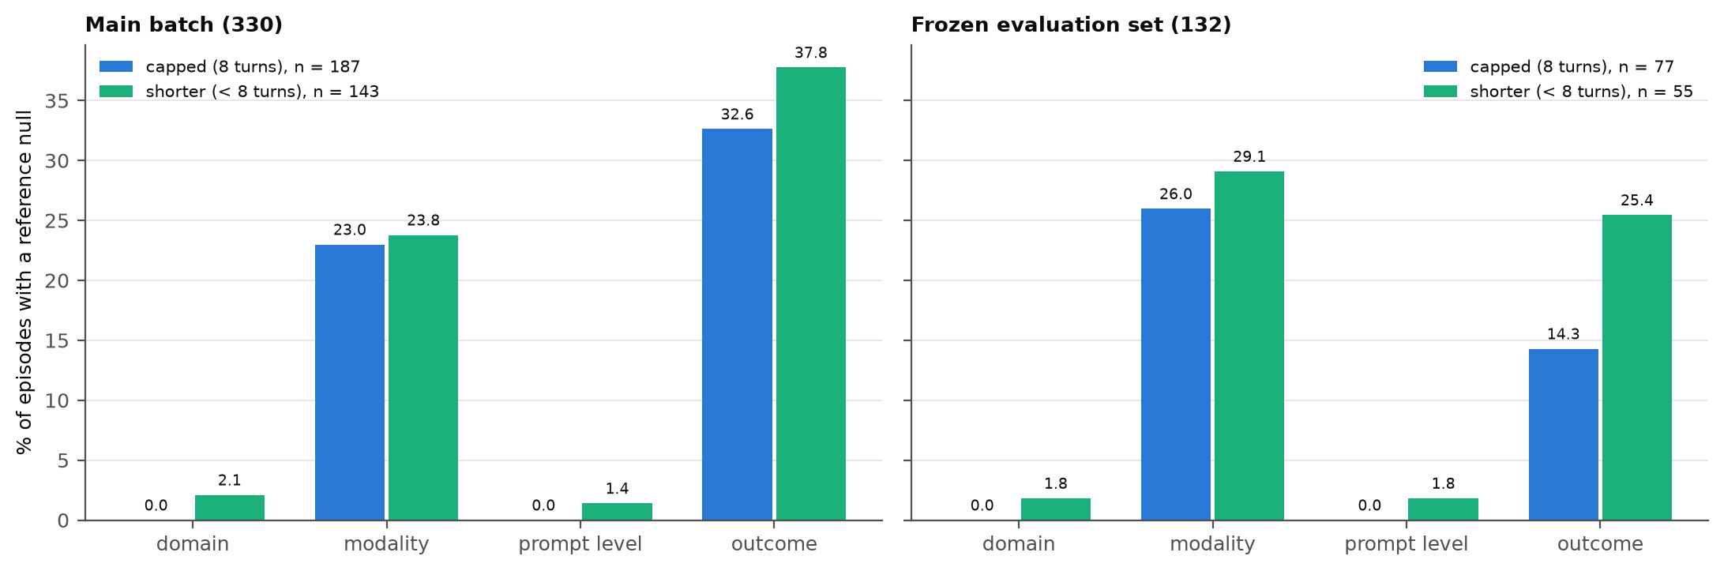
Figure 2. Share of episodes whose reference value is null, by field, for capped (8-turn) and shorter episodes, in the main batch and the frozen 132.
Supporting argument
- Why it matters for unsupported assertion. The unsupported-assertion rate is computed over reference-null slots, so a group with fewer nulls offers fewer opportunities. The null-slot totals are similar in size between groups (104 vs 93 in the main batch; 31 vs 32 in the frozen 132), but they sit almost entirely in modality and outcome.
- Scope. The analysis uses the main batch and the original 132, as recorded; it was not rerun on the 121. Denominators are small, and capped episodes may differ from shorter ones in ways other than length; the design cannot separate the two.
Suggested manuscript wording (Methods 2.12; Results; Limitations 4.9)
Methods 2.12 (add): "To describe whether the eight-turn maximum was associated with reference-standard completeness, we compared episodes that reached the maximum (exactly eight speaker turns; 'capped') with shorter episodes, reporting the share of episodes with a reference null for each categorical field and the qwen2.5:7b unsupported-assertion rate, in the main batch and the frozen evaluation set. This comparison is descriptive."
Results (add): "Capped episodes had fewer reference nulls than shorter episodes in both sets (mean across fields 13.9% vs 16.3% in the main batch and 10.1% vs 14.5% in the evaluation set; Table Z). Domain and prompt level were never null in capped episodes; nulls were concentrated in modality and outcome. The qwen2.5:7b unsupported-assertion rate was higher in capped episodes (64.4% vs 48.4%; 61.3% vs 40.6%), on 104–31 null slots per group."
Limitations 4.9 (replace the empirical clause): "… context across those boundaries is lost. Capped episodes differed descriptively from shorter ones in reference-null frequency (Section 3.x), so extraction behaviour and the opportunities for unsupported assertion may differ under longer context windows."

R5-3 · Minor · Conclusion slightly overstates stability of model ranking
The comment, as written
Location: Section 5. Conclusions
Reviewer concern: The Conclusion states that the post-audit 121-set preserved the broad model-ranking conclusions. However, the top-two ordering changes: Qwen 2.5 7B has slightly higher merged agreement on the main batch, while Qwen 3 14B is slightly higher on the post-audit 121-set. The paired difference is small and uncertain, so this is not a substantive scientific problem, but the phrase "preserved the broad model-ranking" is stronger than the results support.
Required action: Replace the phrase with wording such as "preserved the broad comparative pattern and unsupported-assertion conclusions," or explicitly state that the top-two ordering was not stable while the broader comparative conclusions were unchanged.
Status: Open

Response
Short answer
Agreed. The top two generators swap order on merged agreement between the main batch and the 121-set, and every paired interval includes zero. The Conclusion now uses the reviewer's phrase and states that the top-two ordering was not stable.
Table 6. The two strongest generators across evaluation sets: merged agreement (%) and paired differences qwen3:14b − qwen2.5:7b (percentage points, 95% child-cluster CI). Sources: round4_analysis.json (same_universe.groups), round3_analysis.json (paired), round5_analysis.json (equal-child).
Set | qwen2.5:7b merged | qwen3:14b merged | Paired Δ merged | Paired Δ unsupported
Main batch (330) | 43.1 | 42.0 | -1.1 [-3.7, +1.7] | +40.1 [+19.4, +54.2]
Frozen 132 | 38.8 | 40.2 | +1.3 [-3.0, +5.1] | +41.3 [+17.1, +54.5]
121, episode-weighted | 40.5 | 41.3 | +0.8 [-2.6, +3.9] | +39.6 [+14.8, +53.7]
121, equal-child (sensitivity) | 39.7 | 40.2 | +0.5 [-2.8, +3.7] | +20.6 [-7.6, +45.9]

Supporting argument
- What is stable. On every set qwen2.5:3b has the lowest merged agreement and the lowest unsupported-assertion rate, and llama3.2 and qwen3:14b have high unsupported-assertion rates. Under the primary (episode-weighted) estimand the qwen3:14b − qwen2.5:7b unsupported-assertion difference excludes zero on the main batch, the frozen 132 and the 121.
- What is not. The top-two order on merged agreement reverses, on differences of about one point.
- Note on consistency with R5-1. The phrase 'unsupported-assertion conclusions' refers to the primary estimand. Under the equal-child sensitivity analysis the 121-set unsupported-assertion difference between the two strongest generators includes zero; this is stated in Results and Limitations (R5-1).
Suggested manuscript wording (Section 5, Conclusions)
Replace "preserved the broad model-ranking conclusions" with: "preserved the broad comparative pattern and unsupported-assertion conclusions, although the ordering of the two strongest generators on merged agreement was not stable."

Suggested resolution order, with status
Table 7. The reviewer's order, unchanged, with what this round did.
# | Comment | Next action (reviewer) | Status
1 | R5-1 | Check per-child counts and add an equal-child-weighted sensitivity estimate or justify the episode-weighted estimand. | Done; both
2 | R5-2 | Report the capped-versus-shorter reference-null analysis properly or remove the statement. | Done; reported in Methods/Results
3 | R5-3 | Tighten the Conclusion wording around model-ranking stability. | Done; wording supplied

How this document was produced
uv run python -m tests.eval.extraction.round5_analysis # no model calls; needs exp-data/ locally
uv run python docs/paper/make_round5_response.py

