Response to Round-6 Technical Questions
Answers the technical items in 'Round6_review_feedback.docx' (R6-1, R6-3) in their original order, each request quoted first. Branch model-finetuning, built 2026-09-26. Internal working document; not for submission.
Scope as requested: no model re-run, no new annotation, no re-adjudication, no redraw, no replacement of frozen records. Every number is read from round6_analysis.json, computed from preserved outputs, annotator labels and the deterministic CHAT pipeline. Claims are checked by assertion when this document is built.

Results at a glance
Table 1. The two requested analyses in one line each.
Priority | Comment | Result
1 | R6-1 | 5 of 121 evaluation episodes share 1 boundary turn each with 5 main-batch episodes; excluding them (116 left) changes no conclusion
2 | R6-3 | Mean kappa 0.926 on the 121 vs 0.910 on the 132; essentially unchanged

R6-1 – Source-turn overlap audit
The request, as written
Why the reviewer is asking
The current stable-identity audit removes identical episodes, but the episode-construction procedure allows adjacent episodes to share one source utterance. Stable identity based on session + source start line therefore does not by itself prove that the post-audit 121 evaluation episodes share no underlying source turns with the 330 main-batch episodes.
Please perform this audit
• For every episode in the post-audit overlap-excluded 121-set, obtain the exact set/range of underlying source utterance or source-line identifiers used to construct that episode.
• Do the same for the 330 main-batch episodes.
• Within the same child/session, compare the underlying source-line sets and identify any 121-set episode that shares at least one source turn with any main-batch episode.
• Use source-line/utterance identity, not rendered text matching, because different episodes can contain identical text.
Please return these counts
• Number of the 121 evaluation episodes that share at least one source turn with the 330 main batch.
• Number of distinct main-batch episodes involved in such cross-set sharing.
• Number of distinct shared source turns/utterance lines, with a per-child or per-session breakdown if straightforward.
• For each affected evaluation episode, how many source turns are shared with the matched main-batch episode(s).
• The number of evaluation episodes remaining after excluding every source-turn-overlapping evaluation episode for sensitivity analysis.
Sensitivity analysis only if any overlap is found
Without redrawing or replacing any episode, exclude the affected evaluation episodes only for a sensitivity analysis and recompute the central post-audit evaluation metrics for all four generators:
– Merged categorical agreement
– Unsupported-assertion rate
– Whole-record agreement
Please provide the resulting N and point estimates. If the existing analysis utility can produce the same child-cluster 95% confidence intervals with minimal work, include them; otherwise point estimates are sufficient for us to determine whether the manuscript conclusion changes.
Important: This is an audit/sensitivity check only. Do not redraw the frozen evaluation set, do not replace excluded episodes, and do not change the existing reference labels.
Preferred response format for R6-1
• Short explanation of the matching key/logic used.
• Compact table of affected evaluation episodes (opaque/study IDs are fine), child/session, matched main-batch episode, and number of shared turns.
• Summary counts.
• Sensitivity-result table if any overlap exists.
• Name(s) of the source artifact/script/output file used or generated.

Response
Short answer
Overlap exists but is minimal: 5 of the 121 evaluation episodes share exactly one source turn each with 5 distinct main-batch episodes (5 distinct shared utterance lines in total). Every shared turn is the boundary utterance between two adjacent episodes of the same session: the last line of one episode is the first line of the next, which is what the episode-construction rule permits. Excluding the five for sensitivity leaves 116 episodes; no metric for any generator moves by more than 1.0 percentage points, and every qwen3:14b − qwen2.5:7b paired conclusion is unchanged.

Matching key and logic
- Key: (session_id, CHAT source line number) for every utterance used to build an episode. Line numbers are those the parser assigns to each utterance in the source .cha file, carried unchanged through de-identification and segmentation.
- Sets compared: the 121 post-audit evaluation episodes (frozen 132 minus the 11 pool-identity overlaps, resolved through the cap-5000 selection) and the 330 main-batch episodes (resolved through the cap-3000 selection). Both selections draw from the same single segmentation of the corpus, so line sets are directly comparable.
- Rule: within the same session, an evaluation episode is affected if its line set intersects the line set of any main-batch episode. Rendered text was not used.
- Why identity alone was not enough: an episode starts one utterance before the opening child turn, so the last utterance of one episode can be the first of the next while the two have different (session_id, start_line) identities.
- Check: on the full 132 the same audit finds 1 identity overlap with the 330 (the episode the reviewer refers to) and 6 turn overlaps in total, i.e. that one plus the five here.
Table 2. Affected evaluation episodes. Episode IDs are the study segment IDs. Position = where the shared line sits in each episode. Source: round6_analysis.json (turn_audit.affected).
Evaluation episode | Child / session | Matched main-batch episode | Shared line | Eval pos. | Main pos. | Shared turns
seg_016 (brett) | brett / flusberg_brett_060819.cha | seg_017 | 1266 | last | first | 1 of 8
seg_039 (carl) | carl / rollins_carl_030700.cha | seg_003 | 1017 | last | first | 1 of 8
seg_011 (josh) | josh / rollins_josh_020800.cha | seg_010 | 1316 | first | last | 1 of 8
seg_083 (mars) | mars / rollins_mars_030300.cha | seg_050 | 2065 | last | first | 1 of 8
seg_004 (roger) | roger_rollins / rollins_roger_rollins_020800.cha | seg_005 | 181 | last | first | 1 of 8

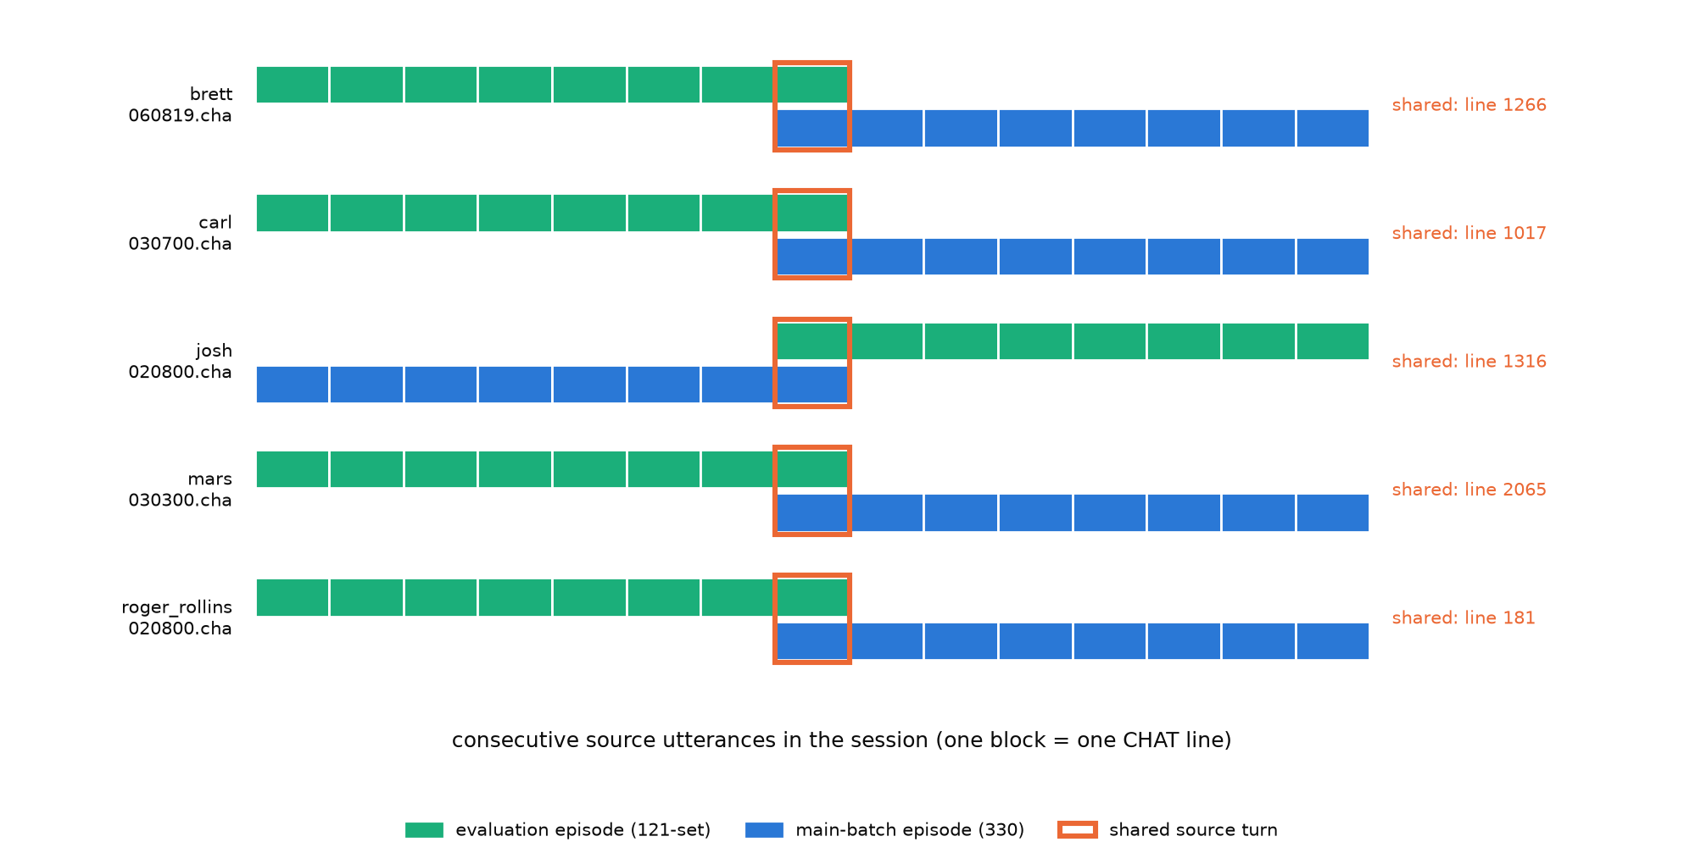
Figure 1. Each affected evaluation episode (top bar) and its matched main-batch episode (bottom bar), aligned on source turns. The only shared turn in each pair (orange) is the boundary utterance between adjacent episodes.
Table 3. Summary counts. Source: round6_analysis.json (turn_audit).
Quantity | Count
Evaluation episodes sharing ≥ 1 source turn with the 330 | 5 of 121
Distinct main-batch episodes involved | 5
Distinct shared source turns (utterance lines) | 5
Shared turns per affected evaluation episode | 1 (each of 5)
Evaluation episodes remaining after excluding all turn-overlapping ones | 116
Per child (affected episodes / shared turns) | brett 1/1; carl 1/1; josh 1/1; mars 1/1; roger_rollins 1/1; all other children 0/0

Table 4. Sensitivity: central metrics on the 121 and on the 116 after excluding the 5 turn-overlapping episodes, % [95% child-cluster CI, 10,000 replicates]. 11 children remain. Nothing redrawn or replaced; reference labels unchanged. Source: round6_analysis.json (sensitivity).
Model | Merged: 121 | Merged: 116 | Unsupp.: 121 | Unsupp.: 116 | Whole: 121 | Whole: 116
llama3.2 | 27.5 [21.6, 32.6] | 28.0 [22.2, 33.3] | 83.0 [75.0, 91.7] | 82.3 [73.8, 91.4] | 0.0 [0.0, 0.0] | 0.0 [0.0, 0.0]
qwen2.5:3b | 12.6 [8.7, 17.2] | 12.7 [8.9, 17.4] | 24.5 [12.5, 36.8] | 25.5 [13.7, 37.1] | 0.0 [0.0, 0.0] | 0.0 [0.0, 0.0]
qwen2.5:7b | 40.5 [33.5, 47.2] | 41.2 [34.1, 48.0] | 50.9 [36.0, 74.2] | 51.0 [35.3, 74.2] | 5.0 [0.0, 10.7] | 5.2 [0.0, 10.8]
qwen3:14b | 41.3 [31.7, 50.4] | 42.0 [32.5, 51.0] | 90.6 [81.4, 97.8] | 90.2 [81.0, 97.7] | 4.1 [0.0, 11.0] | 4.3 [0.0, 11.2]

Table 5. Paired difference qwen3:14b − qwen2.5:7b, percentage points [95% child-cluster CI]. Source: round6_analysis.json (sensitivity.*.paired_qwen3_14b_minus_qwen2_5_7b).
Metric | 121 | 116
Merged agreement | +0.8 [-2.6, +3.9] | +0.9 [-2.5, +3.9]
Unsupported assertion | +39.6 [+15.0, +53.8] * | +39.2 [+13.9, +54.3] *
Whole-record agreement | -0.8 [-3.5, +1.8] | -0.9 [-3.7, +1.9]

* interval excludes zero.
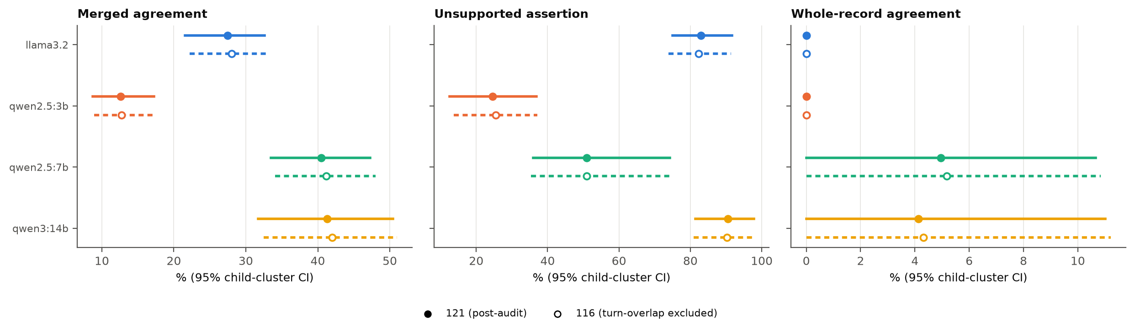
Figure 2. Central metrics on the 121 (filled, solid) and on the 116 after excluding turn-overlapping episodes (open, dashed).

Artefacts
- Script: tests/eval/extraction/round6_analysis.py (reuses the round-4 pipeline rebuild and frame audit).
- Output: tests/eval/extraction/results/round6_analysis.json (turn_audit, sensitivity).
- Inputs: holdout_set.json, annotation_pool.json, scored_against_gold_augmented.json (330 IDs), scored_holdout.json (scored outputs), CHAT sources in exp-data/.

R6-3 – Reliability sensitivity on the overlap-excluded 121-set
The request, as written
Why the reviewer is asking
The frozen 132-set is described as a first-pass evaluation annotation round with mean kappa 0.910. The stable-identity audit later showed that one of those 132 episodes also entered the 330 main batch. The reviewer therefore wants the reliability result recomputed after removing all 11 pool-overlapping episodes.
Please compute from the existing annotator labels
Using the existing pre-adjudication Annotator A and Annotator B labels for the post-audit overlap-excluded 121 evaluation episodes, compute Cohen's kappa separately for:
• domain
• modality
• prompt_level
• outcome
Then report the unweighted mean of the four field-specific kappas, using the same definition used for the published 132-set mean.
If the existing reliability script can produce the same 10,000-replicate child-cluster 95% confidence intervals without substantial new implementation, please include them. Please also show the original 132-set values beside the 121-set values so we can see whether the reliability interpretation materially changes.
Preferred response format for R6-3
• Table: field | 132-set kappa | 121-set kappa | 121-set 95% CI (if available).
• Unweighted mean kappa for the 121-set.
• One sentence stating whether the result is essentially unchanged, modestly changed, or materially changed relative to the 132-set.
• Name of the label/artifact file and script/output used.

Response
Short answer
Mean kappa on the 121-set is 0.926, against 0.910 on the 132-set (+0.016). The result is essentially unchanged: every field's kappa rises slightly (+0.003 to +0.028) and every 121-set value lies inside the 132-set 95% child-cluster interval.
Table 6. Cohen's kappa, pre-adjudication holdout annotators A vs B. 95% child-cluster percentile bootstrap, 10,000 replicates, seed 20260915 (as published). The mean is the unweighted mean of the four field kappas, the published definition; no interval is reported for it, as for the 132. Source: round6_analysis.json (reliability).
Field | 132-set κ | 132-set 95% CI | 121-set κ | 121-set 95% CI | Δ (121 − 132)
domain | 0.879 | [0.806, 0.936] | 0.900 | [0.814, 0.963] | +0.021
modality | 0.929 | [0.822, 1.000] | 0.932 | [0.799, 1.000] | +0.003
prompt level | 0.916 | [0.820, 1.000] | 0.944 | [0.854, 1.000] | +0.028
outcome | 0.914 | [0.877, 0.950] | 0.927 | [0.894, 0.959] | +0.013
Unweighted mean of 4 | 0.910 | – | 0.926 | – | +0.016

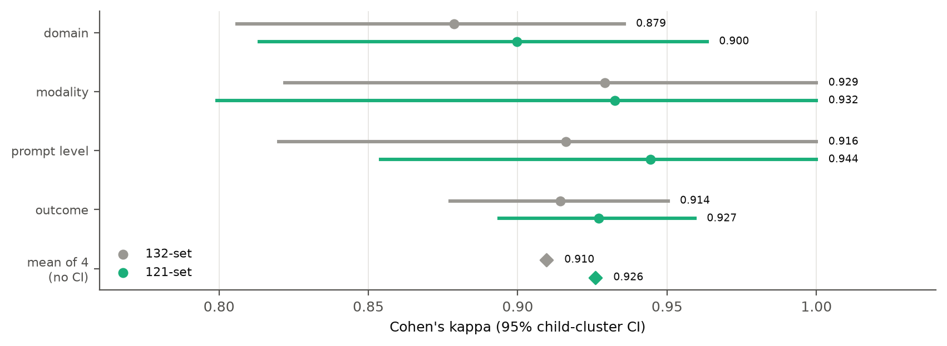
Figure 3. Field kappas with 95% child-cluster intervals on the 132 (grey) and the 121 (teal); diamonds are the unweighted means.
- Check: the same code applied to all 132 reproduces the recorded reliability_holdout.json exactly (mean 0.9096, identical field kappas and intervals) before the 121 subset is taken.
- Interval notes: modality's child-cluster interval rests on 9,997 valid replicates (resamples with a single category leave kappa undefined and are dropped), as on the 132.
- Labels: gold_holdout_annotator_a.json, gold_holdout_annotator_b.json (first-pass, pre-adjudication). Script: tests/eval/extraction/round6_analysis.py, which calls reliability_stats.build_report. Output: round6_analysis.json (reliability.set_121).

No architect action required for R6-2 and R6-4
The request, as written
R6-2 – Strongest-generator comparator is in-sample/data-selected. We already have the required facts. The manuscript will explicitly state that this comparator was selected using the same main-batch reference labels and is therefore an optimistic in-sample benchmark rather than an independently selected policy.
R6-4 – 80.3% is full-policy coverage, not reranking coverage. This is a wording clarification only. The manuscript will distinguish the full MARS selector policy (80.3% returned a record) from the 142 segments that underwent a genuine usable reranking decision.

Response
Response
Noted. No code, model or annotation work was done for R6-2 or R6-4. The facts they rely on are already recorded in earlier rounds (round4_analysis.json mars_clustered; mars_selection_analysis.json).

How this document was produced
uv run python -m tests.eval.extraction.round6_analysis # no model calls; needs exp-data/ locally
uv run python docs/paper/make_round6_response.py

