Response to Round 3 Review Comments
Answers the ten questions in 'Roun3-Review comments.docx', in their original order and wording. Branch model-finetuning, built 2026-09-26. Internal working document; not for submission.
Every number is read from a recorded artifact named in the table that shows it. Two artifacts were added this round, both computed from preserved outputs with no model re-run: round3_analysis.json and segmentation_stats.json. Test counts are run records and are labelled as such.

Summary
Table 1. Each question and the answer in one line.
# | Question | Answer
1 | Final merged κ = 0.801 | Mean of 4 per-field κ over all 330 in final pre-adjudication state (178 round-2 + 152 round-1). Not a before/after effect: the retained 152 were at 0.884 already
2 | Segmentation logic | Rule-based 2–8 turn windows around child turns; all speakers; %spa/%act/%gpx only; 1-turn overlaps; 8 types; nothing excluded; deterministic
3 | 506 examined → 330 | Per-child seeded shuffle (seed 42), walk in order, keep where all 3 generators admissible, stop at 30. Found: 11 held-out segments are pool episodes — conclusions unchanged
4 | Metric definitions | Five judgements per field; four formulas with exact denominators; 'unknown' is a category; an omitted field is scored as null
5 | Cluster CIs for models | Computed. Held-out qwen3:14b − qwen2.5:7b: merged +1.3 [−3.0, +5.1]; unsupported +41.3 [+17.1, +54.6]
6 | Full-policy MARS | Exists: mars_evaluation.json. 2.7% over all 330 (abstain = miss), coverage 80.3%, vs 4.5% for qwen2.5:7b
7 | Model/annotator input | Same text, 330/330 identical; model saw no IDs, goals or metadata; annotators saw no model information
8 | Representation logic | Always applied, not goal-relative, no exemption; single setting or role → never ADEQUATE; 'contributors' = roles
9 | Authorization tests | All five covered; 120 pass; 4 real-DB tests added (revocation, cross-child)
10 | Bootstrap method | Yes: child-cluster, 10,000 percentile. One manuscript sentence says 'segments' and needs fixing

Manuscript changes this round implies
- κ = 0.801: describe the mixed annotation state; relabel the 'after codebook re-annotation' row (Q1).
- Held-out: disclose the 11 pool episodes and add the 121-segment sensitivity analysis; correct 'the entire original stratified pool … is excluded' (Q3).
- Metric definitions: omission is scored as null; 'unknown' is a category (Q4).
- Add child-cluster CIs to the model-performance tables (Q5).
- Adequacy: representation is not goal-relative; 'contributors' are roles (Q8).
- Bootstrap sentence at make_manuscript.py:558 (Q10).

1. Final merged main-batch κ = 0.801
The question, as asked
Could you confirm exactly how the final merged main-batch mean Cohen’s κ of 0.801 was calculated after Round 2?
My understanding is:
- 178 disagreement-enriched segments were re-issued after codebook clarification;
- the remaining 152 retained their Round-1 categorical annotations;
- residual disagreements were then adjudicated.
What I need to understand is the exact calculation that produced 0.801. Was κ recomputed over all 330 using the final annotation state for each segment, or was it calculated in some other way?
This is important because we want to describe the number correctly and avoid implying that 0.801 is a clean causal “before-versus-after” codebook effect.

Response
Short answer
Recomputed over all 330, in each segment's final annotation state, before adjudication. For each of the four categorical fields, Cohen's κ was computed over the 330 paired values: annotator A's value against annotator B's. Each segment contributes its round-2 value if it was one of the 178 re-issued, and its round-1 value otherwise. 0.801 is the unweighted mean of the four per-field κ values. It is not a pooled κ. Adjudication plays no part in it: adjudicated values form the reference standard, not an annotator's labels.
Your understanding is correct, and the number should not be presented as a before/after effect. The 152 retained segments already agreed at κ = 0.884 in round 1, because re-issue selection took the disagreement-enriched segments and left these. Part of the rise from 0.610 to 0.801 therefore comes from which segments were re-annotated, not from the codebook alone.
Table 2. κ by annotation state. Source: round3_analysis.json (kappa_composition). The script asserts that its final-state and round-1 means equal reliability_current.json and reliability_round1.json, and that the 152 retained segments carry identical values in both files.
Set | Values | n | Mean κ | domain | modality | prompt_level | outcome
Round 1, all 330 | round 1 | 330 | 0.610 | 0.751 | 0.570 | 0.595 | 0.524
Retained 152 | round 1 (unchanged) | 152 | 0.884 | 0.734 | 0.961 | 1.000 | 0.841
Re-issued 178, before | round 1 | 178 | 0.420 | 0.732 | 0.385 | 0.281 | 0.284
Re-issued 178, after | round 2 | 178 | 0.690 | 0.691 | 0.866 | 0.574 | 0.628
Final state (reported) | mixed | 330 | 0.801 | 0.718 | 0.911 | 0.831 | 0.743

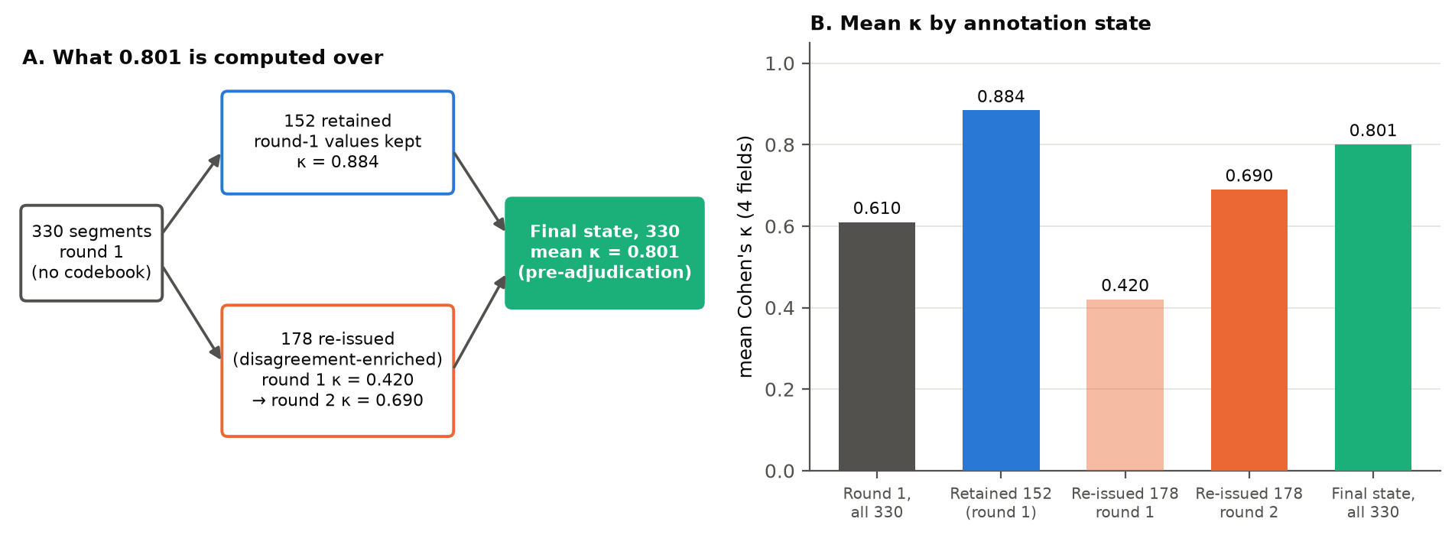
Figure 1. Composition of the reported κ. The 152 retained segments were high-agreement to begin with. The re-issued 178 rose from 0.420 to 0.690.
How to describe it
Suggested wording
"After re-annotation of the 178 disagreement-enriched segments under the codebook, mean κ over all 330 segments, each in its final pre-adjudication state (round-2 values for the 178, round-1 values for the remaining 152), was 0.801. Because the 152 were not re-annotated and had higher round-1 agreement (0.884), this figure is not a before/after estimate of the codebook effect. That estimate comes from the controlled comparison on the 178 re-issued segments, with domain as the untreated control field."
Also relabel the table row that currently reads "after codebook re-annotation" (make_manuscript.py:791). Only 178 of the 330 were re-annotated.

2. Behavioral-episode segmentation logic
The question, as asked
Could you please describe exactly how the 75,003 utterances became 9,018 behavioral episodes?
Specifically:
- What starts an episode?
- What ends an episode?
- How many surrounding turns are retained?
- Which speakers/CHAT tiers are included?
- Can episodes overlap?
- What are the “episode types” used in the child- and episode-type-balanced selection?
- Are any episodes excluded before balancing?
- Is segmentation fully deterministic?
The reviewer wants enough information to understand what one model input actually represents.

Response
Short answer
One model input is a window of 2–8 consecutive transcript turns (mean 6.31) built around child turns, including every speaker's turns inside the window. Segmentation is rule-based, runs session by session, and turns 75,003 utterances in 85 sessions into 9,018 episodes. Two runs produce identical output. Code: data/pipeline/segment_episodes.py; measured by segmentation_stats.py → segmentation_stats.json.
Q What starts an episode?
A child (CHI) turn that either carries a behavioural tier (%spa, %act or %gpx), is the first utterance of the session, or follows a non-child turn. The window opens one turn before that child turn, so the adult turn that prompted it is included.
Q What ends an episode?
Checked at each following turn: the window closes when it reaches 8 turns, when the session ends, or when none of the next 3 utterances is a child turn (once it has at least 2 turns). The closing turn is included.
Q How many surrounding turns are retained?
One preceding turn before the triggering child turn. After it, turns continue until the end rule fires, up to 8 in total. Nothing is added after the closing turn. Measured length: 2 turns: 14, 3 turns: 1,570, 4 turns: 814, 5 turns: 700, 6 turns: 697, 7 turns: 513, 8 turns: 4,710. Most episodes (4,710) hit the 8-turn cap.
Q Which speakers/CHAT tiers are included?
All speakers inside the window: CHI 26,232, MOT 25,955, INV 4,742, INV2 16, UID 1, OTH 1. Of the dependent tiers, only %spa, %act and %gpx are carried into the segment. %mor, %gra, %com, %tim (timing), %xpho and %gls are parsed but dropped. No @header metadata is included.
Q Can episodes overlap?
Yes, by one turn. Because a new window opens one turn before its triggering child turn, it can begin on the previous episode's closing turn. 1,787 adjacent episode pairs share exactly one utterance. Episodes never overlap by more than that.
Q What are the “episode types” used in the child- and episode-type-balanced selection?
Eight types, assigned by the first matching rule in this order: request (%spa REQ/QN/$Q), imitation (IM), protest (%spa NO/PR, or push/turn away, head shake in %gpx), joint attention (%gpx point/show/look at/gaze), response (%spa AN/RP/$R), play (play vocabulary in %act/%gpx/text), initiation (the window opens on a child turn), and other. Imitation never occurs in these corpora. Distribution: see Figure 4B.
Q Are any episodes excluded before balancing?
Two rules exist (windows shorter than 2 turns, and windows with no child turn). Measured on this corpus they exclude 0 and 0 windows. Every window is kept, so the balancing step sees all 9,018. Balancing then keeps, per child, up to ⌈cap/11⌉ episodes, split equally across the child's episode types. Within each type it takes the earliest in transcript order, with no randomness.
Q Is segmentation fully deterministic?
Yes. There is no random step anywhere in parsing, de-identification, segmentation or selection. Two consecutive runs gave the identical episode list, SHA-256 df41518326c11cb2…. One caveat, which matters for Q3: the segment ID number is assigned in selection order, so the same ID can name a different episode under a different cap.
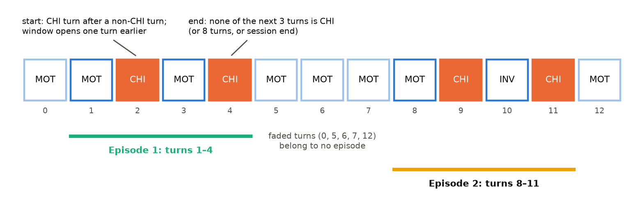
Figure 2. The start and end rules on an illustrative sequence of turns (not corpus text). The episode boundaries are computed by the pipeline's own _find_episode_boundaries, not drawn by hand.
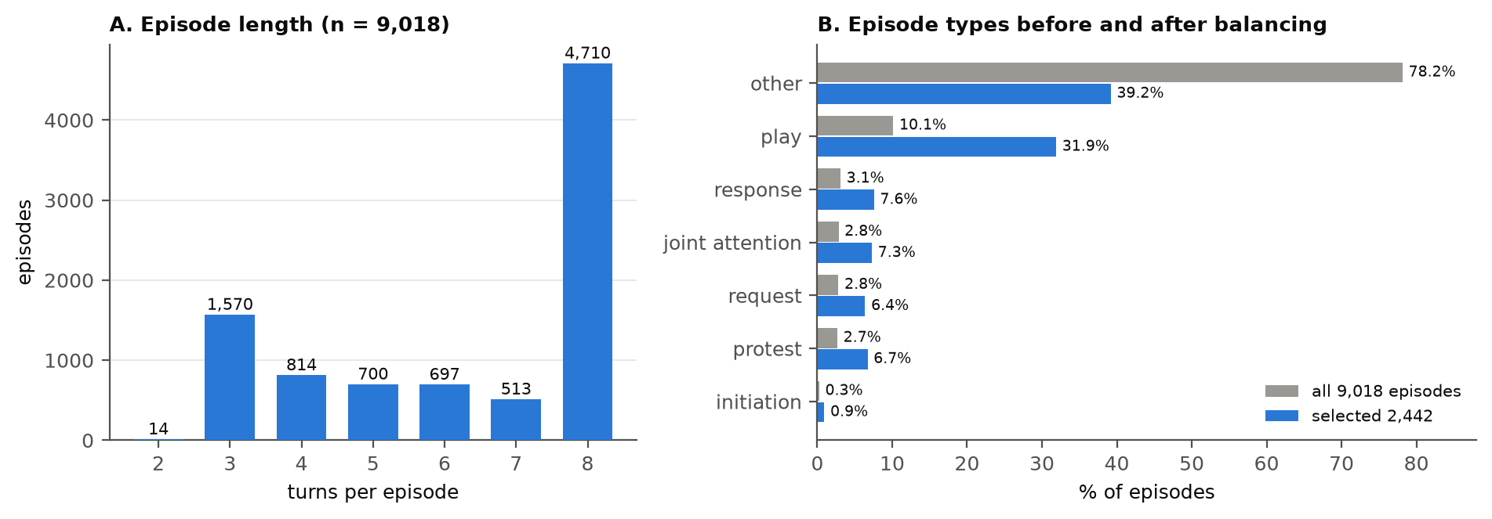
Figure 3. A: most episodes reach the 8-turn cap. B: "other" is 78% of all episodes. The per-type quota reduces it to 39% of the 2,442 selected segments. Source: segmentation_stats.json.
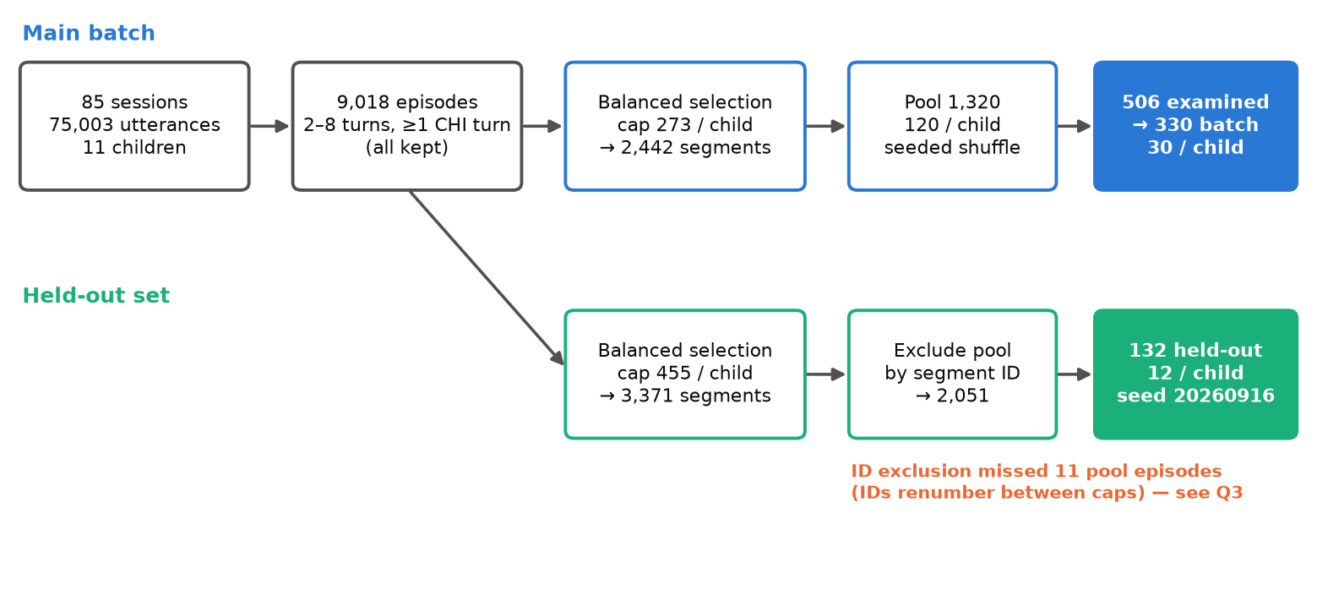
Figure 4. From utterances to model inputs, for both samples. The held-out branch is where the ID instability surfaces (Q3).

3. Main-batch selection order: 506 examined → 330 retained
The question, as asked
We currently state that 506 pool segments were examined to obtain 330 qualifying segments.
Could you confirm:
- In what order were those 506 examined?
- Was the 1,320-segment pool shuffled first?
- Was a fixed seed used?
- Were the 330 simply the first qualifying cases encountered per child?
- Was there any other sampling/selection logic?
Please share the relevant script/path and seed if applicable.

Response
Short answer
Stage 1 shuffled each child's segments with a fixed per-child seed and kept the first 120. Stage 2 walked those 120 in shuffled order and kept each segment where all three generators gave an admissible response, stopping at 30 per child. Script: tests/eval/extraction/build_annotation_batch.py (build_pool, extract_candidates); seed 42; artifacts annotation_pool.json and annotation_batch.json.
Q In what order were those 506 examined?
Child by child, in alphabetical order of child ID. Within each child, in the pool's shuffled order. Stage 2 visits every pool entry and skips a child's remaining entries once that child has 30 kept. The examined set is therefore, for each child, the prefix of its shuffled list up to its 30th kept segment. Reconstructed this way, it contains exactly 506 segments, matching segments_attempted in the artifact.
Q Was the 1,320-segment pool shuffled first?
Yes. Each child's candidates (from the 2,442) were shuffled before the first 120 were taken, and the 1,320-segment pool keeps that order.
Q Was a fixed seed used?
Yes: random.Random(f"42:{child_id}"), i.e. seed 42 combined with the child ID. Seeding per child means adding or removing a child does not reshuffle the others.
Q Were the 330 simply the first qualifying cases encountered per child?
Yes. For each child, the 30 are the first 30 examined segments where every generator returned an admissible response (require="all"). Under the judgeable rule, admissible means the response contains at least one populated extracted field, whatever status the model self-reported.
Q Was there any other sampling/selection logic?
One upstream filter: segments rendering to 20 characters or fewer are dropped before pooling (none were). There is no other sampling, weighting or manual choice. Annotator assignment was a separate step: both annotators received all 330 (100% overlap), each in their own seeded row order.
Table 3. Examined and kept, per child. Reconstructed from the artifacts; the total reproduces the recorded 506.
Child | Pool | Examined | Kept | Joint yield
brett | 120 | 40 | 30 | 75.0%
carl | 120 | 48 | 30 | 62.5%
jack | 120 | 53 | 30 | 56.6%
josh | 120 | 52 | 30 | 57.7%
mark | 120 | 39 | 30 | 76.9%
mars | 120 | 53 | 30 | 56.6%
rick | 120 | 41 | 30 | 73.2%
roger_flusberg | 120 | 45 | 30 | 66.7%
roger_rollins | 120 | 42 | 30 | 71.4%
sid | 120 | 51 | 30 | 58.8%
stuart | 120 | 42 | 30 | 71.4%
Total | 1,320 | 506 | 330 | 65.2%

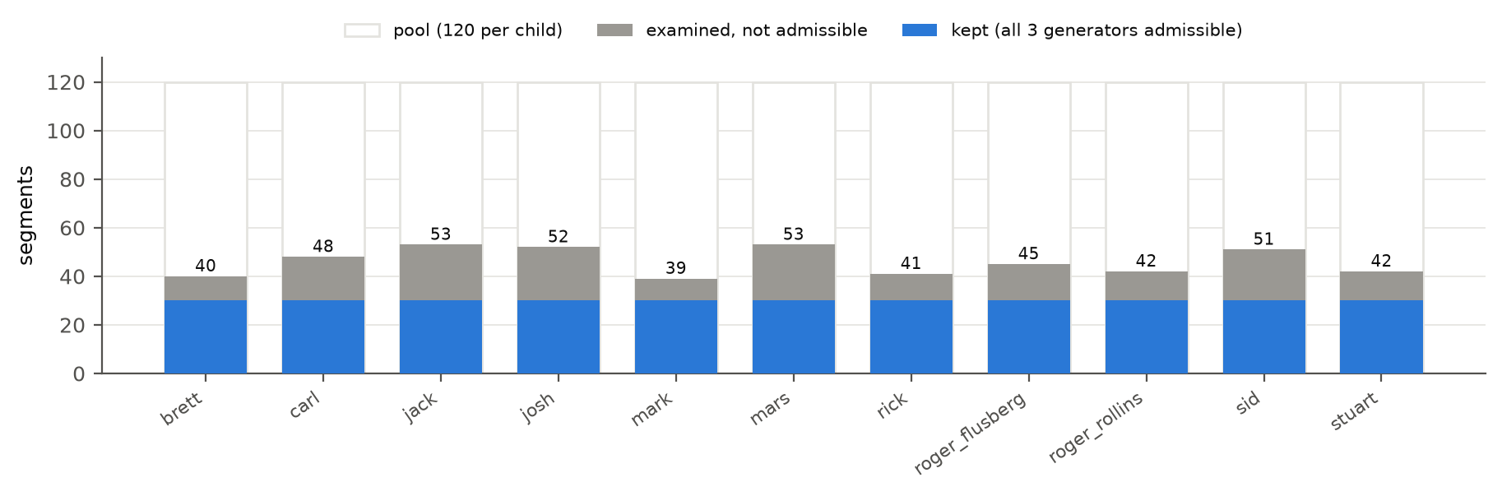
Figure 5. How far into each child's shuffled pool the builder had to go to reach 30 segments where all three generators were admissible.
A defect found while answering this question: held-out leakage
What was found (2026-09-26)
build_holdout_set.py excluded the 1,320-segment pool by segment ID. Segment IDs are numbered in selection order within each session, so under the held-out build's larger cap (455 per child, against 273) the numbering shifts: 338 of the 2,442 IDs name a different episode. Matched by transcript text and confirmed by source line numbers, 11 of the 132 held-out segments are pool episodes. Of those, 4 had model output examined during batch construction, and 1 was annotated in the main batch.
This also corrects my answer in the previous round, which said none of the 132 were in the pool. That check compared IDs, so it could not see this.

Table 4. Held-out results with and without the 11 pool episodes (132 → 121 segments, still 11 children). Source: round3_analysis.json (holdout_sensitivity).
Generator | Merged agreement | Unsupported assertion | Whole-record
llama3.2 | 26.5% → 27.5% | 84.1% → 83.0% | 0.0% → 0.0%
qwen2.5:3b | 12.5% → 12.6% | 28.6% → 24.5% | 0.0% → 0.0%
qwen2.5:7b | 38.8% → 40.5% | 50.8% → 50.9% | 4.5% → 5.0%
qwen3:14b | 40.2% → 41.3% | 92.1% → 90.6% | 3.8% → 4.1%

No conclusion changes. All four generators still score lower on the held-out set than on the main batch, and the order of generators on every metric is unchanged. The Qwen 3 14B minus Qwen 2.5 7B difference stays inside its interval (merged +0.8 points, 95% CI -2.6 to +3.9). Recommendation: keep the frozen 132 as the primary held-out result, so nothing is re-drawn after results were seen. Report the leak and this 121-segment sensitivity analysis alongside it, and fix the builder to exclude by episode identity for any future draw. The manuscript's claim that "the entire original stratified pool … is excluded" (make_manuscript.py:446) must be corrected.

4. Exact definitions of the extraction metrics
The question, as asked
Could you confirm the exact scoring formulas/denominators used for:
- merged categorical agreement;
- whole-record agreement;
- mean field abstention;
- unsupported assertion.
In particular, how are these states treated in each metric:
- categorical value;
- JSON null;
- categorical unknown;
- missing/model-omitted field.
I understand the conceptual distinction, but I want the manuscript definitions to match the scoring implementation exactly.

Response
Short answer
Each field is first given one of five judgements by comparing the model's value with the gold value (score_against_gold.judge_field). All four metrics are counts of those judgements over the four categorical fields, with the free-text behavior field excluded. Code: score_against_gold.py, paper_metrics.summarise_scored, mars_evaluation.is_fully_correct.
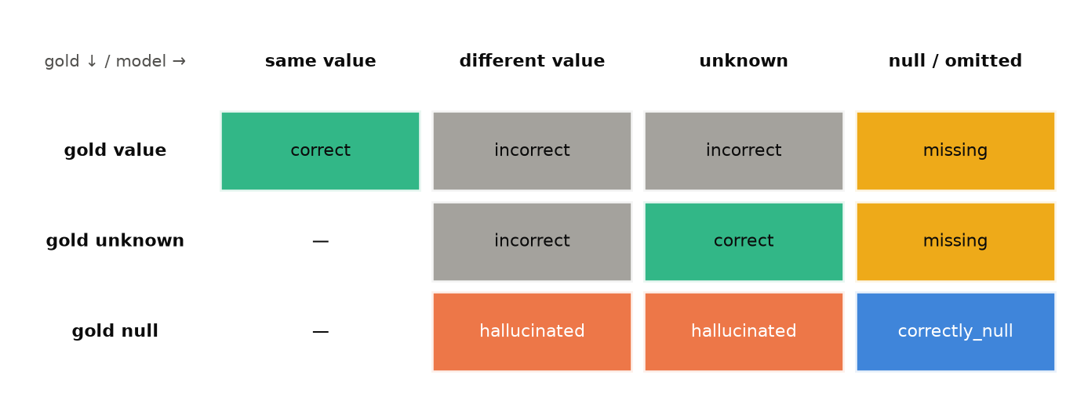
Figure 6. Judgement for every pair of gold state and model state. A dash means the combination cannot occur: a model value cannot equal a gold value that is unknown or null.
Q merged categorical agreement;
For each field: (correct + correctly_null) ÷ all N scored segments. Then the unweighted mean over the four fields. Worked value: qwen2.5:7b, batch: 43.1%.
Q whole-record agreement;
Share of segments where all four fields are correct or correctly_null. Denominator: all N scored segments. Worked value: 15/330 = 4.5%.
Q mean field abstention;
For each field: missing ÷ N. Then the mean over the four fields. Counts only cases where gold has a value and the model gave none. A null where gold is also null is correctly_null, not abstention. Worked value: 12.7%.
Q unsupported assertion.
Σ hallucinated ÷ Σ (hallucinated + correctly_null), pooled across the four fields (not averaged per field). Denominator: every field where gold is null. Worked value: 112/197 = 56.9%.
Table 5. Judgement counts behind the four metrics: qwen2.5:7b, main batch, 4 fields × 330 = 1,320 field judgements. Source: scored_against_gold_augmented.json.
correct | incorrect | missing | hallucinated | correctly_null | total
484 | 471 | 168 | 112 | 85 | 1320

Q categorical value;
An exact match (after case and whitespace are normalised) is correct; otherwise incorrect. If gold is null, any model value is hallucinated.
Q JSON null;
A null on either side is a distinct state. Gold null with model null is correctly_null, which counts as agreement and as a non-hallucinated opportunity. Gold value with model null is missing. The literal strings "null"/"none" are converted to JSON null before scoring (ollama_llm._normalize_null_strings).
Q categorical unknown;
"unknown" is an ordinary category, not a null. Gold unknown with model unknown is correct. Model unknown where gold is null is hallucinated, i.e. an unsupported assertion. Gold unknown with model null is missing. For qwen2.5:7b on the main batch, 28 of its 112 unsupported assertions were the value "unknown".
Q missing/model-omitted field.
Scored exactly as JSON null. The scorer reads a missing field, or a whole missing candidate, as None, so the manuscript must not describe omission as a separate state. On the main batch this cannot occur at candidate level, because inclusion required every generator to respond. On the held-out set, a generator with no admissible response has all four fields judged as null.

5. Child-cluster confidence intervals for model performance
The question, as asked
One reviewer suggested adding uncertainty intervals for the main model-performance results, similar to what we already do for annotation κ.
Can our existing scored outputs/scripts produce child-cluster bootstrap 95% CIs for at least:
- merged categorical agreement;
- unsupported-assertion rate;
- optionally whole-record agreement?
No model rerun should be needed — this should only be analysis of the existing preserved outputs.
If yes, could you please provide the results or point me to the script/artifacts needed to generate them?

Response
Short answer
Yes, and the results are below. tests/eval/extraction/round3_analysis.py computes them from the saved scored outputs (scored_against_gold_augmented.json, scored_holdout.json) with no model call. It uses the same child-cluster percentile bootstrap as the annotation κ: 10,000 replicates, children drawn with replacement, all segments of each drawn child kept. Seed 20260926. Output: round3_analysis.json. Its point estimates are checked against holdout_metrics.json.
Table 6. Main batch (n = 330, 11 children): point estimate [95% child-cluster CI].
Generator | Merged agreement | Unsupported assertion | Whole-record
llama3.2 | 30.8% [24.3%, 37.0%] | 83.2% [79.1%, 86.7%] | 1.5% [0.0%, 3.3%]
qwen2.5:3b | 20.4% [17.9%, 22.9%] | 31.0% [25.3%, 35.6%] | 0.3% [0.0%, 0.9%]
qwen2.5:7b | 43.1% [35.3%, 50.8%] | 56.9% [44.1%, 76.7%] | 4.5% [2.1%, 7.3%]
qwen3:14b | 42.0% [33.4%, 50.7%] | 97.0% [93.7%, 99.3%] | 3.0% [0.9%, 5.5%]

Table 7. Held-out set (n = 132, 11 children): point estimate [95% child-cluster CI].
Generator | Merged agreement | Unsupported assertion | Whole-record
llama3.2 | 26.5% [20.8%, 31.6%] | 84.1% [77.6%, 91.5%] | 0.0% [0.0%, 0.0%]
qwen2.5:3b | 12.5% [8.5%, 16.7%] | 28.6% [18.7%, 40.4%] | 0.0% [0.0%, 0.0%]
qwen2.5:7b | 38.8% [31.6%, 46.6%] | 50.8% [36.0%, 72.7%] | 4.5% [0.0%, 9.8%]
qwen3:14b | 40.2% [30.9%, 49.8%] | 92.1% [83.0%, 98.3%] | 3.8% [0.0%, 10.6%]

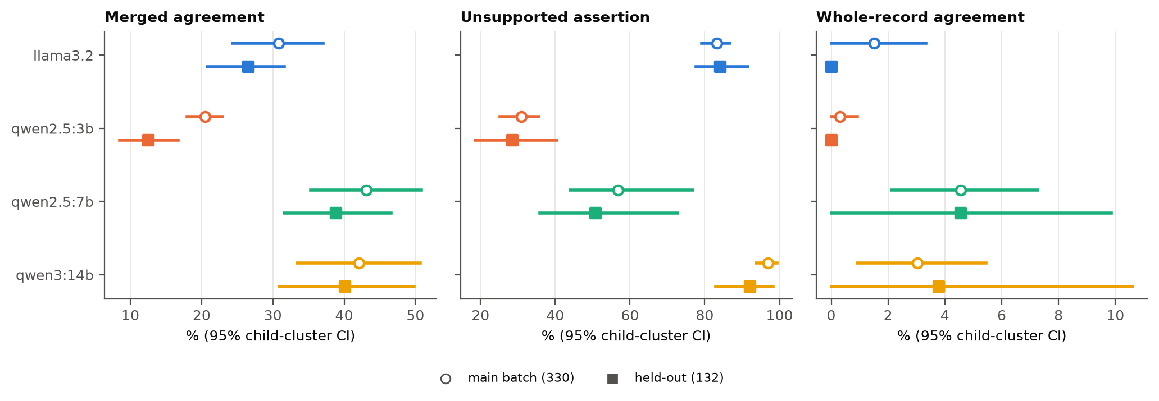
Figure 7. Child-cluster 95% intervals. Merged-agreement intervals for qwen2.5:7b and qwen3:14b overlap heavily. Unsupported-assertion intervals separate the four generators clearly.
Table 8. Paired difference, qwen3:14b minus qwen2.5:7b, in percentage points. Both models are scored on the same resampled children. * marks an interval excluding zero.
Set | Merged agreement | Unsupported assertion | Whole-record
main batch | -1.1 [-3.7, +1.7] | +40.1 [+19.4, +54.2] * | -1.5 [-3.3, +0.3]
holdout | +1.3 [-3.0, +5.1] | +41.3 [+17.1, +54.5] * | -0.8 [-3.0, +1.5]

This answers the question left open in Round 2. On the held-out set, Qwen 3 14B's 1.3-point lead in merged agreement is not distinguishable from zero. Its 41-point higher unsupported-assertion rate is. Whole-record intervals include zero for most generators, because 4.5% of 132 is 6 segments. Report them as descriptive, not as a ranking.

6. Full-policy MARS performance across all 330 segments
The question, as asked
We currently report MARS selection performance on the 142 segments where a genuine usable reranking decision occurred.
The reviewer is also asking what the complete MARS policy looks like over all 330 segments, including:
- 123 single-candidate short-circuits;
- 42 no-reviewable-candidate abstentions;
- 21 judge-disagreement abstentions;
- 2 insufficient-valid-response cases;
- the genuinely reranked cases.
Do we already have a metric/output that evaluates the full MARS policy over all 330?
If yes, what is the correct way to score abstentions in that policy comparison? Please point me to the relevant artifact/script rather than creating a new definition just for the paper.

Response
Short answer
Yes, and it already exists: mars_evaluation.py → mars_evaluation.json. It scores the complete MARS policy over all 330 segments at whole-record level and reports it two ways: accuracy_over_all, where every abstention counts as a miss, and accuracy_over_returned, conditional on MARS returning a record. Each is reported with coverage and the reason for each abstention. No new definition is needed; the one to cite is accuracy_over_all, alongside coverage.
Table 9. How each MARS outcome enters the full-policy score. Source: mars_evaluation.json, mars_selection_analysis.json.
Outcome (as listed) | n | State | Scoring
123 single-candidate short-circuits; | 123 | returned | Scored on the passed-through candidate
42 no-reviewable-candidate abstentions; | 42 | abstained | Miss in accuracy_over_all
21 judge-disagreement abstentions; | 21 | abstained | Miss in accuracy_over_all
2 insufficient-valid-response cases; | 2 | abstained | Miss in accuracy_over_all
the genuinely reranked cases. | 142 | returned | Scored on the selected candidate
Total | 330 | 265 returned / 65 abstained | coverage 80.3%

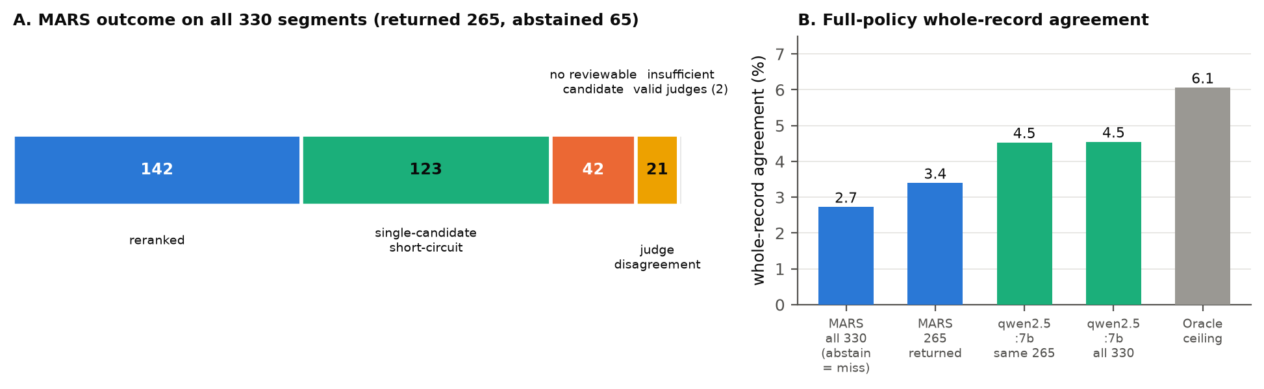
Figure 8. A: the complete policy over 330. B: MARS at whole-record level (2.7% counting abstentions as misses; 3.4% over the 265 it returned) against always using qwen2.5:7b (4.5% on the same 265 and on all 330) and the oracle ceiling (6.1%, 3-generator roster).
Per-field full-policy numbers do not exist, and should not be invented for the paper. Per-field selection quality is defined only on the 142 genuinely reranked segments (mars_selection_analysis: MARS 43.5% vs best generator 47.4% vs random candidate 32.5%, merged). That scope is correct for the question it answers, whether selection chose well. The full-policy figure answers a different question: what the system returns.

7. Exact model-visible and annotator-visible input
The question, as asked
Could you confirm exactly what the extraction models were shown for each behavioral episode?
For example:
- child utterance only or surrounding partner/adult turns too?
- speaker labels?
- CHAT dependent tiers?
- timestamps/session metadata?
- corpus/child identifiers?
- any goal or clinical context?
And separately, during annotation, did the two specialists see exactly the same source representation, or a different rendering?
Most importantly, please confirm that during independent annotation/adjudication they did not see:
- model predictions;
- model identity;
- model confidence/status;
- MARS output;
- model-selection results.

Response
Short answer
The models and the annotators saw the same transcript text, character for character. This was checked on all 330 annotation-sheet rows. The annotators did not see any model information: none of the 16 annotation or adjudication sheets contains a model name, confidence, candidate or MARS field.
Q child utterance only or surrounding partner/adult turns too?
Surrounding turns too: the full 2–8 turn window, with every speaker's turns (Q2), not the child's utterance alone.
Q speaker labels?
Yes: *CHI:, *MOT:, *INV: and so on, plus a guide explaining the codes (CHI child, INV investigator, MOT mother, FAT father).
Q CHAT dependent tiers?
Only %spa, %act and %gpx, with a guide to each. %mor, %gra, %com and %tim are removed.
Q timestamps/session metadata?
None. No timestamps, dates, session IDs or header metadata appear in the prompt. The request carries fixed metadata (setting clinic, role interventionist, date 2026-08-28), which the provider attaches to the output record. It is never rendered into the prompt.
Q corpus/child identifiers?
None in the prompt. Child ID and session ID are fields on the request object, used only to label the output.
Q any goal or clinical context?
None. The prompt gives no goals and no clinical context. goal_ids was empty for the research runs. The system prompt lists the fields and allowed values, and instructs: use null when the text does not clearly support a value; do not infer; do not diagnose, recommend treatment or make causal claims.
Q Did the two specialists see exactly the same source representation?
The transcript cell of every annotation sheet is the chat_text string the model received, compared on all 330 rows: 330/330 identical. Unlike the model, the sheet also shows segment ID, child ID, corpus and session ID, because the importer keys on them. Each annotator received their own seeded row order, so fatigue did not fall on the same segments for both.
Q During independent annotation and adjudication, did they see: model predictions; model identity; model confidence/status; MARS output; model-selection results?
Not shown. The sheet columns are fixed: segment ID, child ID, corpus, session ID, transcript, five value columns, notes. The adjudication sheet adds only the two annotators' own values and the codebook rule. A search of all 16 sheets for model names, confidence, candidate and MARS fields returned nothing.
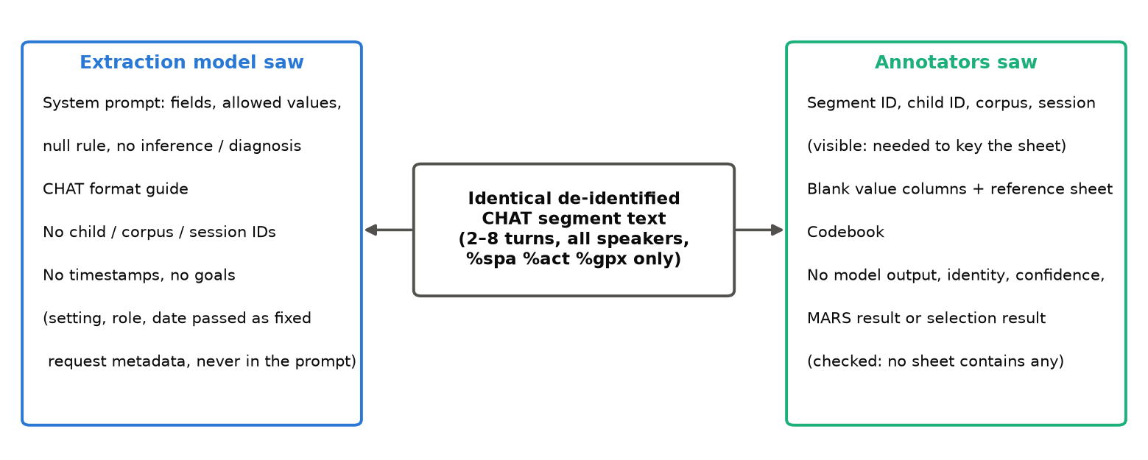
Figure 9. One text, two views: what the extraction model saw and what the annotators saw.

8. Adequacy-router representation logic
The question, as asked
The manuscript currently says representation is evaluated relative to the goal, but the implementation also contains thresholds such as:
- distinct settings ≥ 2;
- distinct contributors ≥ 2.
Could you clarify the actual logic?
For example:
- Are the ≥2 setting/contributor checks always applied?
- Can a goal be explicitly defined as single-setting or single-contributor?
- If yes, does the representation check become not applicable/pass for that goal?
- Or does the current prototype always flag single-setting/single-contributor data as limited?
I want the manuscript to describe the code exactly rather than imply goal-specific exemptions that may not yet exist.

Response
Short answer
Representation is not assessed per goal. Both checks always run over the child's full set of professionally accepted records in the review period, and no goal can be exempted. Only goal coverage looks at goals, and only at their domains. Code: src/backend/ml/adequacy_router.py (_check_contributor_representation, _check_setting_representation, _compute_level).
Q Are the ≥2 setting/contributor checks always applied?
Yes, on every assessment, including when analytics are requested for a single goal. The router is not given the goal ID and does not filter records by goal.
Q Can a goal be explicitly defined as single-setting or single-contributor?
No. The Goal model has type, domain, title, description, criteria and parent, but no setting or contributor attribute, and nothing in the router reads such an attribute.
Q If yes, does the representation check become not applicable/pass for that goal?
Not applicable. There is no goal-specific exemption, so the check never becomes "not applicable".
Q Or does the current prototype always flag single-setting/single-contributor data as limited?
Yes. Data from a single setting or a single contributor role can never be rated ADEQUATE. That level requires every check to pass. The failure also withholds the matching comparison: cross_setting_comparison or cross_contributor_comparison. Alone, it does not make the level INSUFFICIENT: the level is LIMITED, and other analytics are still computed. Note also that "contributors" means distinct contributor roles (parent, teacher and so on), not people: two parents count as one.
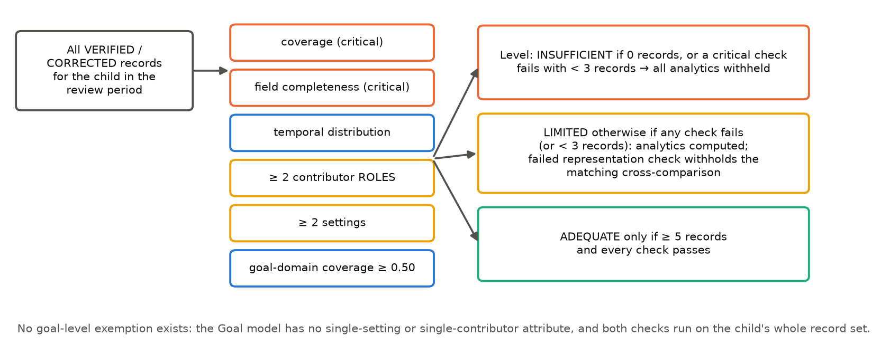
Figure 10. What the router actually does. There is no goal-level branch.
Suggested manuscript wording
"Representation is assessed over all accepted records for the child in the review period: at least two contributor roles and at least two settings. These checks are not goal-specific, and the prototype provides no mechanism to declare a goal single-setting or single-contributor. A failed representation check withholds the corresponding cross-comparison and prevents an ADEQUATE rating, but does not by itself withhold other analytics."

9. Authorization/access-control test evidence
The question, as asked
We make claims that access is child-specific and role-specific and that permissions are enforced beyond the UI.
Do we already have backend/integration tests covering things such as:
- contributor cannot access another child;
- contributor cannot edit goals;
- contributor cannot verify/correct evidence;
- revoked user cannot continue accessing the workspace;
- unauthorized user cannot access professional analytics/reports?
If yes, could you please share the relevant test names/paths and whether they currently pass? We don’t need every test case in the paper, but we need evidence behind the authorization claim.

Response
Short answer
Yes for all five. They pass: 120 tests across 10 suites, run 2026-09-26. Two of the five, access to another child by a contributor and loss of access after revocation, had no real-database test until this round. Four integration tests were added in tests/phase6/integration/test_authorization_e2e.py. The revocation test was confirmed to fail when the revoked_at filter is removed.
Table 10. Evidence for each authorization claim. Paths are under tests/. Run record: 120 passed, 0 failed, 2026-09-26, commit in this round's release.
Claim (as asked) | Tests | Result
contributor cannot access another child; | test_authorization_e2e::test_contributor_confined_to_assigned_child (new, real DB); test_security_rbac::test_cross_child_* ; test_children::test_get_child_not_authorized_returns_403 | pass
contributor cannot edit goals; | test_authorization_e2e::test_contributor_cannot_create_or_edit_goals (new); test_rbac::test_contributor_cannot_create_goal / _update_goal; test_goals::test_contributor_cannot_create_goal | pass
contributor cannot verify/correct evidence; | test_structured_records::test_contributor_cannot_verify / _cannot_correct; test_rbac::test_contributor_cannot_correct_record; governance E2E S6 (live extractor, 2026-09-25) | pass
revoked user cannot continue accessing the workspace; | test_authorization_e2e::test_revoked_contributor_loses_access_immediately (new): same token refused on the next request; test_security_rbac::test_deactivated_user_rejected | pass
unauthorized user cannot access professional analytics/reports? | test_authorization_e2e::test_unrelated_professional_cannot_reach_analytics_or_reports (new); test_analytics_api::test_contributor_denied_analytics; test_reports_api::test_contributor_denied_generate / _list / _flag; test_rbac::test_contributor_cannot_view_analytics / _generate_report / _view_report | pass

The mocked-database suites (tests/phase3/test_rbac.py, tests/phase6/test_security_rbac.py) show that each endpoint applies its role check. The new real-database tests show that the child-level decision holds against real data: a revoked contributor is refused on the very next request, using a token issued before revocation. Enforcement is therefore per request in the API, not in the UI or at login.
uv run pytest tests/phase3/test_rbac.py tests/phase6/test_security_rbac.py tests/phase3/test_structured_records.py \
tests/phase4/test_analytics_api.py tests/phase4/test_reports_api.py tests/phase3/test_children.py \
tests/phase3/test_goals.py tests/phase3/test_observations.py tests/phase3/test_actors.py \
tests/phase6/integration/test_authorization_e2e.py -q # 120 passed

10. Bootstrap interval method
The question, as asked
For the annotation-reliability results, could you confirm whether the reported child-cluster 95% CIs are:
- 10,000-replicate percentile bootstrap intervals,
- with children sampled with replacement and all segments from each sampled child retained?
I know the segment-level sensitivity analysis used bootstrap as well, but I want to make sure the manuscript does not accidentally mix the two procedures.
That should cover all the technical questions I currently cannot safely answer from the manuscript alone.

Response
Short answer
Yes to both. The reported κ intervals are 10,000-replicate percentile bootstraps (2.5th and 97.5th percentiles, linear interpolation). Each replicate draws 11 children with replacement and keeps every segment of each drawn child. Code: reliability_stats.bootstrap_kappa with clusters; seed 20260915. A replicate whose κ is undefined (a resample with a single category) is dropped. This happened in three child-cluster intervals, all for modality: held-out (9,997 of 10,000 valid), and round-comparison round 1 and its difference (9,999 each). Every other interval has 10,000.
Table 11. The two procedures, and where each appears. Both are stored side by side in every reliability artifact.
 | Primary | Sensitivity analysis
Unit resampled | child (cluster) | segment
Draws per replicate | 11 children, all their segments | N segments
Replicates / seed | 10,000 / 20260915 | 10,000 / 20260915
Interval | percentile 2.5–97.5 | percentile 2.5–97.5
Artifact key | cluster_bootstrap_ci | bootstrap_ci
Tables that print it | κ tables (make_manuscript.py:689, 810) | none

One sentence in the manuscript mixes the two
make_manuscript.py:558 reads: "Intervals are 10,000-replicate percentile bootstraps resampling segments". The preceding paragraph and every κ table use the child-cluster interval. Suggested replacement: "Intervals are 10,000-replicate child-cluster percentile bootstraps; segment-level intervals are reported as a sensitivity analysis."
Separately, the MARS paired differences (make_manuscript.py:1478) are segment-level bootstraps, and the caption says so. The model-performance intervals added in Q5 use the child-cluster procedure, so all intervals for annotation and model performance would then share one method.

How this document was produced
uv run python -m tests.eval.extraction.round3_analysis # no model calls
uv run python -m tests.eval.extraction.segmentation_stats # needs exp-data/ locally
uv run python docs/paper/make_round3_response.py

