Response to Reviewer Comments
Manuscript: A Governance-Aware Evaluation Framework for Language-Model Extraction in Autism Intervention Monitoring — Annotation Reliability, Unsupported Inference, Multi-Model Selection, and Reporting Governance
Review addressed: JMIR_Strict_Reviewer_Critical_Issues_Prioritized.docx — “JMIR AI Manuscript: Risk Assessment”. Branch model-finetuning. Working draft for internal review; not a submission document.
The reviewer's comments below are extracted at build time from the review document itself, in its own order and numbering, and are not retyped. Every statistic is read from the recorded artefact named beside it — the single exception, a test-suite count, is labelled as a run record where it appears. Rebuilding this file after a re-scored run updates the response rather than leaving it to contradict the data quietly.

Summary of the response
The review raises 12 numbered issues. All 12 are answered below in the reviewer's order. Eight are closed, one is closed within a stated bound, two are partially addressed and one remains open. Everything not closed is blocked on something outside this repository — an institutional determination, the annotators' credentials, or a release decision — rather than on work that could have been completed here, and each such item says so explicitly rather than being reported as progress.
Table 1. The twelve issues, in the review's order, with the state of each response. Section numbers below match the reviewer's numbering.
# | Issue (reviewer's wording, abbreviated) | Priority | Status | Basis
1 | Extraction performance is too weak to allow unverified AI output into longitud… | Critical | Closed | Mandatory verification gate, enforced in code and pinned by tests
2 | The unbiased held-out evaluation is unfinished | Critical | Closed | Held-out adjudication complete; 132/132 segments scored
3 | The evaluation data distribution does not match the application’s intended rea… | Critical | Closed | Reframed as a proxy/component evaluation in four places
4 | The reporting LLM failed its own governance contract | Critical | Closed | Generative layer declared experimental; deterministic reporter operational
5 | Ethics/IRB status must cover more than the public corpus | Critical | Partially addressed | Overclaim corrected; determination is external and outstanding
6 | The model generates 8 fields, but only 5 are evaluated | High | Closed | Scope verified in code, pinned by 20 tests, stated in the manuscript
7 | Adequacy-router thresholds are deterministic but not clinically validated | High | Closed | Relabelled configurable prototype thresholds in four places
8 | The gold-standard expert description needs more methodological detail | High | Scaffolded | Coverage verified from artefacts; credentials required from the authors
9 | The manuscript risks becoming a ‘kitchen-sink’ paper | High | Closed | Single primary contribution carried through title, abstract and conclusions
10 | No independent professional usability/workflow evaluation of the integrated ap… | Moderate | Closed (bounded) | All benefit claims marked intended or potential, never demonstrated
11 | Reproducibility and data-release details must be fully closed | Moderate | Open | Blocked on repository, release-tag, licence and redistribution decisions
12 | Generative-AI disclosure and citation audit must be unusually rigorous | Moderate | Partially drafted | Disclosure written; citation audit blocked on the reference list

How each response is organised
- Reviewer comment — the objection and the recommended action, verbatim.
- Response — the technical justification, including what was checked in code rather than assumed.
- Changes made — files, tests and manuscript sections that moved.
- Evidence — the measured numbers, each with its denominator and its source artefact.
- Limitations that remain — what the change does not establish.
One change made after the remediation report of 2026-09-22
Extraction results are now reported as agreement with the adjudicated reference standard rather than as accuracy, and the two abilities that the single per-field percentage used to merge — choosing the value the annotators settled on, and correctly recording nothing where they recorded none — are reported separately. The merged per-field figure has been withdrawn from the manuscript. The merged mean over the four fields survives only where one number per generator is unavoidable, in the held-out comparison, and is labelled as merged there. Numbers quoted in this response follow that convention, which is why a figure the earlier remediation report called “mean categorical-field accuracy” appears here as a merged mean agreement of the same value.

CRITICAL ISSUES — Address before submission

Issue 1. Extraction performance is too weak to allow unverified AI output into longitudinal analytics
Why a strict reviewer may object: Qwen 2.5 7B is the strongest single generator, but the reported performance remains modest: 43.1% mean categorical-field accuracy, 4.5% whole-record accuracy, and a substantial unsupported-assertion rate on gold-null opportunities. A deterministic schema validator can reject malformed values, but it cannot detect a semantically wrong value that is still a valid enum. If such a value enters the longitudinal evidence store, downstream deterministic analytics will faithfully compute trends from incorrect evidence.
Recommended action: If the application already requires interventionist verification/correction before an AI-derived record becomes analytics-eligible, state this as a mandatory gate and make it visually clear in the architecture. If not, make professional verification mandatory before submission.
Status: Closed
Response
The objection is accepted in full, and checking it against the code found the defect it predicts. analytics_service.get_current_version_records() admitted records with status VALIDATED. That status is set automatically by the extraction pipeline on four of its five routing paths — ACCEPT, clarification-exhausted, clarification-no-question and RETAIN_WITH_UNKNOWN; only INTERVENTIONIST_REVIEW produced PENDING. AI-extracted records were therefore reaching longitudinal analytics without any human having read them. The reviewer's conditional — “if the application already requires verification” — did not hold, so the second branch of the recommended action applied: professional verification was made mandatory.
The reason deterministic validation cannot close this gap is the one the reviewer states. Validation establishes that a record is schema-conformant; it cannot establish that the record is a correct reading of the source text, because a wrong value drawn from the right enumeration is indistinguishable in form from a right one. At 43.1% merged mean agreement for the strongest generator (qwen2.5:7b) and 4.5% whole-record agreement, the gap is not hypothetical.
The gate is a status transition, not a warning. A new RecordStatus.VERIFIED was added, and the analytics query now admits exactly {VERIFIED, CORRECTED}. Three design decisions are worth recording because each was a place where the gate could have been made cosmetic:
- Verification does not create a new record version. It changes review state, not content, and the immutability rule exists to protect content. Who verified and when are stored on the record; the act is written to the audit trail.
- A PENDING record cannot be verified as written. It was routed for review because the evidence was inadequate, so accepting it unchanged would silently undo the abstention router's decision. It must be corrected or rejected.
- Existing VALIDATED rows were deliberately not migrated to VERIFIED. Nobody reviewed them, and migrating them would have manufactured the very approval the gate exists to require.
Changes made
Table 2. Backend, API and migration changes implementing the verification gate.
File | Change
src/backend/models/observation.py | Added RecordStatus.VERIFIED; added verified_by (FK users) and verified_at
src/backend/services/analytics_service.py | Gate tightened to status.in_([VERIFIED, CORRECTED]); docstring corrected
src/backend/services/observation_service.py | New verify_record()
src/backend/api/structured_records.py | New POST /records/{record_id}/verify
src/backend/schemas/api_schemas.py | verified_by, verified_at on RecordResponse
alembic/versions/004_add_verified_record_status.py | New migration
src/frontend/components/records/VerificationPanel.tsx | New “Review required” panel; offers Verify as written only for VALIDATED, correction-only for PENDING
src/frontend/…/StructuredRecordView.tsx | Status colours corrected — validated no longer renders as success; only verified/corrected read as settled

Tests (15 added). Eight endpoint tests including a 409 on a PENDING record and a child-authorization test asserting the service is *not* called when authorization fails; eight service tests covering the transition, absence of a new version, idempotence, and refusal parametrized across PENDING, REJECTED and ABSTAINED; and tests/phase4/test_analytics_gate.py, which compiles the actual analytics query and asserts the admitted status set is exactly {verified, corrected}. Widening the gate is a one-word edit, so that edit now fails a test.
Evidence
Table 3. Why unverified output cannot be allowed into analytics: the measured state of the roster on the model-conditioned batch (n = 330 segments, four categorical fields, behavior excluded). Source: paper_metrics.json, scored_against_gold_augmented.json.
Generator | Merged mean agreement | Whole-record | Unsupported assertions
llama3.2 | 30.8% | 1.5% | 164/197 (83%)
qwen2.5:3b | 20.4% | 0.3% | 61/197 (31%)
qwen2.5:7b | 43.1% | 4.5% | 112/197 (57%)
qwen3:14b | 42.0% | 3.0% | 191/197 (97%)

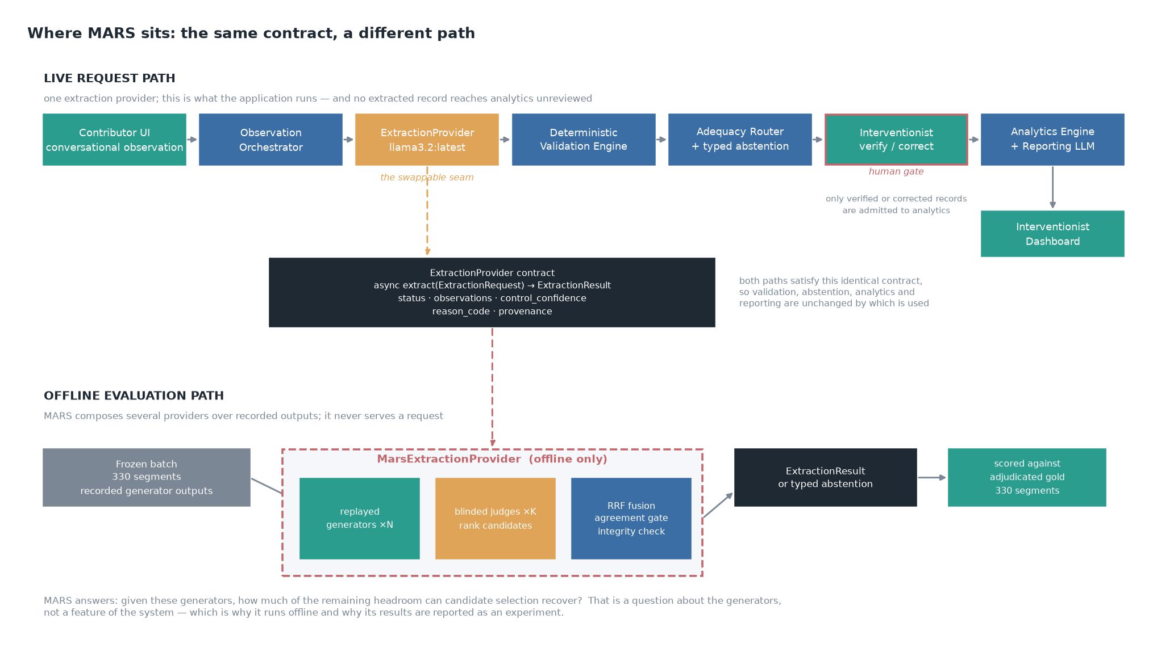
Figure 1. The request path with the verification gate marked. Only verified or corrected records are admitted to analytics; the gate is enforced in analytics_service and asserted by tests/phase4/test_analytics_gate.py.
Limitations that remain
- The gate is a design property enforced in code. It is not a demonstration that interventionists catch model errors — no interventionist has used the system, and automation bias is the evaluation the gate most needs next.
- The review burden the gate creates is unquantified. At the measured whole-record agreement, most records will need correction rather than confirmation, and no time-on-task figure exists.
- All frontend changes are unverified. src/frontend/lib/ — silently excluded from git by an unanchored lib/ pattern in .gitignore — and node_modules are both absent, so neither tsc nor vitest can run in this working copy. The .gitignore pattern is fixed; the directory itself must still be restored.

Issue 2. The unbiased held-out evaluation is unfinished
Why a strict reviewer may object: The 330-segment main batch was selected partly on generator behavior. The model-independent 132-segment held-out set already shows a large selection effect: all 4 generators were jointly admissible on 12.4% of the main batch but only 2.3% of the held-out set. Without completed adjudication, the manuscript cannot report extraction accuracy, whole-record accuracy, or unsupported-assertion rates on an unbiased sample.
Recommended action: Finish held-out adjudication before submission. This is one of the highest-value improvements because the data and generator runs already exist.
Status: Closed
Response
Completed. The returned adjudication sheet was checked before import: 133 of 133 rows decided, no blanks, and no edits to segment_id, field, either annotator column, the transcript or the codebook rule. All 132 held-out segments entered the reference standard — nothing was lost to an undecided row, which matters because dropping undecided rows would have reintroduced selection at the adjudication stage. gold_labels.json was verified byte-identical before and after, so the main-batch results are unaffected.
import_adjudication_sheet → holdout_adjudications.json (133 decisions)
adjudicate → gold_holdout_labels.json (132/132 segments)
score_against_gold → scored_holdout.json (4 generators)
holdout_metrics → holdout_metrics.json (batch vs held-out)
A scoring-policy mismatch was caught before it reached the manuscript, and it is worth reporting because nothing downstream would have revealed it. The first held-out scoring run used the tool's default --behavior-match overlap, which scores five fields. The published batch policy is excluded, which scores four. A mean over four fields and a mean over five are different quantities, and subtracting one from the other yields a plausible number with no meaning — it would have understated the held-out side and inflated the reported selection effect. The held-out set was re-scored under the published policy, and holdout_metrics.check_same_policy now refuses the comparison outright when scoring_fields, behavior_match or behavior_overlap_threshold differ between the two sides.
Evidence
Table 4. The selection effect, measured. Both sides scored against their own model-independent adjudicated gold standard, over the same 4 categorical fields under the same matching rule; the only difference between them is how the segments were chosen. Batch n = 330, held-out n = 132. Source: holdout_metrics.json.
Generator | Agreement, batch | Agreement, held-out | Change (pts) | Unsupported, batch | Unsupported, held-out
llama3.2 | 30.8% | 26.5% | -4.3 | 83.2% | 84.1%
qwen2.5:3b | 20.4% | 12.5% | -8.0 | 31.0% | 28.6%
qwen2.5:7b | 43.1% | 38.8% | -4.3 | 56.9% | 50.8%
qwen3:14b | 42.0% | 40.2% | -1.9 | 97.0% | 92.1%

Every generator is less accurate on segments that were not selected for model tractability, and the direction is uniform across all 4 — which is what a selection effect predicts and a chance difference does not. Unsupported assertion, by contrast, does not improve: the rates are of the same order on both sides and their ordering across the roster is unchanged. The paper's central safety finding survives the move to an unbiased sample. Agreement degrades when the segments stop being easy; the propensity to assert what the transcript does not support does not.
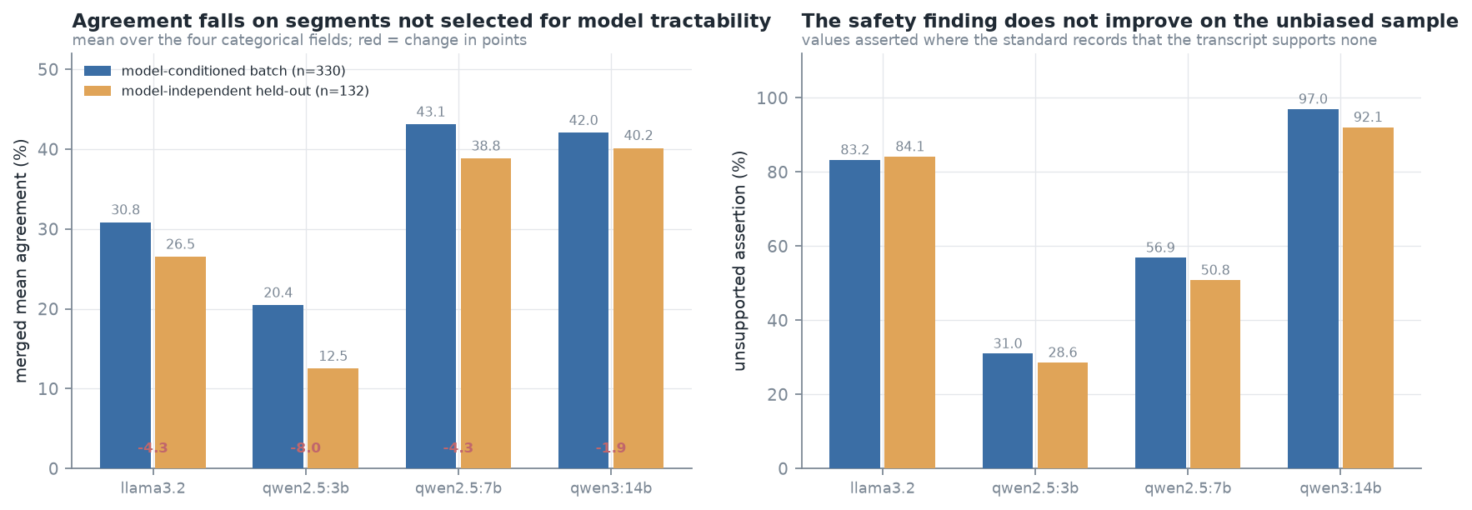
Figure 2. Batch against the model-independent held-out set, same scoring policy on both sides. Left: merged mean agreement, with the change in points in red. Right: unsupported assertion. Source: holdout_metrics.json.
Table 5. Adjudication balance on the held-out round, recomputed for this document from holdout_adjudications.json against both annotators' returned values. Two-sided exact binomial against p = 0.5.
Rows adjudicated | Adopted annotator A | Adopted annotator B | Adopted neither | p
133 | 54 | 79 | 0 | 0.037

The main batch split 89 to 90, and the claim that neither annotator dominated holds there. It does not hold for the held-out round, where the split is 54 to 79 (p = 0.037). This is now stated in Limitations rather than omitted.
Limitations that remain
- The held-out set is 132 segments from the same 11 children. It removes conditioning on model behaviour; it does not remove conditioning on the corpus, the population or the interaction type.
- The held-out adjudication was not balanced between annotators. With 17 genuinely categorical judgements among the decided rows, the imbalance is fragile as an estimate but is reported rather than suppressed.
- Whole-record agreement on the held-out set leaves 1.5 points of headroom between the best generator and the oracle ceiling, so the held-out data cannot discriminate between selection policies either.

Issue 3. The evaluation data distribution does not match the application’s intended real-world input distribution
Why a strict reviewer may object: The intended workflow collects longitudinal observations written by parents, teachers, caregivers, trainers, and intervention professionals. The model evaluation instead uses ASDBank child-parent and child-investigator transcripts segmented into behavioral episodes. These are relevant autism-language data, but they are not the same type of notes the application is designed to process.
Recommended action: Best option: add a modest evaluation on realistic intervention-style observations validated by intervention specialists. If that is not possible before submission, describe the ASDBank experiment explicitly as a proxy/component evaluation and avoid claims that extraction has been validated on real intervention notes.
Status: Closed
Response
Accepted, and the first option — a new evaluation on real intervention-style observations validated by specialists — was not available before submission. The second was taken, and taken in Methods rather than left to a Limitations bullet, because a distribution mismatch that only appears at the end of a paper has already done its work on the reader.
The evaluated data differs from the application's intended input in three respects, each of which could affect extraction independently:
Table 6. How the proxy differs from the target, stated in the manuscript's Methods section.
Axis | Evaluated data (ASDBank) | Intended input | Why it could matter
Authorship | A transcript records what was said | A contributor reports what they chose to report | Selection of content happens before the model sees it
Register | Verbatim dialogue | Retrospective prose about a child | Tense, person and summarisation all differ
Provenance | No framing goal | Written with a goal in mind | Goal framing changes what is foregrounded

A survey of publicly available autism observation data was repeated on 2026-09-23 and confirms the premise on which the proxy rests: no public corpus of practitioner- or caregiver-authored intervention notes exists. The candidates are all a different kind of object.
Table 7. Public autism observation data considered, and why none supplies the target distribution. Surveyed 2026-09-23.
Source | What it contains | Why it is not intervention notes
ASDBank (7 English corpora, incl. the 2 used) | CHAT transcripts of child-parent and child-clinician interaction | Verbatim dialogue, not observer-authored prose
HomeBank | Daylong child-centred audio (LENA), 1,100+ recordings | Audio with sparse transcription; no observer report
MMASD / MMASD+ | Play-therapy sessions as optical flow and 2D/3D skeleton, with clinician evaluation scores | Privacy-preserving motion features; no language at all
DE-ENIGMA | 128 children, 152 h of child-robot interaction, expert valence/arousal and gesture annotation | Multimodal interaction data, not written observations
NIMH Data Archive / SPARK / SSC | Longitudinal standardized instruments (ADOS, Vineland) | Controlled access; instrument scores, not narrative notes

Changes made
- Methods: a paragraph stating the proxy relationship explicitly and why these corpora were chosen — autism interaction data, permissive research access, and enough structure to annotate consistently.
- Results: every extraction figure is described as a component evaluation on proxy data.
- Limitations: the sentence “Extraction is not validated on real intervention notes”, with matching qualifiers in the Abstract (Methods and Conclusions) and in the Discussion conclusions.
- A “Not measured” entry recording the absent evaluation.
Limitations that remain
- No estimate exists of how far extraction performance transfers from transcript segments to observer-authored notes. The direction is not even known: notes are more summarised, which could help or hurt.
- Adding the other ASDBank corpora would broaden the proxy — more children, control groups and a second interaction type — but would not change its kind. The mismatch is categorical, not a sample-size problem.
- The claim that no such public corpus exists is a negative result from a survey, not a proof.

Issue 4. The reporting LLM failed its own governance contract
Why a strict reviewer may object: All 11 reports were structurally conformant and contained no prohibited diagnostic, treatment, causal, or prognostic content, but 0/11 passed governance validation because withheld analyses were not explicitly acknowledged. In addition, 6.6% of numeric assertions were absent from the evidence packet. A reviewer may ask why this component remains in the operational path if it failed the defined governance test.
Recommended action: Either (a) remediate the reporting layer, freeze the change, and run a second evaluation while preserving the original negative result, or (b) keep the generative reporting layer experimental and use a deterministic reporting fallback operationally until it passes governance.
Status: Closed
Response
Option (b) was taken: the generative reporting layer is declared experimental and the deterministic reporter is the operational path. The negative result stands exactly as reported — the layer was not modified and re-evaluated, it was removed from the operational path, and those are different acts which the manuscript now distinguishes.
The finding itself deserves precision, because it is easy to read as worse than it is. All 11 reports were structurally conformant and contained no prohibited diagnostic, treatment, causal or prognostic content (0 of 11 with prohibited content). What failed is narrower and more serious for a governance claim: 0 of 11 passed governance validation, because analyses the adequacy router had withheld were not acknowledged as withheld. The model did not fabricate them; it silently omitted their absence, and a reader cannot distinguish a deliberately withheld analysis from one that was never attempted. A component that fails its own governance test does not belong in the operational path.
Table 8. Governance evaluation of the generative reporting layer, n = 11 reports, one per child, model qwen2.5:7b. Source: reporting_groundedness.json.
Check | Result | Reading
Structurally conformant | 11/11 | No errors and no fallbacks: every report parsed into the required structure
No prohibited content | 11/11 | No diagnostic, treatment, causal or prognostic statements
Every asserted number traceable | 3/11 | 8 of 122 numbers (6.6%) not in the evidence packet
Evidence references valid | 834/836 | 2 invalid (0.24%)
Withheld analyses acknowledged | 0/11 | The failure: silence about withholding, in every report
Passed governance validation | 0/11 | Consequence of the row above

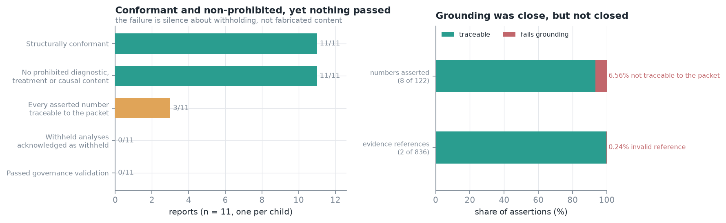
Figure 3. What the governance check found. Left: reports passing each check. Right: assertion-level grounding, drawn as shares because the two denominators differ by an order of magnitude. Source: reporting_groundedness.json.
Changes made
Table 9. Making the deterministic reporter operational and the generative layer visibly experimental.
File | Change
src/backend/config.py | New reporting_mode: Literal["deterministic", "generative_experimental"] = "deterministic"
src/backend/ml/reporting_client.py | generate_report() is mode-aware; in the default mode the LLM is never called. _build_fallback_sections renamed _build_deterministic_sections (and _fallback_* → _deterministic_*): it is the operational reporter now, not an error path
Provenance strings | deterministic_fallback → deterministic; deterministic_fallback_v1 → deterministic_reporter_v1
src/backend/ml/schemas.py | GeneratedReportData.is_experimental
src/backend/schemas/api_schemas.py | ReportResponse.is_experimental as a @computed_field derived from the stored provider, so it cannot drift from what produced the prose. No new column, no migration
src/frontend/…/ReportViewer.tsx | Banner reads “Experimental AI Draft … not an operational report”, replacing “AI-Generated Draft”, which read as routine provenance rather than a warning

Tests. A new TestOperationalReportingMode (5 tests) asserts that the default mode is deterministic, that the default never awaits _call_llm, that the deterministic reporter passes validate_report() — it names every withheld indicator, the check the generative layer failed — that generative output is marked experimental, and that a failed generative call drops the marker. A failed generative call falls back to the deterministic reporter and the result is labelled deterministic, not experimental, because that is what produced it. 28 existing tests were updated: every test that exercises the LLM now has to ask for mode="generative_experimental" explicitly.
Limitations that remain
- Remediability was not tested. Whether a prompt or schema change would make the generative layer pass is unknown, because no remediation was attempted and no second evaluation was run.
- The evaluation is one model, one run, 11 reports, on evidence packets built from adjudicated gold records rather than from real intervention records.
- The experimental generative path can still see the three unevaluated extraction fields through the evidence packet (Issue 6). That is a further reason it is not operational, and it is stated as such rather than fixed by silently stripping fields from the packet.
- The deterministic reporter passing its governance check is a claim about governance, not about language quality or clinical usefulness.

Issue 5. Ethics/IRB status must cover more than the public corpus
Why a strict reviewer may object: The study uses archival public child data, but it also analyzes annotations produced by two autism intervention specialists, including agreement changes across annotation rounds. Depending on the reviewing institution, those specialists may be treated as research participants, expert consultants, or another category. Manual application testing may also involve human contributors if their behavior is recorded as research data.
Recommended action: Do not submit until the ethics determination is final and explicitly addresses the public corpus, specialist annotation/adjudication, and any human involvement in application testing. Report the exact determination wording and protocol number.
Status: Partially addressed
Response
Accepted, and the determination is outstanding — it is external to this repository and the manuscript will not be submitted before it arrives. What could be done here was the wording, and it needed doing, because the ethics section contained an overclaim that sits directly under this issue.
The Ethical considerations section said: “No data was collected from human participants for this work, no participants were recruited or contacted…”. Two autism intervention specialists produced the annotations, and their agreement with one another — including how it changed between rounds — is analysed and reported. That is human-generated research data, and the sentence as written could be read as denying it.
Corrected to “no child data was collected”, with a new paragraph stating that the specialists' labels are research data about a coding scheme rather than about the annotators, that no individual annotator is identified or characterised by performance, and that whether this makes them research participants, expert consultants or neither is a determination for the reviewing institution rather than for the authors. It is put to the Board explicitly rather than assumed.
Table 10. What the determination must address separately, as now required by the manuscript's IRB placeholder.
Category | What is involved | Status
Archival child corpora | Two public ASDBank deposits, de-identified before any model sees them | Expected exemption or non-human-subjects determination; not yet issued
Specialist annotation and adjudication | Two specialists; their labels and their inter-annotator agreement, including change across rounds, are analysed | Category is for the Board to decide; posed explicitly
Human involvement in application testing | Whether any contributor behaviour was recorded as research data | Must be addressed in the determination

Limitations that remain
- The determination itself is outstanding. The manuscript carries a [TO COMPLETE BEFORE SUBMISSION] marker requiring the institution, the exact wording, the protocol number and separate treatment of all three categories.
- The licence terms of both corpora and the scope of depositor consent for secondary computational analysis are unconfirmed, and the manuscript does not assert a licence that has not been checked against the current deposit page.
- If the Board asserts jurisdiction rather than exempting, Methods and Limitations will need revisiting, not only the ethics paragraph.

HIGH-PRIORITY ISSUES — Strongly recommended before submission

Issue 6. The model generates 8 fields, but only 5 are evaluated
Why a strict reviewer may object: The production schema asks the model to generate behavior, domain, duration_seconds, goal_context, modality, outcome, prompt_context, and prompt_level. Only behavior plus the 4 categorical fields are evaluated. The remaining 3 fields have no reference standard in the current study.
Recommended action: Do not describe the complete extractor as validated. Either evaluate the 3 remaining fields, remove them from any validation claim, or ensure they cannot influence analytics without explicit professional verification.
Status: Closed
Response
Accepted, and all three of the reviewer's options were checked rather than one being chosen on assumption. The extractor is asked for eight fields. Five were scored against the adjudicated gold standard (behavior plus the four categorical fields); three have no reference standard in this study (goal_context, prompt_context, duration_seconds).
Reading the code rather than assuming: the three unevaluated fields are read by no KPI, no adequacy check and no deterministic report section. analytics_engine.py uses the five; adequacy_router.py uses three of them; neither touches the unevaluated three. The reviewer's third option — ensure they cannot influence analytics without explicit professional verification — is therefore satisfied, and more strongly than asked, since they do not reach analytics at all.
One exception, stated rather than papered over. analytics_service._record_to_dict() passes the whole record_data into the EvidencePacket, so the three unevaluated fields do reach the reporting layer. The operational deterministic reporter never renders them — it builds prose from KPIs and packet-level counts — but the experimental generative reporter can see them. This is stated in the manuscript as a further reason that path is not operational. The behaviour was left unchanged rather than silently stripping fields from the packet, because a quiet fix would have removed the evidence for the argument.
Table 11. The eight generated fields against every consumer, as enforced in code and asserted by tests/phase4/test_unevaluated_fields.py.
Field | Scored against gold | KPIs / analytics | Adequacy router | Deterministic report | Evidence packet
behavior | Yes (overlap, excluded from whole-record) | Yes | Yes | Yes | Yes
domain | Yes | Yes | Yes | Yes | Yes
modality | Yes | Yes | Yes | Yes | Yes
prompt_level | Yes | Yes | Yes | Yes | Yes
outcome | Yes | Yes | Yes | Yes | Yes
goal_context | No reference standard | No | No | No | Yes — experimental path only
prompt_context | No reference standard | No | No | No | Yes — experimental path only
duration_seconds | No reference standard | No | No | No | Yes — experimental path only

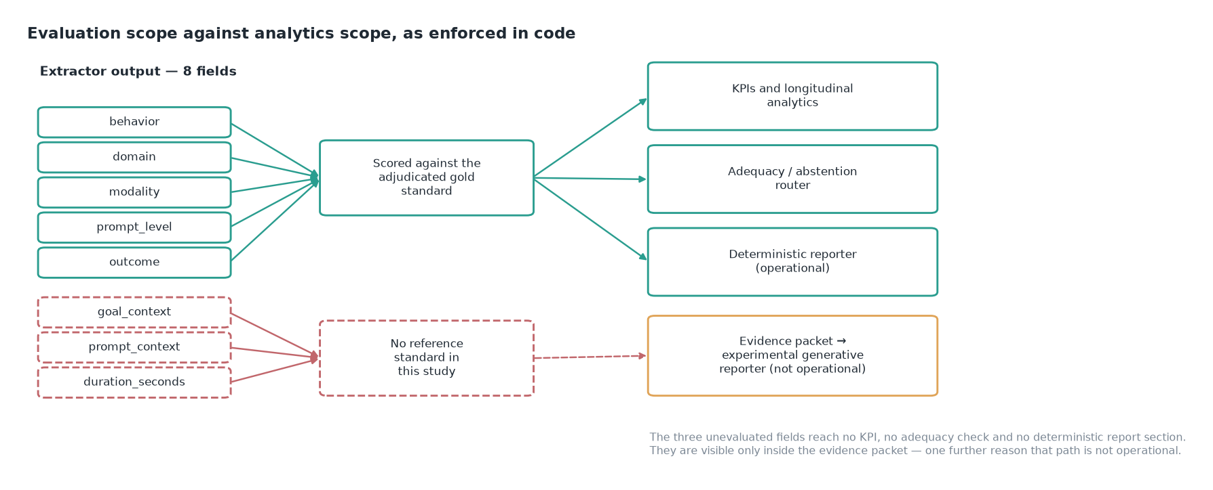
Figure 4. Evaluation scope against analytics scope. The dashed path is the only route by which an unevaluated field can reach generated prose, and it is not the operational path.
Changes made
- Manuscript: a paragraph stating 8 generated / 5 evaluated and that the extractor as a whole is not evaluated; a second paragraph confining the three; a Limitations entry; a “Not measured” entry.
- tests/phase4/test_unevaluated_fields.py (new, 20 tests) — asserts that no unevaluated field name appears in the source of analytics_engine, adequacy_router, forecasting_engine, analytics_service or reporting_client, and the converse for the five evaluated fields, so evaluation scope and analytics scope cannot drift apart.
Limitations that remain
- The extractor as a whole is not evaluated, and the manuscript now says so. Nothing reported constrains how often the model invents the three unevaluated fields.
- The three fields are still generated and stored. They are confined, not removed.
- behavior is scored as token overlap against a human reference band rather than as accuracy, and is excluded from whole-record agreement, so “five fields evaluated” covers two different kinds of evaluation.

Issue 7. Adequacy-router thresholds are deterministic but not clinically validated
Why a strict reviewer may object: Rules such as 5 observations for an adequate state, 0.70 field completeness, 0.80 temporal-clustering ratio, at least 2 settings/contributors, and 50% goal coverage are transparent and deterministic, but determinism does not establish scientific or clinical validity.
Recommended action: Call these configurable prototype governance thresholds, not validated clinical cutoffs. Add expert rationale or a sensitivity analysis if feasible.
Status: Closed
Response
Accepted without reservation. The claim attached to these thresholds is now that withholding is deterministic, inspectable and auditable — not that these are the numbers at which evidence becomes clinically sufficient. No expert-consensus procedure set them, no sensitivity analysis has been run over them, and no outcome has been measured against them. They are configurable prototype governance defaults that a deploying site should revisit.
Table 12. The thresholds as they stand in code, with what each one gates. Source: src/backend/config.py and src/backend/ml/adequacy_router.py.
Threshold | Value | Constant | What it gates
Observations for an adequate state | 5 | adequacy_min_observations | ADEQUATE vs a lower state
Observations for a limited state | 3 | adequacy_limited_observations | LIMITED vs INSUFFICIENT
Field completeness | 0.70 | adequacy_field_completeness_threshold | Whether populated-field coverage is sufficient
Temporal clustering ratio | 0.80 | adequacy_temporal_cluster_max_ratio | Rejects evidence concentrated in one window
Distinct settings | ≥ 2 | literal in _check_setting_diversity | Whether more than one setting is represented
Distinct contributors | ≥ 2 | literal in _check_contributor_diversity | Whether more than one observer is represented
Goal coverage | 0.50 | literal in _check_goal_coverage | Whether enough goals have supporting evidence

Changes made
The framing is stated in four places, so that it cannot be met in one and contradicted in another: a new Discussion subsection *“The status of the governance thresholds”* plus a Limitations entry and a “Not measured” entry for threshold sensitivity; docs/lld/Adequacy_Router.md above the thresholds table; src/backend/config.py at the point of definition; and docs/User_and_Demo_Manual.md where a reader first meets the adequacy levels.
Limitations that remain
- No sensitivity analysis has been run. How much the adequacy verdicts would move under different cutoffs is unknown, and this is recorded as a “Not measured” entry rather than left implicit.
- No expert consensus procedure produced these values, and no clinical outcome has been measured against them.
- Three of the seven thresholds are literals inside the router rather than configuration constants, so a deploying site cannot currently retune them without a code change.

Issue 8. The gold-standard expert description needs more methodological detail
Why a strict reviewer may object: The manuscript currently identifies the annotators as two autism intervention specialists, but reviewers need enough information to judge the credibility and reproducibility of the reference standard.
Recommended action: Report their professional roles/qualifications, relevant years of experience, how they were prepared for the task, confirmation that both independently annotated the full required datasets, and how consensus adjudication was performed.
Status: Scaffolded
Response
Accepted. A new Methods section *“Annotators”* was written in two halves: what the artefacts establish, verified against the files rather than asserted, and what only the authors can supply, marked [TO COMPLETE BEFORE SUBMISSION] rather than filled with plausible text. An invented qualification is worse than a missing one.
Table 13. Coverage, re-derived for this document by counting the returned annotation files. Three tests read the same counts and fail if the prose and the files disagree.
Claim | Artefact | Segments returned | Verdict
Main batch, annotator A | gold_annotator_a.json | 330 | complete
Main batch, annotator B | gold_annotator_b.json | 330 | complete
Held-out set, annotator A | gold_holdout_annotator_a.json | 132 | complete
Held-out set, annotator B | gold_holdout_annotator_b.json | 132 | complete

Adjudication procedure: conflicts surviving round 2 were adjudicated by the two annotators working jointly from the codebook (consensus adjudication), recorded as consensus:annotator_a+annotator_b. Each of the 503 conflicted fields in the main batch was decided with a written rationale, splitting 89 to annotator A and 90 to annotator B, so neither annotator's readings dominated the consensus; three decisions adopted a value neither had recorded, each a correct application of a codebook rule both had missed. On the held-out round the split was 54 to 79 of 133 decisions (p = 0.037), and that asymmetry is reported in Limitations.
Table 14. What is still required from the authors, per annotator. The manuscript carries these as explicit markers.
Required | Why a reviewer needs it
Professional role and qualification | Establishes that the reference standard was set by qualified readers
Years of relevant experience | Bears on the credibility of the labels
Prior experience with structured behavioural coding | Distinguishes domain expertise from coding expertise
Preparation received, and from whom | Reproducibility: another team must be able to prepare annotators similarly
Any relationship to the study or authors bearing on independence | The same pair refined and then applied the codebook

Limitations that remain
- The same pair helped identify the three underspecified definitions and then annotated under the codebook that resolved them. This is recorded as a limitation, not presented as independence.
- There was no third independent adjudicator. Consensus between the two annotators is the reference standard.
- The held-out adjudication was not balanced between annotators (p = 0.037).
- Credentials are absent from the manuscript until the authors supply them; the section is scaffolded, not complete.

Issue 9. The manuscript risks becoming a ‘kitchen-sink’ paper
Why a strict reviewer may object: The work includes application development, annotation-method refinement, generator evaluation, unsupported-inference analysis, MARS, adequacy routing, reporting governance, and end-to-end workflow implementation. Each element is legitimate, but the editorial question will be: what is the single primary contribution?
Recommended action: Maintain one clear hierarchy throughout: the governance-aware longitudinal intervention-support application is the primary contribution; annotation, extraction, MARS, and reporting studies are component evaluations explaining why the governance boundaries are necessary.
Status: Closed
Response
Accepted. The evaluation framework is the primary contribution. The four elements are enumerated in the Introduction, each tied to a question that a conventional accuracy report leaves open, and everything else is explicitly subordinated: the annotation scheme, the four generators, the reranking stage and the reporting layer are “the objects measured, not parallel contributions”, and the application is the setting that motivates the measurements.
Table 15. The four elements of the primary contribution, and the question each answers that an accuracy table does not.
Element | The question it answers
Explicit-null annotation | Without a gold null there is no opportunity against which to count an invented value
Controlled codebook revision | An untreated control field separates the codebook's effect from the effect of simply re-annotating
Oracle-bounded selection analysis | What any selector could have recovered, before what a particular selector did — plus a model-independent held-out set quantifying how far the batch was conditioned on model behaviour
Governance check separate from schema conformance | Prohibited content, numeric grounding, and preservation of abstention state are not the same as a valid schema

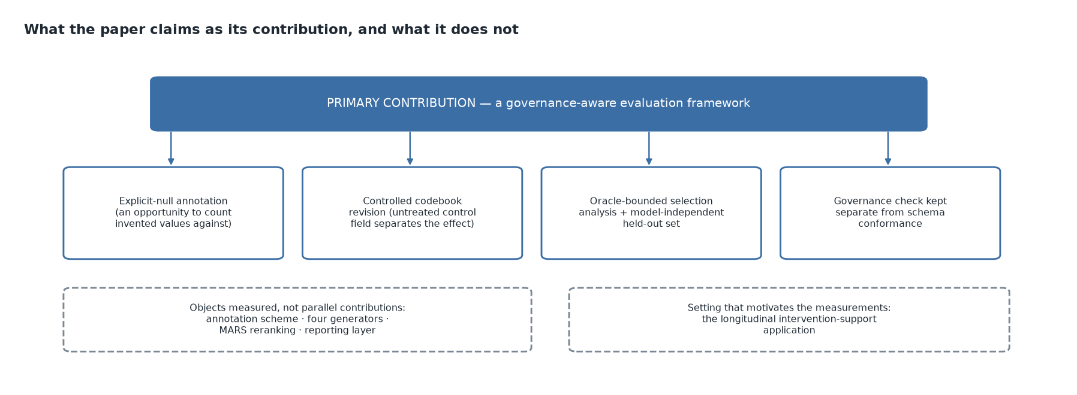
Figure 5. The hierarchy as it now reads across the Introduction, Abstract, Discussion and Conclusions, asserted by TestContributionHierarchy (5 tests).
Carried through the Abstract conclusion, the Discussion, and the Conclusions (“The framework is the contribution; the pipeline is the specimen”). Conclusions now report failure at three layers rather than two, adding the reporting layer. The title was changed to match and is flagged for author approval:
A Governance-Aware Evaluation Framework for Language-Model Extraction in Autism Intervention Monitoring: Annotation Reliability, Unsupported Inference, Multi-Model Selection, and Reporting Governance (previously “Governance-Aware Extraction of Structured Autism Observations: …”).
Limitations that remain
- The title change is proposed, not settled; it needs author approval or reversion.
- The breadth itself has not been reduced — the same components are reported. What changed is the hierarchy among them, which is an editorial remedy for an editorial objection.
- The framework is demonstrated on one pipeline, one corpus pair and one generator roster. Its generality is argued, not measured.

MODERATE / LOWER-PRIORITY ISSUES — Important for acceptance and submission quality

Issue 10. No independent professional usability/workflow evaluation of the integrated application
Why a strict reviewer may object: Manual development testing shows that the application works functionally, but it does not yet show that independent interventionists can use it effectively, that it reduces review burden, or that it improves recognition of missing evidence without creating automation bias.
Recommended action: Keep benefit claims as intended or potential rather than demonstrated. If feasible, add a small independent workflow/usability evaluation; otherwise position it clearly as future validation.
Status: Closed (bounded)
Response
Accepted. The prose was searched for demonstrated-benefit language rather than assuming none had crept in; none was present, and the boundary is now stated explicitly instead of resting on absence.
Table 16. Benefit claims and their status in the manuscript.
Claim a reader might expect | Status in the manuscript
Interventionists can use the system effectively | Not claimed. No independent professional has used it
The workflow reduces review burden | Not claimed. A test fails if “reduces review burden” or “saves time” appears in the prose
It improves recognition of missing evidence | Not claimed. Stated as intended, not demonstrated
The verification gate catches model errors | Not claimed. The gate is a design property enforced in code; automation bias is named as the evaluation it most needs
Development testing shows the application works | Claimed, and bounded: it shows the software functions, nothing about clinical or workflow value

The manuscript states: “Every benefit attributed to the workflow in this paper is intended or potential, never demonstrated.” Two “Not measured” entries record the absent evaluations.
Limitations that remain
- No usability, workflow or burden evaluation has been run, and none is scheduled within this manuscript.
- Automation bias is unmeasured, and a mandatory verification gate is precisely the design in which it would matter most: a reviewer who confirms rather than reads would restore the risk the gate was built to remove.
- Bounding a claim is not evidence. This issue is closed in the sense that the paper no longer overstates, not in the sense that the evaluation exists.

Issue 11. Reproducibility and data-release details must be fully closed
Why a strict reviewer may object: The manuscript makes strong reproducibility claims but still contains placeholders for the repository/archive URL, release tag, license, and final data-sharing statement. TalkBank/ASDBank redistribution terms also need to be respected for derived data and model outputs.
Recommended action: Before submission, finalize the repository/archive, release identifier, licensing language, and exactly which artifacts can be shared. If source-derived data cannot be redistributed, release code, schemas, hashes, prompts, and allowable derived artifacts instead.
Status: Open
Response
Open, and blocked on decisions only the authors can make: the repository or archive URL, the release tag, the licence, and exactly which artefacts may be redistributed under TalkBank/ASDBank terms. The Data availability section carries a [TO COMPLETE BEFORE SUBMISSION] marker naming exactly these.
Table 17. Reproducibility infrastructure that already exists and does not need redoing.
Item | State
Artefact manifest | 61 artefacts recorded, 38 pinned by SHA-256 in docs/paper/artifact_manifest.json
Reproduction sequence | docs/paper/artifacts.md — the full command sequence, generated from the manifest rather than written by hand
Seeds and runtime versions | Documented in clarification answer Q20
Reproducibility boundary | Everything downstream of the recorded generator outputs is deterministic; regenerating those outputs is not, because no generation seed was set. This is stated, not implied
Numbers in the manuscript | Re-derived from artefacts by tests; a changed artefact fails the manuscript consistency suite

Table 18. Decisions required before submission.
Decision | Consequence if unresolved
Repository or archive URL and release tag | The reproducibility claim has no referent
Licence for code and derived artefacts | Reuse terms undefined
Which derived artefacts may be redistributed under corpus terms | If source-derived data cannot be shared, release code, schemas, hashes, prompts and allowable derived artefacts instead

Limitations that remain
- Generator outputs cannot be reproduced bit-for-bit: no generation seed was set when they were produced, and setting one now would not recover the recorded run.
- The redistribution question is genuinely unresolved. Segment text derived from ASDBank transcripts may not be redistributable even de-identified, which would restrict the release to code, schemas, hashes, prompts and metrics.

Issue 12. Generative-AI disclosure and citation audit must be unusually rigorous
Why a strict reviewer may object: Generative AI was used both as the object of study and during software development, technical ideation, and manuscript drafting/editing. This creates a higher-than-usual disclosure and verification burden.
Recommended action: Prepare a detailed JMIR-compliant AI-use disclosure, retain prompts/records as required, and independently verify every reference, DOI, statistic, model description, and factual claim before submission.
Status: Partially drafted
Response
Partially drafted. The AI-use disclosure is written and is honest about the dual role: the extraction and judge models are the object of study, and AI assistance was also used for evaluation tooling and manuscript drafting. It states that no AI system authored, selected or altered a gold-standard value, an adjudication decision or a reported statistic — every annotation and adjudication is human, statistics are computed by code from recorded artefacts, and tests re-derive each reported number from its artefact.
Table 19. Disclosure and audit items against their state.
Item | State
AI use as object of study | Disclosed: four generators, four judges, one reporting model, all named with versions and configuration
AI use in software development and tooling | Disclosed
AI use in manuscript drafting and editing | Disclosed
Boundary: what AI did not do | Stated — no gold value, adjudication or statistic
Prompt and configuration records | Retained as artefacts; prompts and config hashes recorded per run
Citation and DOI audit | Blocked — no reference list exists yet
Author contributions | Unwritten
Conflict-of-interest declarations | Unwritten

Note for a possible frontier-model arm: benchmarking Claude models in a manuscript drafted with Claude Code has to be stated plainly in this section. It is not disqualifying; it has to be visible.
Limitations that remain
- The citation audit cannot begin until the reference list exists, and the “Comparison with prior work” section — 14 claims requiring citation — is unwritten.
- Author contributions and conflict-of-interest declarations are unwritten.
- Verification of every reference, DOI, statistic and model description is therefore incomplete, and this is the one issue where the response is a plan rather than a result.

What I would NOT treat as fatal by itself
Reviewer: The following are limitations rather than automatic rejection reasons if they are reported transparently: only 11 children for cluster-bootstrap inference; the same specialist pair helping refine and then use the codebook; no third independent adjudicator; no frontier-model comparison; a negative MARS result; and the reporting-layer failure itself. Negative results can strengthen the paper when they are used to justify governance boundaries rather than hidden.
Response
All six are reported transparently, and the negative results are used to justify governance boundaries rather than hidden — which is the condition the reviewer attaches.
Table 20. Where each non-fatal limitation is reported.
Limitation | Where it is stated
Only 11 children for cluster-bootstrap inference | Limitations; every cluster-bootstrap interval carries the child count
The same specialist pair refined and then used the codebook | Methods (Annotators) and Limitations — recorded, not presented as independence
No third independent adjudicator | Methods (adjudication procedure) and Limitations
No frontier-model comparison | “Not measured”, with the reason: blocked on corpus terms for third-party API processing and on the IRB determination
A negative MARS result | Results and Discussion — reported as a measured ceiling, with the headroom available to any selector stated
The reporting-layer failure | Results, Discussion and Limitations; it is the reason the generative layer is not operational (Issue 4)

Strict Reviewer Decision Today
Reviewer: Likely recommendation: Major Revision. The core idea and novelty are strong enough for JMIR AI consideration, but the manuscript should not be submitted until the critical issues above are resolved or explicitly bounded. The most important pre-submission work is:
Reviewer: Confirm a mandatory human verification gate before extracted fields can influence longitudinal analytics.
Reviewer: Complete the 132-segment held-out adjudication and frozen scoring.
Reviewer: Sharpen or supplement the evidence linking ASDBank-based component evaluation to the intended intervention-note workflow.
Reviewer: Resolve the reporting-layer governance failure operationally or experimentally.
Reviewer: Close the ethics/IRB determination completely.
Response
The reviewer's five pre-submission items are answered as follows. Two are complete, two are complete within stated bounds, and one is external and outstanding.
Table 21. The reviewer's pre-submission checklist against the current state.
The reviewer's item | State | Evidence
Confirm a mandatory human verification gate before extracted fields can influence longitudinal analytics | Complete | RecordStatus.VERIFIED; analytics admits exactly {VERIFIED, CORRECTED}; tests/phase4/test_analytics_gate.py compiles the query and asserts the admitted set (Issue 1)
Complete the 132-segment held-out adjudication and frozen scoring | Complete | 133 decisions imported, 132/132 segments in gold, four generators scored under the published policy; best held-out agreement 38.8% (Issue 2)
Sharpen or supplement the evidence linking ASDBank-based component evaluation to the intended intervention-note workflow | Bounded, not supplemented | Reframed as a proxy/component evaluation in Methods, Results, Abstract and Limitations; no public corpus of intervention notes exists to supplement it with (Issue 3)
Resolve the reporting-layer governance failure operationally or experimentally | Resolved operationally | reporting_mode defaults to deterministic; the LLM is never called in the default path; generative output is marked experimental (Issue 4)
Close the ethics/IRB determination completely | Outstanding | External. The overclaim in the ethics section was corrected and the placeholder now requires all three categories to be addressed separately (Issue 5)

On the reviewer's likely recommendation of Major Revision: the response does not contest it. Of the three blockers named — the safety gate, the unfinished held-out evaluation, and the distribution mismatch — the first two are closed with evidence, and the third is bounded rather than solved, because solving it requires data that does not publicly exist.

Verification of this response
Every claim of the form “enforced in code” or “pinned by tests” in this document is checked by a test that fails if the code stops enforcing it. The commands below reproduce the state described here.
uv run pytest tests/ -q --ignore=tests/phase6/integration
uv run python docs/paper/verify_artifacts.py
uv run python docs/paper/make_figures.py
uv run python docs/paper/make_response_figures.py
uv run python docs/paper/make_manuscript.py
uv run python docs/paper/make_reviewer_response.py
Recorded result of the last full run, 2026-09-23: 1363 passed, 4 skipped. That count is a fact about this working copy rather than a study result, so it is stated as a run record and is the one number in this document not read from an artefact.
The artefact manifest records 61 artefacts, of which 38 are pinned by SHA-256. Frontend changes are the exception and are stated as such under Issue 1: src/frontend/lib/ and node_modules are both absent from this working copy, so neither tsc nor vitest can run here and no frontend change in this response has been executed.

What remains open before submission
Table 22. Items that cannot be closed inside this repository, with what each is waiting on. Nothing here is reported as progress.
Issue | Item | Blocked on
5 | IRB determination, addressing all three participant categories separately | The reviewing institution. Outstanding as of the build date
8 | Annotator credentials: role, qualification, years of experience, preparation, independence | The authors — five facts per annotator
11 | Repository or archive URL, release tag, licence, redistribution scope under TalkBank/ASDBank terms | Author decisions
12 | Citation audit | The reference list, which is unwritten; the AI-use disclosure itself is drafted
— | “Comparison with prior work” section | 14 claims requiring citation
— | src/frontend/lib/ | Restoration; the frontend cannot build without it

Six [TO COMPLETE BEFORE SUBMISSION] markers remain in make_manuscript.py: Annotators, Ethics/IRB, Comparison with prior work, Data availability, Author contributions and conflicts of interest, and References.

