Practical 1

Task 1 : Write a program to draw a line using the built-in line function of “Graphics.h” .

Source Code:

#include<graphics.h>
int main()
{
int gd = DETECT,gm;
initgraph(&gd,&gm,NULL);
line(20,20,100,100);
delay(5000);
closegraph();
return 0;
}

Output:
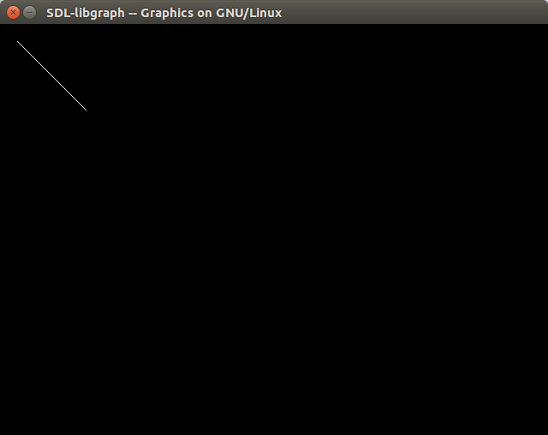

Task 2 : Write a program to draw a rectangle using the built-in line function of “Graphics.h” .

Source Code:

#include<graphics.h>
int main()
{
int gd = DETECT,gm,left=100,top=100,right=200,bottom=200,x= 300,y=150,radius=50;
initgraph(&gd,&gm,NULL);
line(10,10,100,10);
line(10,10,10,100);
line(10,100,100,100);
line(100,10,100,100);

delay(5000);
closegraph();
return 0;
}

Output :
