Practical 3

Task 1 : Write a program to draw a line using Bresenham’s Line Drawing algorithm and “Graphics.h”.

Source Code:

#include<graphics.h>
#include<stdio.h>

int main()
{
int gd = DETECT,gm;
int xa,ya,xb,yb;
float xi,yi,steps;
printf("Enter the starting point");
scanf("%d %d",&xa,&ya);
printf("Enter the ending point");
scanf("%d %d",&xb,&yb);
initgraph(&gd,&gm,NULL);
if((xb<xa && yb<ya)||(xb>xa && yb>ya))
{
if (xb<xa && yb<ya)
{
int temp=xb;
xb=xa;
xa=temp;
temp=yb;
yb=ya;
ya=temp;
}
int dx = xb-xa;
int dy = yb-ya;
int D = dy-dx;
int y = ya;
for ( int x = xa;x<xb;x++)
{
putpixel(x,y,WHITE);
if ( D>=0)
{
y++;
D=D-dx;
}
D=D+dy;
}
}
else
{
if (xb<xa && yb>ya)
{
int temp=xb;
xb=xa;
xa=temp;
temp=yb;
yb=ya;
ya=temp;
}
int dx = xb-xa;
int dy = yb-ya;
int D = dy-dx;
int x = xa;
for ( int y = ya;y>yb;y--)
{
putpixel(x,y,WHITE);
if ( D>=0)
{
x++;
D=D-dy;
}
D=D+dx;
}
}
delay(5000);
closegraph();
return 0;
}

Output:

For Positive Slope:

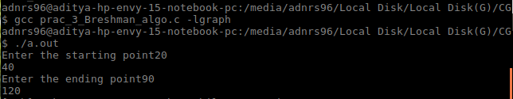

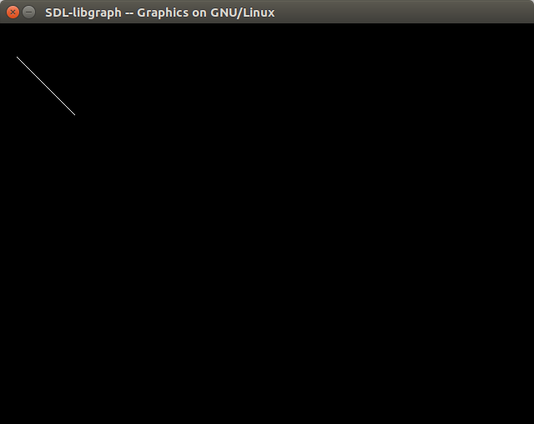

For Negative Slope:

