Practical 5

Task 1 : Write a program to perform 2D-Rotation operations.

Source Code:

#include<graphics.h>
#include<stdio.h>
#include<math.h>

#define PI 3.14159265

int main()
{
int gd = DETECT,gm;
float xa,ya,xb,yb,xao,yao,xbo,ybo;
printf("Rotation in 2D space\n");
printf("Enter the starting point\n");
scanf("%f %f",&xa,&ya);
printf("Enter the ending point\n");
scanf("%f %f",&xb,&yb);
xao=xa,yao=ya,xbo=xb,ybo=yb;
int rx,ry;
double ang,val;
printf("Enter coordinates for point about which should i rotate\n");
scanf("%d %d",&rx,&ry);
printf("Enter angle by which to rotate\n");
scanf("%lf",&ang);
xa=xa+rx;
xb=xb+rx;
ya=ya+ry;
yb=yb+ry;
val = PI / 180.0;
ang=ang*val;
float nxa=xa,nya=ya,nyb=yb,nxb=xb;
xa = (nxa*cos(ang))-(nya*sin(ang));
ya = (nxa*sin(ang))+(nya*cos(ang));
xb = (nxb*cos(ang))-(nyb*sin(ang));
yb = (nxb*sin(ang))+(nyb*cos(ang));
xa=xa-rx;
xb=xb-rx;
ya=ya-ry;
yb=yb-ry;

initgraph(&gd,&gm,NULL);
line(xa,ya,xb,yb);
setlinestyle(DASHED_LINE,0,THICK_WIDTH);
line(xao,yao,xbo,ybo);
delay(5000);
closegraph();
return 0;
}

Output:

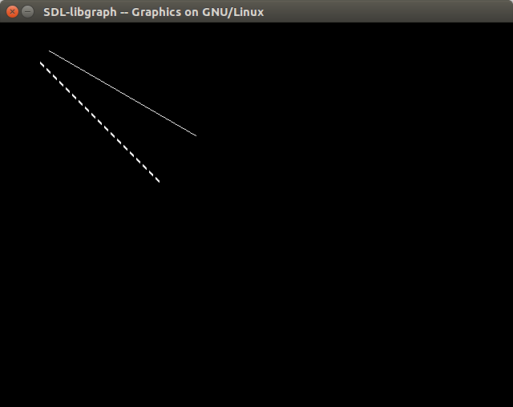
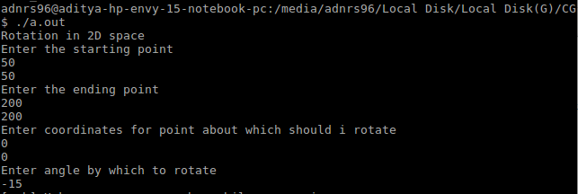

DASHED_LINE is the original line.

