Practical 6

Task 1 : Write a program to perform 2D-Scaling operations.

Source Code:

#include<graphics.h>
#include<stdio.h>
#include<math.h>

#define PI 3.14159265

int main()
{
int gd = DETECT,gm;
float xa,ya,xb,yb,xao,yao,xbo,ybo;
printf("Scaling in 2D space\n");
printf("Enter the starting point\n");
scanf("%f %f",&xa,&ya);
printf("Enter the ending point\n");
scanf("%f %f",&xb,&yb);
xao=xa,yao=ya,xbo=xb,ybo=yb;
int sx,sy;
printf("Enter scaling factors for x and y directions\n");
scanf("%d %d",&sx,&sy);
int rx,ry;
printf("Enter coordinates for point about which should i Scale\n");
scanf("%d %d",&rx,&ry);
xa=xa+rx;
xb=xb+rx;
ya=ya+ry;
yb=yb+ry;

xa=xa*sx;
xb=xb*sx;
ya=ya*sy;
yb=yb*sy;

xa=xa-rx;
xb=xb-rx;
ya=ya-ry;
yb=yb-ry;

initgraph(&gd,&gm,NULL);
line(xa,ya,xb,yb);
setlinestyle(DASHED_LINE,0,THICK_WIDTH);
line(xao,yao,xbo,ybo);
delay(5000);
closegraph();
return 0;
}

Output:

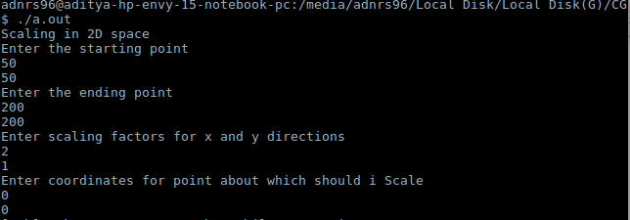
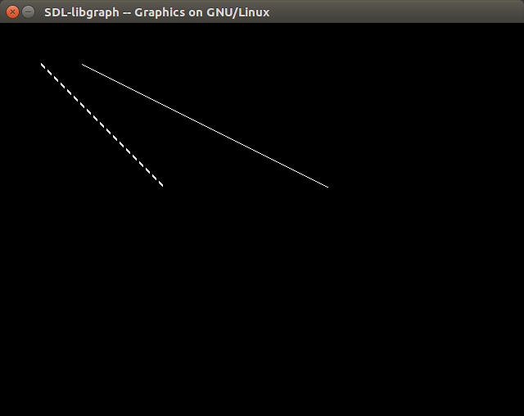

DASHED_LINE is the original line.

