Practical 4

Task 1 : Write a program to perform 2D-Translation operations.

Source Code:

#include<graphics.h>
#include<stdio.h>
#include<math.h>

#define PI 3.14159265

int main()
{
int gd = DETECT,gm;

float xa,ya,xb,yb,xao,yao,xbo,ybo;

printf("Translation in 2D space\n");
printf("Enter the starting point\n");
scanf("%f %f",&xa,&ya);
printf("Enter the ending point\n");
scanf("%f %f",&xb,&yb);
xao=xa,yao=ya,xbo=xb,ybo=yb;
int ox,oy;
printf("Enter new coordinates for Translation origin\n");
scanf("%d %d",&ox,&oy);
xa=xa-ox;
xb=xb-ox;
ya=ya-oy;
yb=yb-oy;

initgraph(&gd,&gm,NULL);
line(xa,ya,xb,yb);
setlinestyle(DASHED_LINE,0,THICK_WIDTH);
line(xao,yao,xbo,ybo);
delay(5000);
closegraph();
return 0;
}

Output:

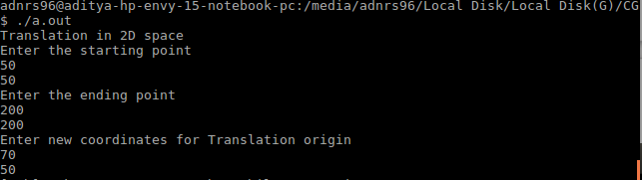
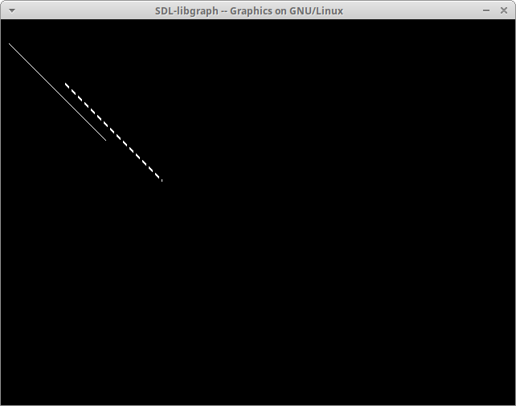
DASHED_LINE is the original line.

