Practical 7

Task 1 : Write a program to perform Composite 2D-Transformation operations.

Source Code:

#include<graphics.h>
#include<stdio.h>
#include<math.h>

#define PI 3.14159265

int main()
{
int gd = DETECT,gm;
float xa,ya,xb,yb,xao,yao,xbo,ybo;

printf("Enter the starting point\n");
scanf("%f %f",&xa,&ya);
printf("Enter the ending point\n");
scanf("%f %f",&xb,&yb);
xao=xa,yao=ya,xbo=xb,ybo=yb;

int choice=0;
while(choice!=6){
choice=0;
printf("Enter the type of transformation from list given\n");
printf("1) Translation\n");
printf("2) Rotation\n");
printf("3) Scaling\n");
printf("4) Shear X\n");
printf("5) Shear Y\n");
printf("6) Exit and print\n");
scanf("%d",&choice);
if (choice==1)
{
int ox,oy;
printf("Enter new coordinates for Translation origin\n");
scanf("%d %d",&ox,&oy);
xa=xa-rx;
xb=xb-rx;
ya=ya-ry;
yb=yb-ry;
}
else if(choice==2)
{
int rx,ry;
double ang,val;
printf("Enter coordinates for point about which should i rotate\n");
scanf("%d %d",&rx,&ry);
printf("Enter angle by which to rotate\n");
scanf("%lf",&ang);
xa=xa-rx;
xb=xb-rx;
ya=ya-ry;
yb=yb-ry;

val = PI / 180.0;
ang=ang*val;
float nxa=xa,nya=ya,nyb=yb,nxb=xb;

xa = (nxa*cos(ang))-(nya*sin(ang));
ya = (nxa*sin(ang))+(nya*cos(ang));
xb = (nxb*cos(ang))-(nyb*sin(ang));
yb = (nxb*sin(ang))+(nyb*cos(ang));

xa=xa+rx;
xb=xb+rx;
ya=ya+ry;
yb=yb+ry;

}
else if (choice==3)
{
int sx,sy;
printf("Enter scaling factors for x and y directions\n");
scanf("%d %d",&sx,&sy);
int rx,ry;
printf("Enter coordinates for point about which should i Scale\n");
scanf("%d %d",&rx,&ry);
xa=xa-rx;
xb=xb-rx;
ya=ya-ry;
yb=yb-ry;

xa=xa*sx;
xb=xb*sx;
ya=ya*sy;
yb=yb*sy;

xa=xa+rx;
xb=xb+rx;
ya=ya+ry;
yb=yb+ry;
}
else if (choice==4)
{
int sx;
printf("Enter Shear factors for x direction\n");
scanf("%d",&sx);
xa=xa+sx*ya;
xb=xb+sx*yb;

}
else if(choice==5)
{
int sy;
printf("Enter Shear factors for y direction\n");
scanf("%d",&sy);
ya=ya+sy*xa;
yb=yb+sy*xb;
}

}

initgraph(&gd,&gm,NULL);
line(xa,ya,xb,yb);
setlinestyle(DASHED_LINE,0,THICK_WIDTH);
line(xao,yao,xbo,ybo);
delay(5000);
closegraph();
return 0;
}

Output:

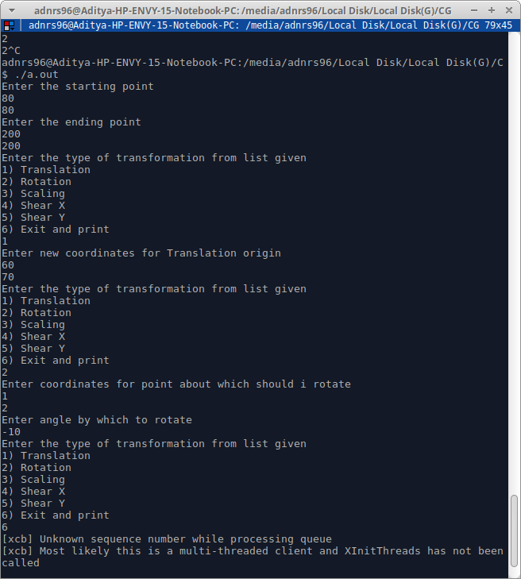

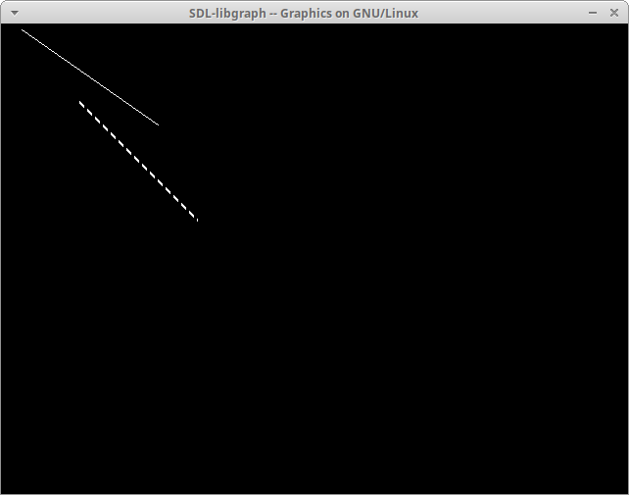

DASHED_LINE is the original line.

