Minor Project 3: Fitness Studio
Aida Van Voorhis
Repository: https://github.com/adnvanv/547 (folder minorProj3)

Overview
Fitness Studio is an ASP.NET Core Razor Pages web application (.NET 10) for managing a small gym. It is backed by a new SQL Server database, FitnessStudioDB, and a separate data-layer project that uses Entity Framework Core.
- Members: search, add, edit and delete members. Search works by member ID or by first name, last name, email or phone, with "contains", "starts with" or "ends with" matching.
- Instructors: add, edit and delete instructors. An instructor who still teaches classes cannot be deleted.
- Classes: add, edit and delete classes on the weekly schedule.
- Administration: membership plans are the admin-only table. They can only be changed on the Administration page, which is locked until Administrator mode is turned on in Settings.
- Settings: theme (light, dark or match the system), accent color, date format, 12/24-hour clock, delete confirmation, and administrator mode. Settings are saved in a browser cookie.

Database
Table | Rows | Notes
MembershipPlans | 4 | Admin-only. Unique name, price check constraint, active flag.
Members | 22 | FK to MembershipPlans. Unique email. Searchable.
Instructors | 8 | Unique email.
FitnessClasses | 14 | FK to Instructors. Day, duration and capacity check constraints.
Total | 48

Scripts: FitnessStudio/Scripts/01_FitnessStudioDB_DDL.sql (creates the database and tables) and 02_FitnessStudioDB_DML.sql (sample data).

Solution structure
- FitnessStudio.Data: class library with the entity classes, the EF Core DbContext, and one service class per table (MemberService, InstructorService, FitnessClassService, MembershipPlanService). The services translate SQL Server errors, like foreign-key and unique violations, into friendly messages.
- FitnessStudio.Web: the Razor Pages web app. Each table has an Index (list), Edit (used for both insert and update) and Delete (confirmation) page. The pages only talk to the services, never to SQL directly.

How to run
- Run 01_FitnessStudioDB_DDL.sql and then 02_FitnessStudioDB_DML.sql against .\SQLEXPRESS.
- From FitnessStudio/Code, run: dotnet run --project FitnessStudio.Web (NuGet packages restore automatically), then browse to http://localhost:5139.
- If your SQL Server instance has a different name, change ConnectionStrings:FitnessStudioDB in appsettings.json.

Screenshots

Search
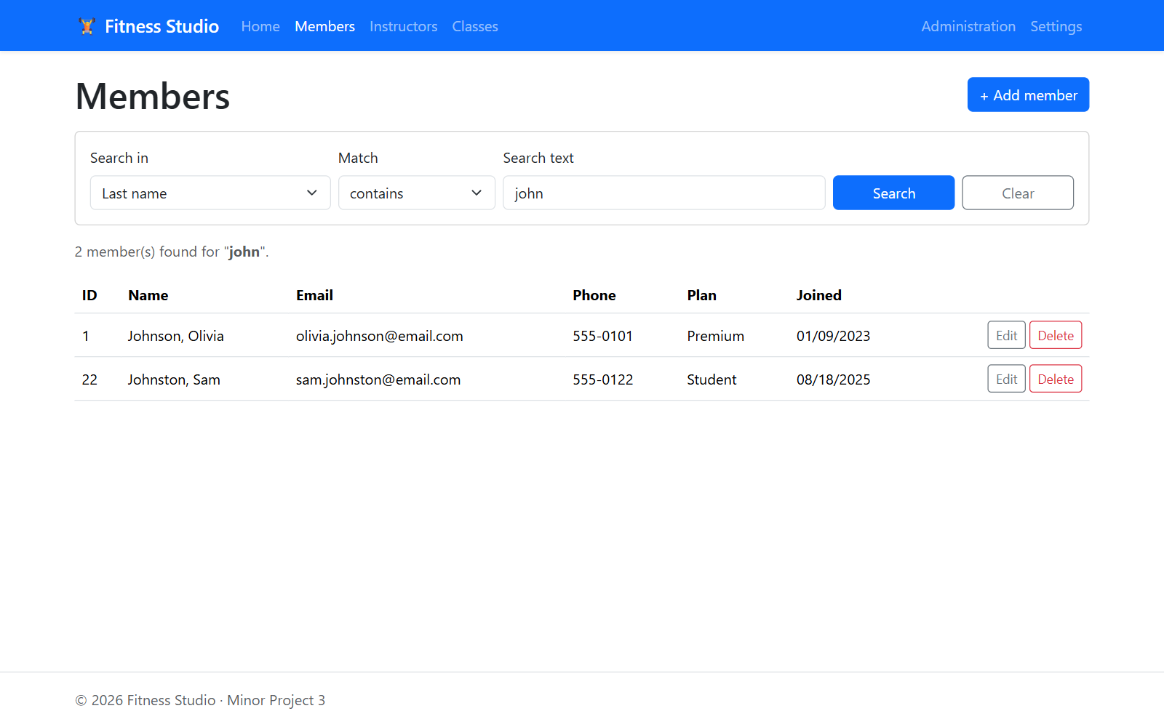
Search members: last name contains "john"
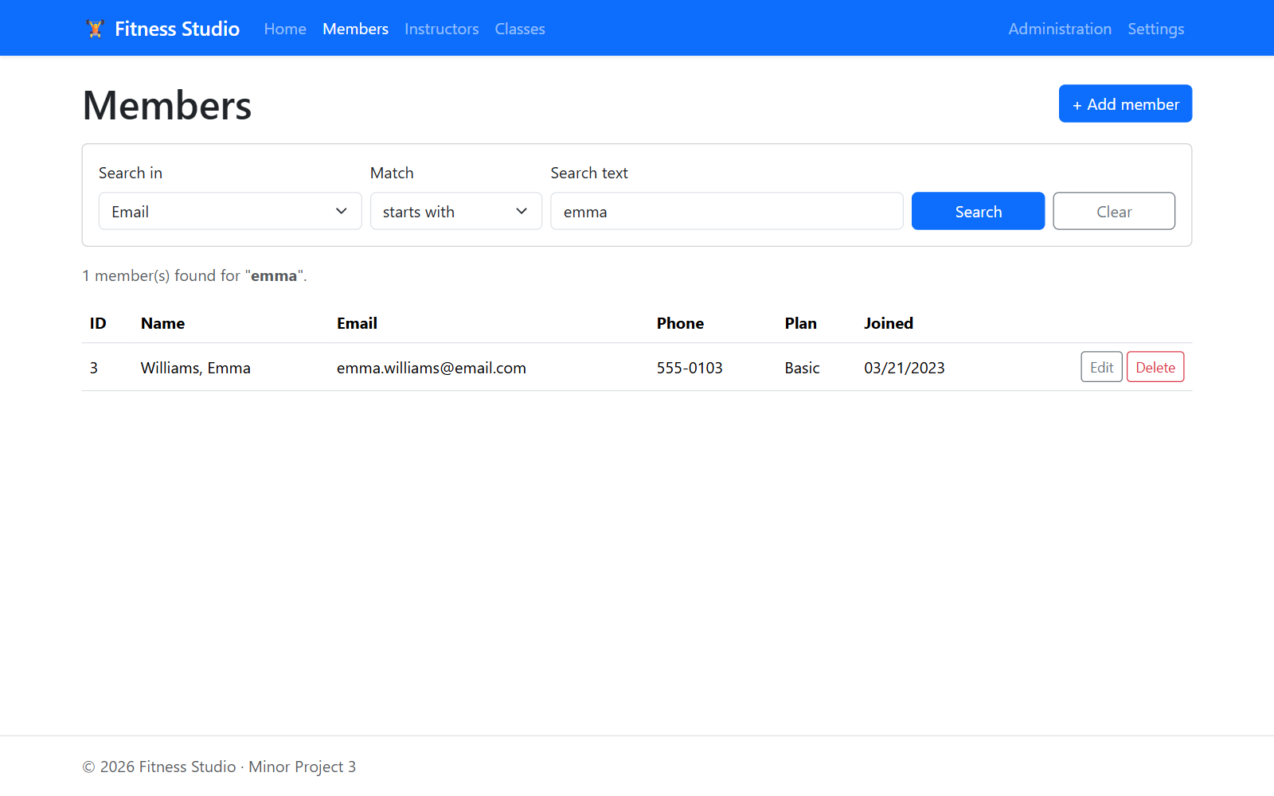
Search members: email starts with "emma"
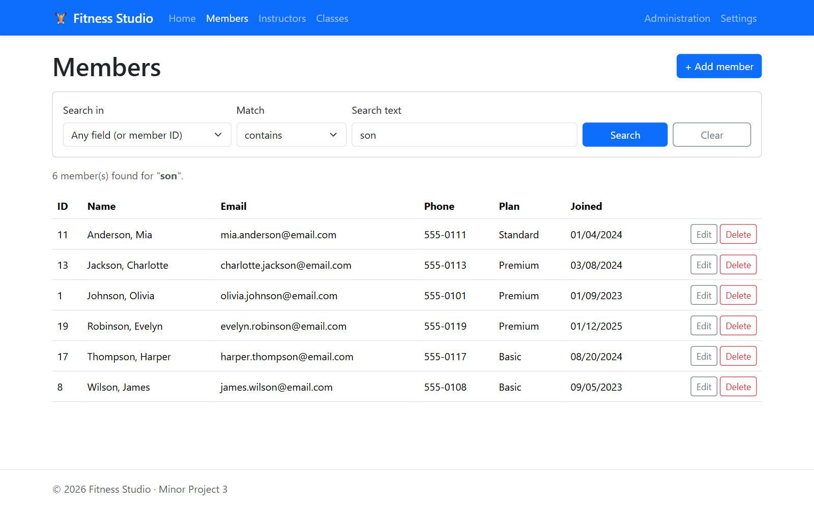
Search members: any field contains "son"

Insert
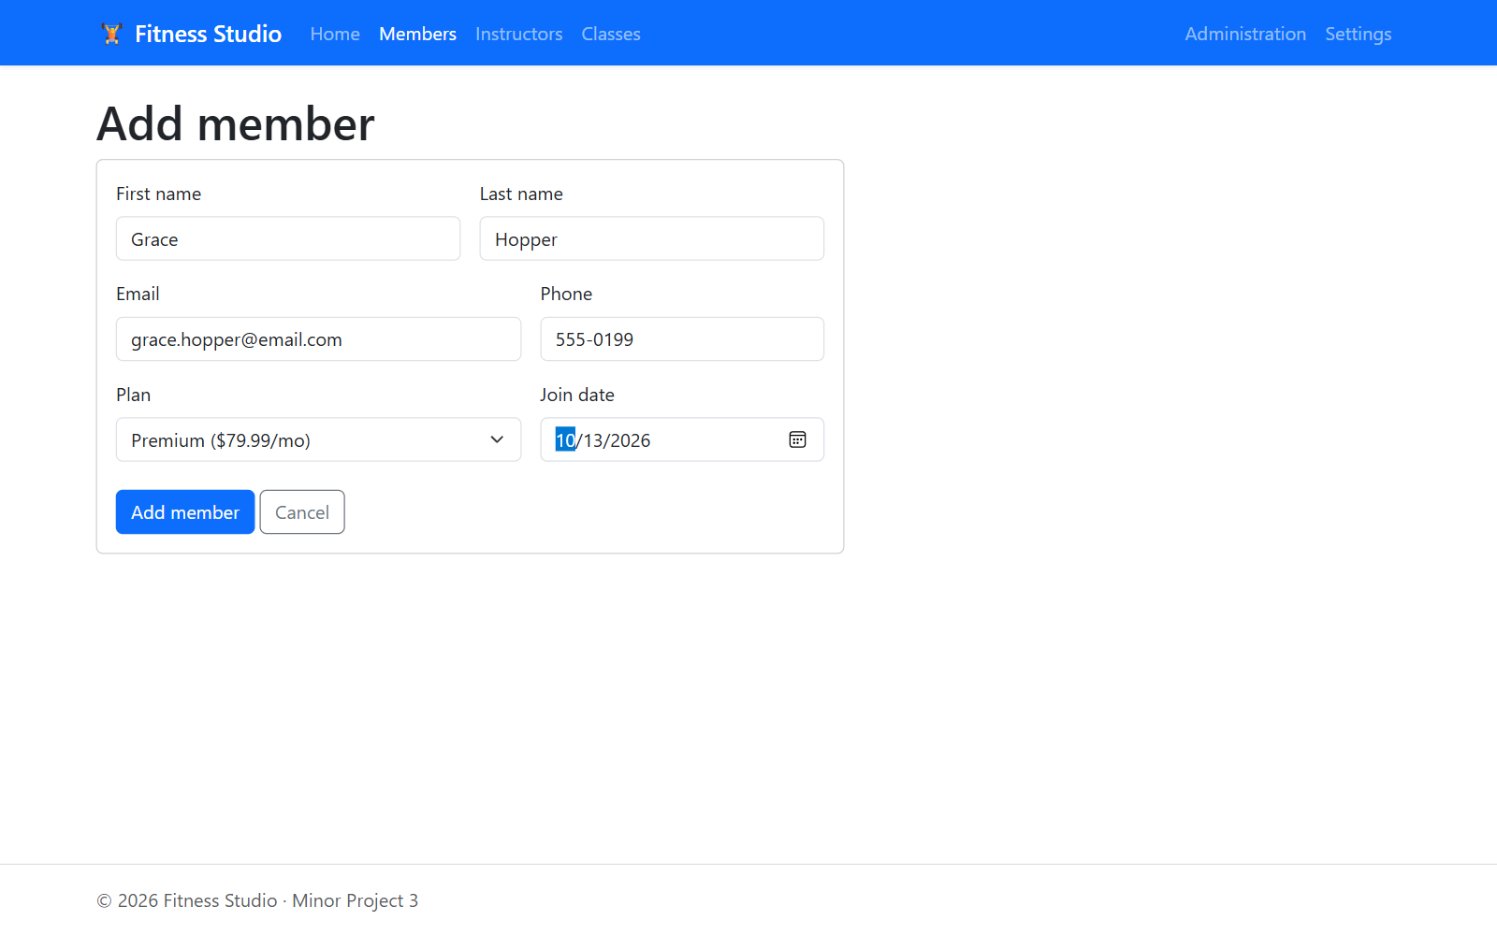
Insert: new member form
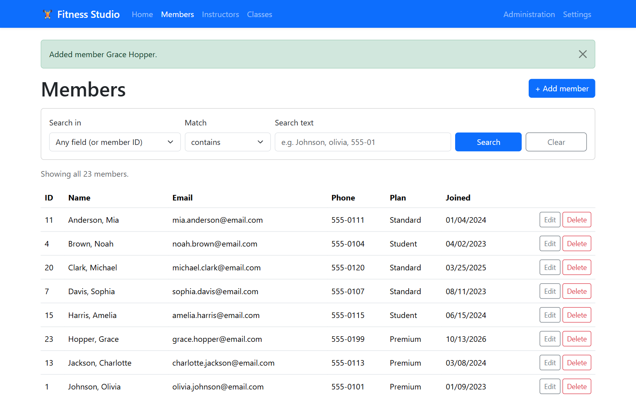
Insert: member saved (confirmation message)
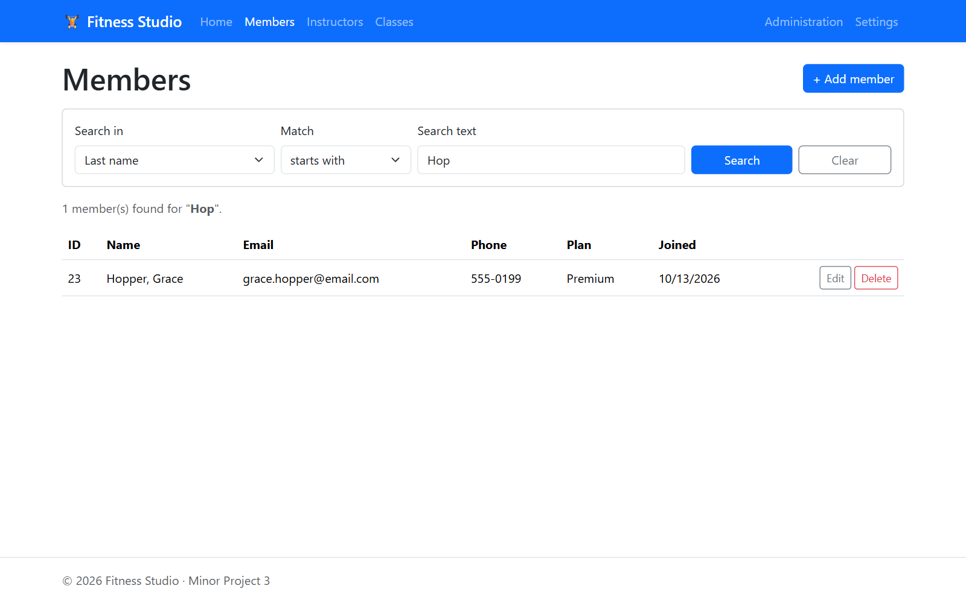
Insert: the new member found by searching last name starts with "Hop"
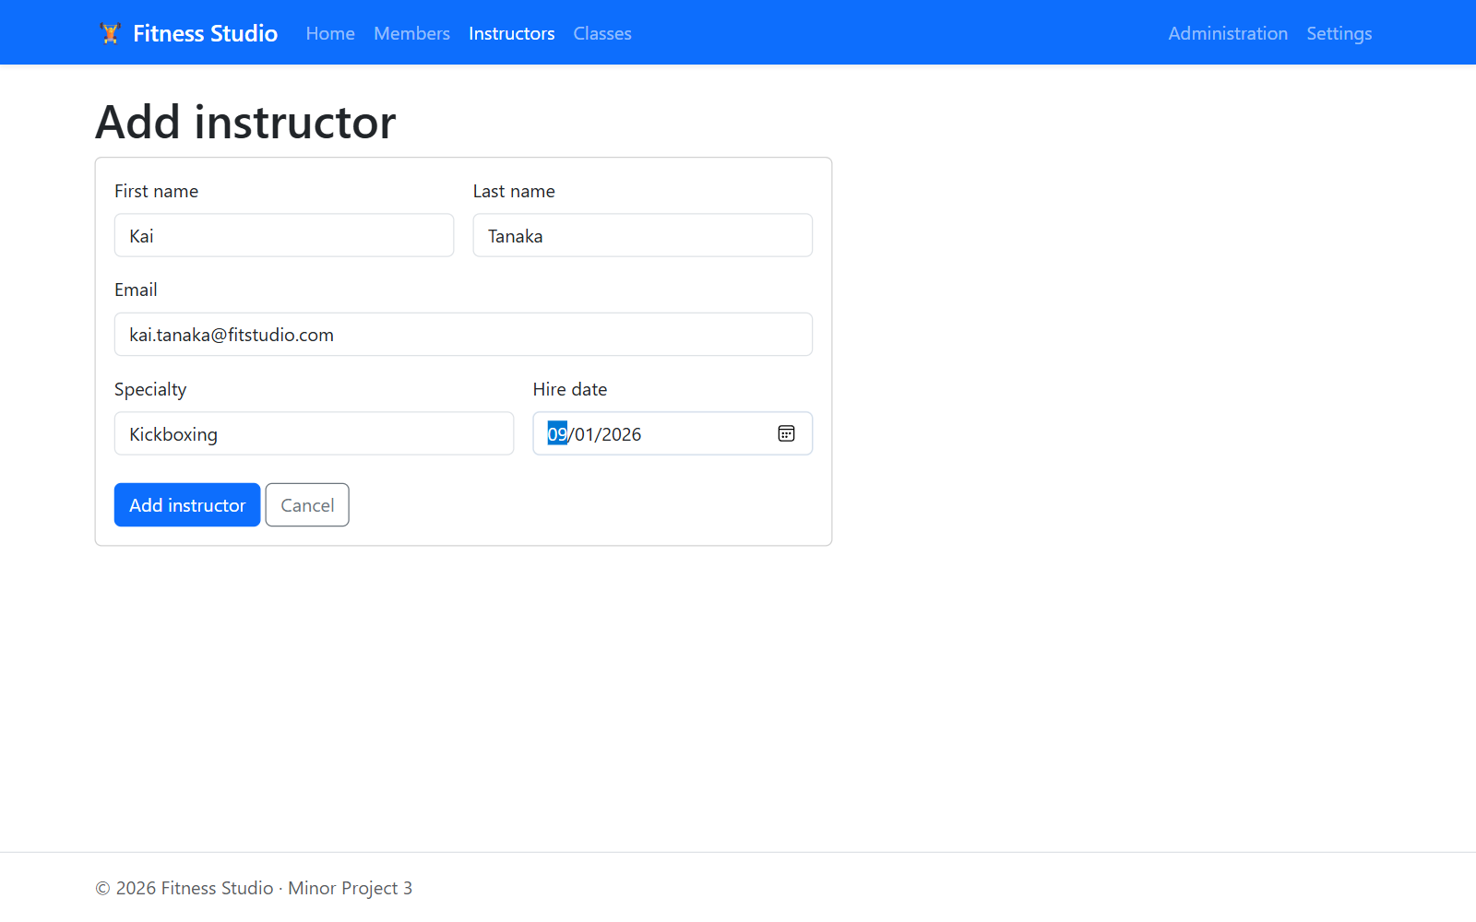
Insert: new instructor form
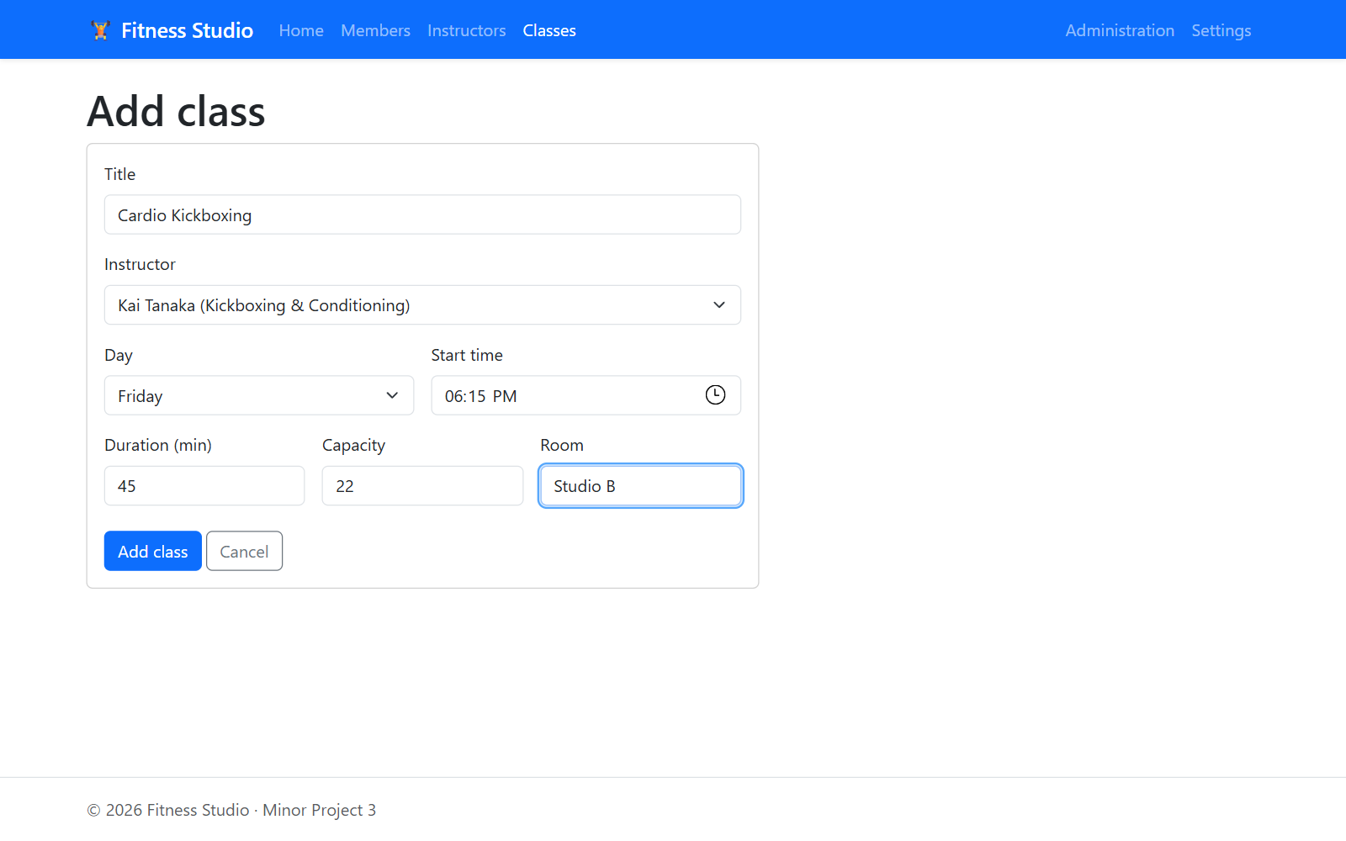
Insert: new class form
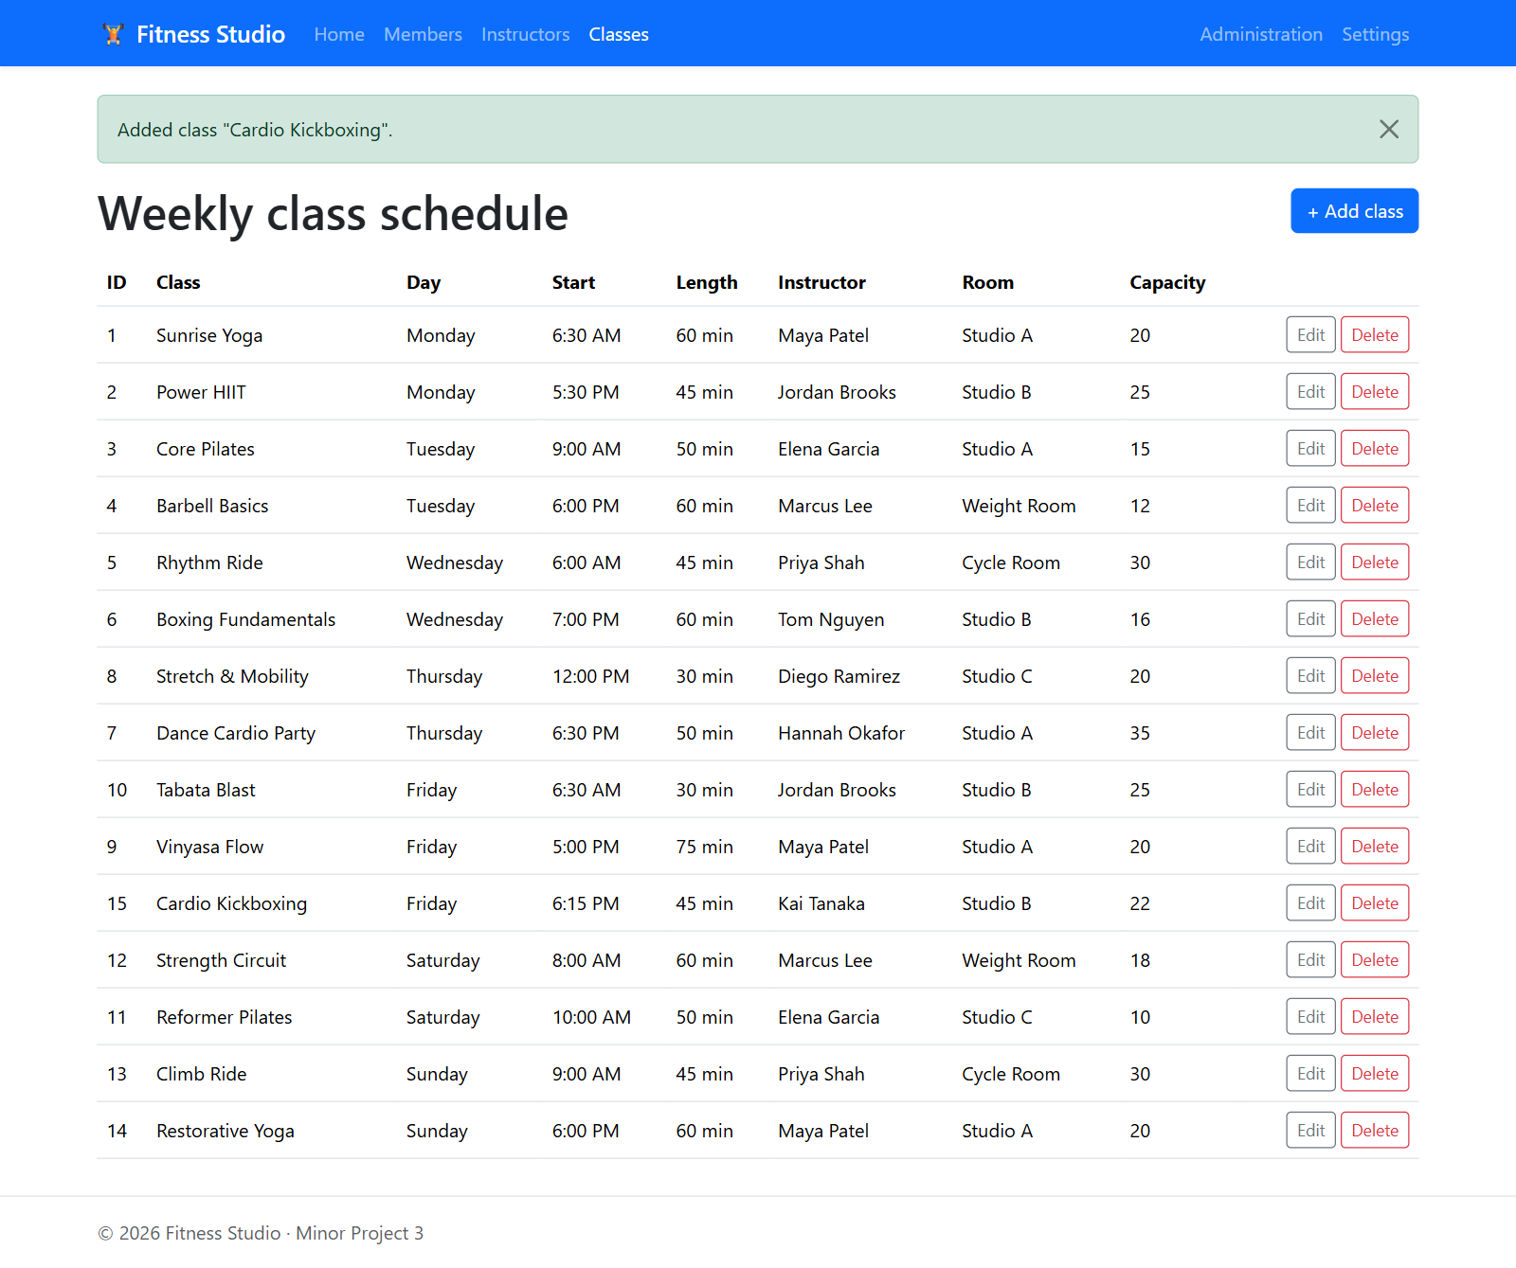
Insert: class saved and shown in the weekly schedule

Update
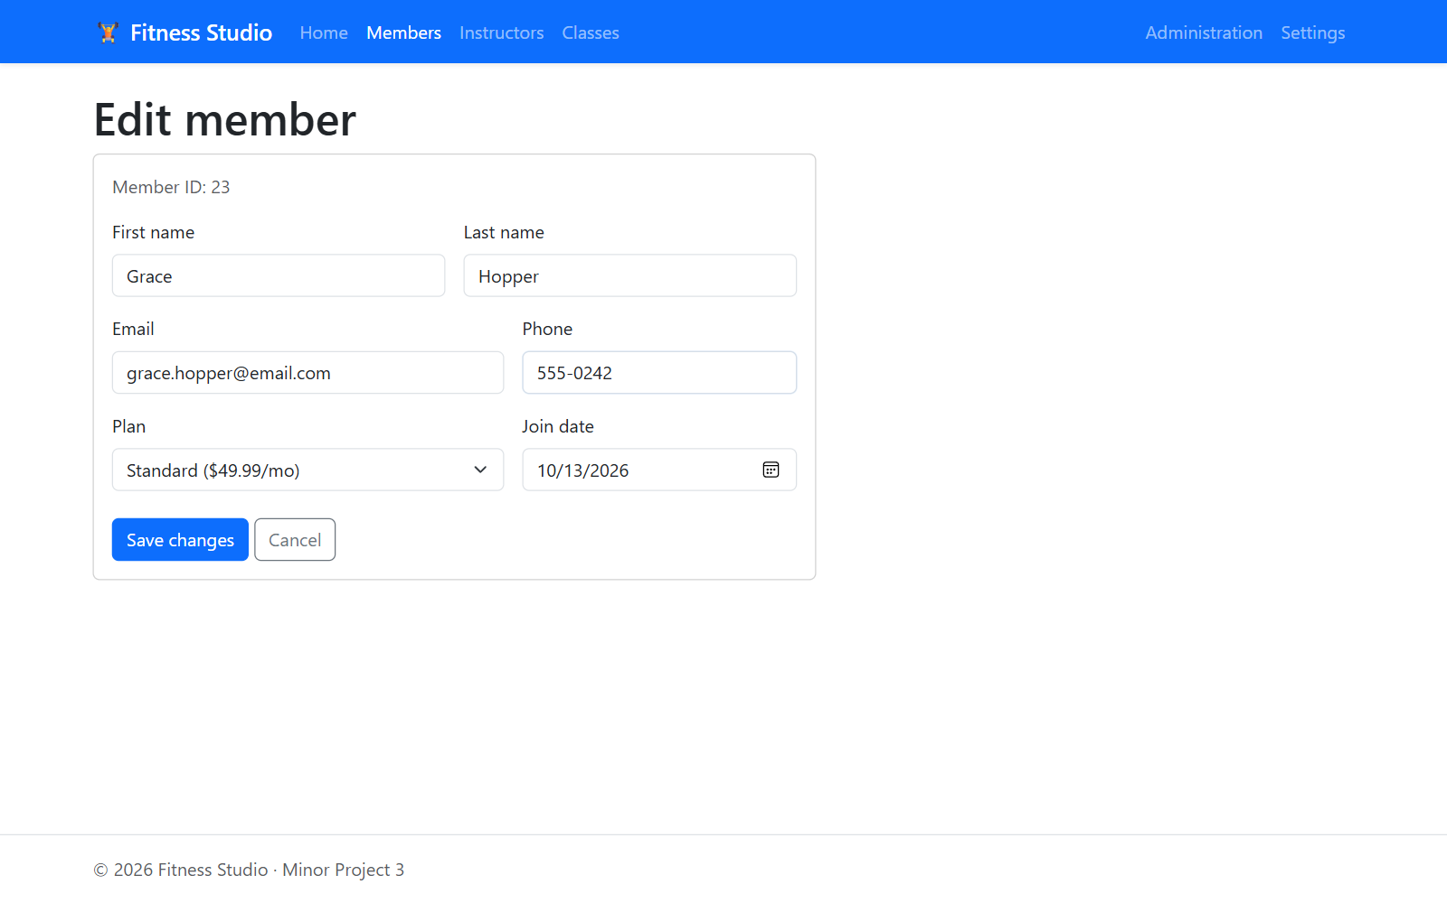
Update: editing the member (new phone number and plan)
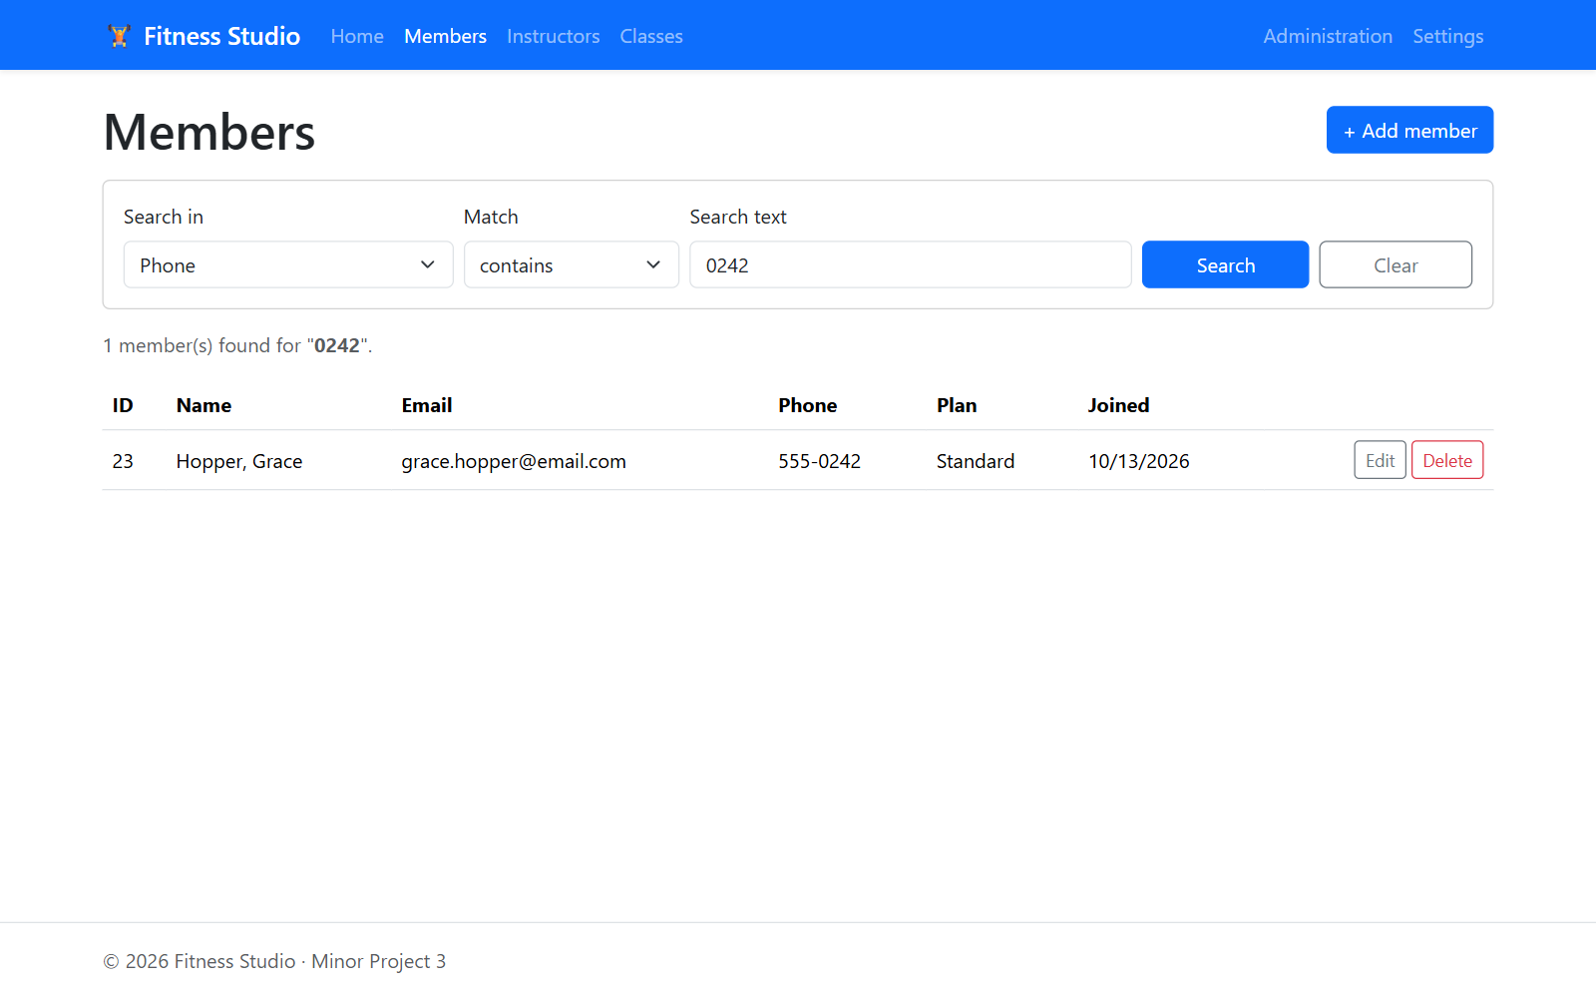
Update: member saved with the new phone number and plan
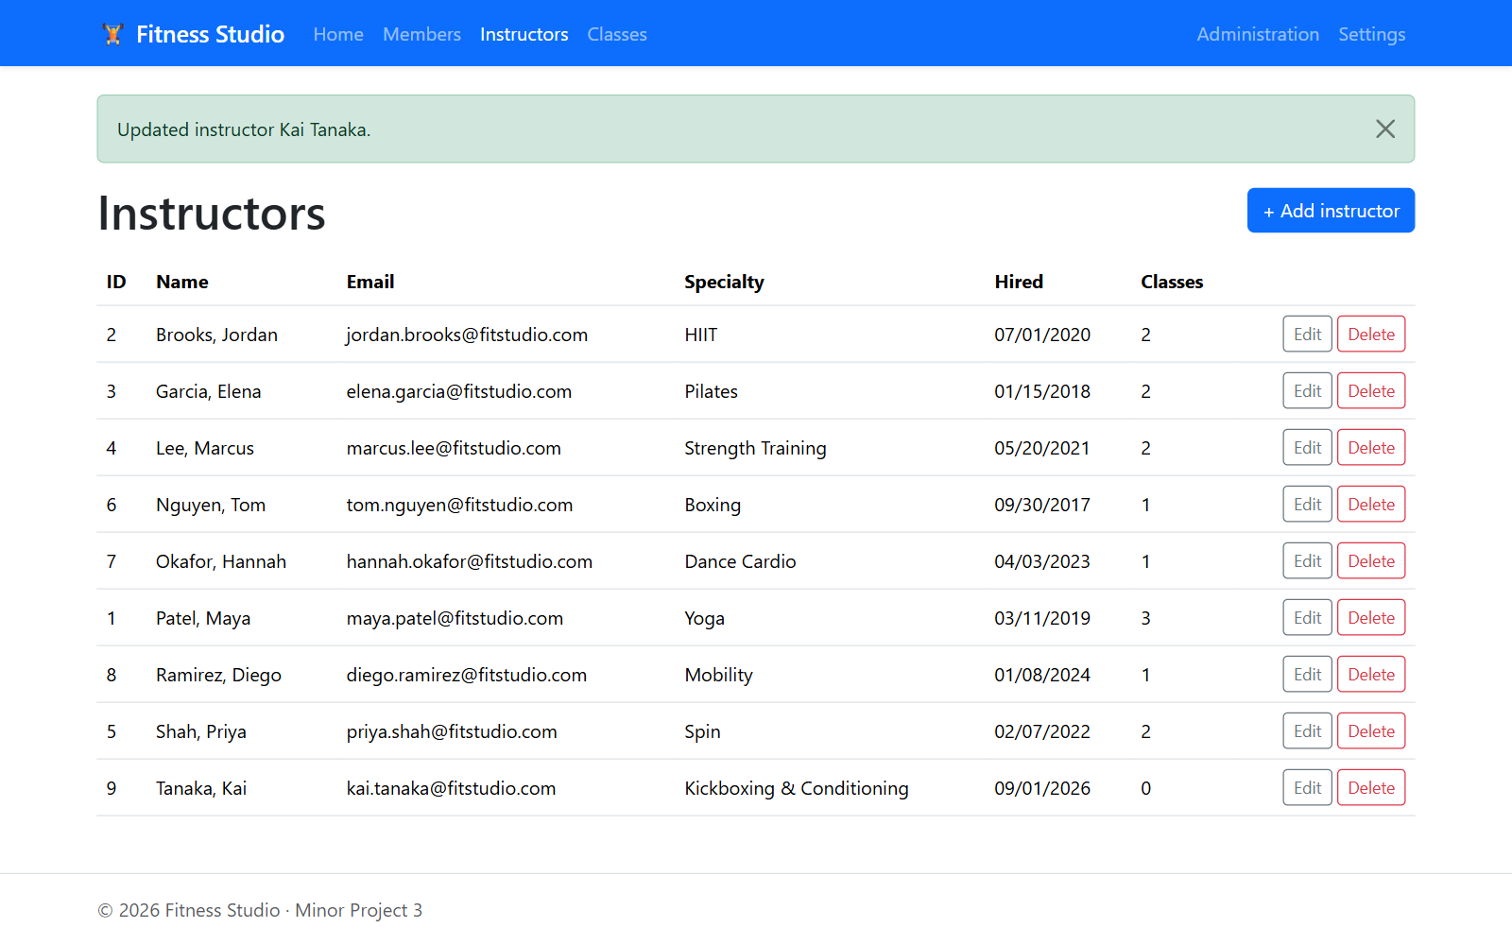
Update: instructor specialty changed
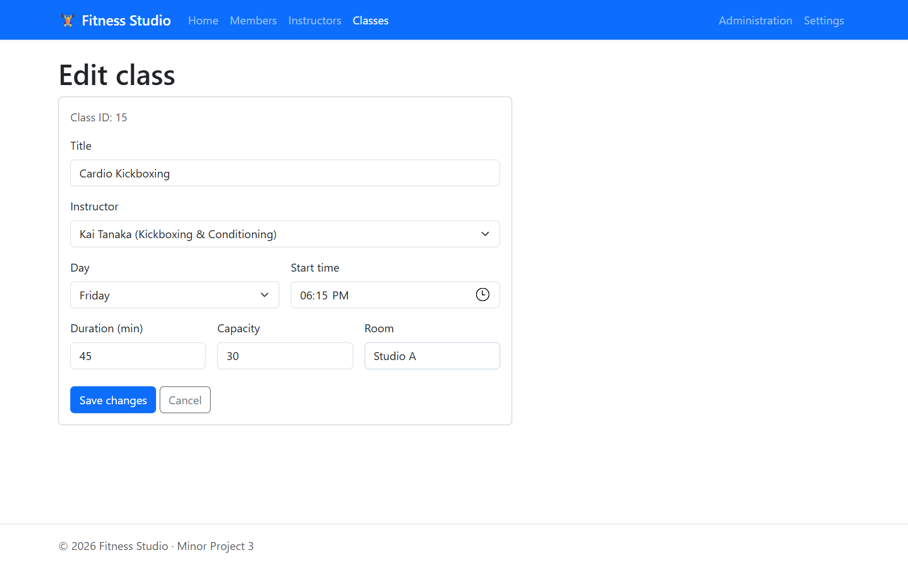
Update: editing a class (capacity and room)

Delete
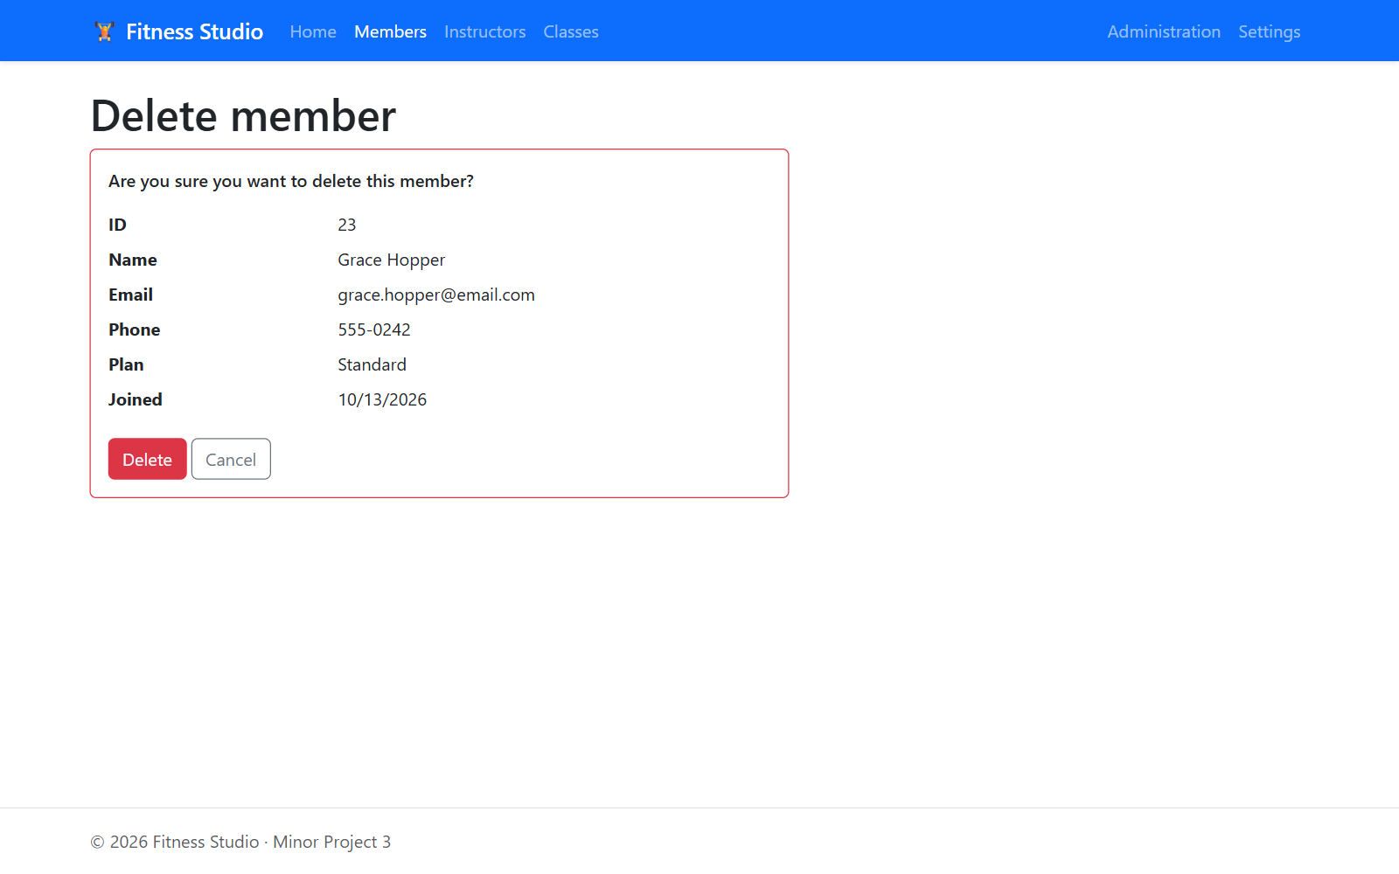
Delete: member confirmation page
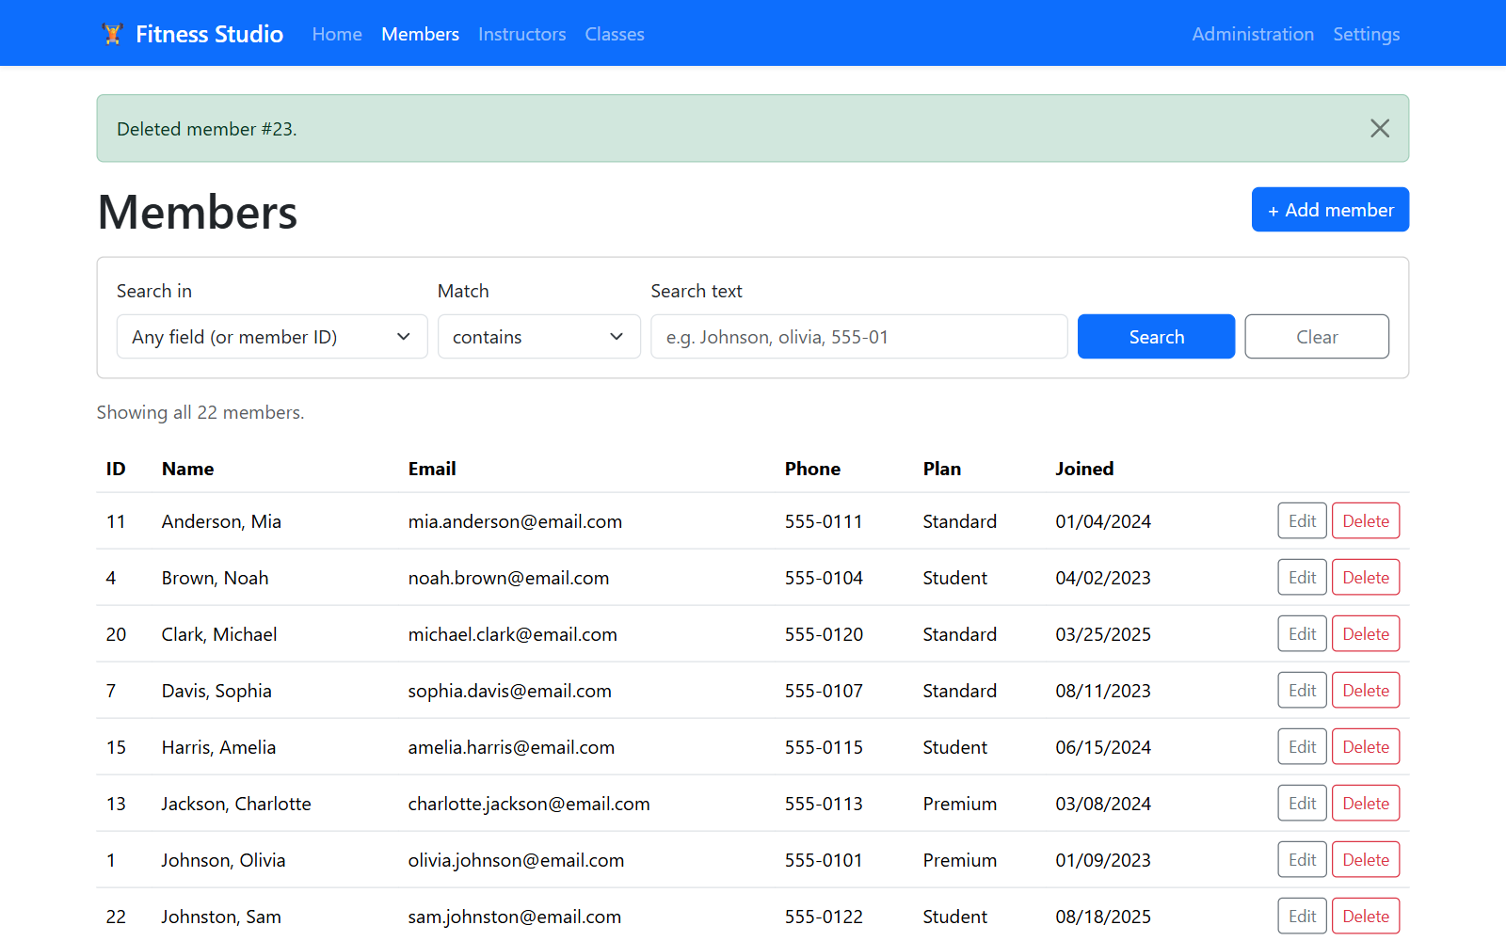
Delete: member deleted
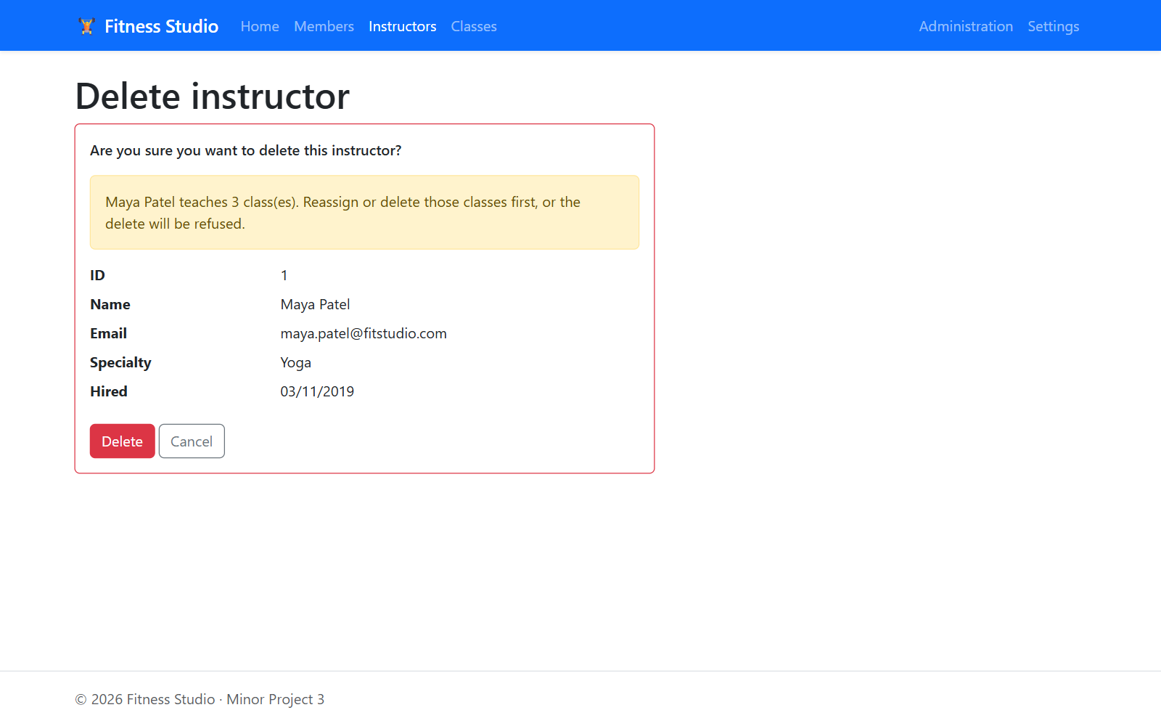
Delete: warning for an instructor who still teaches classes
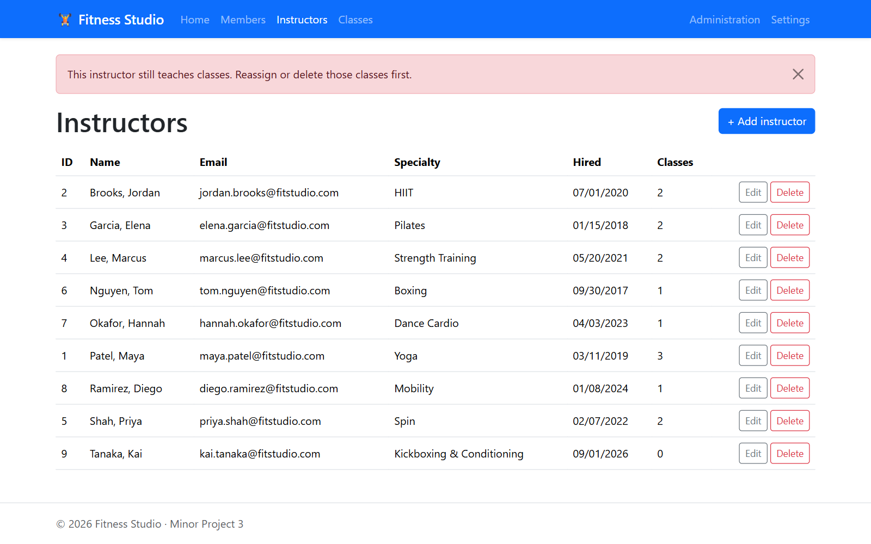
Delete: the database refuses the delete and the app shows a friendly message
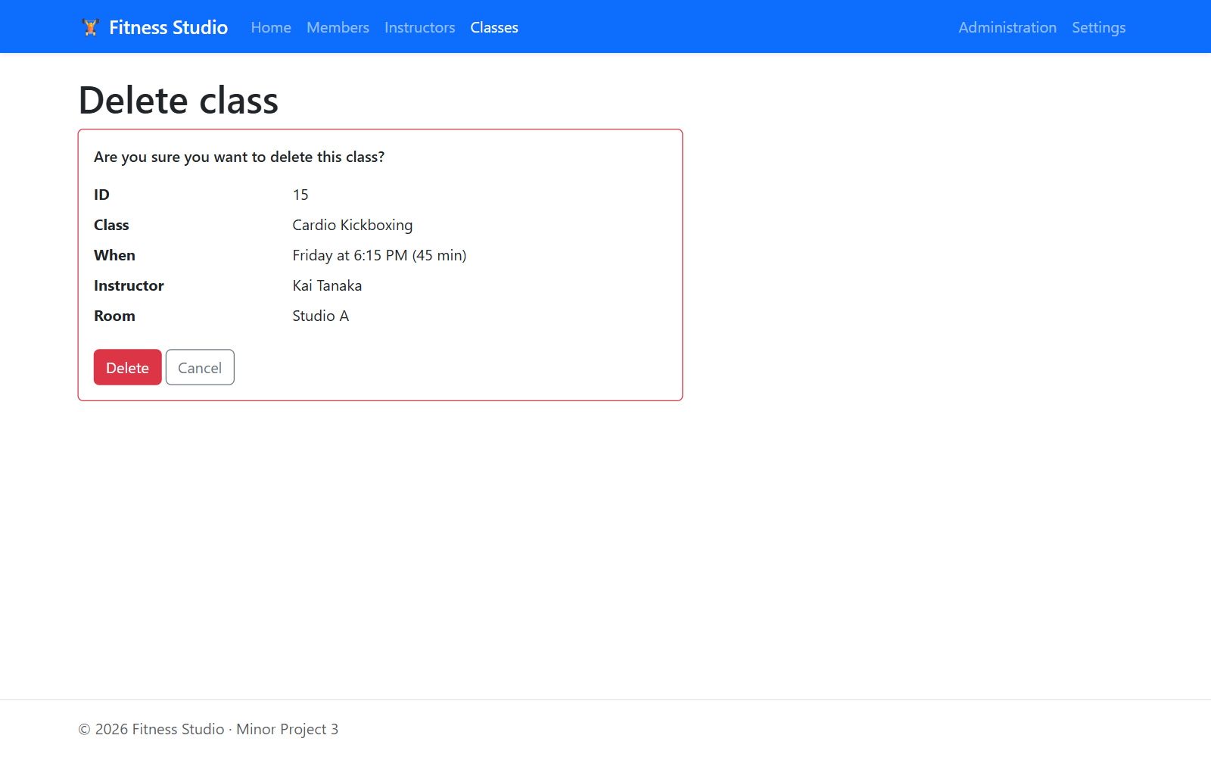
Delete: class confirmation page
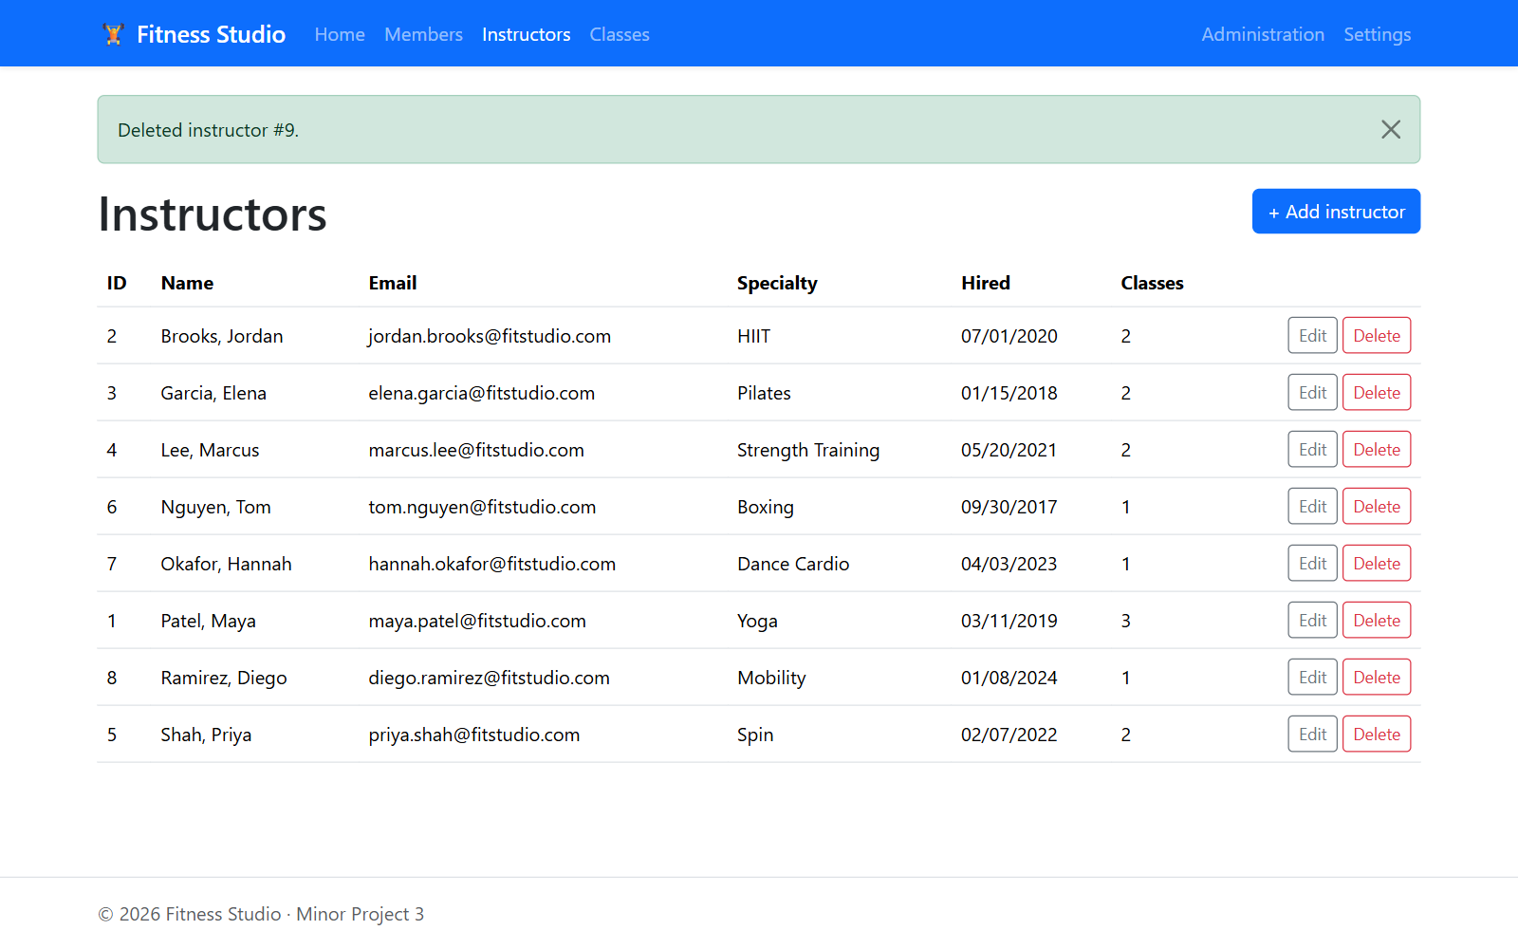
Delete: instructor with no classes deleted

Settings
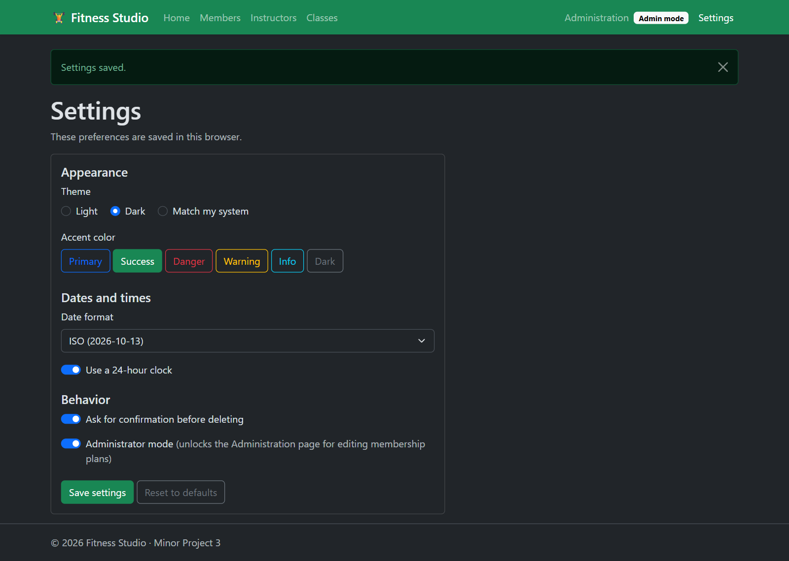
Settings: dark theme, green accent, ISO dates, 24-hour clock and administrator mode
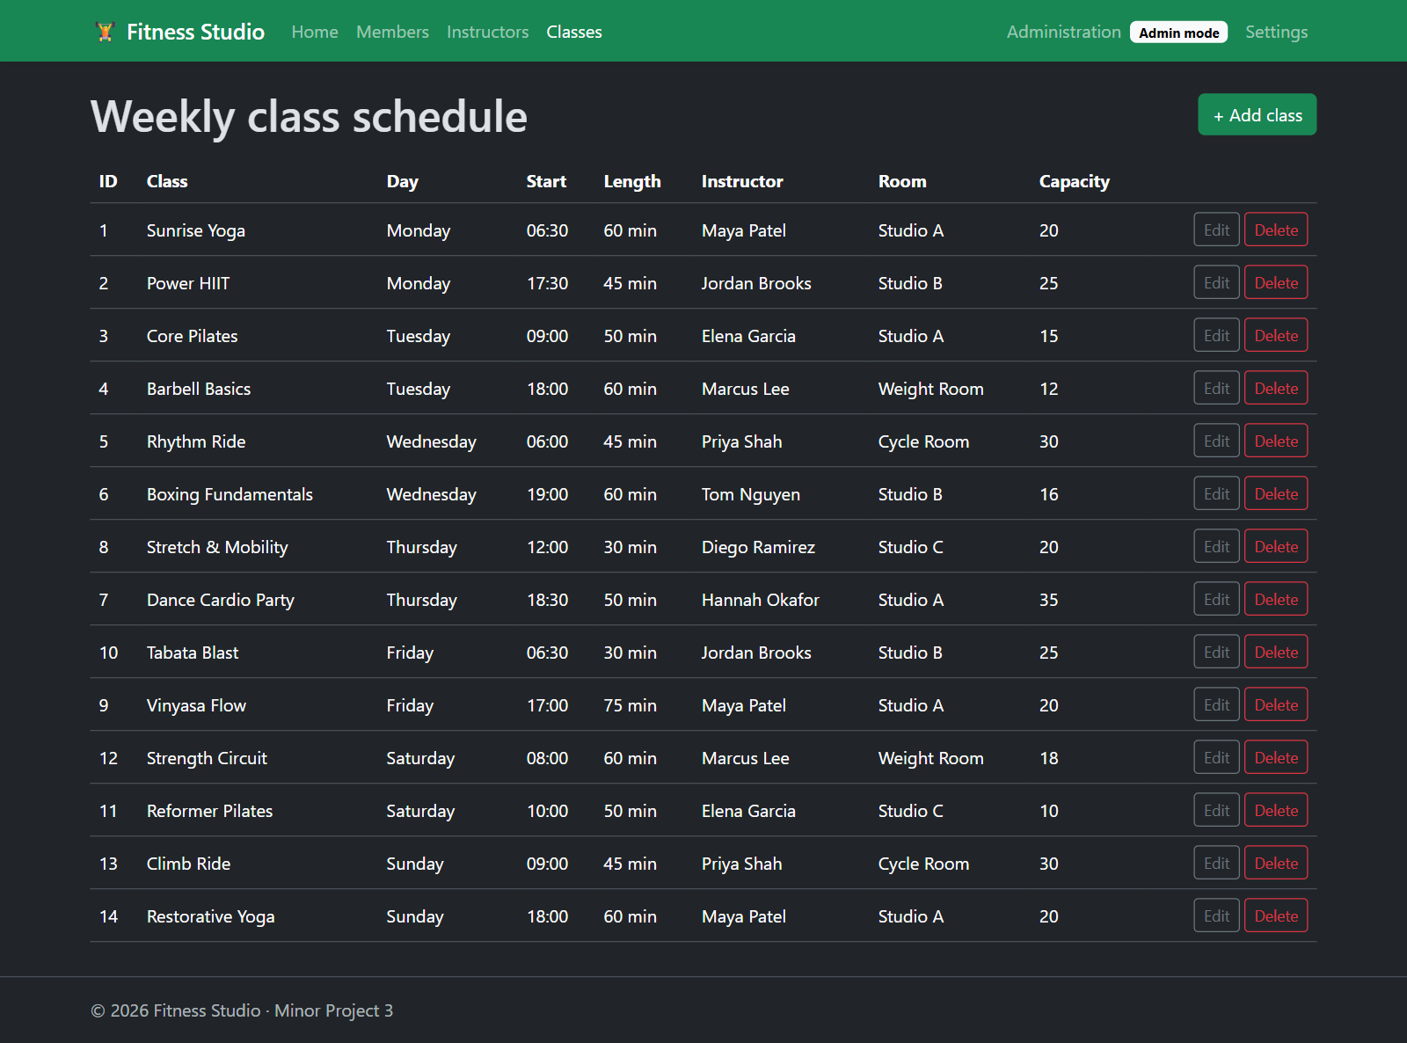
Settings applied: class schedule in dark theme with a 24-hour clock

Administration (admin-only table)
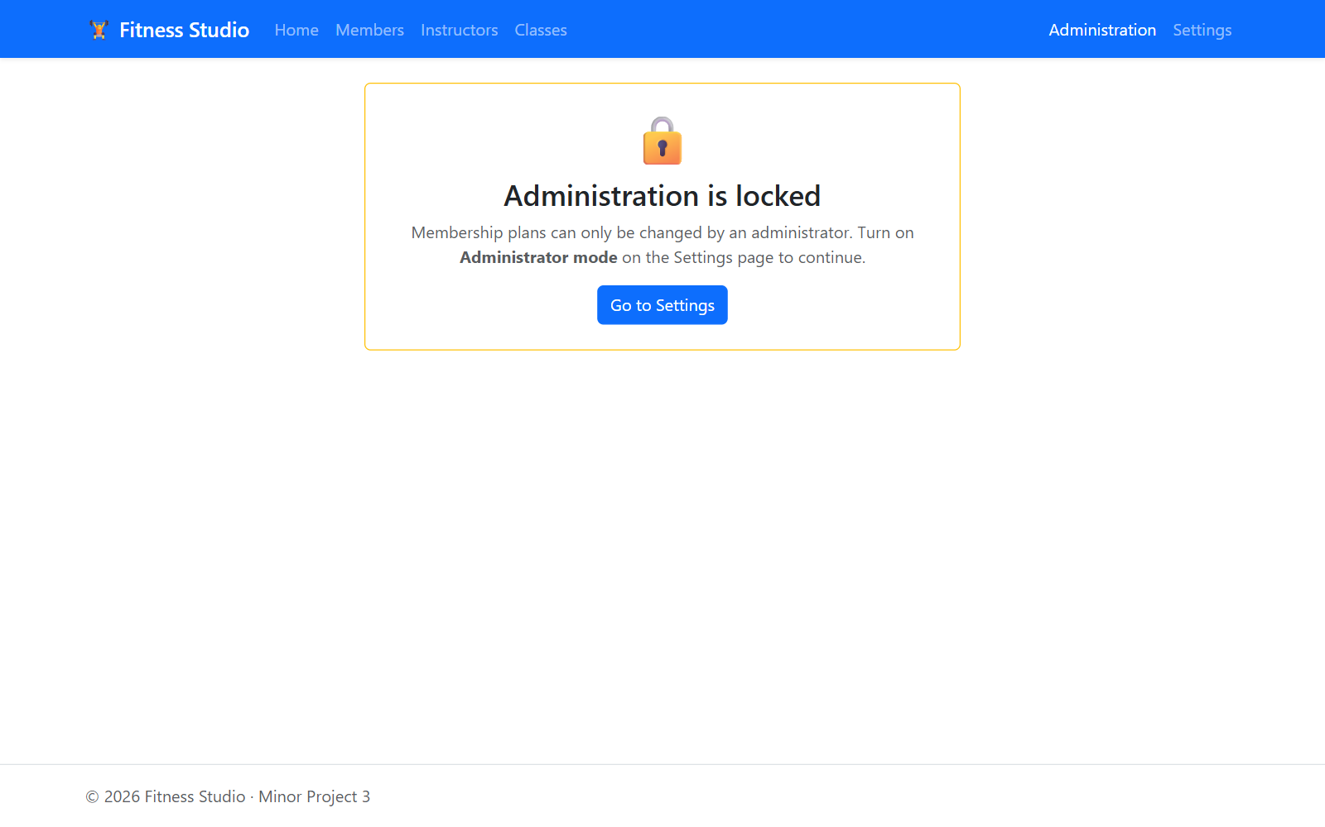
Administration is locked until administrator mode is turned on
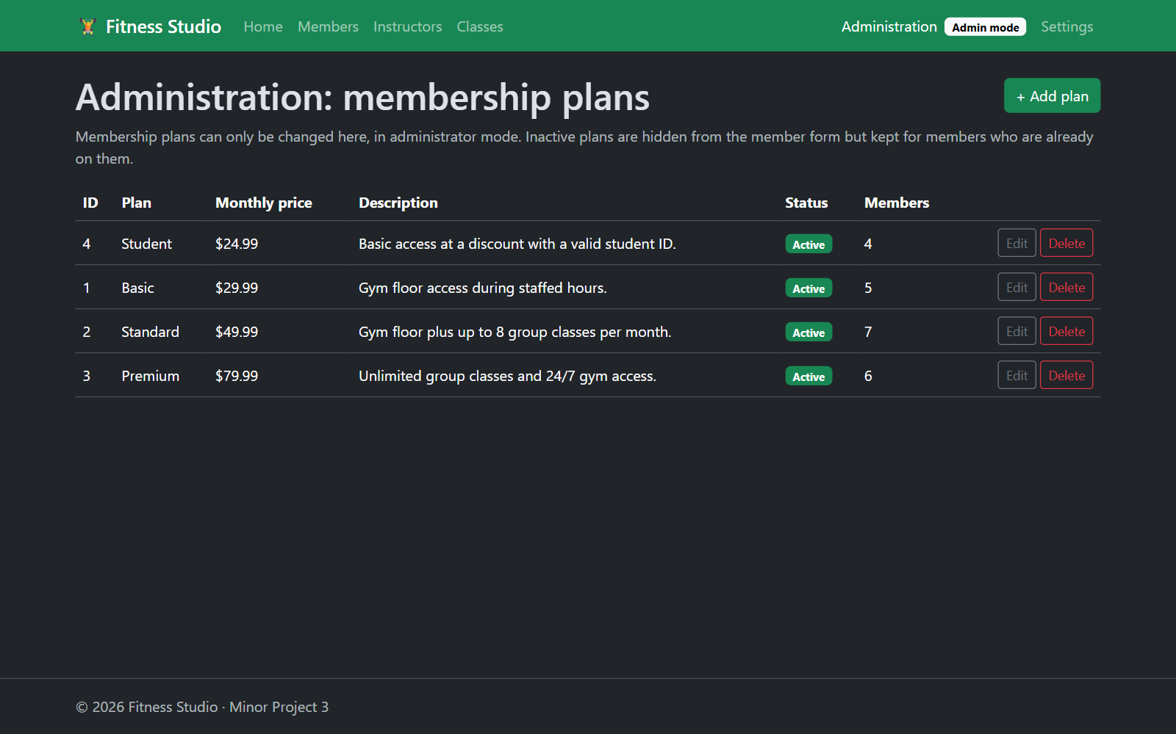
Administration: membership plans
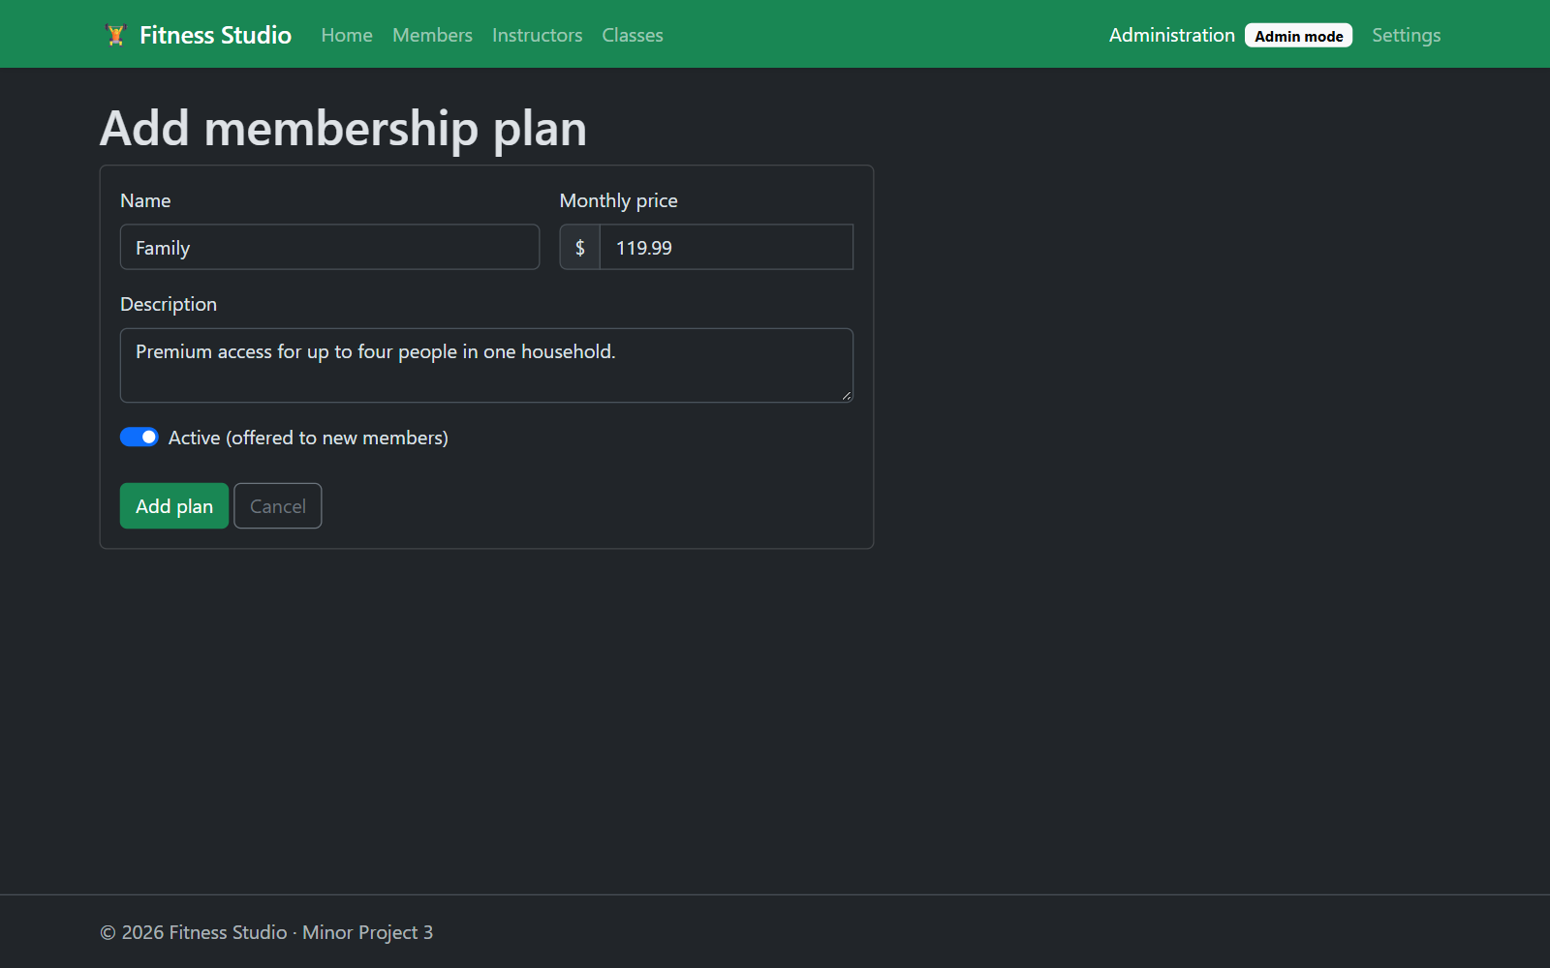
Administration insert: new "Family" plan
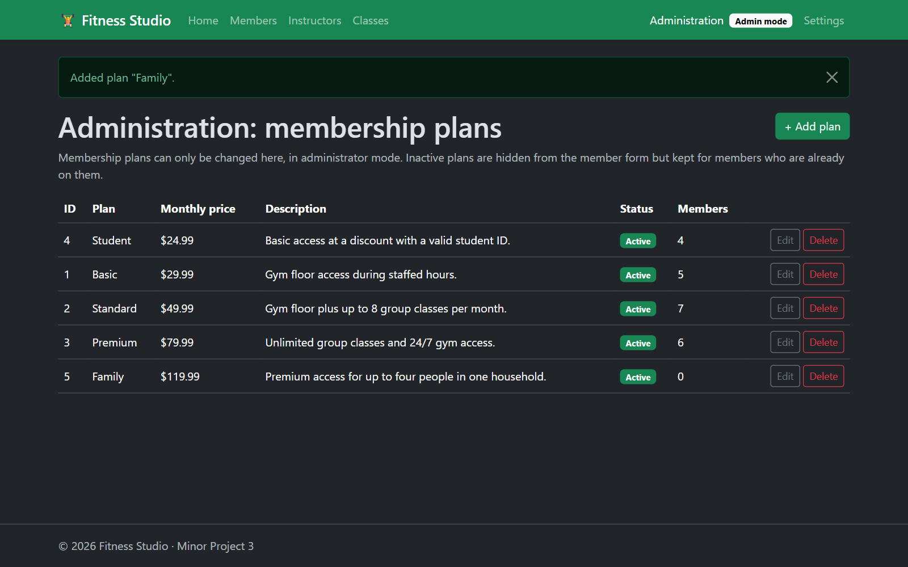
Administration insert: plan saved
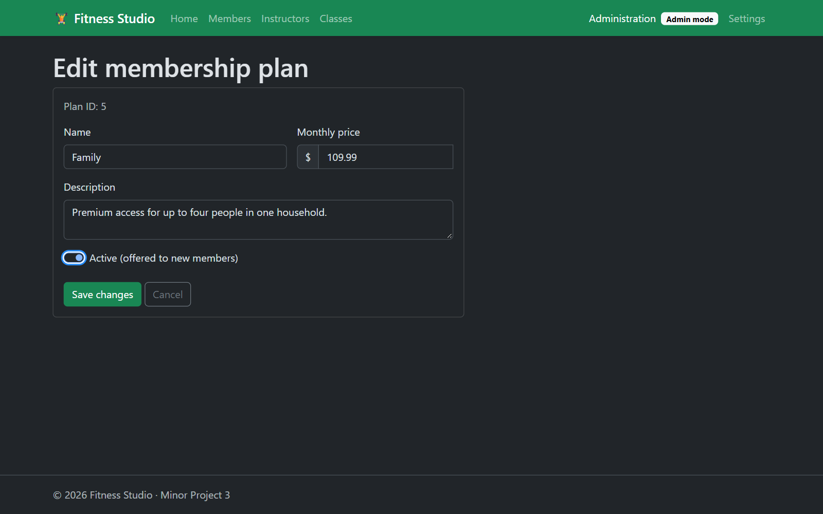
Administration update: new price, plan marked inactive
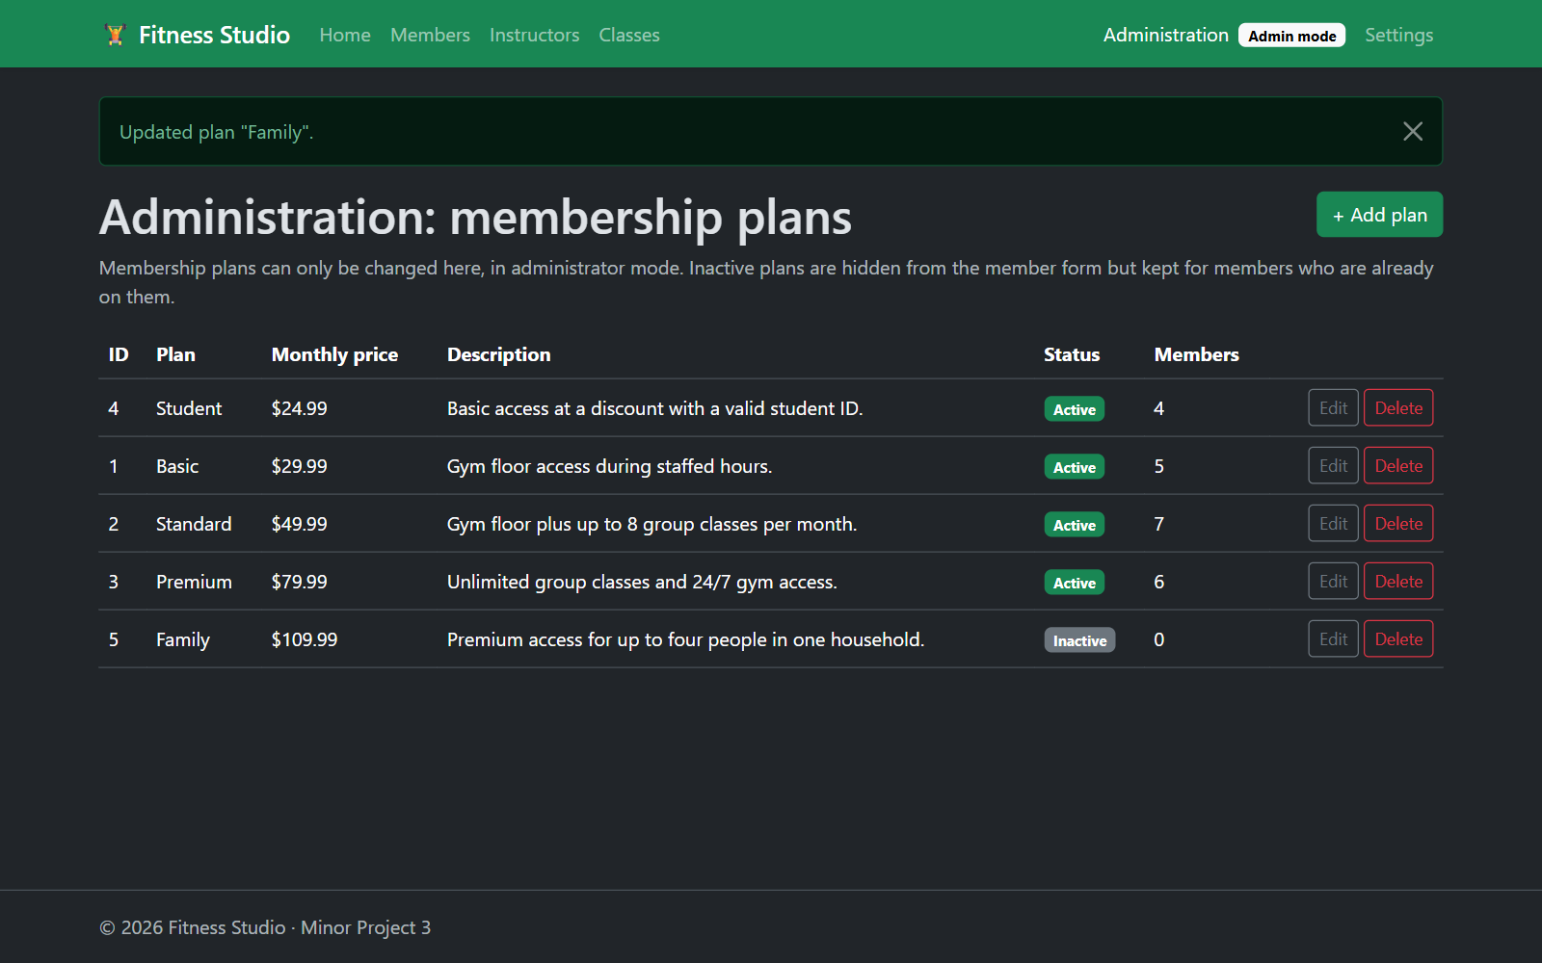
Administration update: plan saved
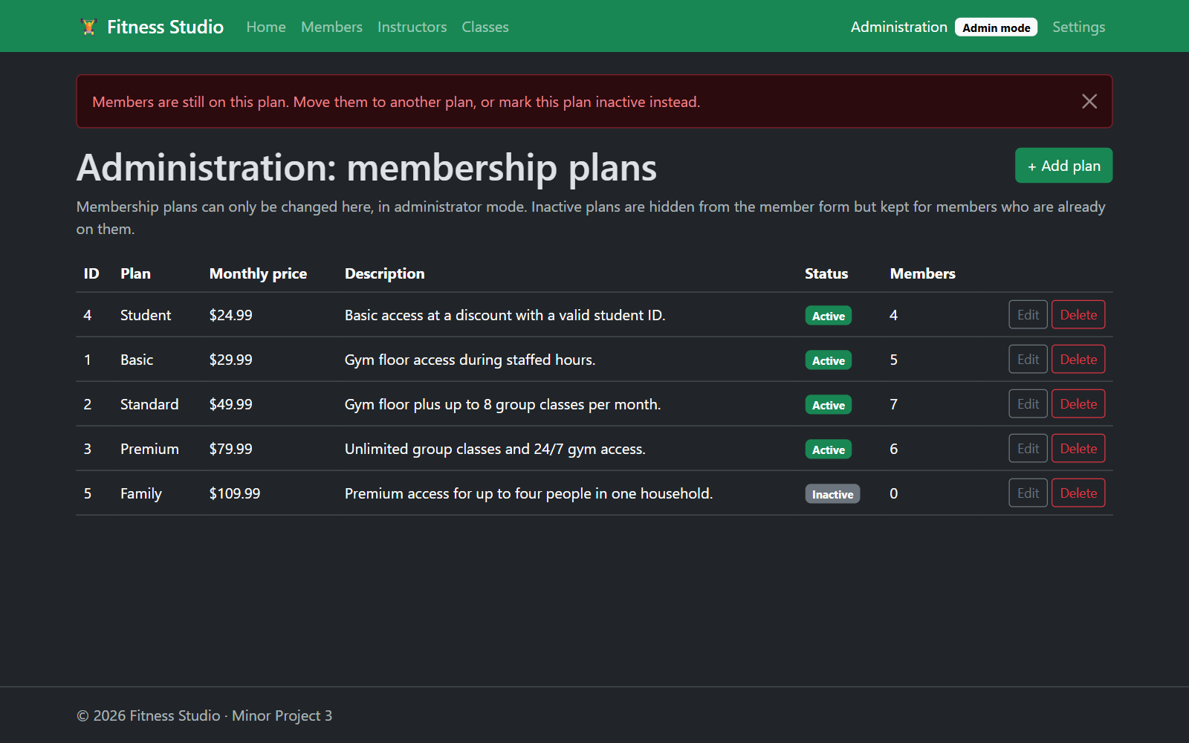
Administration delete: a plan that members are on cannot be deleted
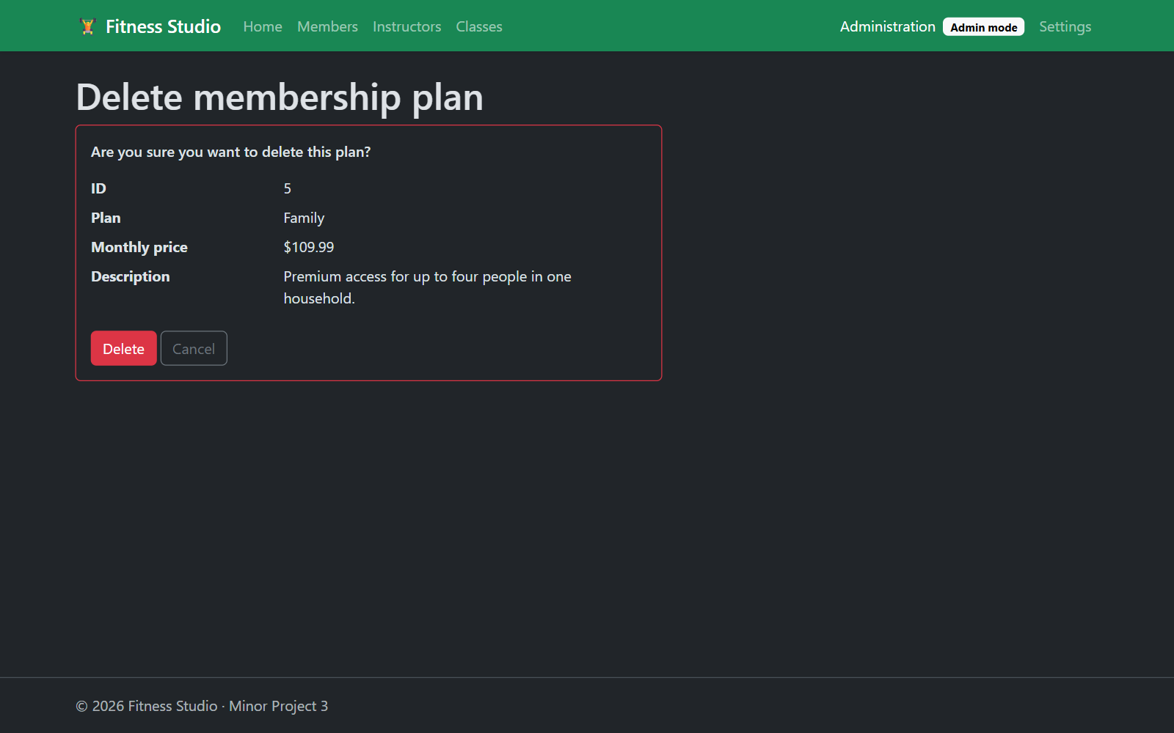
Administration delete: confirmation page
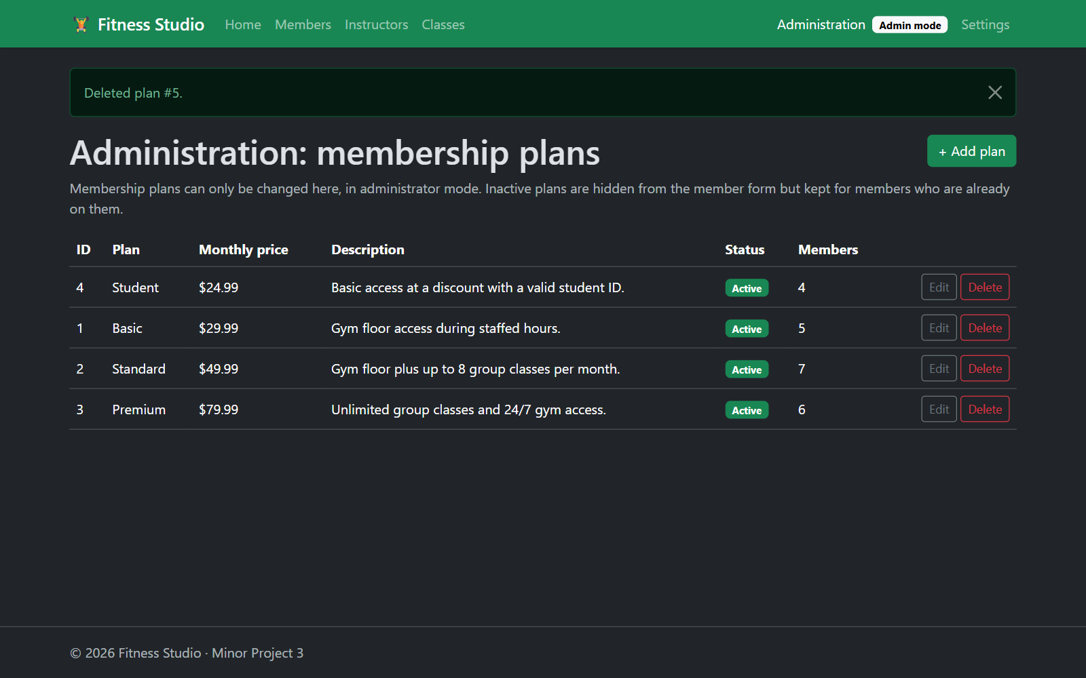
Administration delete: plan deleted

Questions

1. Describe a challenge you overcame in this project
The hardest part was handling deletes on rows that other rows depend on. If you delete an instructor who still teaches classes, or a plan that members are on, SQL Server rejects it with a foreign-key error. EF Core wraps that error in a DbUpdateException, which would show up as a crash page. I set the relationships to DeleteBehavior.Restrict so nothing gets cascade-deleted by accident. Then I wrote one SaveAsync method in the data layer that catches the exception, checks the SQL error number (547 for foreign-key/check violations, 2627/2601 for duplicates), clears the change tracker, and throws a DataLayerException with a message the user can understand. The pages just show that message. I also added a warning on the delete confirmation page so the user knows ahead of time when a delete will be refused.

2. Describe a technique you learned in this project
I learned how to search with Entity Framework Core instead of writing SQL by hand. String methods like Contains, StartsWith and EndsWith in a LINQ Where clause are translated by EF into SQL LIKE queries, and the search text is still sent as a parameter, so it is safe from SQL injection. To let the user pick both the field and the match type without writing a separate query for every combination, I built the Where condition with System.Linq.Expressions. The code takes a field selector (like m => m.LastName) and the chosen method name and builds the expression from them, and EF still translates it to SQL. I also learned the Razor Pages pattern of using one Edit page for both insert and update, chosen by whether an id is in the route, and the Post/Redirect/Get pattern with TempData for showing success messages.

3. What more would you want to refine to make it ready to sell, ship, and deploy?
- Real security: replace the "administrator mode" switch with real login (ASP.NET Core Identity) and role-based authorization, so only staff accounts can reach the Administration page.
- Saved user settings: store settings per user in the database instead of a cookie, so they follow the user between devices.
- Features: add paging and sorting to the member list, and class bookings so members can sign up for classes up to capacity.
- Testing: automated unit and integration tests for the services and pages, run in a CI pipeline (for example GitHub Actions).
- Deployment: keep the connection string in user secrets or a key vault, use EF migrations or a database project to manage schema changes, add logging and health checks, and host it on Azure App Service with Azure SQL.
- Polish: concurrency checks (a rowversion column) so two people editing the same record cannot overwrite each other, plus accessibility testing and real translations if the business needs other languages.

4. Which technology did you choose (Razor or MVC) and why?
I chose Razor Pages. This app is mostly forms and lists (list, add, edit, delete for each table), and Razor Pages fits that well. Each page keeps its markup (.cshtml) and its logic (the PageModel) side by side, so I did not have to keep controllers, actions and view folders in sync like MVC requires. Things like [BindProperty], named handlers (I used one for "Reset to defaults" on the Settings page) and the route templates on each page made the CRUD pages short and easy to follow. It also made it easy to put the admin check in one base class (AdminPageModelBase) that all the Administration pages inherit from.

