Minor Project 5: Hotel Reservations Service Layer
Aidan Van Voorhis
Repository: https://github.com/adnvanv/547 (folder minorProj5)

Overview
This project puts an ASP.NET Core Web API (.NET 10) in front of the HotelReservationsDB database from Minor Project 4. The solution is split into four projects so each layer only talks to the one below it, and a small HTML/JavaScript client, served from a different port, calls the API with fetch().
Layer | Project | What it contains
Data | HotelReservations.Data | One data object per table (RoomType, Room, Guest, Reservation) whose properties match the columns, a SqlDatabase ADO.NET helper, and one repository per table with SelectAll, SelectById, Insert, Update and Delete.
Business | HotelReservations.Business | RoomTypeManager, RoomManager, GuestManager and ReservationManager. Insert and Update are combined into Save (id 0 = insert). Adds friendlier operations (Search, GetAvailable, GetForGuest, Cancel), validation, the double-booking and room-capacity rules, and combined records (e.g. a reservation with its guest, room and room type, nights and total cost).
Service | HotelReservations.Api | One controller per service model: GuestsController, RoomsController, RoomTypesController, ReservationsController. Service model classes (GuestModel, RoomModel, RoomTypeModel, ReservationModel) hold what the client shows, and ModelMapper converts to and from the business layer. A CORS policy lets the client's origin call the API.
Client | HotelReservations.Client | Static index.html + app.js + site.css served on http://localhost:5311. Tabs for the four tables, each with Get all and Get by ID.

Database
The database is reused from Minor Project 4, and copies of its scripts are included in this project: HotelReservations/Scripts/01_HotelReservationsDB_DDL.sql (database, 4 tables, keys and constraints) and 02_HotelReservationsDB_DML.sql (6 room types, 16 rooms, 20 guests, 22 reservations). Full CRUD is implemented for all four tables in the data, business and service layers.

Service endpoints
Every controller has the same core methods; POST inserts when the id is 0 (returns 201 Created) and updates otherwise (returns 200). Business-rule errors come back as 400 and missing records as 404, both as JSON problem details.
Verb | Route | Purpose
GET | /api/{resource} | Get all (resource = guests, rooms, roomtypes, reservations)
GET | /api/{resource}/{id} | Get one record by id
POST | /api/{resource} | Save: insert (id 0) or update (existing id)
DELETE | /api/{resource}/{id} | Delete (refused with a message if other records still use it)
GET | /api/guests?search=text | Search guests by name, email, phone or city
GET | /api/guests/{id}/reservations | A guest's reservations
GET | /api/rooms/available?checkIn=&checkOut=&guests= | Free, in-service rooms big enough for the party
GET | /api/roomtypes?activeOnly=true | Only room types that can be assigned to rooms
GET | /api/reservations?includeCancelled=false | Hide cancelled reservations
POST | /api/reservations/{id}/cancel | Cancel a reservation (keeps the history, frees the room)

How to run
- Run 01_HotelReservationsDB_DDL.sql and then 02_HotelReservationsDB_DML.sql against .\SQLEXPRESS (skip this if HotelReservationsDB from Project 4 already exists).
- From HotelReservations/Code: dotnet run --project HotelReservations.Api (http://localhost:5310).
- In a second terminal: dotnet run --project HotelReservations.Client (http://localhost:5311), or open HotelReservations.sln in Visual Studio and start both projects. NuGet packages restore automatically.
- If the SQL Server instance has a different name, change ConnectionStrings:HotelReservationsDB in HotelReservations.Api/appsettings.json. If the client is served from another address, add it to Cors:AllowedOrigins in the same file.

Screenshots

Service running
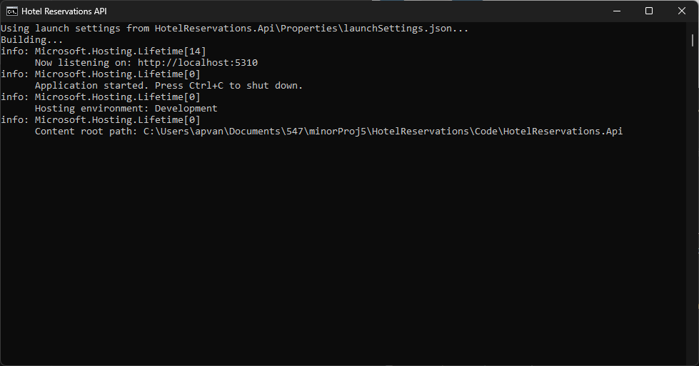
The Web API running locally (dotnet run), listening on http://localhost:5310
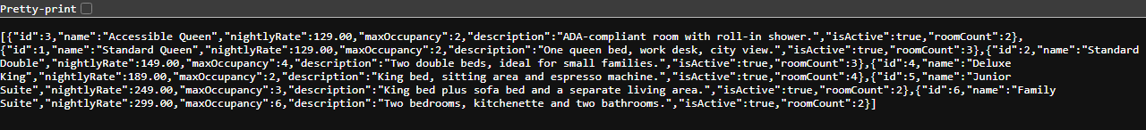
The running service answering GET /api/roomtypes in the browser

Client
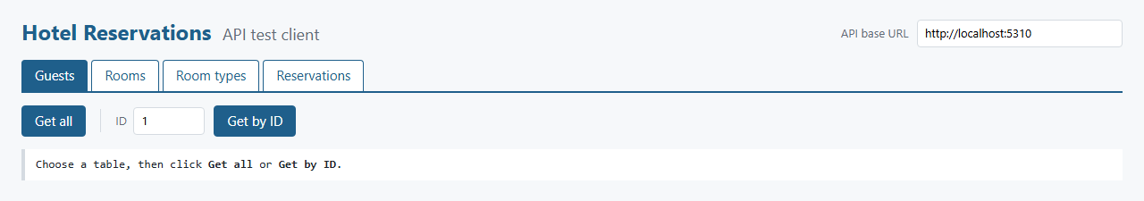
The HTML client (http://localhost:5311): pick a table, then Get all or Get by ID

Guests
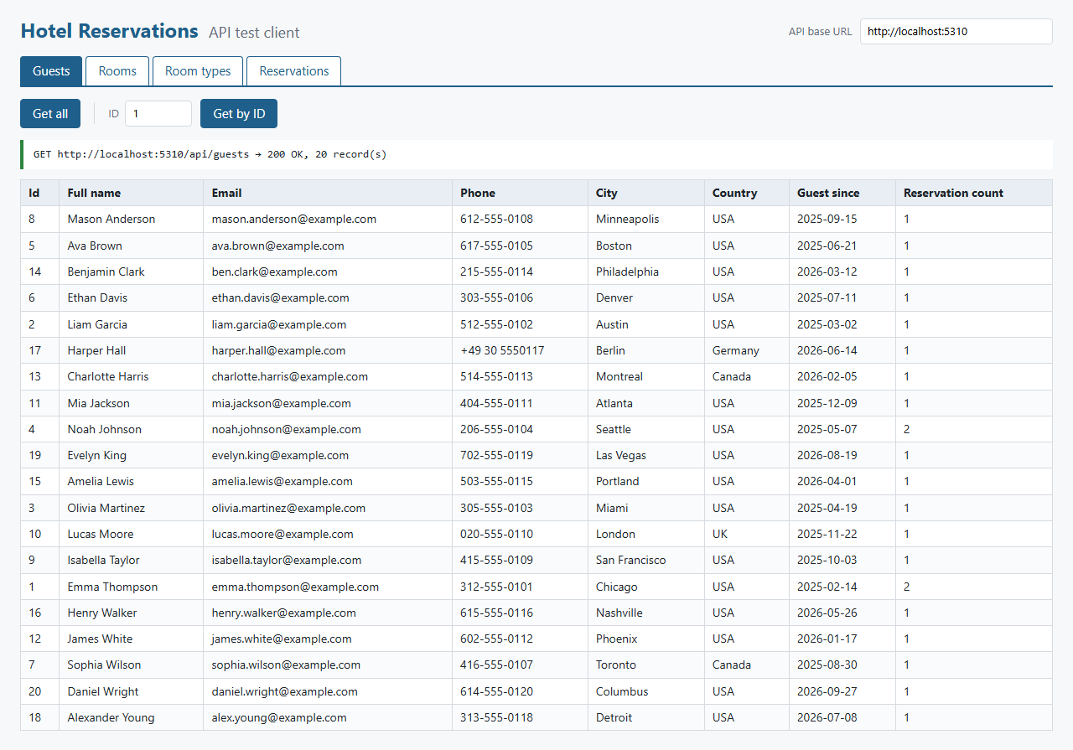
Guests: Get all (GET /api/guests, 20 records)
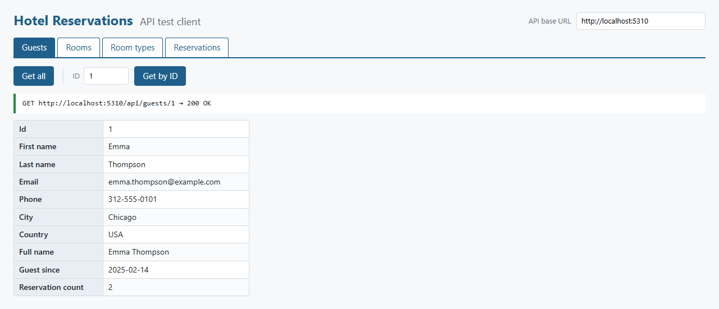
Guests: Get by ID (GET /api/guests/1)

Rooms
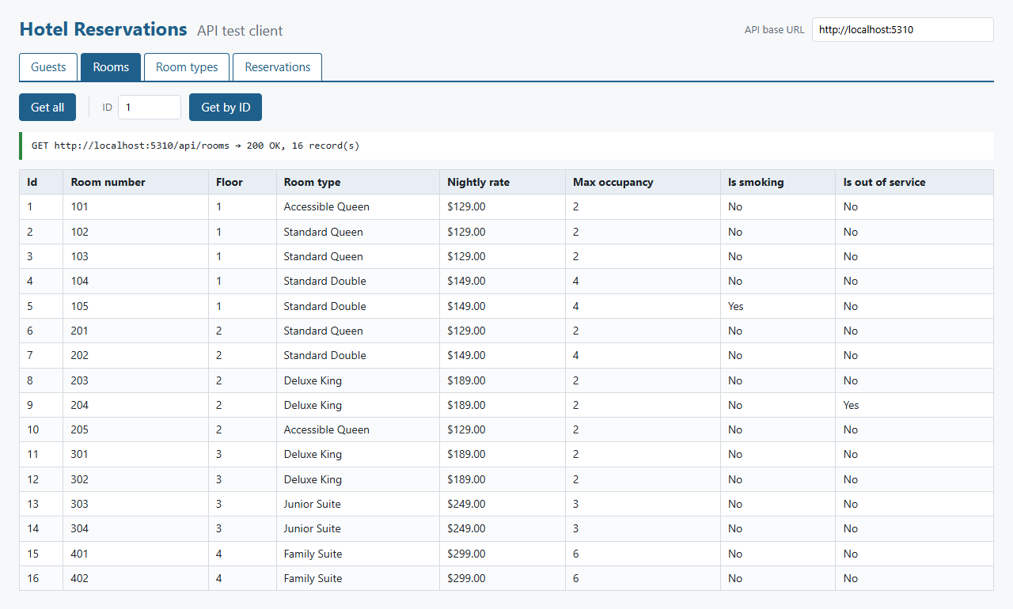
Rooms: Get all (GET /api/rooms, 16 records, with room type and rate from the business layer)
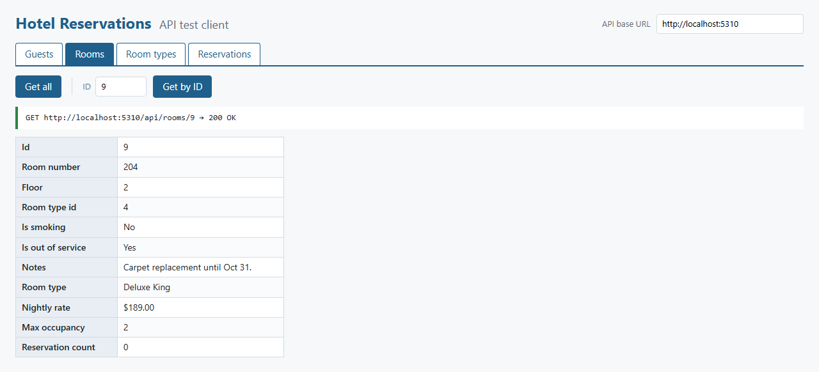
Rooms: Get by ID (GET /api/rooms/9)

Room types
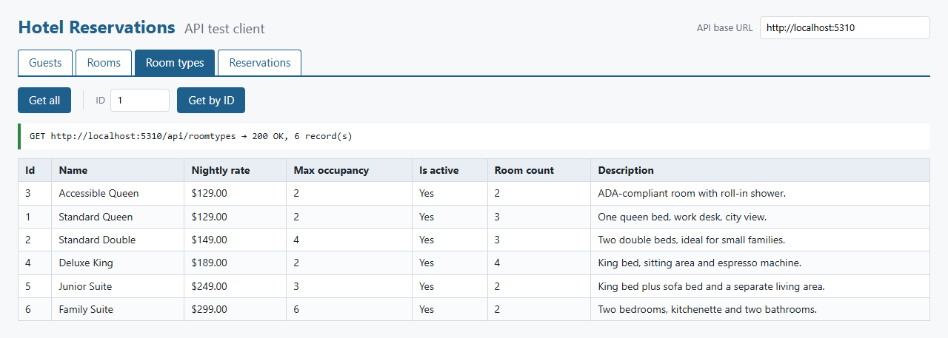
Room types: Get all (GET /api/roomtypes, 6 records)
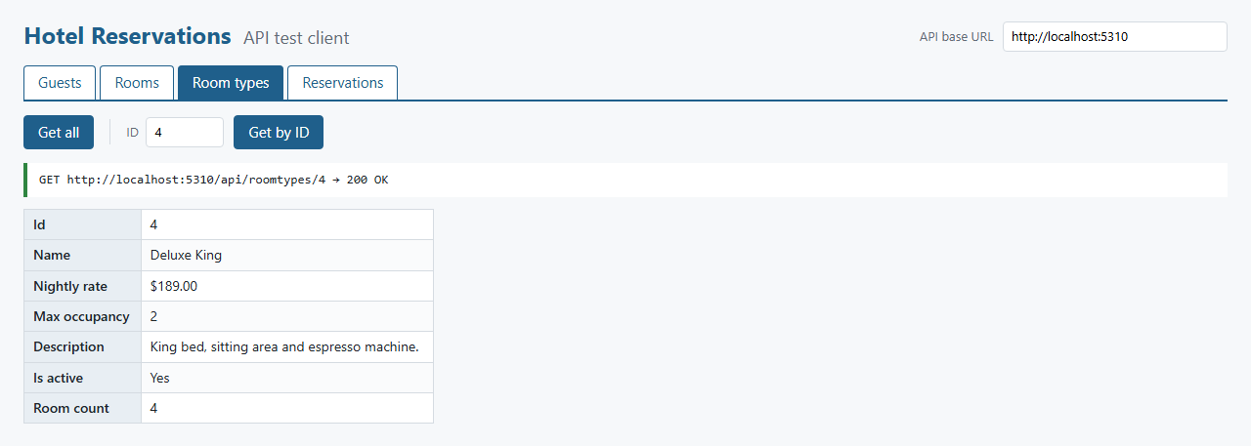
Room types: Get by ID (GET /api/roomtypes/4)

Reservations
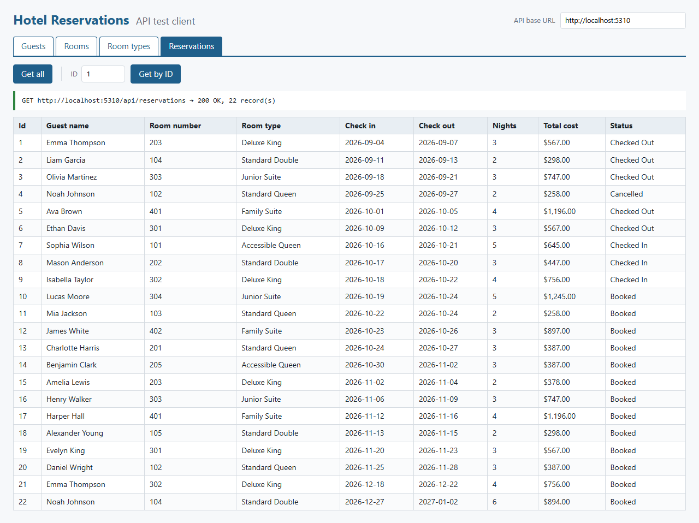
Reservations: Get all (GET /api/reservations, 22 records, with nights and total cost)
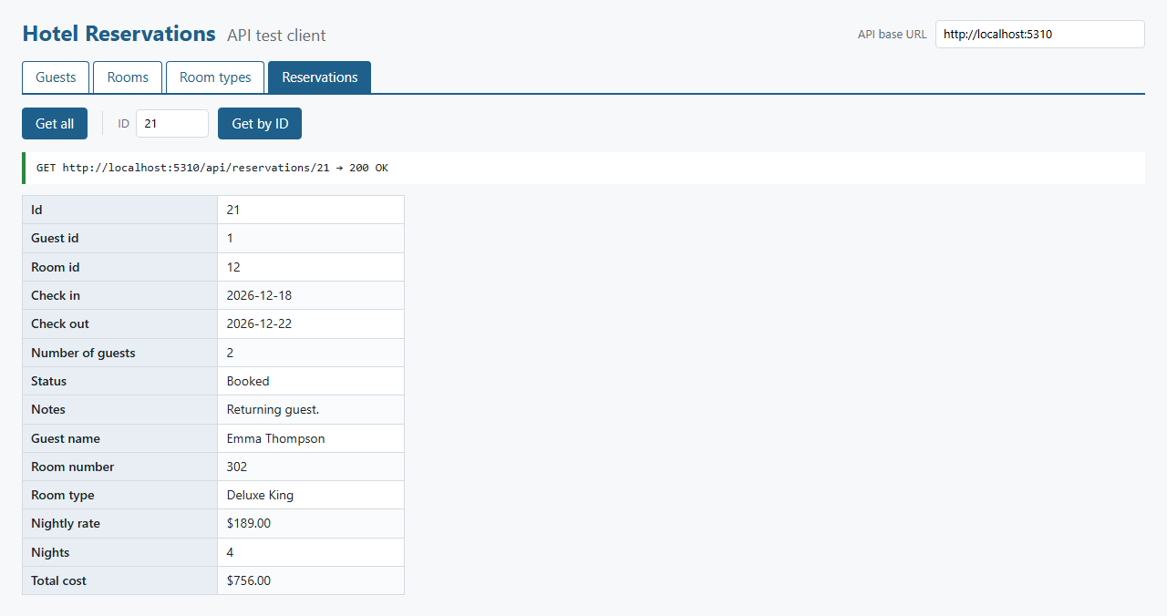
Reservations: Get by ID (GET /api/reservations/21)

Errors and CORS
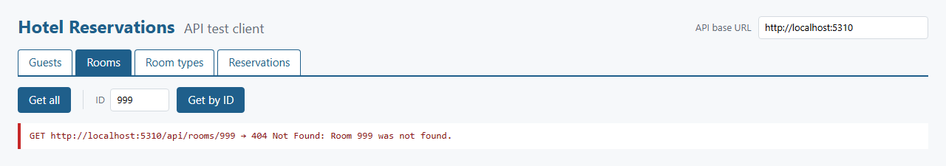
Get by ID for a record that doesn't exist: the API returns 404 with a readable message
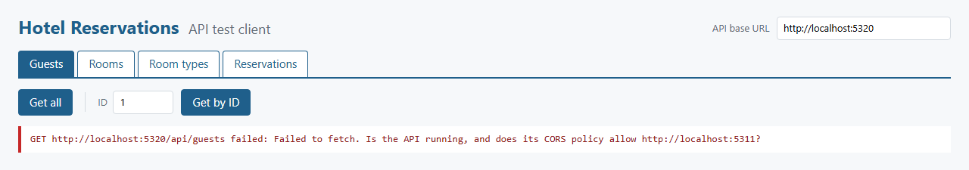
CORS: the same client pointed at an API instance whose allowed-origins list does not include http://localhost:5311. The browser blocks the response.

Questions

1. Describe a challenge you overcame in this project
CORS. The client is served from http://localhost:5311 and the API from http://localhost:5310. A different port makes it a different origin, so the browser will only hand the API's response to the page if the response includes an Access-Control-Allow-Origin header for the client's origin. What made it tricky is that the API itself works fine: curl and opening the URL directly in the browser both return the JSON, and the server log shows a 200. Only the page fails, and fetch() just rejects with "Failed to fetch", with no reason. The real error is only in the browser's developer console:
Access to fetch at 'http://localhost:5310/api/guests' from origin 'http://localhost:5311' has been blocked by CORS policy: No 'Access-Control-Allow-Origin' header is present on the requested resource.
The fix was a named CORS policy in Program.cs that reads the allowed origins from appsettings.json (Cors:AllowedOrigins) and allows GET, POST and DELETE with any header. Details that mattered:
- Exact origins. The origin is scheme + host + port with no trailing slash, and localhost and 127.0.0.1 are different origins, so both are listed.
- Middleware order. app.UseCors() has to run before MapControllers(), so it can answer the browser's OPTIONS preflight request for POST and DELETE with a JSON body.
- CORS on error responses too. UseCors runs after UseExceptionHandler, so 400 and 404 responses also carry the header. Without that, the browser treats a 404 as a CORS failure and the client can't show the "Room 999 was not found" message.
- Testing it. I checked the headers with curl (a preflight from http://localhost:5311 gets Access-Control-Allow-Origin back, a request from another origin doesn't), and screenshot 13 shows what the client looks like when its origin is not on the list.
The client also says this in its error message ("Is the API running, and does its CORS policy allow http://localhost:5311?"), because a plain "Failed to fetch" doesn't tell you where to look.

2. Describe a technique you learned in this project
Separating the layers with their own models and mapping between them. The data objects match the tables exactly (a Room only has RoomTypeId). The business layer combines them into records such as ReservationDetails (reservation + guest + room + room type, with Nights and TotalCost computed). The service layer has its own models shaped for the client (ReservationModel has GuestName, RoomNumber and TotalCost as flat fields) and a ModelMapper that converts both ways. That means the database can change without changing the JSON the client depends on, and the client never sees columns it shouldn't set.
I also learned to turn business errors into HTTP responses in one place. The business layer throws BusinessRuleException or NotFoundException, and an IExceptionHandler registered in Program.cs turns them into 400 or 404 ProblemDetails JSON. The controllers don't need try/catch, and every error response has the same shape. Combined with [ApiController] (automatic 400s from the data annotations on the service models) and CreatedAtAction (201 with a Location header for inserts), the controllers stay a few lines per method.

3. What more would you want to refine in your project, to make it ready to sell, ship, and deploy?
- Security: authentication (JWT bearer tokens or API keys) and role-based authorization, so only front-desk staff can change data and only managers can change room types and rates. HTTPS only.
- Performance: the business layer builds the combined records by loading whole tables and joining in memory, which is fine for 64 rows but not for a real hotel. I would move the joins and filters into SQL (or stored procedures) and add paging and sorting to the GET-all endpoints.
- Data safety: the double-booking check and the insert should run in one transaction (or be enforced by the database), and updates should use a rowversion column so two clerks can't overwrite each other.
- API documentation and versioning: OpenAPI/Swagger docs, a /v1/ route prefix so the API can change without breaking clients, and PUT/PATCH for partial updates.
- Deployment: the connection string in a key vault or environment variables instead of appsettings.json, the production client URL in the CORS origin list, health checks, structured logging, rate limiting, and hosting on Azure App Service or IIS.
- Testing: unit tests for the business rules and integration tests for every endpoint, run in CI (GitHub Actions) on every push.
- Client: a real front end that also uses the POST and DELETE endpoints (booking, check-in, cancellation) instead of only reading data.

