Minor Project 4: Hotel Reservations
Aidan Van Voorhis
Repository: https://github.com/adnvanv/547 (folder minorProj4)

Overview
Lakeside Hotel Reservations is an ASP.NET Core MVC web application (.NET 10) for running a small hotel's front desk. It uses a new SQL Server database, HotelReservationsDB, accessed through a separate ADO.NET data layer project (HotelReservations.Data). The app has:
- Guests: full create, read, update and delete. Guests can be searched by guest ID or by first name, last name, email or city, using "contains", "starts with" or "ends with" matching. The search runs as a parameterized SQL LIKE query. Each guest also has a details page listing their stays.
- Rooms: full create, read, update and delete. A room that has reservations cannot be deleted; it can be marked out of service instead.
- Reservations: full create, read, update and delete. The data layer refuses double bookings (two active reservations for the same room on overlapping dates) and parties larger than the room sleeps. Nights and the total cost are calculated from the dates and the room type's rate.
- Administration: room types (with their nightly rates) are the admin-only table. They can only be changed on the Administration page, which is locked until Administrator mode is turned on in Settings.
- Settings: theme (light, dark or match the system), accent color, language (English or Spanish), date format, show or hide cancelled reservations, delete confirmation, and administrator mode. Settings are saved in a browser cookie, since the assignment asks for no login.

Database
Scripts: HotelReservations/Scripts/01_HotelReservationsDB_DDL.sql (creates the database, tables, keys and constraints) and 02_HotelReservationsDB_DML.sql (sample data, 64 rows).
Table | Rows | Purpose
RoomTypes | 6 | Admin-only: name, nightly rate, max occupancy, active flag
Rooms | 16 | Room number, floor, room type (FK), smoking, out of service
Guests | 20 | Name, email (unique), phone, city, country; searchable
Reservations | 22 | Guest (FK), room (FK), check-in/out dates, guests, status

Solution structure
- HotelReservations.Data: class library with the model classes, a small SqlDatabase helper (opens a connection, runs parameterized SQL, maps rows and turns SQL Server errors into friendly messages), and one repository class per table (GuestRepository, RoomRepository, ReservationRepository, RoomTypeRepository). All SQL lives here.
- HotelReservations.Web: the MVC web app. Each table has a controller with Index (list), Edit (used for both insert and update) and Delete (confirmation) actions and matching views. Controllers only call the repositories; they never touch SQL directly.

How to run
- Run 01_HotelReservationsDB_DDL.sql and then 02_HotelReservationsDB_DML.sql against .\SQLEXPRESS (SSMS, or sqlcmd -S .\SQLEXPRESS -E -i <file>).
- From HotelReservations/Code, run: dotnet run --project HotelReservations.Web (or open HotelReservations.sln in Visual Studio). NuGet packages restore automatically. Then browse to http://localhost:5299.
- If your SQL Server instance has a different name, change ConnectionStrings:HotelReservationsDB in HotelReservations.Web/appsettings.json.

Screenshots
A selection of screenshots is shown below. The full set of 43, covering every table, the error handling and the Spanish/dark settings, is in the repository under minorProj4/Documentation/screenshots.

Search
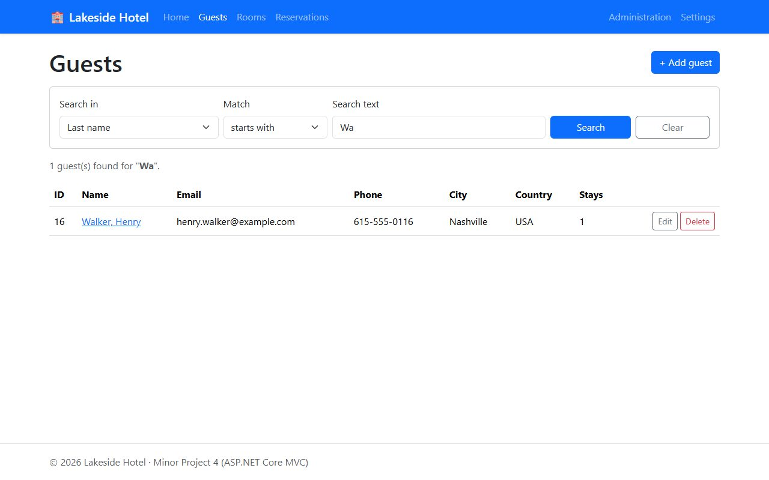
Search guests: last name starts with "Wa"
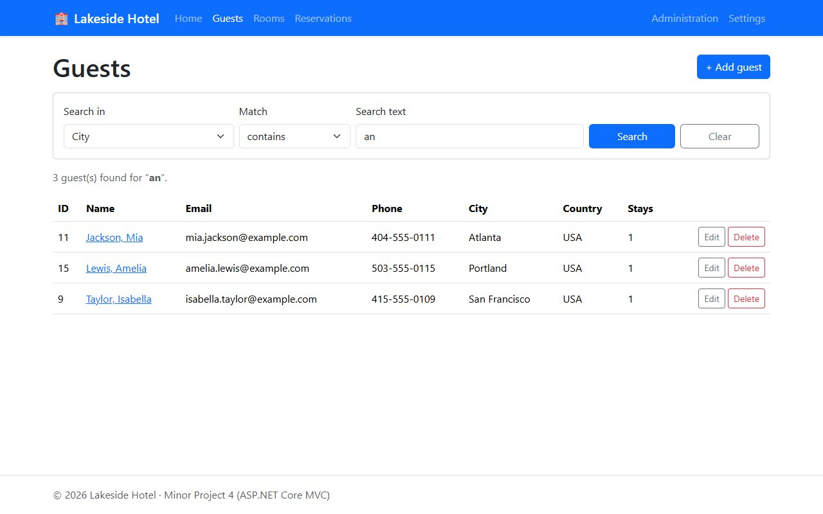
Search guests: city contains "an"
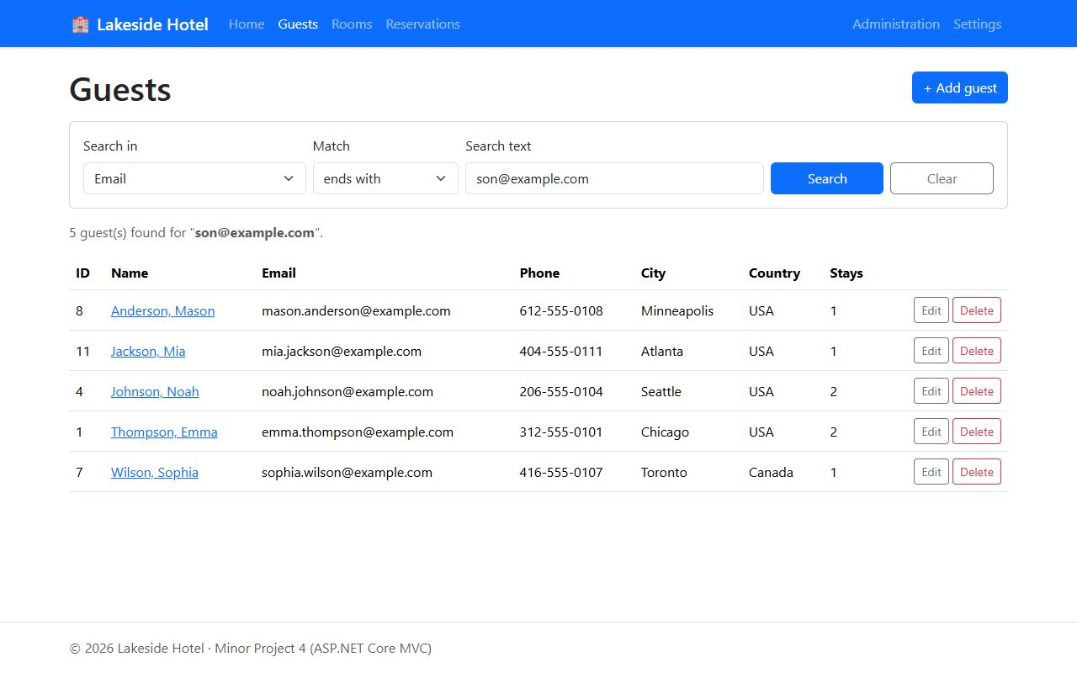
Search guests: email ends with "son@example.com"
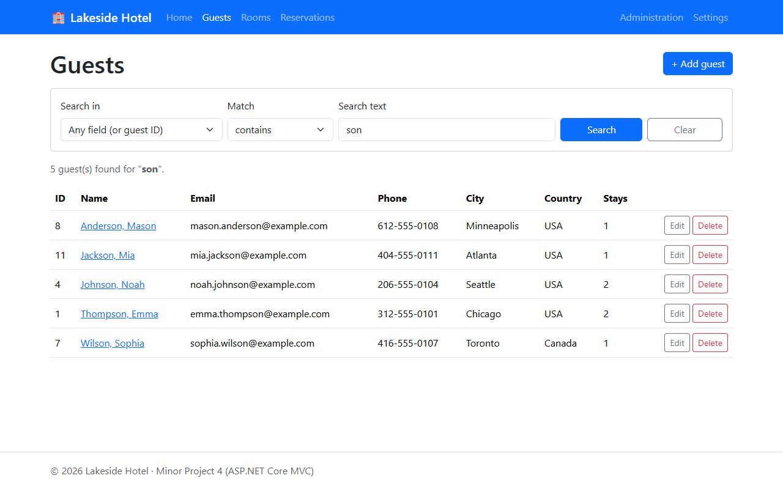
Search guests: any field contains "son" (searches first name, last name, email and city)

Insert
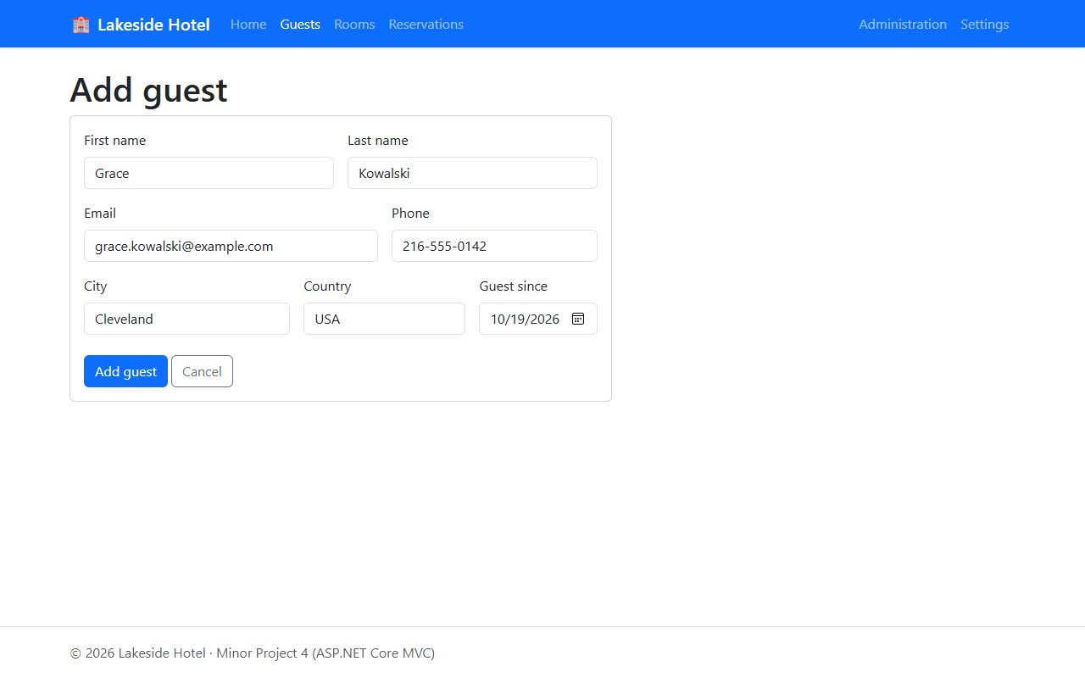
Insert: new guest form
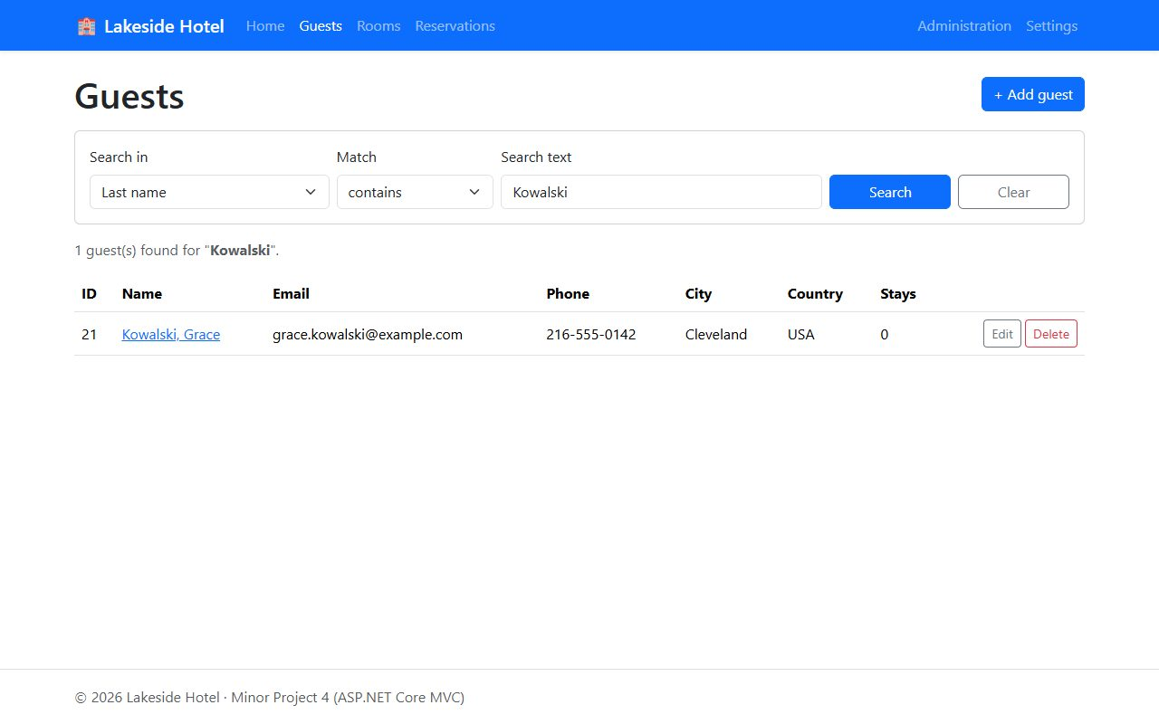
Insert: the new guest saved and found by searching last name
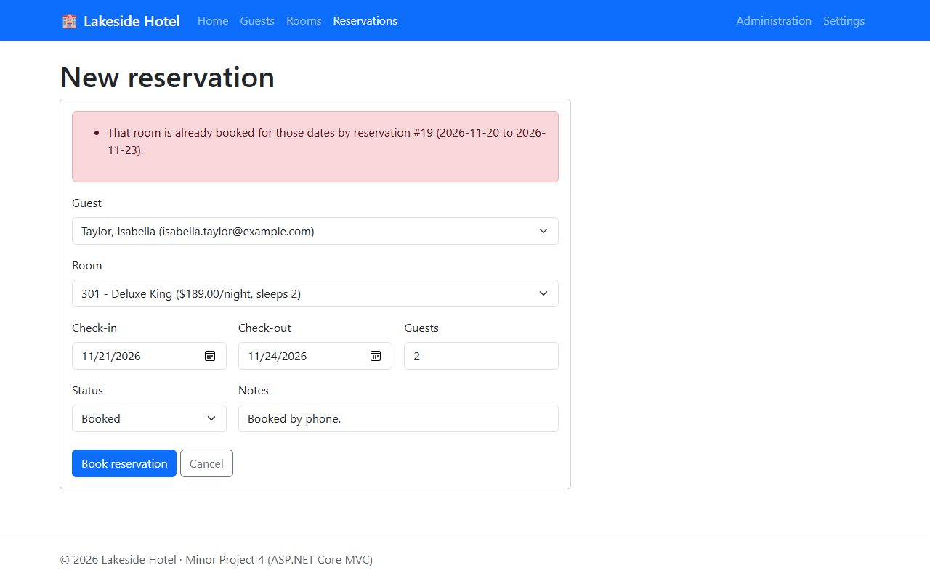
Insert: a reservation that overlaps an existing booking for the same room is refused
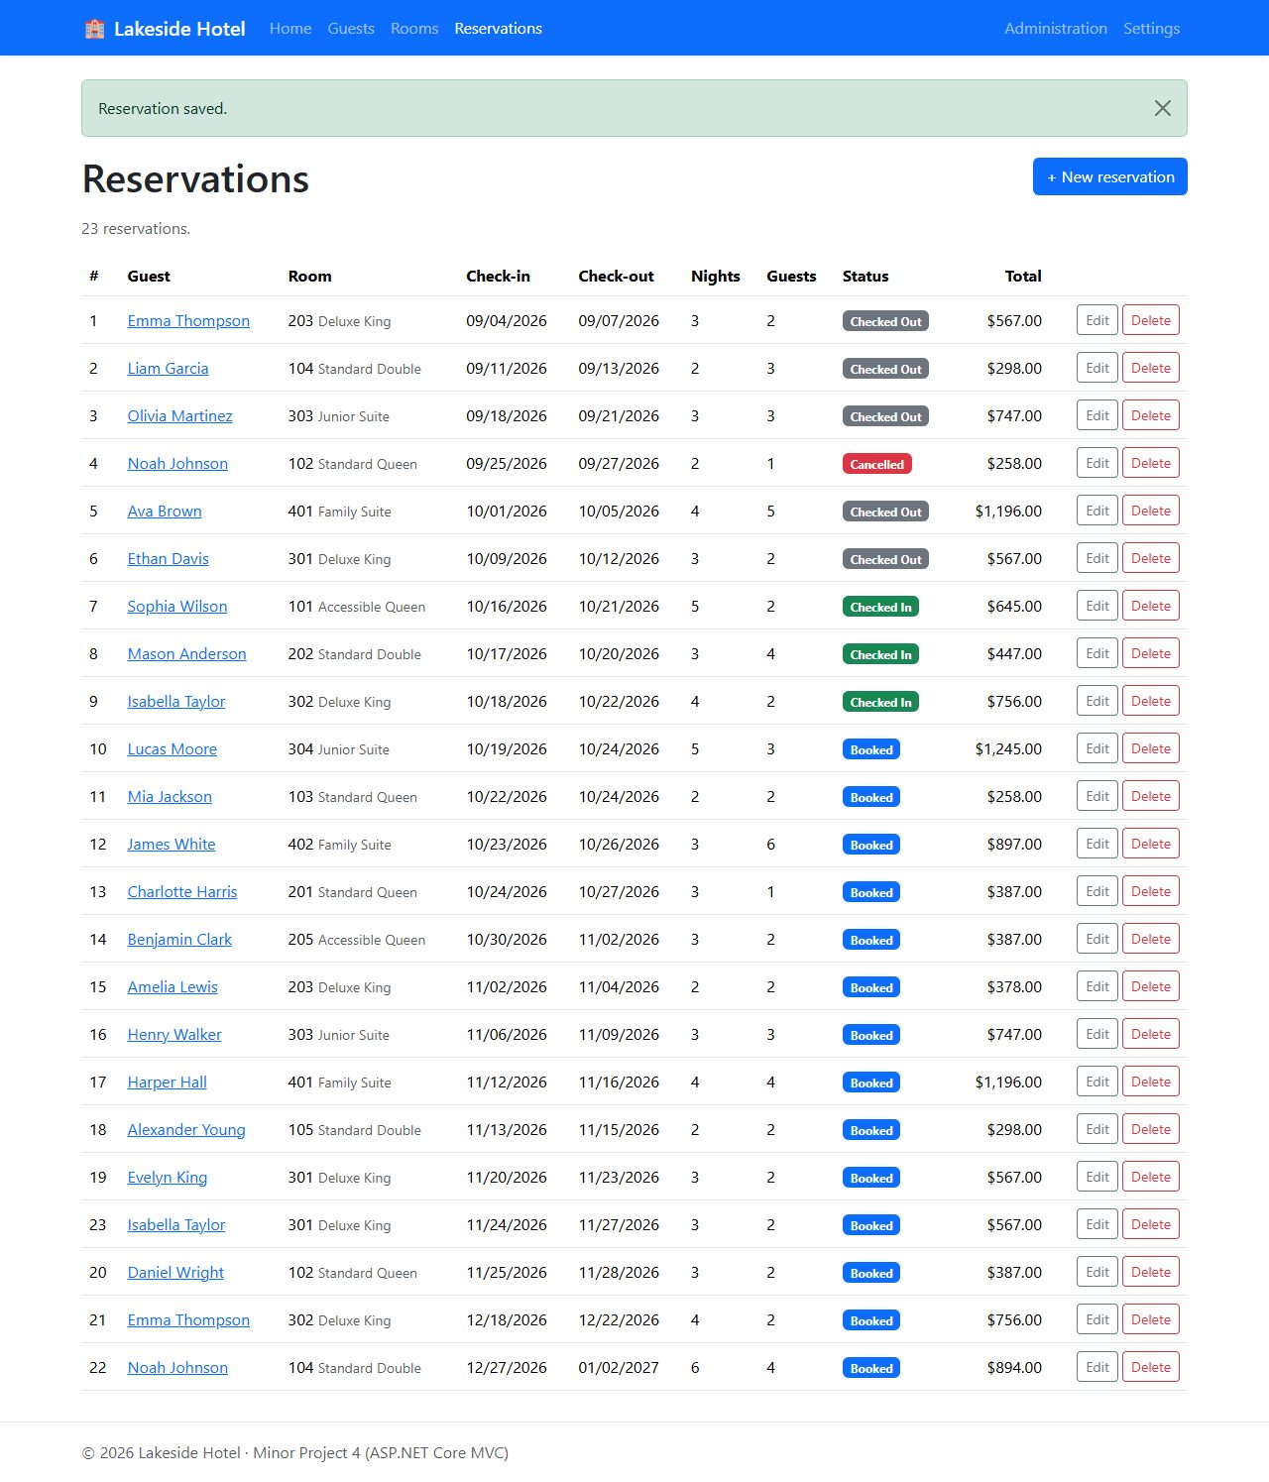
Insert: the reservation saved after moving it to free dates (#23)

Update
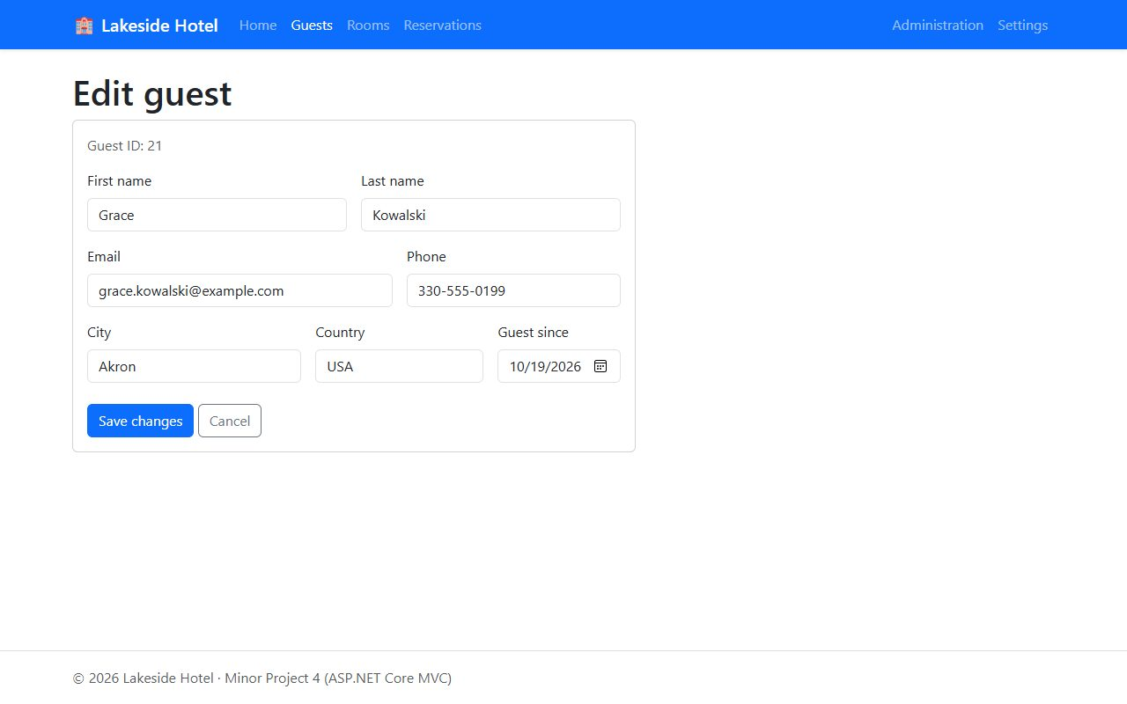
Update: editing the guest (new city and phone number)
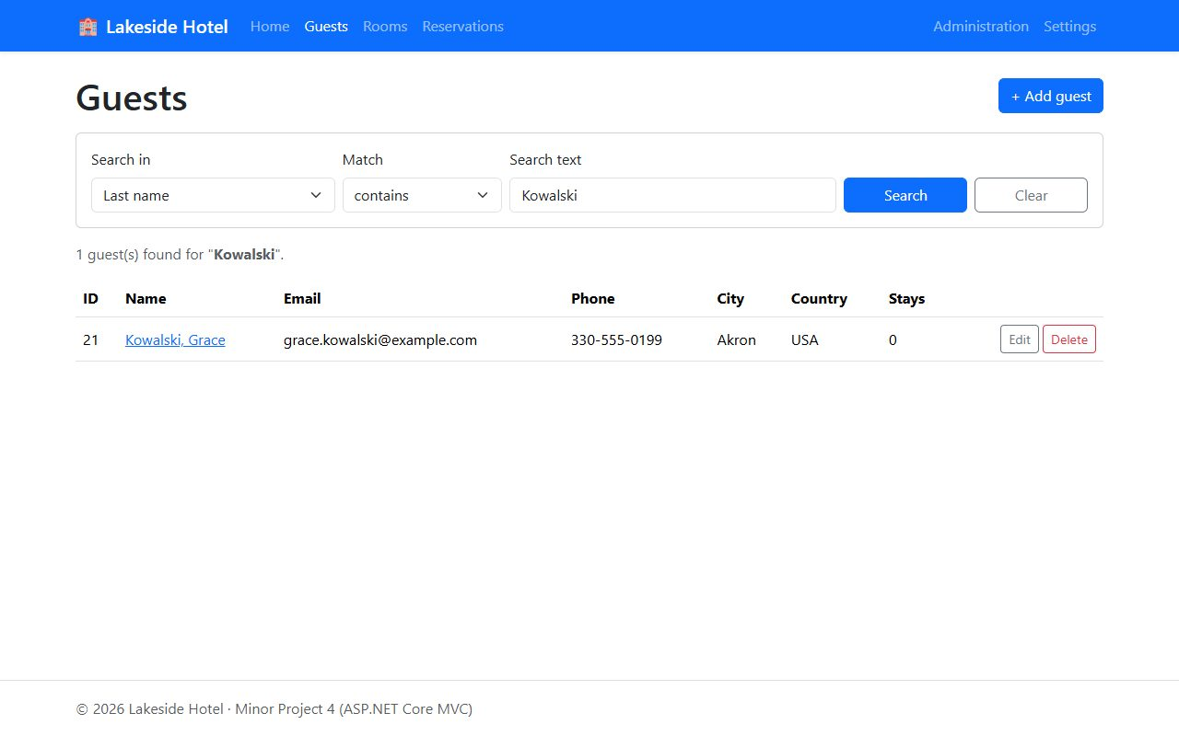
Update: guest saved with the new city and phone number
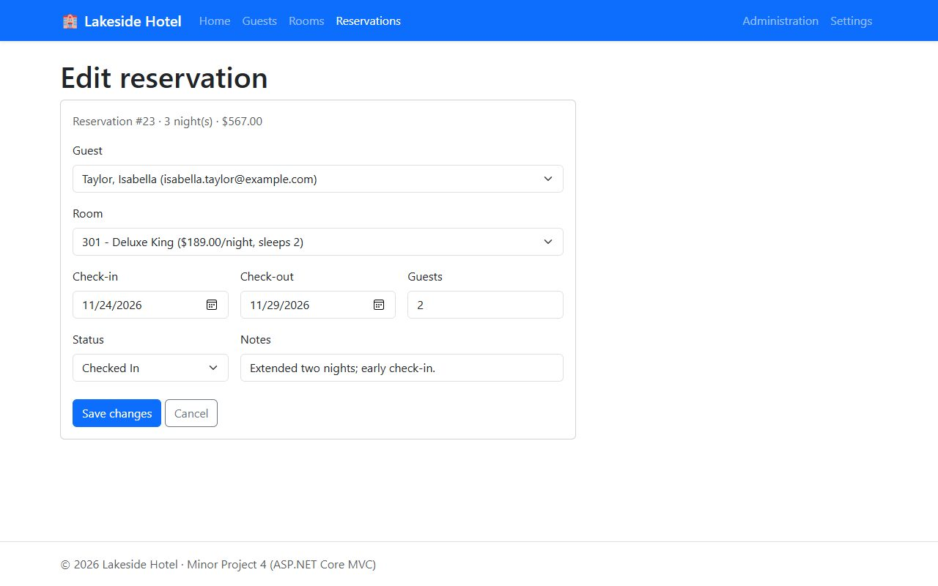
Update: extending the reservation by two nights and checking the guest in
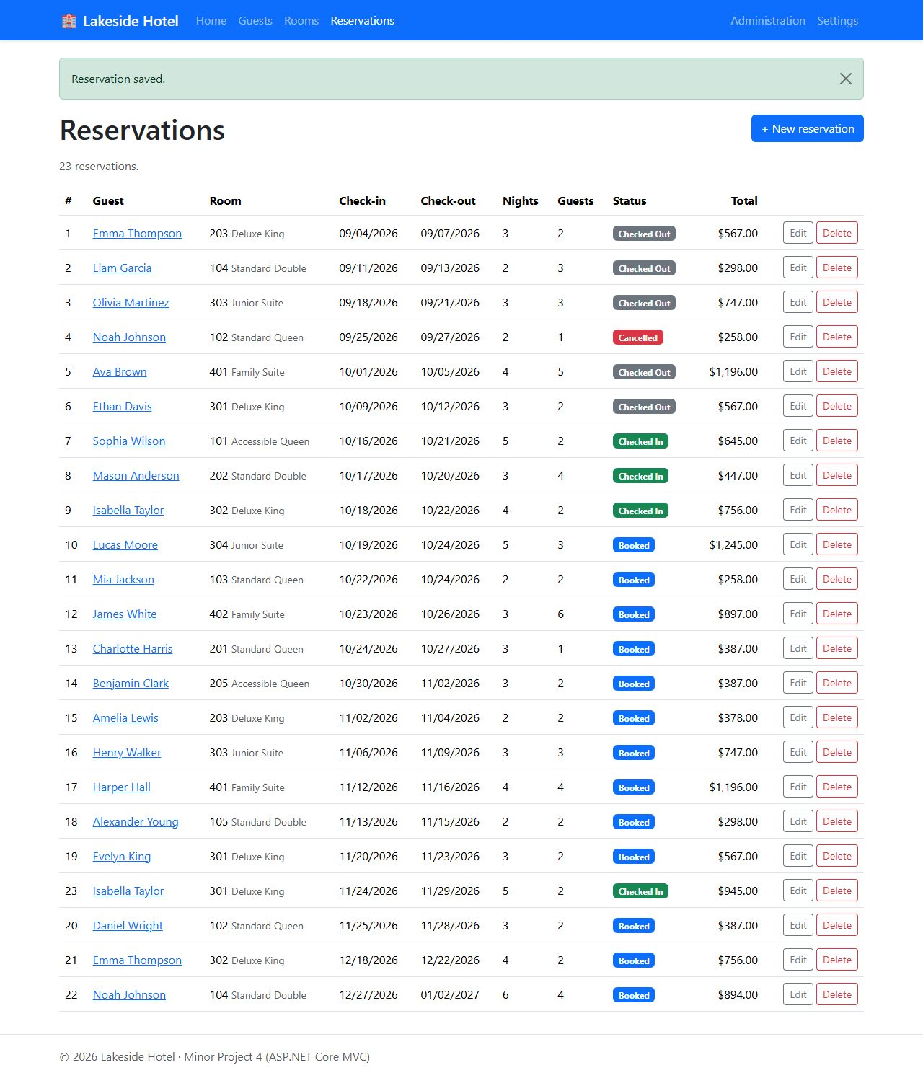
Update: reservation #23 saved; nights and total recalculated

Delete
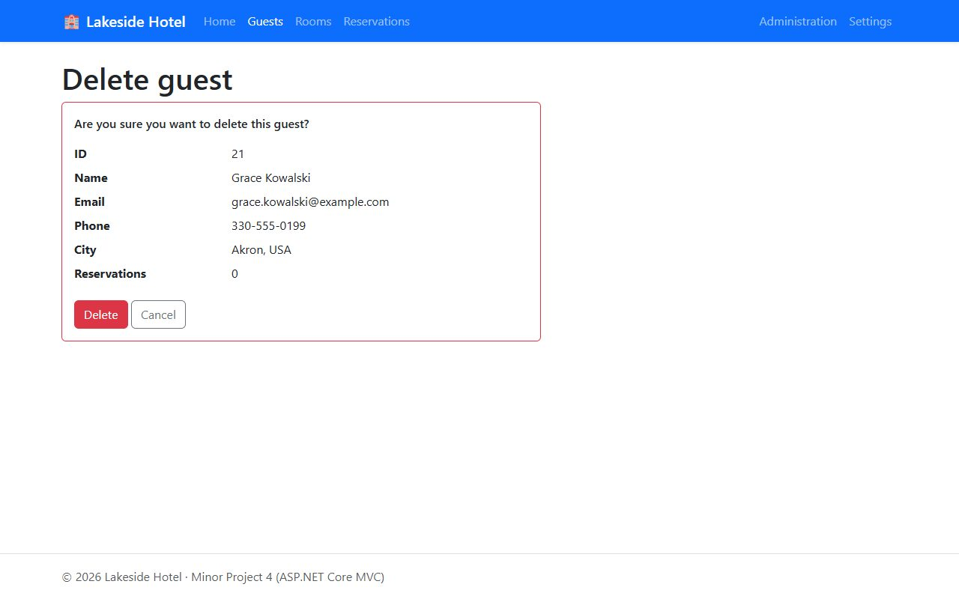
Delete: guest confirmation page
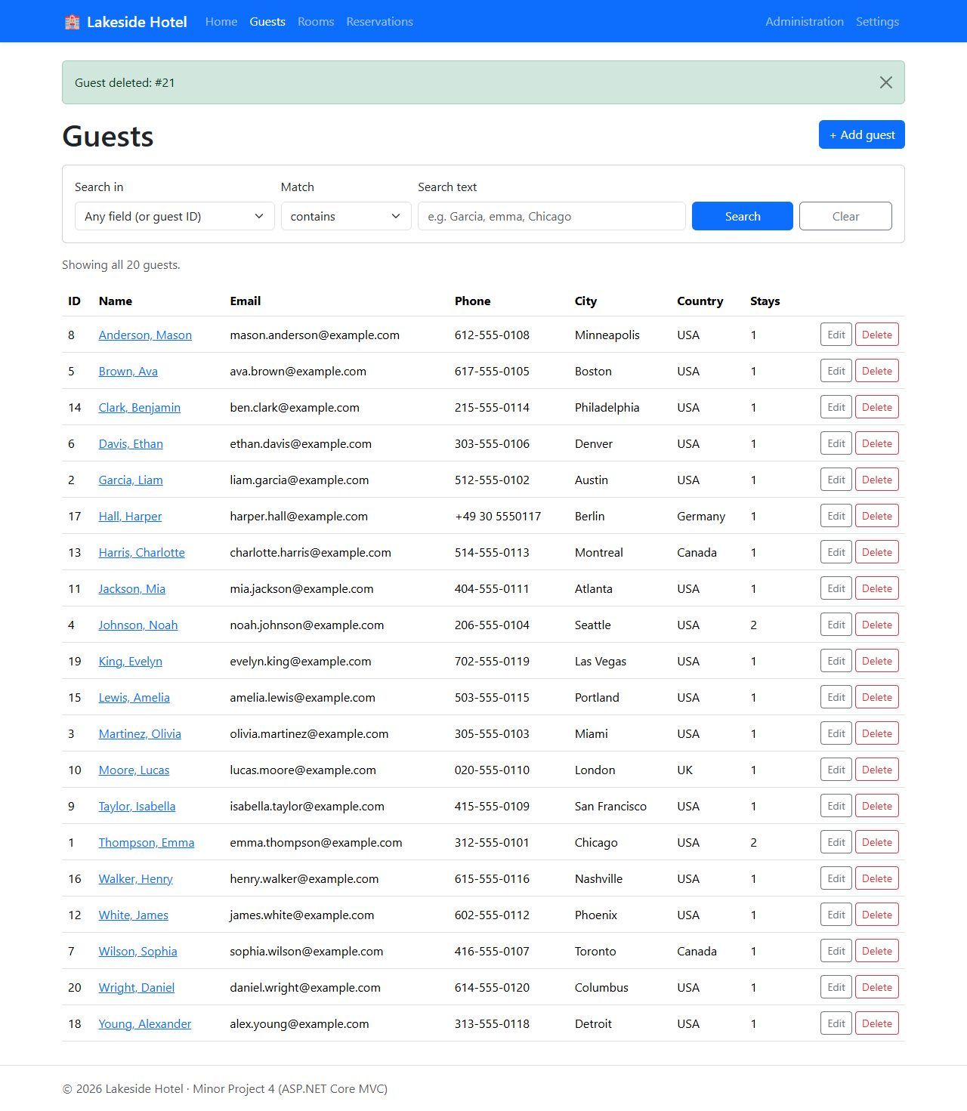
Delete: guest deleted
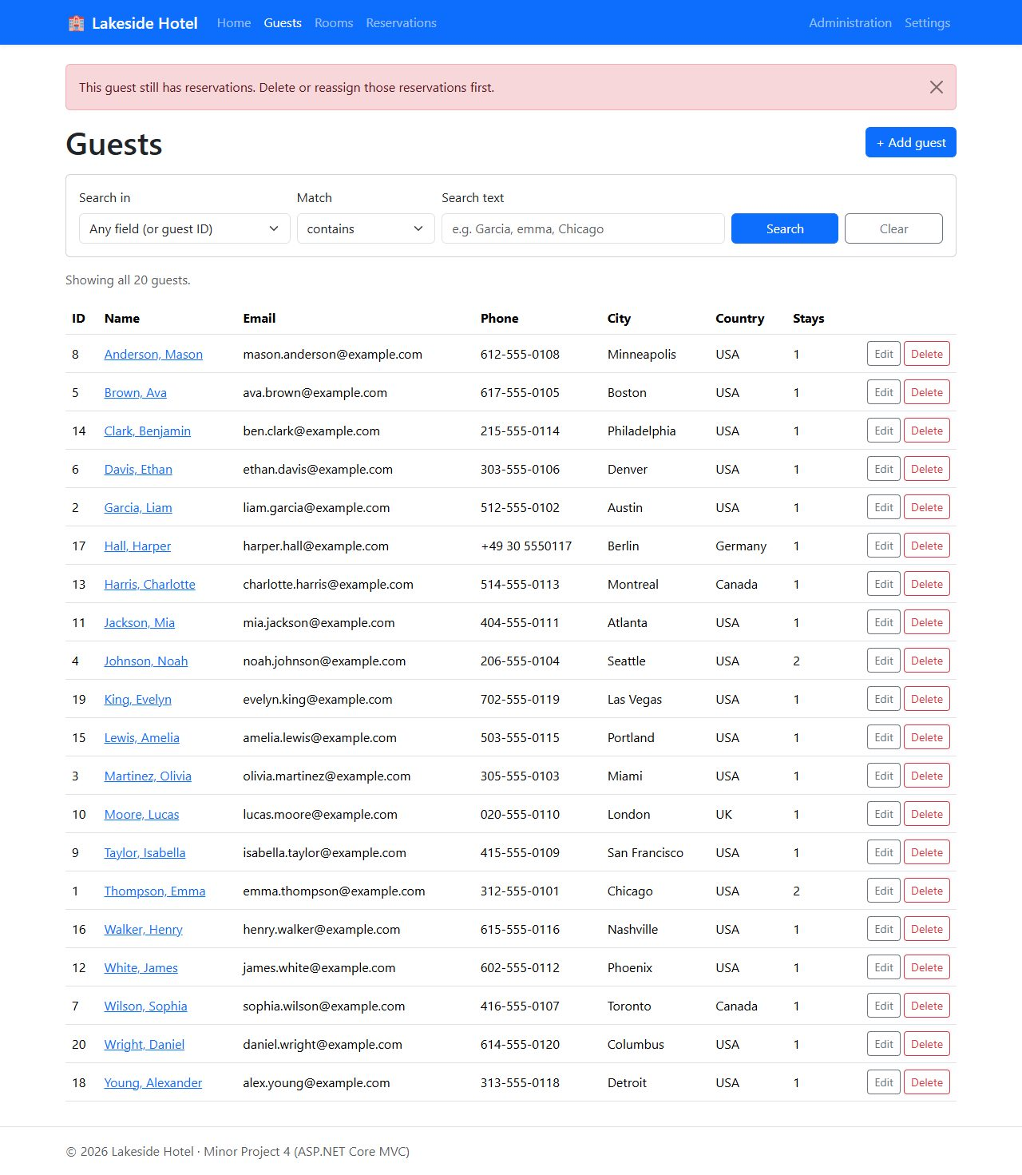
Delete: a guest who still has reservations cannot be deleted, so the app shows a friendly message
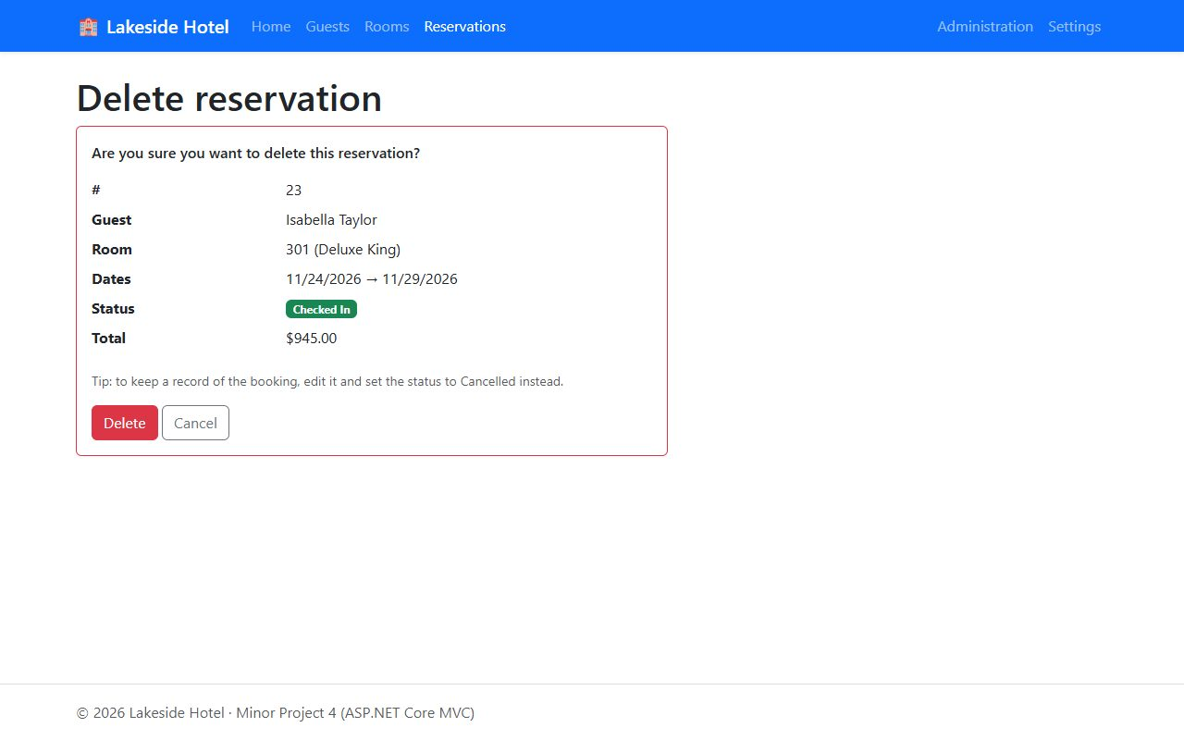
Delete: reservation confirmation page

Settings and Administration
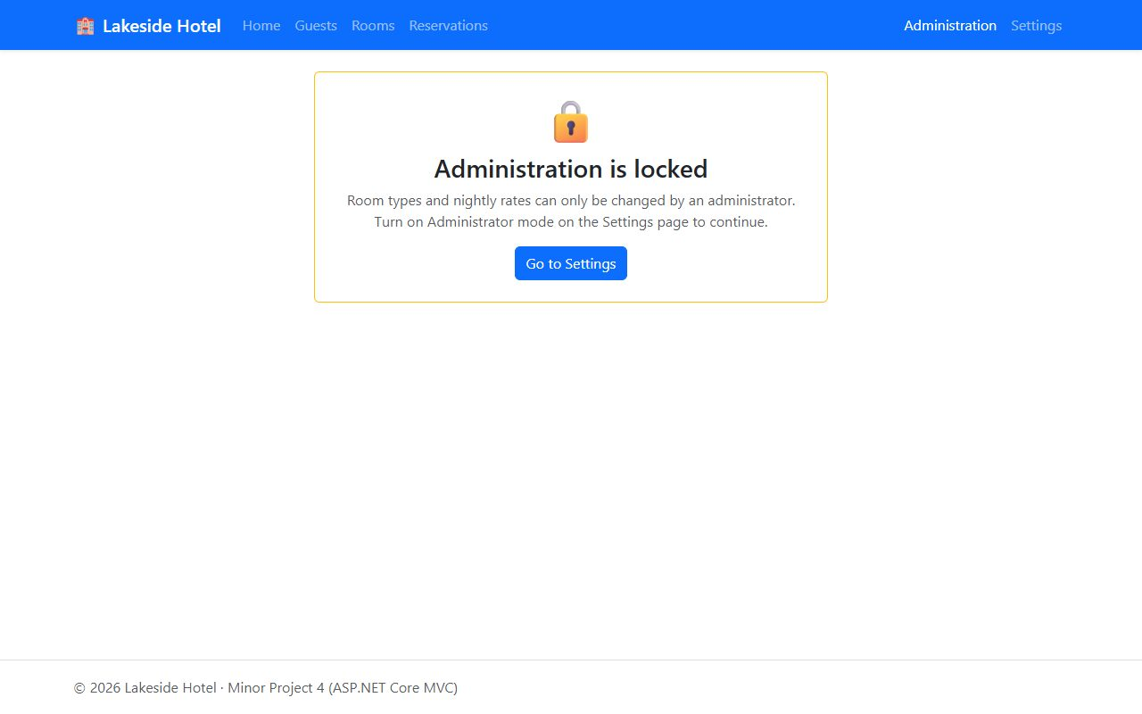
Administration is locked until administrator mode is turned on
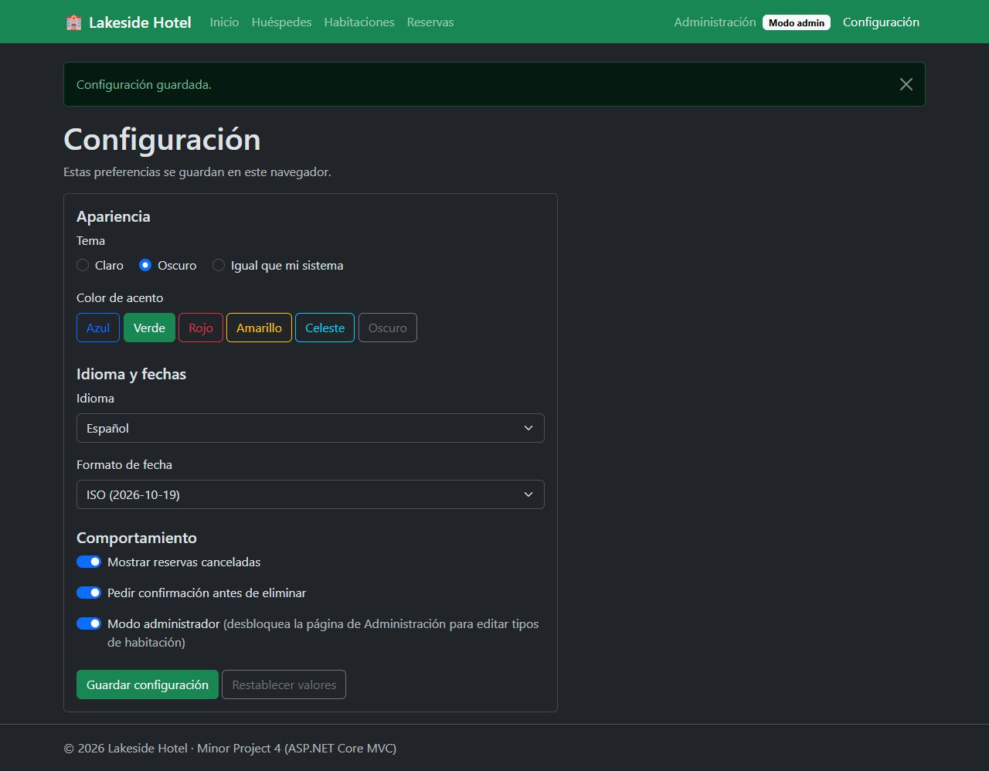
Settings: dark theme, green accent, Spanish, ISO dates and administrator mode
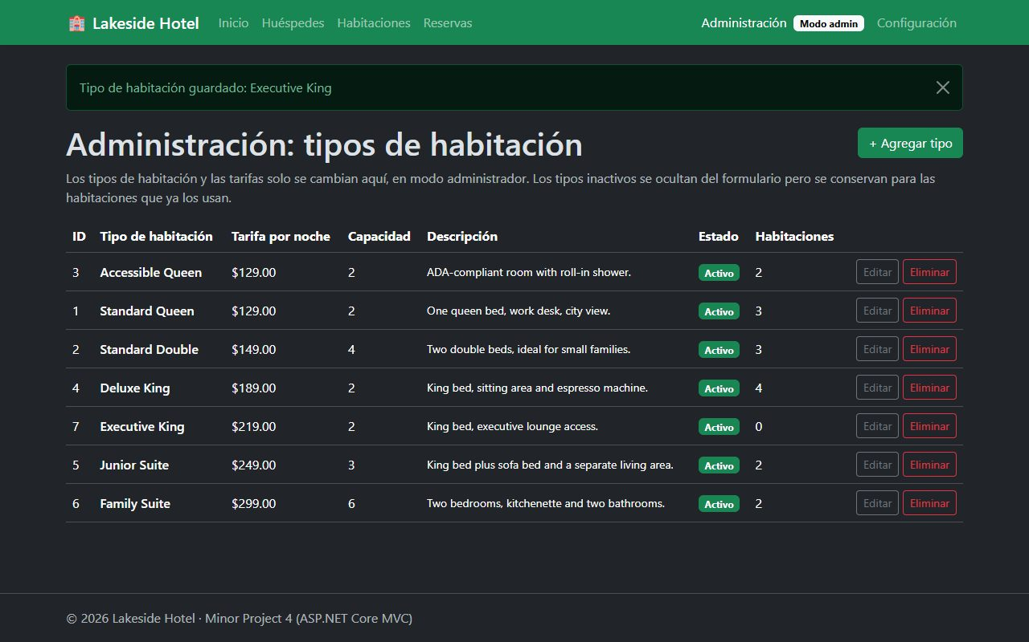
Administration (admin-only table): a new room type added
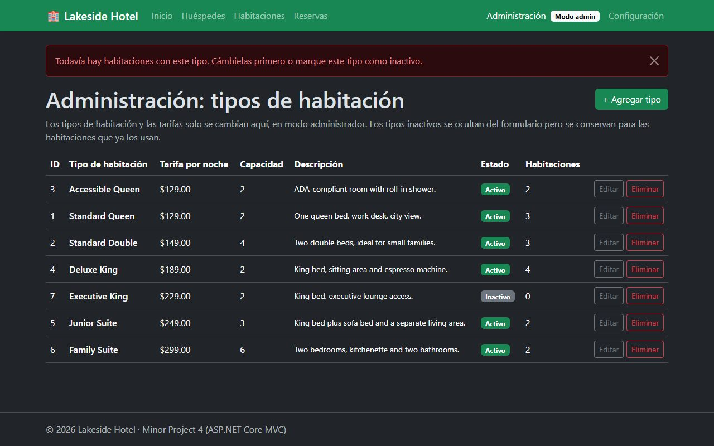
Administration: a room type that rooms still use cannot be deleted

Questions

1. Describe a challenge you overcame in this project
The biggest challenge was stopping double bookings. A foreign key or CHECK constraint can make sure a reservation points at a real room and that check-out is after check-in, but it cannot say "this room is already taken on those nights." I had to write that rule myself in ReservationRepository. Before saving, it runs a query for any other reservation on the same room that is not cancelled and whose dates overlap. Two date ranges overlap when the existing check-in is before the new check-out and the new check-in is before the existing check-out. Getting that condition right took some testing: back-to-back stays (one guest checks out on the 24th and the next checks in on the 24th) must be allowed, an edited reservation must not conflict with itself, and cancelled reservations must not block anything. If there is a conflict, the repository throws a DataLayerException that names the conflicting reservation, and the controller shows it on the form so the user can pick other dates without losing what they typed.

2. Describe a technique you learned in this project
In Project 3 I used Entity Framework, so this time I wrote the data layer with plain ADO.NET (Microsoft.Data.SqlClient) to learn what EF does for you. I learned to write parameterized queries with SqlCommand and SqlParameter, map rows from a SqlDataReader into objects, and use OUTPUT INSERTED.Id to get the new identity value back from an INSERT. For searching I used SQL LIKE with a parameter: the search text is never put into the SQL string. Instead it goes into @Pattern with % added at the front, back or both for "ends with", "starts with" or "contains". I also learned that the user's own % and _ characters have to be escaped (with ESCAPE '\') or they act as wildcards. Only column names from a fixed list are put into the SQL text, so the search is safe from SQL injection. I also learned to read SQL Server error numbers (547 for a foreign key or check violation, 2627/2601 for a duplicate key) so the app can show a clear message instead of crashing.

3. What more would you want to refine to make it ready to sell, ship, and deploy?
- Real security: replace the "administrator mode" switch with real login (ASP.NET Core Identity) and role-based authorization, so only managers can change room types and rates.
- Availability search: let staff pick dates and party size and see only the rooms that are free, instead of finding out about a conflict after submitting the form. Add a calendar view of room occupancy.
- Data safety: wrap the double-booking check and the insert in one transaction (or a database constraint/trigger) so two clerks booking the same room at the same moment cannot both succeed, and add a rowversion column so two people editing the same record cannot overwrite each other.
- Features: payments and invoices, taxes and seasonal rates, paging and sorting on the lists, and email confirmations to guests.
- Full translation: move the Spanish text into .resx resource files with ASP.NET Core localization, and translate validation and data-layer messages too.
- Testing and deployment: unit and integration tests run in CI (for example GitHub Actions), the connection string in user secrets or a key vault, logging and health checks, and hosting on Azure App Service with Azure SQL.

4. Which technology did you choose (Razor, MVC, Blazor, or Blazor SPA) and why?
I chose ASP.NET Core MVC. I used Razor Pages for Project 3, so the assignment called for one of the other options, and MVC let me compare the two directly on a similar kind of app. MVC splits the work into controllers (handle requests and call the data layer), models (the Guest, Room, Reservation and RoomType classes) and views (the .cshtml markup). One controller per table keeps all of that table's actions (Index, Edit, Delete) together, and shared behavior like turning a database error into a message is written once in a base controller class. Features like action filters also made the admin lock simple: one [AdminOnly] attribute on the AdminController protects every action in it. Compared to Razor Pages it needs a bit more wiring (routing by controller and action, passing dropdown lists through ViewBag), but the separation is clearer, and it is the pattern used in many existing business applications. I chose it over Blazor because this app is mostly forms and lists that work well as normal server-rendered pages and do not need a live connection or WebAssembly.

