Minor Project 6: Azure Functions
Aidan Van Voorhis
Repository: https://github.com/adnvanv/547 (folder minorProj6)

Overview
This project starts from the Project 5 Hotel Reservations Web API and adds an Azure Functions app with two HTTP functions. The business layer calls each function with an HttpClient, the service layer exposes each one as a new endpoint, and the client calls those endpoints. The client never calls Azure directly.
Request path: client (browser) > service layer (Web API) > business layer (AzureFunctionsClient) > Azure Functions.

What changed from Project 5
Layer | Project | Change
Azure Functions (new) | HotelReservations.Functions | .NET 10 isolated worker app with the StayQuote and Loyalty HTTP functions. Published to Azure.
Business | HotelReservations.Business | AzureFunctionsClient builds the HTTP requests. One new method per function: ReservationManager.GetQuoteAsync and GuestManager.GetLoyaltyAsync.
Service | HotelReservations.Api | GET api/reservations/{id}/quote and GET api/guests/{id}/loyalty pass through to the business layer. AzureFunctions:BaseUrl in appsettings.json holds the function app's address.
Client | HotelReservations.Client | Price quote (Azure) button on Reservations and Loyalty status (Azure) button on Guests, both calling the new service endpoints.

Azure functions
Neither function uses storage. The business layer reads what it needs from HotelReservationsDB and sends it in the request.
Function | Route | What it does
StayQuote | POST /api/quote | Prices a stay night by night. Fridays and Saturdays are 15% higher, each guest past two adds $20 per night, stays of 7 or more nights get 10% off, and 12% occupancy tax is added.
Loyalty | POST /api/loyalty | Awards 1 point per dollar spent, 50 per night and 100 per stay, then returns the tier: Member, Silver (1,000 points, 5% off), Gold (3,000, 10%) or Platinum (7,500, 15%).

Azure resources
Everything is in an Azure for Students subscription, activated with my school email and no credit card or other payment method.
Resource | Name | Configuration
Resource group | rg-hotelreservations | North Central US
Function app | func-hotelres-9858 | Flex Consumption plan, which has a monthly free grant. .NET 10 isolated, Linux, 2048 MB instances, 40 instance maximum.
App Service plan | ASP-rghotelreservations-1154 | FC1 (Flex Consumption), created with the function app
Storage account | sthotelres9858 | Standard LRS, required by every function app
Application Insights | func-hotelres-9858 | Logging and request metrics, created with the function app

The subscription page in the portal (screenshot 2) reports a current cost of $0.00, a forecast of $0.00, and no free service over its limit.

How to run
- Run 01_HotelReservationsDB_DDL.sql and then 02_HotelReservationsDB_DML.sql against .\SQLEXPRESS (skip this if HotelReservationsDB already exists).
- From HotelReservations/Code: dotnet run --project HotelReservations.Api (http://localhost:5310).
- In a second terminal: dotnet run --project HotelReservations.Client (http://localhost:5311), or open HotelReservations.sln in Visual Studio and start both projects.
- Open the client. On Reservations or Guests, enter an ID and click the Azure button. The API calls the functions already published at https://func-hotelres-9858.azurewebsites.net.

Screenshots

Azure portal
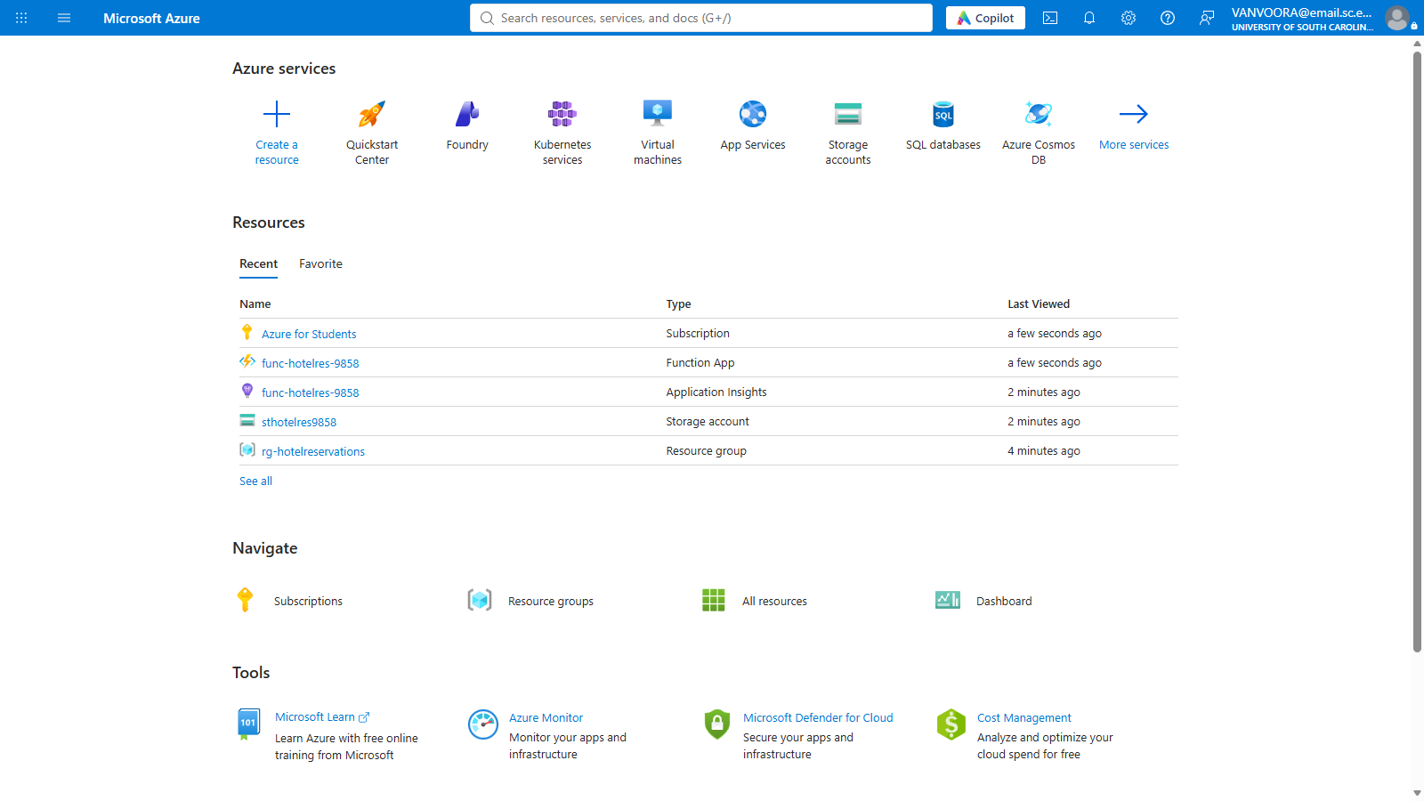
1. Azure portal signed in with the school account, showing the project's resources
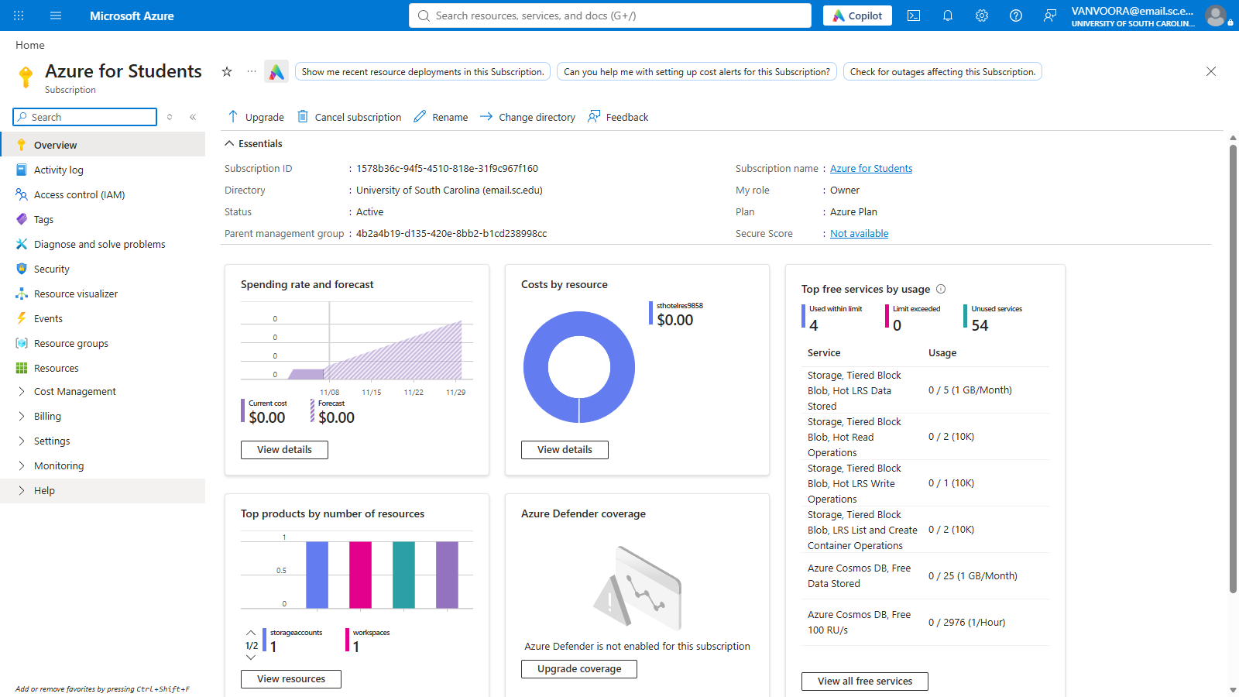
2. Azure for Students subscription: $0.00 current cost and forecast, no free service limits exceeded
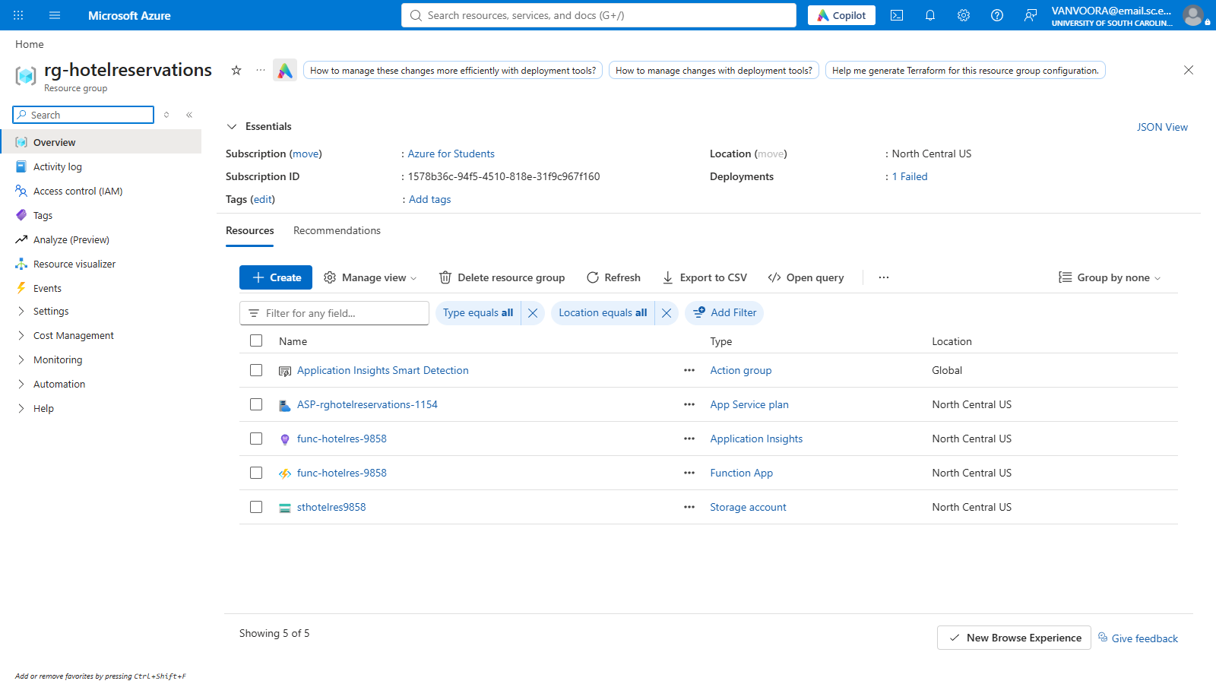
3. Resource group with all project resources. The one failed deployment is explained under Question ii.
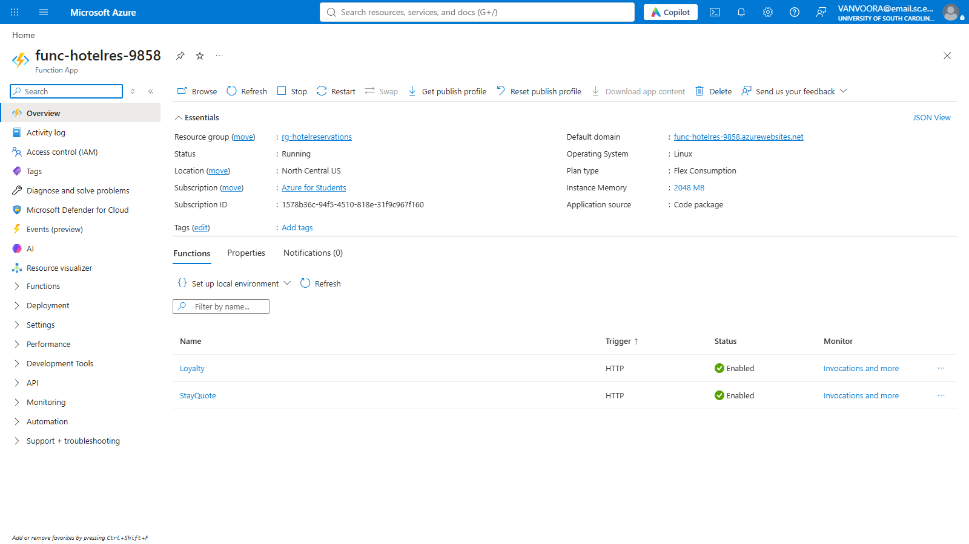
4. Function app overview: running, Flex Consumption plan, both functions enabled
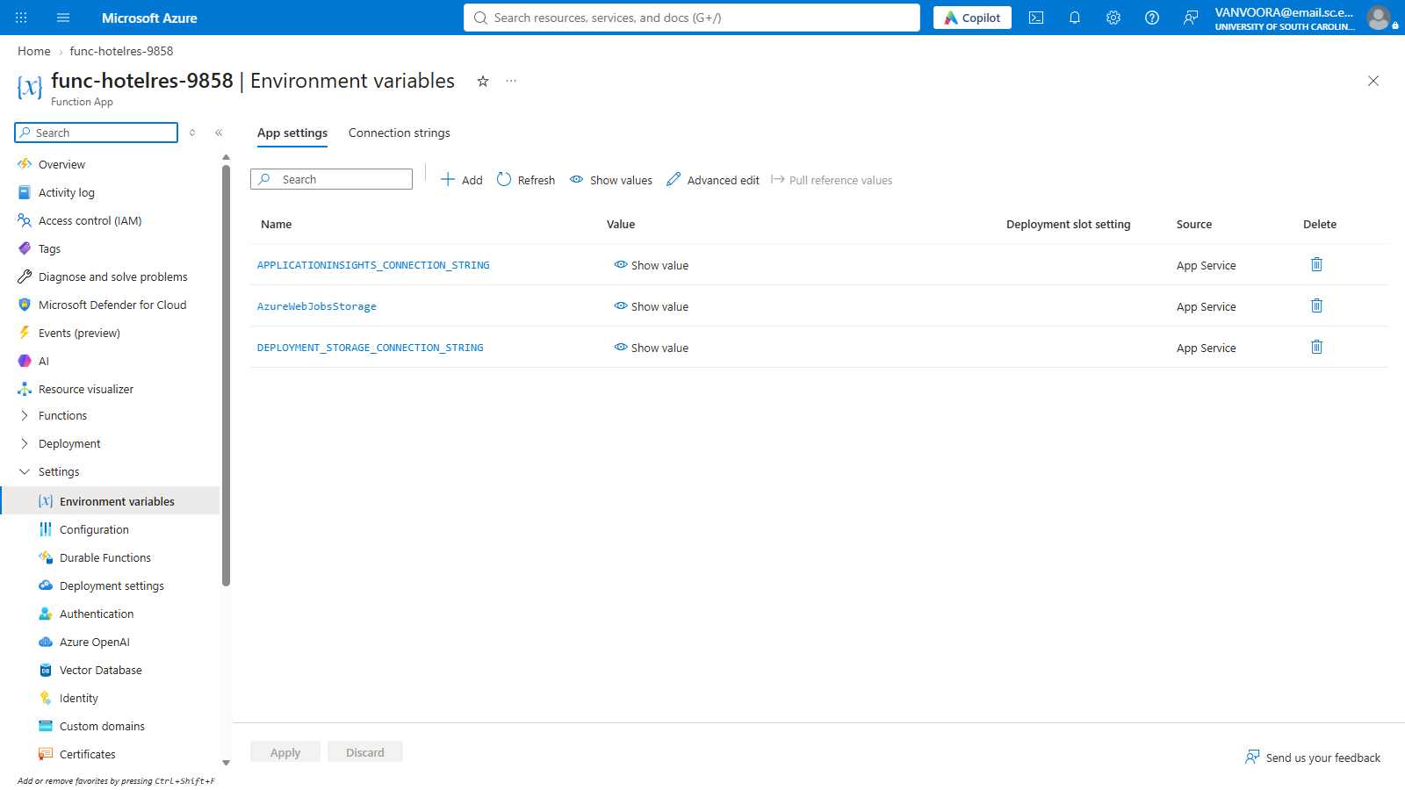
5. Function app configuration: environment variables (values hidden)
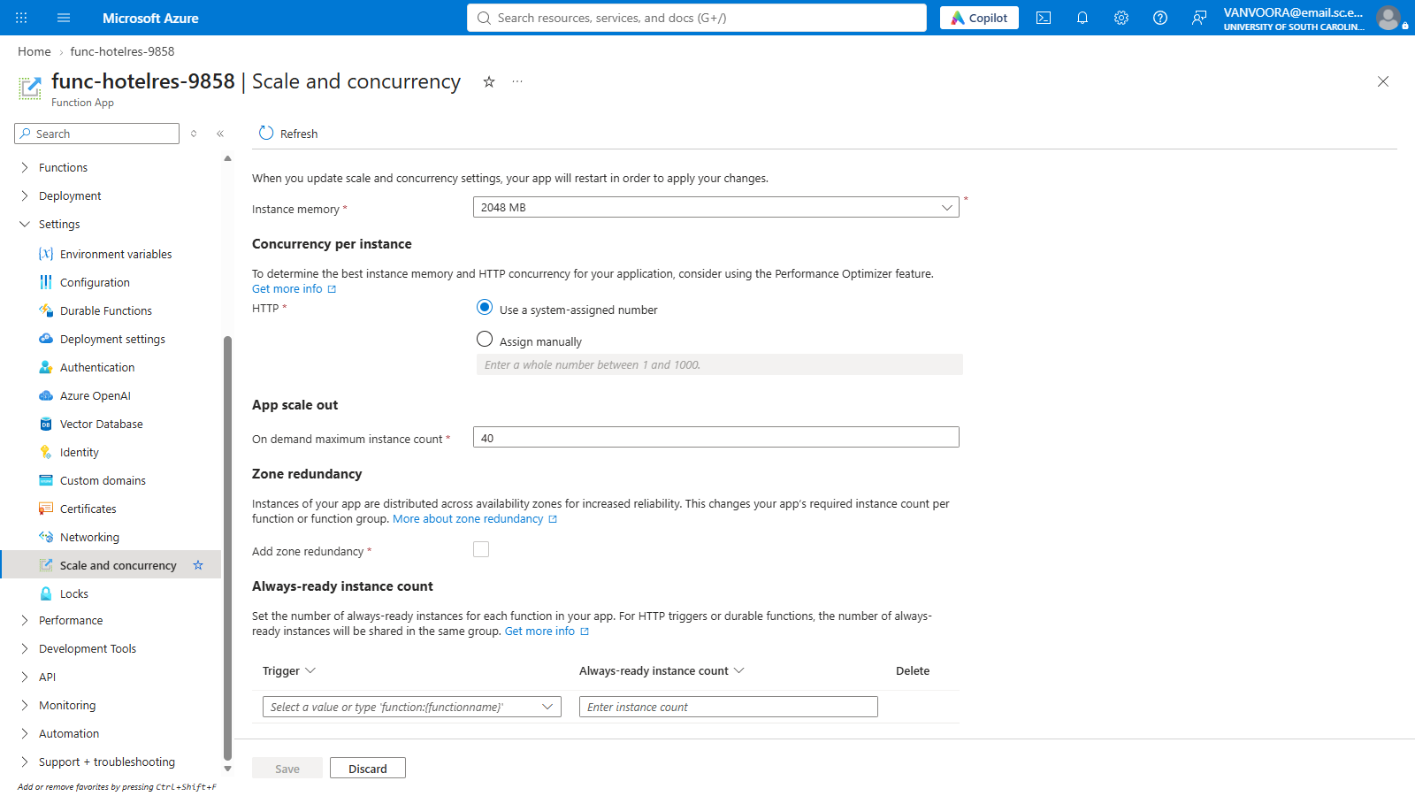
6. Function app configuration: scale and concurrency
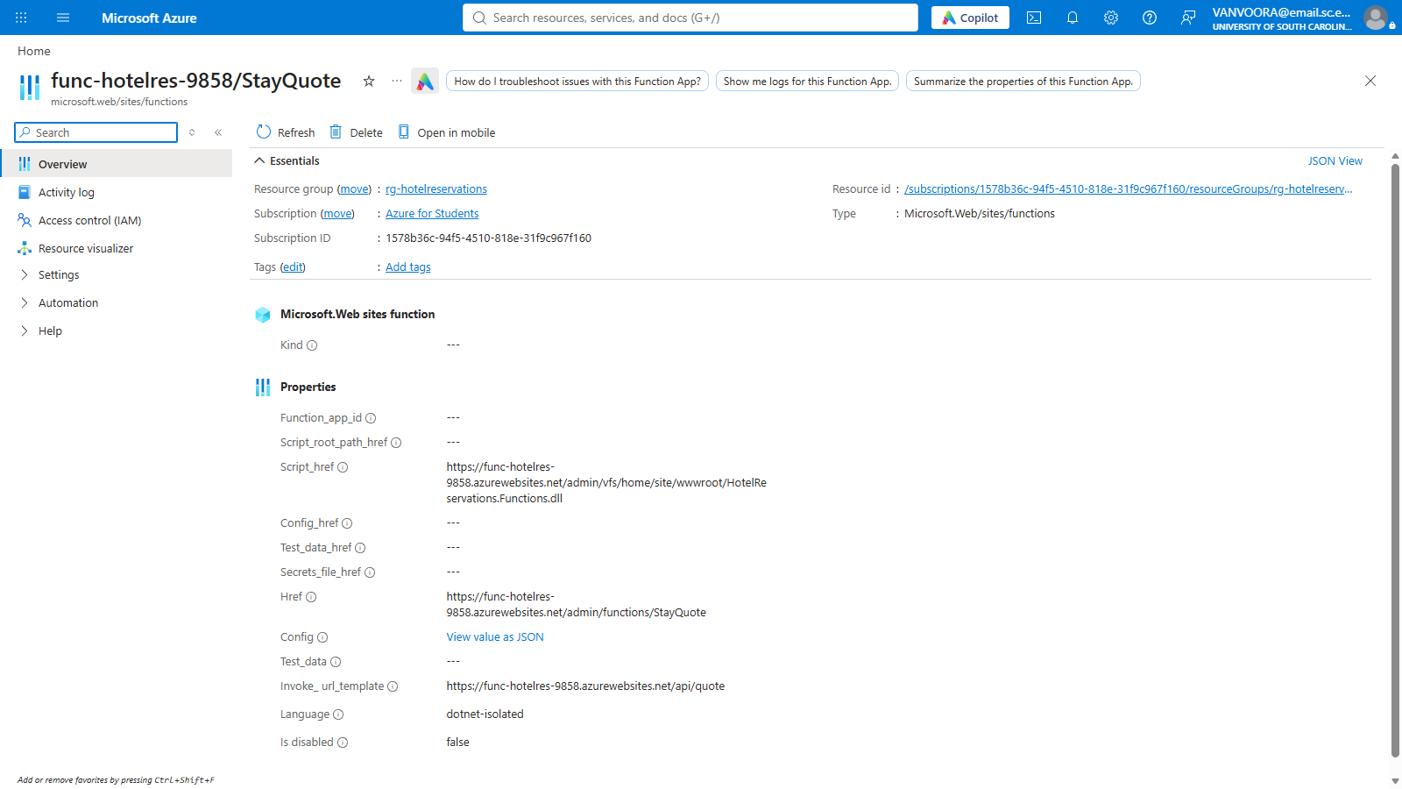
7. StayQuote function, invoked at /api/quote
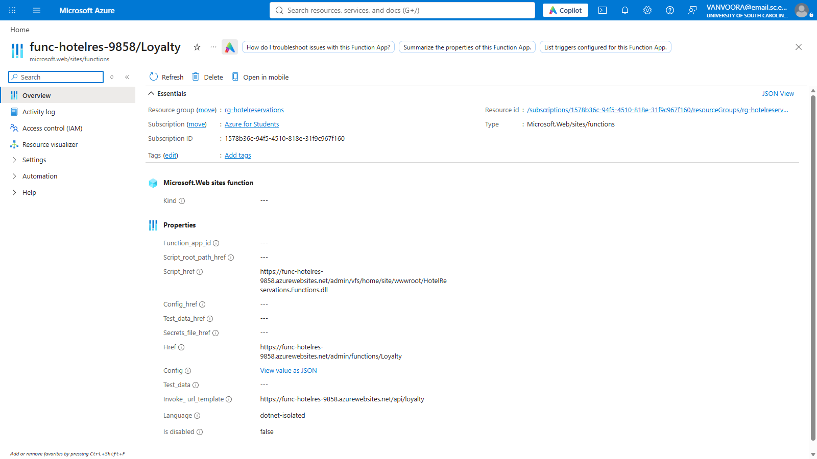
8. Loyalty function, invoked at /api/loyalty
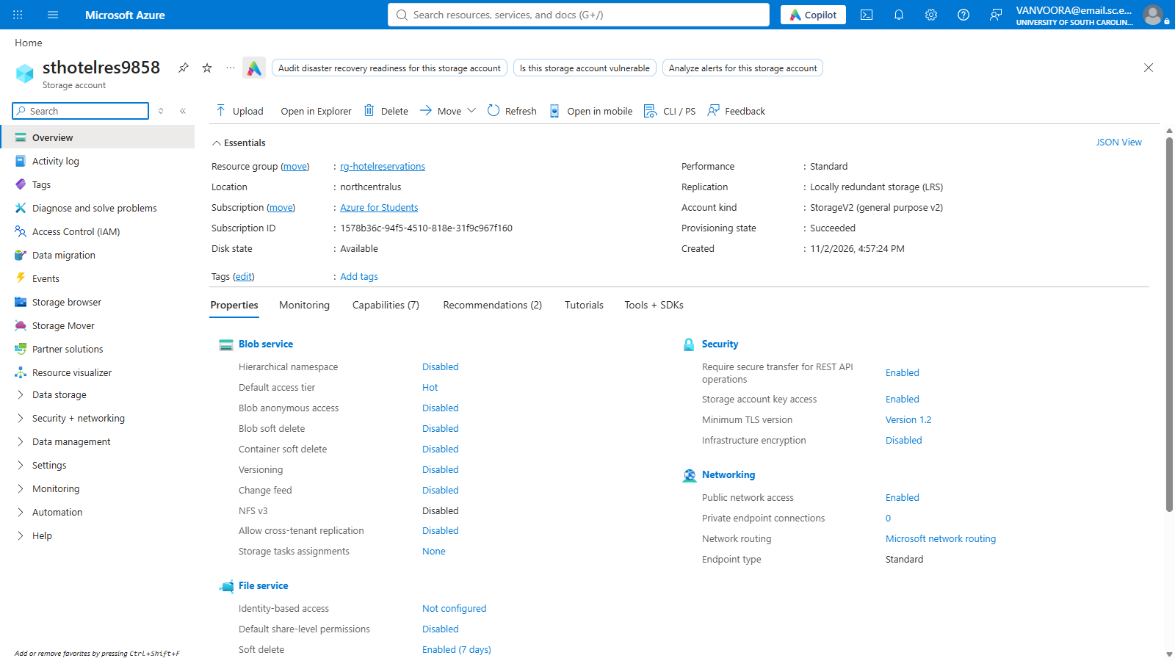
9. Storage account: Standard performance, locally redundant, blob anonymous access disabled
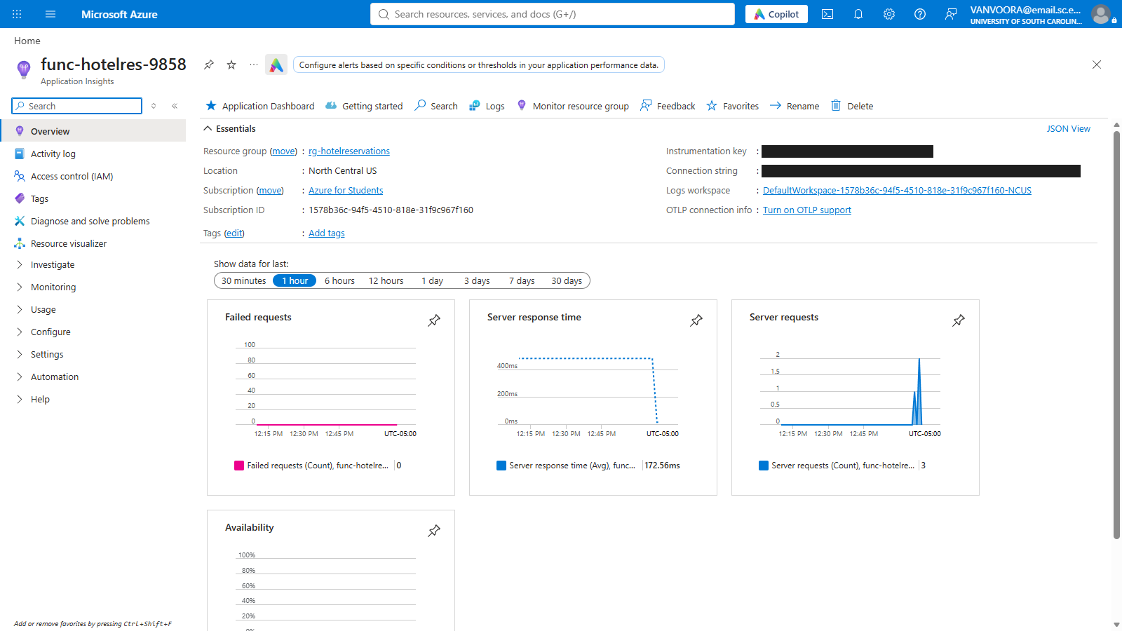
10. Application Insights receiving requests from the function app (keys blacked out)

Client before and after

Home page
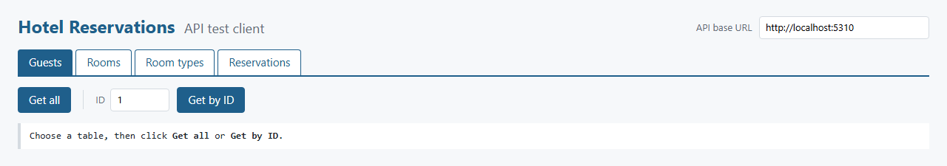
Before (Project 5): Get all and Get by ID only
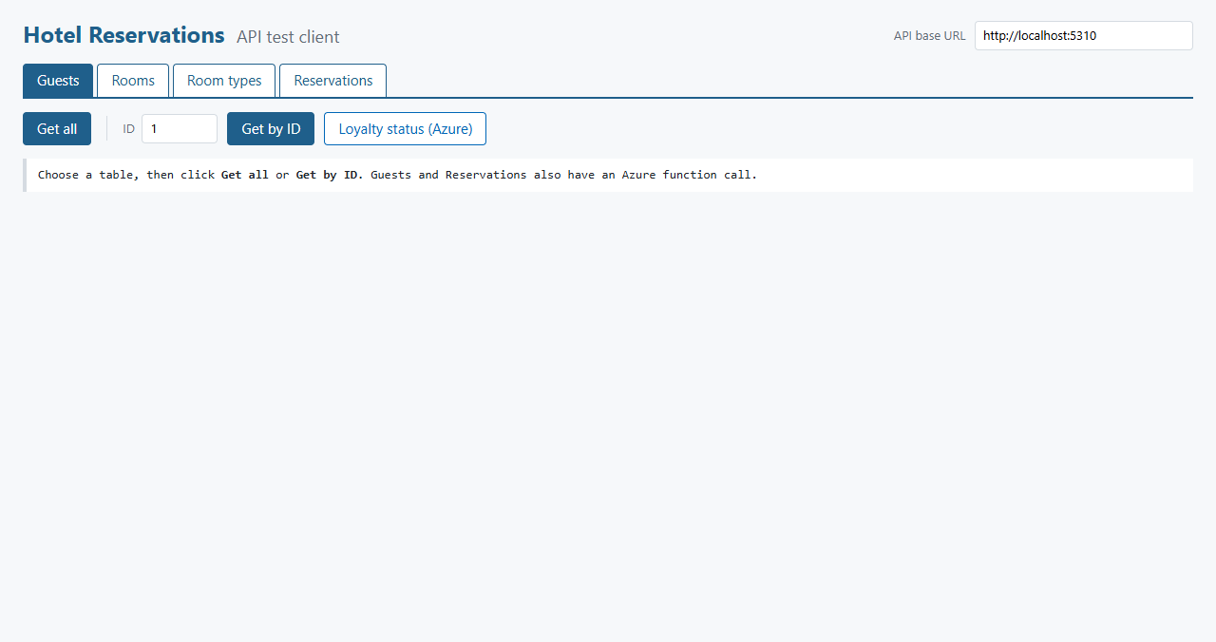
After (Project 6): the same page with a new Azure button

Guests
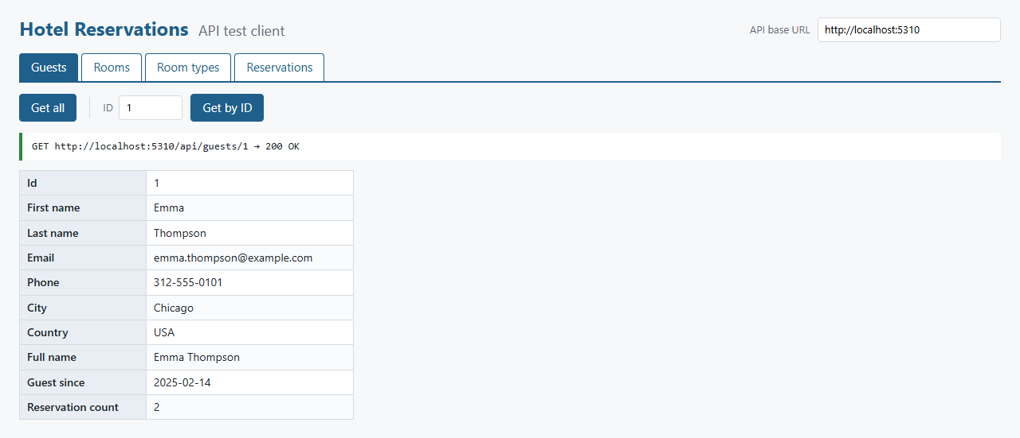
Before (Project 5): Guests, Get by ID (GET /api/guests/1)
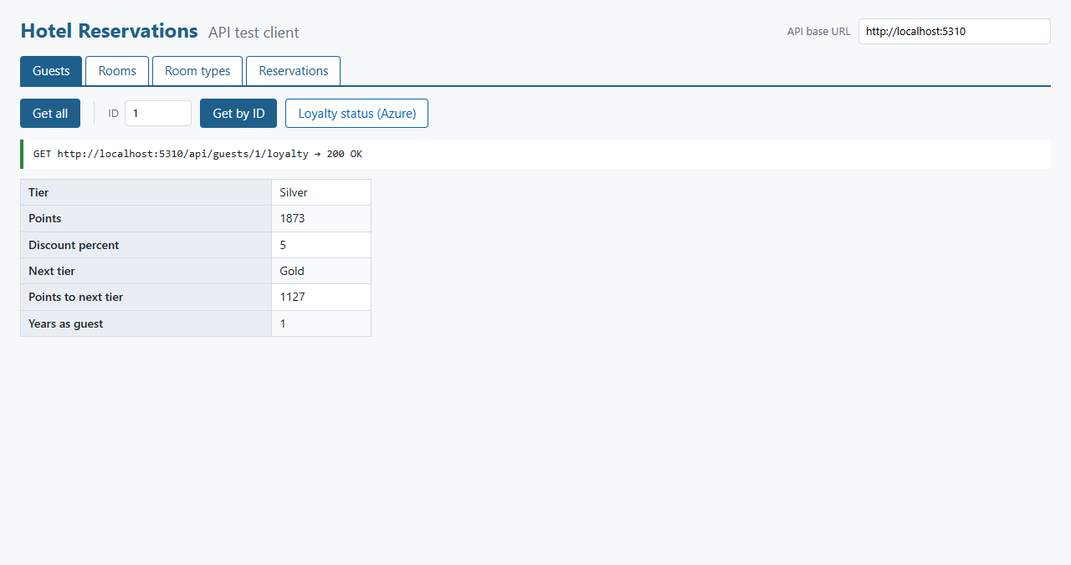
After (Project 6): guest 1's loyalty status (GET /api/guests/1/loyalty), worked out by the Loyalty function in Azure

Reservations
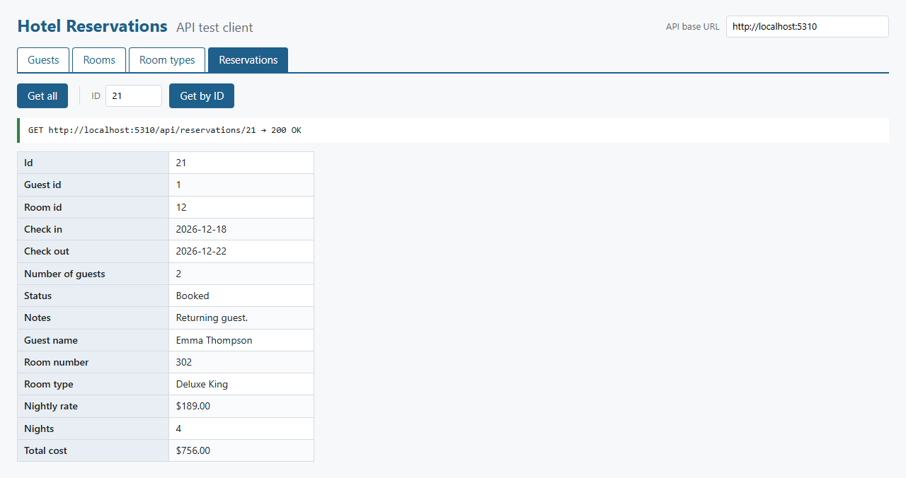
Before (Project 5): Reservations, Get by ID
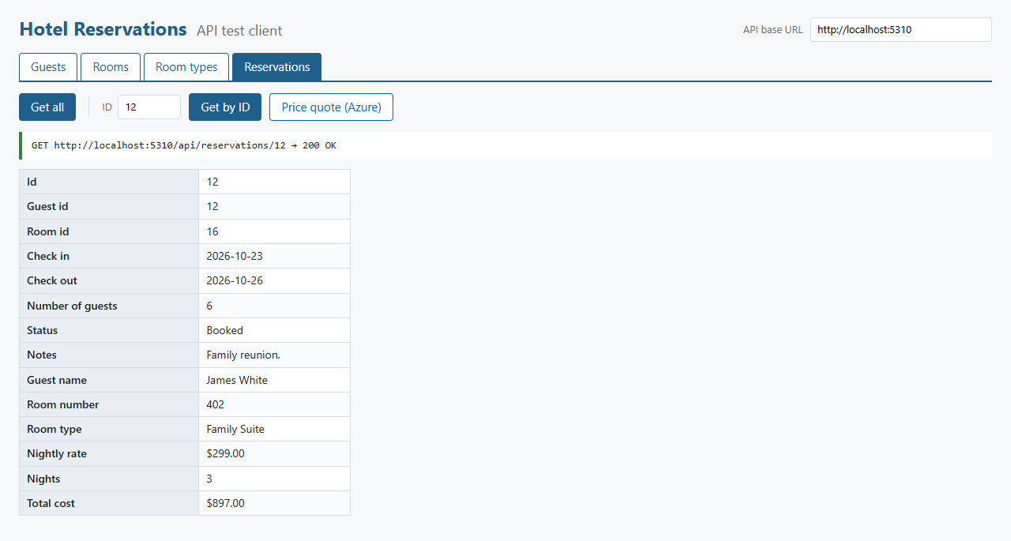
After (Project 6): Get by ID still works, and the Price quote button is available
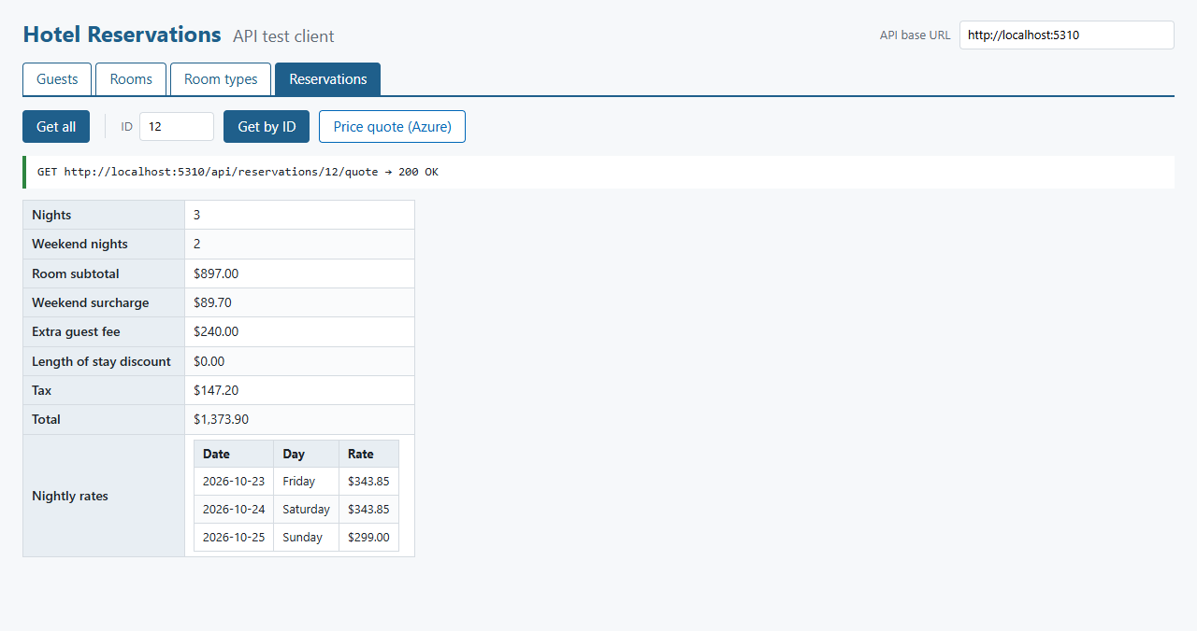
After (Project 6): quote for reservation 12 (GET /api/reservations/12/quote), including weekend rates and the fee for 6 guests

More service calls
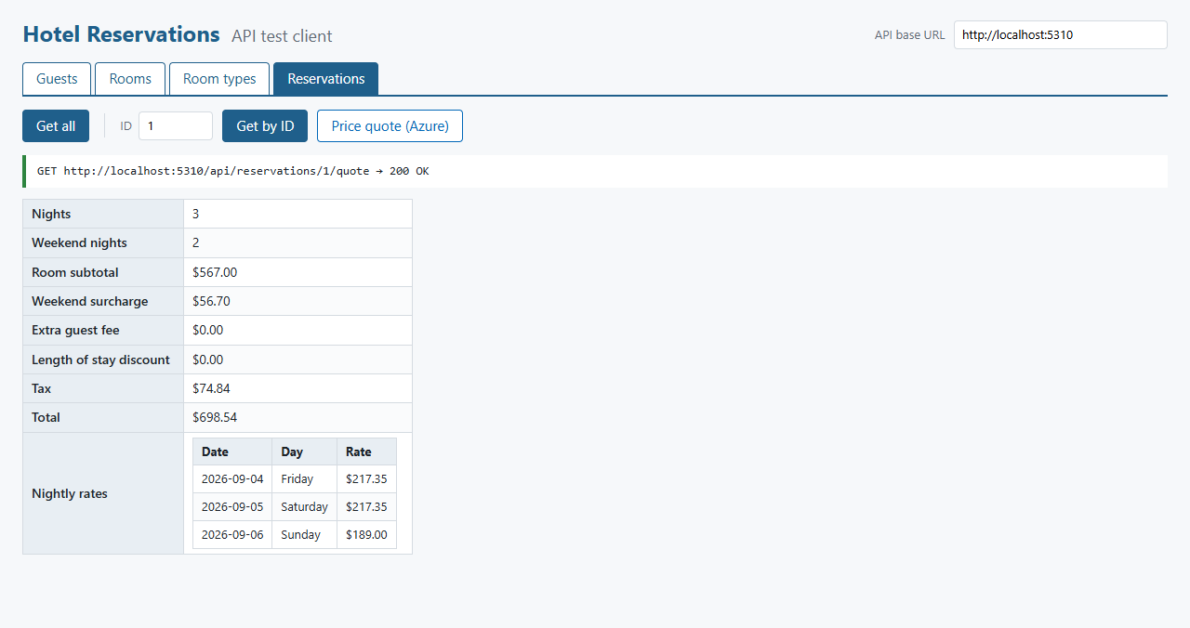
Quote for reservation 1: two weekend nights, two guests, no extra guest fee
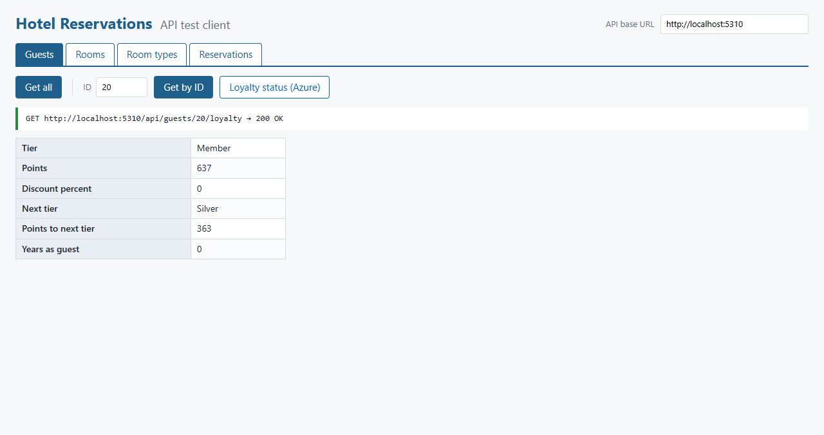
Loyalty status for guest 20, a newer guest at the Member tier

Errors
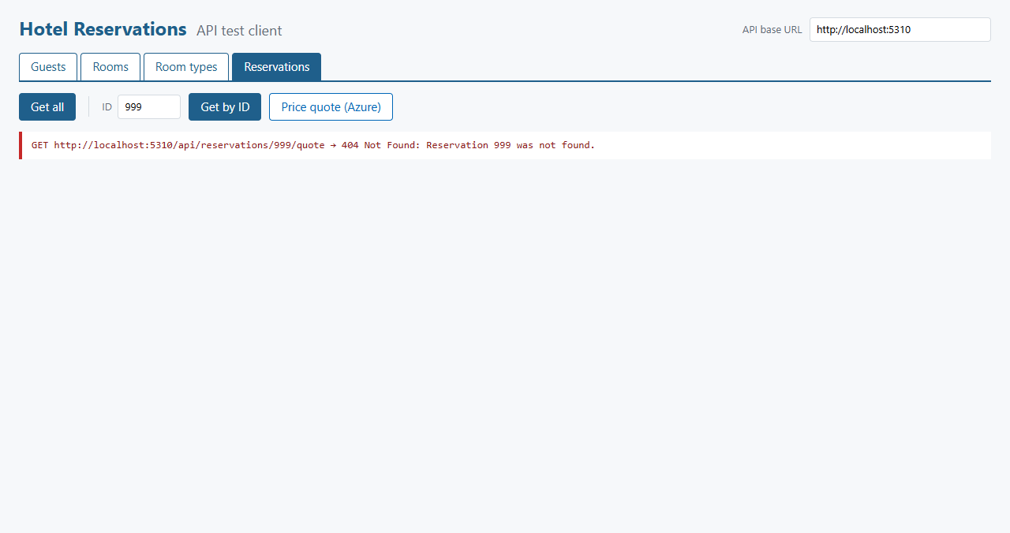
A quote for a reservation that doesn't exist returns 404 before Azure is called
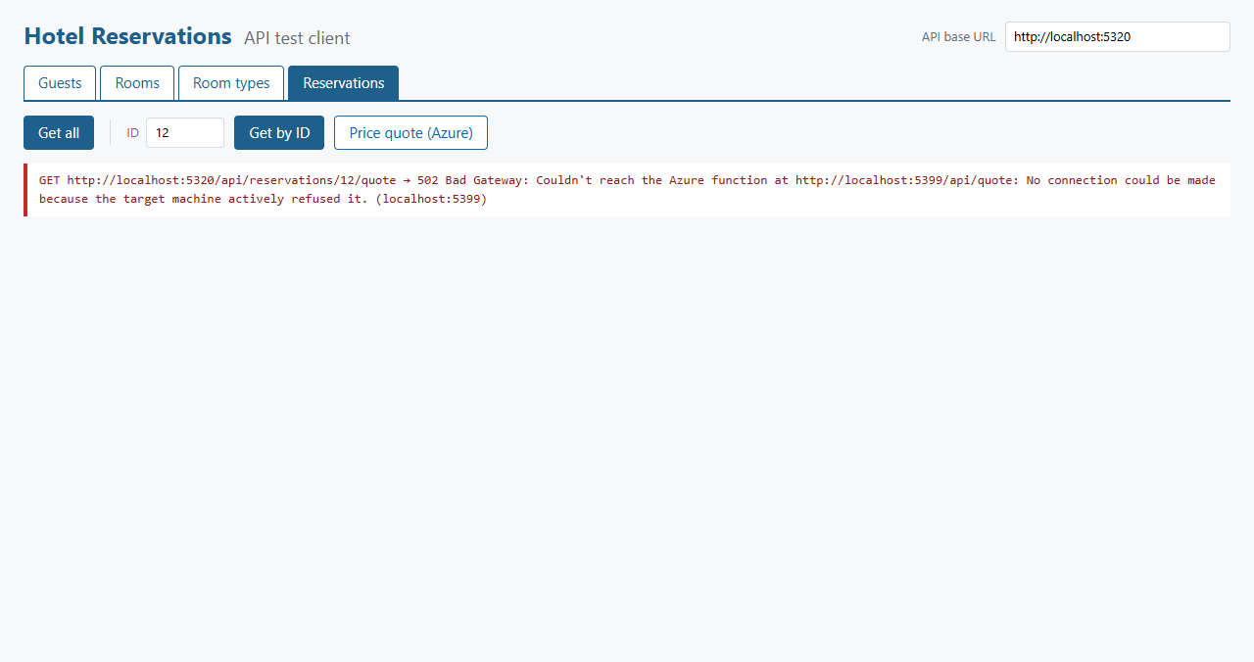
A copy of the API pointed at a dead function address: the client shows the 502 and its reason

Questions

i. What steps did you take to configure Azure?
- Activated Azure for Students at azure.microsoft.com/free/students with my school email. No credit card or other payment method was registered.
- Installed Azure CLI and Azure Functions Core Tools, then signed in with az login --use-device-code.
- Registered the resource providers the project needs: Microsoft.Web, Microsoft.Storage, Microsoft.Insights and Microsoft.OperationalInsights.
- Checked the subscription's policy, which only allows five regions, and confirmed that North Central US supports the Flex Consumption plan with .NET 10.
- Created the resource group: az group create --name rg-hotelreservations --location northcentralus.
- Created the storage account as StorageV2, Standard_LRS, with TLS 1.2 as the minimum and public blob access off.
- Created the function app on Flex Consumption with az functionapp create, using the dotnet-isolated runtime version 10, 2048 MB instances and a maximum of 40 instances. Application Insights was created with it.
- Published the code from the Functions project folder: func azure functionapp publish func-hotelres-9858 --dotnet-isolated.
- Tested both live URLs with curl, then set AzureFunctions:BaseUrl in the API's appsettings.json to the function app's address.
The functions use anonymous HTTP access, and no CORS setup was needed on the function app because the Web API calls it from the server, not from a browser.

ii. Describe a challenge you overcame in this project
Getting from a new Azure account to a working deployment. The code was the quick part. Each step of the setup failed in a way I had to diagnose:
- Sign-in. az login opened a Windows account popup that did nothing when I chose the work or school option. Device code sign-in (az login --use-device-code) worked through the normal browser.
- No subscription. The first successful sign-in reported "No subscriptions found", because signing in with a school account doesn't activate Azure for Students. I had to activate the offer and sign in again.
- Region policy. The subscription only allows deployments to five regions, so I listed the policy assignment first and picked a region from it that supports Flex Consumption and .NET 10.
- Running locally. func start stalled for this isolated project, and Core Tools recommended dotnet run. That then failed from the repository root because it looks for bin\Debug\net10.0 relative to the current directory, so it has to be run from the Functions project folder.
- A failed deployment. The resource group shows one failed deployment (screenshot 3). I looked it up and it is Application Insights' optional failure anomalies alert rule, which needs the Microsoft.AlertsManagement provider. The function app, storage and logging all deployed correctly, so it doesn't affect the project.
- Testing a clean copy. A clean build failed with MSB3030 in a very deep temporary folder, because the Functions SDK generates a nested project and the path passed the Windows length limit. The same files built with no errors from a short path.

iii. Describe a technique you learned in this project
Calling a remote service through a typed HttpClient. The API's Program.cs registers AzureFunctionsClient with AddHttpClient and gives it the base address from configuration, so the business layer only knows relative paths like api/quote. Moving from a local function host to Azure was a one-line settings change, with no code changes.
I also learned to treat a remote call as something that can fail. AzureFunctionsClient catches connection failures and timeouts and turns them into an ExternalServiceException, which the service layer returns as a 502 with a readable reason. A 400 from a function becomes the same BusinessRuleException used by the other business rules. The client doesn't need to know any of this; it shows the message like any other error.
Azure Functions itself was new as well: the isolated worker model, HTTP triggers with routes, and how a Flex Consumption app scales to zero and starts on demand, which is why the HttpClient has a 30 second timeout.

iv. What more would you want to refine in your project, to make it ready to sell, ship, and deploy?
- Security: require function keys or Microsoft Entra authentication instead of anonymous access, keep the key in Azure Key Vault, and add authentication and roles to the Web API.
- Resilience: retries with backoff and a circuit breaker on the HttpClient, and a fallback (such as the simple nights times rate total) when Azure is unavailable.
- Hosting: move the Web API and database to Azure as well, since only the functions are in the cloud today and the rest still runs on my machine.
- Shared contract: the request and response shapes are currently duplicated in the Business and Functions projects. A shared package would stop them drifting apart.
- Pricing rules: surcharges, fees, tax rates and loyalty tiers are constants in code. A real hotel needs them configurable by date, property and tax jurisdiction, and the quote should be what is actually charged.
- Deployment: a GitHub Actions pipeline to build, test and publish the functions, with separate development and production environments, and infrastructure defined in Bicep rather than one-off CLI commands.
- Testing: unit tests for the quote and loyalty calculations, including date boundaries and rounding, and integration tests for the new endpoints.
- Monitoring: Application Insights alerts for failures, a budget alert on the subscription, and an always-ready instance if cold starts become noticeable to users.

