**Interface (A)**

Title

Video Screen

Timeline scrubbing

(Interactive ) transcript

Play speed

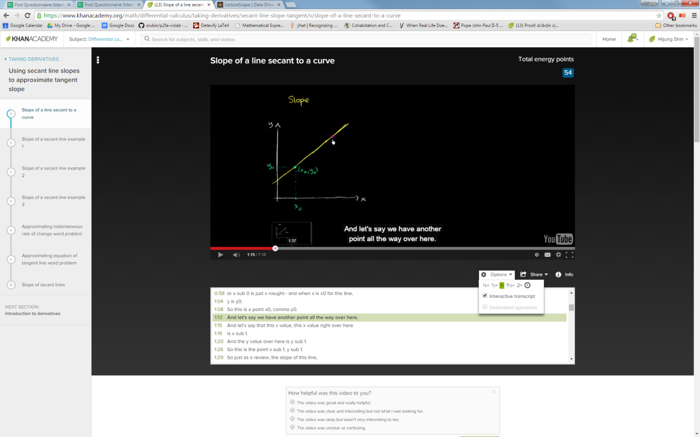

Closed caption

Thumbnail preview

Play / pause

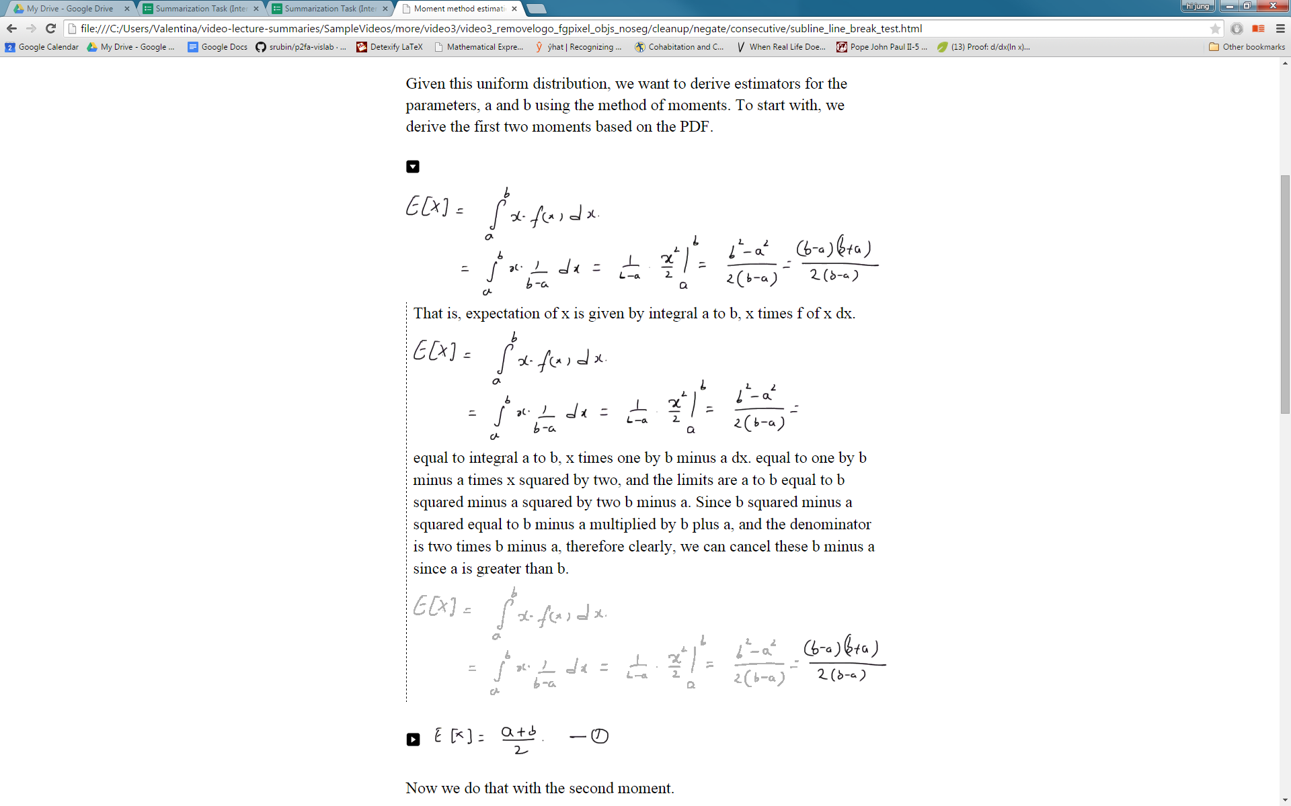**Interface (B)**

Figure time-lapse   
(inside transcript expand)

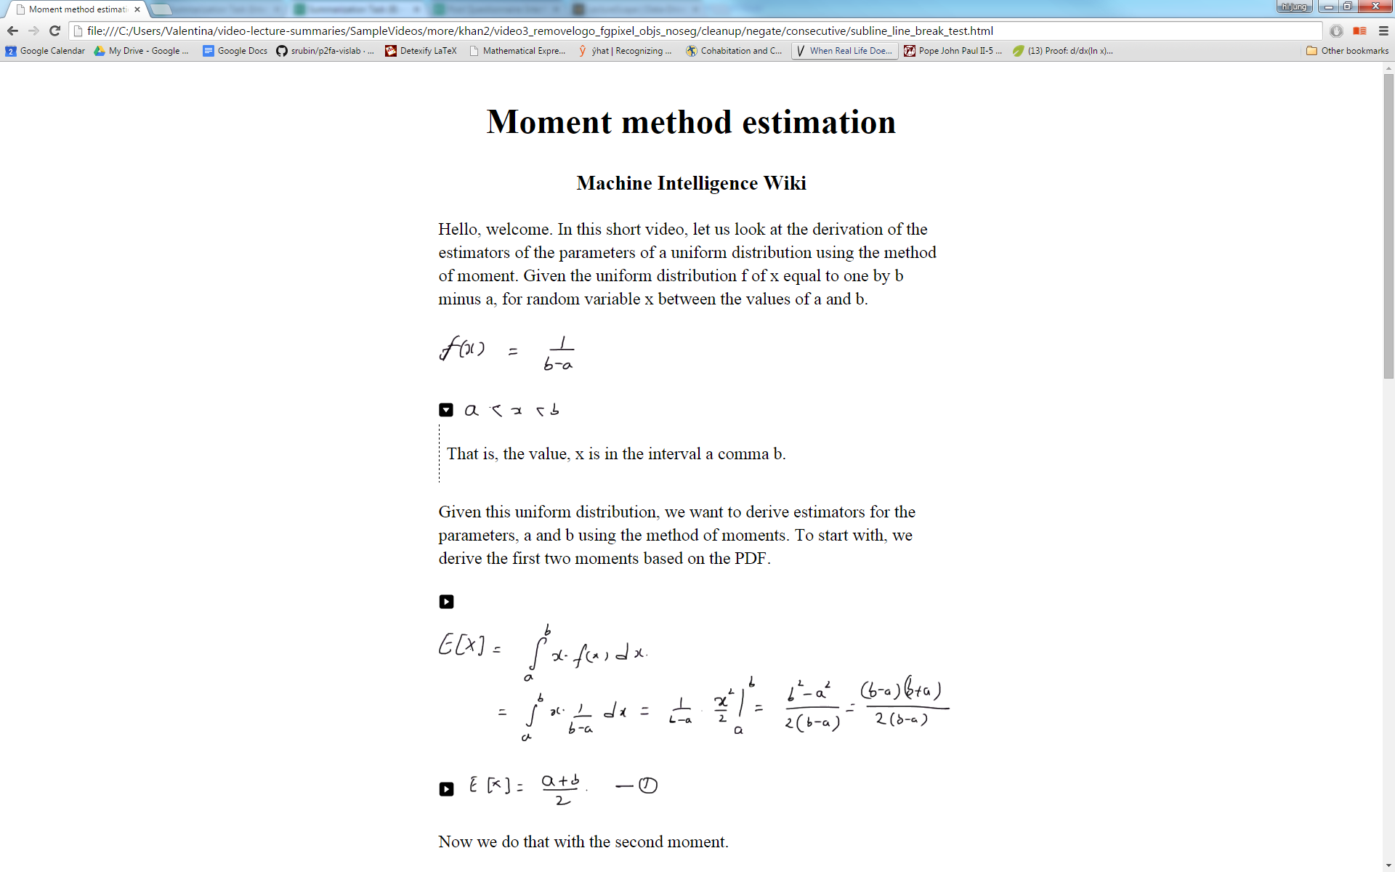

Title

Transcript text

Transcript collapse/expand

Figures